A PROJECT REPORT

ON

### “Intelligent Customer Help Desk With Smart Document Understanding”

**UNDER THE GUIDANCE OF**

SmartInternz

**SUBMITTED BY**

SOHAIL KHAN

**INDEX**

|  |  |
| --- | --- |
| **SR.No** | **Contents** |
|  | Introduction |
|  | Literature Survey |
|  | Specifications |
|  | Block Diagram |
|  | * 1. Block Diagram description |
|  | Software Implementation |
|  | Results |
|  | Advantages & Applications  8.1 Advantages  8.2 Applications |
|  | Conclusion   * 1. Conclusion   2. Future Development |
|  | Bibliography |

**CHAPTER NO. 1**

**INTRODUCTION**

**1. INTRODUCTION**

If the customer question is about the operation of a device, the application shall pass the question onto Watson Discovery Service, which has been pre-loaded with the device’s owners manual. So now, instead of “Would you like to speak to a customer representative?” we can return relevant sections of the owners manual to help solve our customers’ problems.

To take it a step further, the project shall use the Smart Document Understanding feature of Watson Discovery to train it on what text in the owners manual is important and what is not. This will improve the answers returned from the queries.

.

**CHAPTER NO. 2**

**LITERATURE SURVEY**

**2. LITERATURE SURVEY**

**1. Existing problem:**

The typical customer care chatbot can answer simple questions, such as store locations and hours, directions, and maybe even making appointments. When a question falls outside of the scope of the pre-determined question set, the option is typically to tell the customer the question isn’t valid or offer to speak to a real person.

**2. Proposed solution:**

In this project, there will be another option. If the customer question is about the operation of a device, the application shall pass the question onto Watson Discovery Service, which has been pre-loaded with the device’s owners manual. So now, instead of “Would you like to speak to a customer representative?” we can return relevant sections of the owners manual to help solve our customers’ problems.To take it a step further, the project shall use the Smart Document Understanding feature of Watson Discovery to train it on what text in the owners manual is important and what is not. This will improve the answers returned from the queries

**Scope of Work :**

* Create a customer care dialog skill in Watson Assistant
* Use Smart Document Understanding to build an enhanced Watson Discovery collection
* Create an IBM Cloud Functions web action that allows Watson Assistant to post queries to Watson Discovery
* Build a web application with integration to all these services & deploy the same on IBM Cloud Platform

**CHAPTER NO.3**

**Flow & DESCRIPTION**

## Flow And Description

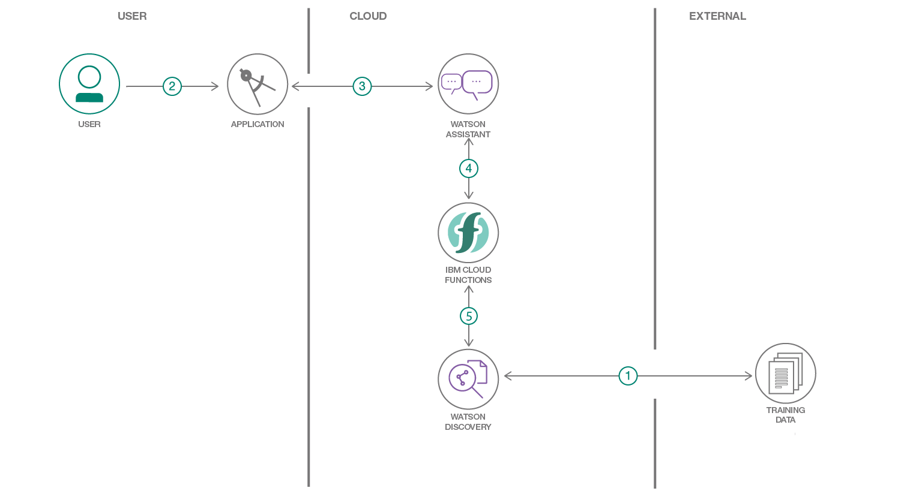

1. The document is annotated using Watson Discovery Smart Document Understanding.
2. The user interacts with the back-end server via the app UI. The front-end app UI is a chatbot that engages the user in a conversation.
3. Dialog between the user and back-end server is coordinated using a Watson Assistant dialog skill.
4. If the user asks a product operation question, a search query is passed to a predefined IBM Cloud Functions action.
5. The IBM Cloud Functions action will query the Watson Discovery Service and return the results.

**CHAPTER NO. 6**

**SOFTWARE IMPLEMENTATION**

### 1. Create IBM Cloud services

Create the following services:

* [**Watson Discovery**](https://cloud.ibm.com/catalog/services/discovery)
* [**Watson Assistant**](https://cloud.ibm.com/catalog/services/assistant)
* **Node red**

### 2. Configure Watson Discovery

#### Import the document

As shown below, launch the Watson Discovery tool and create a new data collection by selecting the Upload your own data option. Give the data collection a unique name. When prompted, select and upload the ecobee3_UserGuide.pdf file. The Ecobee is a popular residential thermostat that has a wifi interface and multiple configuration options.

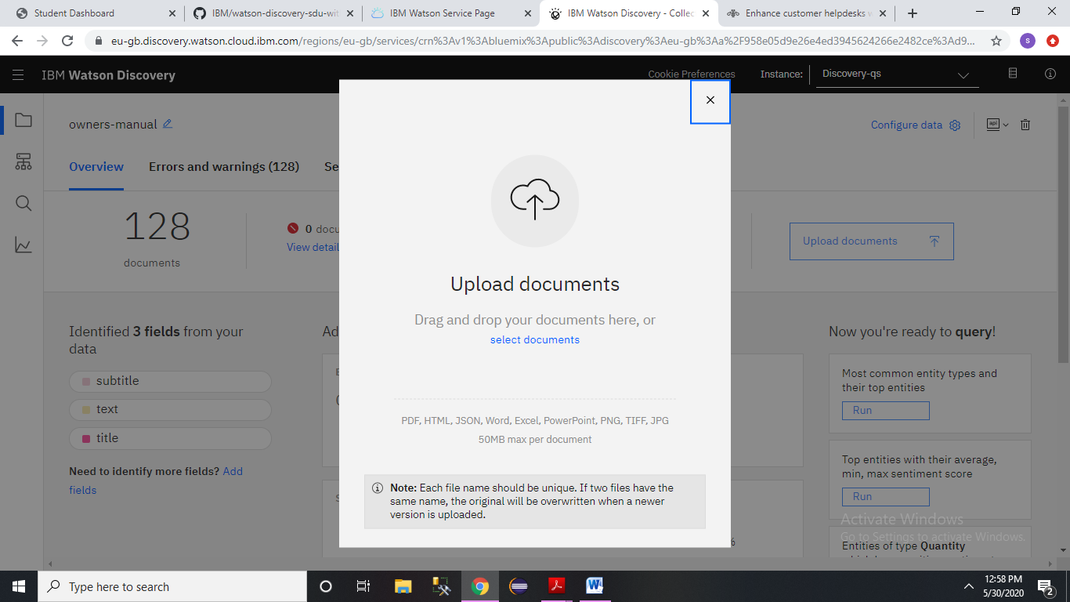

Click the Build your own query  button.

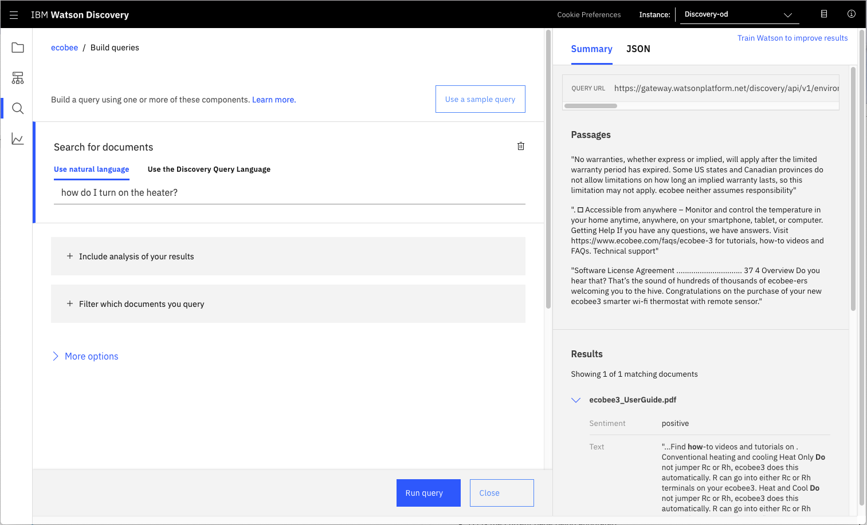

#### Annotate with SDU

Now let's apply SDU to our document to see if we can generate some better query responses.

From the Discovery collection panel, click the Configure data button (located in the top right corner) to start the SDU process.

Here is the layout of the Identify fields tab of the SDU annotation panel:

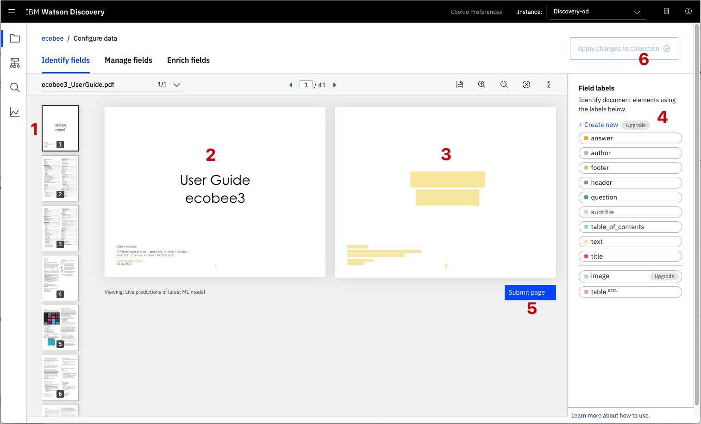

Next, click on the Manage fields [1] tab.

Here is where you tell Discovery which fields to ignore.Using the on/off buttons, turn off all labels except subtitles and text.

is telling Discovery to split the document apart, based on subtitle.

Click to submit your changes.

### 3. Create IBM Cloud Functions action

Now let's create the web action that will make queries against our Discovery collection.

Start the IBM Cloud Functions service by selecting Create Resource from the IBM Cloud dashboard. Enter functions as the filter [1], then select the Functions card [2]:

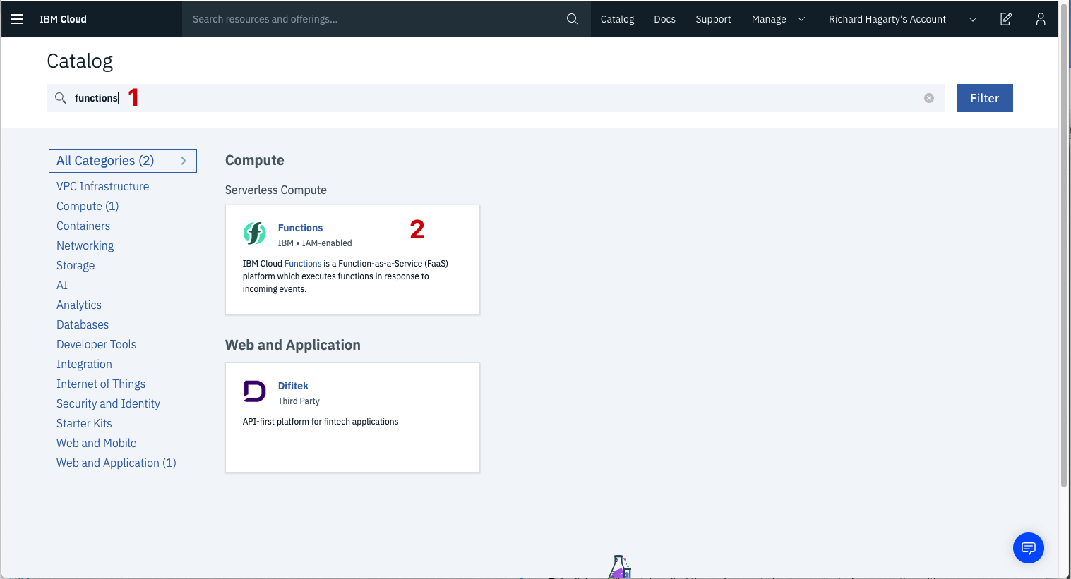

From the Functions main panel, click on the Actions tab. Then click on Create.

From the Create panel, select the Create Action option.

On the Create Action panel, provide a unique Action Name [1], keep the default package , and select the Node.js runtime. Click the Create button to create the action.

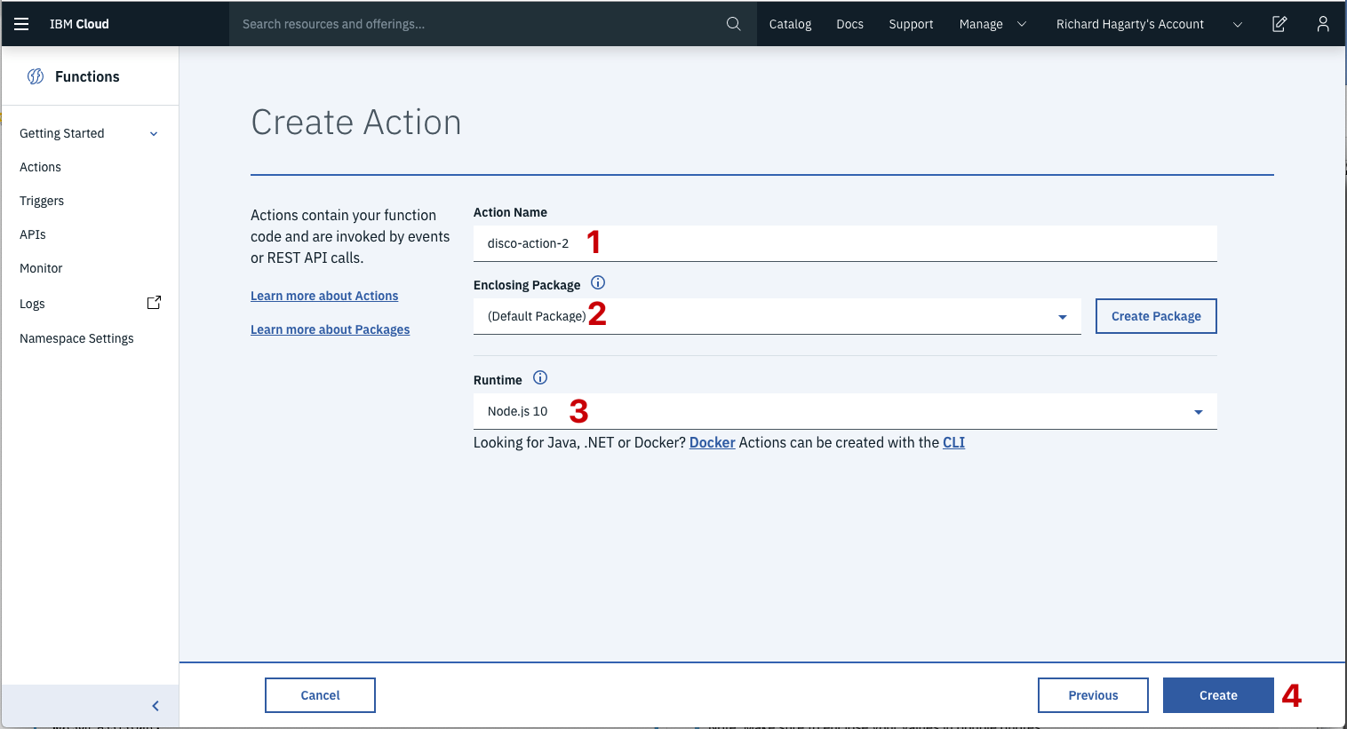

Once your action is created, click on the Code tab

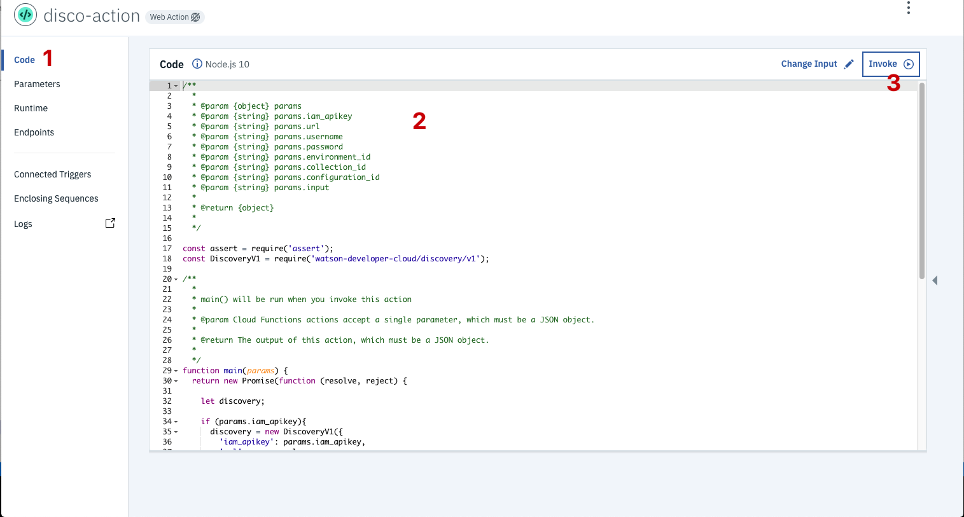

In the code editor window , cut and paste in the code from the disco-action.js file found in the actions directory of your local repo. The code is pretty straight-forward - it simply connects to the Discovery service, makes a query against the collection, then returns the response.

If you press the Invoke button , it will fail due to credentials not being defined yet. We'll do this next.

Select the Parameters tab

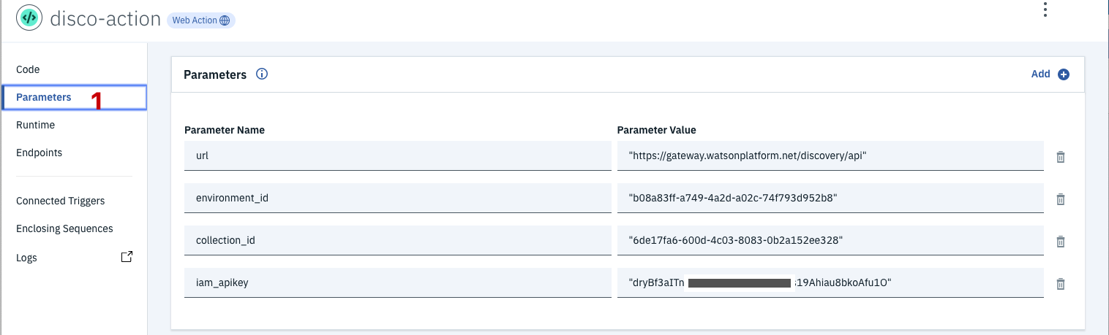

Now that the credentials are set, return to the Code panel and press the Invoke button again. Now you should see actual results returned from the Discovery service:

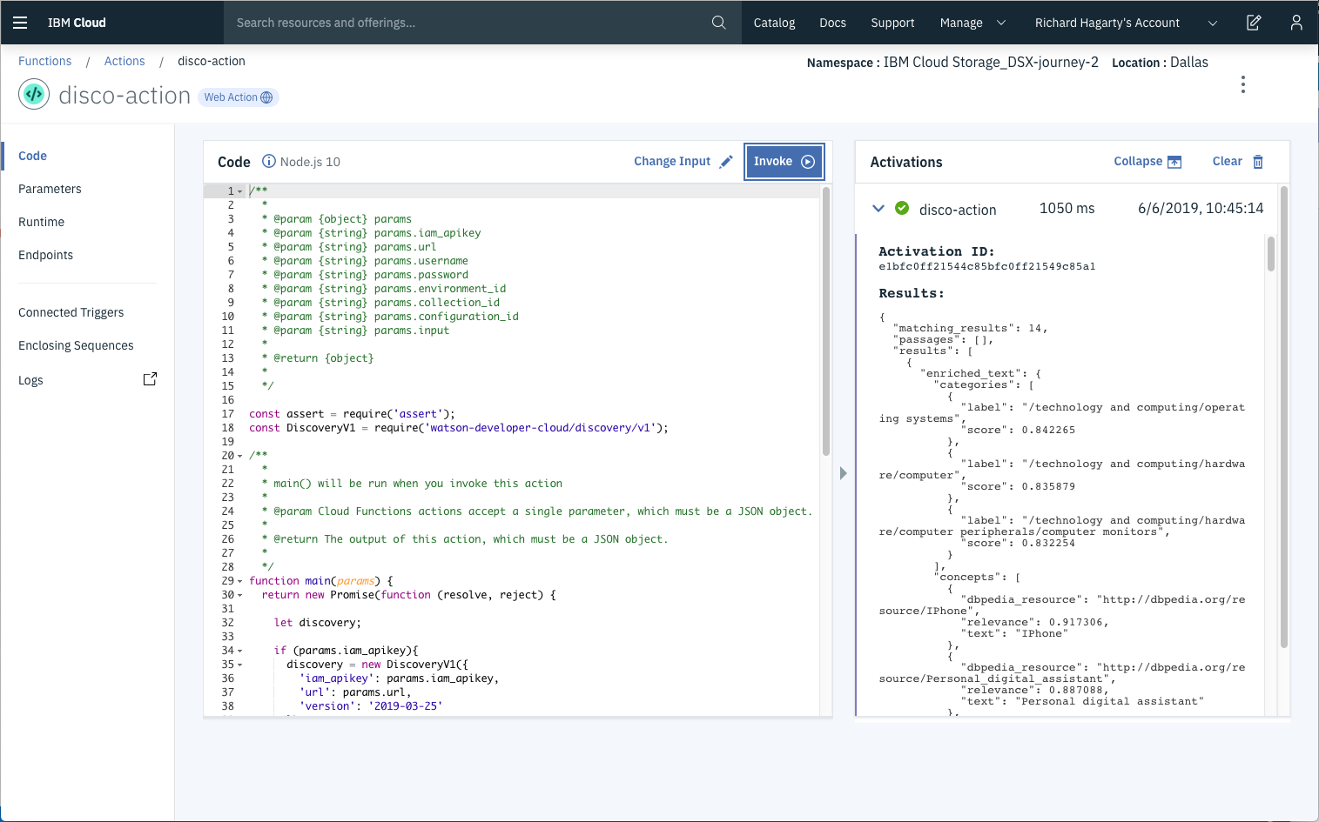

Next, go to the Endpoints panel :

Click the checkbox for Enable as Web Action . This will generate a public endpoint URL .

Take note of the URL value , as this will be needed by Watson Assistant in a future step.

To verify you have entered the correct Discovery parameters, execute the provied curl command . If it fails, re-check your parameter values.

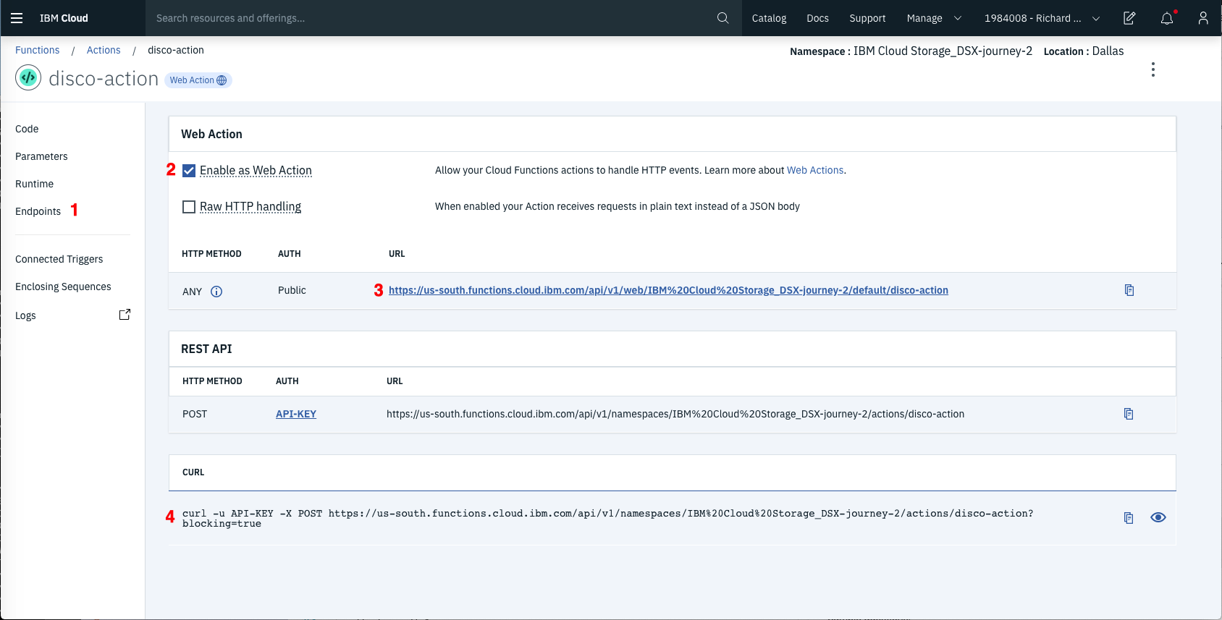

### 4. Configure Watson Assistant

As shown below, launch the Watson Assistant tool and create a new dialog skill. Select the Use sample skill option as your starting point.

#### Add new intent

The default customer care dialog does not have a way to deal with any questions involving outside resources, so we will need to add this.

Create a new intent that can detect when the user is asking about operating the Ecobee thermostat.

From the Customer Care Sample Skill panel, select the Intents tab.

Click the Create intent button.

Name the intent #Product_Information, and at a minimum, enter the following example questions to be associated with it.

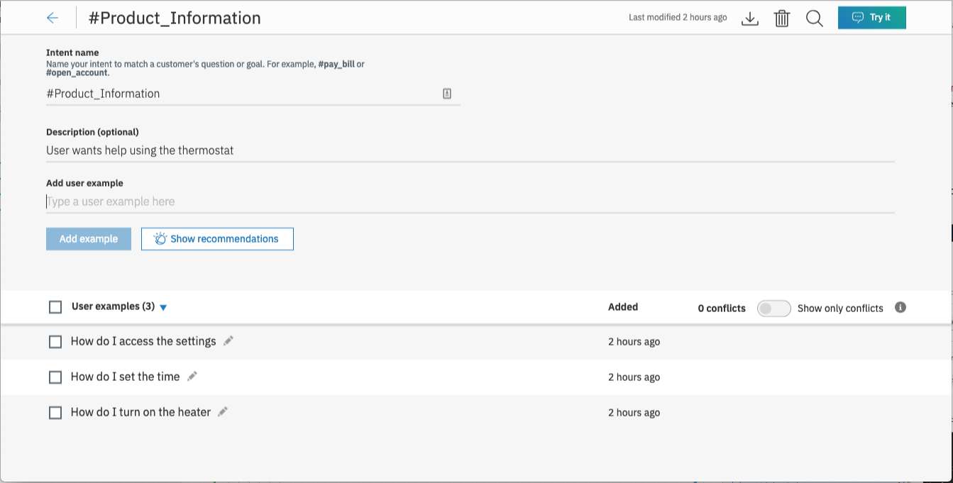

#### Create new dialog node

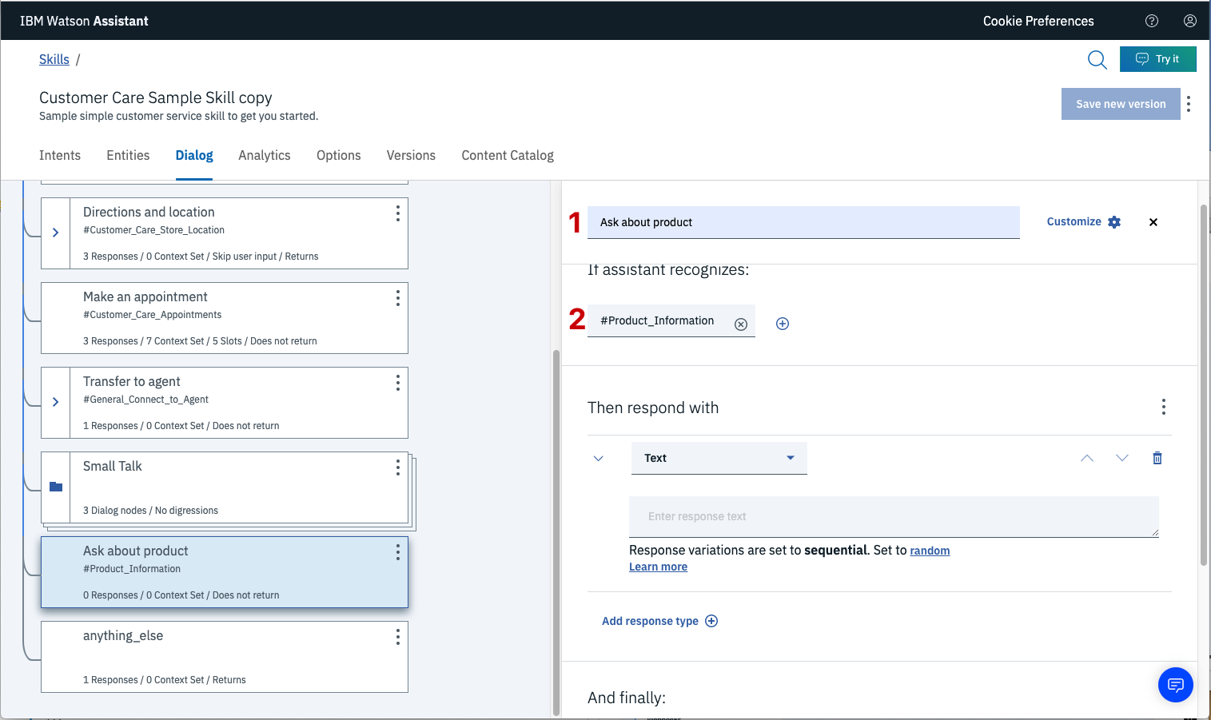

**Enable webhook from Assistant**

Set up access to our wehbook for the IBM Cloud Functions action

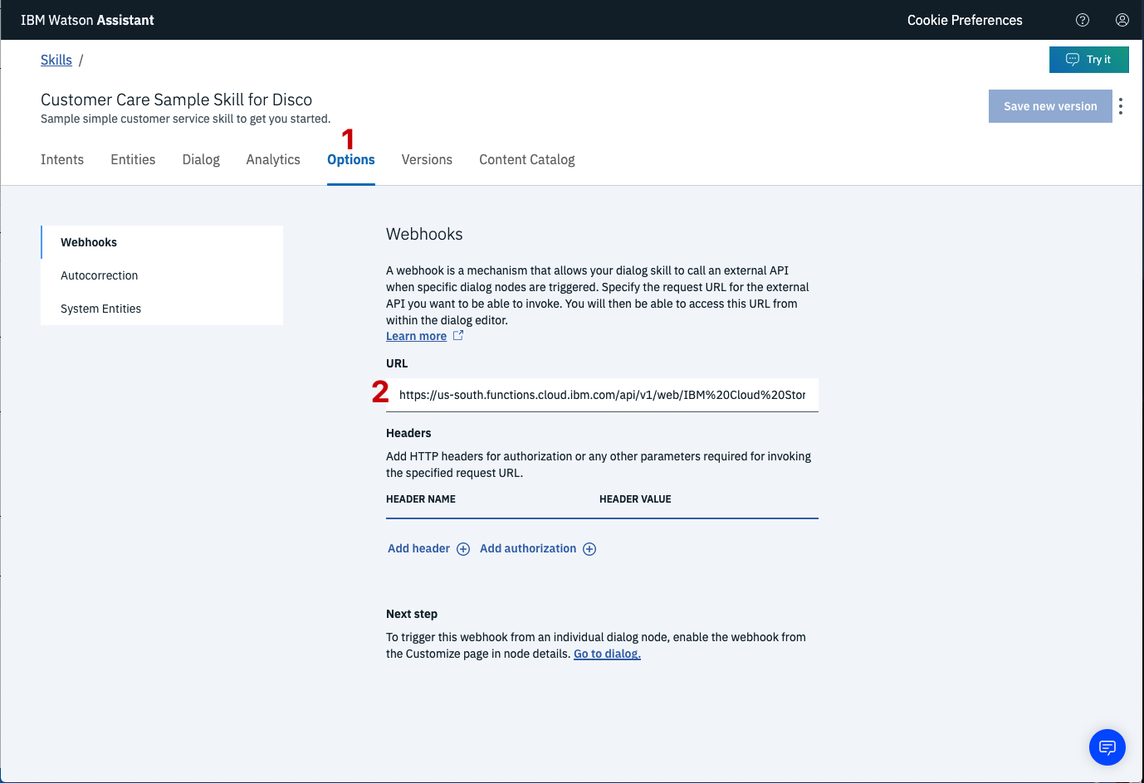

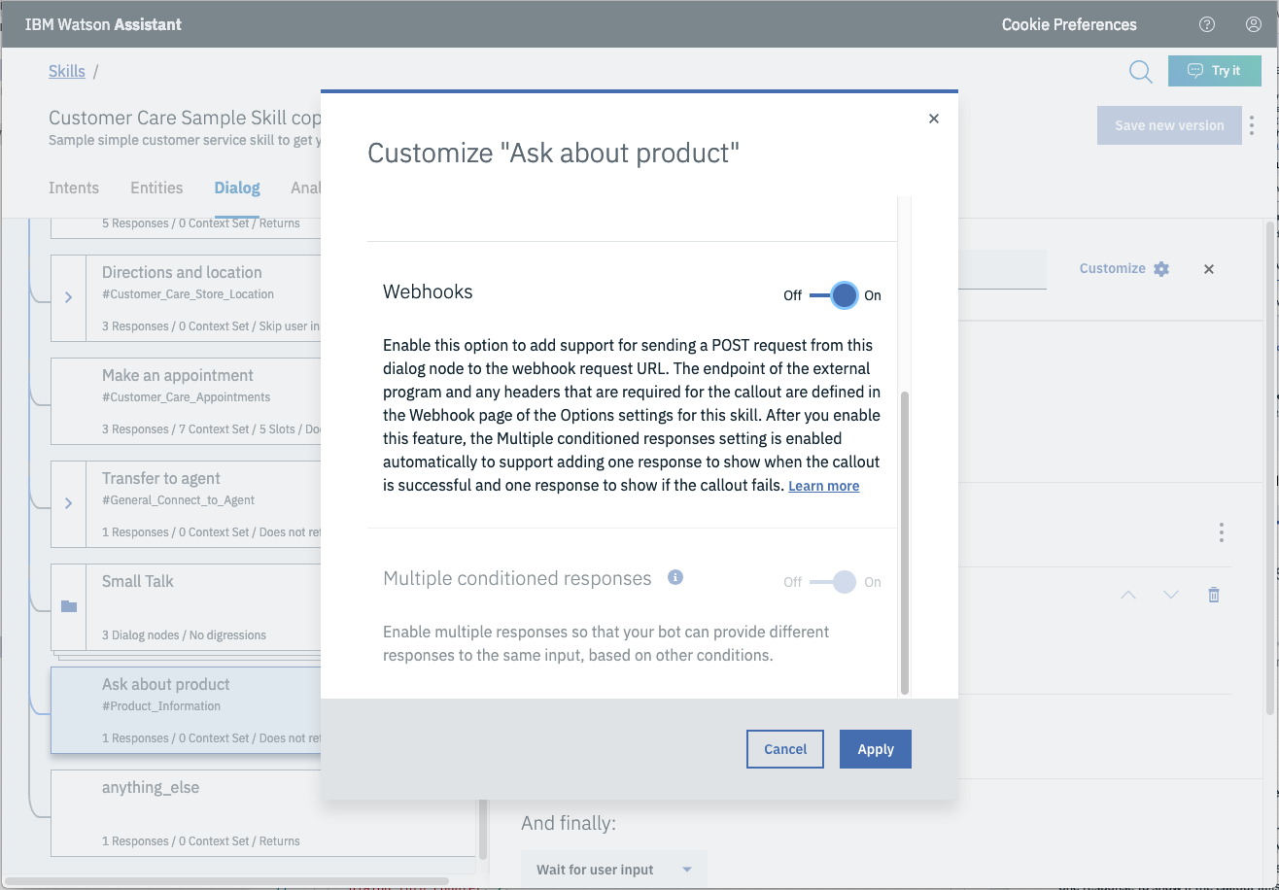

You will also need to pass in the users question via the parameter input [2]. The key needs to be set to the value:

"<?input.text?>"

If you fail to do this, Discovery will return results based on a blank query.

Optionally, you can add these responses to aid in debugging:

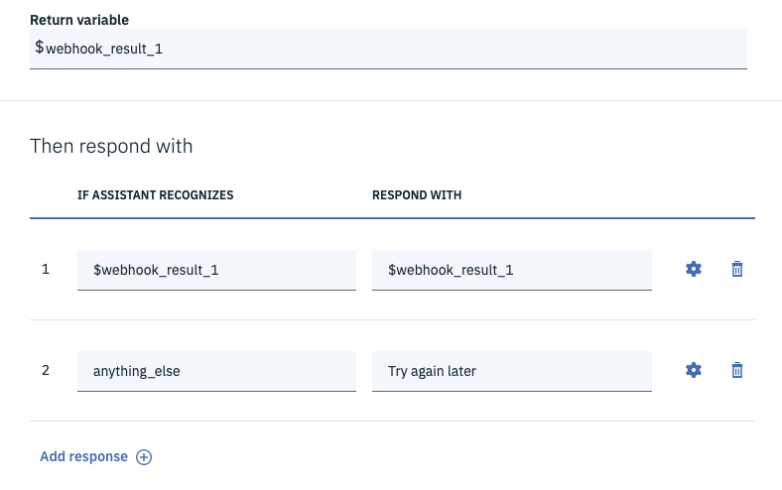

### 4. Build Node-RED Flow To Integrate All Services

Node Red Flow

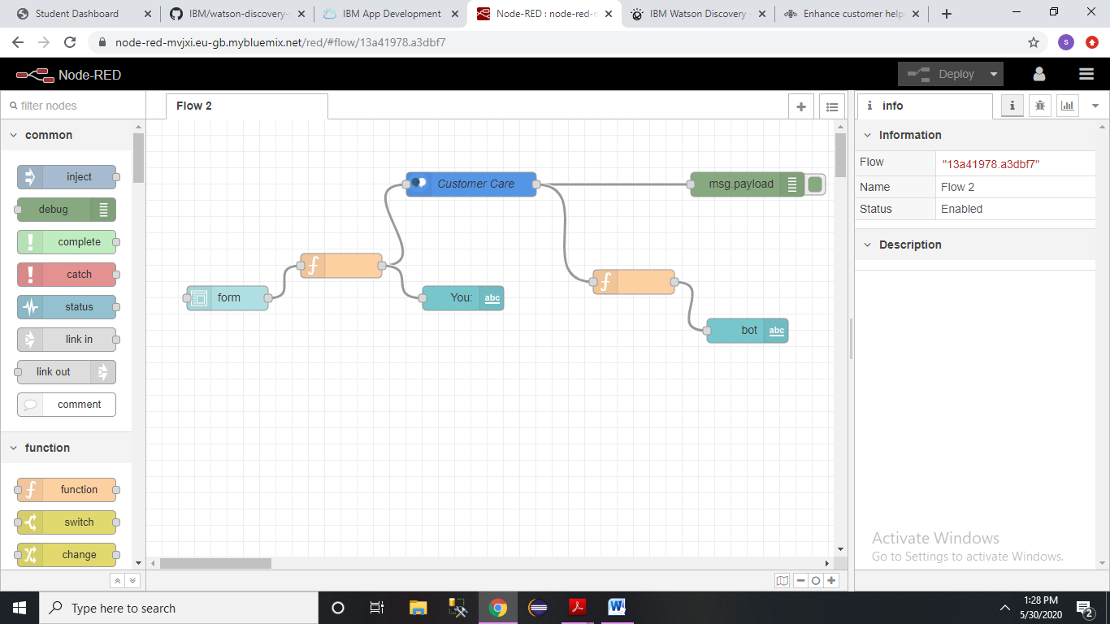

**CHAPTER NO. 7**

**Results**

* 1. **Result on Watson Assistant**

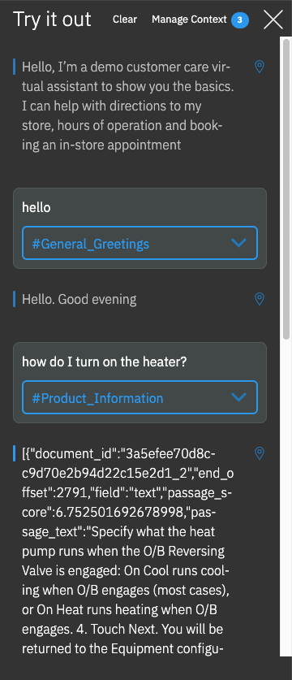

* 1. **Result of SmartBot**

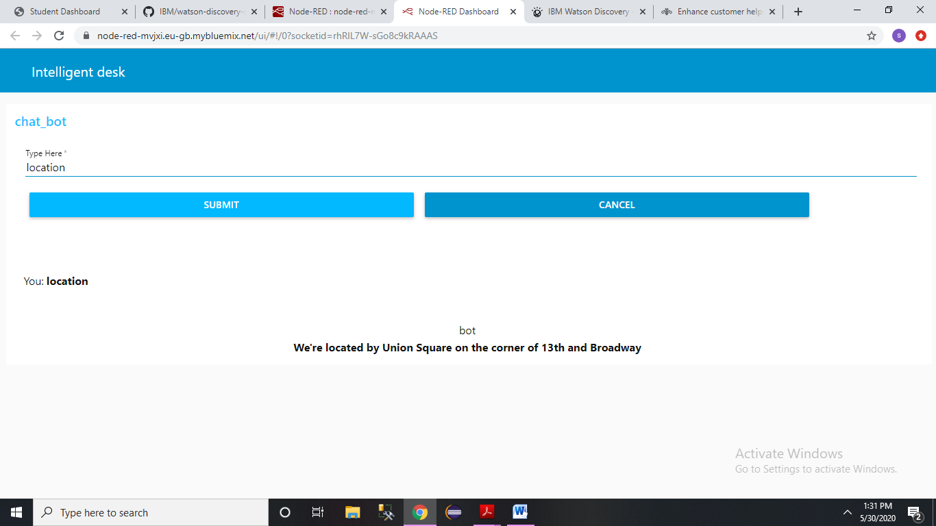

**CHAPTER NO. 8**

**ADVANTAGES &APPLICATIONS**

* **ADVANTAGES:**
* Campanies can deploy chatbots to rectifiy simple and general human queries .
* No need to divert calls to customer agent and customer agent can look on other works.
* Reduces human workforce .
* **APPLICATIONS:**
* Chatbots can be deploy on popular social media platforms like facebook,slack,telegram.
* Chatbots can be used to book appointments, cabs with the help of some steps.

**CHAPTER NO. 9**

**CONCLUSION AND FUTURE SCOPE**

**CONCLUSION**

We use the Smart Document Understanding feature of Watson Discovery to train it on what text in the owners manual is important and what is not. This will improve the answers returned from the queries.

**FUTURE SCOPE**

* In the future Watson services like Text-To-Speech and Speech-To-Text can be integrated in the chatbot. This can make the chatbot Hands-free.

**CHAPTER NO. 10**

**Bibliography**

**Bibliography**

* [**https://www.ibm.com/cloud/get-started**](https://www.ibm.com/cloud/get-started)
* [**https://developer.ibm.com/tutorials/how-to-create-a-node-red-starter-application/**](https://developer.ibm.com/tutorials/how-to-create-a-node-red-starter-application/)
* [**https://www.ibm.com/watson/products-services**](https://www.ibm.com/watson/products-services)
* **https://developer.ibm.com/articles/introduction-watson-discovery/**