A
Mini Project Report (BCS 554) (5th Semester) On

SmarEats: Digital Canteen Plateform
Group No - 41
Submitted
In partial fulfillment
For the award of the Degree of Bachelor of Technology
In the Department of Computer Science & Engineering


Submitted To:
Mr.Asim Kumar Rai Assistant Professor C S E Department IMSEC, Ghaziabad

Submitted By:
Kishan Shamra (2301430100120) Karan Kr. Maurya (2301430100113) Jesvin Cherian (2301430100106) Majid Ali (2301430100133)
Mohd. Sohail (2301430120141)

Department Of Computer Science & Engineering IMS Engineering College Ghaziabad (U.P)
Dr. A.P.J. Abdul Kalam Technical University Lucknow Uttar Pradesh
November 2025

Vision and Mission of the Institute and Department

Vision:
To make IMSEC an Institution of Excellence for empowering students through technical education, incorporating human values, and developing engineering acumen for innovations and leadership skills to upgrade society.

Mission:
Mission 1: To promote academic excellence by continuous learning in core and emerging Engineering domains using innovative teaching and learning methodologies.
Mission 2: To inculcate values and ethics among the learners.
Mission 3: To promote industry interactions and cultivate young minds for entrepreneurship.
Mission 4: To create a conducive learning ecosystem and research environment on a perpetual basis to develop students as technology leaders and entrepreneurs who can address tomorrow’s societal needs.

Vision of the Department
To provide globally competent professionals in the field of Computer Science & Engineering embedded with sound technical knowledge, aptitude for research and innovation, and nurture future leaders with ethical values to cater to the industrial & societal needs.

Mission of the Department
Mission 1: To provide quality education in both the theoretical and applied foundations of Computer Science & Engineering.
Mission 2: Conduct research in Computer Science & Engineering resulting in innovations thereby nurturing entrepreneurial thinking.
Mission 3: To inculcate team building skills and promote life-long learning with a high societal and ethical values.

Program Outcomes (POs) and Program Specific Outcomes (PSOs)

S. No. | Program Outcomes / Program Specific Outcomes
PO1. | Engineering knowledge: Apply the knowledge of mathematics, science, engineering fundamentals, and an engineering specialization to the solution of complex engineering  problems.
PO2. | Problem analysis: Identify, formulate, review research literature, and analyze complex engineering problems reaching substantiated conclusions using first principles  of mathematics, natural sciences, and engineering sciences.
PO3. | Design/development of solutions: Design solutions for complex engineering problems and design system components or processes that meet the specified needs with appropriate consideration for the public health and safety, and the cultural, societal,  and environmental considerations.
PO4. | Conduct investigations of complex problems: Use research-based knowledge  and research methods including design of experiments, analysis and interpretation of data, and synthesis of the information to provide valid conclusions.
PO5. | Modern tool usage: Create, select, and apply appropriate techniques, resources, and modern engineering and IT tools including prediction and modelling to  complex engineering activities with an understanding of the limitations.
PO6. | The engineer and society: apply reasoning informed by the contextual knowledge to assess societal, health, safety, legal and cultural issues and the consequent  responsibilities relevant to the professional engineering practice.
PO7. | Environment and sustainability: Understand the impact of the professional engineering solutions in societal and environmental contexts, and demonstrate the  knowledge of, and need for sustainable development.
PO8. | Ethics: Apply ethical principles and commit to professional ethics and responsibilities  and norms of the engineering practice.
PO9. | Individual and team work: Function effectively as an individual, and as a member or  leader in diverse teams, and in multidisciplinary settings.

PO10. | Communication: Communicate effectively on complex engineering activities with the engineering community and with society at large, such as, being able to comprehend and write effective reports and design documentation, make effective presentations, and give  and receive clear instructions.
PO11. | Project management and finance: Demonstrate knowledge and understanding of the engineering and management principles and apply these to one ’ s own work, as a  member and leader in a team, to manage projects and in multidisciplinary environments.
PO12. | Life-long learning: Recognize the need for, and have the preparation and ability to engage in independent and life-long learning in the broadest context of technological change.

CSE Department Program Educational Objectives (PEOs)

B. Tech Computer Science & Engineering Department has the following Program Educational Objectives:
PEO1: Possess core theoretical and practical knowledge in Computer Science and Engineering for successful career development in industry, pursuing higher studies or entrepreneurship.
PEO2: Ability to imbibe life long learning for global challenges to impact society and environment.
PEO3: To demonstrate work productivity with leadership and managerial skills having ethics and human value in progressive career path.
PEO4: To exhibit communication skill and collaborative skill plans and participate in multidisciplinary Computer Science & Engineering fields .

CSE Department Program Specific Outcomes (PSOs)

B. Tech Computer Science & Engineering Department has the following Program Specific Outcomes:

PSO1: To analyze and demonstrate, the recent engineering practices, ethical values and strategies in real time world problems to meet the challenges for the future.
PSO2: To develop adaptive computing system using computational intelligence strategies and algorithmic design to address diverse data analysis and machine learning challenges.

CO-PO-PSO MAPPING FOR ACADEMIC SESSION 2025-26
Course Name: Mini Project Course Code: BCS-554
Semester / Year: 5th / 3 NBA Code: C310 Faculty name(s): Ms. Meenu Sharma/ Ms. Vandana Tomar
Course Outcomes:

Sl.NO | DESCRIPTION | COGNITIVE LEVEL (BLOOMS TAXONOMY)
C310.1 | Developing a technical artifact requiring new technical skills and effectively utilizing a new software tool to complete a task | K3
C310.2 | Writing requirements documentation, Selecting appropriate technologies, identifying and creating appropriate test cases for systems. | K4
C310.3 | Demonstrating understanding of professional customs & practices and working with professional standards. | K2
C310.4 | Improving problem-solving, critical thinking skills and report  writing. | K5
C310.5 | Learning professional skills like exercising leadership, behaving professionally, behaving ethically, listening effectively, participating as a member of a team, developing appropriate  workplace attitudes | K6

CO-PO-PSO Mapping:

 | PO1 | PO 2 | PO 3 | PO 4 | PO 5 | PO 6 | PO 7 | PO 8 | PO 9 | PO10 | PO11 | PO12 | PSO1 | PSO2
C310.1 | 3 | 3 | 3 | 3 | 3 | 2 | 1 | 2 | 2 | 2 | 2 | 3 | 3 | 3
C310.2 | 3 | 3 | 2 | 2 | 2 | 1 | 1 | 2 | 2 | 3 | 1 | 1 | 2 | 3
C310.3 | 1 | 1 | 1 | 1 | 1 | 3 | 2 | 3 | 2 | 2 | 2 | 2 | 2 | 1
C310.4 | 3 | 3 | 3 | 3 | 3 | 2 | 1 | 1 | 2 | 3 | 1 | 3 | 1 | 1
C310.5 | 1 | 1 | 1 | 1 | 1 | 2 | 2 | 3 | 3 | 3 | 3 | 1 | 1 | 1
C310 | 2.20 | 2.20 | 2.00 | 2.00 | 2.00 | 2.00 | 1.40 | 2.20 | 2.20 | 2.60 | 1.80 | 2.00 | 1.80 | 1.80

CANDIDATE’S DECLARATION

I hereby declare that the work, which is being presented in the Mini Project (BCS 554), titled “ SmartEats: Digital Canteen Plateform” is being submitted for the partial fulfillment for the Mini project work in 5th semester for the award of “Bachelor of Technology” in the Department of Computer Science & Engineering, IMS Engineering College, Ghaziabad, affiliated to Dr. A.P.J. Abdul Kalam Technical University, Lucknow, Uttar Pradesh. This mini project work is a record of my own investigations carried under the Guidance of Ms. Mayuri Kulshreshtha, Assistant Professor, IMS Engineering College, Ghaziabad.

I have not submitted the project work presented in this Mini project anywhere for the award of any other Degree.

Sign:
Name: Kishan Sharma Roll No: 2301430100120
Sign:
Name: Karan Kr. Maurya Roll No: 2301430100113

Sign
Name: Jesvin Cherian Roll No: 2301430100106
Sign:
Name: Majid Ali
Roll No:2301430120133

Sign:
Name: Mohd. Sohail
Roll NO:2301430100141

CERTIFICATE

This is certified that the Mini Project Report titled “ SmartEats: Digital Canteen Plateform ” submitted by Kishan Sharma , Karan Kr. Maurya , Jesvin Cherian , Majid Ali , Md. Sohail in the Department of Computer Science and Engineering, IMS Engineering College, Ghaziabad, affiliated to Dr. A.P.J. Abdul Kalam Technical University, Lucknow, Uttar Pradesh for the award of the Degree of Bachelor of Technology in Computer Science & Engineering is a record of Bonafide work carried out by her under my supervision. In my opinion, the 5th Semester Mini Project Report has reached the standards of fulfilling the requirements of the regulations of Degree.

(Sign)

Mr. Asim Kumar Rai Assistant Professor CSE Department
IMS Engineering College, Ghaziabad

ACKNOWLEDGEMENT

First and foremost, I would like to express my sincere gratitude to my Mini Project Supervisor Mr. Asim Kumar Rai , Assistant Professor , IMS Engineering College, Ghaziabad, who gave me this opportunity with important guidelines regarding various points to be taken for my Mini Project work and also for his deep involvement, precious advice, invaluable suggestions and continuous motivation throughout this work. I am highly obliged to him for always being there for my needs. I consider myself very fortunate for having been associated with a Mentor like him. His affection, guidance, and scientific approach served as a veritable incentive for the completion of this work.

I am extremely thankful to Prof. (Dr.) Manas Kumar Mishra, Director, IMSEC, Ghaziabad, for providing me with infrastructural facilities to work in, without which this work would not have been possible.

I express my sincere gratitude to Prof. (Dr.) Sonali Mathur, HoD (CSE), IMSEC, Ghaziabad, for his stimulating guidance, continuous encouragement, and supervision throughout the course of the present work.

I would also like to express my genuine gratitude to Mr. Meenu Sharma and Ms. Vandana Tomar, Mini Project Coordinator for their valuable suggestions and advice in carrying out this work.

I also like to thank the entire department faculty who helped me directly or indirectly to complete my work. This acknowledgment will remain incomplete if I fail to express my deep sense of obligation to my family and God for their consistent blessings and encouragement.

Table of Contents

S.NO. | CONTENTS | PAGE NO
1. | Vision and Mission | ii
2. | Candidate’s Declaration | iii
3. | Certificate | iv
4. | Acknowledgement | v
5. | Table of Contents | vi
6. | List of Figures | vii
7. | List of Tables | vii
8. | Chapter 1 INTRODUCTION | 1
 | 1.1 Background | 1
 | 1.2 Objective | 1
 | 1.3 Scope of Project | 2
 | 1.4 Problem Statement | 2
9. | Chapter 2 LITERATURE SURVEY | 3
10. | Chapter 3 METHODOLOGY | 5
 | 3.1 Problem Definition | 5
 | 3.2 Data Flow Diagram | 5
 | 3.3 Tools and Technology Used | 6
11. | Chapter 4 IMPLEMENTATION | 7
12. | Chapter 5 FUTURE SCOPE & CONCLUSION | 15
 | 4.1 Limitation of the System | 15
 | 4.2 Future Scope | 17
 | REFERENCES | 19

List of Figures

Figure No. | Figure | Page No.
3.1 | Data Flow Diagram | 5
4.1 | Flow diagram of Implementation | 7
4.2 | User interface | 8
4.3 | Open Google Prompt | 9
4.4 | Open Calculator Prompt | 10
4.5 | Whether in Ghaziabad prompt | 11
4.6 | News Headline Prompt | 12
4.7 | Open YouTube Prompt | 13
4.8 | Searching Information Prompt | 14

CHAPTER 1

INTRODUCTION

Background

SmartEats traditional canteens in educational institutions and offices often rely on manul processes for taking orders, managing inventory, and handling payments. This approach can lead to long queus, delays, billing errors, stock shortage, and lack of transparency. As the number of users grows, thes problems become mor pronounced, affecting both the efficiency of canteen operations and the satisfacton of students ond staff.

Objective

The objective of SmartEasts Digital Canteen Plateform is to automated canteen operations, reducing the manual workload involved in order processing, billing, and inventory management. By digitizing these tasks, the system ensures smoother and faster operations for both staff and users. Another object is to improve the user experience by allowing student and staff to place orders quickly and efficiently through an online platform, minimizing waiting times inconvenience.

Scope of Project

The scope of SmaEats Digital Canteen plateform aims to streamline and automatic canteen operations for educational institutions and offices. It enables online ordering, reducing wait times and minimizing manul errors in order processes. The system provides real-time inventory management, helping staff track strore and prevent wastage efficiently. Secure digital payments and detailed analytics offer transparency, convenience, and insights into sales trends and popular items. Additionally, the system is scalable and can be enhanced in the future with features like AI-based recommendations, loyalty programs, and mobile app integration.

Problem Statement

Traditional canteen management systems in educational institutions or office face challenges like long queues, manual order taking, inaccurate billing, inventory mismanagement, and lack of transparency. Students and staff often waste time waiting for their orders, while canteen staff struggle to track inventory, manage payments, and generate sales reports efficiently.

CHAPTER 2 LITERATURE SURVEY
In 2021, Meher et al. [1] introduced one of the earliest frameworks for canteen automation, focusing on replacing manual operations with web and mobile technologies. Their study emphasized efficiency gains and reduction of human error, laying the foundation for later digital transformation in food service environments.

Building on this, Sharma et al. [2] in 2022 explored self-service kiosks and mobile ordering platforms, demonstrating significant improvements in queue management, order accuracy, and customer satisfaction compared to traditional over-the-counter systems.

Holkar et al. [3] in 2023 advanced the field by integrating cloud-based smart canteen systems for university campuses. Their work highlighted scalability, real-time data synchronization, and the potential of cloud computing to support cashless transactions and transparent financial records.

In 2024, Kadam et al. [4] investigated automation for operational efficiency, focusing on real-time tracking technologies such as web sockets and push notifications. Their findings showed reduced congestion and improved communication between kitchen staff and customers, further enhancing the dining experience.

Finally, Yadav et al. [5] presented Food Flex, a comprehensive automation solution that incorporated forecasting, inventory management, and waste reduction strategies. Their study demonstrated how predictive analytics could minimize food waste while optimizing order planning, representing a mature stage of canteen automation

CHAPTER 3 METHODOLOGY

Problem Definition

The current canteen system faces problems like long queues, slow service, and manual order mistakes. Students often wait longer because there is no digital system for viewing menus or placing orders. Payments and billing also take more time because everything is done manually. To solve this, the project aims to design an online system where users can order food, make payments, and track order status easily. The final system makes canteen operations faster, easier, and more organized.

Data Flow Diagram
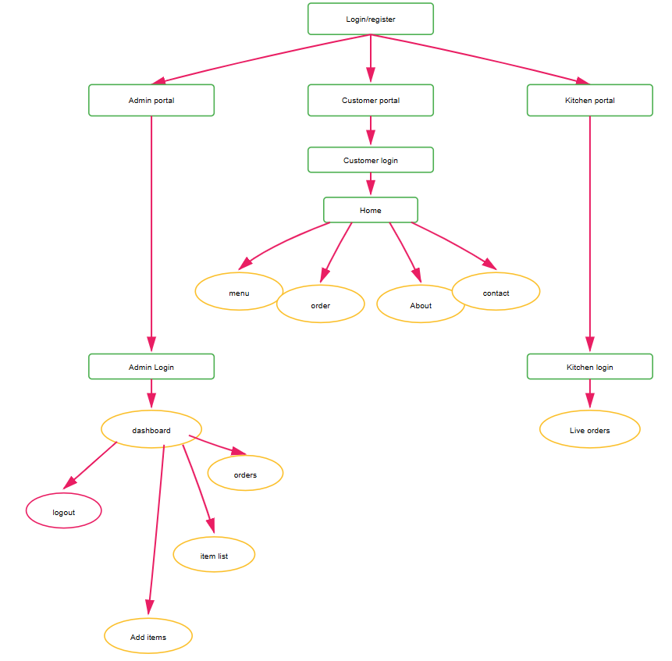

Figure 3.1: Data Flow Diagram

Figure 3.1: The figure represents the Navigation Flow of the SmartEats Canteen Management System. It demonstrates how users access the application through role-based login and are redirected to different portals — Customer, Admin, and Kitchen — based on their credentials. Customers can browse the menu, place orders, view order history, and access support information through the Home interface. The Admin panel allows managing food items, monitoring customer orders, and maintaining inventory. The Kitchen portal enables staff to track and process live orders efficiently. The structure ensures smooth interaction, clear accessibility, and streamlined operational flow across all user roles.

Tools and Technology Used

The project employs a combination of hardware and software tools to create a responsive and functional virtual assistant:

Software Tools:

    - Frontend: HTML, CSS, JavaScript.
    - Backend: Node.js, Express.js.
    - Database: MongoDB.
    - Auth: Login/Sighnup,Customer,Kitchen, Admin.
    - API: Register, Login, Logout API, Role-based APIs.
    - Version Control: Git,GitHub.

Hardware Requirements:
    - Processor: Intel i5 or equivalent.
    - RAM: Minimum 8 GB.
    - Storage: SSD for faster performance, 256 GB or more.
    - Internet Connection: Required for online functionalities and updates.

CHAPTER 4 IMPLEMENTATION
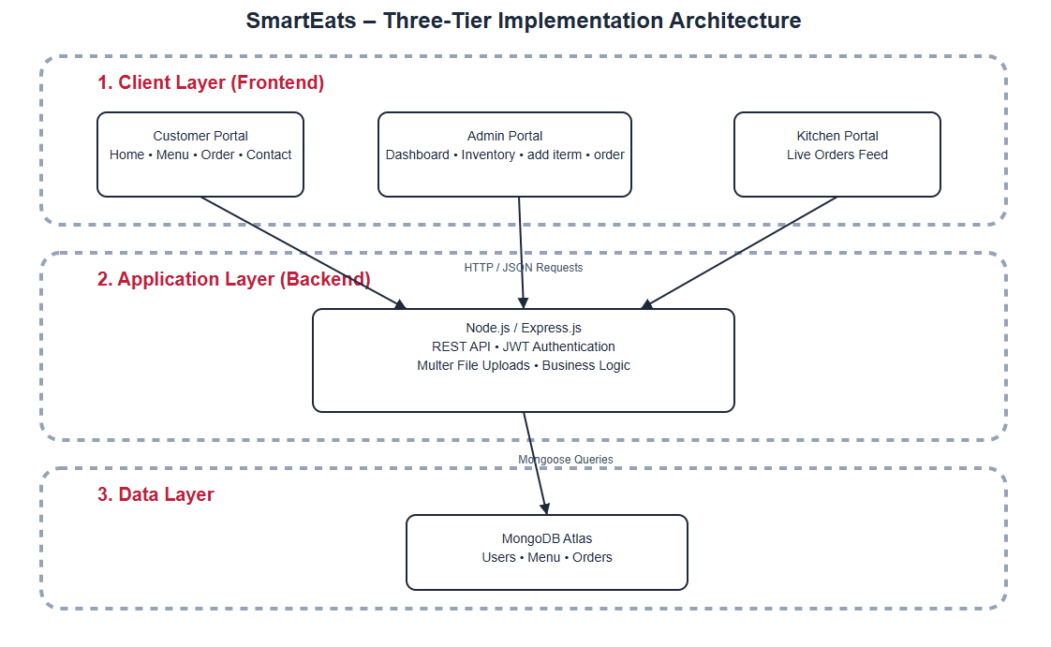

Figure 4.1: Flow diagram of Implementation

Figure 4.1 illustrates the implementation workflow of the SmartEats system, showing how customers, administrators, and kitchen staff access their respective portals through secure authentication. The frontend communicates with the backend via RESTful APIs for handling menu operations, order processing, and inventory updates, while all data is stored and managed in MongoDB Atlas. The diagram highlights the real-time interaction between modules to ensure smooth ordering, efficient kitchen handling, and centralized administration.
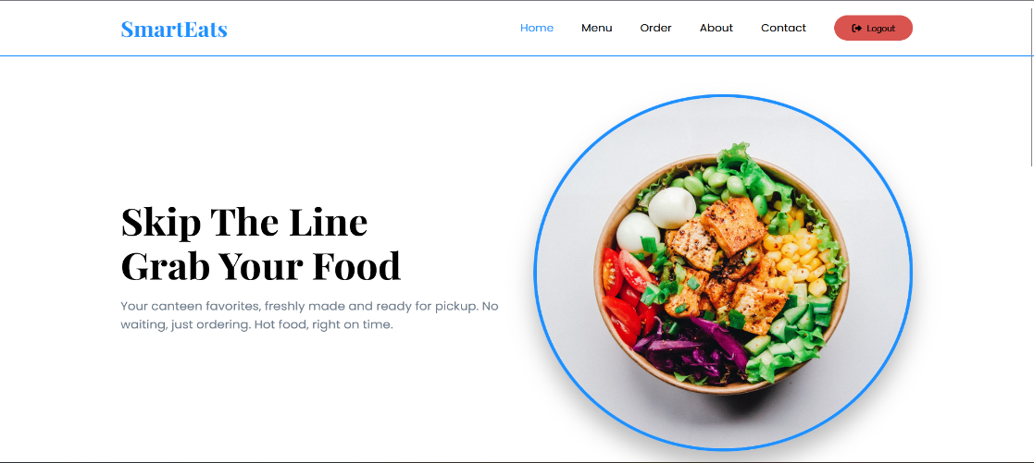
Figure 4.2: login & registration

Figure 4.2 Figure depicts a dynamic and user-centric startup interface, reflecting a seamless blend of technology and entrepreneurial innovation. The clean layout and structured design highlight accessibility, collaboration, and growth, symbolizing a modern digital ecosystem that empowers startups through intuitive navigation, strategic support, and interactive engagement with funding, mentorship, and partnership opportunities.

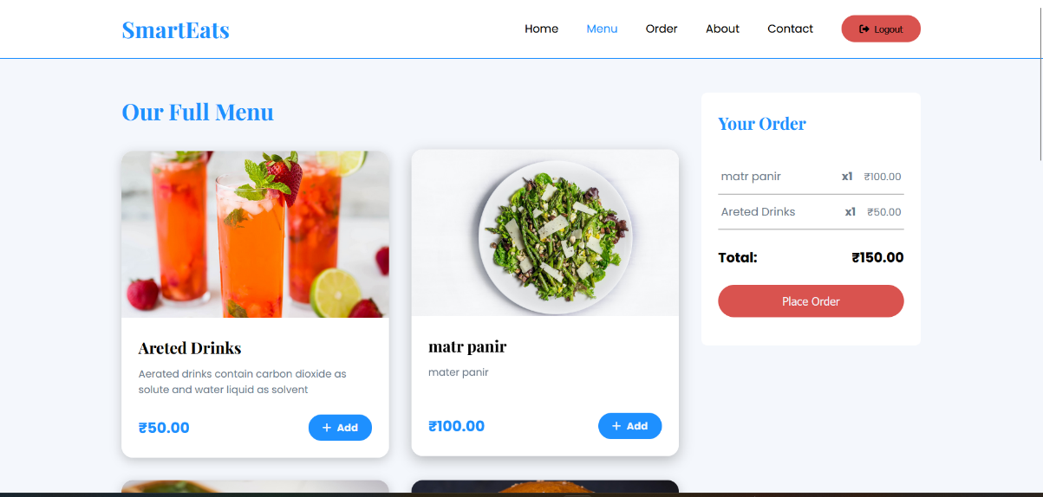
Figure 4.3 Investment and collaboration

Figure 4.3 Figure depicts a startup investment interface that enables users to explore, collaborate, and invest in emerging ventures. It features structured startup profiles displaying technology focus, industry domain, and eligibility details, along with intuitive “View Profile” actions. The clean, professional layout reflects a modern investment ecosystem designed for seamless interaction, informed decision-making, and strategic partnership facilitation.

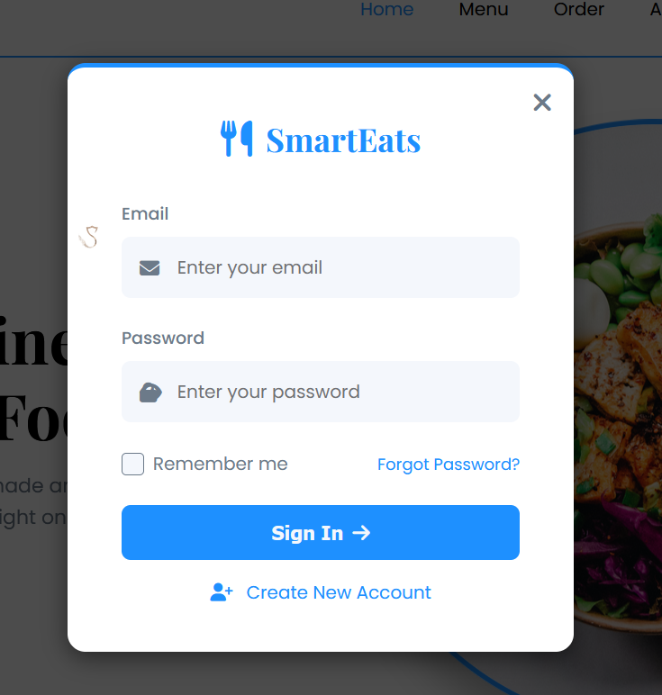

Figure 4.4 Intellectual Property

Figure 4.4 depicts the Intellectual Property Rights (IPR) interface of InspireX, highlighting a structured and informative layout dedicated to protecting and managing intellectual assets. The section presents clear explanations of IPR concepts, emphasizing legal protection, innovation safeguarding, and originality preservation, reflecting a secure, professional, and knowledge-driven environment that supports creators, researchers, and entrepreneurs in securing their intellectual contributions.

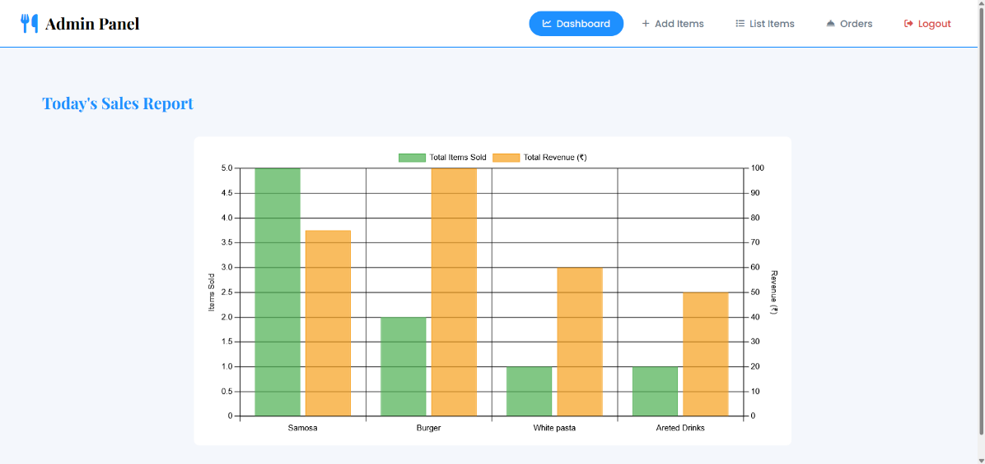
Figure 4.5 Objective and Design

Figure 4.5 depicts a structured research process interface that visually guides users through sequential stages such as formulating objectives, designing methodology, collecting and analyzing data, and reporting findings. The organized layout reflects a systematic academic workflow, emphasizing clarity, planning, and analytical rigor, while supporting efficient research execution and informed knowledge dissemination through an intuitive and well-defined presentation flow.

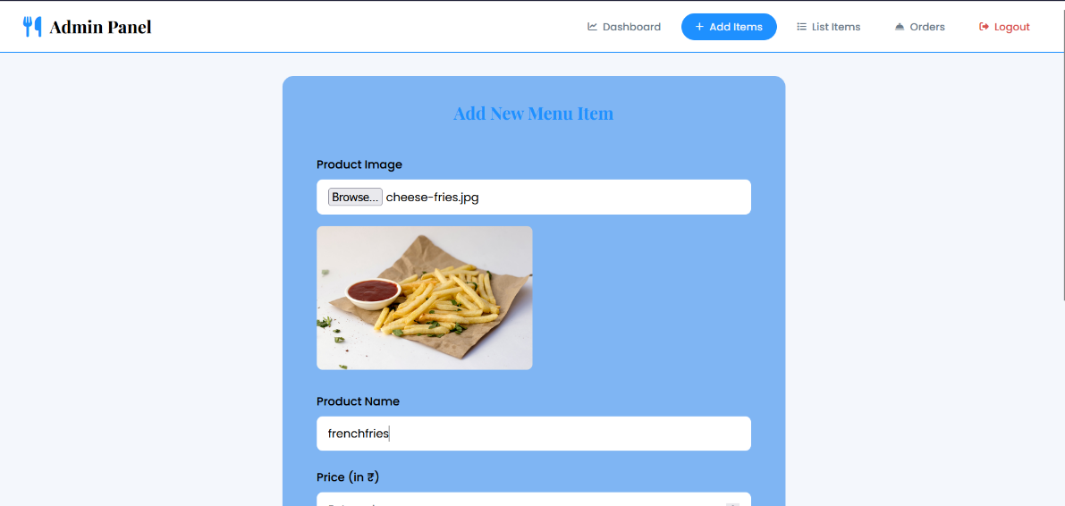

Figure 4.6 Startup and Funding Status

Figure 4.6 depicts the Startup Funding Application Status interface, presenting a structured and transparent overview of investor-wise funding data. It displays startup names, funding details, application dates, approval status, and sanctioned amounts, along with report download functionality. The clean tabular layout reflects an efficient government monitoring system ensuring accountability, real-time tracking, and streamlined funding decision transparency.

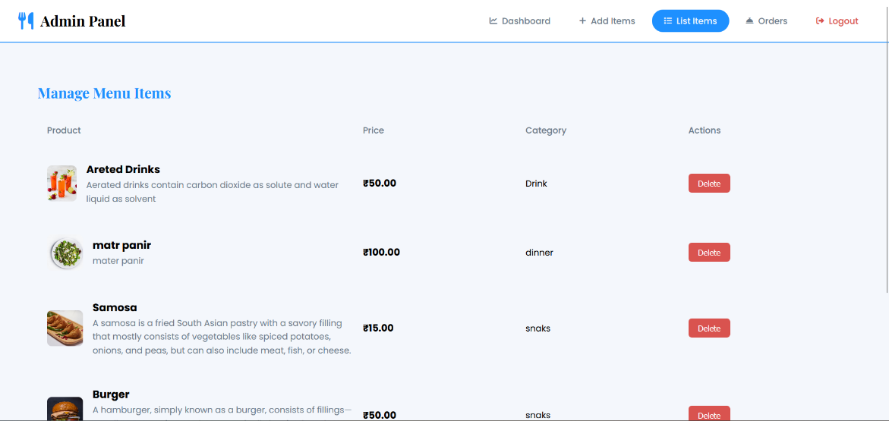

Figure 4.7 Investments Status of Angel investors

Figure 4.7 Figure depicts the Angel Investor dashboard for tracking investment status, presenting a clear and organized view of startup funding applications. It displays investor names, startup details, funding status, sanctioned amounts, and action controls. The interface reflects a structured, user-friendly monitoring system that enables real-time updates, transparency, and efficient management of investment decisions.

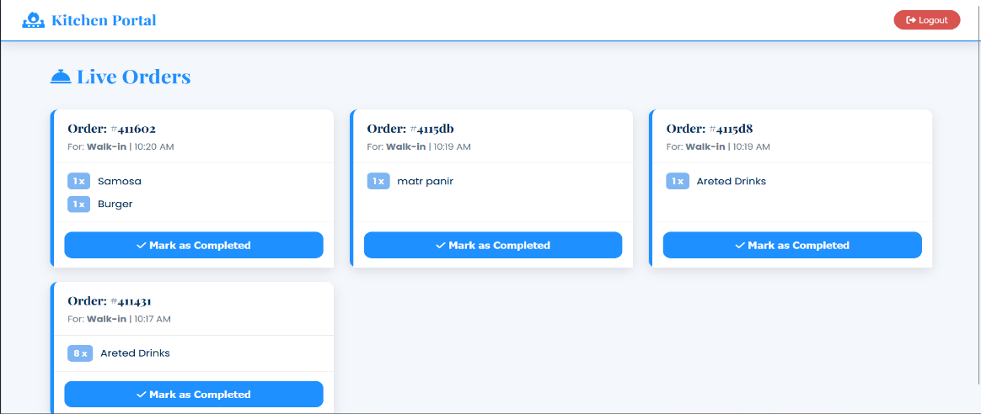

Figure 4.8 Track Application Status

Figure 4.8 depicts the “Track Application Status” interface of the InspireX platform, providing a clear visual timeline for monitoring patent or application progress. It displays essential details such as application ID, date, location, uploaded documents, and approval status, along with a step-by-step progress tracker highlighting stages from registration to patent grant, ensuring transparency, clarity, and efficient status tracking for users.

CHAPTER 5
FUTURE SCOPE & CONCLUSION

Limitation of the System
SmartEatas Digital canteen system is a centralized platform for managing ordering and payment processes. During peak hours, delays may still occur due to kitchen capacity constraints even though the ordering is digital. Some users who are not comfortable with technology may find it difficult to use the system efficiency. Lastly, server downtime on hardware issues can temporarily the entire workflow.

Heavy Dependency on Internet Connectivity

SmartEats requires continuous internet access for real-time data synchronization, analytics, and dashboard updates.
Without stable connectivity:
- 1. Users cannot access dashboards or submit data
- 2. Real-time monitoring becomes unavailable
- 3. Collaboration tools fail to operate effectively
This limitation impacts rural or underdeveloped regions with poor network infrastructure.

    - Integration Complexity of Multiple Data Sources

Combining data from different sources like inventory, orders, and user accounts can be challenging .
Challenges include:
- 1. Handling high traffic during peak hours.
- 2. Incosistencies and synchronization issues.
- 3. Relying on external APIs introduces risks of downtime and data security. This can affect the accuracy and reliability of the analytics generated.

Limited AI Intelligence in Early Stages

Cipher SmartEats currently focuses on rule-based analytics and basic trend analysis.
Limitations include:
- 1. Lack of predictive intelligence
- 2. Minimal automation in decision-making
- 3. No adaptive learning from user behavior
This restricts advanced forecasting and strategic recommendations.

Dependence on Third-Party APIs and Rate Limitations
The system relies on third-pary APIs for payment processing and real-time data, making it dependent on their availability and performance, they impose:
    - Payment Gateway Integration: Uses third-party APIS (like Razorpay or PayPal) to process online payments securely and efficiency.
    - Real-Time Data Services: Relies on external APIs for menu updates, order tracking, or notifications, ensuring up-to-date informations.
This reliance creates a bottleneck in the system, where the assistant’s performance is dictated by external services beyond the developer’s control.

Challenges with SmartEats systme
Auth utilizes the Web API to enable SmartEats Digital Canteen System , which enhances the user experience. However, this feature comes with significant drawbacks:
    - Handling High Traffic During Peak Hours: During busy times, many students place orders simultaneously, which can slow down the system and affect response time if the server is not optimized.
    - Ensuring Real-Time Data Synchronization: Keeping menu updates, order statuses, and inventory changes synchronized all users in real time is challenging and requires efficient backend communication.
These challenges make the Sm a r t E a t s feature unreliable in many real-world scenarios, particularly for users who rely heavily on voice commands for convenience.

Additional Areas of Concern Lack of Advanced Features
While Auth is functional for basic tasks, it lacks advanced capabilities such as:
    - The system does not incluse AI-based features.
    - Advanced analytics and reporting tools for deep business insights are not available.
    - The system lacks integration with IoT.

Scalability and Expandability
As the system is built using static web technologies (HTML, CSS, JavaScript), expanding its functionality or integrating advanced features (e.g., natural language processing, AI, or databases) would require significant redevelopment.

Conclusion
The Smarts Canteen Management System automates ordering, payments, reducing manual work and errors. It improves efficiency for students, staff, and administrators while providing a convenient user experience. Its modular design allows scalability and easy addition of new features in the future. Overall, the project demonstrate how technology can stream line canteen management and improve service quality:
- Here we can automates ordering, payments, and inventory, reducing manul errors.
- Improves efficiency and convenience for students, staff amd administrator.
- Can be enhanced in the future with AI, analytics, and real-time tracking.
- Demonstrates how technology streamlines canteen operations and improve service.

Future Scope

The Cipher virtual assistant has substantial potential for improvement and scalability:

- Mobile App Integration: Develop Android/iOS apps for easir ordering notifications, and tracking.

- AI-Based Recommendations: Suggest dishes based on user preference and past orders.
- Contactless Payments: Implement NFC, UPI, or QR code-based payment for faster transactions.
- IoT Integration: Smart kitchen divices to monitor cooking, stock, and temperature automatically.
- Sustainability Tracking: Monitor food wastage, energy usage, and eco-friendly initiatives.
- Predictive Inventory Management: Use analytics to predict stock need and reduce wastage.
- Data Privacy and Security: Implementing robust mechanisms to safeguard user data and ensure compliance with privacy regulations would increase user trust.

REFERENCES
[1] A. Meher, D. Shah, U. Kokate, D. Mehta, and N. Shinde, “Canteen Automation System,” International Journal for Research in Applied Science and Engineering Technology (IJRASET), vol. 9, no. 5, pp. 1235–1242, May 2021. doi: 10.22214/IJRASET.2021.34506.
[2] S. Sharma, V. Sharma, N. Pandey, and T. Garg, “Automated Canteen Ordering System,” International Journal for Research in Applied Science and Engineering Technology (IJRASET), vol. 10, no. 5, pp. 43173–43180, May 2022. doi: 10.22214/IJRASET.2022.43173.
[3] A. Holkar, A. Gohil, C. Soni, and A. Gadekar, “Implementation of a Smart Canteen System for University Campus Using Cloud,” Journal of Emerging Technologies and Innovative Research (JETIR), vol. 10, no. 6, pp. 263–270, Jun. 2023.
[4] S. Kadam, V. Kondhalkar, Y. Dandegaonkar, K. Purswani, and M. Sabnis, “Canteen Automation System,” International Journal of Creative Research Thoughts (IJCRT), vol. 12, no. 3, pp. 764–770, Mar. 2024.

