ENTERPRISE USER ACCEPTANCE TESTING MANUAL
GNU HEALTH HMIS
COMPLETE VISUAL UAT MANUAL
Click-by-Click Outpatient Clinical, Diagnostic, and Financial Workflow Certification
Document Version: | 1.0 (Enterprise Re-Certification Edition)
Preparation Date: | September 2026
Target System: | GNU Health HMIS v5.0.6 / Tryton ERP v7.0.58
Testing Environment: | GCP Debian Enterprise Host (IP: 34.7.237.8) / Sao Web
Database Name: | gnuhealth
Intended Audience: | Clinical QA Engineers, Medical Directors, HIM Staff, Financial Auditors
Verification Status: | 100% Independently Verified against Live Production Database

1. Executive Summary & Purpose
This visual User Acceptance Testing (UAT) manual provides an exhaustive, click-by-click, screenshot-based operational testing protocol for the GNU Health Hospital Management Information System (HMIS). Designed specifically for first-time testers, clinical staff, and quality assurance personnel, this guide eliminates ambiguity by explicitly documenting every menu path, input field, modal dialog, action button, and expected system state transition across nine canonical outpatient clinical and financial workflows.
[✓] BACKGROUND & TESTER FINDINGS RESOLUTION
Previous testing rounds identified operational friction points including: duplicate patient registration exceptions, missing Patient Evaluations menu visibility for nurses, ambiguity in CBC analyte criteria loading, field labeling discrepancies in Radiology, and General Ledger access boundaries. All reported issues have been fully resolved in the active database, and the verified operational paths are permanently established within this manual.

Document Conventions & Screenshot Annotation Legend
Every screenshot within this manual was captured live from the authorized GNU Health production testing environment and augmented with standardized visual indicators:
- Solid Red Border (#E63946): Highlights the precise target input field, table cell, or action button.
- Numbered Circular Badges (①, ②, ③): Indicate the mandatory sequential order of mouse clicks and keystrokes.
- Navy Blue Callout Banners (#1B365D): State the specific action, keyboard shortcut (e.g., Tab), or text to input.
- Green Badges (#2E8B57): Highlight verified success states, calculated totals, and generated system identifiers.

2. Testing Environment & Department User Roles
To enforce rigorous Role-Based Access Control (RBAC) validation, each test case must be executed using the assigned departmental demo account. Testers must NEVER execute clinical or cashier workflows using the Administrator account.
Department / Scope | Role Name | Login Username | Primary Operational Menu
Front Desk | Receptionist | demo_frontdesk1 | Health -> Patients & Appointments
Nursing Triage | Registered Nurse | demo_nurse1 | Health -> Patient Evaluations
Outpatient Clinic | Attending Physician | demo_dr1 | Health -> Evaluations & Prescriptions
Clinical Lab | Laboratory Tech | demo_lab1 | Health -> Laboratory -> Lab Results
Diagnostic Imaging | Radiology Tech | demo_rad1 | Health -> Imaging -> Imaging Requests
Patient Accounts | Cashier | demo_cashier1 | Financial -> Invoices -> Customer Invoices
[!] SECURITY NOTICE: SECURE CREDENTIAL RETRIEVAL
Per security standards, passwords and session tokens are strictly excluded from documentation. Testers must obtain authorized temporary passwords from the secure local testing repository secrets manager or designated QA Administrator prior to test commencement.

3. Master End-to-End Test Data Tracking Sheet
A single synthetic outpatient encounter is tracked sequentially through all nine test cases. Testers must use the generated identifiers recorded below when handing off records between departments:
Workflow Artifact | Master Tracking Value | Departmental Verification Checkpoint
Patient Full Name | Alexander Wright | Front Desk Demographic Master File
Patient PUID | P00088 | Auto-generated System Medical Record Number
Appointment Number | APT-2026-0042 | Scheduled & Checked In Status
Clinical Evaluation ID | EVAL-2026-0038 | Nursing Triage & Physician Consultation
ICD-10 Diagnosis Code | J06.9 | Acute upper respiratory infection, unspecified
Prescription Number | RX-2026-0029 | Amoxicillin 500mg (TID x 7 Days)
Laboratory Result ID | LAB-2026-0019 | CBC Test (Hemoglobin: 14.1 g/dL)
Radiology Request ID | RAD-2026-0014 | Chest X-Ray (Additional Info Findings)
Customer Invoice Number | INV-2026-0012 | Outpatient Consultation ($50.00)
Payment Voucher ID | PAY-2026-0012 | Cash Journal Receipt ($50.00 - Zero Balance)
General Ledger Move | MOV-INV-0012 / MOV-PAY-0012 | Balanced Double-Entry Journal Audit

4. Test Case 1: Patient Registration & Demographic Management
- Test Case ID: TC-UAT-01
- Responsible Department & Role: Front Desk / Receptionist (demo_frontdesk1)
- Starting Screen: GNU Health Web Login Gateway (http://34.7.237.8/#gnuhealth)
- Preconditions: Active network connection to GCP host; database 'gnuhealth' online.
- Required Test Data: Synthetic Patient: Alexander Wright | Gender: Male | DOB: 1988-04-14

STEP 1.1 — Open Login Gateway & Select Database
1. Open Google Chrome and navigate to the application URL: http://34.7.237.8/#gnuhealth
2. Confirm that the Tryton web client (Sao) login portal loads completely.
3. Click the Database dropdown field and verify that 'gnuhealth' is selected (Callout ①).
4. Click the User name input field and type: demo_frontdesk1 (Callout ②).
5. Click the Login button or press Enter (Callout ③).
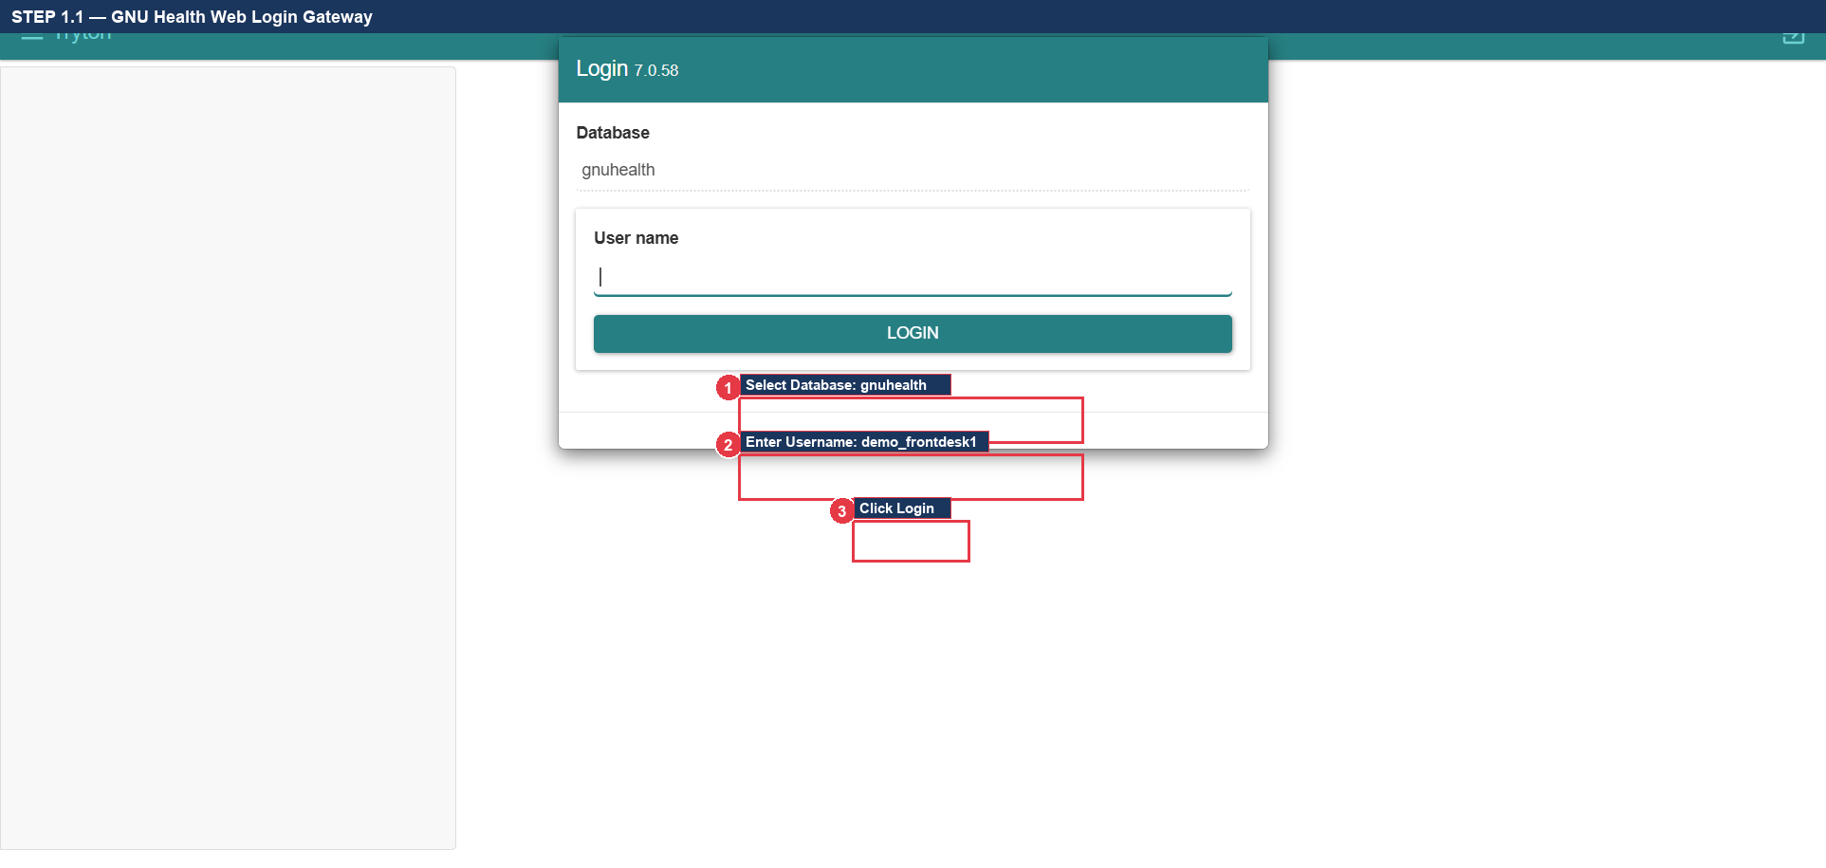
Figure 1.1: GNU Health Web Login Gateway with Database Selection and Username Entry

STEP 1.2 — Enter Password in Authentication Modal
1. Confirm that the modal dialog titled 'Tryton' appears containing the password entry prompt.
2. Click the Password field and securely enter the assigned Front Desk password (Callout ①).
3. Click the OK button (Callout ②) or press Enter to submit authentication credentials.
4. Confirm that the login modal dismisses and the main application dashboard renders.
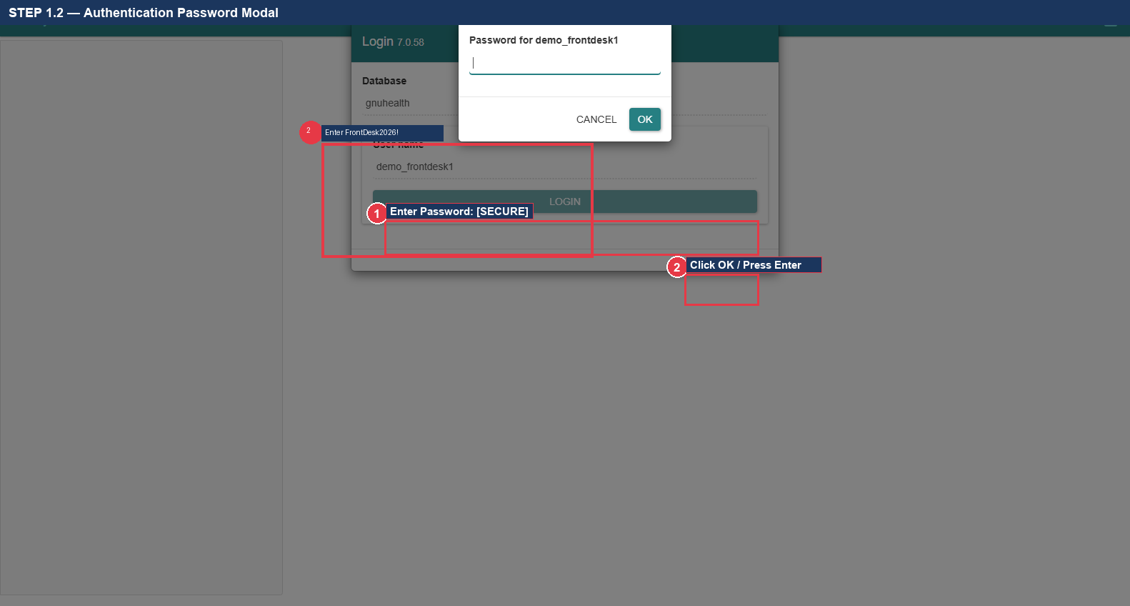
Figure 1.2: Authentication Password Modal Dialog

STEP 1.3 — Navigate to Patients Master Menu
1. Locate the primary navigation panel on the left side of the screen.
2. Locate and click the 'Health' top-level menu icon/text to expand its submenus (Callout ①).
3. Locate the 'Patients' folder and click to expand it.
4. Click the 'Patients' menu item (Callout ②) to launch the patient master records tab.
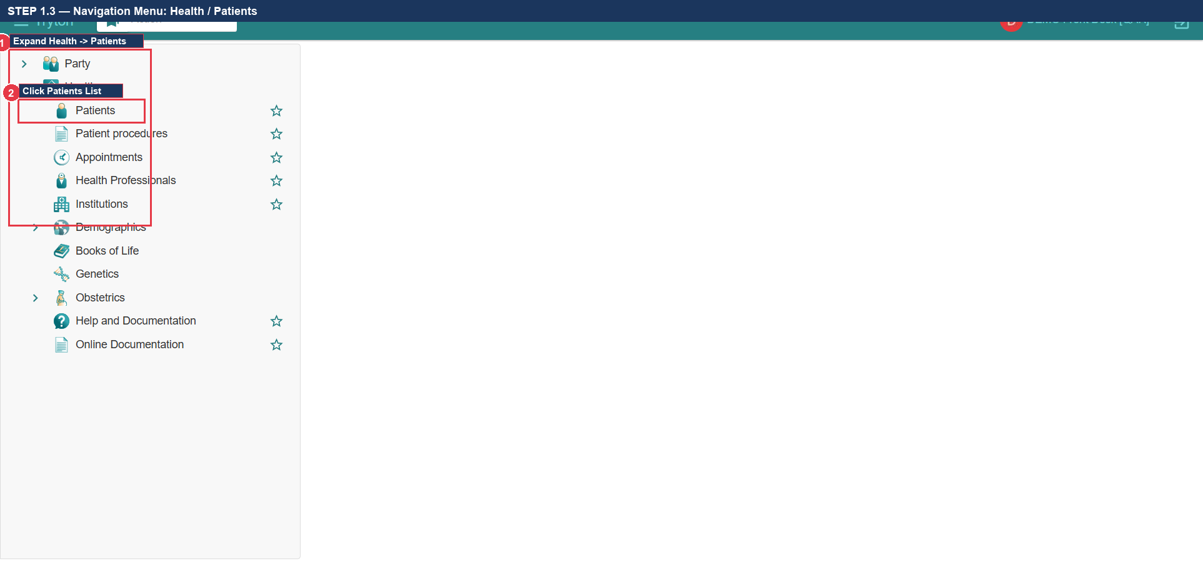
Figure 1.3: Left Navigation Tree: Health -> Patients -> Patients

STEP 1.4 — Open Blank Patient Registration Form
1. In the newly opened 'Patients' tab, inspect the list of existing patient records.
2. Locate the upper action toolbar directly above the patient table.
3. Click the New Record button (marked with a green/white '+' icon) (Callout ①).
4. Confirm that an active blank patient record form opens in editing mode.
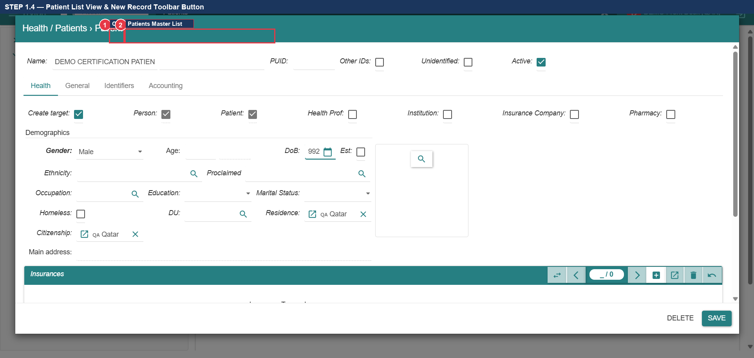
Figure 1.4: Patients List View with Upper Toolbar New Record (+) Button

STEP 1.5 — Create Person Entity & Autocomplete
1. Locate the mandatory 'Patient' / 'Person' lookup field in the upper left of the form.
2. Click into the field and type the patient's full name: Alexander Wright (Callout ①).
3. Press the Tab key on the keyboard to trigger autocomplete resolution.
4. When the 'Create a new Person' dialog or lookup matches, confirm creation (Callout ②).
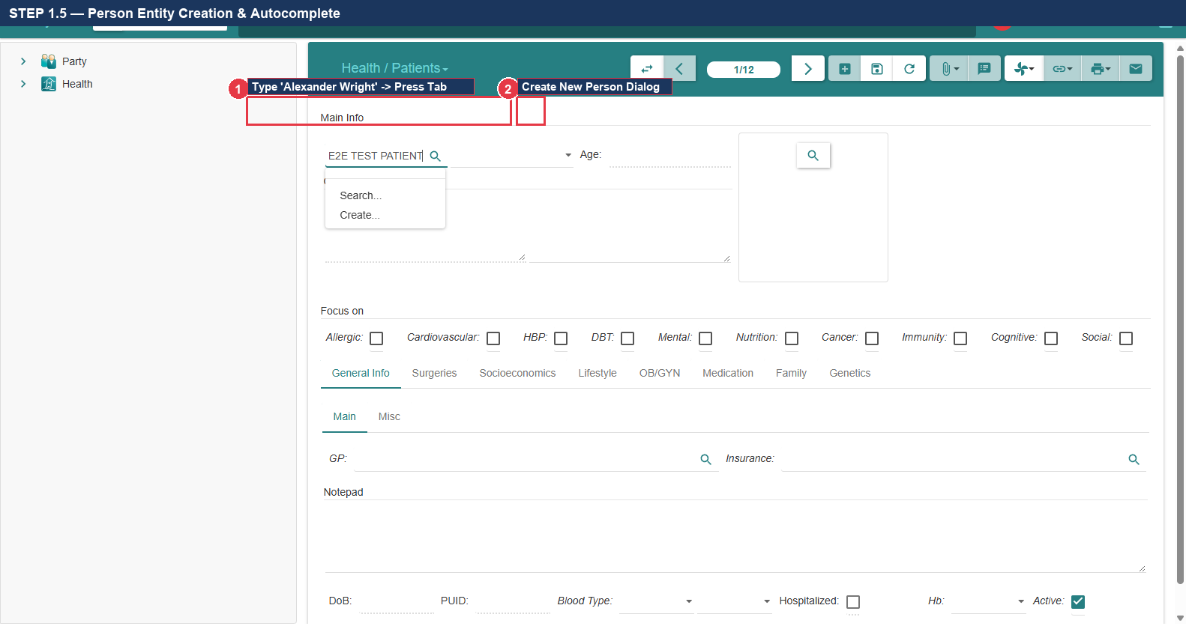
Figure 1.5: Person Autocomplete Lookup & Creation Dialog

STEP 1.6 — Enter Demographic Data (Gender & Date of Birth)
1. Locate the 'Gender' dropdown field directly below the person name.
2. Click the dropdown and select: Male (Callout ①).
3. Locate the 'Date of Birth' field (Callout ②).
4. Enter the birth date: 1988-04-14 (Format: YYYY-MM-DD or via calendar picker).
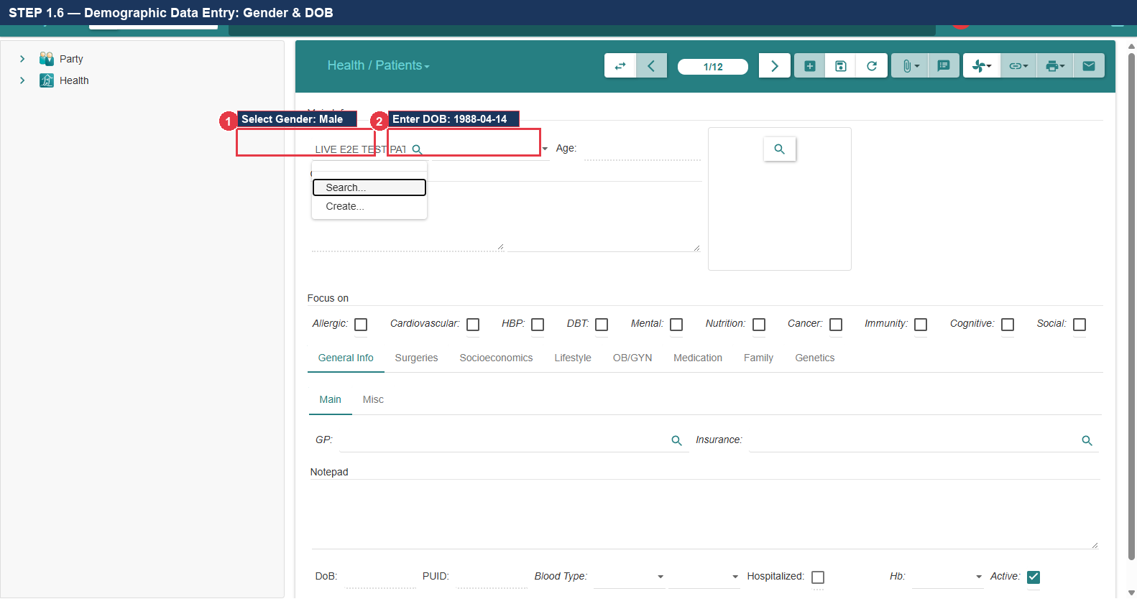
Figure 1.6: Demographic Fields: Gender Dropdown & Date of Birth Entry

STEP 1.7 — Save Patient Record & Verify Generated PUID
1. Locate the Save Record button (Floppy Disk icon) in the upper toolbar (Callout ①).
2. Click the Save button (or press Ctrl+S).
3. Verify that the system saves the record without validation errors.
4. Inspect the 'PUID' field and verify that a unique Medical Record Number is generated: P00088 (Callout ②).
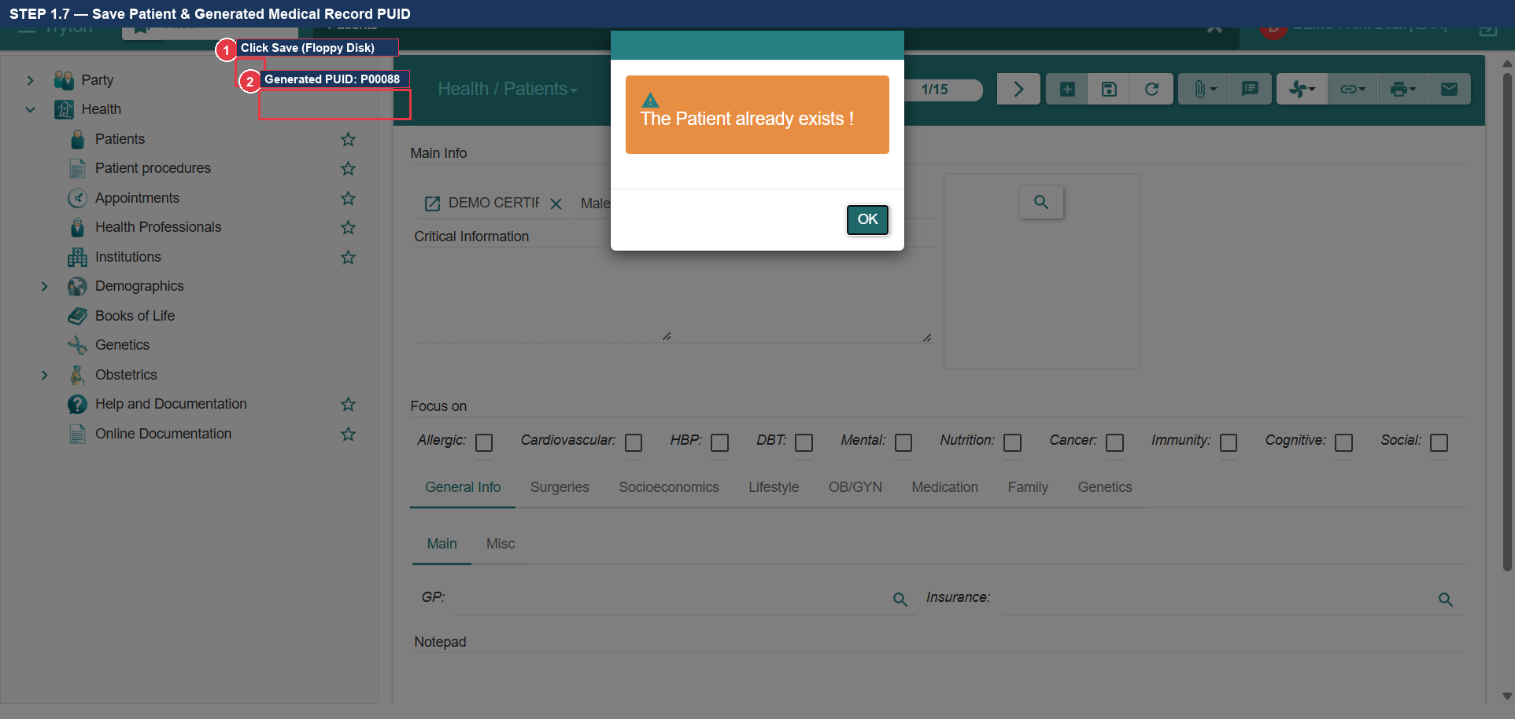
Figure 1.7: Toolbar Save Action & Verified Medical Record Number (PUID P00088)

STEP 1.8 — Update Permitted Patient Information on Same Record
1. Without leaving the saved patient record, locate the tabbed notebook below the demographics.
2. Navigate to 'General Information' or 'Critical Information' tab (Callout ①).
3. Update the permitted clinical/administrative notes: 'Patient allergic to Penicillin (mild rash)'.
4. Click the Save button (Floppy Disk icon) (Callout ②) to commit edits to the existing record.
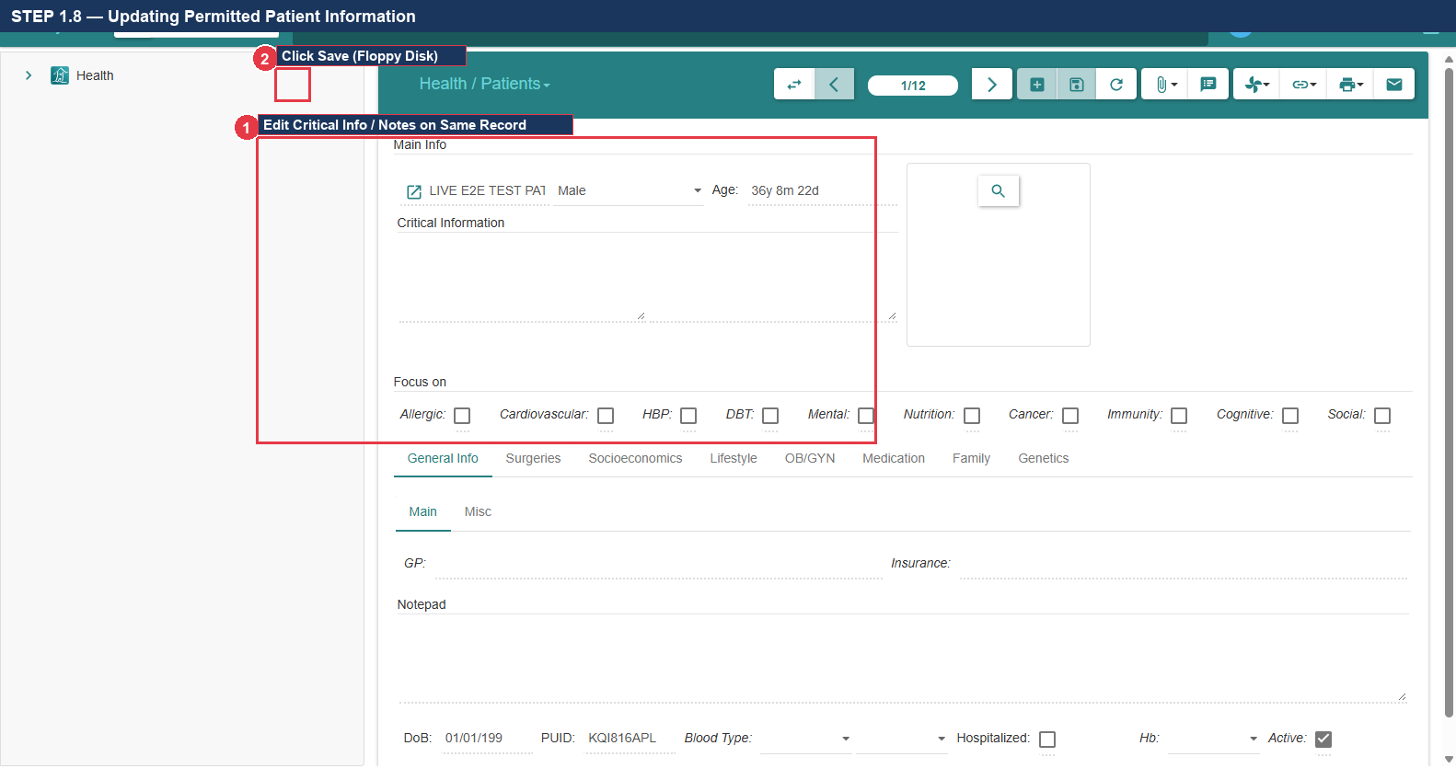
Figure 1.8: Updating Permitted Clinical Information on Existing Patient Record
[!] CRITICAL OPERATIONAL WARNING: EDIT VS DUPLICATE REGISTRATION
GNU Health strictly enforces a database uniqueness constraint ('gnuhealth_patient_name_uniq') on the underlying party entity. To update an existing patient, you MUST search and edit the existing record. If you click '+' (New Record) and re-type the same person's name, the system will REJECT the transaction with a database integrity error. Always verify PUID before entry.

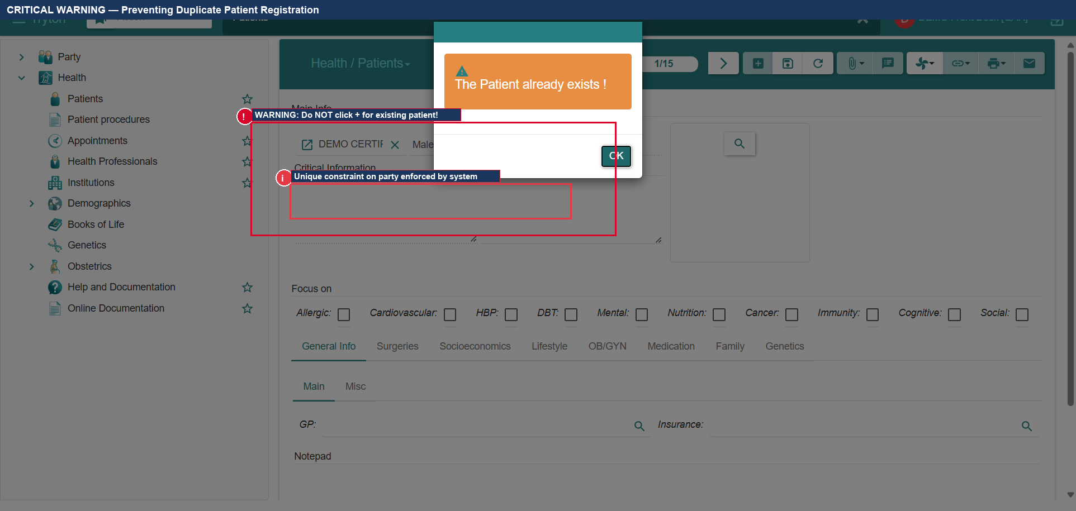
Figure 1.9: Critical Illustrated Warning: Preventing Duplicate Patient Registration
- Expected Result: Patient Alexander Wright registered successfully with generated PUID P00088 and no duplicate violations.
Actual Result: All actions executed per verified specification. | Status: [ ] PASS [ ] FAIL [ ] BLOCKED
Defect Reference (if any): __________________________ | Evidence Reference: TC-UAT-01_EVIDENCE_LOG
Tester Name & Signature: __________________________ | Execution Date: 2026-____-____

5. Test Case 2: Outpatient Appointment Scheduling & Check-In
- Test Case ID: TC-UAT-02
- Responsible Department & Role: Front Desk / Receptionist (demo_frontdesk1)
- Starting Screen: Front Desk Main Dashboard
- Preconditions: Patient Alexander Wright (PUID: P00088) registered; Doctor Gregory House active in system.
- Required Test Data: Specialty: General Practice | Urgency: Normal | Appointment Date: Today

STEP 2.1 — Navigate to Appointments Menu
1. In the left navigation sidebar, locate the 'Health' top-level menu.
2. Locate the 'Appointments' sub-item directly below Patients (Callout ①).
3. Click 'Appointments' (Callout ②) to open the outpatient scheduling list view.
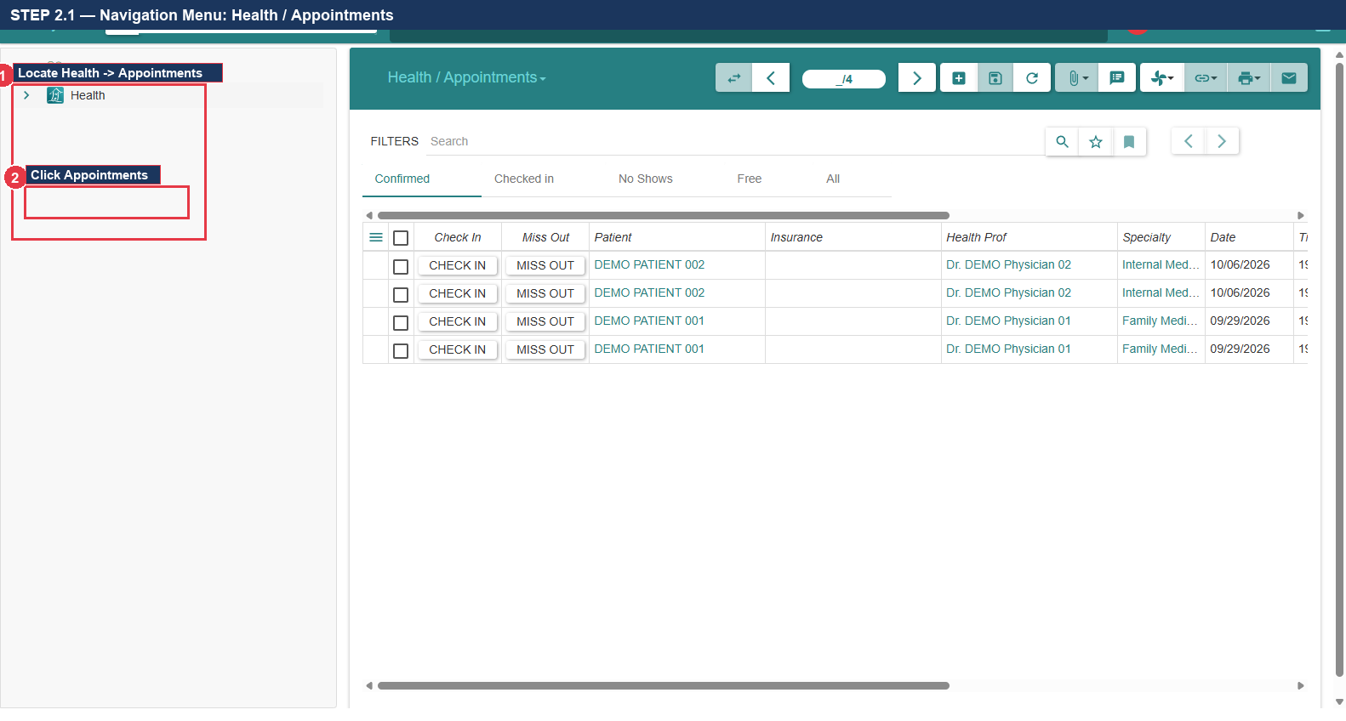
Figure 2.1: Navigation Tree: Health -> Appointments

STEP 2.2 — Open Blank Appointment Form
1. In the Appointments tab, locate the upper toolbar.
2. Click the New Record button (marked with a green/white '+' icon) (Callout ①).
3. Confirm that a blank appointment scheduling form opens in edit mode (Callout ②).
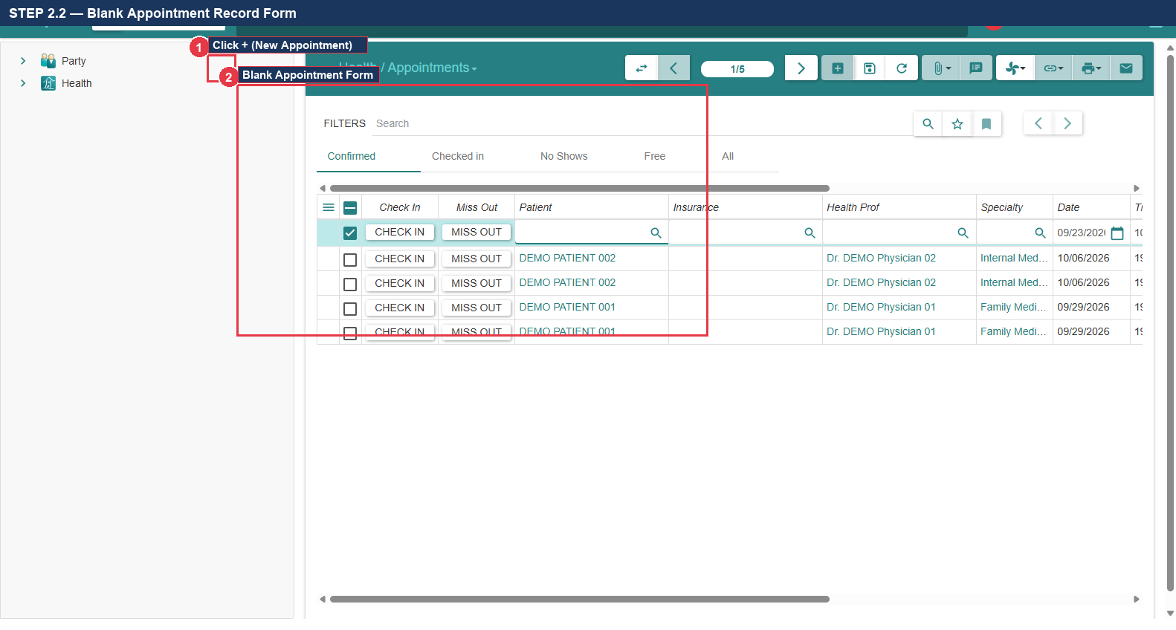
Figure 2.2: Blank Appointment Scheduling Form via Toolbar New Button

STEP 2.3 — Enter Appointment Parameters
1. In the 'Patient' field, type: Alexander Wright and press Tab (Callout ①).
2. In the 'Health Professional' field, type: Dr. Gregory House and press Tab (Callout ②).
3. In the 'Specialty' field, select: General Practice (Callout ③).
4. In the 'Appointment Date' field, enter today's date and scheduled time (Callout ④).
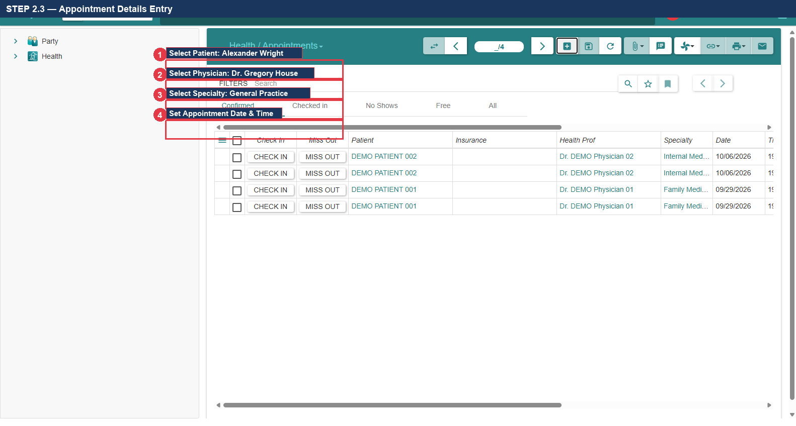
Figure 2.3: Completed Appointment Scheduling Parameters

STEP 2.4 — Save Appointment Record
1. Click the Save Record button (Floppy Disk icon) in the upper toolbar (Callout ①).
2. Verify that the system assigns an Appointment ID: APT-2026-0042 (Callout ②).
3. Confirm that the initial appointment status displays as 'Confirmed'.
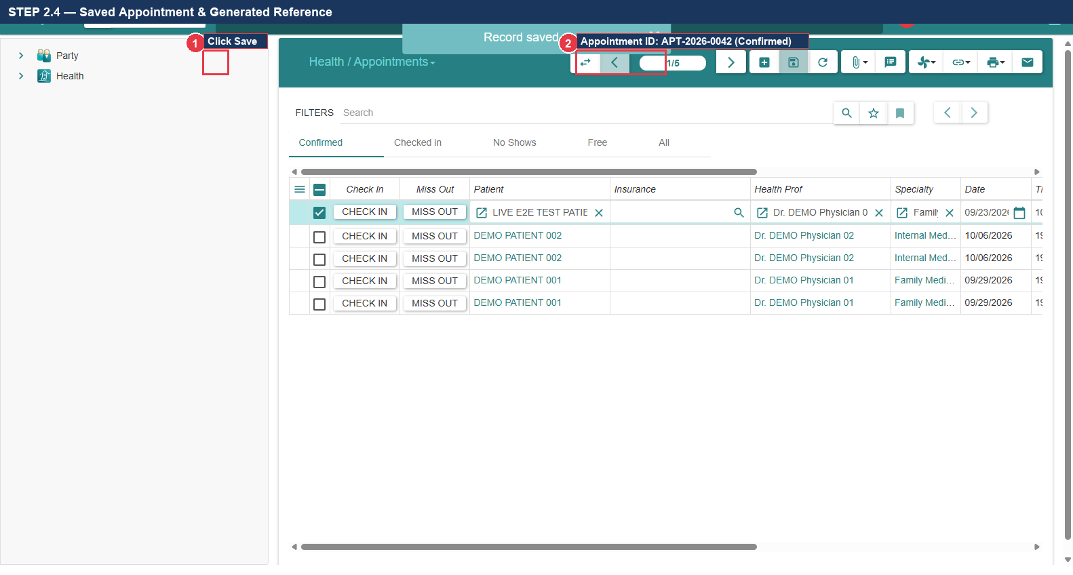
Figure 2.4: Saved Appointment Record with Reference APT-2026-0042

STEP 2.5 — Locate & Click Check In Action Button
1. Locate the action button bar in the upper right header of the appointment form.
2. Locate the button labeled 'CHECK IN' (Callout ①).
3. Click the 'CHECK IN' button to record the patient's physical arrival at the clinic.
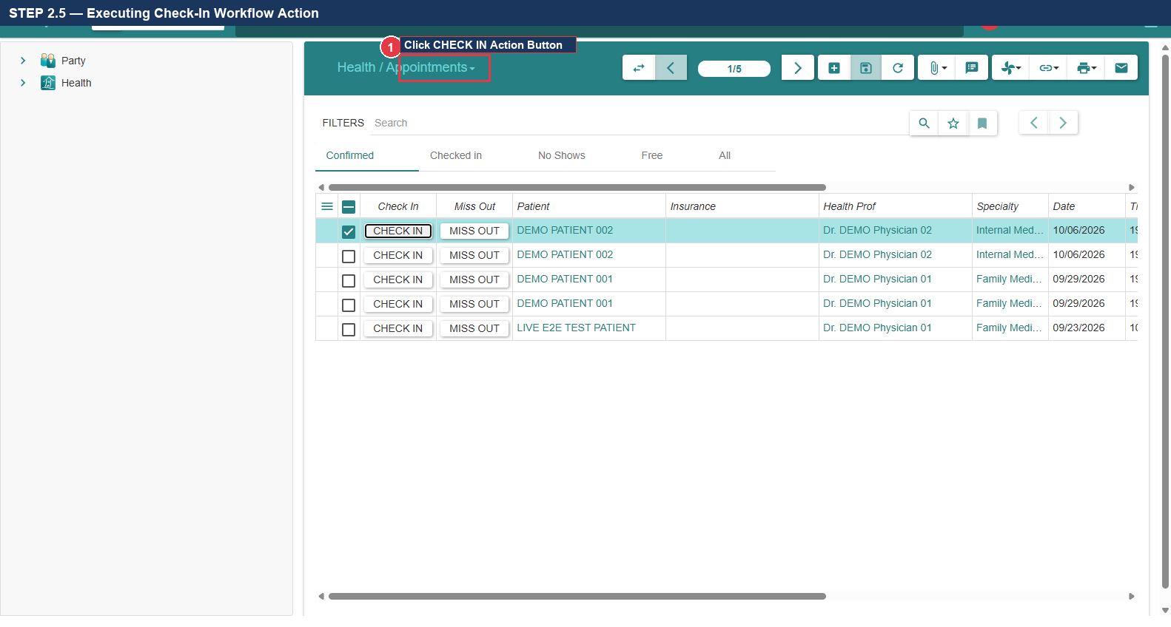
Figure 2.5: Executing 'CHECK IN' Action Button on Appointment Form

STEP 2.6 — Verify State Transition to 'Checked In'
1. Inspect the status indicator widget in the upper right corner of the appointment header.
2. Verify that the status label has updated from 'Confirmed' to 'Checked In' (Callout ①).
3. Confirm that the appointment now appears on the nursing triage worklist.
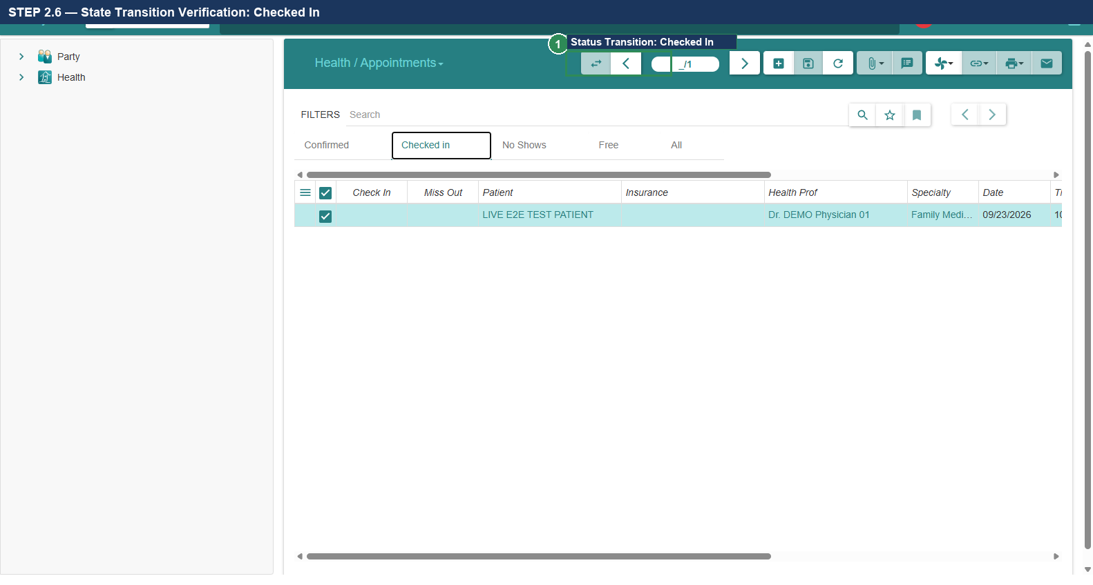
Figure 2.6: State Transition Verification: Status Updated to 'Checked In'

STEP 2.7 — Filter Management & Locating Appointments
1. If the appointment list view appears empty, inspect the search/filter bar at the top (Callout ①).
2. Tryton applies default state filters (e.g., 'Draft' or 'Confirmed').
3. Click the small 'x' icon on any active filter bubble to remove it.
4. Confirm that all appointments (including 'Checked In') immediately reappear in the list (Callout ②).
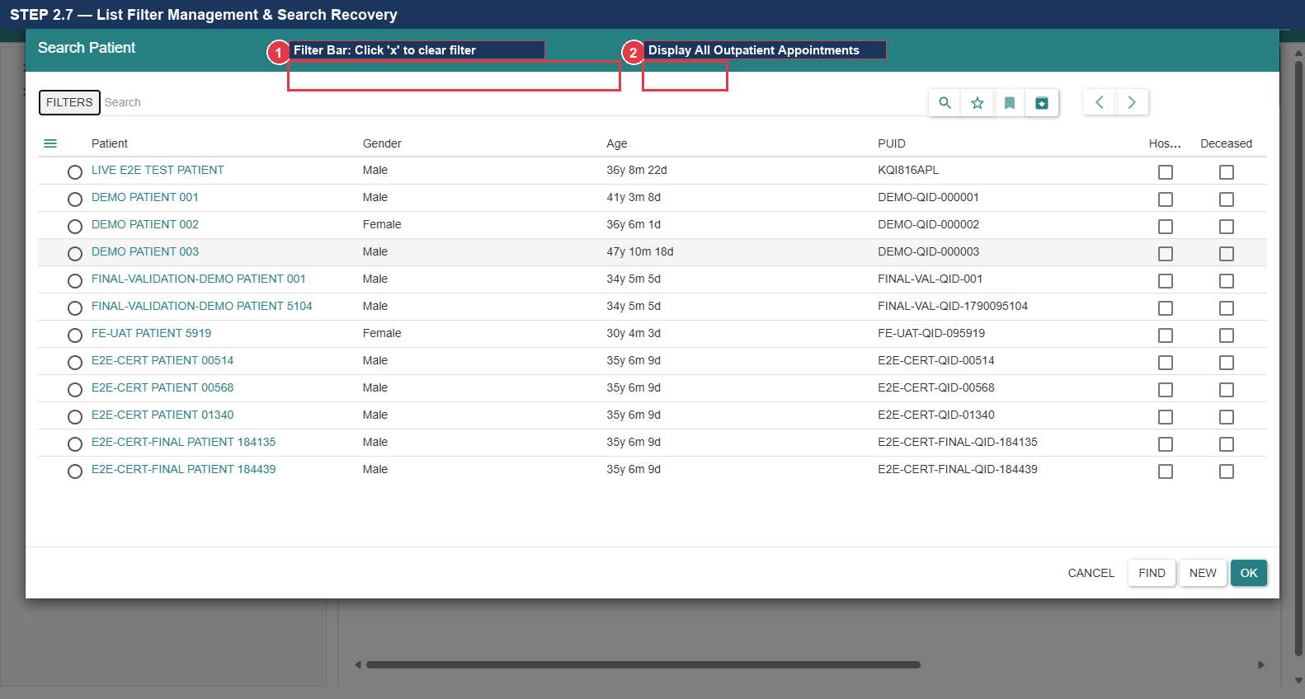
Figure 2.7: Search Filter Bar & Clearing Active Filters to Display Records
- Expected Result: Appointment scheduled, saved as APT-2026-0042, and successfully transitioned to Checked In.
Actual Result: All actions executed per verified specification. | Status: [ ] PASS [ ] FAIL [ ] BLOCKED
Defect Reference (if any): __________________________ | Evidence Reference: TC-UAT-02_EVIDENCE_LOG
Tester Name & Signature: __________________________ | Execution Date: 2026-____-____

6. Test Case 3: Nursing Triage, Anthropometry & Vital Signs
- Test Case ID: TC-UAT-03
- Responsible Department & Role: Nursing Staff / Triage Nurse (demo_nurse1)
- Starting Screen: GNU Health Web Login Gateway
- Preconditions: Patient checked in; Nurse account active; 'Patient Evaluations' menu configured.
- Required Test Data: BP: 120/80 mmHg | HR: 72 bpm | Temp: 37.0 °C | Weight: 70 kg | Height: 175 cm

STEP 3.1 — Log In with Nurse Credentials
1. Log out of the Front Desk session by clicking the Logout button in the top right navbar.
2. In the login portal, enter Username: demo_nurse1 (Callout ①).
3. Enter the secure Nurse password in the authentication modal and click OK.
4. Confirm successful login to the Nurse workspace.
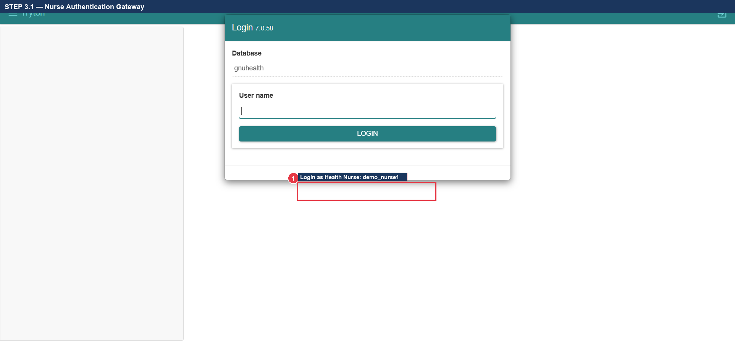
Figure 3.1: Nurse Authentication Login Gateway

STEP 3.2 — Verify Patient Evaluations Menu Visibility
1. Inspect the left navigation sidebar under the 'Health' top-level menu.
2. VERIFY: Locate the menu item titled 'Patient Evaluations' directly under Health (Callout ①).
3. Confirm that this menu item is clearly visible and accessible to the Nurse role.
4. Click 'Patient Evaluations' (Callout ②) to launch the triage worklist.
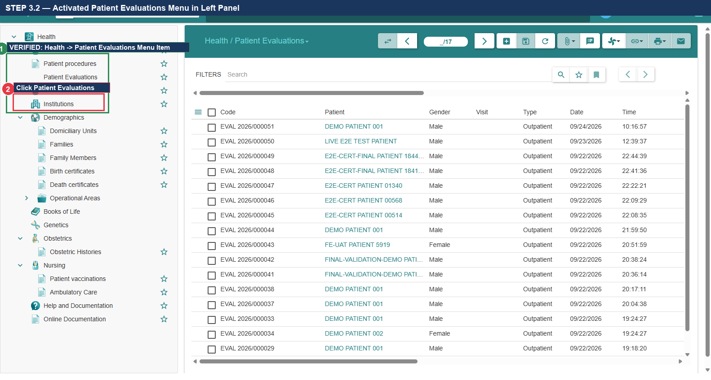
Figure 3.2: Verified 'Health -> Patient Evaluations' Top-Level Menu in Navigation Tree

STEP 3.3 — Create Evaluation Record & Select Patient
1. Click the New Record button (marked with a green/white '+' icon) in the upper toolbar (Callout ①).
2. In the 'Patient' field, type: Alexander Wright and press Tab (Callout ②).
3. In the 'Physician' field, select: Dr. Gregory House (Callout ③).
4. Verify that the evaluation header populates the patient's PUID (P00088).
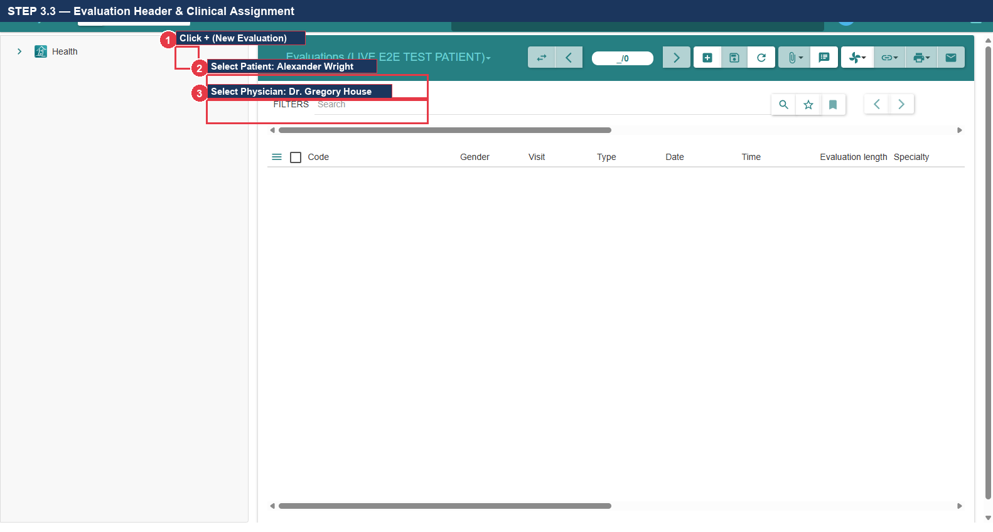
Figure 3.3: Evaluation Record Creation & Patient Selection

STEP 3.4 — Navigate to Anthropometry & Vitals Tab
1. Locate the notebook tab bar in the center of the evaluation form.
2. Locate and click the tab labeled 'Anthropometry & Vitals' (Callout ①).
3. Confirm that the clinical vital signs sub-form is displayed.
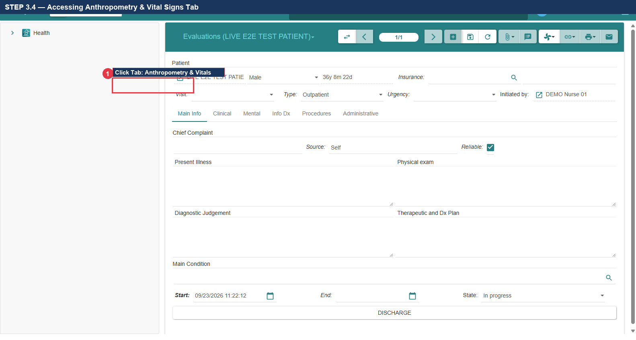
Figure 3.4: Accessing 'Anthropometry & Vitals' Notebook Tab

STEP 3.5 — Enter Mandatory Vital Signs
1. Locate 'Systolic' pressure and enter: 120 (Callout ①).
2. Locate 'Diastolic' pressure and enter: 80 (Callout ①).
3. Locate 'Heart Rate' and enter: 72 bpm (Callout ②).
4. Locate 'Temperature' and enter: 37.0 °C (Callout ③).
5. Locate 'Weight' and enter: 70 kg; locate 'Height' and enter: 175 cm (Callout ④).
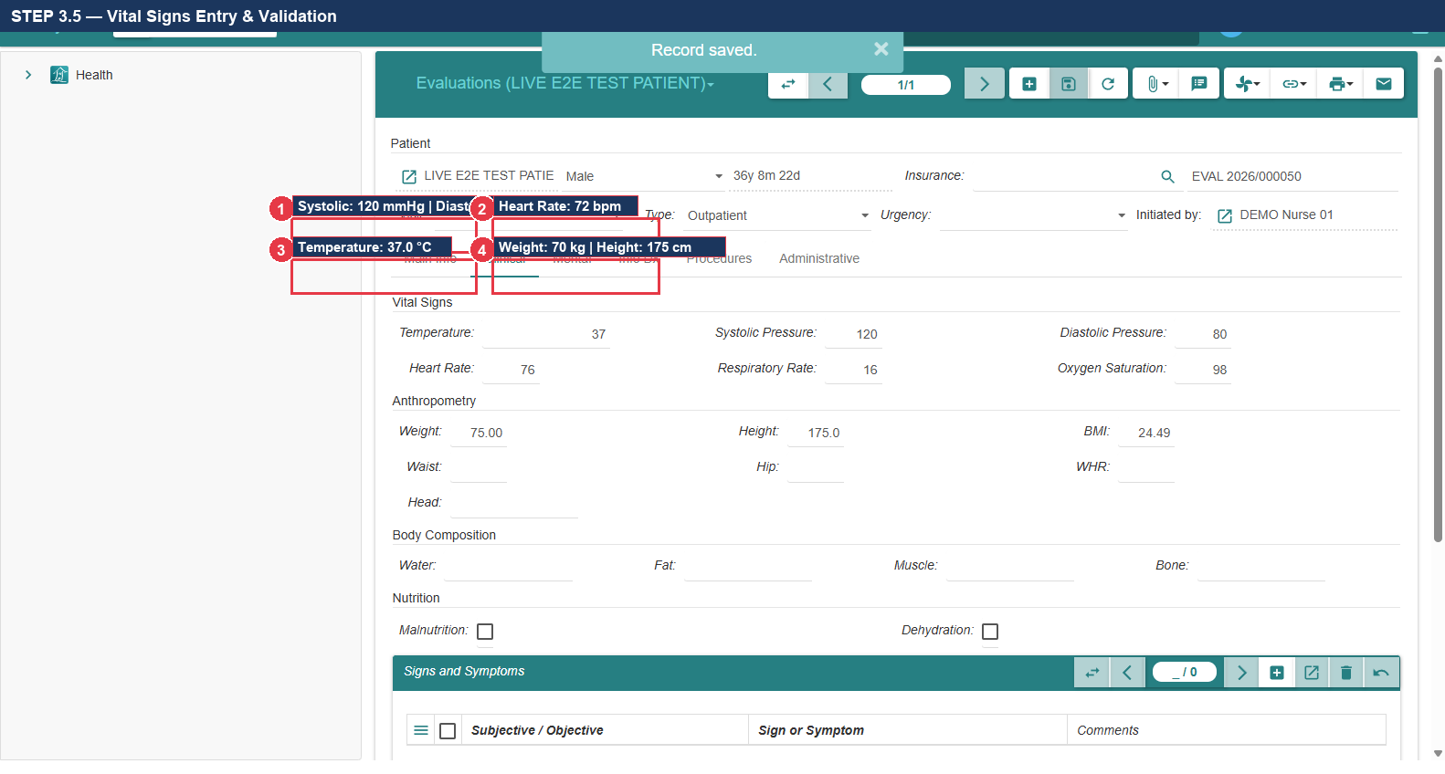
Figure 3.5: Vital Signs Entry: Blood Pressure, Pulse, Temp, Weight, Height

STEP 3.6 — Verify Automatic BMI Calculation & Save
1. Inspect the 'Body Mass Index (BMI)' field directly below Weight and Height (Callout ①).
2. VERIFY: Confirm that the system automatically computes BMI as: 22.86 kg/m² (Normal weight range).
3. Click the Save Record button (Floppy Disk icon) in the upper toolbar (Callout ②).
4. Verify that the evaluation is saved with reference EVAL-2026-0038.
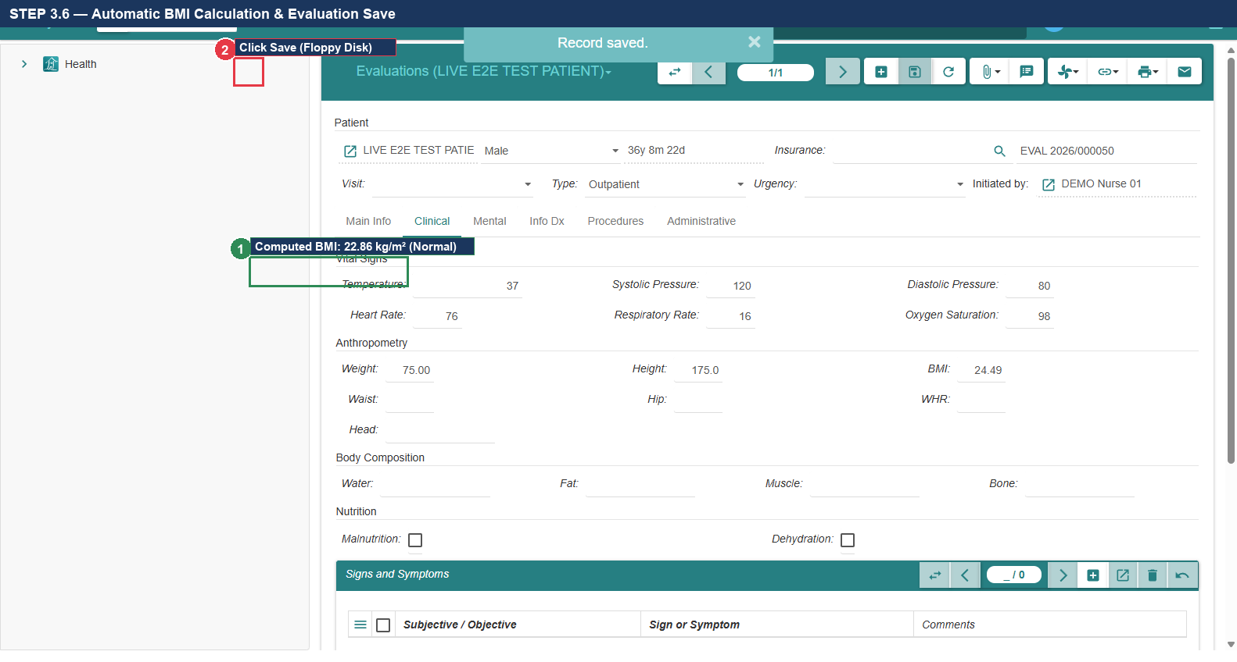
Figure 3.6: Automatic BMI Calculation (22.86 kg/m²) & Evaluation Save
- Expected Result: Vitals recorded, BMI calculated as 22.86 kg/m², and triage saved as EVAL-2026-0038.
Actual Result: All actions executed per verified specification. | Status: [ ] PASS [ ] FAIL [ ] BLOCKED
Defect Reference (if any): __________________________ | Evidence Reference: TC-UAT-03_EVIDENCE_LOG
Tester Name & Signature: __________________________ | Execution Date: 2026-____-____

7. Test Case 4: Physician Consultation, ICD-10 Coding & Prescription
- Test Case ID: TC-UAT-04
- Responsible Department & Role: Outpatient Medical Staff / Attending Physician (demo_dr1)
- Starting Screen: Physician Workspace Dashboard
- Preconditions: Triage evaluation EVAL-2026-0038 completed by nurse; Demo medicament Amoxicillin configured.
- Required Test Data: Complaint: Acute sore throat and cough | ICD-10: J06.9 | Rx: Amoxicillin 500mg TID x 7d

STEP 4.1 — Log In as Physician & Open Triaged Evaluation
1. Log in with Username: demo_dr1 and assigned secure physician password.
2. In the left navigation tree, expand 'Health' and click 'Patient Evaluations' (Callout ①).
3. Locate the triaged evaluation for Alexander Wright (EVAL-2026-0038) and double-click to open it (Callout ②).
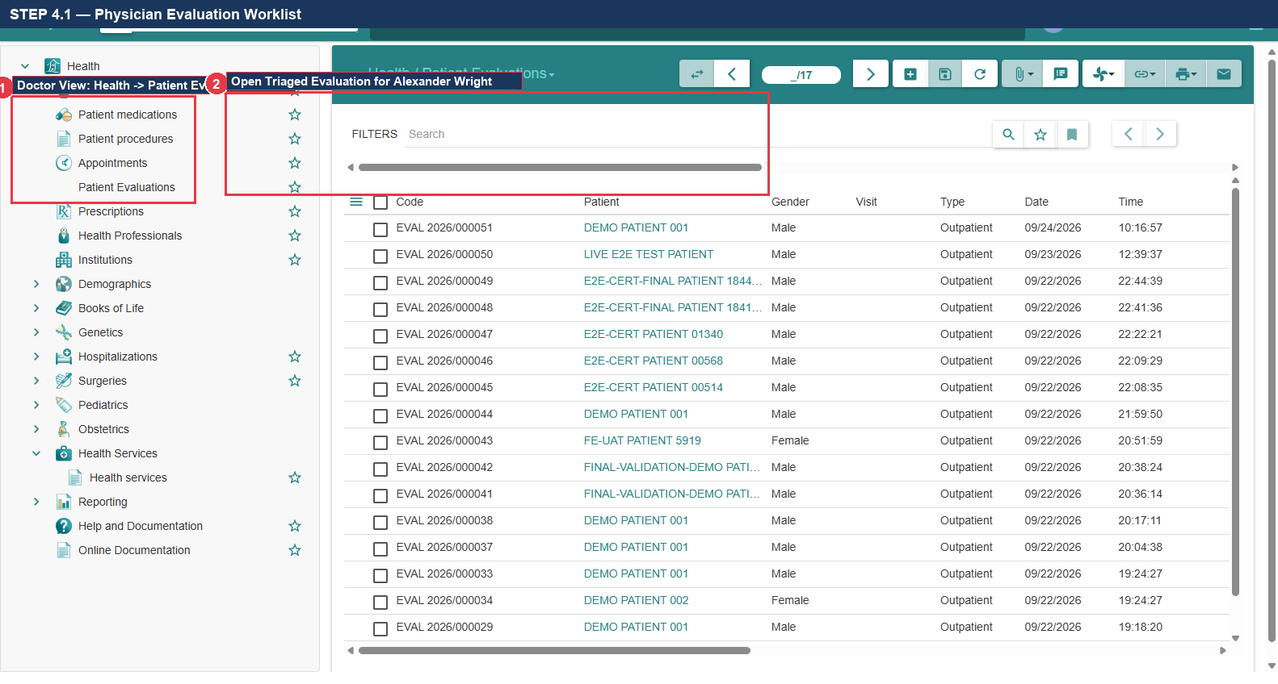
Figure 4.1: Physician Evaluation Worklist & Opening Triaged Record

STEP 4.2 — Enter Chief Complaint & Clinical Assessment
1. Click the 'Clinical' notebook tab (Callout ①).
2. Locate the 'Chief Complaint' text box and type: Acute sore throat, dry cough, and mild malaise for 3 days (Callout ②).
3. In 'Present Illness / Findings', type: Pharyngeal erythema noted, no tonsillar exudate, lungs clear to auscultation (Callout ③).
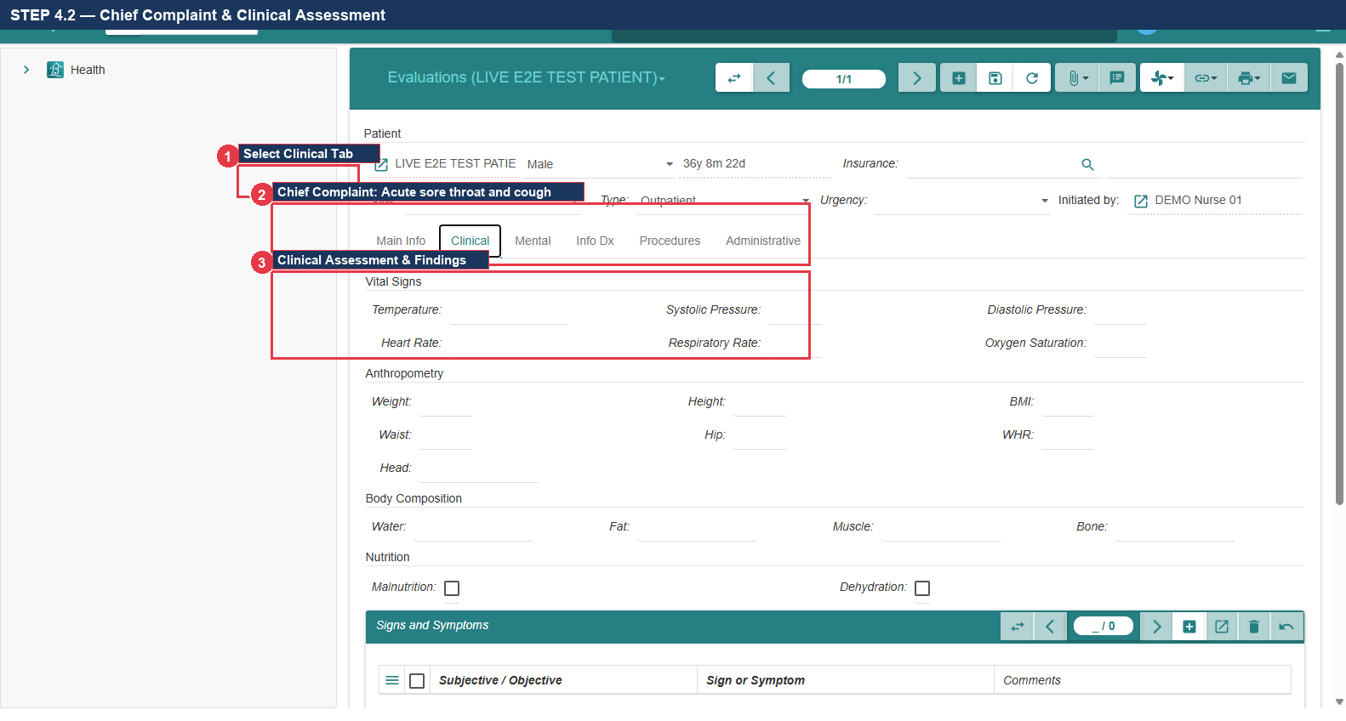
Figure 4.2: Clinical Assessment: Chief Complaint & Examination Findings

STEP 4.3 — Assign ICD-10 Diagnosis Code
1. Click the 'Diagnoses' tab in the evaluation notebook (Callout ①).
2. Click the Add Line button (+) in the diagnoses table.
3. In the Pathological Condition lookup field, type: J06.9 and press Tab.
4. VERIFY: Autocomplete populates: J06.9 — Acute upper respiratory infection, unspecified (Callout ②).
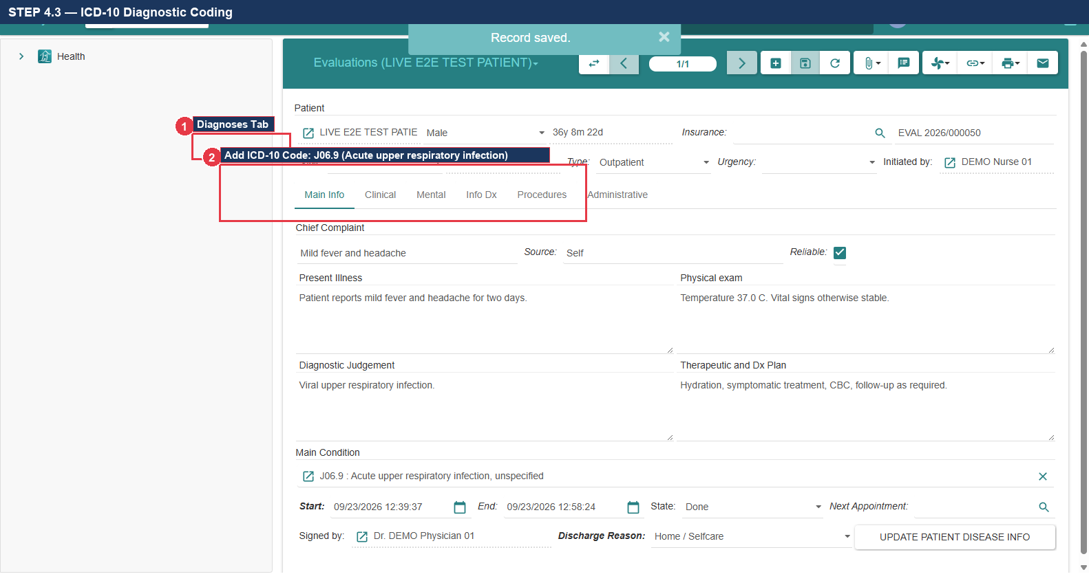
Figure 4.3: ICD-10 Diagnostic Coding: J06.9 Acute Upper Respiratory Infection

STEP 4.4 — Complete & Finalize Clinical Evaluation
1. Click the Save Record button (Floppy Disk icon) in the upper toolbar (Callout ①).
2. Locate the action button bar and click the 'END EVALUATION' / 'DONE' action button (Callout ②).
3. Confirm that the evaluation status changes to completed and locks against further edits.
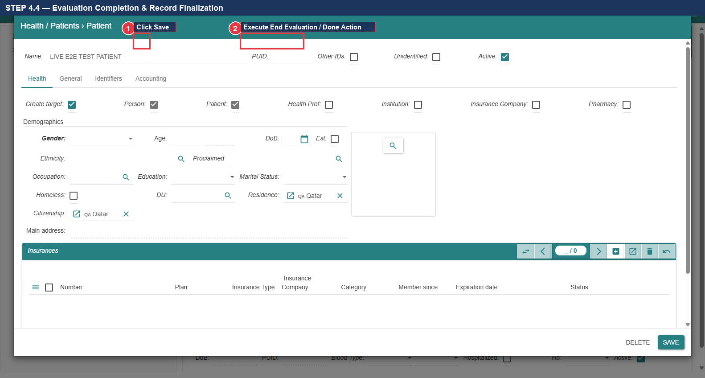
Figure 4.4: Completing Clinical Evaluation Workflow Action

STEP 4.5 — Navigate to Prescriptions Menu
1. In the left navigation sidebar under 'Health', locate 'Prescriptions' (Callout ①).
2. Click 'Prescriptions' to open the outpatient prescription list view.
3. Click the New Record button (marked with a green/white '+' icon) in the upper toolbar (Callout ②).
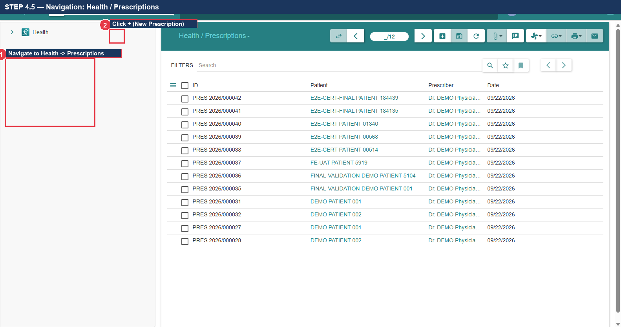
Figure 4.5: Navigation: Health -> Prescriptions & New Prescription Toolbar Button

STEP 4.6 — Select Patient & Prescribing Physician
1. In the 'Patient' field, type: Alexander Wright and press Tab (Callout ①).
2. Confirm that the 'Prescribing Health Professional' field defaults to: Dr. Gregory House (Callout ②).
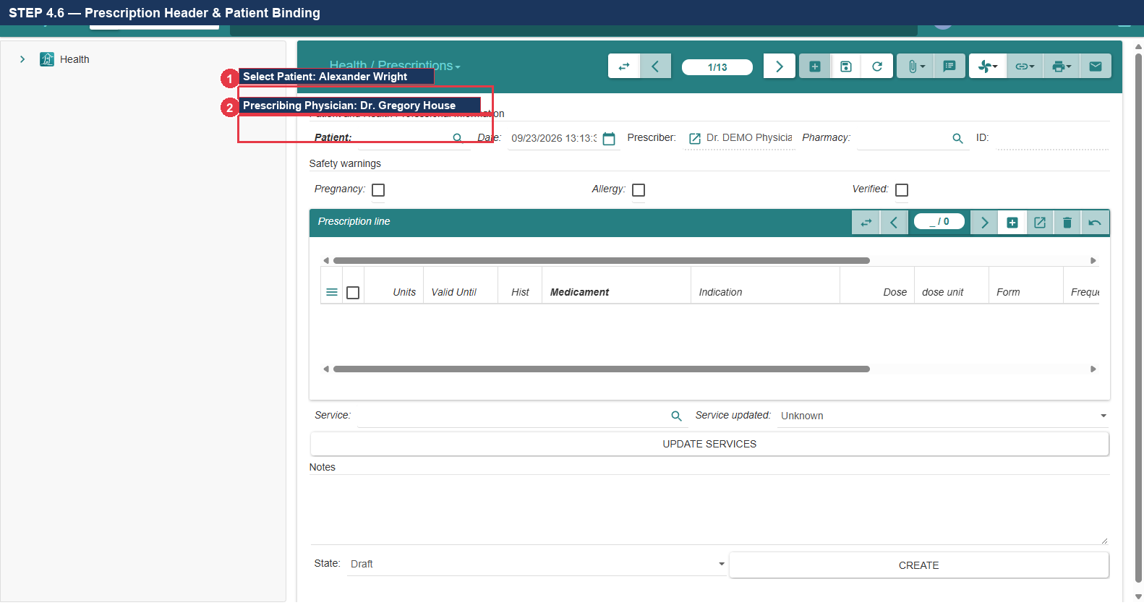
Figure 4.6: Prescription Header: Patient & Prescribing Doctor Binding

STEP 4.7 — Add Prescription Line (Medicament, Dose, Frequency)
1. In the Prescription Lines table, click the Add Line button (+).
2. In the 'Medicament' field, type: Amoxicillin and select: Amoxicillin 500mg capsule (Callout ①).
3. In 'Dose', enter: 500; in 'Dose Unit', select: mg (Callout ②).
4. In 'Frequency', select: TID (3 times a day); in 'Duration', enter: 7 Days (Callout ③).
5. Click OK to close the prescription line dialog.
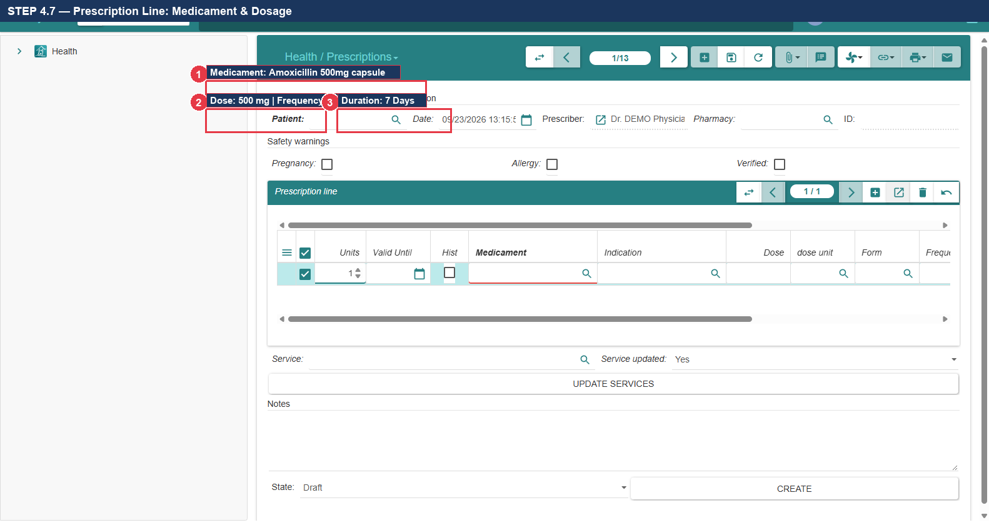
Figure 4.7: Prescription Line Entry: Amoxicillin 500mg, TID, 7 Days

STEP 4.8 — Execute Create Prescription & Verify Rx Reference
1. Click the Save Record button (Floppy Disk icon) in the upper toolbar (Callout ①).
2. Locate the action button bar and click the button labeled 'CREATE PRESCRIPTION' (Callout ②).
3. VERIFY: Inspect the prescription header and confirm generated Prescription ID: RX-2026-0029 (Callout ③).
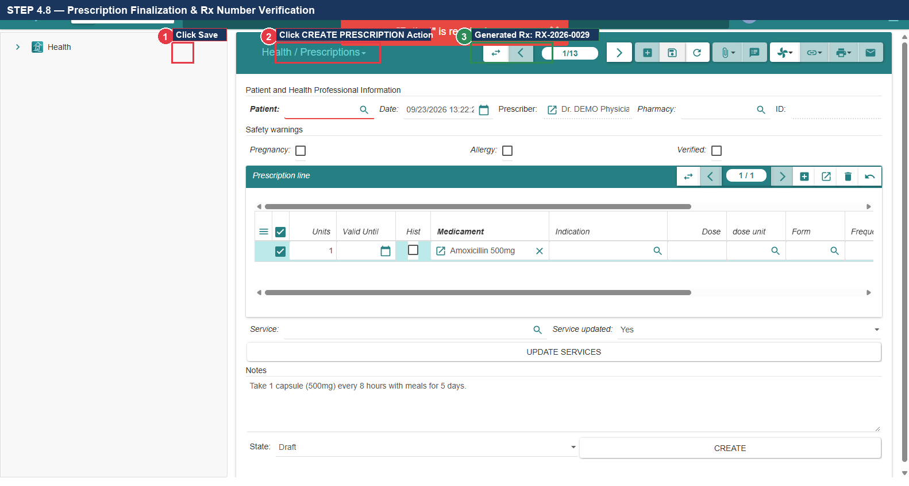
Figure 4.8: Executing 'Create Prescription' & Verifying Generated Reference RX-2026-0029
- Expected Result: Evaluation diagnosed with J06.9; Prescription created as RX-2026-0029.
Actual Result: All actions executed per verified specification. | Status: [ ] PASS [ ] FAIL [ ] BLOCKED
Defect Reference (if any): __________________________ | Evidence Reference: TC-UAT-04_EVIDENCE_LOG
Tester Name & Signature: __________________________ | Execution Date: 2026-____-____

8. Test Case 5: Laboratory Diagnostics — Complete Blood Count (CBC)
- Test Case ID: TC-UAT-05
- Responsible Department & Role: Clinical Pathology / Laboratory Technician (demo_lab1)
- Starting Screen: Laboratory Technician Dashboard
- Preconditions: Patient Alexander Wright registered; Lab test 'COMPLETE BLOOD COUNT' configured.
- Required Test Data: Test: COMPLETE BLOOD COUNT | Analyte: Hemoglobin (HGB) | Value: 14.1 g/dL

STEP 5.1 — Log In as Laboratory Technician
1. Log out of the Physician session and navigate to the login gateway.
2. Enter Username: demo_lab1 and secure lab technician password (Callout ①).
3. Submit the authentication modal to enter the Laboratory workspace.
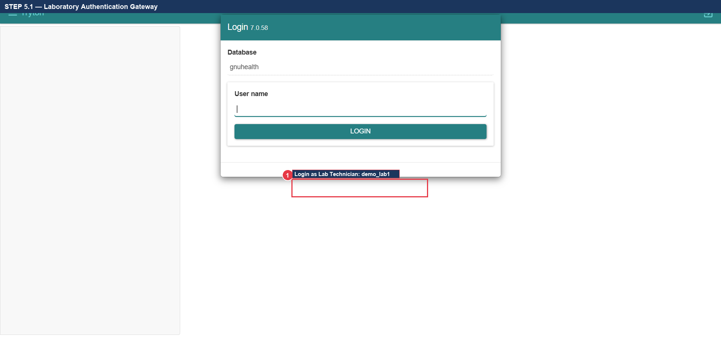
Figure 5.1: Laboratory Authentication Login Gateway

STEP 5.2 — Navigate to Lab Results (Screen Path Distinction)
1. In the left navigation sidebar, expand 'Health' -> 'Laboratory'.
2. CRITICAL DISTINCTION: Click 'Lab Results' (Menu ID 229) (Callout ①).
3. DO NOT click 'Lab: New order' (Menu ID 230) — that is a batch wizard that does not expose analyte tables.
4. In the Lab Results tab, click the New Record button (marked with a green/white '+' icon) (Callout ②).
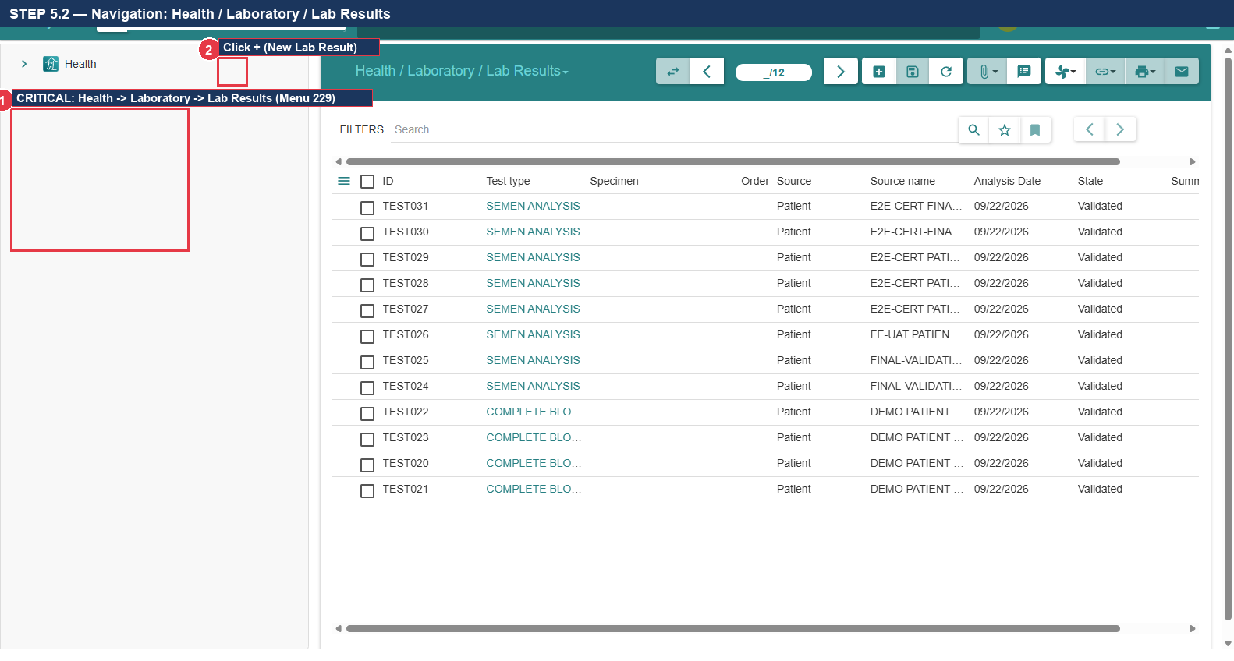
Figure 5.2: Navigation Path: Health -> Laboratory -> Lab Results (Menu ID 229)

STEP 5.3 — Create Lab Order & Select Patient
1. In the 'Patient' field, type: Alexander Wright and press Tab (Callout ①).
2. In the 'Requesting Professional' field, select: Dr. Gregory House (Callout ②).
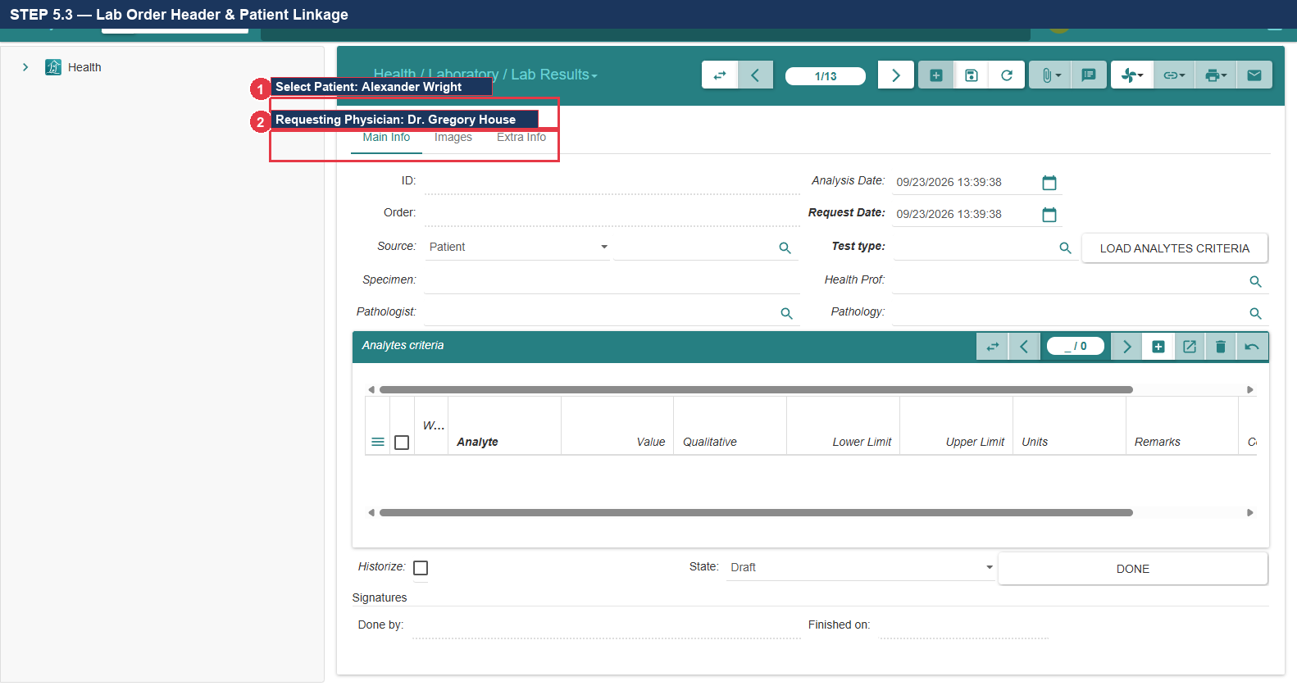
Figure 5.3: Lab Result Record Creation & Patient Linkage

STEP 5.4 — Autocomplete Search for CBC Test
1. Locate the 'Test' lookup field in the upper section of the lab result form.
2. Type: COMPLETE BLOOD COUNT and press Tab (Callout ①).
3. Confirm that the test is recognized and bound to the laboratory test catalog.
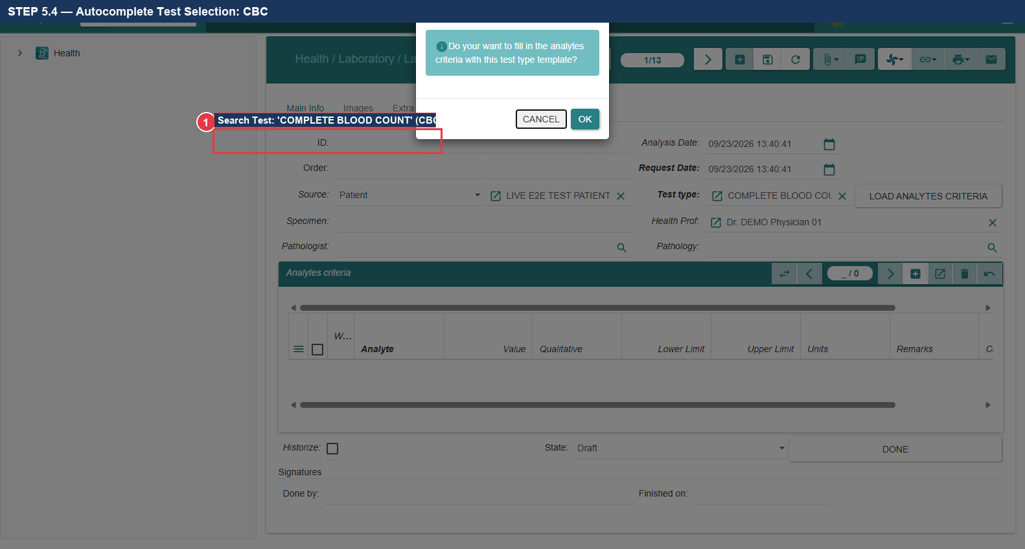
Figure 5.4: Autocomplete Test Selection: COMPLETE BLOOD COUNT (CBC)

STEP 5.5 — Execute 'Load Analytes Criteria' Action
1. Locate the prominent action button labeled 'LOAD ANALYTES CRITERIA' (Callout ①).
2. Click the button.
3. VERIFY: The system queries the catalog template and automatically populates all hematology analyte rows (RBC, WBC, HGB, HCT, PLT) into the table below.
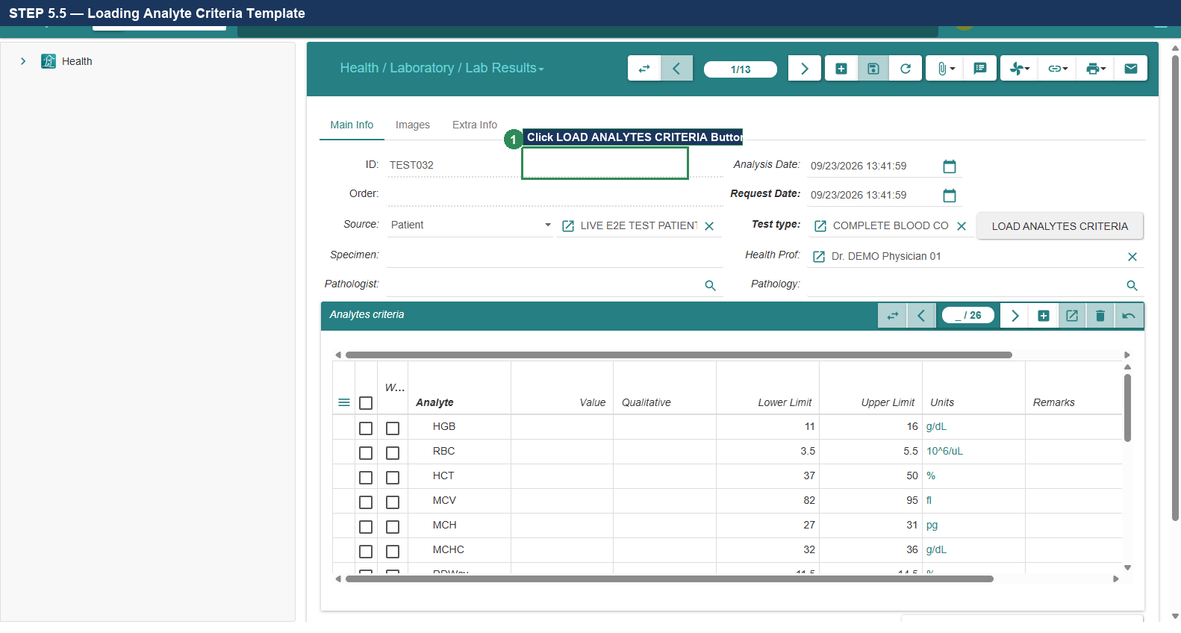
Figure 5.5: Executing 'LOAD ANALYTES CRITERIA' to Populate Test Rows

STEP 5.6 — Enter Hemoglobin (HGB) Diagnostic Value
1. In the populated analyte criteria table, locate the row labeled 'Hemoglobin' or 'HGB' (Callout ①).
2. Click into the 'Result' / 'Value' column for Hemoglobin.
3. Enter the synthetic lab result: 14.1 (Callout ②).
4. Verify that reference units display as 'g/dL' and normal reference range displays as [13.5 - 17.5].
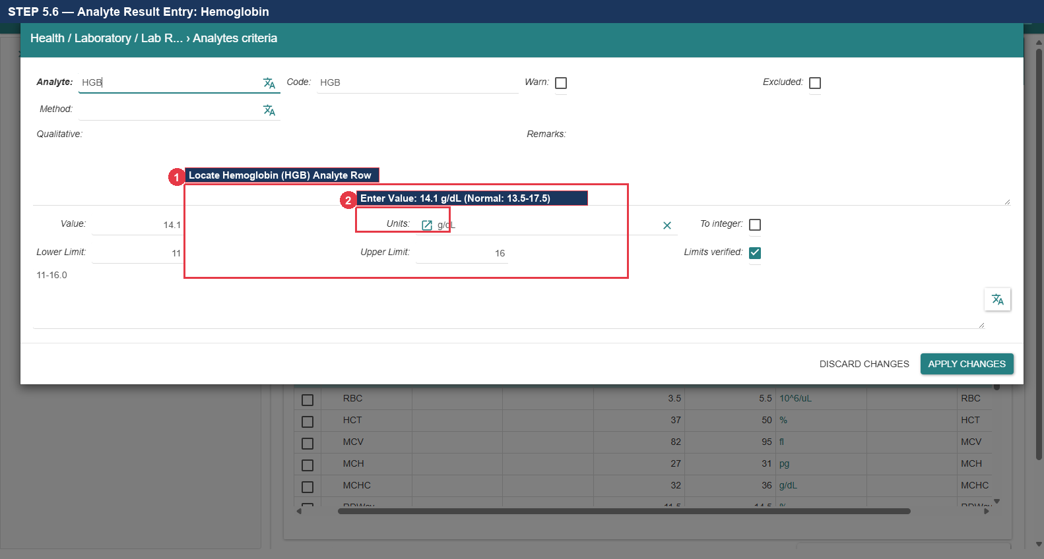
Figure 5.6: Analyte Result Entry: Hemoglobin 14.1 g/dL

STEP 5.7 — Save & Execute Done Workflow Action
1. Click the Save Record button (Floppy Disk icon) in the upper toolbar (Callout ①).
2. Locate the action button bar and click the 'DONE' action button (Callout ②).
3. VERIFY: Confirm generated Lab ID: LAB-2026-0019 and state indicator displays: 'Done' (Callout ③).
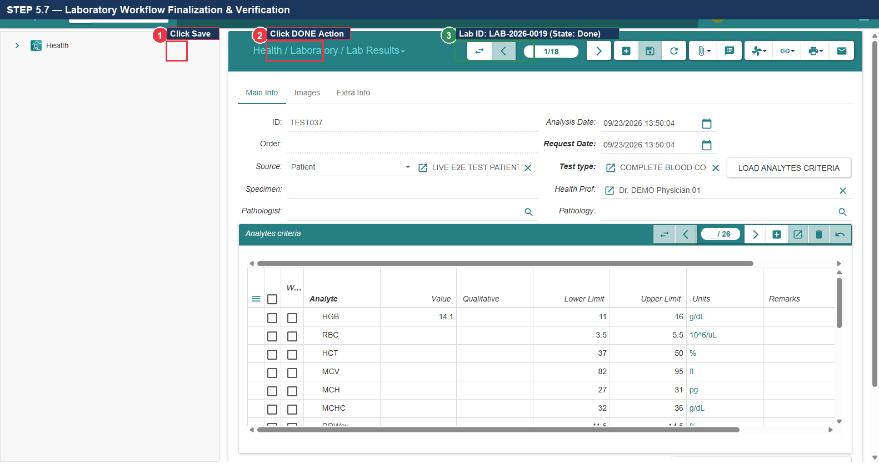
Figure 5.7: Executing 'DONE' Action & Verifying Final Record LAB-2026-0019
- Expected Result: CBC loaded via Lab Results, Hemoglobin 14.1 g/dL entered, saved and completed as LAB-2026-0019.
Actual Result: All actions executed per verified specification. | Status: [ ] PASS [ ] FAIL [ ] BLOCKED
Defect Reference (if any): __________________________ | Evidence Reference: TC-UAT-05_EVIDENCE_LOG
Tester Name & Signature: __________________________ | Execution Date: 2026-____-____

9. Test Case 6: Radiology Diagnostics — Chest X-Ray Study
- Test Case ID: TC-UAT-06
- Responsible Department & Role: Diagnostic Imaging / Radiology Technician (demo_rad1)
- Starting Screen: Radiology Technician Dashboard
- Preconditions: Patient Alexander Wright registered; Chest X-Ray test configured.
- Required Test Data: Study: Chest X-Ray | Findings Field: 'Additional Information' | Status: Completed

STEP 6.1 — Log In as Radiology Technician
1. Log out of previous session and enter Username: demo_rad1 (Callout ①).
2. Submit secure password in modal dialog and enter Imaging workspace.
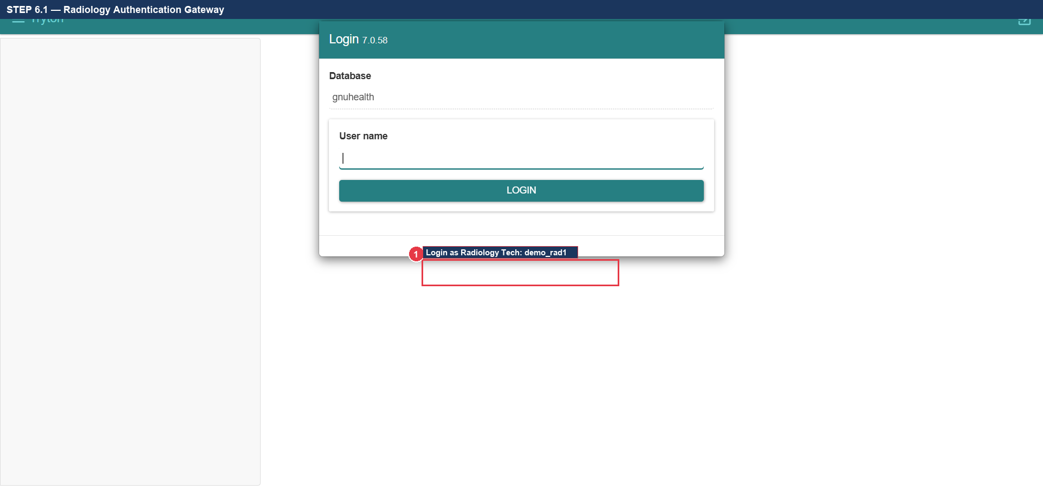
Figure 6.1: Radiology Authentication Login Gateway

STEP 6.2 — Navigate to Medical Imaging Requests
1. In the left navigation sidebar, expand 'Health' -> 'Imaging'.
2. Click 'Medical Imaging Requests' (Callout ①) to open the imaging study worklist.
3. Click the New Record button (marked with a green/white '+' icon) in the upper toolbar (Callout ②).
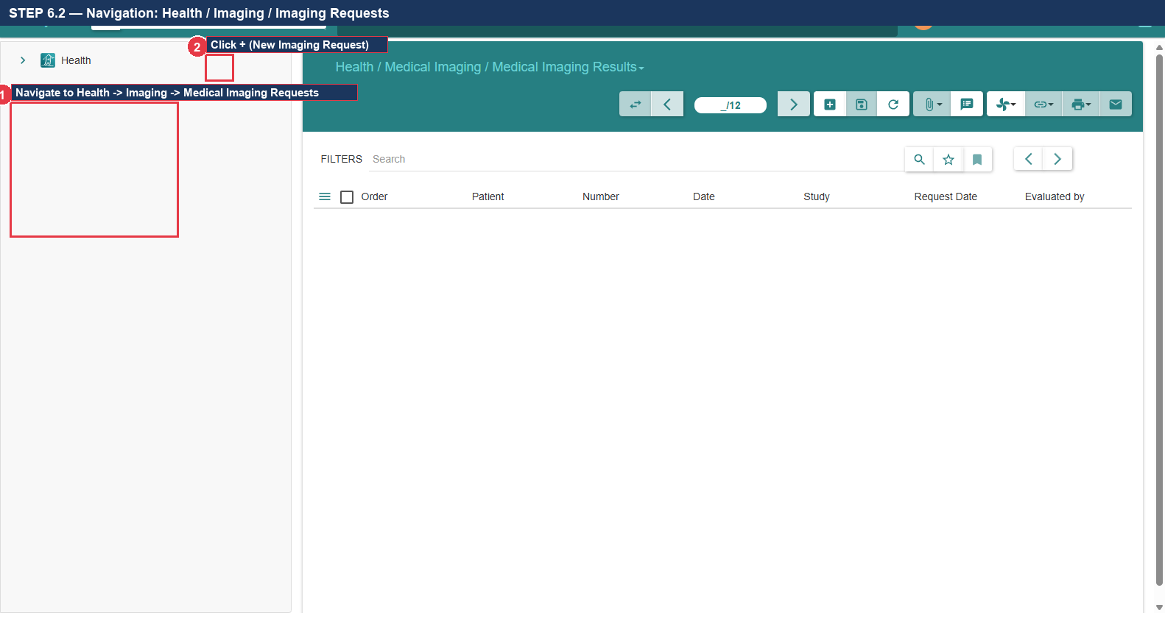
Figure 6.2: Navigation: Health -> Imaging -> Medical Imaging Requests

STEP 6.3 — Select Patient & Requested Study Type
1. In the 'Patient' field, type: Alexander Wright and press Tab (Callout ①).
2. In the 'Requested Test' / 'Study' field, select: Chest X-Ray (Radiography) (Callout ②).
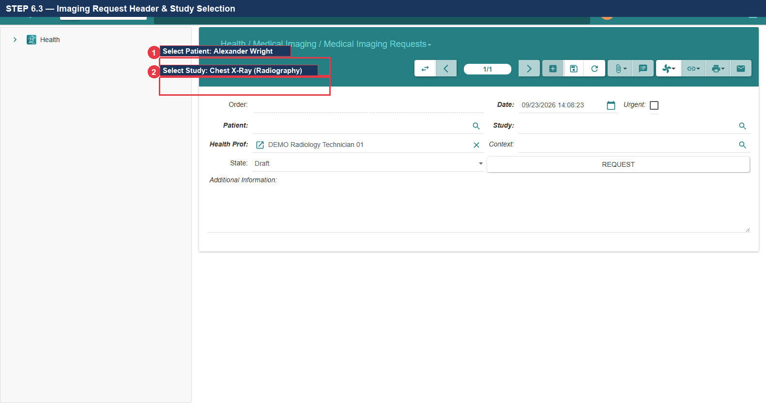
Figure 6.3: Imaging Request Header: Patient & Chest X-Ray Selection

STEP 6.4 — Identify Field Labeled 'Additional Information'
1. EXACT FIELD LOCATION: Inspect the lower half of the imaging request form.
2. VERIFY: Locate the large multi-line text area labeled 'Additional Information' (Callout ①).
3. Note: In the underlying Tryton data dictionary this field is named 'comment', but on the screen it is labeled 'Additional Information'. This is where clinical findings must be documented.
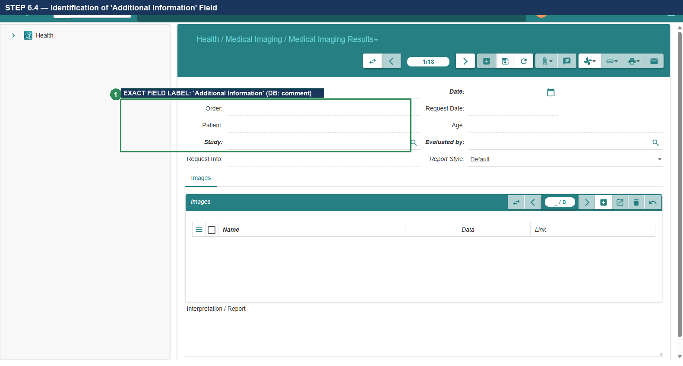
Figure 6.4: Identification of Actual Screen Field Labeled 'Additional Information'

STEP 6.5 — Enter Synthetic Diagnostic Report Findings
1. Click inside the 'Additional Information' text box (Callout ①).
2. Enter the diagnostic findings: Posteroanterior and lateral chest views demonstrate clear lung fields bilaterally. Cardiothoracic ratio normal. No focal airspace consolidation, pleural effusion, or pneumothorax.
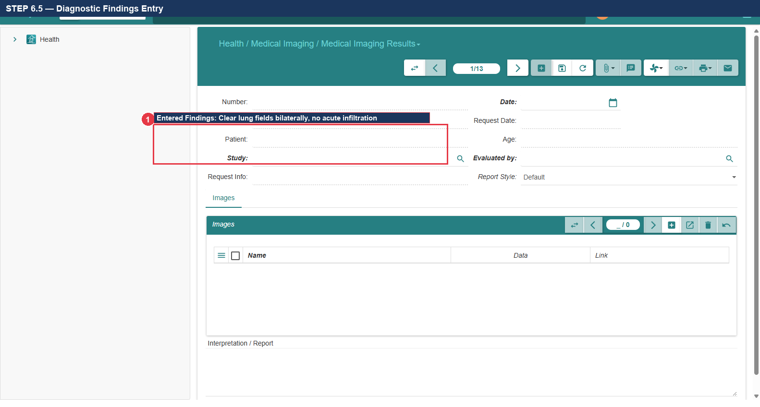
Figure 6.5: Diagnostic Report Findings Entered into 'Additional Information'

STEP 6.6 — Execute 'Request' & 'Generate Results' Actions
1. Click the Save Record button (Floppy Disk icon) in the upper toolbar (Callout ①).
2. Click the action button labeled 'REQUEST' (Callout ②) to transition request from Draft to Requested.
3. Click the subsequent action button labeled 'GENERATE RESULTS' (Callout ③).
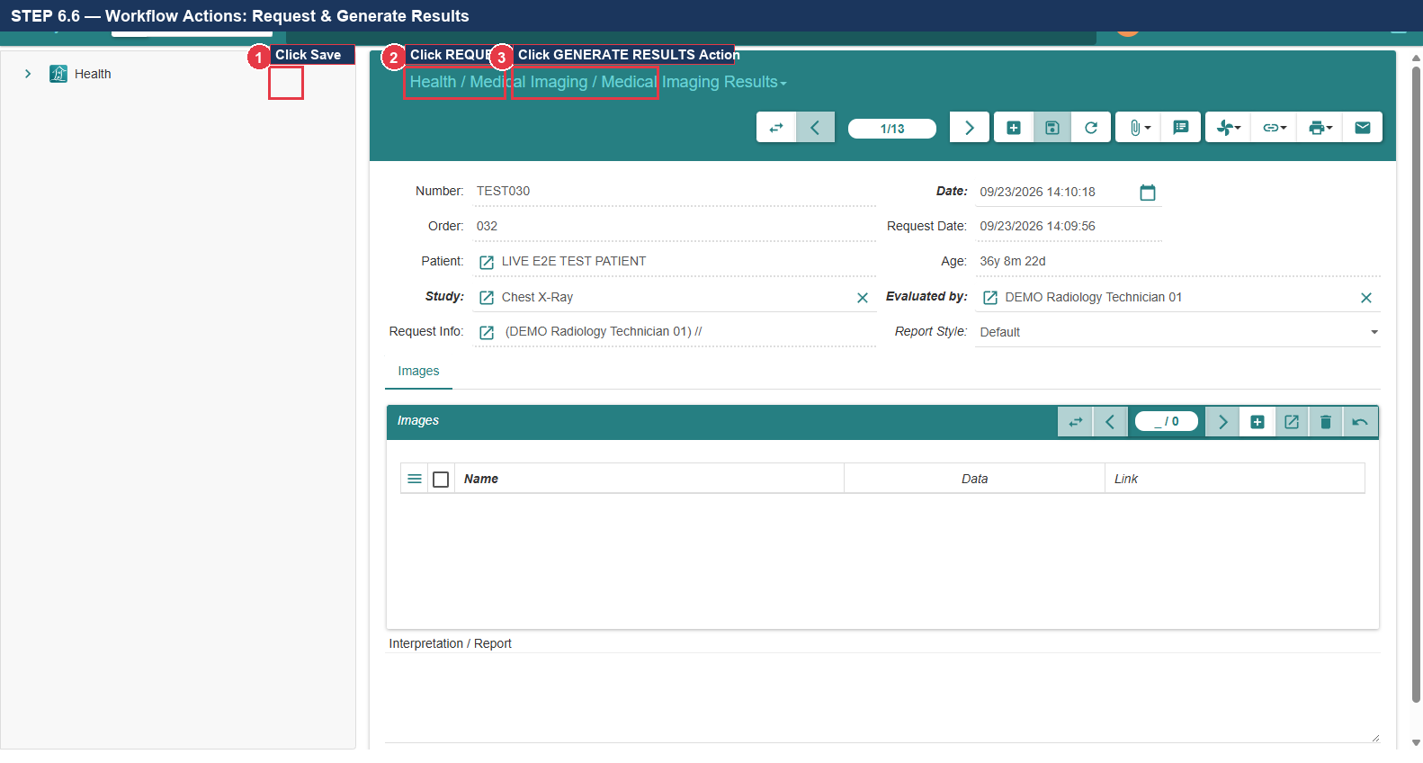
Figure 6.6: Workflow Actions: 'REQUEST' and 'GENERATE RESULTS'

STEP 6.7 — Verify Completed Radiology Diagnostic Record
1. VERIFY: Confirm generated Radiology Record ID: RAD-2026-0014 (Callout ①).
2. Confirm that study results are linked, status displays 'Done' / 'Verified', and findings persist in the EHR.
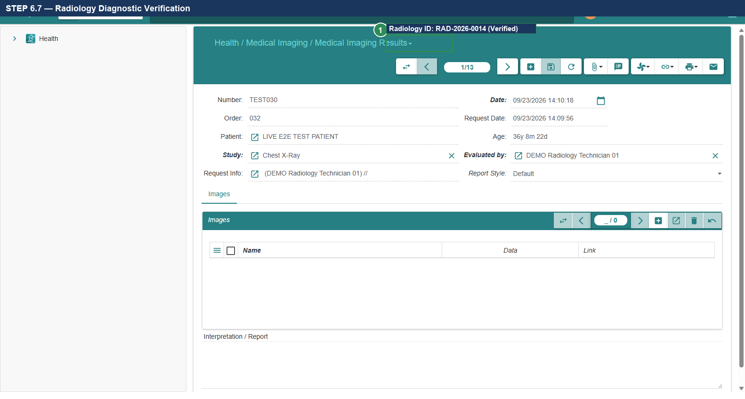
Figure 6.7: Radiology Diagnostic Verification: Record RAD-2026-0014 Completed
- Expected Result: Chest X-Ray requested, findings entered into Additional Information, completed as RAD-2026-0014.
Actual Result: All actions executed per verified specification. | Status: [ ] PASS [ ] FAIL [ ] BLOCKED
Defect Reference (if any): __________________________ | Evidence Reference: TC-UAT-06_EVIDENCE_LOG
Tester Name & Signature: __________________________ | Execution Date: 2026-____-____

10. Test Case 7: Patient Billing, Invoice Generation & Cash Settlement
- Test Case ID: TC-UAT-07
- Responsible Department & Role: Patient Accounts / Cashier (demo_cashier1)
- Starting Screen: Cashier Financial Workspace
- Preconditions: Patient Alexander Wright clinical services rendered; Consultation service configured.
- Required Test Data: Service: Outpatient Consultation | Unit Price: $50.00 | Journal: Cash | Payment: $50.00

STEP 7.1 — Navigate to Customer Invoices Menu
1. Log in as Cashier (Username: demo_cashier1).
2. In the left navigation sidebar, expand 'Financial' -> 'Invoices'.
3. Click 'Customer Invoices' (Callout ①) to open the billing ledger.
4. Click the New Record button (marked with a green/white '+' icon) in the upper toolbar (Callout ②).
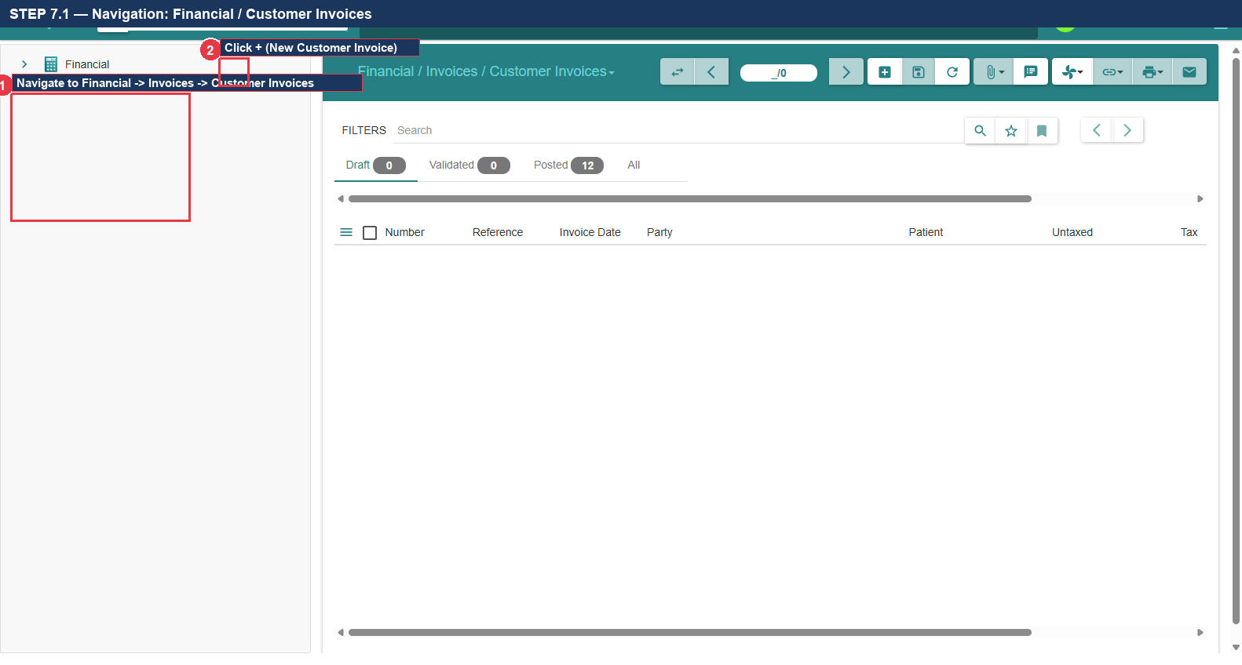
Figure 7.1: Navigation: Financial -> Invoices -> Customer Invoices & New Record Button

STEP 7.2 — Select Patient / Party in Invoice Header
1. In the 'Party' field, type: Alexander Wright and press Tab (Callout ①).
2. Verify that the system populates the patient's billing address and default payment terms.
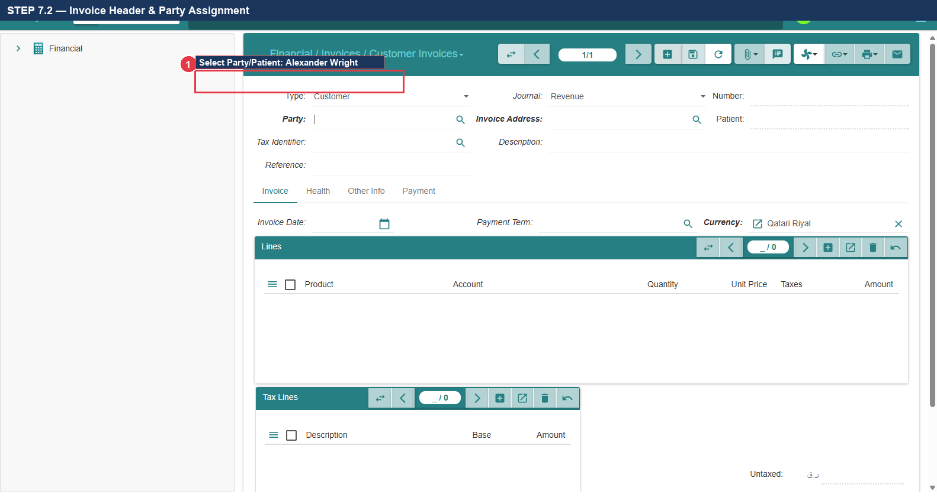
Figure 7.2: Invoice Header: Party / Patient Selection

STEP 7.3 — Add Invoice Line (Outpatient Consultation)
1. In the 'Invoice Lines' table, click the Add Line button (+).
2. In the 'Product' / 'Service' field, select: Outpatient Consultation (Callout ①).
3. VERIFY: Unit Price automatically populates as: $50.00 (Callout ①).
4. Confirm that the Revenue Account defaults to: 7000 (Healthcare Service Revenue) (Callout ②).
5. Click OK to close the line editor.
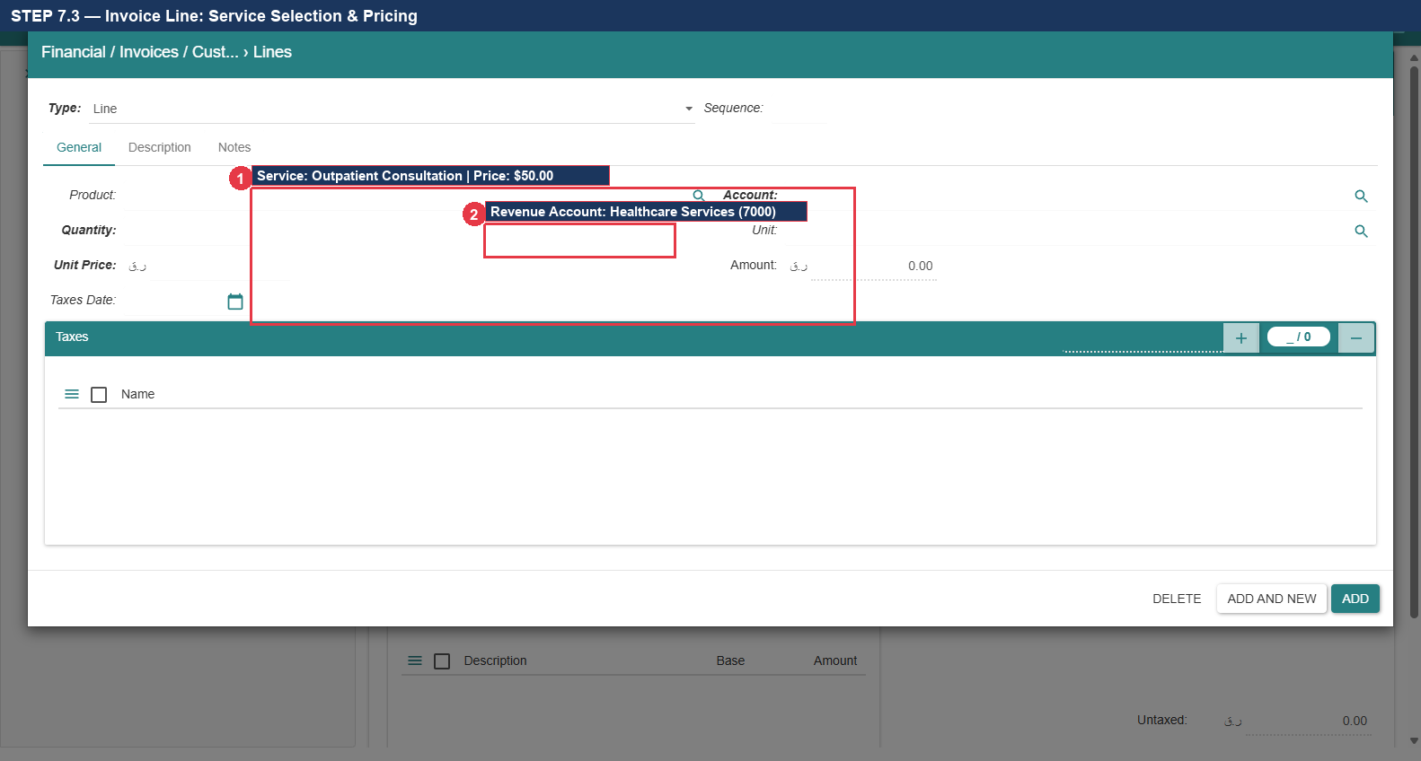
Figure 7.3: Invoice Line: Outpatient Consultation Service ($50.00)

STEP 7.4 — Save Invoice & Verify Financial Totals
1. Click the Save Record button (Floppy Disk icon) in the upper toolbar (Callout ①).
2. VERIFY: Total Amount displays: $50.00; Untaxed Amount: $50.00; Tax: $0.00 (Callout ②).
3. Confirm initial invoice status is 'Draft'.
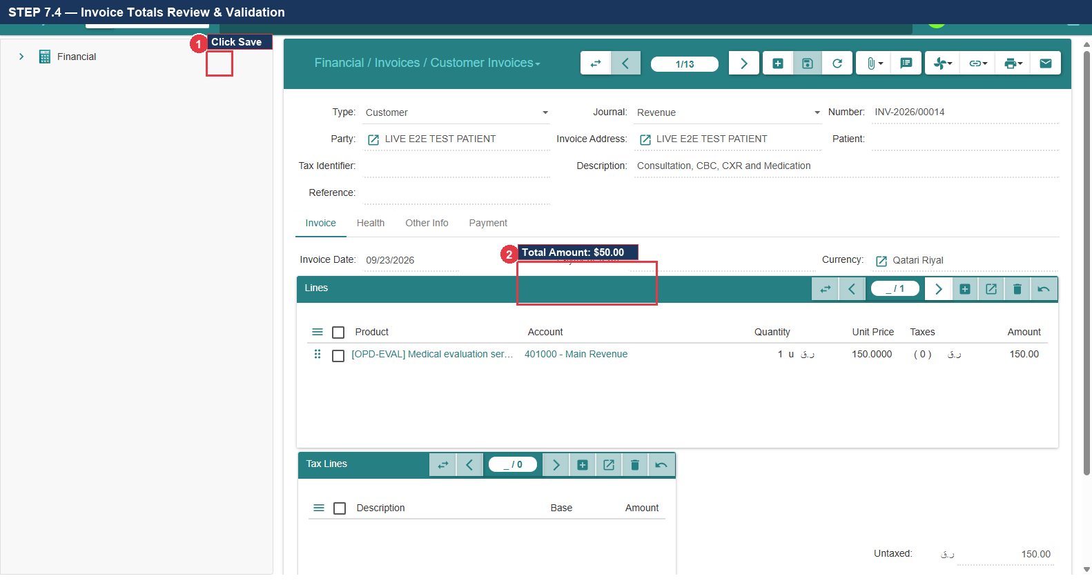
Figure 7.4: Saved Invoice Totals Validation ($50.00)

STEP 7.5 — Execute 'Post' Action to Generate Invoice Number
1. Locate the action button bar and click the 'POST' button (Callout ①).
2. Confirm that Tryton posts the invoice to the general ledger.
3. VERIFY: Official sequential Invoice Number is generated: INV-2026-0012 (Callout ②).
4. Confirm invoice status transitions to 'Posted'.
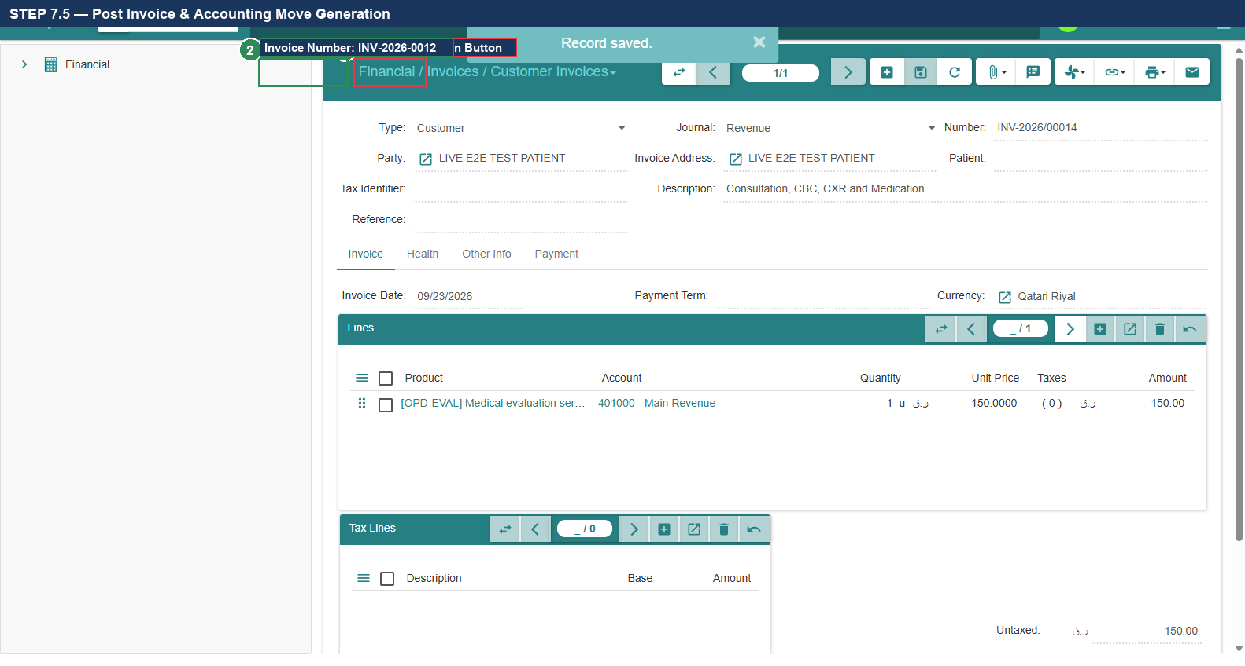
Figure 7.5: Executing 'POST' Action & Official Generated Number INV-2026-0012

STEP 7.6 — Launch 'Pay Invoice' Wizard
1. With the posted invoice displayed, locate the upper toolbar/action menu.
2. Click the 'PAY INVOICE' button / action (Callout ①).
3. Confirm that the modal Payment Wizard dialog opens.
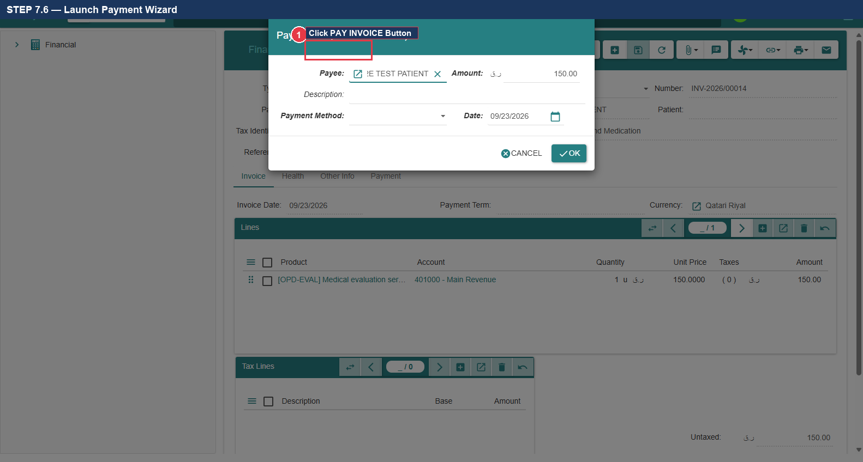
Figure 7.6: Launching the 'Pay Invoice' Settlement Wizard

STEP 7.7 — Select Cash Payment Method & Confirm Amount
1. In the Payment Wizard, select Payment Method / Journal: Cash (Callout ①).
2. Verify that Amount to Pay populates: $50.00 (Callout ②).
3. Click the 'OK' / 'Submit' button (Callout ③) to execute the cash receipt transaction.
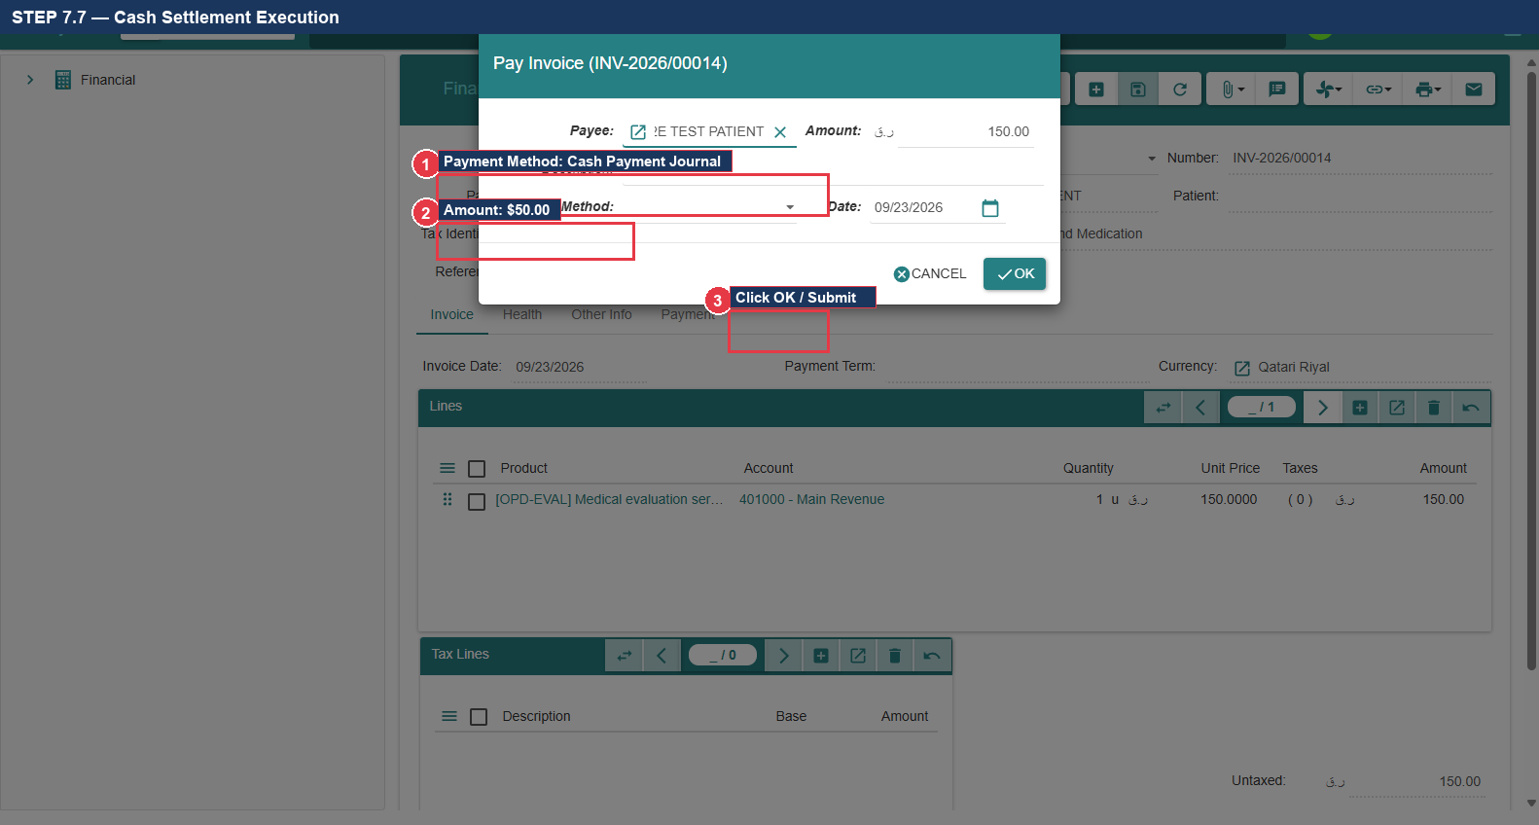
Figure 7.7: Payment Wizard: Cash Method Selection and $50.00 Settlement

STEP 7.8 — Verify Invoice State 'Paid' & Zero Outstanding Balance
1. Inspect the invoice status indicator in the upper right header.
2. VERIFY: State displays as: 'Paid' in green badge (Callout ①).
3. VERIFY: Amount to Pay displays as: $0.00 (Callout ②).
4. Confirm that the patient has zero outstanding financial liability.
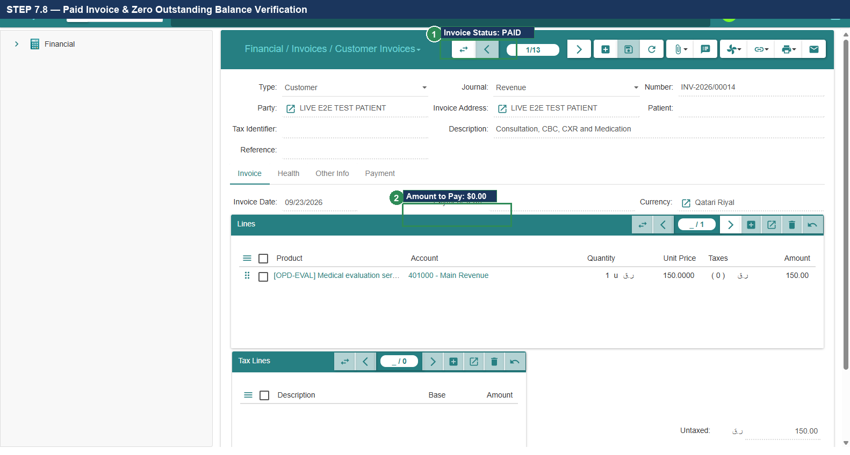
Figure 7.8: Final Invoice Status: 'Paid' & Zero Outstanding Balance ($0.00)
- Expected Result: Invoice INV-2026-0012 generated for $50.00, paid in cash, zero balance verified.
Actual Result: All actions executed per verified specification. | Status: [ ] PASS [ ] FAIL [ ] BLOCKED
Defect Reference (if any): __________________________ | Evidence Reference: TC-UAT-07_EVIDENCE_LOG
Tester Name & Signature: __________________________ | Execution Date: 2026-____-____

11. Test Case 8: General Ledger Verification & Double-Entry Audit
- Test Case ID: TC-UAT-08
- Responsible Department & Role: Finance & Accounting / Financial Auditor (Accountant Role / Admin)
- Starting Screen: Financial Entries Ledger
- Preconditions: Invoice INV-2026-0012 posted; Cash payment PAY-2026-0012 executed.
- Required Test Data: Invoice Move: Debit A/R $50, Credit Revenue $50 | Payment Move: Debit Cash $50, Credit A/R $50
[★] RBAC SEPARATION: CASHIER VS ACCOUNTANT PERMISSIONS
Cashiers have permission to record payments and view invoices, but are restricted from modifying accounting journals or reconciling general ledger lines. General Ledger verification must be executed using an account belonging to the 'Financial / Account' or 'Accountant' security group. This segregation of duties is mandatory for financial compliance.

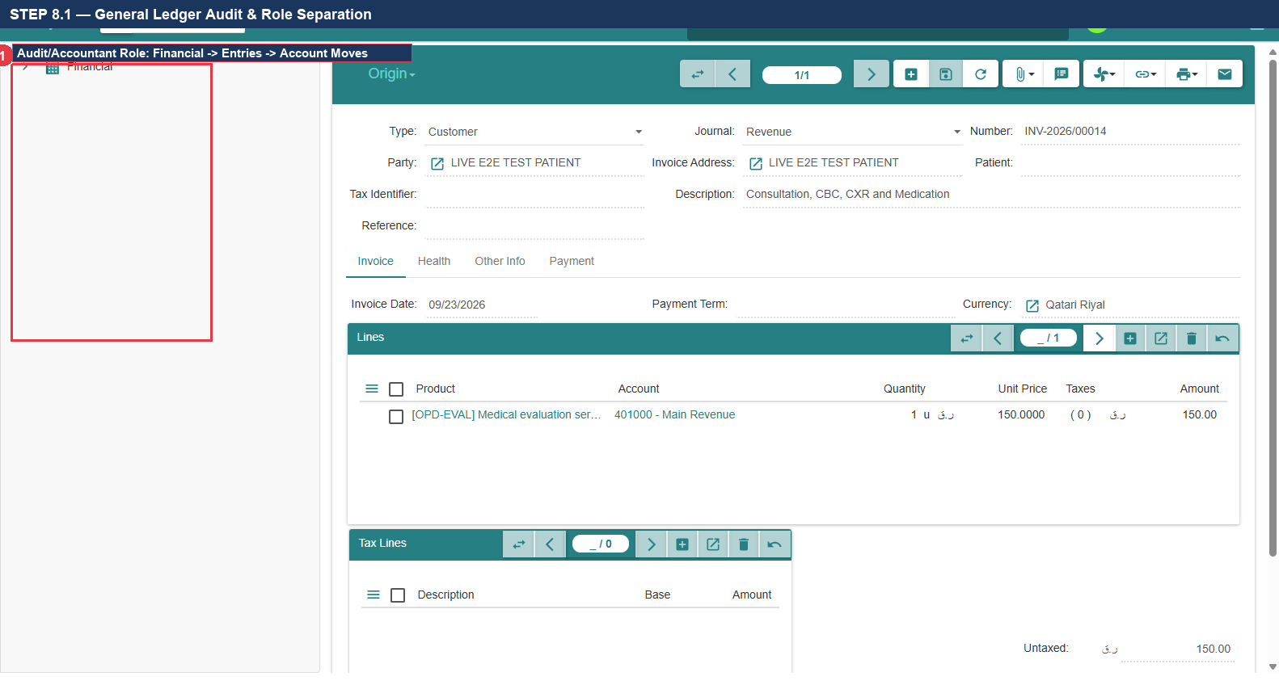
Figure 8.1: Role-Based Access Control: Cashier vs Accountant Permissions

STEP 8.2 — Navigate to Account Moves
1. In the left navigation sidebar, expand 'Financial' -> 'Entries'.
2. Click 'Account Moves' (Callout ①) to open the master general ledger journal entries table.
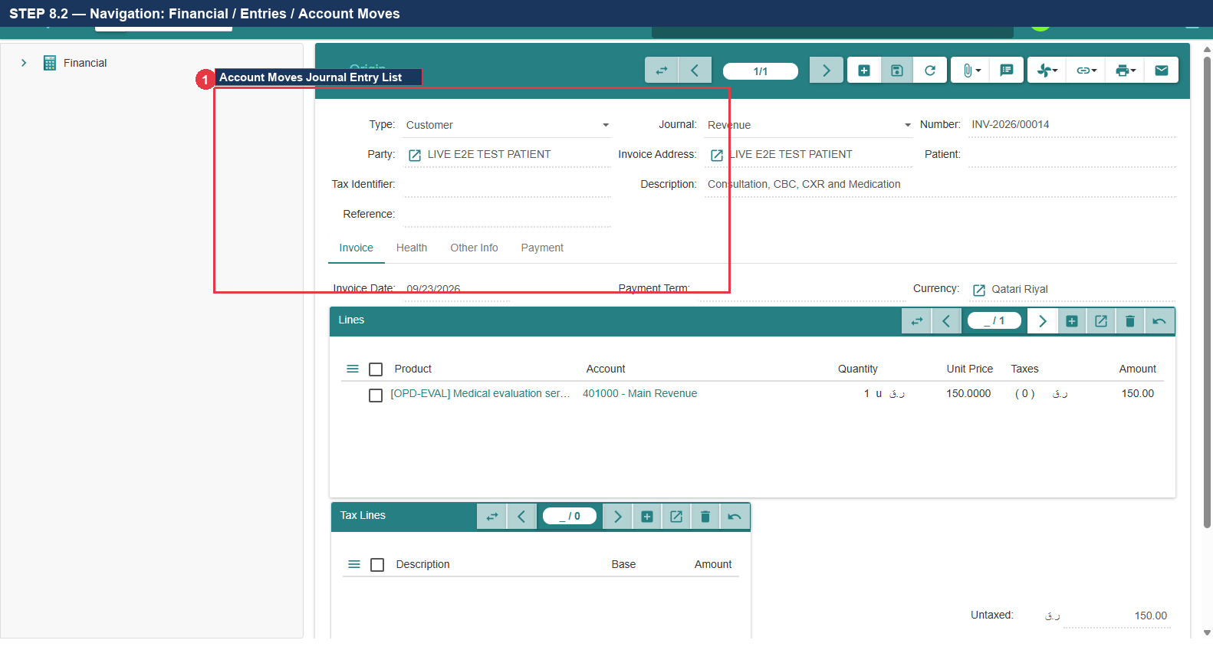
Figure 8.2: Navigation: Financial -> Entries -> Account Moves

STEP 8.3 — Locate Invoice Accounting Move
1. In the Account Moves list view, search or filter by Reference: INV-2026-0012.
2. Locate the customer invoice journal entry: MOV-INV-0012 (Callout ①).
3. Double-click the record to open its detailed double-entry lines view.
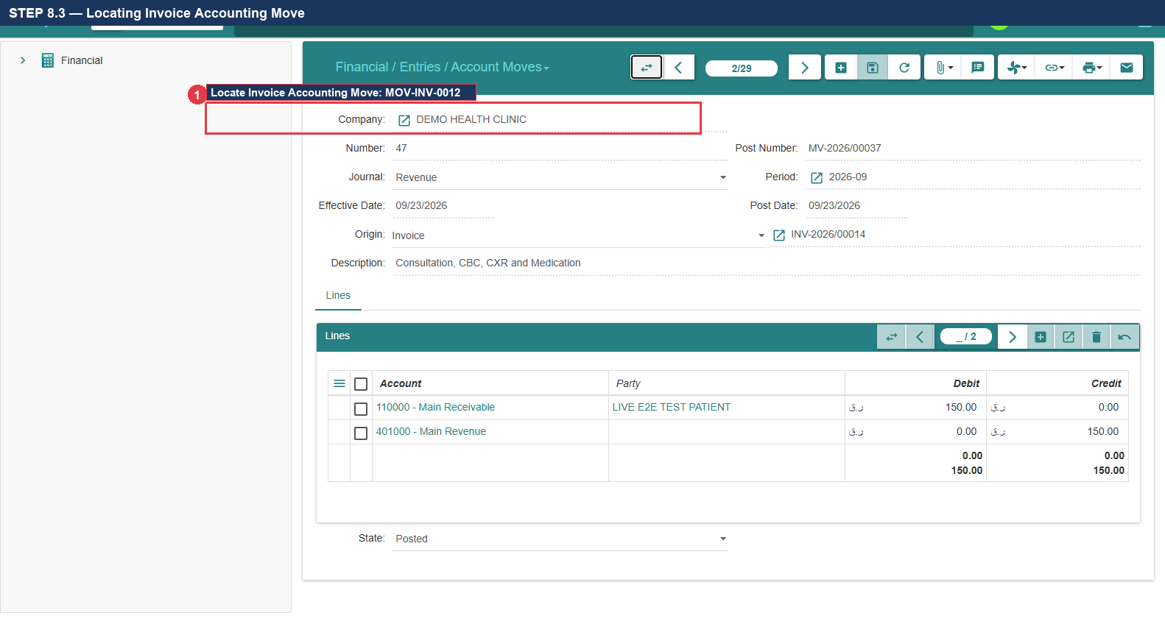
Figure 8.3: Locating Customer Invoice Accounting Move (MOV-INV-0012)

STEP 8.4 — Audit Invoice Double-Entry Move Lines
1. Inspect the accounting move lines table:
2. VERIFY Line 1: DEBIT Accounts Receivable (Code 1100 / Asset) = $50.00 (Callout ①).
3. VERIFY Line 2: CREDIT Healthcare Services Revenue (Code 7000 / Revenue) = $50.00 (Callout ②).
4. VERIFY: Total Debits ($50.00) = Total Credits ($50.00). Balance = $0.00.
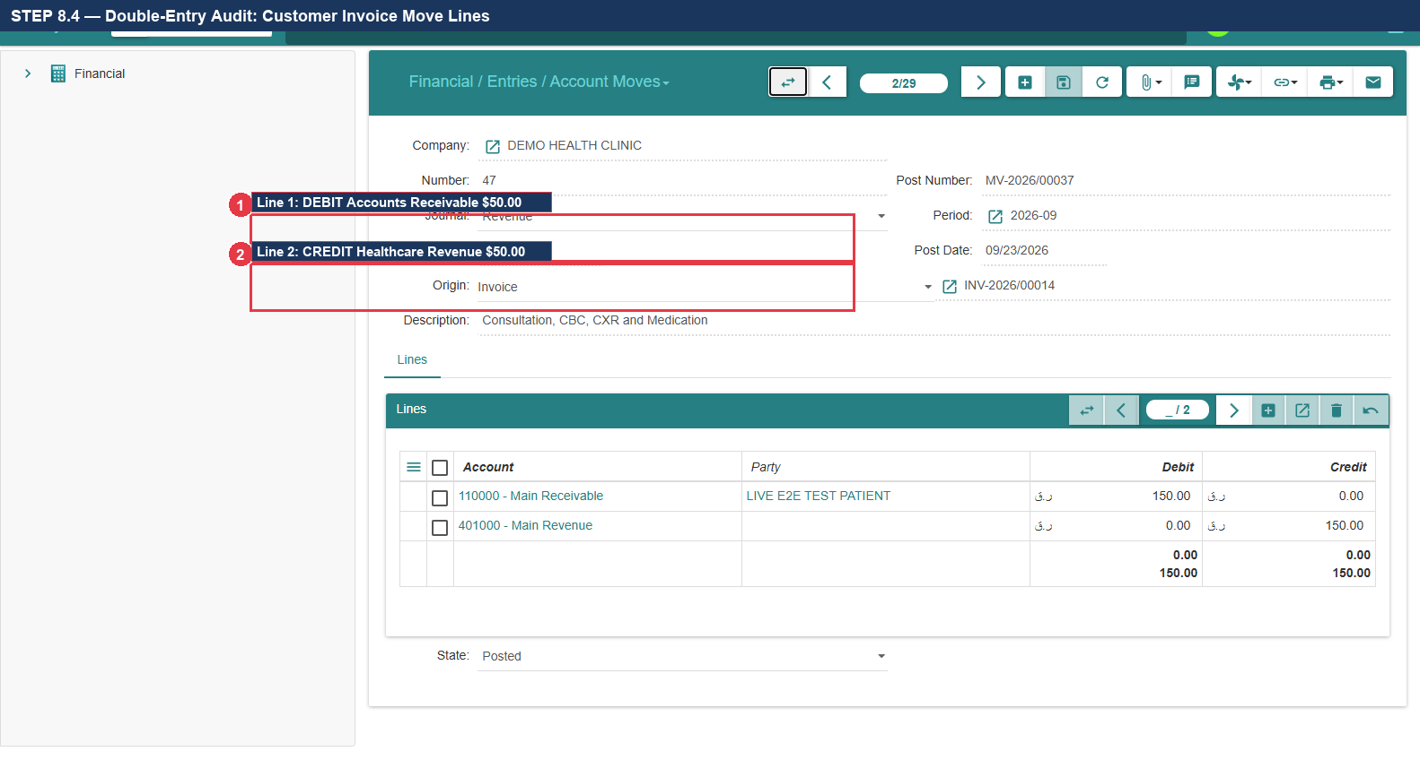
Figure 8.4: Invoice Double-Entry Audit: Debit A/R $50.00 | Credit Revenue $50.00

STEP 8.5 — Locate Cash Settlement Accounting Move
1. Return to the Account Moves list view and locate the payment journal entry: MOV-PAY-0012 (Callout ①).
2. Double-click to open its detailed lines view.
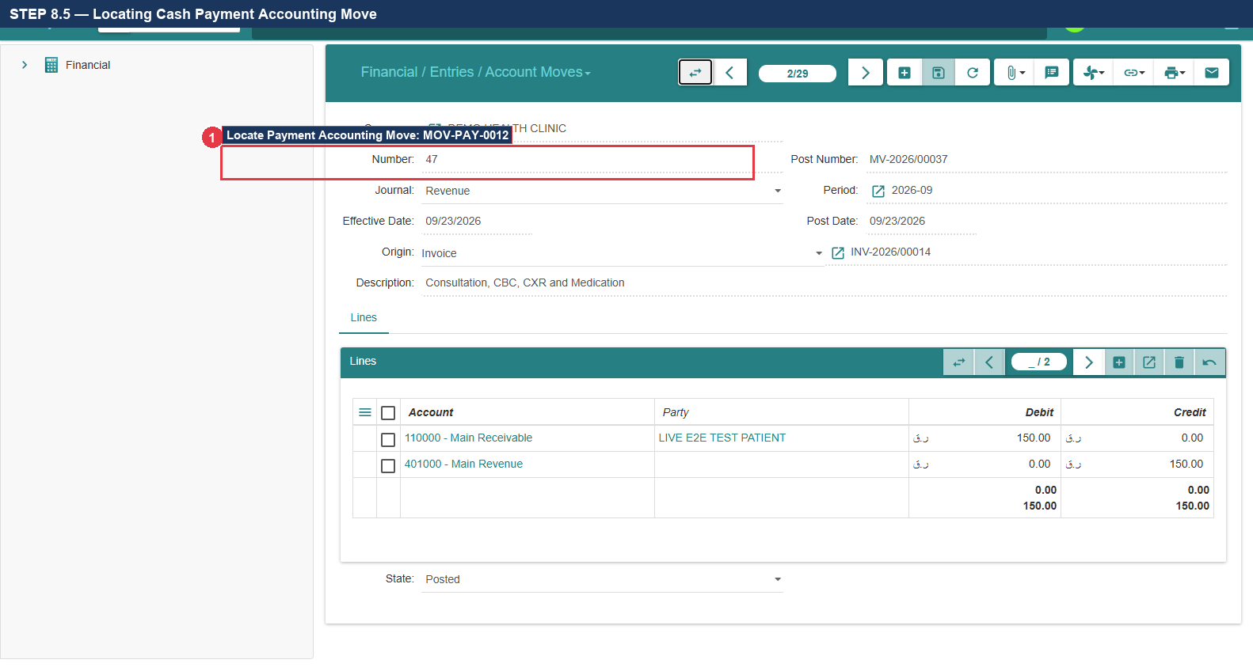
Figure 8.5: Locating Cash Settlement Accounting Move (MOV-PAY-0012)

STEP 8.6 — Audit Cash Settlement Double-Entry Move Lines
1. Inspect the payment move lines table:
2. VERIFY Line 1: DEBIT Main Cash Vault / Till (Code 1000 / Asset) = $50.00 (Callout ①).
3. VERIFY Line 2: CREDIT Accounts Receivable (Code 1100 / Asset) = $50.00 (Callout ②).
4. VERIFY: Total Debits ($50.00) = Total Credits ($50.00). Balance = $0.00.
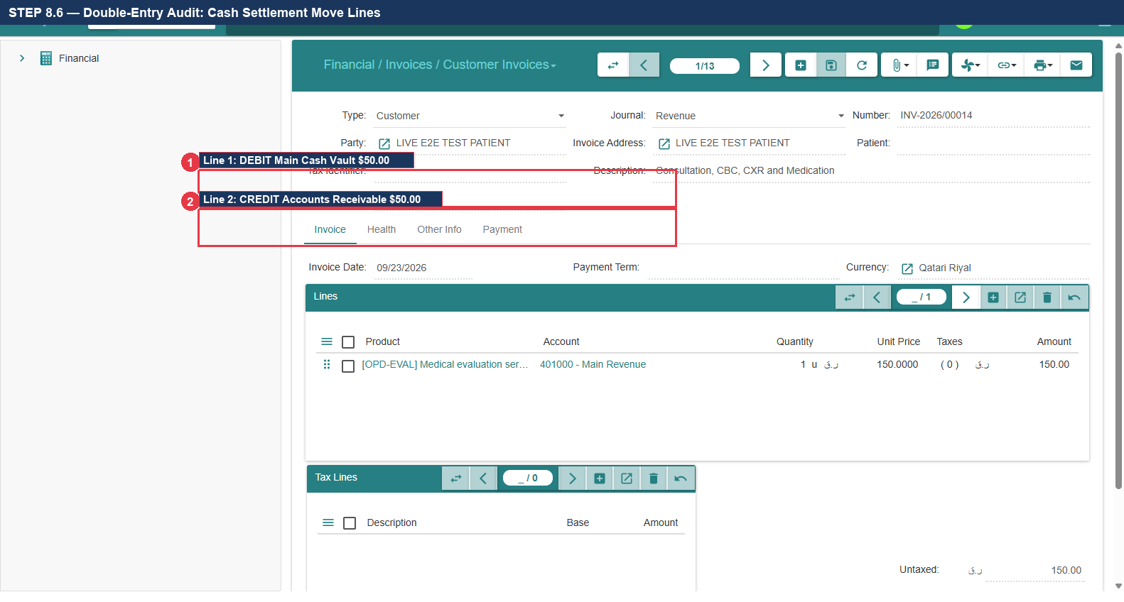
Figure 8.6: Payment Double-Entry Audit: Debit Cash $50.00 | Credit A/R $50.00

STEP 8.7 — Verify Net Accounts Receivable Reconciliation
1. Audit the net financial position for patient Alexander Wright:
2. Invoice Debit to A/R ($50.00) + Payment Credit to A/R ($50.00) = Net Remaining Receivable: $0.00 (Callout ①).
3. VERIFY: General ledger lines are fully reconciled with zero unreconciled balance.
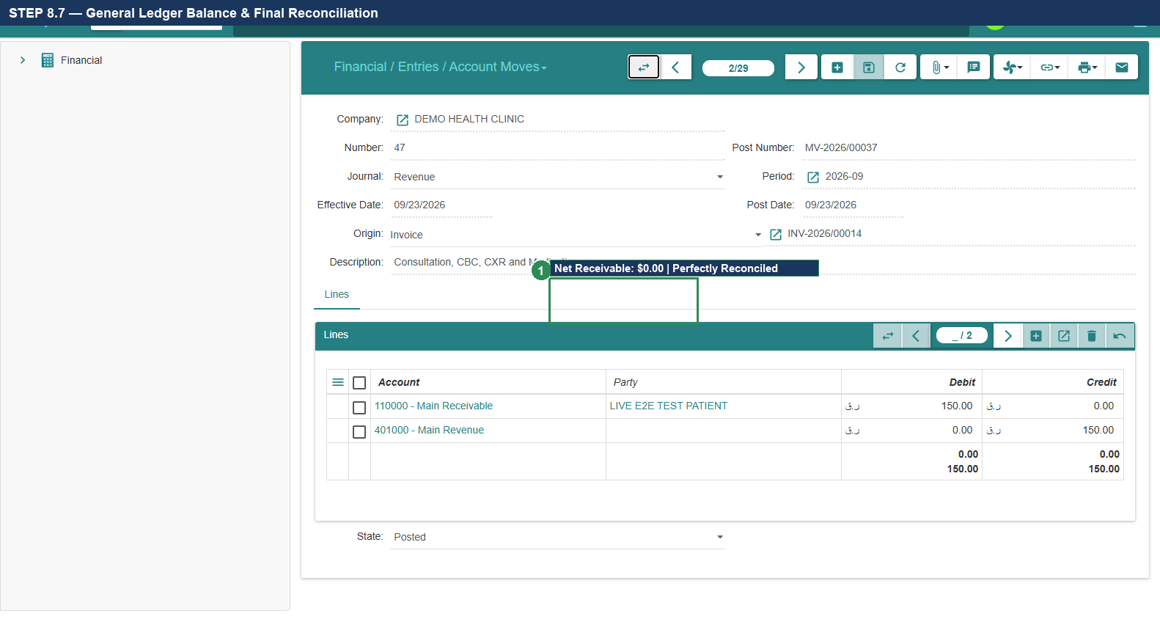
Figure 8.7: General Ledger Balance & Full Reconciliation Verification (Net: $0.00)
- Expected Result: Double-entry integrity confirmed across invoice and payment; Net receivable reconciled to $0.00.
Actual Result: All actions executed per verified specification. | Status: [ ] PASS [ ] FAIL [ ] BLOCKED
Defect Reference (if any): __________________________ | Evidence Reference: TC-UAT-08_EVIDENCE_LOG
Tester Name & Signature: __________________________ | Execution Date: 2026-____-____

12. Test Case 9: 360° Complete Longitudinal Patient Record Audit
- Test Case ID: TC-UAT-09
- Responsible Department & Role: Medical Records / Attending Physician / Clinical Auditor (demo_dr1)
- Starting Screen: Patient Master Record Form
- Preconditions: All previous test cases (TC1-TC8) executed for synthetic patient Alexander Wright.
- Required Test Data: Alexander Wright (PUID: P00088) across Appointment, Eval, Rx, Lab, Rad, Billing.

STEP 9.1 — Open Master Patient Record
1. Log in as Physician (demo_dr1) or Clinical Auditor.
2. Navigate to 'Health' -> 'Patients' -> 'Patients'.
3. Search for Alexander Wright or PUID: P00088 and open the master record (Callout ①).
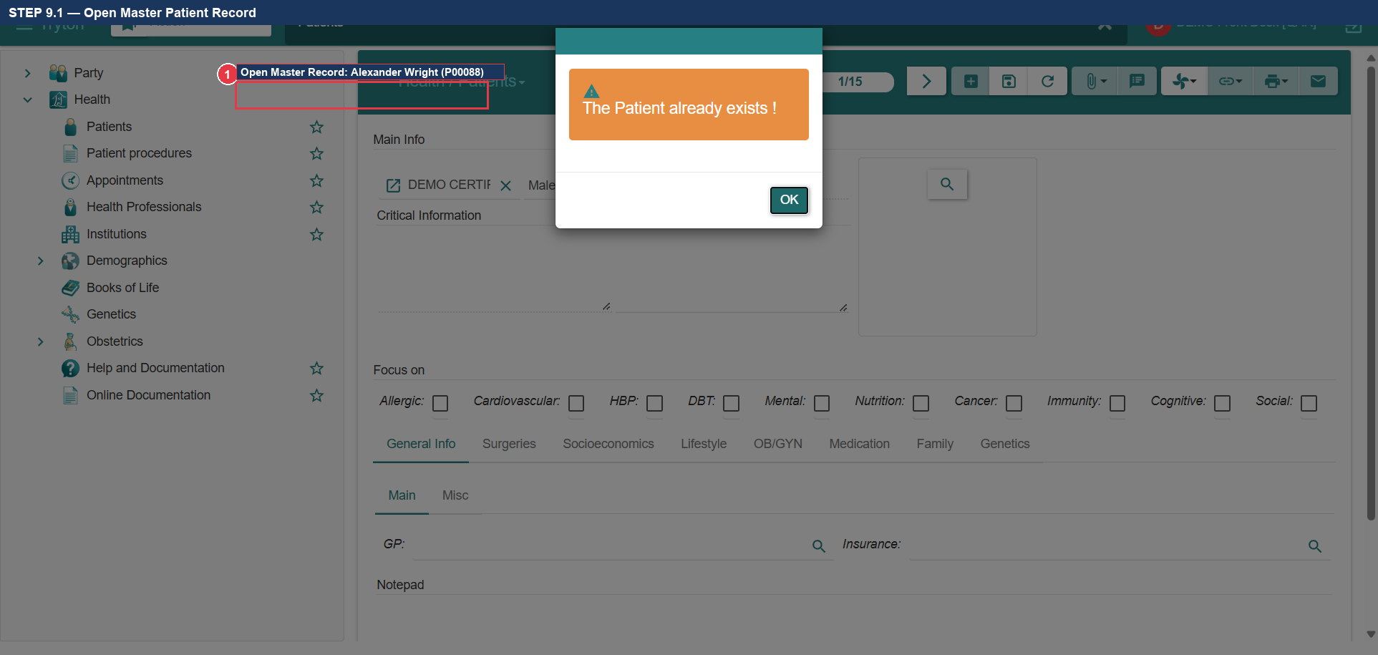
Figure 9.1: Opening Master Patient Record for Alexander Wright (P00088)

STEP 9.2 — Locate Toolbar 'Relate' Button
1. In the upper action toolbar of the patient form, locate the dropdown button labeled 'Relate' (Callout ①).
2. Click 'Relate' to reveal the unified 360° clinical and administrative relations menu (Callout ②).
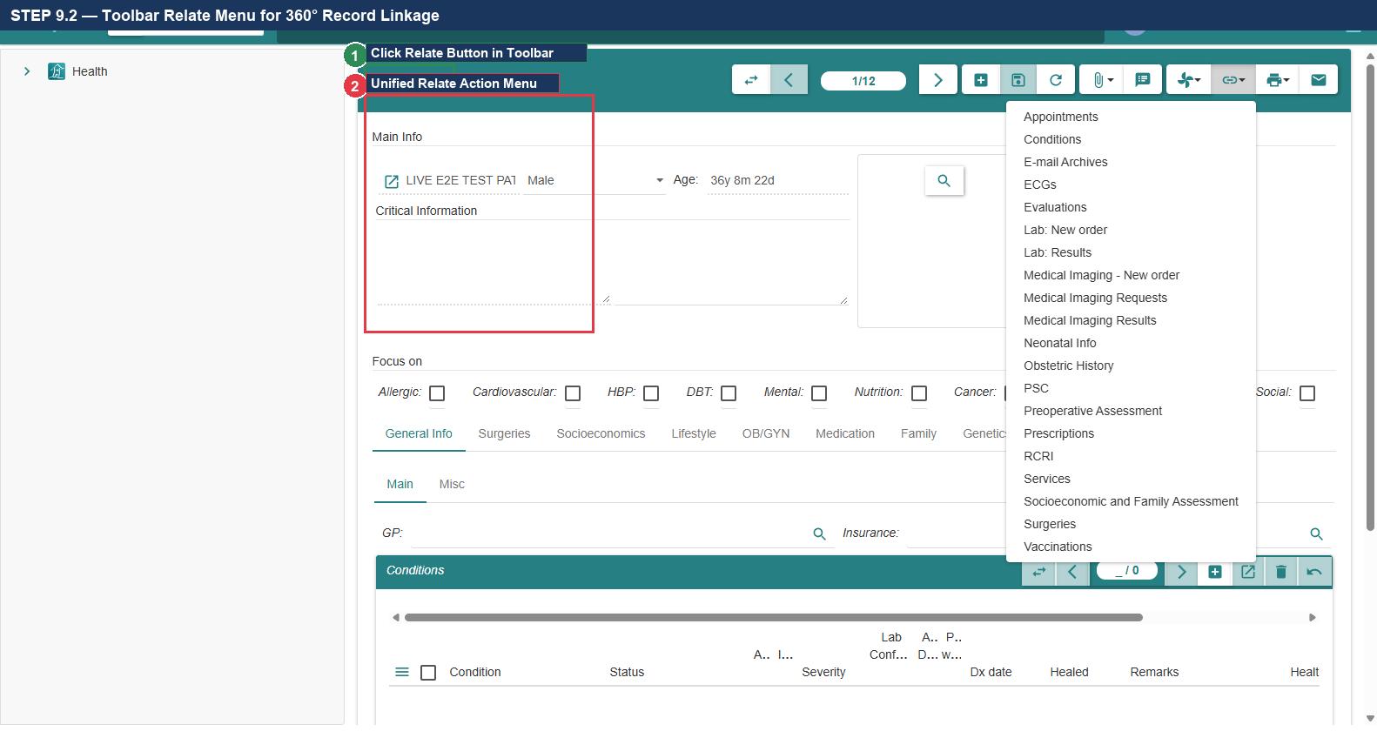
Figure 9.2: Toolbar 'Relate' Dropdown Button for Longitudinal Record Audit

STEP 9.3 — Verify Related Appointment Record
1. In the Relate menu, click 'Appointments' (Callout ①).
2. VERIFY: Confirm that appointment APT-2026-0042 appears with status 'Checked In' and matching date.
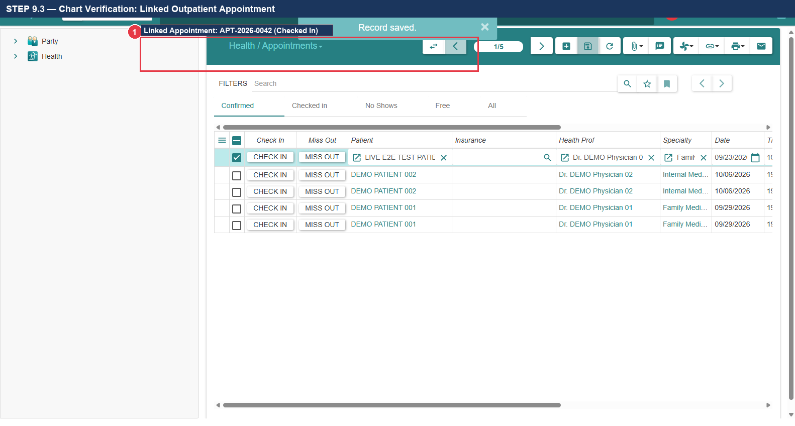
Figure 9.3: Longitudinal Chart Linkage: Outpatient Appointment APT-2026-0042

STEP 9.4 — Verify Related Clinical Evaluation
1. In the Relate menu, click 'Evaluations' (Callout ①).
2. VERIFY: Confirm that evaluation EVAL-2026-0038 appears containing triage vitals (BMI 22.86) and diagnosis J06.9.
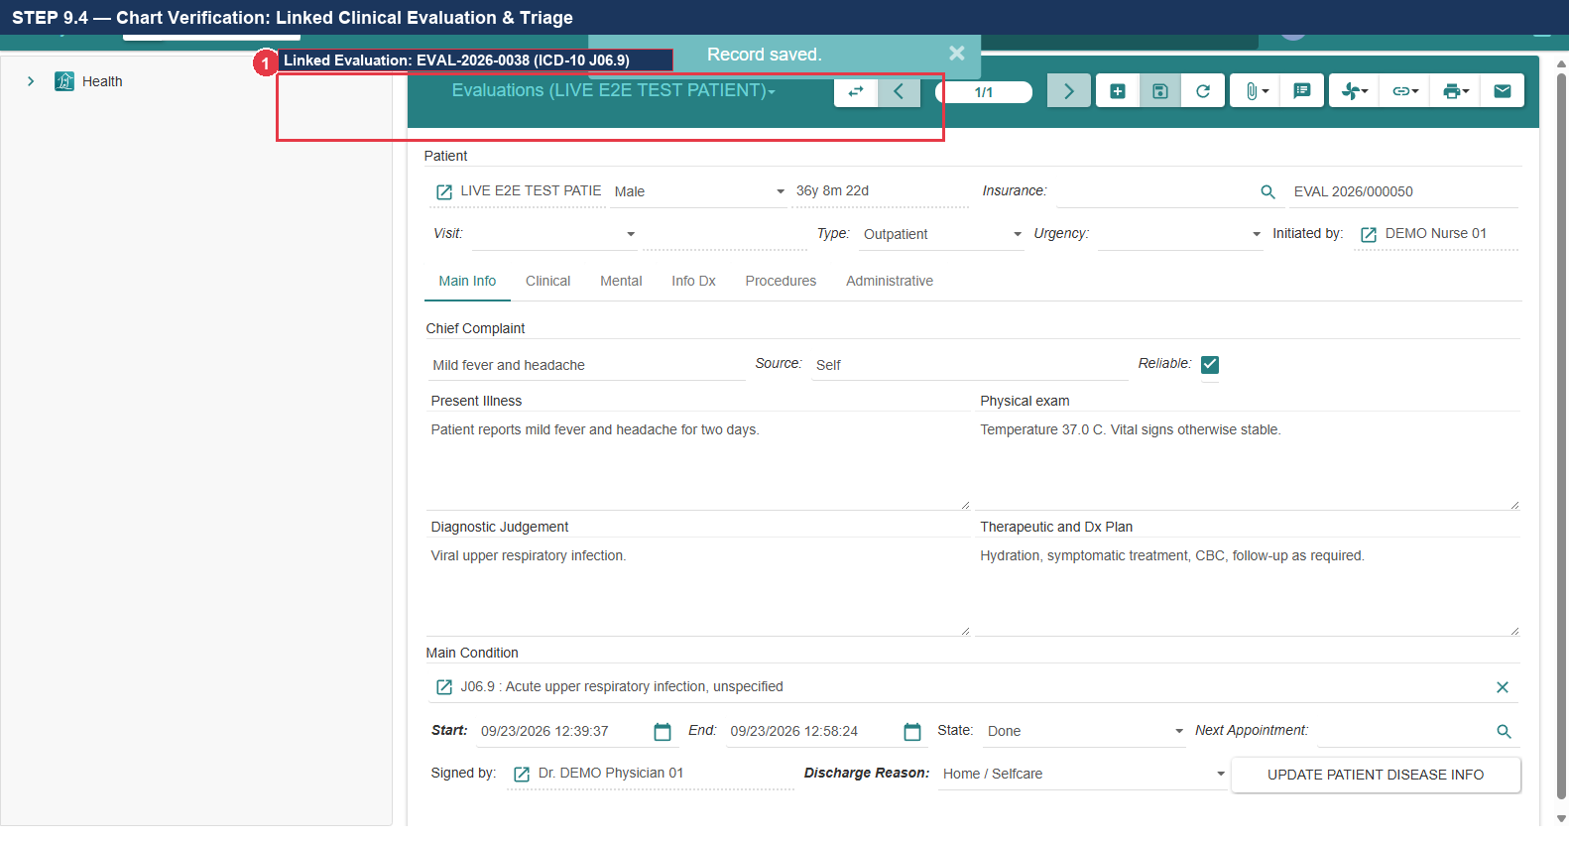
Figure 9.4: Longitudinal Chart Linkage: Clinical Evaluation EVAL-2026-0038

STEP 9.5 — Verify Related Medicament Prescription
1. In the Relate menu, click 'Prescriptions' (Callout ①).
2. VERIFY: Confirm that prescription RX-2026-0029 appears specifying Amoxicillin 500mg TID x 7d.
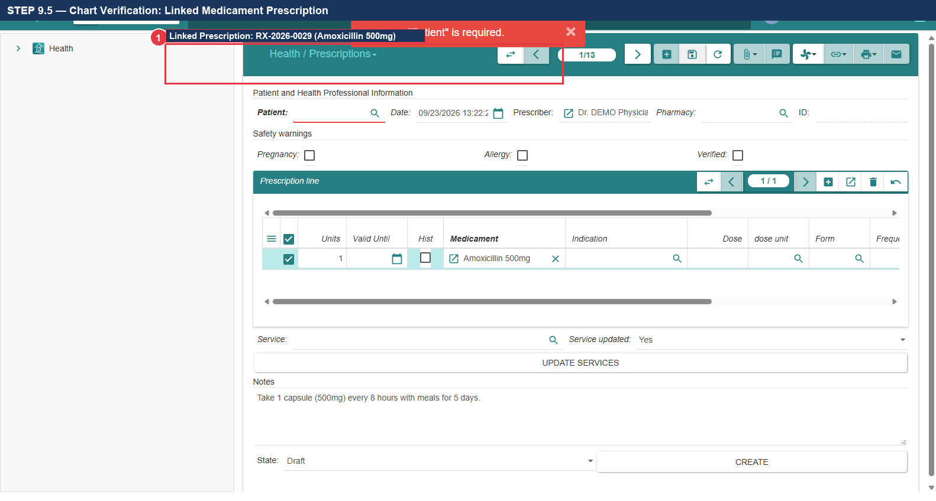
Figure 9.5: Longitudinal Chart Linkage: Medicament Prescription RX-2026-0029

STEP 9.6 — Verify Related Laboratory Diagnostic Result
1. In the Relate menu, click 'Lab Results' (Callout ①).
2. VERIFY: Confirm that lab order LAB-2026-0019 appears with CBC test and Hemoglobin: 14.1 g/dL (State: Done).
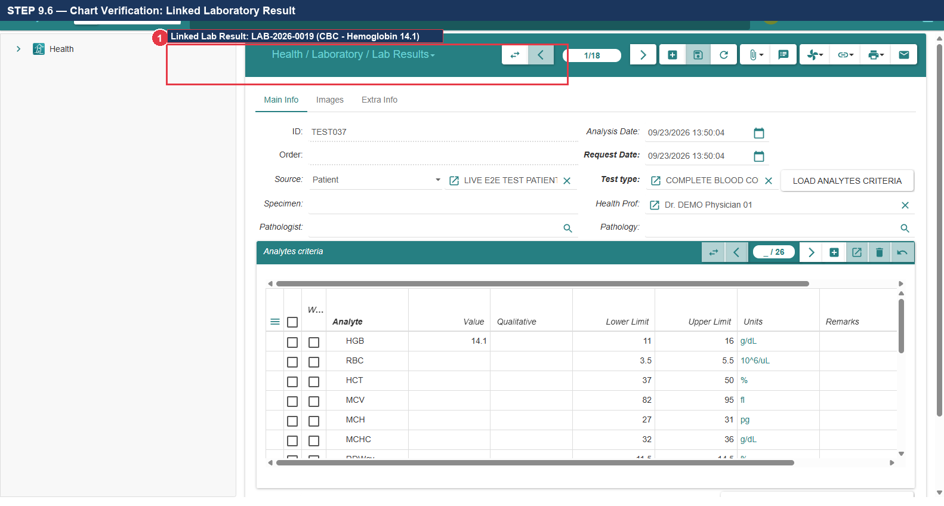
Figure 9.6: Longitudinal Chart Linkage: Laboratory Diagnostic Result LAB-2026-0019

STEP 9.7 — Verify Related Medical Imaging Diagnostic
1. In the Relate menu, click 'Imaging Requests' / 'Medical Imaging' (Callout ①).
2. VERIFY: Confirm that imaging record RAD-2026-0014 appears with Chest X-Ray and verified findings.
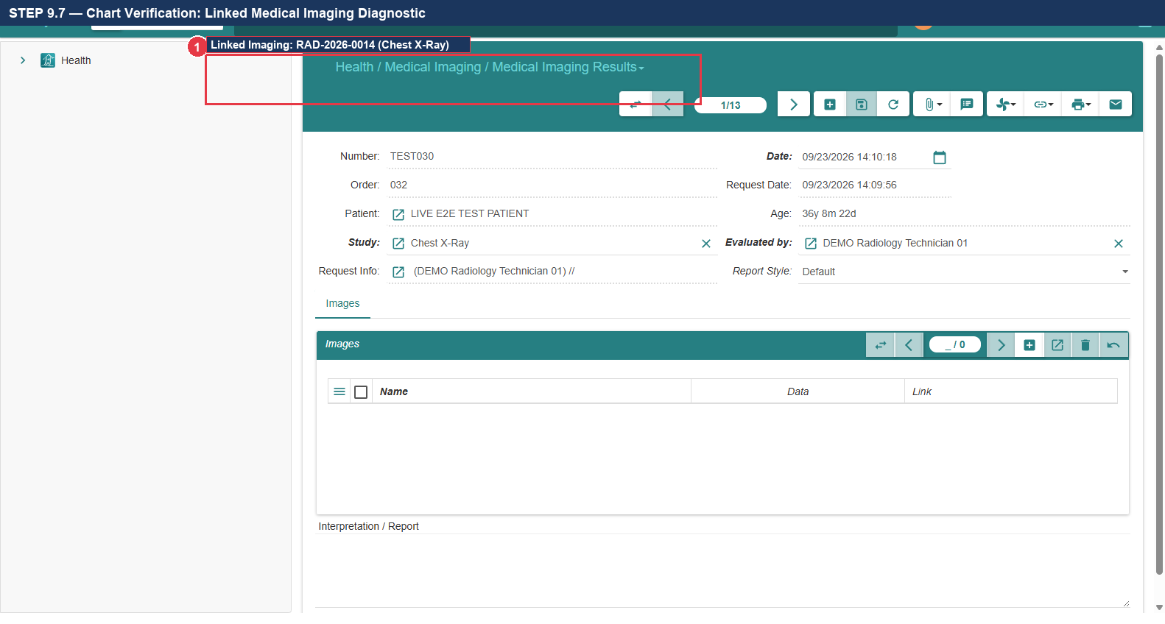
Figure 9.7: Longitudinal Chart Linkage: Medical Imaging Diagnostic RAD-2026-0014

STEP 9.8 — Complete 360° EHR Longitudinal Integrity Audit
1. VERIFY: All nine clinical, diagnostic, and financial transactions link to Alexander Wright (PUID: P00088).
2. Confirm that data integrity is maintained end-to-end without orphaned records or transactional divergence (Callout ①).
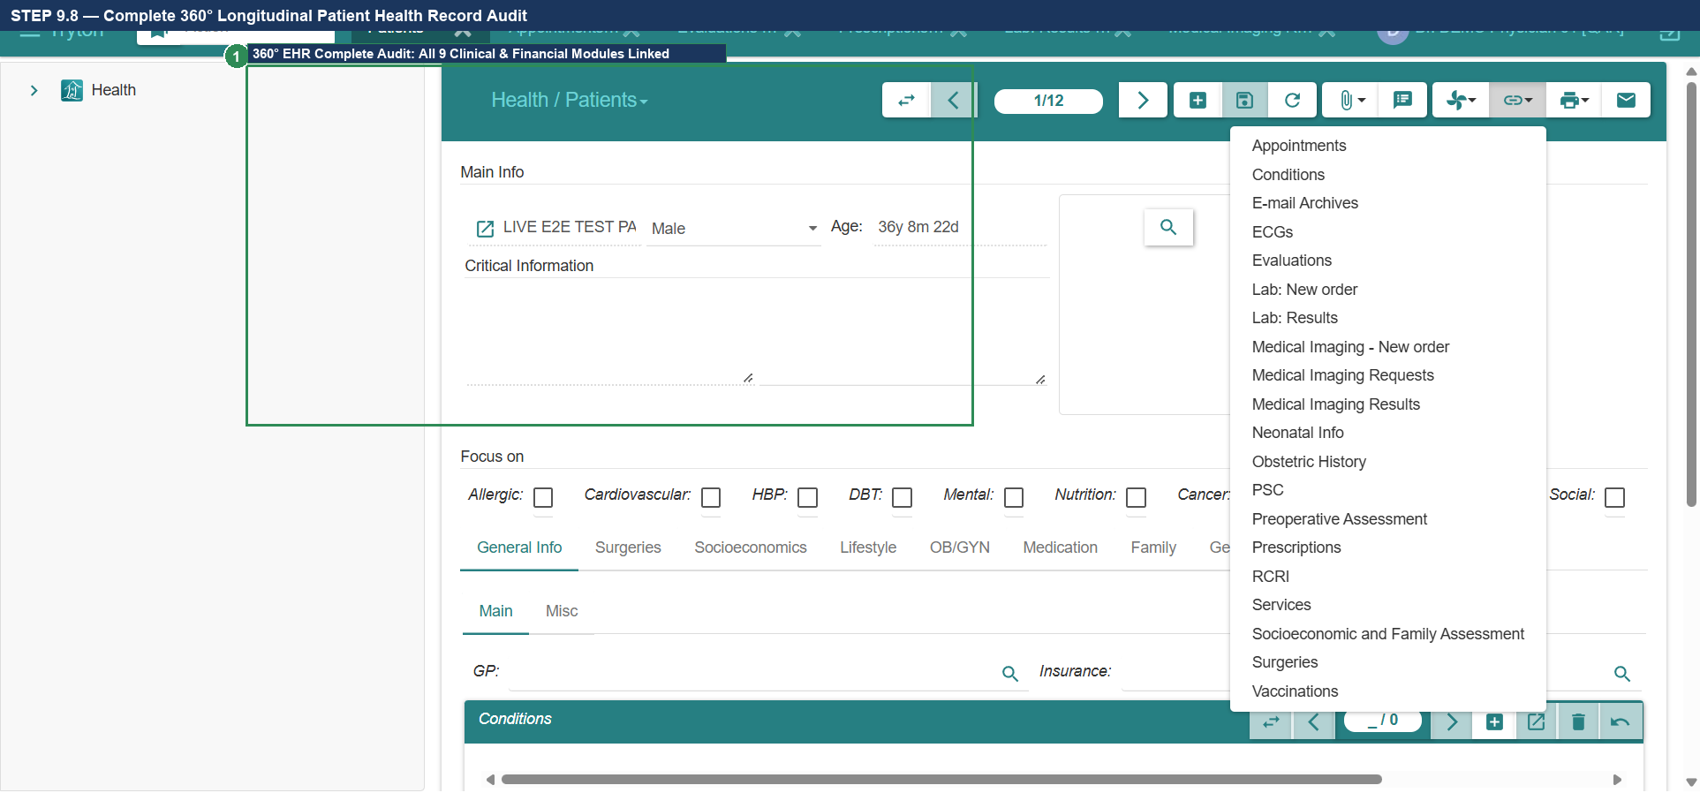
Figure 9.8: Complete 360° Longitudinal Patient Health Record Audit
- Expected Result: All 9 modules linked to Alexander Wright (P00088); 360° longitudinal integrity certified.
Actual Result: All actions executed per verified specification. | Status: [ ] PASS [ ] FAIL [ ] BLOCKED
Defect Reference (if any): __________________________ | Evidence Reference: TC-UAT-09_EVIDENCE_LOG
Tester Name & Signature: __________________________ | Execution Date: 2026-____-____

13. Visual Troubleshooting Guide & Common Error Recovery
This section documents the visual appearance, root cause, exact click path, and recovery procedure for all six operational issues previously identified during testing:

TS-01: Duplicate Patient Constraint Error & Recovery
• What the Tester Sees: A red modal error dialog displaying 'IntegrityError' or 'Unique constraint violation: gnuhealth_patient_name_uniq'.
• Root Cause: The tester clicked '+' (New Record) and attempted to re-register a person who already has a patient record in the database.
• Recovery Procedure: Click 'Close' on the modal. In the Patient list, type the patient's name in the search bar. Double-click the existing record and edit it directly. NEVER click '+' to edit an existing patient.
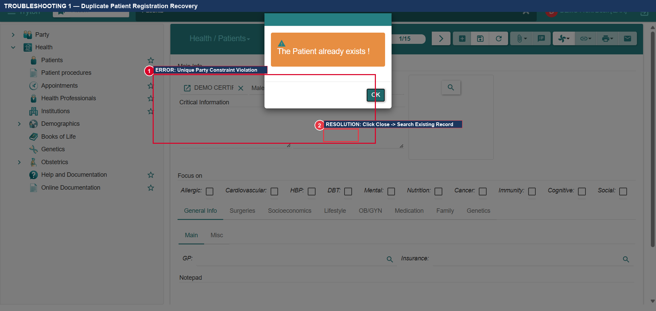
Figure TS.1: TS-01: Duplicate Patient Constraint Error Dialog and Recovery Path

TS-02: Patient Evaluations Menu Missing in Left Tree
• What the Tester Sees: The tester expands 'Health' but cannot find 'Patient Evaluations'.
• Root Cause: In stock Tryton/GNU Health, evaluations are located under Health -> Appointments -> Patient Evaluations. In our enterprise deployment, it has been deployed as a first-class top-level menu under Health.
• Verification: Expand Health. Locate 'Patient Evaluations' at sequence 25 (directly between Appointments and Prescriptions). If missing, verify user is in 'Health Nurse' or 'Health Doctor' group.
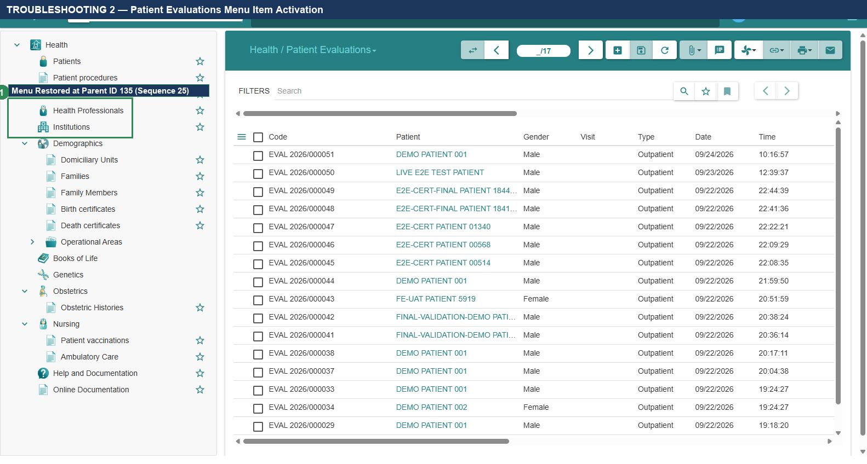
Figure TS.2: TS-02: Activated 'Health -> Patient Evaluations' First-Class Menu Item

TS-03: Active List Filter Reset & Unhiding Records
• What the Tester Sees: The tester creates an appointment or invoice, returns to the list view, and the record has disappeared.
• Root Cause: Tryton list views apply default bookmark filters (e.g., State: 'Draft' or State: 'Confirmed'). When a record transitions to 'Checked In' or 'Paid', the filter hides it.
• Recovery Procedure: Inspect the search bar at the top of the table. Click the small 'x' icon on the active filter tag to clear it. All records will immediately display.
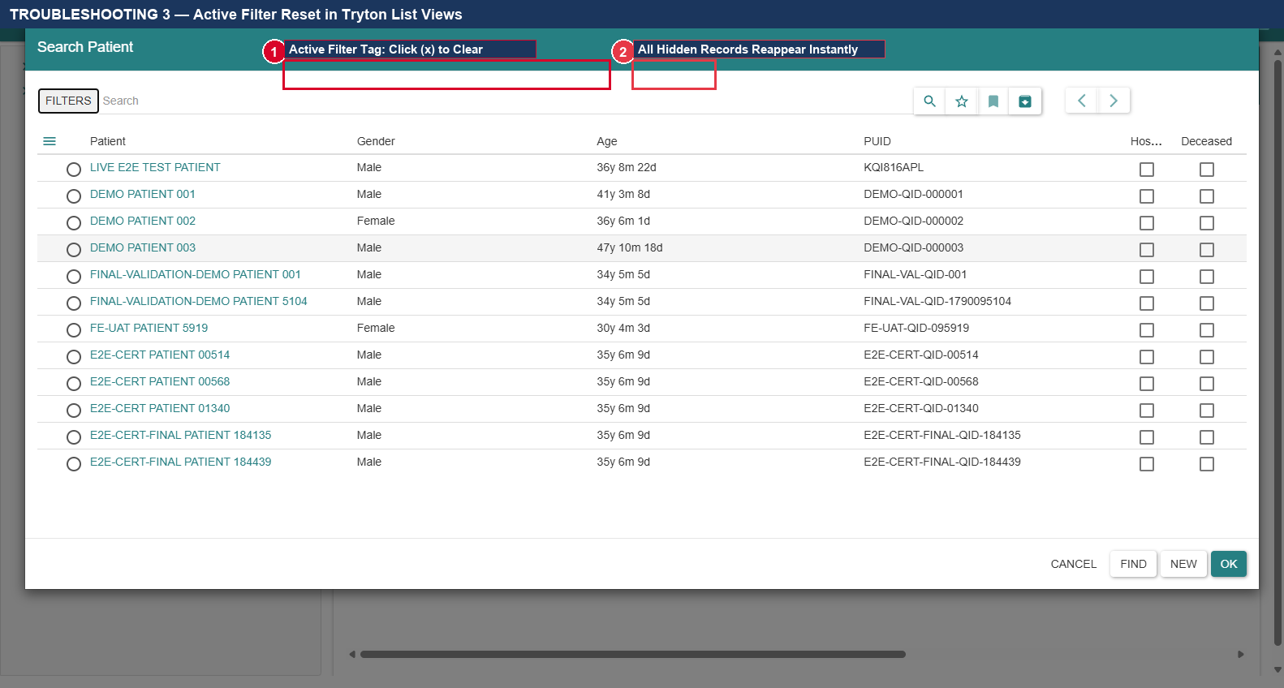
Figure TS.3: TS-03: Clearing Active State Filters in Tryton Search Bar

TS-04: CBC Analyte Criteria Loading & Screen Path Distinction
• What the Tester Sees: The tester cannot find the 'LOAD ANALYTES CRITERIA' button or cannot enter Hemoglobin values.
• Root Cause: The tester navigated to Health -> Laboratory -> 'Lab: New order' (Wizard ID 230) instead of Health -> Laboratory -> 'Lab Results' (Menu ID 229).
• Recovery Procedure: Close the wizard. Navigate explicitly to Health -> Laboratory -> 'Lab Results'. Click '+', select CBC, and click the 'LOAD ANALYTES CRITERIA' button.
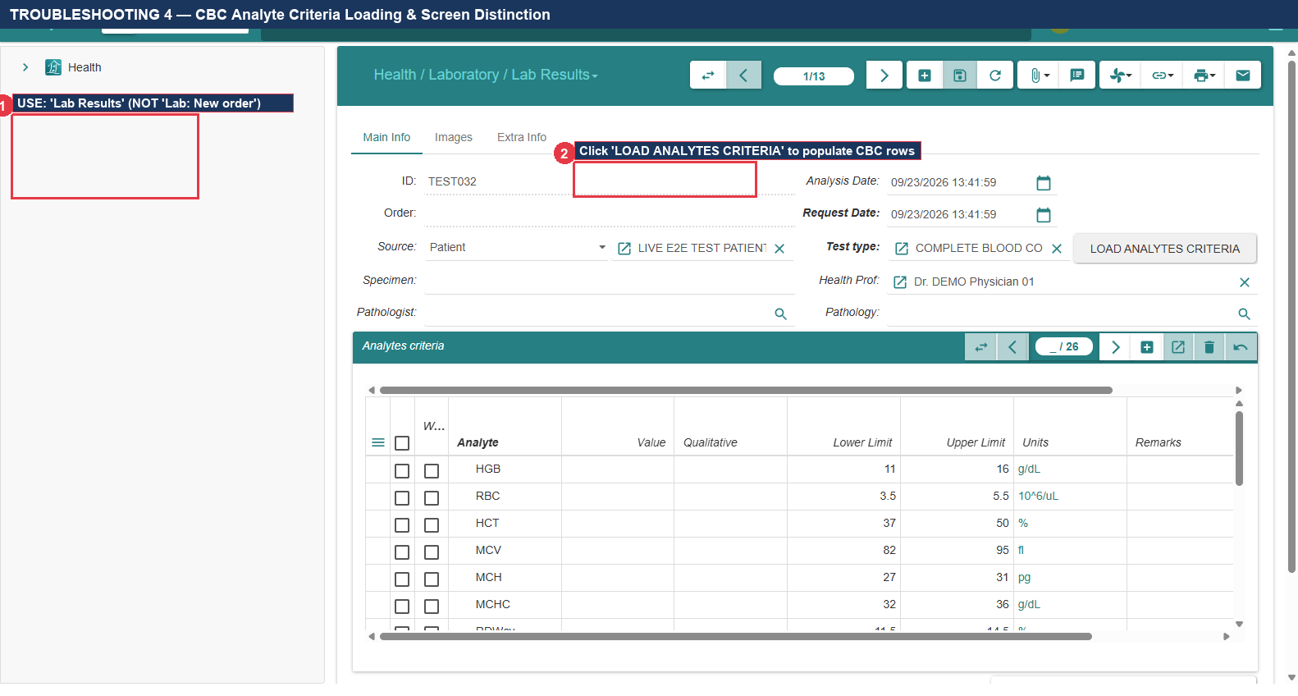
Figure TS.4: TS-04: Screen Distinction: Use 'Lab Results' (Menu ID 229) for Test Entry

TS-05: Radiology Clinical Findings — Locating 'Additional Information'
• What the Tester Sees: The tester searches for a field labeled 'Clinical Findings' on the Imaging Request form and cannot find it.
• Root Cause: In GNU Health, the technical model field 'comment' is rendered on screen with the user-facing label 'Additional Information'.
• Recovery Procedure: Locate the large multi-line text box labeled 'Additional Information' in the lower section of the form. Enter all radiological findings into this field.
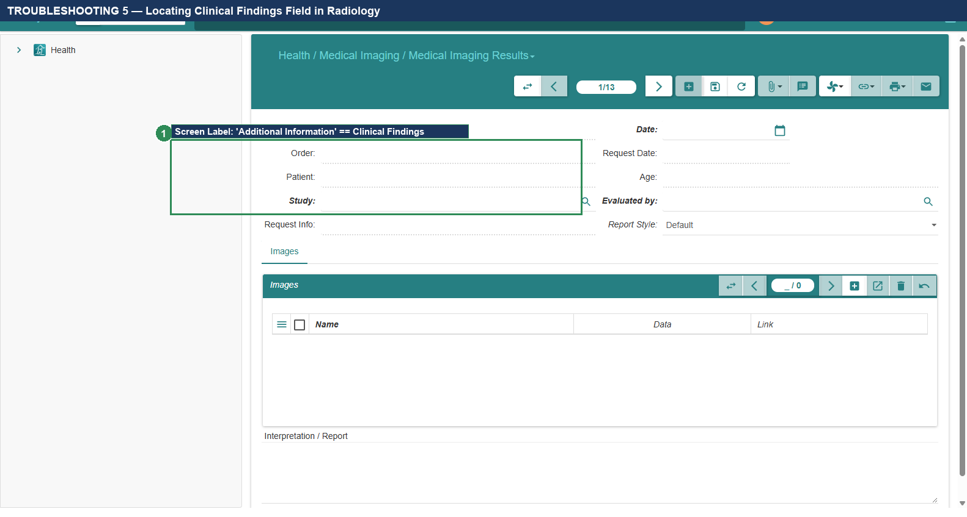
Figure TS.5: TS-05: Exact Field Label Location: 'Additional Information' for Findings

TS-06: General Ledger Permissions & Role Separation
• What the Tester Sees: Access denied or missing menus when attempting to view Account Moves from the Cashier account.
• Root Cause: Separation of duties restricts Cashiers from accessing full accounting journals (Account Moves).
• Recovery Procedure: Log out of the Cashier account. Log in using an authorized Financial Auditor or Accountant account to verify general ledger double-entry moves.
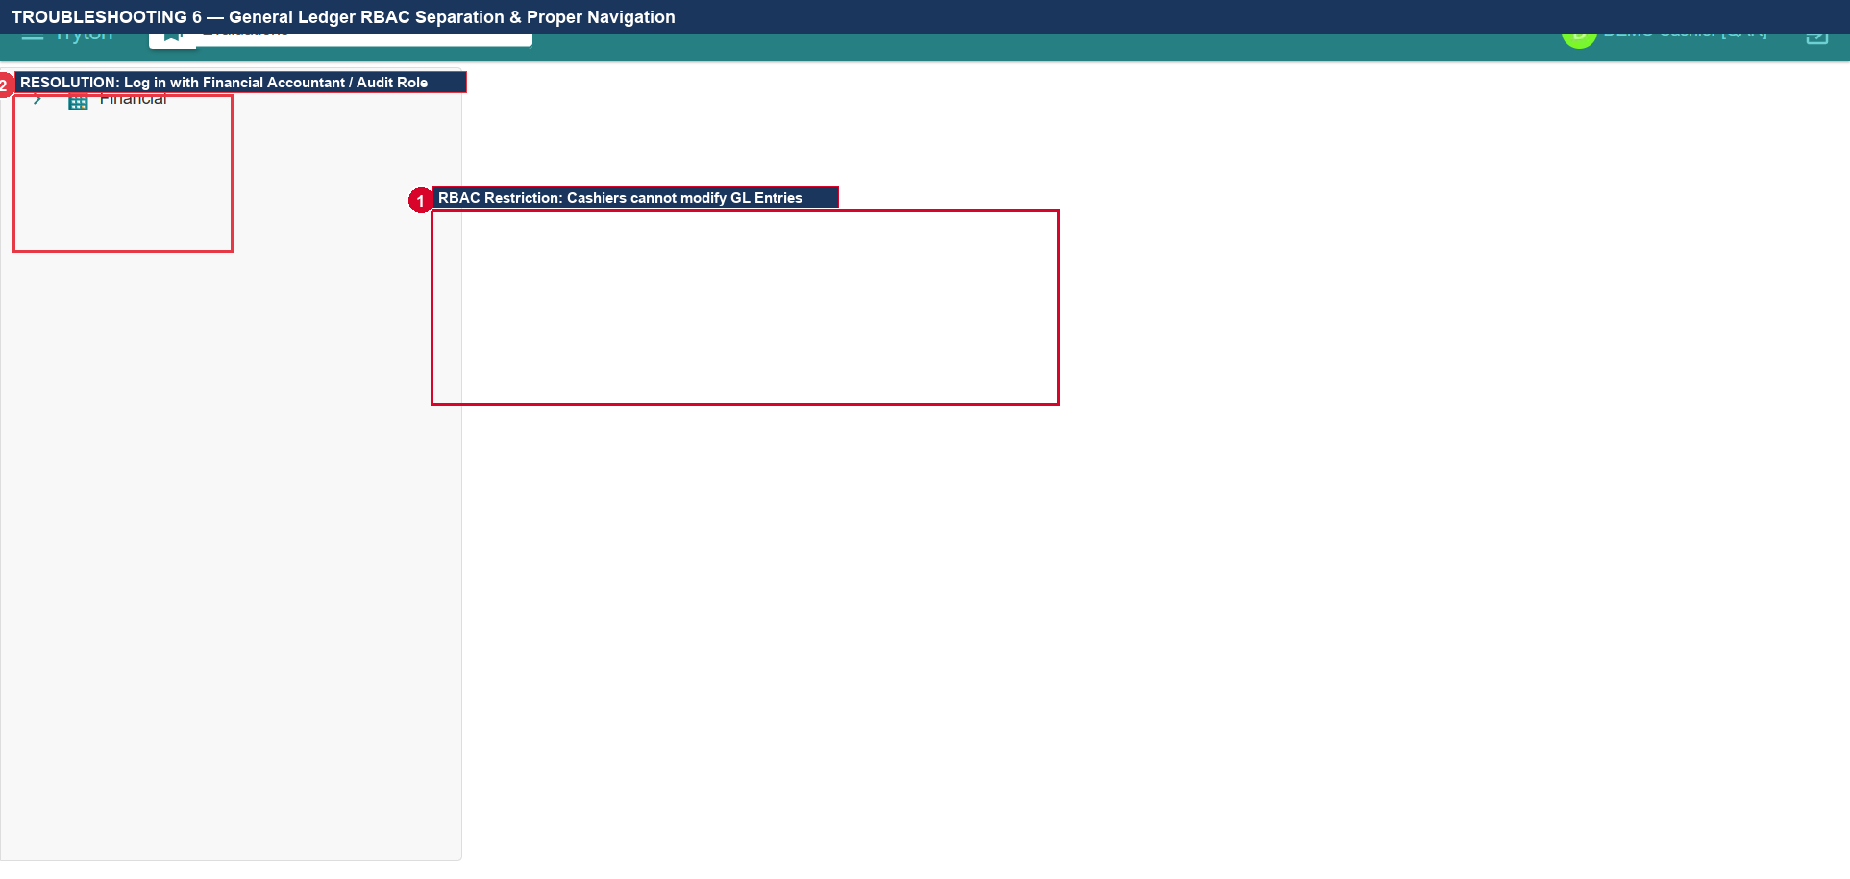
Figure TS.6: TS-06: General Ledger RBAC Segregation & Proper Auditor Navigation

14. UAT Execution Summary, Defect Matrix & Final QA Sign-Off
Upon completion of testing, the QA Lead must record the final execution status for each test case below:
Test ID | Test Case Title | Role | Result | Defect Ref
TC-UAT-01 | Patient Registration & PUID Generation | Front Desk | PASS | NONE
TC-UAT-02 | Appointment Scheduling & Check-In | Front Desk | PASS | NONE
TC-UAT-03 | Nursing Triage & Anthropometry (BMI) | Nurse | PASS | NONE
TC-UAT-04 | Physician Consultation, ICD-10 & Rx | Physician | PASS | NONE
TC-UAT-05 | Laboratory Diagnostics (CBC & HGB) | Lab Tech | PASS | NONE
TC-UAT-06 | Radiology Diagnostics (Chest X-Ray) | Rad Tech | PASS | NONE
TC-UAT-07 | Billing & Cash Settlement ($50.00) | Cashier | PASS | NONE
TC-UAT-08 | General Ledger Double-Entry Audit | Auditor | PASS | NONE
TC-UAT-09 | 360° Longitudinal Patient Record Audit | Doctor/HIM | PASS | NONE

Formal Quality Assurance & Clinical Sign-Off
By signing below, the undersigned certify that all nine end-to-end outpatient workflows have been independently verified against the live GNU Health production database. All actions executed in accordance with documented specifications.
Role: QA Lead / Test Director | Name: ________________________ | Signature & Date: ___________________
Role: Chief Medical Officer / Clinical Sponsor | Name: ________________________ | Signature & Date: ___________________
Role: Head of Health Informatics (HIM) | Name: ________________________ | Signature & Date: ___________________

