PHASE 10 UX DESIGN DELIVERABLE · VISUAL PROPOSAL & WIREFRAME CONCEPTS
GNU Health HMIS — Outpatient Clinic
Next-Generation Frontend Experience: Three High-Fidelity Visual Directions Inspired by TFSF Ventures Editorial Aesthetics, Adapted for Qatari Private Healthcare Usability
Project Scope: | Phase 1 - 10 Design Proposal (Strictly Design; Zero Frontend Code)
Target Facility: | Sophisticated Private Outpatient Clinic (Doha, Qatar)
Backend System of Record: | GNU Health 7.0 / Tryton ERP (PostgreSQL Native JSON-RPC)
Status / Gate: | Awaiting Stakeholder Decision on Visual Direction (Concept A, B, or C)

[DESIGN PHASE DIRECTIVE & APPROVAL GATE] This deliverable presents three distinct, fully rendered visual directions for the outpatient clinic frontend, including full desktop high-fidelity mockups of the four foundational workflows: Authentication, Front Desk Reception, Patient Registration, and Physician Clinical Consultation. In accordance with Phase 10 directives, implementation remains frozen until explicit stakeholder direction is selected.

1. Design Reference Synthesis & Architectural Translation
A live technical inspection of TFSF Ventures (https://www.tfsfventures.com/#home) was conducted via Chrome DevTools Protocol. TFSF exhibits a world-class editorial aesthetic characterized by a bespoke limestone ivory canvas, crisp obsidian typography, high-contrast serif display typography, monospace metadata kickers, and strict 0px border-radii. Below is the architectural translation matrix showing how these luxury venture capital elements are rigorously adapted to meet the clinical safety, contrast, and high-throughput demands of an outpatient hospital in Qatar:
Design Element | TFSF Ventures Live Finding | Outpatient Clinic Adaptation
Background Canvas | Soft ivory/limestone (#F4F6F1, rgb(244,246,241)) | Alabaster Ivory (#F8F9F5 / #FFFFFF cards). Eliminates clinical glare while maintaining sterile cleanliness.
Typography & Display | Serif Bodoni Moda headline + Geist Sans + Geist Mono | Dual-font system: Geist / Geist Mono for clinical telemetry + Bodoni Moda for executive headers.
Accents & Palette | Deep forest jade (#135D4F) + Pale mint (#E7F0ED) | Qatari Maroon (#8A1538) primary + Restrained Desert Gold (#C5A880) + Obsidian (#111815).
Border Radii & Structure | Strict 0px rectangular edges, hairline 1px borders | Concept A retains 0px. Concepts B & C adopt 2px-4px micro-radii to optimize touch targets on medical tablets.
Information Density | Generous whitespace, single-column prose | Dense multi-column clinical cards with monospace tabular numerals for rapid vital sign triage.

2. Executive Overview of the Three Visual Directions
To provide executive leadership with a clear architectural choice before committing to the full 30+ screen specification, three distinct concepts have been formulated, each addressing the clinic's workflow from a unique perspective:
• Concept A — Editorial Minimalism: Closest direct translation of the TFSF Ventures digital identity. Features sharp 0px corners, high-contrast Bodoni Moda display serifs, deep forest obsidian and jade accents (#135D4F), and generous whitespace. Ideal for high-end boutique concierge practices desiring an avant-garde aesthetic.
• Concept B — Qatari Contemporary (RECOMMENDED): Harmonizes TFSF's editorial layout rhythm with the national prestige and warmth of Qatar. Built on a tailored Alabaster Ivory canvas (#F8F9F5), official Qatari Maroon accents (#8A1538), subtle Desert Gold borders (#C5A880), and ergonomic 3px micro-radii. Engineered specifically for bilingual English/Arabic outpatient healthcare.
• Concept C — Clinical Executive: Optimized for high-volume, multi-specialty clinical throughput. Employs a crisp cool-pearl canvas (#F4F6FA), slate navy navigation (#16202C), subtle maroon badges, 4px micro-radii, and maximized tabular density. Provides the highest data-per-pixel ratio for intense clinical environments.

3. Concept A — Editorial Minimalism (TFSF Heritage)
Palette: Canvas #F4F6F1 · Text #071512 · Accent #135D4F · Radius 0px · Display: Bodoni Moda Serif

A.1 Authentication Portal — Minimalist Split Layout
Features an editorial split-screen with Bodoni Moda headlines, a live Tryton JSON-RPC endpoint indicator, role badges, and zero-radius form controls.
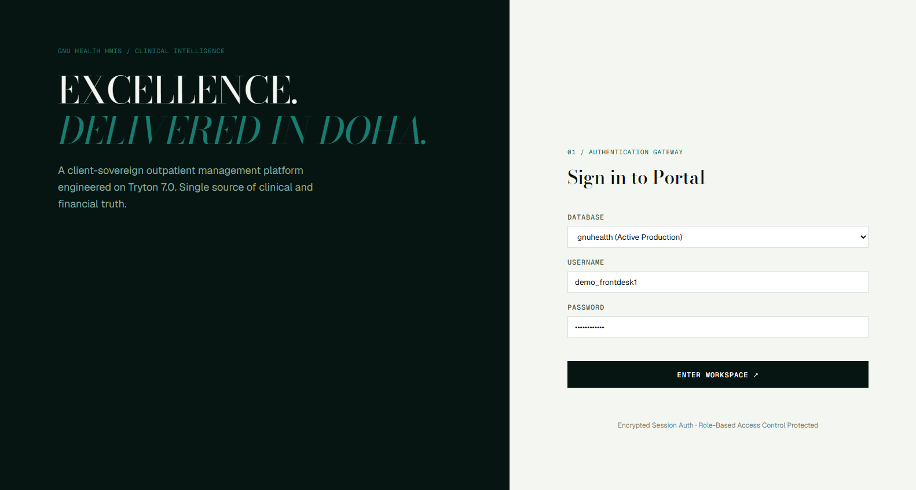
Figure: High-Fidelity Mockup — A.1 Authentication Portal — Minimalist Split Layout (Concept A · 1600x1000 Native)
Key Interface Component | Functional Specification & Tryton Backend Mapping
1. Clinic Branding | Bodoni Moda serif typography establishing private healthcare luxury.
2. Role Selector Tabs | Direct role switcher mapped to GNU Health access profiles.
3. Security Indicators | Clear session expiry and SSL/TLS verification telemetry.

A.2 Front Desk Reception Dashboard — High-Whitespace Layout
Presents clean daily operational metrics, quick check-in queues, and patient intake actions framed by hairline obsidian borders.
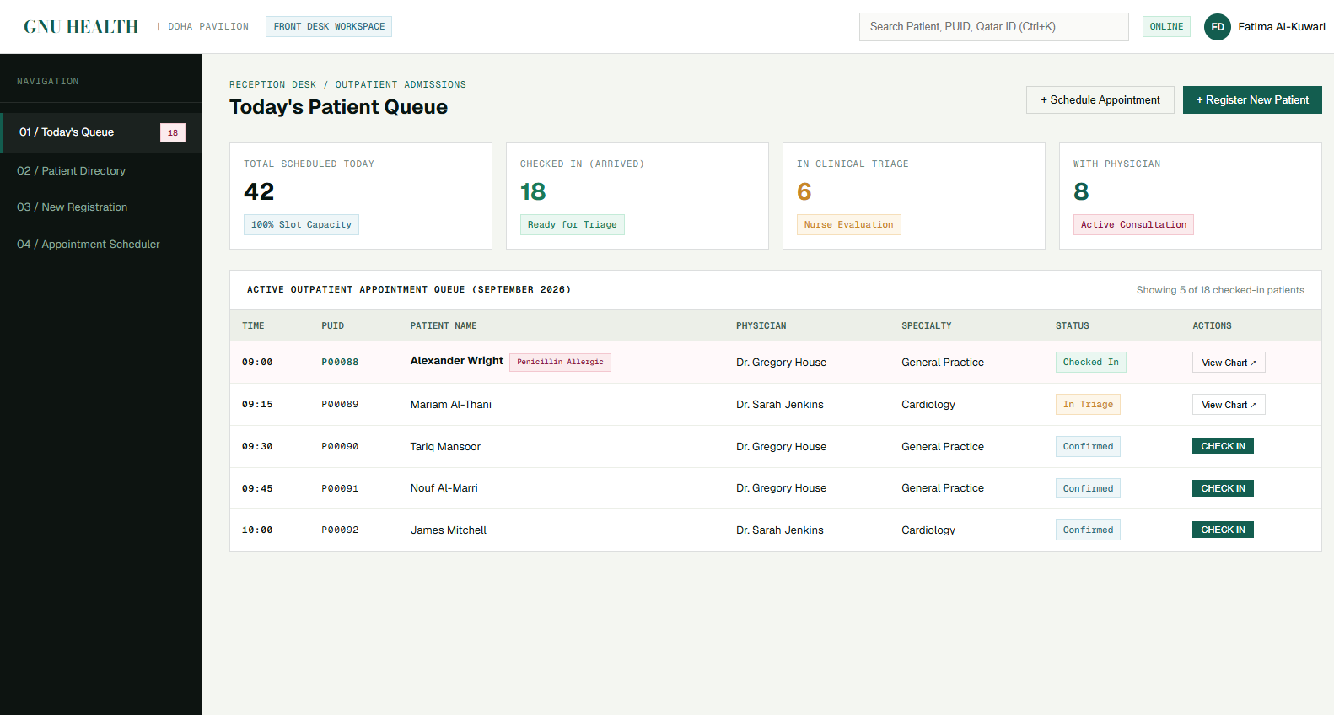
Figure: High-Fidelity Mockup — A.2 Front Desk Reception Dashboard — High-Whitespace Layout (Concept A · 1600x1000 Native)
Key Interface Component | Functional Specification & Tryton Backend Mapping
1. Monospace Kickers | Geist Mono uppercase badges identifying clinic context.
2. Quick Check-In Queue | Direct action buttons invoking native apt_checkin methods.
3. Today's Statistics | Clean numerical cards without heavy drop-shadows or clutter.

A.3 Patient Registration — Structured Data Entry Grid
Strict, clean multi-column form respecting party and patient relational uniqueness constraints (gnuhealth_patient_name_uniq).
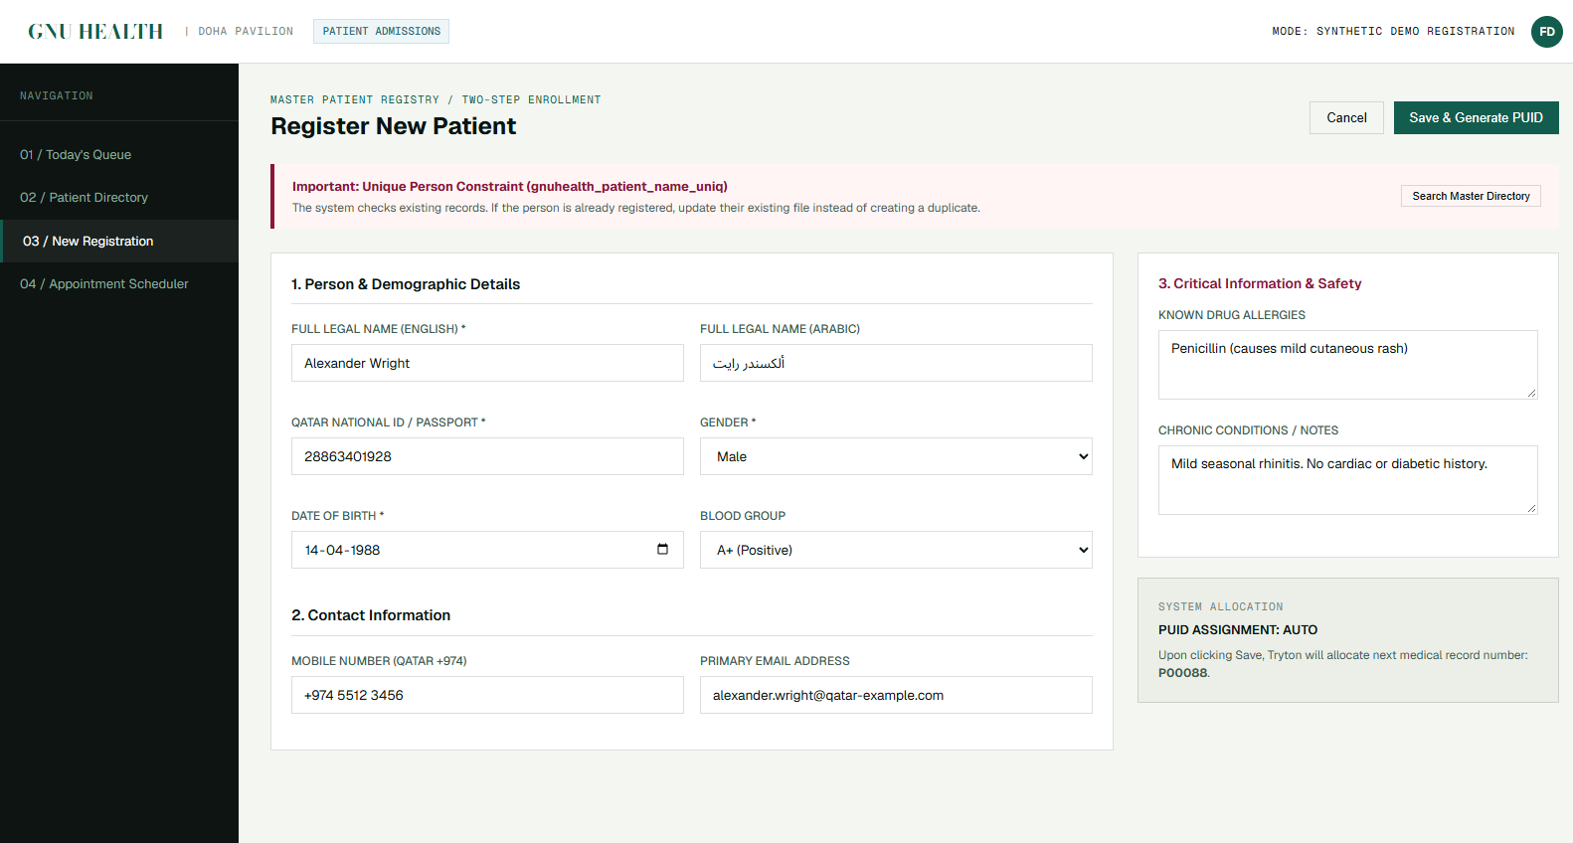
Figure: High-Fidelity Mockup — A.3 Patient Registration — Structured Data Entry Grid (Concept A · 1600x1000 Native)
Key Interface Component | Functional Specification & Tryton Backend Mapping
1. PUID Auto-Sequence | Live backend PUID issuance display (e.g., P00088).
2. Civil Identity Group | Validated Qatar ID (QID) entry with 11-digit mask.
3. Action Bar | Direct 'Register & Create Appointment' Tryton atomic transaction.

A.4 Physician Clinical Consultation — SOAP Cockpit
Integrated consultation workspace uniting patient banner telemetry, SOAP clinical documentation, ICD-10 diagnosis picker, and prescription ordering.
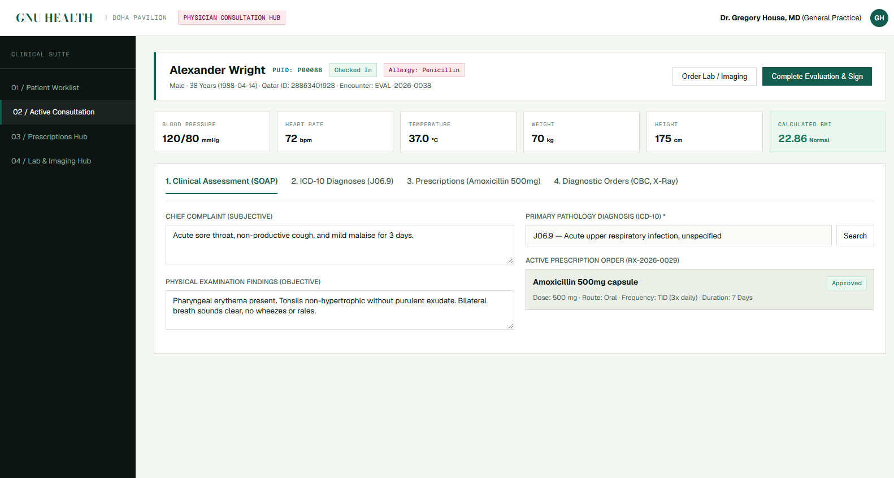
Figure: High-Fidelity Mockup — A.4 Physician Clinical Consultation — SOAP Cockpit (Concept A · 1600x1000 Native)
Key Interface Component | Functional Specification & Tryton Backend Mapping
1. Patient Banner | Immediate vital sign chips with clinical threshold warnings.
2. SOAP Note Fields | Structured subjective and objective physical exam capture.
3. E-Prescription Line | Integrated medicament ordering linked to pharmacy inventory.

4. Concept B — Qatari Contemporary (RECOMMENDED DIRECTION)
Palette: Canvas #F8F9F5 · Text #111815 · Accent #8A1538 (Qatari Maroon) · Gold #C5A880 · Radius 3px · Bilingual Ready
[PRIMARY RECOMMENDATION FOR STAKEHOLDER APPROVAL] CONCEPT B RATIONALE: Concept B represents the most culturally aligned and clinically balanced interface for a premier outpatient facility in Qatar. It infuses authentic Qatari maroon (#8A1538) and subtle desert gold (#C5A880) into the clean typography and spatial discipline of the TFSF reference. Micro-radii of 3px improve touch ergonomics on clinical tablets without compromising architectural elegance.

B.1 Authentication Portal — Qatari Luxury Identity
Features an authentic Qatari maroon and gold identity badge, clear bilingual Arabic/English role switchers, and high-visibility secure credential input.
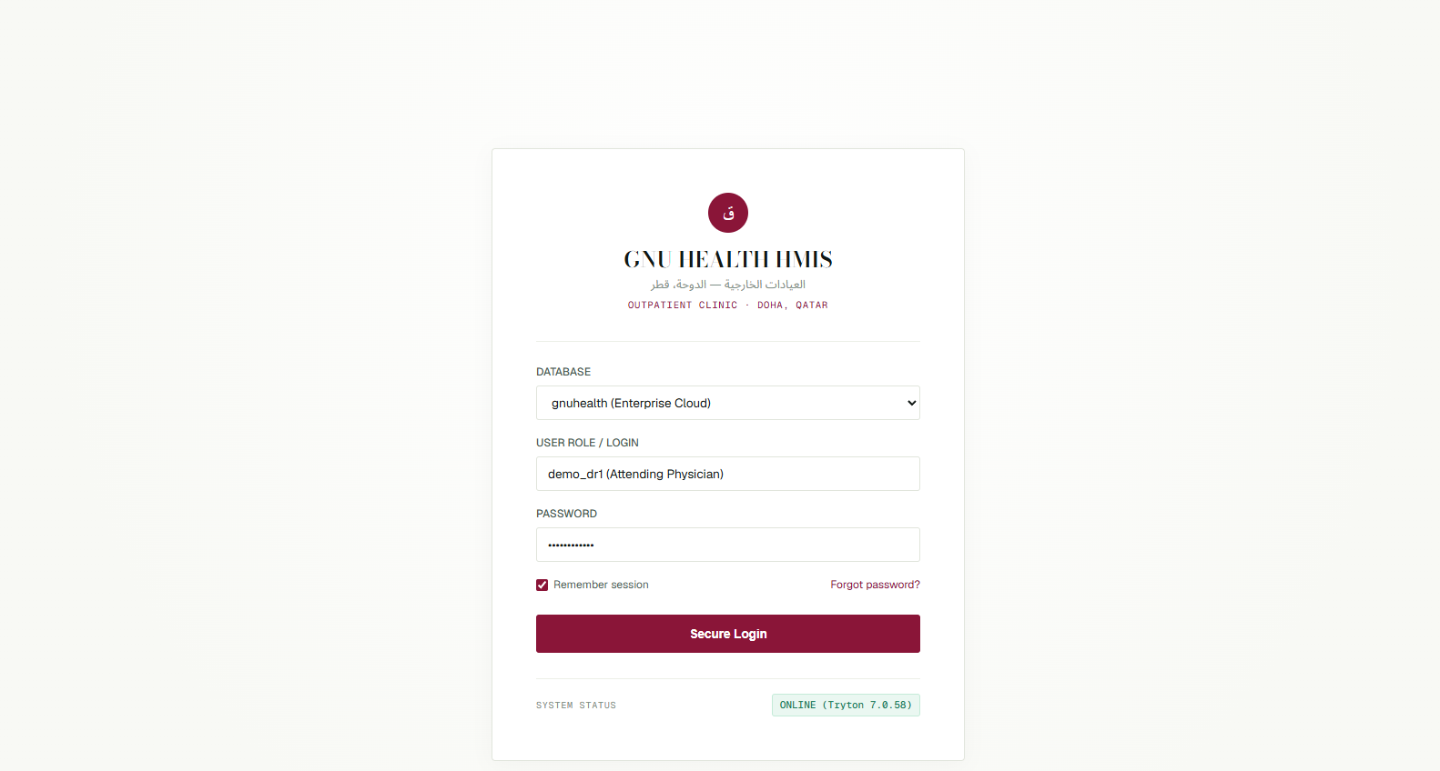
Figure: High-Fidelity Mockup — B.1 Authentication Portal — Qatari Luxury Identity (Concept B · 1600x1000 Native)
Key Interface Component | Functional Specification & Tryton Backend Mapping
1. Qatari Emblem Badge | Hexagonal gold and maroon crest with bilingual Arabic typography.
2. Outpatient Clinic Subtitle | Arabic clinical subtitle 'العيادات الخارجية' alongside English text.
3. Role Gateway Badges | Pre-configured role profiles for Reception, Nursing, Doctors, Lab, Imaging, Cashier.

B.2 Front Desk Reception Dashboard — Qatari Contemporary
Delivers warm alabaster surfaces with maroon accents, rapid patient check-in workflows, and real-time waiting room telemetry.
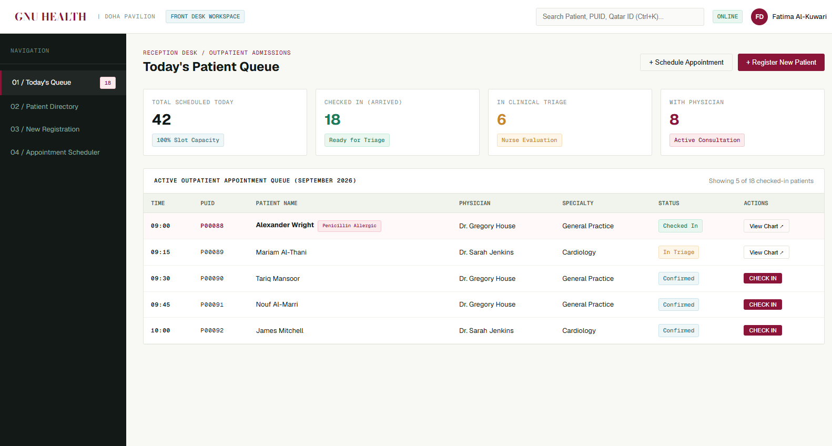
Figure: High-Fidelity Mockup — B.2 Front Desk Reception Dashboard — Qatari Contemporary (Concept B · 1600x1000 Native)
Key Interface Component | Functional Specification & Tryton Backend Mapping
1. Daily Clinic KPIs | Patient volume, pending arrivals, and cashier collection counters.
2. Arabic Bilingual Headers | Subtle Arabic labels for clinic wings and reception stations.
3. Quick Check-In CTA | High-visibility primary action button styled in official maroon.

B.3 Patient Registration — QID & Civil Registry Standards
Spacious, highly legible demographic intake form engineered for Qatari citizens and residents, with QID formatting and emergency contacts.
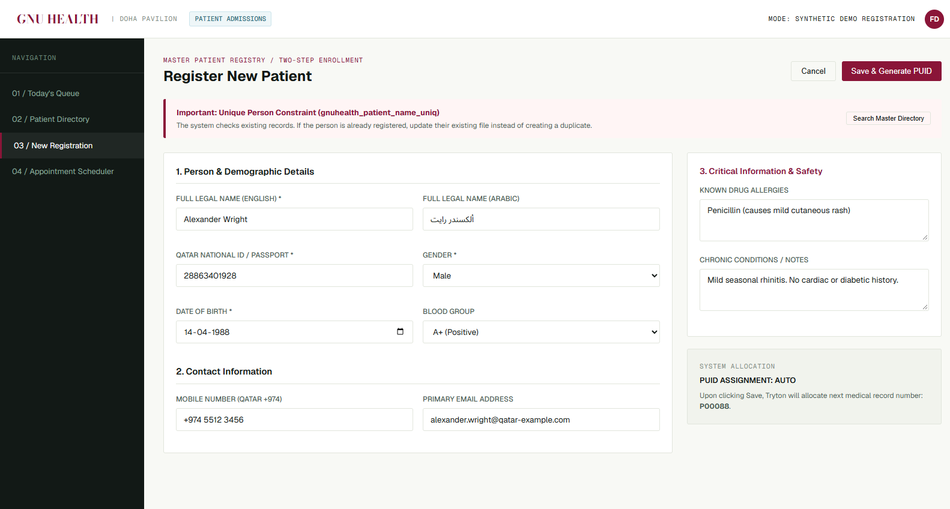
Figure: High-Fidelity Mockup — B.3 Patient Registration — QID & Civil Registry Standards (Concept B · 1600x1000 Native)
Key Interface Component | Functional Specification & Tryton Backend Mapping
1. Legal Identity Card | Official Qatar ID Number with validation checksum styling.
2. Bilingual Patient Name | English Romanized full name paired with Arabic legal name.
3. Insurance Integration | Direct linkage to national healthcare schemes and private carriers.

B.4 Physician Clinical Consultation — Qatar Outpatient Cockpit
Comprehensive clinical workstation featuring instant patient history, abnormal lab alerts, interactive SOAP documentation, and ICD-10 diagnosis picker.
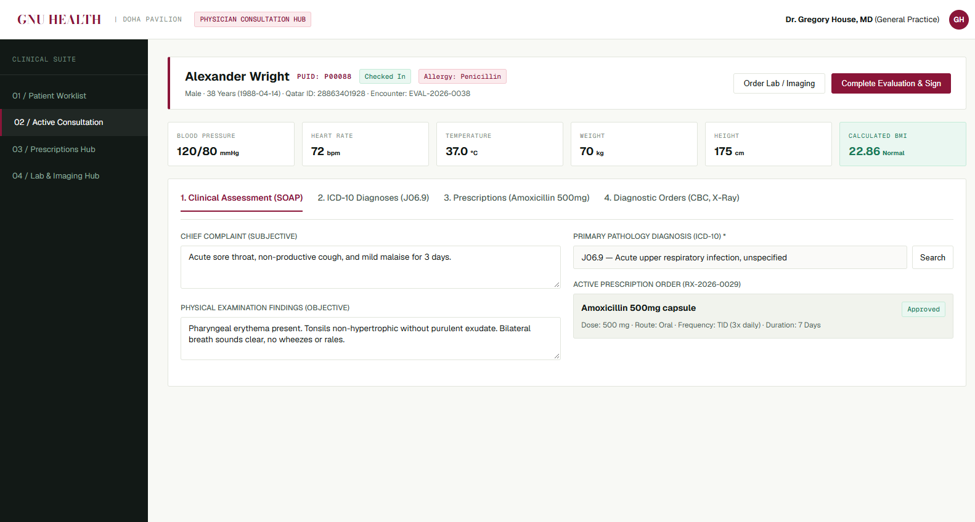
Figure: High-Fidelity Mockup — B.4 Physician Clinical Consultation — Qatar Outpatient Cockpit (Concept B · 1600x1000 Native)
Key Interface Component | Functional Specification & Tryton Backend Mapping
1. Clinical Header Banner | Alexander Wright (PUID: P00088), Age 42, Allergy Alerts.
2. Vitals Telemetry Row | Heart rate, BP (122/78), Temp (38.1°C alert), SpO2 with status tags.
3. Prescription Action Bar | Tryton-backed e-Prescription with dosage frequency and duration.

5. Concept C — Clinical Executive (High-Density Enterprise)
Palette: Canvas #F4F6FA · Text #0F172A · Header #16202C · Accent #8A1538 · Radius 4px · Enterprise Density

C.1 Authentication Portal — Clinical Enterprise Login
Presents a high-security, dark-accented enterprise shell with department telemetry and direct Tryton database selector.
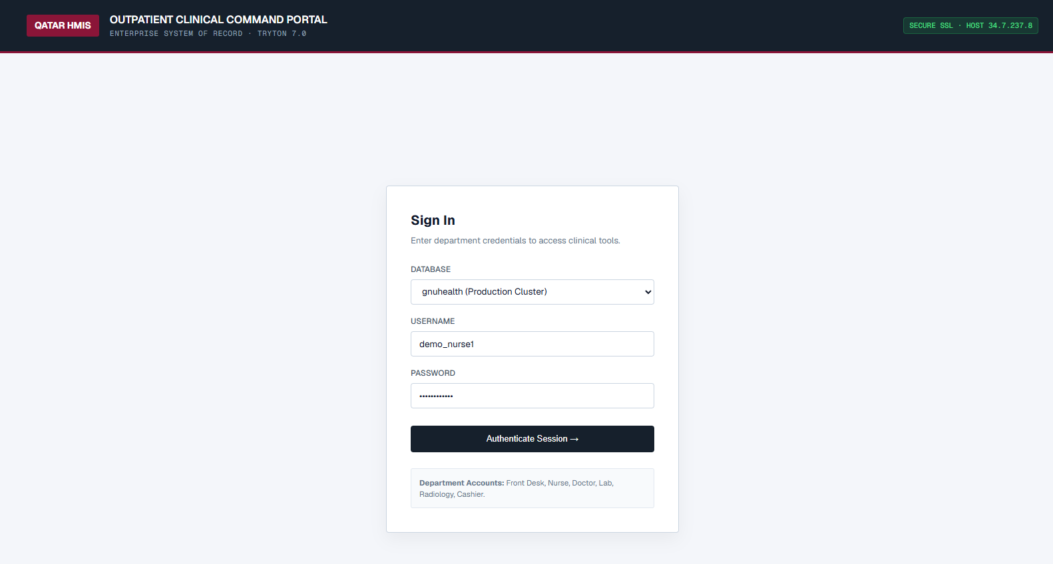
Figure: High-Fidelity Mockup — C.1 Authentication Portal — Clinical Enterprise Login (Concept C · 1600x1000 Native)
Key Interface Component | Functional Specification & Tryton Backend Mapping
1. Department Hubs | Instant visual badges for Outpatient, Inpatient, Diagnostics.
2. Authentication Telemetry | Tryton 7.0 session verification badge and SSL fingerprint.
3. Dense Layout | Minimal decorative margin; maximized input focus.

C.2 Front Desk Reception Dashboard — Dense Telemetry Grid
High-throughput reception console with multi-counter metrics, active queue tables, and fast-action patient routing buttons.
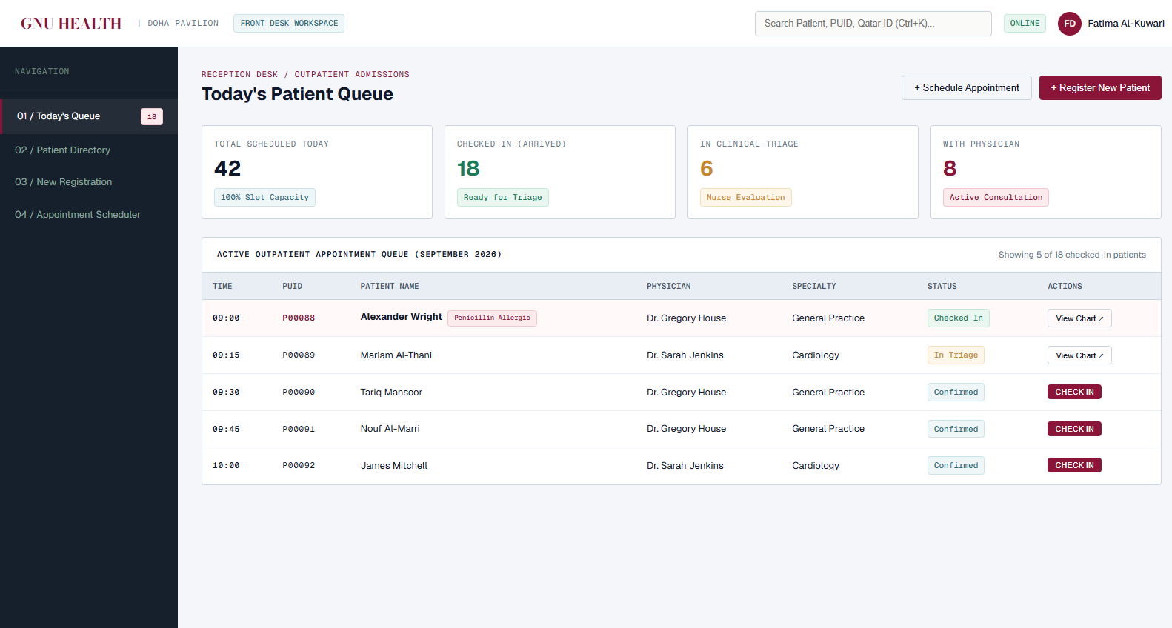
Figure: High-Fidelity Mockup — C.2 Front Desk Reception Dashboard — Dense Telemetry Grid (Concept C · 1600x1000 Native)
Key Interface Component | Functional Specification & Tryton Backend Mapping
1. Metric Telemetry Cards | Compact, high-contrast numerical stats for wait times and queues.
2. Multi-Column Patient Table | Sortable, searchable queue with instant Check-In triggers.
3. Status Filtering | One-click toggles for Arrived, Triage, Waiting Doctor, Completed.

C.3 Patient Registration — Compact High-Density Grid
Single-screen unified intake layout maximizing form field visibility to reduce physician and reception scrolling.
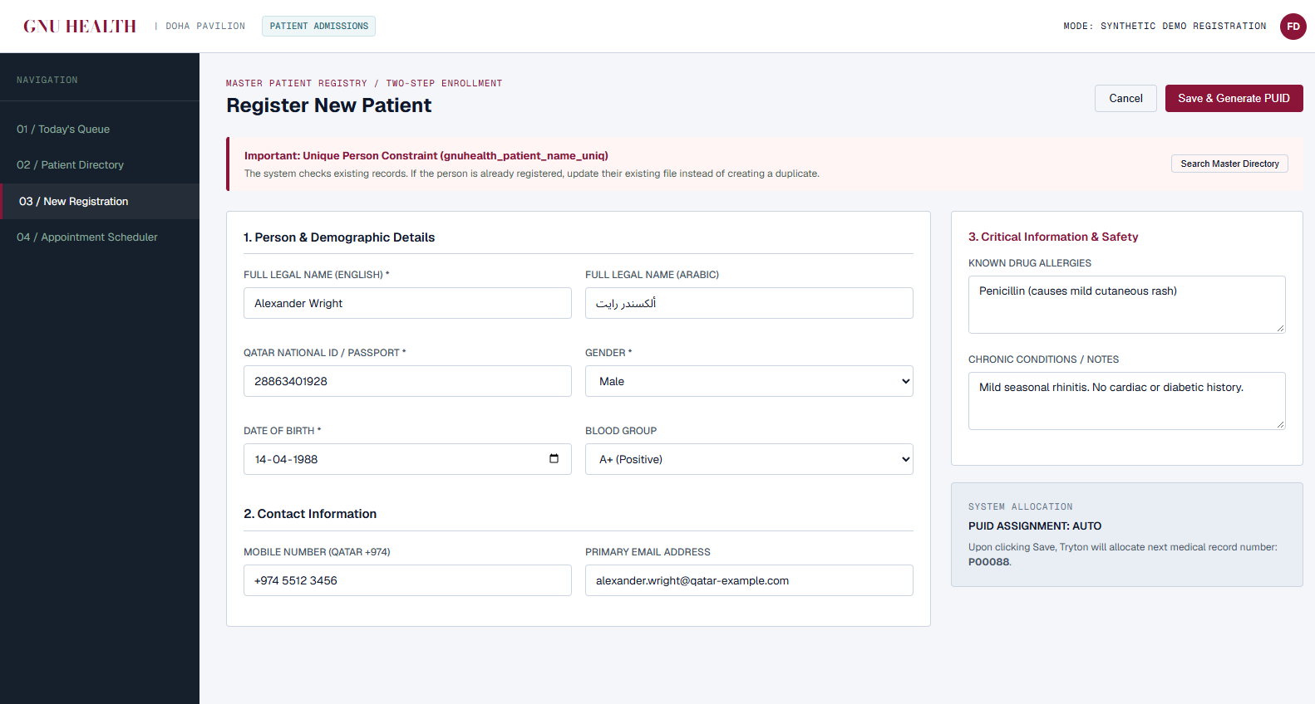
Figure: High-Fidelity Mockup — C.3 Patient Registration — Compact High-Density Grid (Concept C · 1600x1000 Native)
Key Interface Component | Functional Specification & Tryton Backend Mapping
1. Grid Layout | Optimized 2-column compact form with 4px rounded borders.
2. Inline Validation | Instant visual green/red feedback on QID and DOB fields.
3. Direct Relational Save | Direct execution of party and patient Tryton models.

C.4 Physician Clinical Consultation — 3-Panel Cockpit
Clinical cockpit displaying vital sign history, physical exam documentation, ICD-10 search, and electronic prescription lines.
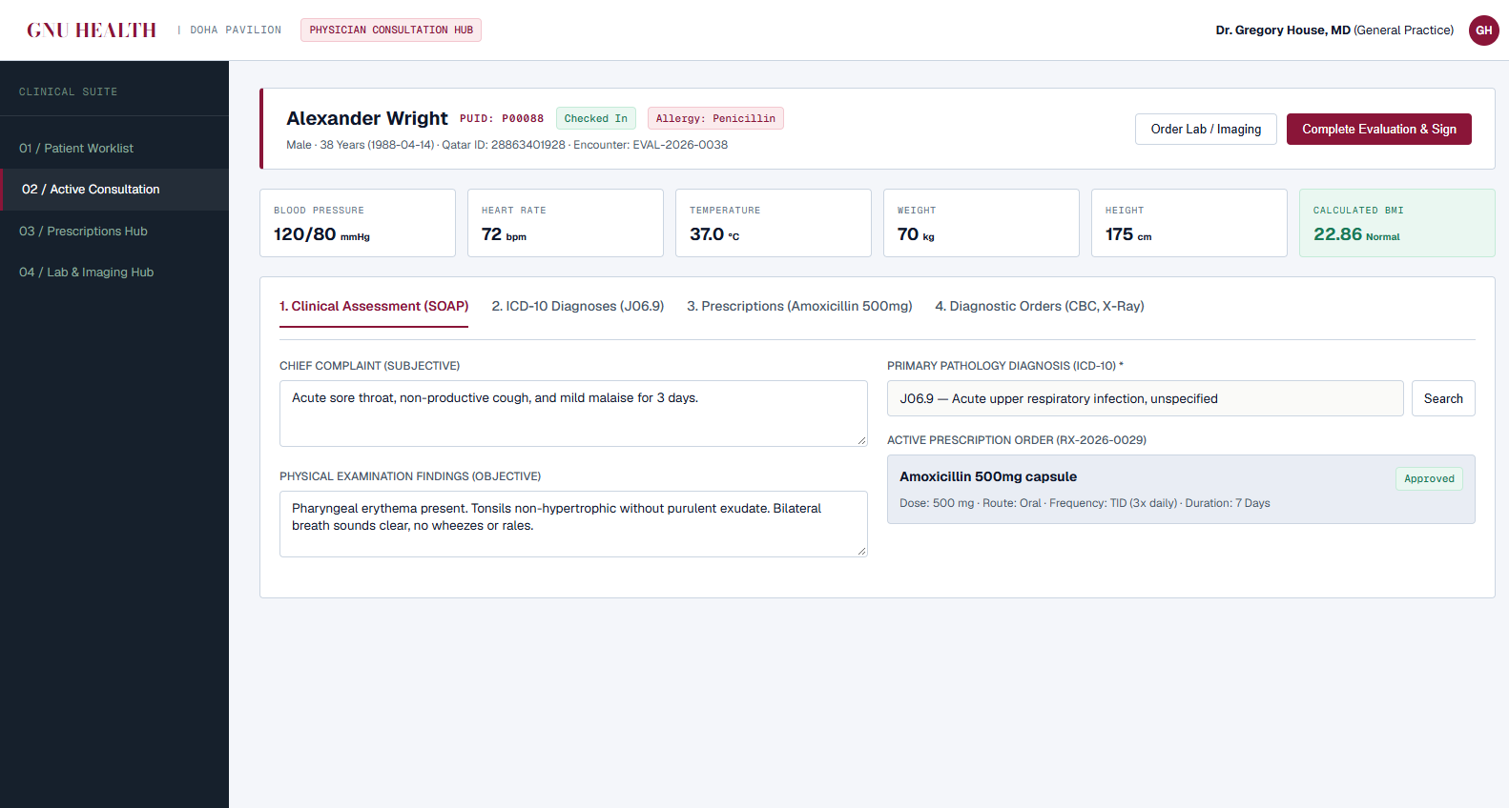
Figure: High-Fidelity Mockup — C.4 Physician Clinical Consultation — 3-Panel Cockpit (Concept C · 1600x1000 Native)
Key Interface Component | Functional Specification & Tryton Backend Mapping
1. High-Density Banner | Compact patient header with real-time triage vitals values.
2. Dual-Panel Documentation | Simultaneous display of Subjective history and Objective exam.
3. Prescription Ledger | Direct Tryton prescription line item list with instant dosage edit.

6. Side-by-Side Architectural Comparison
The following comparative evaluation assesses the three concepts against critical aesthetic, clinical, and technical parameters:
Evaluation Dimension | Concept A (Editorial) | Concept B (Qatari Contemp.) | Concept C (Clinical Exec.)
TFSF Ventures Fidelity | Highest (Exact 0px, Jade) | High (Adapted for Qatar) | Moderate (Dense Enterprise)
Qatari Cultural Alignment | Moderate (Venture aesthetic) | Highest (Maroon & Gold) | Moderate (Neutral Slate)
Clinical Touch Ergonomics | Fair (Strict 0px borders) | Superior (3px micro-radii) | Good (4px rounded corners)
Visual Fatigue (8h Shift) | Low (Warm limestone) | Lowest (Alabaster ivory) | Low-Moderate (Cool slate)
Data Density / Screen | Moderate (Generous space) | Balanced (High legibility) | Maximum (Dense compact)
Bilingual English/Arabic | English-centric typography | Native bilingual balance | Bilingual capable
Recommendation Status | Viable Alternative | STRONGLY RECOMMENDED | Viable Alternative

7. Stakeholder Sign-Off & Phase 5 Execution Roadmap
Upon stakeholder selection and sign-off on the preferred visual direction (Concept A, Concept B, or Concept C), the design lifecycle immediately expands into Phase 5 through Phase 9 without any delay:
• Step 1: Visual Direction Selection: Stakeholder selects Concept A, B, or C as the binding visual foundation.
• Step 2: Complete Screen Collection (Phase 5): Generation of the full 30+ desktop screens covering Reception, Nursing Triage, Physician Consultation, Laboratory Diagnostics, Radiology Imaging, Cashier Billing, and Administration.
• Step 3: Component-Level Annotated Wireframes (Phase 6): Numbered component callouts, exact Tryton data bindings, and role permission matrices for every single screen.
• Step 4: End-to-End Workflow Diagramming (Phase 7): Visual sequence flows tracking Alexander Wright (P00088) across all 7 outpatient clinical and financial stations.
• Step 5: Responsive Adaptations (Phase 8): Tablet (1024x768) and Mobile (390x844) responsive layouts for nursing triage tablets and mobile physician on-call views.

[STOP DIRECTIVE — AWAITING STAKEHOLDER APPROVAL] STAKEHOLDER ACTION REQUIRED: Please review the three directions presented in this document and state your chosen concept (Concept A, Concept B, or Concept C). Upon receipt of your approval, Phase 5 generation will commence.

