BSAI-3B
Lab_Task_2
- SOHAIL ASGHER
(FizzBuzz Game)
Overview:
This is a Dynamic FizzBuzz Game built in Python.
The twist in this version is that instead of simply counting numbers in sequence, the game adds a random number to the previous one and challenges the player to identify the correct output (Fizz, Buzz, FizzBuzz, or the number itself).
The goal is simple:
- One wrong guess and the game ends.
- Survive through the rounds to keep winning!

How It Works:
1. Player Setup
- The game welcomes the player and asks for their name.
- Rules are displayed so the player understands how to respond.
2. Random Number Generation
- Each round, the program generates a random number between 1 and 20.
- This number is added to the previously generated number to form a running total (t).
3. FizzBuzz Rules Applied on the Running Total
- If t is divisible by both 3 and 5, the correct answer is "FizzBuzz".
- If t is divisible by 3 only, the correct answer is "Fizz".
- If t is divisible by 5 only, the correct answer is "Buzz".
- Otherwise, the correct answer is simply the number itself (as a string).
4. Player Input & Checking
- The player must type their answer (Fizz, Buzz, FizzBuzz, or the number).
- The program checks the player’s guess against the correct result.
- If the guess is wrong, the game displays the correct answer and ends immediately.
5. Winning Condition
- The game continues indefinitely until the player makes a mistake.
- If the player survives all rounds, they are declared the winner (though realistically, the challenge goes as long as they can).

Example Run:

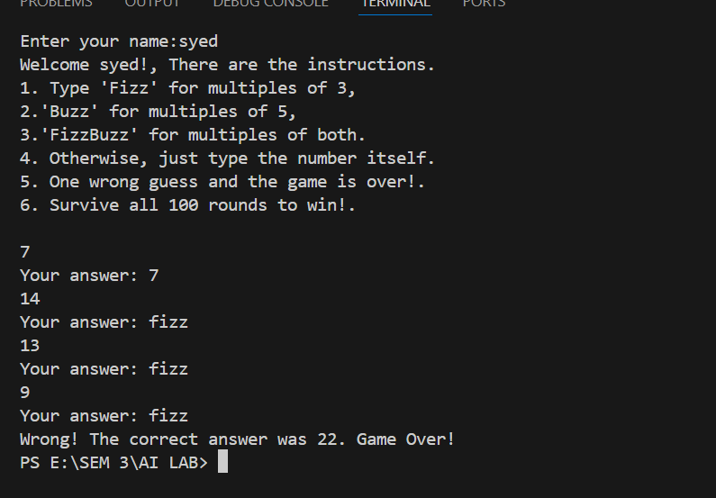

Features:
- Randomized gameplay → makes every round unpredictable.
- Dynamic running total instead of simple counting.
- Strict FizzBuzz rules applied at each step.
- Instant feedback when the player makes a mistake.
- Replayability: outcomes change every time due to randomness

