1. Class-based BFS Implementation

Explanation & Working:
1. A BFS class is created that uses graphs represented as adjacency lists.
2. The constructor initializes two things:
- The graph structure.
- A visited list to record explored nodes.
3. The search(start, goal) method works as follows:
- It begins from the start node and explores level by level.
- For each node, if it has not already been visited, it is added to the visited list.
- If the current node equals the goal, the search ends and confirms the goal is found.
- Otherwise, all of the node’s neighbors are added to the next level of search.
- This process repeats until all nodes are checked.
- If the goal is never encountered, it prints 'Not Found'.
4. The get_visited() method is used to return the order in which nodes were visited.
5. Example: Starting from node A and searching for G, the algorithm explores A → B → C → D → E → F → G, and confirms that G is found.

2. Function-based BFS Implementation

Explanation & Working:
1. Instead of a class, a simple function bfs() is defined.
2. A list visited_nodes is used to track which nodes have been visited.
3. A queue is initialized with the start node. This queue ensures that nodes are explored in a first-in, first-out manner.
4. While the queue is not empty:
- The first element is removed and processed.
- If it has not been visited before, it is added to visited_nodes.
- If it matches the target, the function confirms 'Target Found' and ends.
- Otherwise, all its neighboring nodes are added to the queue for later exploration.
5. If no match is found after the queue is empty, the function prints 'Target Not Found'.
6. Example: When starting from A to search for I, the function explores nodes level by level until I is reached, and then shows the order of traversal.

3. Comparison Between Class-based and Function-based BFS
- The class-based BFS is object-oriented, meaning it stores the visited nodes as part of the object’s memory, allowing the search to be reused multiple times.
- The function-based BFS is procedural and simpler but does not store state for reuse.
- The class-based version is better for larger projects where multiple searches are needed on the same graph.
- The function-based version is better for simple and quick BFS tasks.
- Both follow the same BFS principle: exploring nodes level by level in breadth-first order.
OUTPUT 1
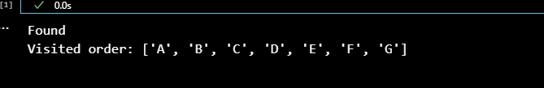
OUTPUT 2
