BSAI-3B
Lab_Task_2
- SOHAIL ASGHER
Movie Budget Project
Overview:
This is a Movie Budget Analysis Project built in Python.
The program stores a collection of movies and their budgets, calculates the average budget, and shows which movies are above that average.
The project is interactive, allowing users to:
- View all movies in the dataset.
- Add new movies and their budgets.
- Display the average budget and identify which movies exceed it.

How It Works:
1. Initial Dataset
- The program starts with a predefined list of movies, each paired with its budget (e.g., sultan,saiyaara etc.).
2. User Menu
The program runs continuously, presenting the user with the following options:
- Show All Movies → Displays all movies and their budgets.
- Add Movies → Allows the user to input new movies and budgets.
- Show Average and High Budget Movies → Calculates the average and lists movies above it.
- Exit → Ends the program.
3. Adding Movies
- The user chooses how many movies to add.
- For each, the program asks for the name and budget.
- These are added to the dataset dynamically.
4. Calculating Average Budget
- The program sums up all movie budgets.
- Divides the total by the number of movies.
- Displays the average as a whole number (no decimals).
5. Movies Above Average
- Each movie is compared against the average.
- If a movie’s budget is higher, it is displayed along with the difference.
6. Displaying Results
- A summary is shown with:
  - The average budget.
  - A list of movies above average (if any).
  - The total count of above-average movies.
Example Run:
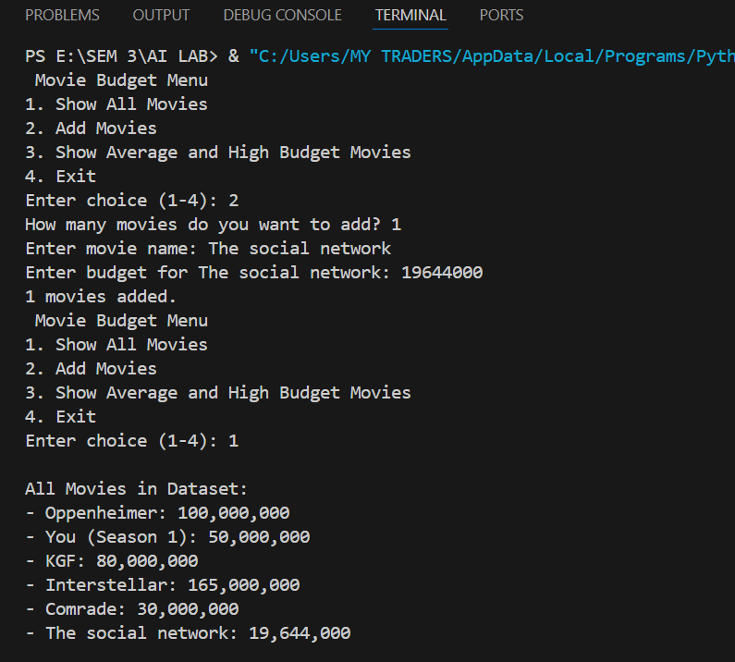
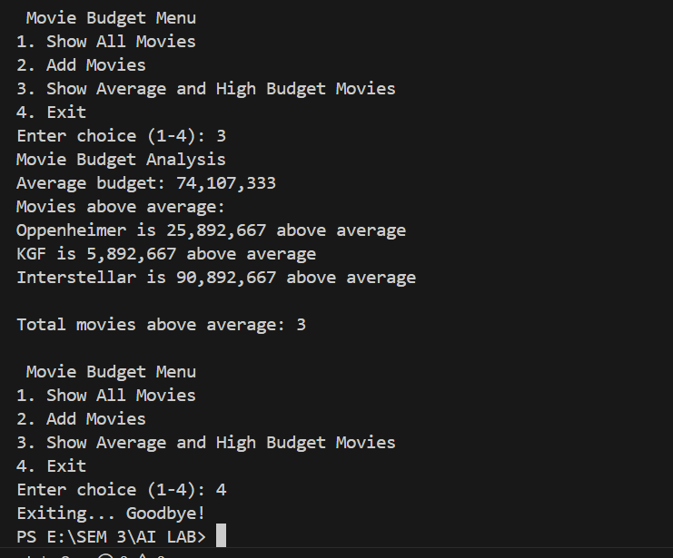
Features:
- Interactive menu-driven interface.
- Dynamic dataset – movies can be added anytime.
- Accurate budget analysis using averages.
- Clear results showing above-average movies with differences.
- User-friendly design with options to exit gracefully.

