* Project flow:
  + MVC project is use for the Ui representation.
  + MVC Project call an API to have the db transaction and different action
  + You can change the API base URL from GlobalVariable.cs file
* API Detail
  + api/Products– get method to return the list of all product
  + IHttpActionResult GetProduct(int id)–
    - get method to return the list of product based on ID
    - api/Products/5
  + IHttpActionResult PutProduct(int id, Product product)
    - Put method to update prouct based on provided ID and product details
    - PUT: api/Products/5
  + IHttpActionResult PostProduct(Product product) -
    - Post method to insert new record inproduct
    - // POST: api/Products
  + IHttpActionResult DeleteProduct(int id)
    - Delete metod todelete record from product based on ID
    - // DELETE: api/Products/5
* MVC screenshot

List of record

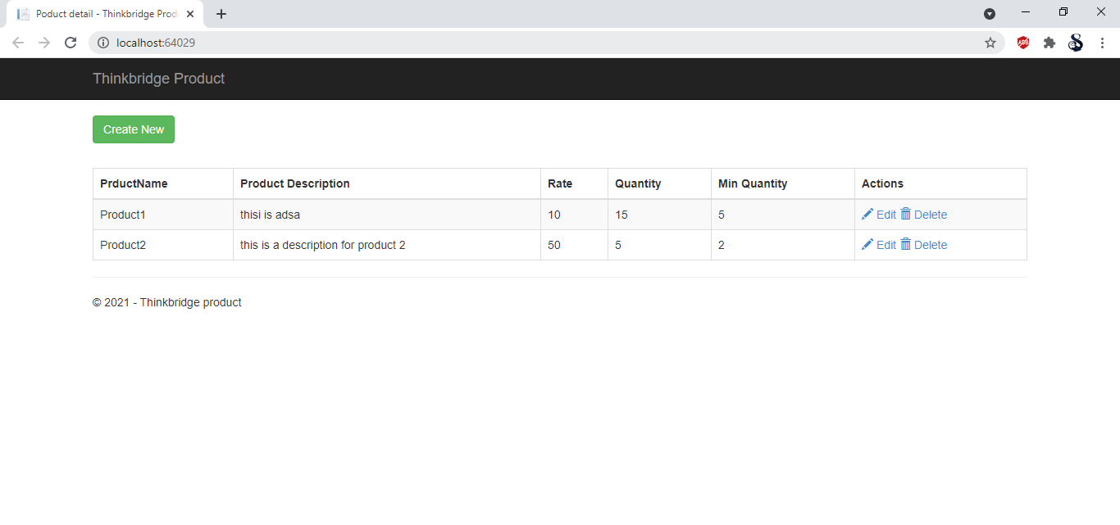

Add or edit produt

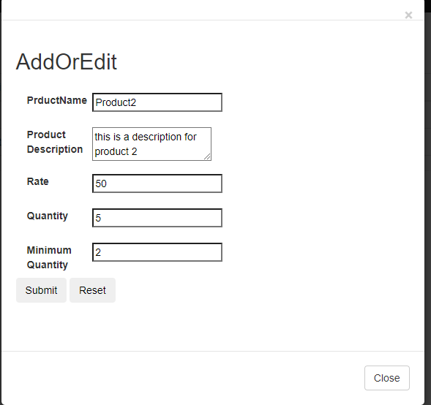

Confirmation for deleting record

