Lecture 2:
- Control Statement:
  - Selection (Conditional, Branching) statements
    - If
    - If .. else
    - Switch.. case
  - Iteration (looping) statements
    - For loop
    - While loop
    - Do .. while loop
- How character stored in memory (Normal Key, Extended Key)

Lab:
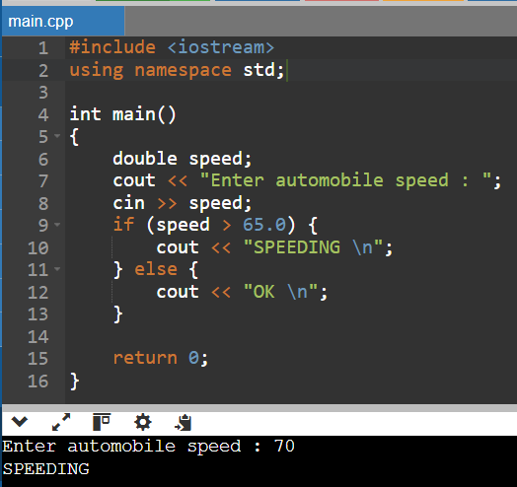
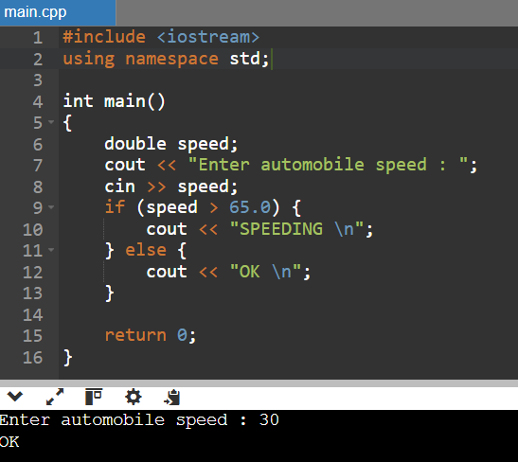
- Write a program to simulate a state police radar gun. The program input is automobile speed and display the message SPEEDING if the speed exceeds 65mph

- The National Earthquake Information Centered has asked you to write a program implementing the following decision table to characterize an earthquake based on its Richter scale number
Richter Scale Number (n) | Characterization
n < 5.0 | Little or no damage
5.5 ≤ n < 5.5 | Some damage
5.5 ≤ n < 6.5 | Serious damage : walls may crack or fall
6.5 ≤ n < 7.5 | Disaster: houses and buildings may collapse
Higher | Catastrophe: most buildings destroyed

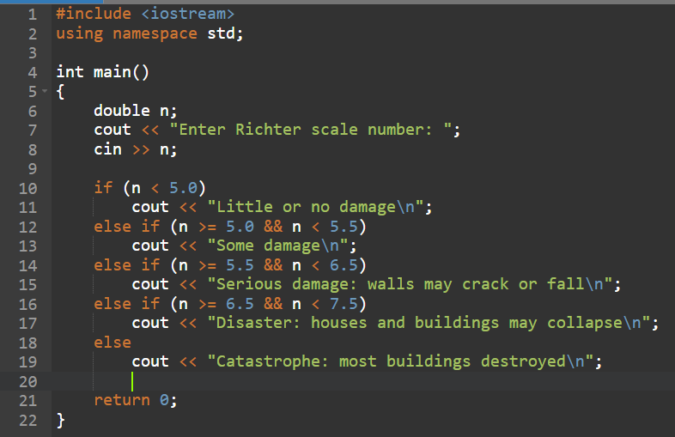

- Write a program that takes the x-y coordinates of a point in Cartesian plan and display a message telling either an axis on which the point lies or the quadrant in which it is found:
Example: (-1.0, -2.5) is in quadrant 3
(0.0, 4.8) is on the y axis
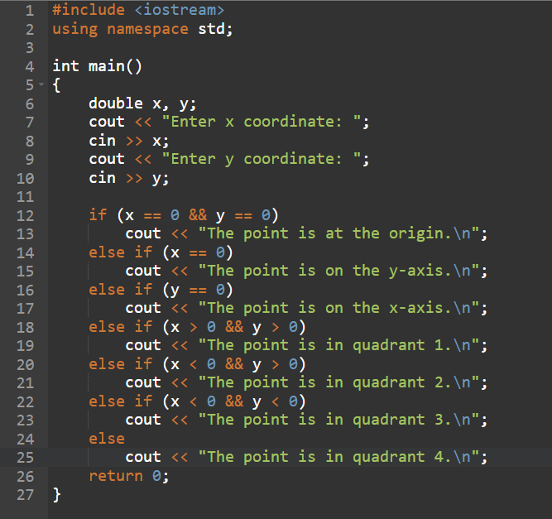

- Write a program that reports the contents of a compressed-gas cylinder based on the first letter of the cylinder’s color. The program input is a character representing the observed color of the cylinder: ‘Y’ or ‘y’ for yellow, ‘O’ or ‘o’ for orange, and so on. Cylinder colors and associated contents are as follows:
Orange ammonia
Brown carbon monoxide
Yellow hydrogen
Green oxygen
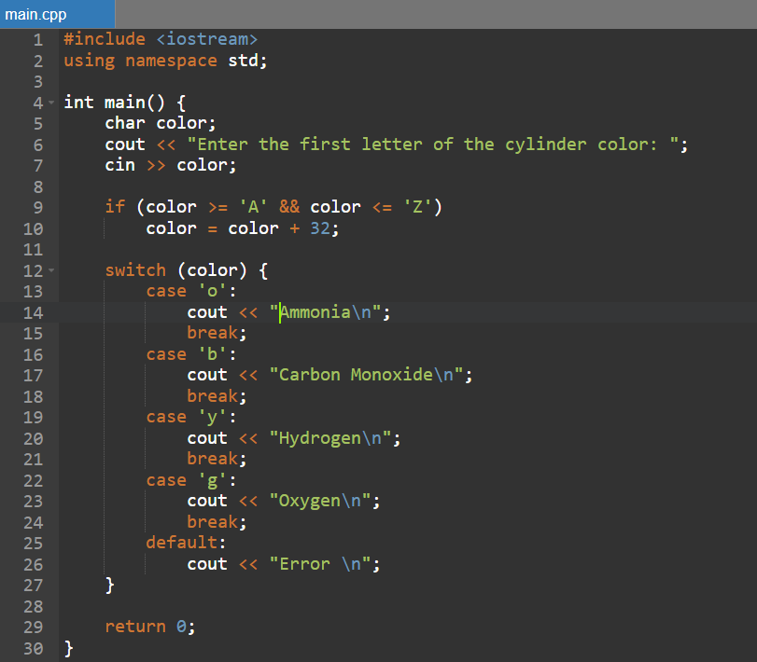

- Write a program that solve the second degree equation
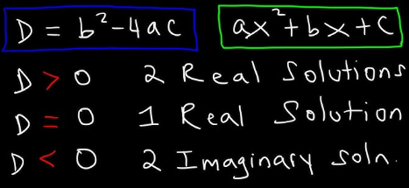

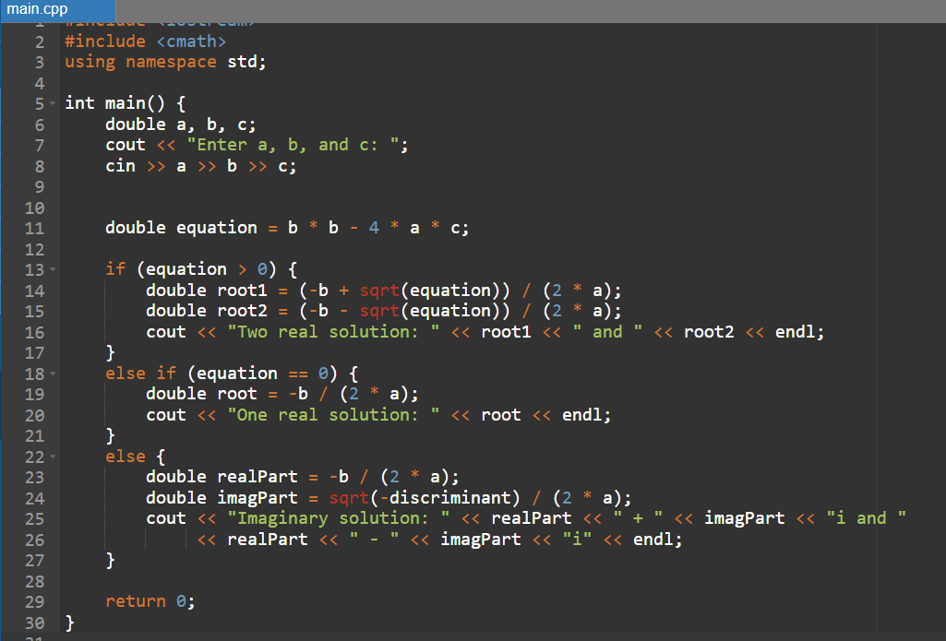

- Write a program that solve the magic box, getting number of rows / columns (odd number)
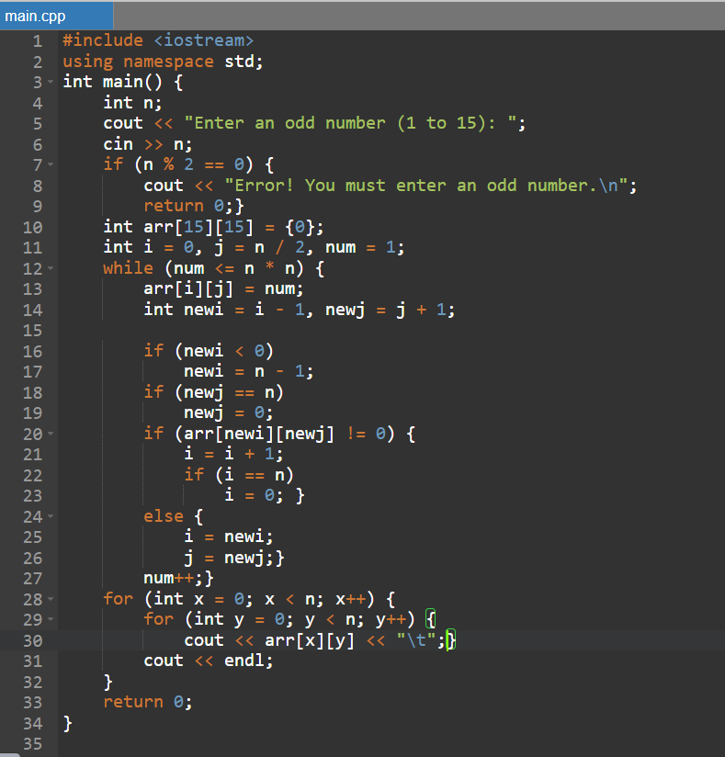

- The value for π can be determined by the series equation
$$π=4*(1- \frac{1}{3}+ \frac{1}{5}- \frac{1}{7}+ \frac{1}{9}- \frac{1}{11}+ \frac{1}{13}-…)$$
Write an interactive program that asks the user how many terms of the series equation to use in approximation
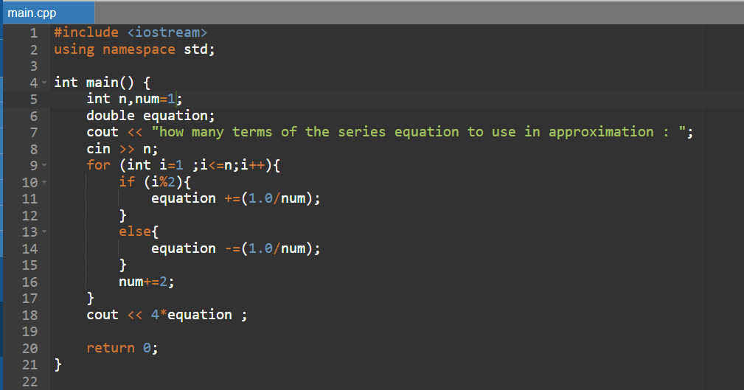

- (Sales Tax) Sales tax is collected from buyers and remitted to the government. A retailer has to file a monthly sales tax report which lists the sales for the month and the amount of sales tax collected, at both the county and state levels. Develop a program that will input the total collections for a month, calculate the sales tax on the collections, and display the county and state taxes. Assume that states have a 4% sales tax and counties have a 5% sales tax. Here is a sample input/output dialog.
Enter total amount collected (-1 to quit): 45678
Enter name of month: January
Total Collections: $ 45678.00
Sales: $ 41906.42
County Sales Tax: $ 2095.32
State Sales Tax: $ 1676.26
Total Sales Tax Collected: $ 3771.58
Enter total amount collected (-1 to quit): 98000
Enter name of month: February
Total Collection: $ 98000
Sales: $ 89908.26
County Sales Tax: $ 4495.41
State Sales Tax: $ 3596.33
Total Sales Tax Collected: $ 8091.74
Enter total amount collected (-1 to quit): -1
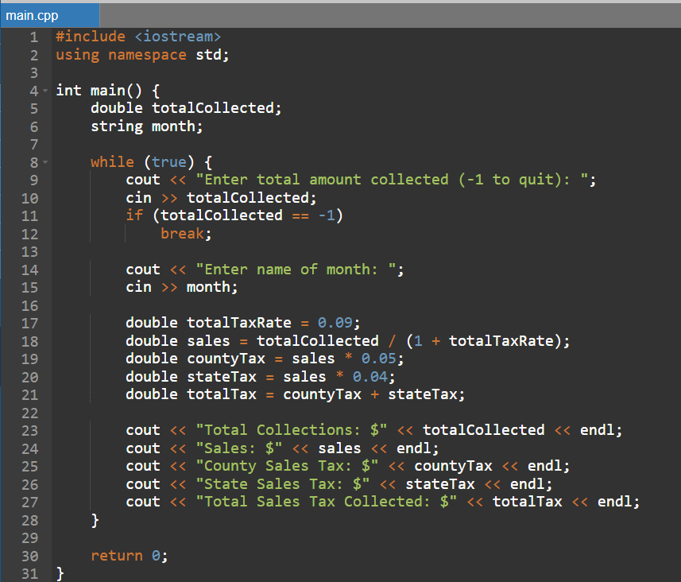
- Develop a C program to calculate the interest accrued on a bank customer's
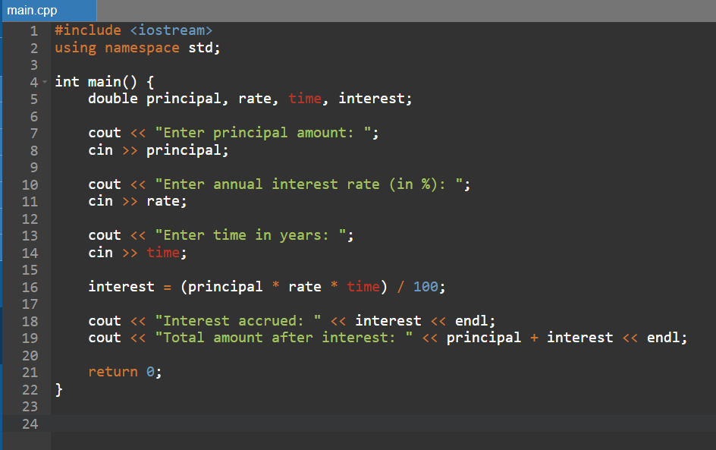

- mortgage. For each customer, the following facts are available:
the account number
the mortgage amount
the mortgage term
the interest rate
The program should input each fact, calculate the total interest payable ( = mortgage amount × interest rate × mortgage term), and add it to the mortgage amount to get the total amount payable.
It should calculate the required monthly payment by dividing the total amount payable by the number of months in the mortgage term. The program should display the required monthly payment rounded off to the nearest dollar. The program should process each customer's account at a time. Here is a sample input/ output dialog:
Enter account number (-1 to end): 100
Enter mortgage amount (in dollars): 6500
Enter mortgage term (in years): 3
Enter interest rate (as a decimal): 0.075
The monthly payable interest $ 221
Enter account number (-1 to end): 200
Enter mortgage amount (in dollars): 12000
Enter mortgage term (in years): 10
Enter interest rate (as a decimal): 0.045
The monthly payable interest is: $ 145
Enter account number (-1 to end): -1

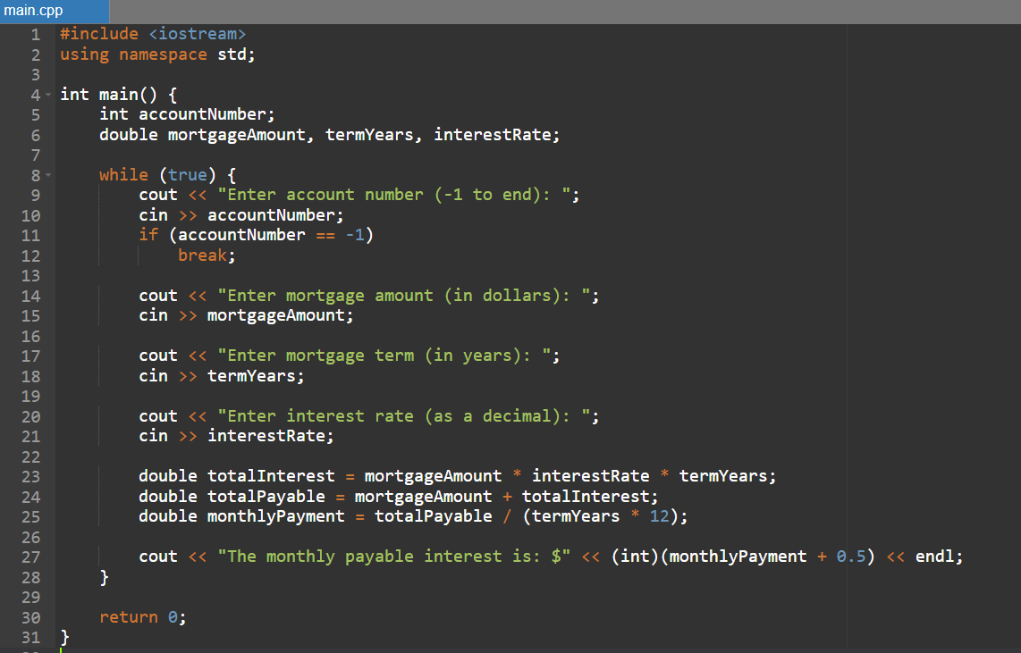
11.One large chemical company pays its salespeople on a commission basis. The salespeople receive $200 per week plus 9% of their gross sales for that week. For example, a salesperson who sells $5000 worth of chemicals in a week receives $200 plus 9% of $5000, or a total of $650. Develop a program that will input each salesperson’s gross sales for last week and will calculate and display that salesperson’s earnings. Process one salesperson's figures at a time. Here is a sample input/output dialog:
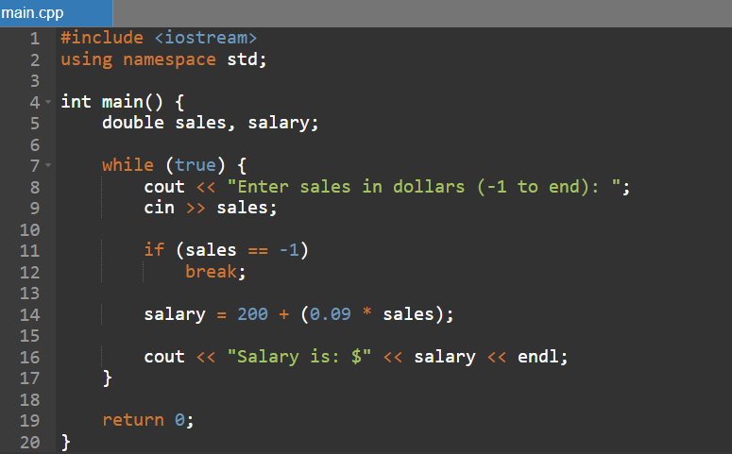
Enter sales in dollars (-1 to end): 5000.00
Salary is: $650.00
Enter sales in dollars (-1 to end): 1234.56
Salary is: $311.11
Enter sales in dollars (-1 to end): -1

