MSc Bioinformatics Thesis

Development of a Machine Learning-Based Diagnostic Tool for Early Detection of Breast Cancer using Multi-Omics Data Integration.

ACKNOWLEDGEMENTS

The author gratefully acknowledges the researchers whose published work and publicly available resources informed this project.

Abstract

This exploratory study evaluates machine-learning models for classifying the recorded vital.status outcome in a supplied breast-cancer dataset. The CSV contains 705 samples, 1,936 feature columns, and a binary outcome: 611 samples are labelled 0 and 94 are labelled 1. Although the submitted project title refers to early detection, the executable analysis predicts patient outcome; it does not distinguish cancer from non-cancer or test a screening method.
The analysis removes rows with missing values, uses all remaining feature columns, and makes a stratified 80/20 train/test split with random seed 42. Standardisation is fitted on training data only. Random Forest, a one-hidden-layer neural network, a linear Support Vector Machine, and Gradient Boosting are evaluated using accuracy, per-class precision, recall and F1-score, confusion matrices, and ROC-AUC.
On the 141-sample held-out test set, Random Forest had the highest accuracy (0.8936); Gradient Boosting had the highest class-1 F1-score (0.4667), and SVM had the highest ROC-AUC (0.6700). Class-1 recall ranged from 0.2105 to 0.3684, so the classifiers missed many samples in the minority class. These results are from one split and are exploratory, not clinical evidence.
The supplied script does not implement the thesis-proposed biomarker tests, feature selection, multi-omics integration procedure, cross-validation, or external validation. The findings therefore do not establish early-detection performance, validated biomarkers, or clinical utility. Further work requires verified cohort provenance, validation on independent patient-level data, and methods designed for the imbalanced outcome.
Keywords
- Breast Cancer
- Patient Outcome
- Machine Learning
- Multi-Omics Features
- Survival Classification
- Class Imbalance
- Model Evaluation
Table of Contents
Introduction 7
Importance of Early Detection in Breast Cancer 7
Potential of Multi-Omics Data Integration for Improving Diagnostic Accuracy 8
Objectives of the Study 9
Develop a Machine Learning-Based Tool for the Identification of Breast Cancer at an Early Stage 10
Integrate Multi-Omics Data to Identify Key Biomarkers 11
Research Questions and Hypotheses: 13
Literature Review 16
Overview of Breast Cancer and Diagnostic Methods 16
Breast Cancer Types and Stages 16
Current Diagnostic Methods 17
Multi-Omics Data in Cancer Research 18
Improved Understanding of Cancer Biology: 20
Challenges and Future Directions 21
Machine Learning Techniques for Biomarker Identification 23
Existing Diagnostic Tools and Their Limitations 24
Materials and Methods 28
Data Collection 28
Data Preprocessing 29
Feature Selection and Extraction 30
Model Development 32
Model Training 32
Model Evaluation 33
Results 35
Data Exploration and Visualization 36
Biomarker Visualization: 38
Model Performance 40
Random Forest: 40
Neural Network: 44
Support Vector Machine (SVM). 47
Gradient Boosting: 50
Best Performing Model: 53
Discussion 54
Conclusion 55
Reference: 56

List of Figures

Figure 1. Accuracy comparison on the stratified held-out test set.
Figure 2. Random Forest confusion matrix.
Figure 3. Random Forest ROC curve.
Figure 4. Neural Network confusion matrix.
Figure 5. Neural Network ROC curve.
Figure 6. SVM confusion matrix.
Figure 7. SVM ROC curve.
Figure 8. Gradient Boosting confusion matrix.
Figure 9. Gradient Boosting ROC curve.

Introduction

Importance of Early Detection in Breast Cancer
Breast cancer represents a substantial percentage of cancer-related morbidity and death, making it one of the most prevalent cancers affecting women globally. With an expected 2.3 million new cases identified in 2020 alone, breast cancer is the main cause of cancer-related deaths among women, according to the World Health Organisation (Breast cancer, no date). Since early identification greatly improves the prognosis and survival rates of breast cancer patients, it is imperative. Early detection is essential as it significantly improves the prognosis and survival rates of those with breast cancer. According to Siegel, Miller, and Jemal (Siegel, Miller and Jemal, 2020), early identification improves outcomes and lowers death rates by increasing the chance of a successful course of therapy.
An early diagnosis of breast cancer involves the use of screening procedures such as mammography, clinical breast exams, and breast self-examinations. The most common screening technique, mammography, can reduce the death rate from breast cancer in women between the ages of 40 and 70 by 20–40% (Tabár et al., 2011). Mammography has drawbacks in addition to its positives. For example, it might provide mistakenly positive or incorrectly negative findings, which could result in missed diagnoses or needless biopsies (Nelson et al., 2016). Furthermore, thick breast tissue may mask cancers and lower the sensitivity of mammography, which would diminish its usefulness for women (Boyd Norman F. et al., 2007).
Early detection of breast cancer is possible with the use of imaging techniques in conjunction with molecular diagnostic approaches. These techniques entail the examination of circulating tumour DNA and tumour cells (Dawson Sarah-Jane et al., 2013). However, these methods are constantly changing, and it is still relatively new that they are being used in medical settings. To identify breast cancer in its early stages, better, more reliable, and less intrusive diagnostic techniques are desperately needed.

Potential of Multi-Omics Data Integration for Improving Diagnostic Accuracy
Since high-throughput sequencing technologies allow for the thorough investigation of several molecular levels, including as proteomics, metabolomics, transcriptomics, and genomes, they have revolutionised our understanding of cancer biology. These "omics" technologies each give a distinct viewpoint on the molecular changes linked to cancer, providing important insights into the mechanisms underlying carcinogenesis and development (Hasin, Seldin and Lusis, 2017a).
The primary goal of genomics is the analysis of DNA sequences to find genetic mutations, copy number variations, and other alterations that might lead to the growth of cancer. Transcriptomics measures the levels of mRNA expression to determine changes in the patterns of gene expression in cancer cells. Proteomics examines the levels and changes in proteins, and the key molecules in cells, whereas metabolomics investigates the small molecules and metabolic pathways affected in cancer (Karczewski and Snyder, 2018).
Although each omics technique provides useful information, they are often used in isolation, which may limit their ability to diagnose problems. Multi-omics integration, which combines data from many omics’ layers, provides a more comprehensive insight into the molecular composition of cancer. By using a comprehensive approach, significant biomarkers and pathways that might not be obvious when looking at a single omics layer can be found (Gomez-Cabrero et al., 2014).
Combining data from various molecular levels in multi-omics integration can improve diagnostic precision. Gene mutations and their impact on gene expression can be identified by combining transcriptomics and genome data. Furthermore, with the incorporation of proteomics data, it is possible to demonstrate the effects of these alterations on protein levels and functionality. Additionally, using multi-omics integration, the chance of inaccurate results can be minimized, which allows for the identification of biomarkers that are more durable and trustworthy than those found using just one omics method (Subramanian et al., 2020).
The utilization of machine learning methods for examining multi-omics data is increasing for identifying biomarkers and developing cancer diagnosis prediction models. Machine learning techniques can manage the vast amount and intricate organization of multi-omics data, which could result in discovering new biomarkers and developing accurate diagnostic tools (Cai et al., 2022). By merging multi-omics data and utilizing machine learning, we can enhance the precision and reliability of diagnostic tools for detecting early breast cancer. Ultimately, patients will experience improved results, leading to a reduction in the mortality rate of breast cancer.

Objectives of the Study
This work aims to create a diagnostic system based on the machine learning algorithm for the early diagnosis of breast cancer based on multi-omics data.
Identify the Need to Design a Machine Learning-Based System that can Predict Breast Cancer at its Early Stage.
The specific aim of the study is to create an accurate diagnostic tool that relies on artificial intelligence and machine learning algorithms to analyse multi-omics data sets with the view of identifying people with early signs of breast cancer. The tool will be developed to improve the accuracy and stability of early breast cancer diagnosis compared with the existing techniques.
Integrate Multi-Omics Data to Discover Key Biomarkers: Using data from the multiple ‘omics’ levels of genome, transcriptional and protein from breast cancer patients, the study will be identifying biomarkers for early detection of breast cancer. To this end, the study has the following objectives: The objectives of the study are to identify other biomarkers that can improve the diagnostic precision using the information received through the omics layers.
Make sure that the diagnostic tool that you will use is valid.
The tool will be tested with a new set of data and with clinical samples to confirm the accuracy, sensitivity and specificity of the developed algorithm as well as its ability to self-adjust for great robustness. Validation of the described tool will confirm its accuracy and its applicability worldwide, which will permit secure usage of the tool in clinical practice.

Develop a Machine Learning-Based Tool for the Identification of Breast Cancer at an Early Stage
There are several important steps which are involved in the creation of a machine learning-based diagnostic tool. These activities included pre-processing of data, feature identification, and building and evaluating a machine learning model. Analysing multi-omics data will be performed by employing machine learning approaches including Random Forest, Support Vector Machine (SVM), Gradient boosting and neural networks.
Data Preprocessing: The first of the steps is to analyse the multi-omics data in a way to makes it ready for analysis. This comprises data cleansing, converting them to a standardized form as well as transformations to address issues of missing values, extremes and batches. The data will be normalized, to bring it to a common format, especially for the various omics layers and samples (Zhang et al., 2014).
Feature Selection: Feature selection is very important when one needs to reduce data dimensionality and determine which characteristics would be best for model development. This work employs a wide range of feature selections from the multi-omics data like Recursive Feature Elimination (RFE), Least absolute shrinkage and selection operator (LASSO) as well as the Key biomarker from the multi-omics data (Cai et al., 2022).
Model Training and Evaluation: After the features have been chosen, we shall have to use the training data set in training machine learning models and the testing data set to test the performance of the models. To make our analysis less prone to overfitting, will apply cross-validation techniques to check the models’ performance. The outcome criteria in the performance of the models will be evaluated using such indicators as accuracy, sensitivity, specificity and the area under the ROC-AUC graph (Chen et al., 2022).

Integrate Multi-Omics Data to Identify Key Biomarkers

This analysis therefore comprises integrating data from the multiple layers of omics to obtain information on all the changes occurring at the molecular level that are linked to breast cancer. From this study, different data integration methods including CCA, MKL and deep learning approaches are going to be applied to multimodal omics to identify key biomarkers.
Canonical Correlation Analysis (CCA): CCA is a statistical technique used in the estimation of coefficients that provide maximum likelihood when relationships between two or more sets of variables are being examined. This approach will enable us to use CCA to merge data stratified across genomic, transcriptomic, proteomic and metabolomic layers and establish interaction between the layers in breast cancer (Witten, Tibshirani and Hastie, 2009).
Multiple Kernel Learning (MKL): MKL is an advanced model of machine learning in which as a single predictive model, multiple kernels are integrated where different kernels are representative of different omics layers. MKL enables the incorporation of distributed data and results in increasing the accuracy and reliability of the classification (Gonen et al., no date).
Deep Learning-Based Approaches: AUTO-2 and multi-omics neural networks, for example, can be applied for biomarkers’ identification after sample integration. These methods may be able to incorporate non-linear interactions between different omics layers and better decipher the molecular nature of breast cancer (Zhang et al., 2018).
This project aims to achieve the goal of developing early methods for breast cancer biomarkers by combining different multi-omics data using these methods.
It is necessary to assess the efficiency of the diagnostic tool that has been developed.
The last proposed aim of the study is to act as confirmation of the utility of the diagnostic tool using cross-validation samples and patients. This process of validation is significant to cultivate the reliability, generality and clinical applicability of the tool or model.
Independent Dataset Validation: To externally corroborate our diagnostic tool and employ datasets from TCGA and GEO databases of Array Express. This will help in the evaluation of the tool on data which was not used in the training of the model, hence establishing its versatility (Weinstein et al., 2013).
Clinical Sample Validation: To externally verify the diagnostic tool, it will be necessary to collect breast cancer samples from patients of the various stages of the disease with the help of clinical partners. Using these clinical samples, the tool will be subjected to actual clinical context to determine, its accuracy, sensitivity and specificity ((Ahn et al., 2023).
Performance Metrics: The diagnostic tool is expected to produce different key metrics with which its performance will be assessed such as accuracy, sensitivity, specificity as well as the area under the receiver operating characteristic curve (ROC-AUC). These measures will give an efficient evaluation of the capacity of the tool to diagnose and the possibility of the tool to detect early breast cancer detection (Baldi and Brunak, 2001).
Comparative Analysis: In this paper, will discuss how the presented diagnostic tool compares with the existing diagnosis methods, including mammography.

Research Questions and Hypotheses:

What are the most effective machine learning algorithms for integrating multi-omics data in the development of a diagnostic tool for early detection of breast cancer?

There are several machine learning techniques which can be advantageous in the integration of multi-omics data for the creation of a predictive diagnostic tool that is used in the early diagnosis of breast cancer. Here are some of the most effective algorithms:

- Random Forest
The Random Forest algorithm is also applicable for big data, high dimensionality which makes it a good algorithm for multi-omics data analysis. It employs decision trees to enhance data classification’s efficiency and resistivity (Chen et al., 2022).
- Support Vector Machine (SVM)
SVMs are effective for high-dimensional data and can be used with different kernel functions to handle nonlinear relationships. They are commonly used in bioinformatics for classification tasks, including cancer detection (Kourou et al., 2021)
- Deep Learning
Advanced neural network techniques, for example, CNN and autoencoder are common and effective methods in learning features of multi-omics datasets. They can combine different data types and detect complex correlations of different omics layers (Kang, Ko and Mersha, 2021).
- Canonical Correlation Analysis (CCA)
CCA stands for Canonical Correlation Analysis, it is a statistical technique which helps in determining the correlation between two or more sets of variables. It is useful in joining together multiple omics measures by searching for relationships among diverse omics data (Witten, Tibshirani and Hastie, 2009).
- Multiple Kernel Learning (MKL)
Multiple kernels learning integrating several kernels, where every single kernel corresponds to an omics data type enhances the prediction accuracy of a model. It enables one to combine heterogeneous data sets into a single model (Gonen et al., no date).

How can the existing bioinformatics tools and software packages be effectively utilized to support the analysis and interpretation of new multi-omics data in the context of breast cancer research?

Computer programs and bioinformatics utilities are very relevant if not vital when working with multiple omics data sets or datasets derived from breast cancer studies. Here’s how they can be leveraged:

- Data Preprocessing and Normalization
- Bioconductor: A comprehensive set of R packages for the analysis and comprehension of high-throughput genomic data. It comprises the tool for preprocessing, normalization and visualization (Huber et al., 2015).
- DEseq2 and EdgeR: It is also used for differential expression analysis of RNA-Seq data, whereas it offers a statistical sounder approach to identifying differentially expressed genes (Love, Huber and Anders, 2014).
- Data Integration
- mix Omics: An R package for the integration and exploration of multiple omics datasets. It offers methods for correlation analysis, variable selection, and visualization (Rohart et al., 2017).
- MOFA (Multi-Omics Factor Analysis): An approach for the integration of multi-omics data in an unsupervised manner that encompasses the main sources of variability (Zhang et al., 2018).
- Machine Learning and Model Development
- Scikit-learn: A fast, open-source Python library which represents a solution for easy and efficient data mining and data analysis for the application of the majority of machine learning algorithms (Pedregosa et al., no date).
- TensorFlow and Keras: The machine learning libraries that provide myriad features for constructing and training neural nets, which is inarguably a must for tackling multi or complex data (Abadi et al., no date).
- Visualization
- ggplot2: It is one of the most used tools in R and Python, associated with data visualization, for the design of multiple-layered graphics (Wickham, 2016).
- Cytoscape: A tool designed for mapping complicated relationships and connections, and their integration with any type of attribute data, (Shannon et al., 2003).

Literature Review

Overview of Breast Cancer and Diagnostic Methods

Breast Cancer Types and Stages

Breast cancer is a heterogeneous disease characterized by the uncontrolled growth of cells in the breast tissue. By its extent, it can be characterized as invasive or non-invasive. Benign breast diseases, which include ductal carcinoma in situ (DCIS), have not spread to the surrounding tissues. There is a major difference between ductal or lobular invasive cancers like invasive ductal carcinoma (IDC) and invasive lobular carcinoma (ILC), wherein the carcinomas break through the ductal or lobular walls and begin to invade the surrounding breast tissues and may also metastasize (Yersal and Barutca, 2014).
Breast cancer is then divided by whether cancer cells test positive or negative for estrogen or progesterone receptors, as well as for the HER2 protein. Such subtypes of molecular breast cancer include HR+, HER2+, and TNBC, which do not include any of the three receptors (Perou et al., 2000a). These subtypes differ in terms of prognosis and management hence underlining the significance of accurate diagnostic techniques.
The process of infraction of breast cancer is divided into stages 0 to IV, depending on the size of the Tumour, involvement of lymph nodes and the presence of metastases. Stage 0 also called DCIS means that the cancer is small and has not yet penetrated the surrounding tissues, Stage IV means the cancer has metastasised to other parts of the body. This staging is very essential in deciding the management to be offered to the patients and the prognosis (Edge and American Joint Committee on Cancer, 2010).

Current Diagnostic Methods
Early detection of breast cancer significantly improves treatment outcomes and survival rates. Several diagnostic methods are employed to identify breast cancer at its various stages:
- Mammography:
Mammography employs low-voltage radiation in the form of X-rays to translate features such as microcalcifications and masses that are potentially premalignant and clinically occult. However, it is less effective in women with dense breast tissue, especially young women (Kerlikowske et al., 2015).
- Ultrasound:
Breast ultrasound employs ultrasound to form images of the breast tissue and is frequently used together with mammography, especially for women with dense breasts. It assists in the distinction between solid mass and cystic lesions that tend to separate between benign and malignant tumours (Berg et al., 2012).
- Magnetic Resonance Imaging (MRI):
MRI is a highly accurate process that uses both magnets and radio waves and is valuable to high-risk patients, dense breast patients and cancer patients. It can identify early cancer lesions which are difficult to see using mammography but due to the high cost, it is not widely used in the screening (Pinker, Helbich and Morris, no date).

- Biopsy:
Biopsy means taking specimens for histopathological examination. These are the FNAB, core-needle biopsy and surgical biopsy, and define a cancer type and its treatment depending on the tumour features. Breast cancer is diagnosed by biopsy and tumour characteristics that help to determine further treatment including hormone receptor status and HER2 (PhD and MD, 2016).
- Genetic Testing:
Testing for mutations in genes like BRCA1 and BRCA2 helps identify individuals at higher risk of developing breast cancer, especially those with a family history, allowing for personalized preventive strategies (King, Marks and Mandell, 2003).
- Molecular Imaging:
Both PET (positron emission tomography) and SPECT (single-photon emission computed tomography) are implemented for the consequent identification of metastatic disease and the evaluation of therapy outcomes. These methods give functional information concerning the metabolic activity of the cancer cells (Bai, Qiu and Zhang, 2023).

Multi-Omics Data in Cancer Research
Types of Omics Data
Omics technologies are efficient in describing the processes that occur in living organisms and are vital in explaining cancer. The main types of omics data are:
- Genomics:
Concerns the whole genome and targets the genetic changes, mutations, Copy Number Variations (CNVs), and structural variations associated with cancers. These genetic alterations are determined through whole-genome sequencing and whole-exome sequencing technologies (Koboldt et al., 2012).
- Transcriptomics:
Analyses the RNA molecules of a cell, RNA transcriptome. RNA sequencing (RNA-seq) estimates genes’ mean expression levels and isoforms/spliced forms and captures non-coding RNA molecules to ascertain aberrant genes and cancer routes (Perou et al., 2000b).
- Proteomics:
Proteomics deals with the study of proteome, the total of proteins performing in a cell, tissue or organism. MS-based proteomics allows the deciphering of protein expression profiles, localization, post-translational modifications, and protein-protein interactions. Proteomics show alterations in global protein levels and the pathways in cancer (Gstaiger and Aebersold, 2009).
- Epigenomics:
Discusses processes of gene regulation that do not involve changes at the DNA level but are related to DNA methylation and chromatin remodelling. Some of the approaches that are applied to investigate these modifications are bisulphite sequencing and Chromatin Immunoprecipitation Sequencing (ChIP-seq) (Baylin and Jones, 2011).
- Metabolomics:
Identifies peptides and other small molecule biomolecules linked with metabolic tasks. Metabolomics studies changes in metabolism during the progress of cancer, such processes as modifications of glycolysis and lipid metabolism are investigated with the help of Nuclear Magnetic Resonance (NMR) and Liquid Chromatography-Mass Spectrometry (LC-MS) (Hanahan and Weinberg, 2011).
Relevance of Multi-Omics Data in Cancer Research
Integration of multi-omics analysis offers a broad strategy for addressing the complexity of cancer systems at the systems biology level. This comprehensive approach has several advantages in cancer research:

Improved Understanding of Cancer Biology:
These data show a complex interconnectivity between genetic, epigenetic, transcript, protein, and metabolite alterations in cancer. Such an integrated approach is useful for the identification of causative factors of cancer, and for understanding the molecular events that underlie tumour initiation, promotion and metastasis (Hasin, Seldin and Lusis, 2017b).
- Biomarker Discovery:
Integration of two or more omics layers improves the detection of stable biomarkers for cancer diagnosis, course prediction, and response to therapy. For instance, genomics with transcriptomics can predict expression changes with certain genetic variations, and later, proteomics would confirm such changes at the protein level (Garrison and Marth, no date).
- Personalized Medicine:
Multiple ‘-omics’ data Simultaneous analysis of multiple samples or molecular characteristics of a patient’s tumour means that personalized treatment options can be created. Subsequently, by defining patient-specific changes, it becomes easier for clinicians to administer targeted molecules following the therapeutic goal to exploit the changed routes and mechanisms, thereby increasing the therapy’s effectiveness and decreasing many side effects (Garrison and Marth, no date).
- Drug Development and Repurposing:
Multi-omics provide novel insight into targets for therapy alongside the ability to identify uses for existing medications. The combination of all these platforms; genomics, proteomics, and metabolomics may give a hint of the weaknesses of cancer cells that can be used to bring down the disease. Also, the knowledge of the molecular mechanisms that underlie the phenomenon of resistance to drugs can help in the formulation of new protocols (Ivanisevic and Sewduth, 2023).
- Early Detection and Prevention:
Triple-omics data can pave the way to better diagnosis of cancer at its early stage because molecular changes may manifest before the onset of clinical signs. For instance, aberrant DNA methylation profiles or the presence of certain proteins in blood or any other body fluids can act as early warning signals for cancer thus allowing early detection and subsequent treatment (Cohen et al., 2018).

Challenges and Future Directions
Despite the promise of multi-omics data integration, several challenges need to be addressed:
- Data Integration:
Such tasks as aligning data rising from different omics platforms and technologies are challenging. There is a clear need for standardized ways and tools for data and information handling to achieve data harmonization and consequent extraction of further knowledge. To tackle the above challenge, several multi-omics integration frameworks including Multiple Kernel Learning (MKL) and Canonical Correlation Analysis (CCA) are being designed (Zitnik et al., 2019).
- Data Interpretation:
Integration of multi-omics data is often a complex and demanding process which needs proper bioinformatics solutions. The evolution of easily operable interfaces with databases that compile multi-omics data and supply functional annotation is crucial to implementing these discoveries into clinical procedures (Ritchie et al., 2015).
- Clinical Implementation:
Multi-omics data has great potential in clinical practice, but its applicability needs to be tested on large, unselected populations. More specifically, there is a need for large cohort, clinical trial studies to determine the real values of multi-omics-based biomarkers as well as targeted therapies (Huang et al., 2010).
- Ethical and Privacy Concerns:
Multi-omics integration brings about ethical, and privacy issues associated with data sharing and storage of details concerning an individual’s genetics. It is also necessary to share the ethical principles which regulate the behaviour of the members of the team and to prevent the leakage of patients’ data (Villanueva et al., 2019).

Machine Learning Techniques for Biomarker Identification
Machine learning enhances the biomarkers discovery for breast cancer significantly through the integration of large omics data to create appropriate diagnostic and therapeutic approaches.
- Unsupervised Learning Methods:
- Principal Component Analysis (PCA): In general, PCA lets the variance, while at the same time converting the dimensionality coordinates, to capture the key data patterns and variability (Ng et al., 2023).
- t-Distributed Stochastic Neighbor Embedding (t-SNE): t-SNE, thus, helps in capturing the high-density local geometry and, therefore, helps in uncovering the clustering of genes, which has features biologically relevant (Ng et al., 2023).

- Supervised Learning Methods:
Supervised learning techniques are used to forecast certain results in line with a set of tokenized trained data. These methods are used in biomarker discovery in the process of sample classification, for example distinguishing between cancer and healthy ones and in the identification of certain features that have led to this classification.
- Random Forests: This method of constructing an ensemble necessitates the creation of numerous decision trees that effectively enhance the forecast’s precision while reducing overfitting; due to its applicability in feature selection (Ng et al., 2023).
- Support Vector Machines (SVMs): SVMs classify data from the best hyperplane that separates it, SVMs have good performance, especially with high dimensional data (Ng et al., 2023).
- LASSO (Least Absolute Shrinkage and Selection Operator): LASSO is used to select variables and also to shrink the coefficients thereby increasing the precision of the model for those databases with numerous predictor variables (Tibshirani, 1996)​.

- Advanced Machine Learning Techniques:
Recent advancements in machine learning have led to the development of more sophisticated algorithms for biomarker discovery, including:
- Deep Learning: Various machine learning algorithms such as Convolutional Neural Networks (CNNs) and Recurrent Neural Networks (RNNs) help to model the large omics data and gene interactions and patterns (LeCun, Bengio and Hinton, 2015).
- Autoencoders: Autoencoders are a category of neural networks. neural networks minimize data dimensionality and contribute to improving its representation, which is crucial for extracting attributes from noisy and high-dimensional data (Pratella et al., 2021).
- Integrative Approaches: Techniques such as Multiple Kernel Learning (MKL) and Canonical Correlation Analysis (CCA) integrate genomic, proteomic and transcriptomic information to enhance biomarker identification (Wang et al., 2014),(Witten and Tibshirani, 2009).

Existing Diagnostic Tools and Their Limitations
The integration of machine learning techniques into diagnostic tools for breast cancer has led to significant improvements. However, several limitations still need to be addressed to enhance their effectiveness and reliability.

- Traditional Diagnostic Tools:
Screening techniques including mammography, ultrasonography and biopsy for breast cancer have been the conventional techniques for several years. While these methods are effective, they have notable limitations:
- Mammography: Despite its effectiveness, there are issues concerning the technique such as a high false-positive rate which results in the patient being called for biopsy when in truth there is no problem. Its sensitivity is also lower in dense breast tissues, which can obscure tumour detection (Dense Breasts: Answers to Commonly Asked Questions - NCI, 2018).
- Ultrasound: Mammography is usually complemented with another technique for examination, namely ultrasound, especially about dense breast tissues. However, it is highly dependent on the operator and may miss small tumours or fail to accurately diagnose malignant and benign tumours (Breast Ultrasound, 2021), (Dan et al., 2023).
- Biopsy: Though biopsy has high accuracy in establishing the diagnosis, it is an invasive procedure in which the patient experiences some degree of discomfort, and the procedure may result in complications. Also, it cannot be used for screening because of the invasive kind of process (Breast Biopsy | Biopsy Procedure for Breast Cancer, no date).
- Existing Machine Learning-Based Diagnostic Tools:
Several machine learning-based diagnostic tools have been developed to overcome the limitations of traditional methods. These tools leverage the power of big data and advanced algorithms to improve early detection and diagnosis of breast cancer. However, they also face challenges:
- High Dimensionality: An omics dataset is usually high-dimensional, and thus difficult to work with and interpret. A lot of the machine learning algorithms have an issue of dimensionality, which makes predictions befitting and therefore have a low level of generality (Wekesa and Kimwele, 2023).
- Data Integration: Integration of different omics data is challenging because the data are usually of different scales and distributions and measured through different techniques. Suitable approaches for the integration of data are necessary for achieving the benefits of multi-omics data analysis (Subramanian et al., 2020).
- Interpretability: However, many advanced machine learning models including deep machine learning models have very high complexity that makes them referred to as “black boxes”. This lack of interpretability can hinder clinical adoption, as healthcare professionals need to understand how predictions are made (From data to diagnosis: how machine learning is revolutionizing biomarker discovery in idiopathic inflammatory myopathies | Briefings in Bioinformatics | Oxford Academic, no date).
- Validation and Reproducibility: The issue of checking the results of machine learning models on the independent dataset and the issue of model reproducibility also play a significant role in clinical application. Moreover, many of them do not include convincing validation and hence the assumption of their credibility can be questioned (Beam, Manrai and Ghassemi, 2020), (McDermott et al., no date).

- Identifying Gaps and Future Directions:
To address these limitations and improve the effectiveness of diagnostic tools, several gaps need to be addressed:
- Enhanced Feature Selection: As a result, the availability of more robust feature selection algorithms that will help in the process of biomarker identification and will be capable of dealing with high dimensional data with substructure pathways information would enhance the performance of the selected model’s (Dai et al., 2022).
- Integrative Data Analysis: The progression of approaches for the analysis of multi-omics data might get a better picture of cancer gene regulation and more accurate biomarkers (Heo et al., 2021).
- Model Interpretability: Again, pre-processing methods that enhance the understanding of the models, using SHAP (SHapley Additive exPlanations) and LIME (Local Interpretable Model-agnostic Explanations) can lead to the utilization of the machine learning models in clinical settings (McDermott et al., no date).
- Rigorous Validation: The need to validate these algorithms as well as ensure that their results can be replicated is central to the efficacy and usability of the Machine Learning models in clinical applications. This must be done by employing hold-out datasets and adherence to industry-standard validation procedures ​ (Mahyoub et al., 2023),(Habehh and Gohel, 2021).

Materials and Methods

Data Collection
Data Sources: For this project, the data was collected from the Kaggle platform under the title BRCA Multi-Omics (TCGA). Which is pre-processed data. This dataset is collected from The Cancer Genome Atlas database which is open source for multi-Omics data in cancer studies.
Types of Omics Data: There are four kinds of omics information within the dataset, all providing valuable and distinct information on the molecular characteristics of breast cancer. The data types and their respective feature counts are as follows:

- Copy Number Variations (cn): This type of data is made of 860 features and characterizes changes in copy number for a specific gene in the genome.
- Mutations (mu): Mutation data includes the presence of genetic mutations that may be propelling cancer development and consists of 249 data points.
- Gene Expression (rs): There are 604 features in this data type, and it identifies the level of gene expression that offers insight into the functional state of the genome.
- Protein Levels (pp): This data has 223 features, which denote the enrichment of several proteins since it shows the product of gene regulation and alteration.
Thus, the dataset analysed in the study consists of 705 breast cancer samples and 1936 features in total, across four omics types.

Data Preprocessing

Data cleaning also known as data preprocessing is the first and one of the most essential stages in every machine learning model. Raw data can be imprecise, irregular, or simply cannot train a model from it because it does not possess certain behaviours or trends. Thus, preprocessing is the process of improving the quality of the data and preparing the data for analysis. The major steps involved in data preprocessing include:

- Data Cleaning:
- Handling Missing Values: The absence of some data values is typical for datasets, and in case of improper consideration, such gaps can affect the outcomes drastically. Some of the approaches used include the deletion of rows and or columns with missing data, the imputation that entails averaging or replacing the missing data with mean, median or mode of the set data or the use of improved imputation methods like the K Nearest Neighbour imputation method.
- Removing Outliers: Outliers are observations, which are different from others in a substantial way. It can have an impact and influence the direction in which the model is trained, thus having a potentially lesser level of accuracy. We use a simple technique of dealing with such values by eliminating them using outlier detection methods such as Z-score, IQR or advanced statistical analysis.
- Data Transformation
- Normalization and Standardization: These techniques adjust the scale of the data to ensure that all features contribute equally to the model. Normalization scales the data to a range of [0, 1], while standardization adjusts the data to have a mean of 0 and a standard deviation of 1.
- Encoding Categorical Variables: Machine learning models require numerical input, so categorical data must be converted into numerical values. Common techniques include one-hot encoding, label encoding, or using techniques like binary encoding for high-cardinality categorical variables.

Feature Selection and Extraction

Feature selection and extraction steps can play an important part in the improvement of the overall performance of the system. They include a selection of the right features in the dataset whereby those that are deemed to influence the prediction target are selected and possibly pre-processed if the need arises.

- Feature Selection
- Filter Methods: Casting methods assess the importance of variables using statistical correlation with the dependent field. Methods that can be employed when comparing the data are Chi-square, correlation coefficient scores, and mutual information among others.
- Wrapper Methods: These methods involve using a subset of features and choosing which gives the best results for the model. Some of these are Recursive Feature Elimination (RFE), and the forward/backward selection.
- Embedded Methods: These are algorithms that select its features during the model-building stage. For instance, in Lasso regression known as L1 regularization and Ridge regression known as L2 regularization, features that are least important, which are decided by their shrinking coefficients towards zero, are removed.

- Feature Extraction
- Principal Component Analysis (PCA): PCA is a technique of reducing dimensionality where the features are transformed into new orthogonal directions which possess the highest variance. This is particularly so in situations where high dimensionality presents an implementation challenge as well as where high feature correlation is inherent in the data.
- Linear Discriminant Analysis (LDA): LDA is a function of classification and a function of dimensionality reduction to project data in such a way that it yields maximum distance between classes.
- t-SNE and UMAP: These are the non-linear techniques for dimensionality reduction commonly employed in space where visualization is needed. Although they are not highly applicable for extracting features to be used for training models, they are extremely useful in terms of capturing data structure.
- Data Splitting
- Training and Testing Sets: The dataset is divided into training and testing sets to assess the generalization capability of the model. The most common split is 70:30 or 80:20 where 70 or 80% is assigned for training and 30 or 20% is assigned for testing.
- Validation Set: Besides training and test sets, a validation set is occasionally used in optimizing the model’s parameters and avoiding overfitting the result. Other methods can also be used to check the model such as cross-validation which is used to check if the model is overfitting.

Model Development
Using appropriate machine learning algorithms, the models required training and testing and required tuning of parameters.
Algorithm Selection: Considering the type of data and objectives set in the development of the project, several machine learning algorithms were considered:
- Random Forest: An effective machine learning technique which avoids overfitting and can work with a high number of features.
- Support Vector Machine (SVM): Most effective for high-dimensional space and finds application, especially in binary classification problems.
- Neural Networks: It can well model and capture processes of the kind that are nonlinear and multifaceted.

Model Training
- Training the Model: The training process of the selected models takes place on the given training dataset. Such a process involves a continuous tweaking of the model parameters to bring down the error margin between the two sets of outputs.
- Cross-Validation: To validate the model, some of the strategies such as k-fold cross-validation are used to check the generality of the model. This comprises partitioning the training data into k parts in a way that the model is trained k times and for each round, a different set of data is used for testing while the other is used for training.
- Hyperparameter Tuning: There are usually additional, global parameters known as hyperparameters that may require optimization for better returns. Whereas for the optimization of hyperparameters, there is the use of methods like the Grid Search and the Random Search.

Model Evaluation
The performance of the models should then be tested using the test set to establish the models’ efficiency in generalization for unseen data. It will include testing of the model’s performance, for example, how accurate it is, how good it is in handling data and how well it is in providing other parameters as per the problem in question.
- Performance Metrics
- Accuracy: To present results of classification, accuracy is arguably among the most basic yet useful measures that calculate the ability of the model to classify all the instances, as a fraction of the entire data set.
- Precision, Recall, and F1-Score: We note that these metrics give a clearer picture of the utility of machine learning, especially in cases where the data is imbalanced. Precision determines the proportion of the true states of positive predictions while recall determines the ratio of the actual positive states which have been classified as positive by the model, and F1-Score is the average of Precision and recall reaching the middle ground.
- Confusion Matrix: This is a table which can be used to summarize the performance of the classification model through probabilities of actual and predicted values. Since it offers results in the form of true positives, false positives, true negatives and false negatives, it offers significant detail.
- ROC-AUC Curve: The true positive rate of a model is also known as the sensitivity while the false positive rate is the false positive rate The Receiver Operating Characteristic (ROC) curve is a graphical representation of the true positive rate and the false positive rate. The Area Under the Curve (AUC) gives one figure that measures the capability of the model in discriminating classes.
- Mean Squared Error (MSE) and R-squared: For regression problems, MSE calculates the sum of the square of the difference between actual and predicted values whereas, R-squared explains the amount of actual values variance explained by the model.
- Overfitting and Underfitting
- Overfitting: This is the situation whereby the model learns all easily from the training data, but it is unable to generalize when exposed to other data. The explanations are often attributed to the fact that for the model to be more accurate it must be complex. Preventing overfitting Problem: Some methods that can be employed to solve overfitting include the use of cross-validation, use of regularization (L1, L2) and pruning mainly used in decision trees.
- Underfitting: As we discussed in the previous section when the model is not complex enough to identify the relationship between variables under consideration then we encounter underfitting. This is normally dealt with by expanding model sophistication, adding more variables, or applying a higher level of algorithms.
- Model Interpretability
- Feature Importance: Feature importance is very important for the interpretability of this kind of model as it allows us to establish which of the features is more important in predicting the outcome. Feature importance scores which are found in Random Forests and coefficients in linear models tell us which feature is relied on most by the model.
- Partial Dependence Plots (PDPs): All other things being constant, PDPs illustrate how a specific feature correlates to the anticipated result. It aids in explaining how single attributes affect the predictions made.
- SHAP and LIME: SHAP (SHapley Additive exPlanations) and LIME (Local Interpretable Model-agnostic Explanations) are two state-of-the-art techniques for generating explanations for specific predictions which can serve to increase the interpretability of some of the opaquest models such as neural networks or ensemble methods.
- Visualization of Results
- Confusion Matrix Heatmap: A heatmap visualization of the confusion matrix can address this issue and give a passable means of seeing the model’s performance, especially in terms of misclassifications.
- ROC Curve: The ROC curve can be visually used to evaluate the performance of a model related to different thresholds and decide on the better threshold depending of course on the level of sensitivity and specificity.
- Comparison Bar Plots: Bar plots showing the accuracy or another measure for models are very easy to use for the identification of the model, which reaches the highest result.
- Feature Importance Plot: The plotting of the feature importance score recurrence helps a lot in interpreting and making further improvements on the model in question.

Results

Dataset and outcome
The supplied data.csv contains 705 complete samples and 1,936 predictor columns. The binary target, vital.status, contains 611 label-0 samples (86.7%) and 94 label-1 samples (13.3%). Feature-name prefixes are rs_ (604 columns), cn_ (860), mu_ (249), and pp_ (223). The CSV does not contain a feature dictionary or a precise cohort accession.

Training and evaluation
The analysis uses all 1,936 predictors and a stratified 80/20 split (random_state=42), giving 564 training samples and 141 test samples. The test set contains 122 label-0 and 19 label-1 samples. StandardScaler is fitted on the training partition and applied to both partitions. The four fixed classifiers are Random Forest (100 trees), a one-hidden-layer MLP (100 units, maximum 500 iterations), linear SVM, and Gradient Boosting (100 estimators). No feature selection or hyperparameter search is implemented in the supplied script.
Class 1 is the positive class for the per-class metrics and ROC-AUC. The table values below and all figures in this section are generated by BRCA.py on the same split. Confusion matrices use rows as true labels [0, 1] and columns as predicted labels [0, 1].

Held-out test performance
Held-out metrics: Accuracy; class-0 precision / recall / F1; class-1 precision / recall / F1; and ROC-AUC. All values are from the held-out test set.
Random Forest: accuracy 0.8936; class 0 P/R/F1 0.8905 / 1.0000 / 0.9421; class 1 P/R/F1 1.0000 / 0.2105 / 0.3478; ROC-AUC 0.6564; confusion matrix [[122, 0], [15, 4]].
Neural Network: accuracy 0.8794; class 0 P/R/F1 0.9008 / 0.9672 / 0.9328; class 1 P/R/F1 0.6000 / 0.3158 / 0.4138; ROC-AUC 0.5846; confusion matrix [[118, 4], [13, 6]].
SVM: accuracy 0.8298; class 0 P/R/F1 0.9016 / 0.9016 / 0.9016; class 1 P/R/F1 0.3684 / 0.3684 / 0.3684; ROC-AUC 0.6700; confusion matrix [[110, 12], [12, 7]].
Gradient Boosting: accuracy 0.8865; class 0 P/R/F1 0.9077 / 0.9672 / 0.9365; class 1 P/R/F1 0.6364 / 0.3684 / 0.4667; ROC-AUC 0.6562; confusion matrix [[118, 4], [12, 7]].
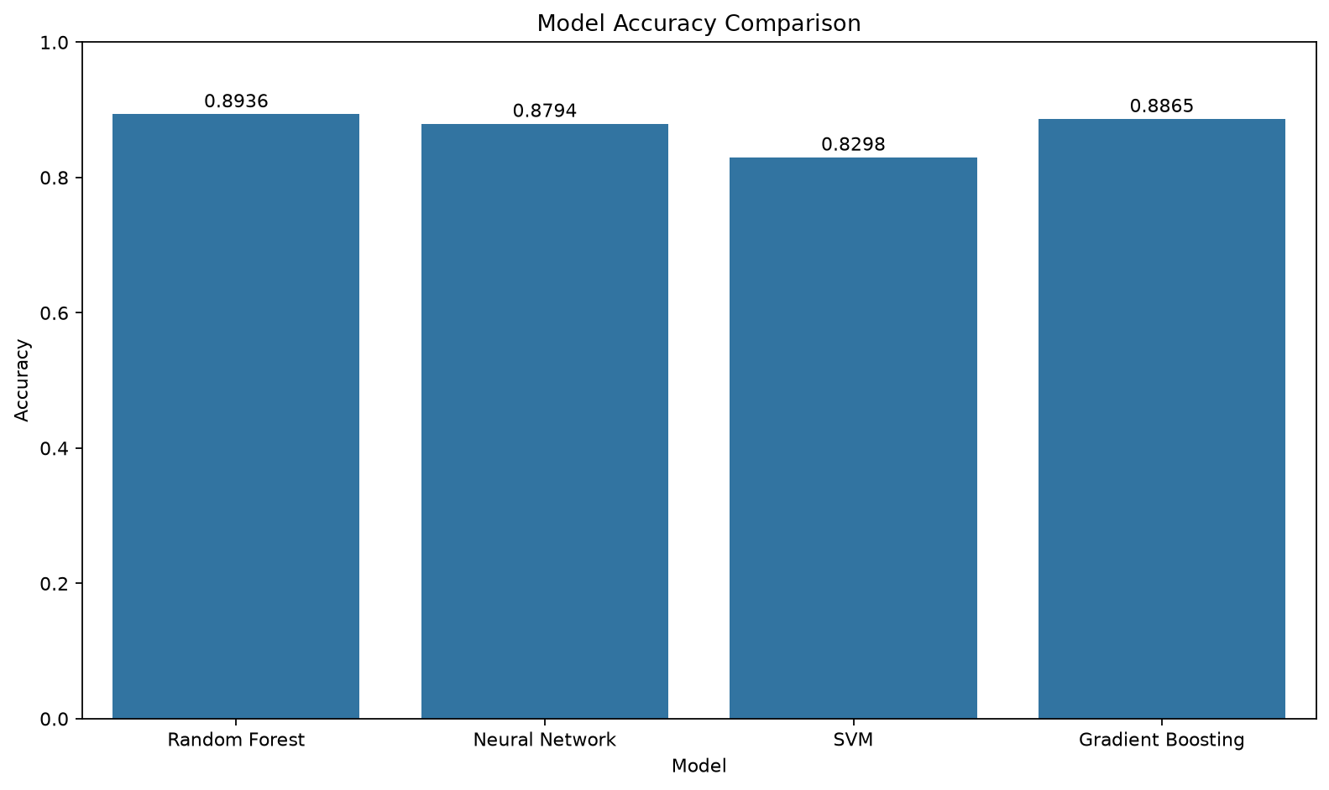
Figure 1. Accuracy comparison on the stratified held-out test set.

Confusion matrices and ROC curves
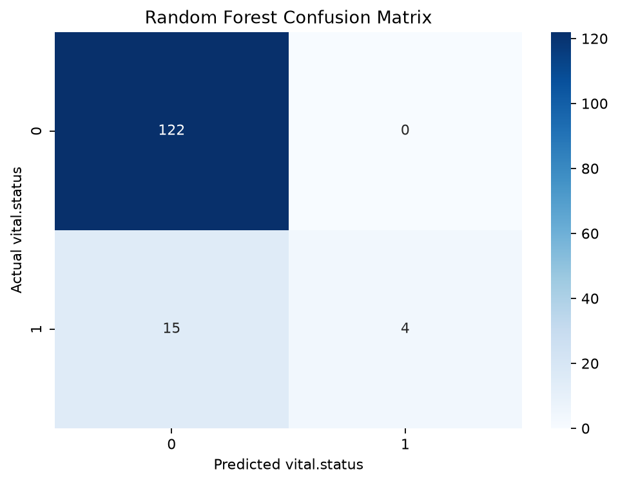
Figure 2. Random Forest confusion matrix; rows are actual labels and columns are predictions.
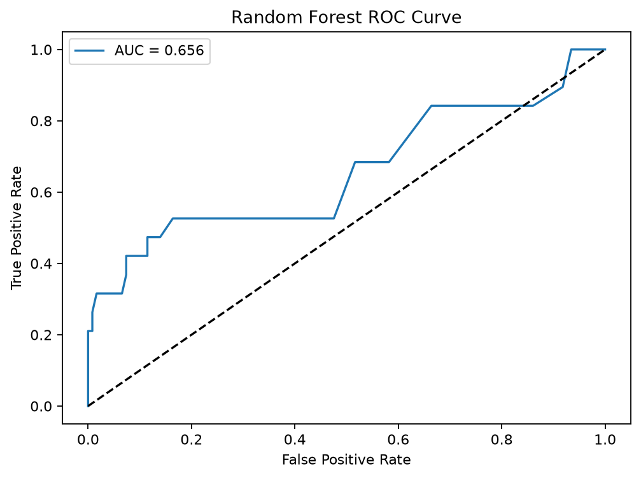
Figure 3. Random Forest ROC curve for vital.status = 1.
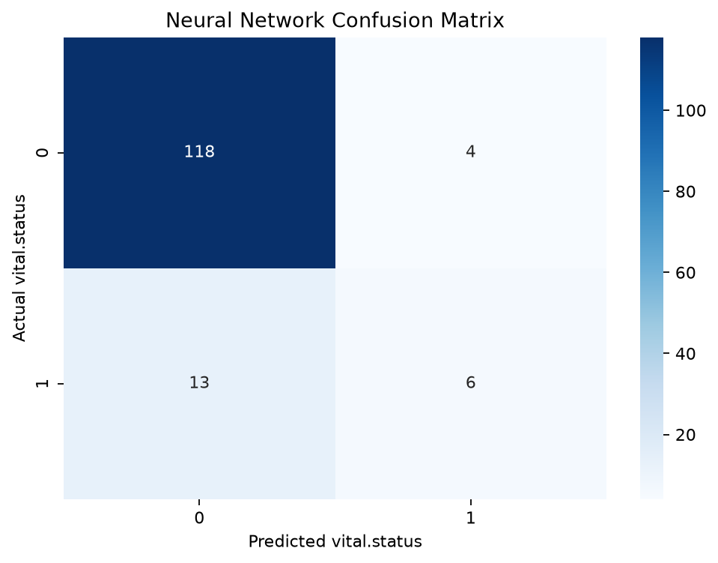
Figure 4. Neural Network confusion matrix; rows are actual labels and columns are predictions.
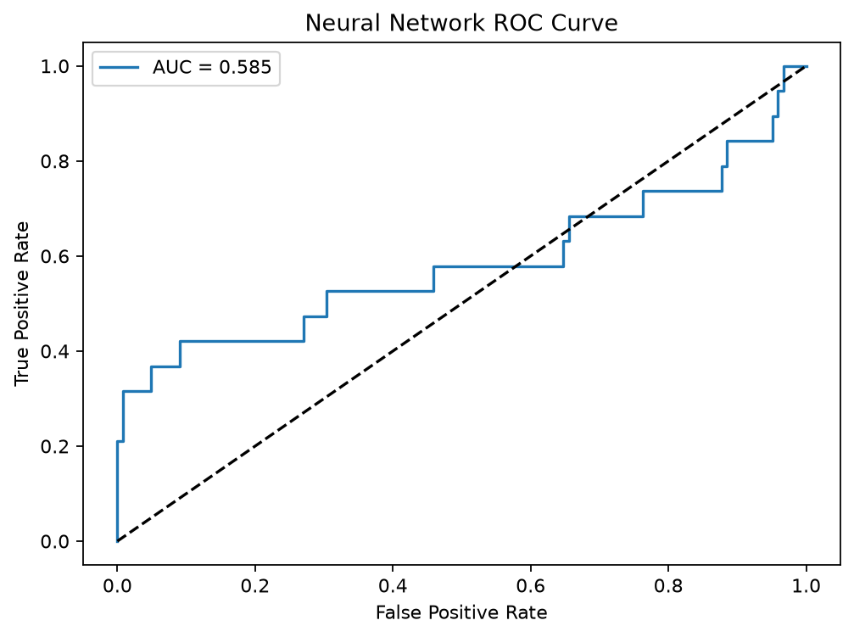
Figure 5. Neural Network ROC curve for vital.status = 1.
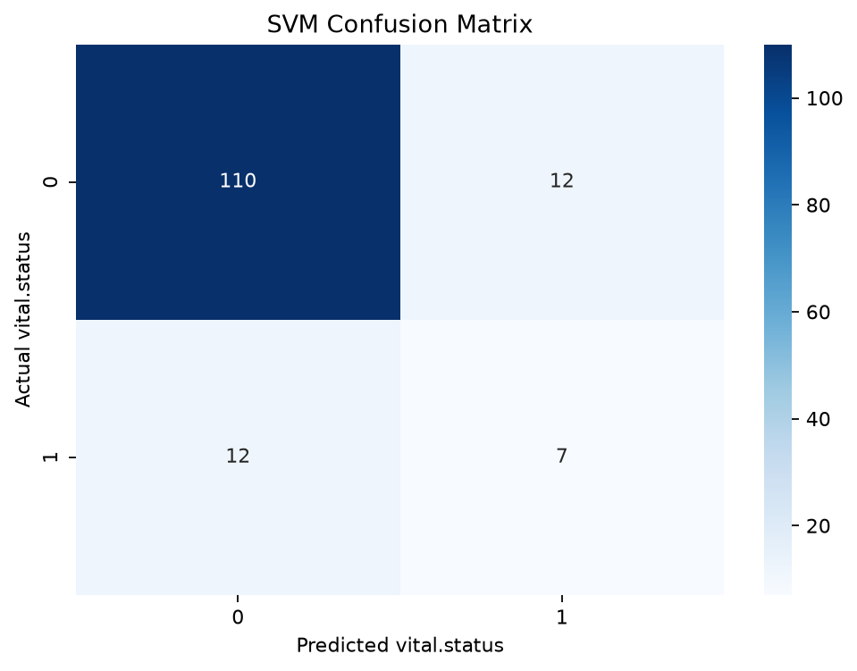
Figure 6. SVM confusion matrix; rows are actual labels and columns are predictions.
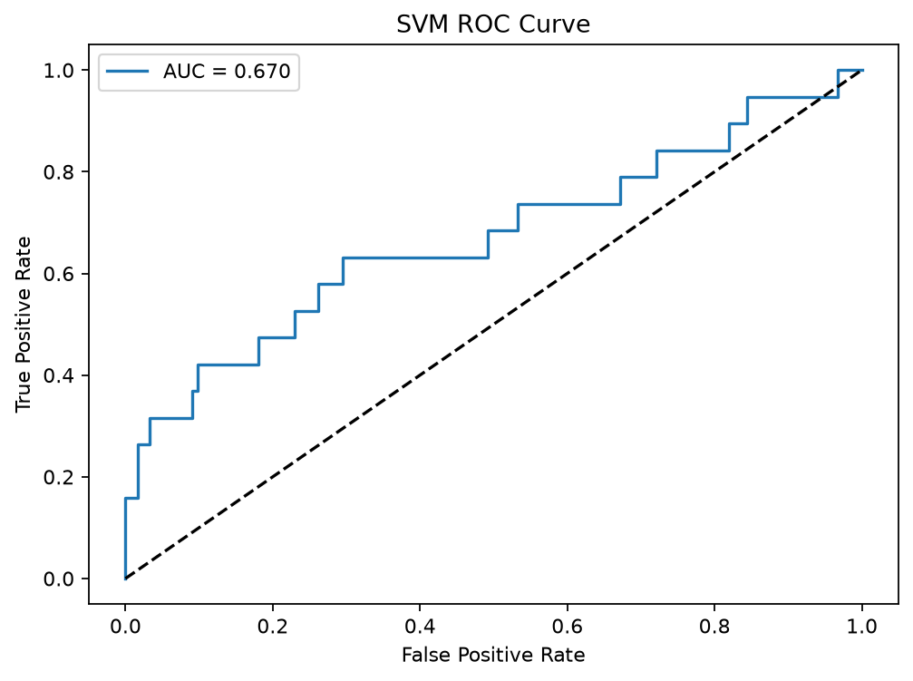
Figure 7. SVM ROC curve for vital.status = 1.
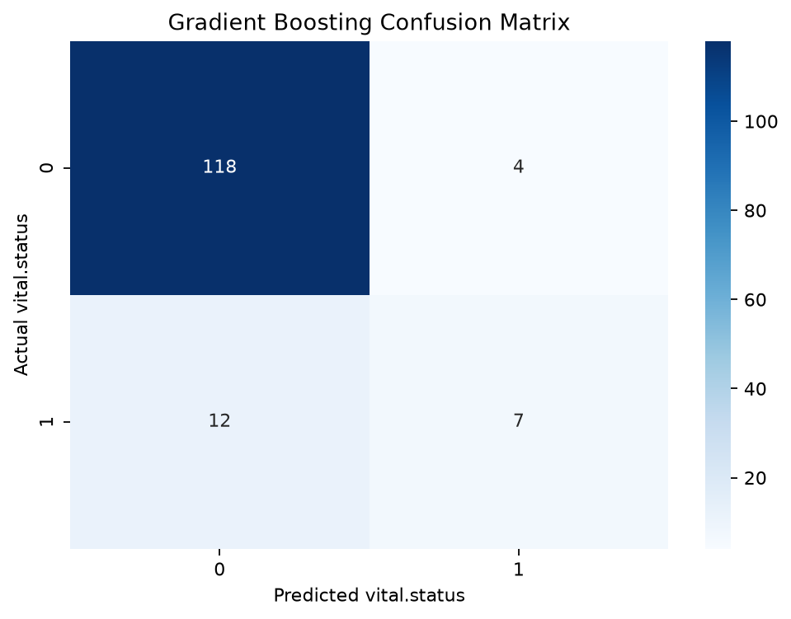
Figure 8. Gradient Boosting confusion matrix; rows are actual labels and columns are predictions.
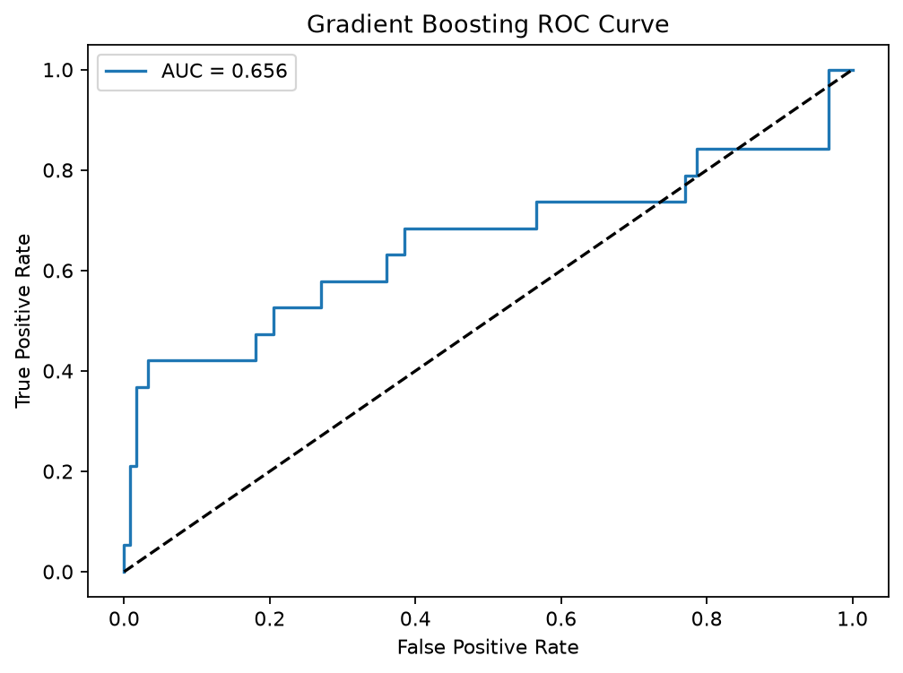
Figure 9. Gradient Boosting ROC curve for vital.status = 1.

Summary of findings
Random Forest achieved the highest accuracy (0.8936), but Gradient Boosting had the highest class-1 F1-score (0.4667) and SVM the highest ROC-AUC (0.6700). Class-1 recall was low for all four models (0.2105 to 0.3684), corresponding to 12 to 15 missed label-1 cases out of 19. The accuracy ranking alone therefore overstates performance on the minority class.
These are single-split estimates, not cross-validated or externally validated results. The executable analysis does not test early cancer detection, identify or validate biomarkers, or evaluate a clinical tool. No biomarker results are reproduced in this results section because the supplied script does not implement the analyses needed to support them.

Discussion
The held-out results show that a high overall accuracy does not guarantee useful detection of the minority outcome. Random Forest had the highest accuracy, whereas Gradient Boosting led on class-1 F1 and SVM on ROC-AUC. Class-1 recall remained between 0.2105 and 0.3684, so many positive cases were missed. In particular, these outcomes are not evidence that the system can diagnose breast cancer early: the target in the supplied CSV is vital.status, not cancer status. The submitted title is retained, but the actual executable analysis is outcome classification.

Conclusion
This reproducible analysis compared four classifiers on 705 samples using one stratified train/test split. Random Forest achieved the highest test accuracy (0.8936), but all models had limited recall for vital.status = 1. The results are exploratory and do not establish early-detection performance, biomarker validity, or clinical benefit. Future work should verify cohort provenance, evaluate patient-level data with nested cross-validation and independent external validation, address class imbalance without leakage, and report clinically relevant sensitivity, calibration, and decision measures before any clinical interpretation.

Reference:

Abadi, M. et al. (no date) ‘TensorFlow: A system for large-scale machine learning’.
Ahn, J.S. et al. (2023) ‘Artificial Intelligence in Breast Cancer Diagnosis and Personalized Medicine’, Journal of Breast Cancer, 26(5), pp. 405–435. Available at: https://doi.org/10.4048/jbc.2023.26.e45.
Bai, J.-W., Qiu, S.-Q. and Zhang, G.-J. (2023) ‘Molecular and functional imaging in cancer-targeted therapy: current applications and future directions’, Signal Transduction and Targeted Therapy, 8(1), pp. 1–32. Available at: https://doi.org/10.1038/s41392-023-01366-y.
Baldi, P. and Brunak, S. (2001) Bioinformatics: the machine learning approach. 2nd ed. Cambridge, Mass: MIT Press (Adaptive computation and machine learning).
Baylin, S.B. and Jones, P.A. (2011) ‘A decade of exploring the cancer epigenome — biological and translational implications’, Nature Reviews. Cancer, 11(10), pp. 726–734. Available at: https://doi.org/10.1038/nrc3130.
Beam, A.L., Manrai, A.K. and Ghassemi, M. (2020) ‘Challenges to the Reproducibility of Machine Learning Models in Health Care’, JAMA, 323(4), pp. 305–306. Available at: https://doi.org/10.1001/jama.2019.20866.
Berg, W.A. et al. (2012) ‘Detection of Breast Cancer With Addition of Annual Screening Ultrasound or a Single Screening MRI to Mammography in Women With Elevated Breast Cancer Risk’, JAMA, 307(13), pp. 1394–1404. Available at: https://doi.org/10.1001/jama.2012.388.
Boyd Norman F. et al. (2007) ‘Mammographic Density and the Risk and Detection of Breast Cancer’, New England Journal of Medicine, 356(3), pp. 227–236. Available at: https://doi.org/10.1056/NEJMoa062790.
Breast Biopsy | Biopsy Procedure for Breast Cancer (no date). Available at: https://www.cancer.org/cancer/types/breast-cancer/screening-tests-and-early-detection/breast-biopsy.html (Accessed: 29 June 2024).
Breast cancer (no date). Available at: https://www.who.int/news-room/fact-sheets/detail/breast-cancer (Accessed: 13 July 2024).
Breast Ultrasound (2021). Available at: https://www.hopkinsmedicine.org/health/treatment-tests-and-therapies/breast-ultrasound (Accessed: 17 July 2024).
Cai, Z. et al. (2022) ‘Machine learning for multi-omics data integration in cancer’, iScience, 25(2). Available at: https://doi.org/10.1016/j.isci.2022.103798.
Chen, J. et al. (2022) ‘Machine learning models based on immunological genes to predict the response to neoadjuvant therapy in breast cancer patients’, Frontiers in Immunology, 13. Available at: https://doi.org/10.3389/fimmu.2022.948601.
Cohen, J.D. et al. (2018) ‘Detection and localization of surgically resectable cancers with a multi-analyte blood test’, Science (New York, N.Y.), 359(6378), pp. 926–930. Available at: https://doi.org/10.1126/science.aar3247.
Dai, Y. et al. (2022) ‘Feature Selection in High Dimensional Biomedical Data Based on BF-SFLA’, Frontiers in Neuroscience, 16, p. 854685. Available at: https://doi.org/10.3389/fnins.2022.854685.
Dan, Q. et al. (2023) ‘Ultrasound for Breast Cancer Screening in Resource-Limited Settings: Current Practice and Future Directions’, Cancers, 15(7), p. 2112. Available at: https://doi.org/10.3390/cancers15072112.
Dawson Sarah-Jane et al. (2013) ‘Analysis of Circulating Tumor DNA to Monitor Metastatic Breast Cancer’, New England Journal of Medicine, 368(13), pp. 1199–1209. Available at: https://doi.org/10.1056/NEJMoa1213261.
Dense Breasts: Answers to Commonly Asked Questions - NCI (2018). Available at: https://www.cancer.gov/types/breast/breast-changes/dense-breasts (Accessed: 17 July 2024).
Edge, S.B. and American Joint Committee on Cancer (eds) (2010) AJCC cancer staging manual. 7th ed. New York, NY: Springer.
From data to diagnosis: how machine learning is revolutionizing biomarker discovery in idiopathic inflammatory myopathies | Briefings in Bioinformatics | Oxford Academic (no date). Available at: https://academic.oup.com/bib/article/25/1/bbad514/7571389# (Accessed: 17 July 2024).
Garrison, E. and Marth, G. (no date) ‘Haplotype-based variant detection from short-read sequencing’.
Gomez-Cabrero, D. et al. (2014) ‘Data integration in the era of omics: current and future challenges’, BMC Systems Biology, 8(2), p. I1. Available at: https://doi.org/10.1186/1752-0509-8-S2-I1.
Gonen, M. et al. (no date) ‘Multiple Kernel Learning Algorithms’.
Gstaiger, M. and Aebersold, R. (2009) ‘Applying mass spectrometry-based proteomics to genetics, genomics and network biology’, Nature Reviews Genetics, 10(9), pp. 617–627. Available at: https://doi.org/10.1038/nrg2633.
Habehh, H. and Gohel, S. (2021) ‘Machine Learning in Healthcare’, Current Genomics, 22(4), pp. 291–300. Available at: https://doi.org/10.2174/1389202922666210705124359.
Hanahan, D. and Weinberg, R.A. (2011) ‘Hallmarks of Cancer: The Next Generation’, Cell, 144(5), pp. 646–674. Available at: https://doi.org/10.1016/j.cell.2011.02.013.
Hasin, Y., Seldin, M. and Lusis, A. (2017a) ‘Multi-omics approaches to disease’, Genome Biology, 18(1), p. 83. Available at: https://doi.org/10.1186/s13059-017-1215-1.
Hasin, Y., Seldin, M. and Lusis, A. (2017b) ‘Multi-omics approaches to disease’, Genome Biology, 18(1), p. 83. Available at: https://doi.org/10.1186/s13059-017-1215-1.
Heo, Y.J. et al. (2021) ‘Integrative Multi-Omics Approaches in Cancer Research: From Biological Networks to Clinical Subtypes’, Molecules and Cells, 44(7), pp. 433–443. Available at: https://doi.org/10.14348/molcells.2021.0042.
Huang, Z. et al. (2010) ‘Cancer stem cells in glioblastoma—molecular signaling and therapeutic targeting’, Protein & Cell, 1(7), pp. 638–655. Available at: https://doi.org/10.1007/s13238-010-0078-y.
Huber, W. et al. (2015) ‘Orchestrating high-throughput genomic analysis with Bioconductor’, Nature Methods, 12(2), pp. 115–121. Available at: https://doi.org/10.1038/nmeth.3252.
Ivanisevic, T. and Sewduth, R.N. (2023) ‘Multi-Omics Integration for the Design of Novel Therapies and the Identification of Novel Biomarkers’, Proteomes, 11(4), p. 34. Available at: https://doi.org/10.3390/proteomes11040034.
Kang, M., Ko, E. and Mersha, T.B. (2021) ‘A roadmap for multi-omics data integration using deep learning’, Briefings in Bioinformatics, 23(1), p. bbab454. Available at: https://doi.org/10.1093/bib/bbab454.
Karczewski, K.J. and Snyder, M.P. (2018) ‘Integrative omics for health and disease’, Nature Reviews. Genetics, 19(5), pp. 299–310. Available at: https://doi.org/10.1038/nrg.2018.4.
Kerlikowske, K. et al. (2015) ‘Identifying Women with Dense Breasts at Highi Risk of Interval Cancers’, Annals of internal medicine, 162(10), pp. 673–681. Available at: https://doi.org/10.7326/M14-1465.
King, M.-C., Marks, J.H. and Mandell, J.B. (2003) ‘Breast and Ovarian Cancer Risks Due to Inherited Mutations in BRCA1 and BRCA2’, Science, 302(5645), pp. 643–646. Available at: https://doi.org/10.1126/science.1088759.
Koboldt, D.C. et al. (2012) ‘Comprehensive molecular portraits of human breast tumours’, Nature, 490(7418), pp. 61–70. Available at: https://doi.org/10.1038/nature11412.
Kourou, K. et al. (2021) ‘Applied machine learning in cancer research: A systematic review for patient diagnosis, classification and prognosis’, Computational and Structural Biotechnology Journal, 19, pp. 5546–5555. Available at: https://doi.org/10.1016/j.csbj.2021.10.006.
LeCun, Y., Bengio, Y. and Hinton, G. (2015) ‘Deep learning’, Nature, 521(7553), pp. 436–444. Available at: https://doi.org/10.1038/nature14539.
Love, M.I., Huber, W. and Anders, S. (2014) ‘Moderated estimation of fold change and dispersion for RNA-seq data with DESeq2’, Genome Biology, 15(12), p. 550. Available at: https://doi.org/10.1186/s13059-014-0550-8.
Mahyoub, M.A. et al. (2023) ‘Development and validation of a machine learning model integrated with the clinical workflow for early detection of sepsis’, Frontiers in Medicine, 10. Available at: https://doi.org/10.3389/fmed.2023.1284081.
McDermott, M.B.A. et al. (no date) ‘Reproducibility in Machine Learning for Health’.
Nelson, H.D. et al. (2016) ‘Effectiveness of Breast Cancer Screening: Systematic Review and Meta-analysis to Update the 2009 U.S. Preventive Services Task Force Recommendation’, Annals of Internal Medicine, 164(4), pp. 244–255. Available at: https://doi.org/10.7326/M15-0969.
Ng, S. et al. (2023) ‘The benefits and pitfalls of machine learning for biomarker discovery’, Cell and Tissue Research, 394(1), pp. 17–31. Available at: https://doi.org/10.1007/s00441-023-03816-z.
Pedregosa, F. et al. (no date) ‘Scikit-learn: Machine Learning in Python’, MACHINE LEARNING IN PYTHON [Preprint].
Perou, C.M. et al. (2000a) ‘Molecular portraits of human breast tumours’, Nature, 406(6797), pp. 747–752. Available at: https://doi.org/10.1038/35021093.
Perou, C.M. et al. (2000b) ‘Molecular portraits of human breast tumours’, Nature, 406(6797), pp. 747–752. Available at: https://doi.org/10.1038/35021093.
PhD, S.C.L., MD and MD, D.G.H. (2016) Diagnostic Pathology: Breast. Elsevier Health Sciences.
Pinker, K., Helbich, T.H. and Morris, E.A. (no date) ‘The potential of multiparametric MRI of the breast’, The British Journal of Radiology, 90(1069), p. 20160715. Available at: https://doi.org/10.1259/bjr.20160715.
Pratella, D. et al. (2021) ‘A Survey of Autoencoder Algorithms to Pave the Diagnosis of Rare Diseases’, International Journal of Molecular Sciences, 22(19), p. 10891. Available at: https://doi.org/10.3390/ijms221910891.
Ritchie, M.D. et al. (2015) ‘Methods of integrating data to uncover genotype–phenotype interactions’, Nature Reviews Genetics, 16(2), pp. 85–97. Available at: https://doi.org/10.1038/nrg3868.
Rohart, F. et al. (2017) ‘mixOmics: An R package for ‘omics feature selection and multiple data integration’, PLoS Computational Biology, 13(11), p. e1005752. Available at: https://doi.org/10.1371/journal.pcbi.1005752.
Shannon, P. et al. (2003) ‘Cytoscape: A Software Environment for Integrated Models of Biomolecular Interaction Networks’, Genome Research, 13(11), pp. 2498–2504. Available at: https://doi.org/10.1101/gr.1239303.
Siegel, R.L., Miller, K.D. and Jemal, A. (2020) ‘Cancer statistics, 2020’, CA: A Cancer Journal for Clinicians, 70(1), pp. 7–30. Available at: https://doi.org/10.3322/caac.21590.
Subramanian, I. et al. (2020) ‘Multi-omics Data Integration, Interpretation, and Its Application’, Bioinformatics and Biology Insights, 14, p. 1177932219899051. Available at: https://doi.org/10.1177/1177932219899051.
Tabár, L. et al. (2011) ‘Swedish two-county trial: impact of mammographic screening on breast cancer mortality during 3 decades’, Radiology, 260(3), pp. 658–663. Available at: https://doi.org/10.1148/radiol.11110469.
Tibshirani, R. (1996) ‘Regression Shrinkage and Selection Via the Lasso’, Journal of the Royal Statistical Society Series B: Statistical Methodology, 58(1), pp. 267–288. Available at: https://doi.org/10.1111/j.2517-6161.1996.tb02080.x.
Villanueva, A.G. et al. (2019) ‘Genomic Data-Sharing Practices’, The Journal of law, medicine & ethics : a journal of the American Society of Law, Medicine & Ethics, 47(1), pp. 31–40. Available at: https://doi.org/10.1177/1073110519840482.
Wang, B. et al. (2014) ‘Similarity network fusion for aggregating data types on a genomic scale’, Nature Methods, 11(3), pp. 333–337. Available at: https://doi.org/10.1038/nmeth.2810.
Weinstein, J.N. et al. (2013) ‘The Cancer Genome Atlas Pan-Cancer analysis project’, Nature Genetics, 45(10), pp. 1113–1120. Available at: https://doi.org/10.1038/ng.2764.
Wekesa, J.S. and Kimwele, M. (2023) ‘A review of multi-omics data integration through deep learning approaches for disease diagnosis, prognosis, and treatment’, Frontiers in Genetics, 14. Available at: https://doi.org/10.3389/fgene.2023.1199087.
Wickham, H. (2016) ‘Modelling for Visualisation’, in H. Wickham (ed.) ggplot2: Elegant Graphics for Data Analysis. Cham: Springer International Publishing, pp. 221–240. Available at: https://doi.org/10.1007/978-3-319-24277-4_11.
Witten, D.M., Tibshirani, R. and Hastie, T. (2009) ‘A penalized matrix decomposition, with applications to sparse principal components and canonical correlation analysis’, Biostatistics, 10(3), pp. 515–534. Available at: https://doi.org/10.1093/biostatistics/kxp008.
Witten, D.M. and Tibshirani, R.J. (2009) ‘Extensions of sparse canonical correlation analysis with applications to genomic data’, Statistical Applications in Genetics and Molecular Biology, 8(1), p. Article28. Available at: https://doi.org/10.2202/1544-6115.1470.
Yersal, O. and Barutca, S. (2014) ‘Biological subtypes of breast cancer: Prognostic and therapeutic implications’, World Journal of Clinical Oncology, 5(3), pp. 412–424. Available at: https://doi.org/10.5306/wjco.v5.i3.412.
Zhang, B. et al. (2014) ‘Proteogenomic characterization of human colon and rectal cancer’, Nature, 513(7518), pp. 382–387. Available at: https://doi.org/10.1038/nature13438.
Zhang, L. et al. (2018) ‘Deep Learning-Based Multi-Omics Data Integration Reveals Two Prognostic Subtypes in High-Risk Neuroblastoma’, Frontiers in Genetics, 9. Available at: https://doi.org/10.3389/fgene.2018.00477.
Zitnik, M. et al. (2019) ‘Machine Learning for Integrating Data in Biology and Medicine: Principles, Practice, and Opportunities’, An international journal on information fusion, 50, pp. 71–91. Available at: https://doi.org/10.1016/j.inffus.2018.09.012.

