

NAME | SOHAIL ZULFIQAR
REGISTERATION ID | 578135
EMAIL | szulfiqar.ms25igis@student.nust.edu.pk
PROGRAM | MS GIS & RS - 2025
SUBJECT | Web GIS
INSTRUCTOR | Dr. Shahid Nawaz
SUBMISSION TYPE | Assignment -1 (First Web Map)
GitHub URL | https://github.com/sohailzulfiqarrao/webgis-ms25igis-578135
Live Pages URL | https://sohailzulfiqarrao.github.io/webgis-ms25igis-578135/

Institute of Geographical Information Systems (IGIS)
School of Civil and Environmental Engineering (SCEE)
National University of Sciences and Technology (NUST)
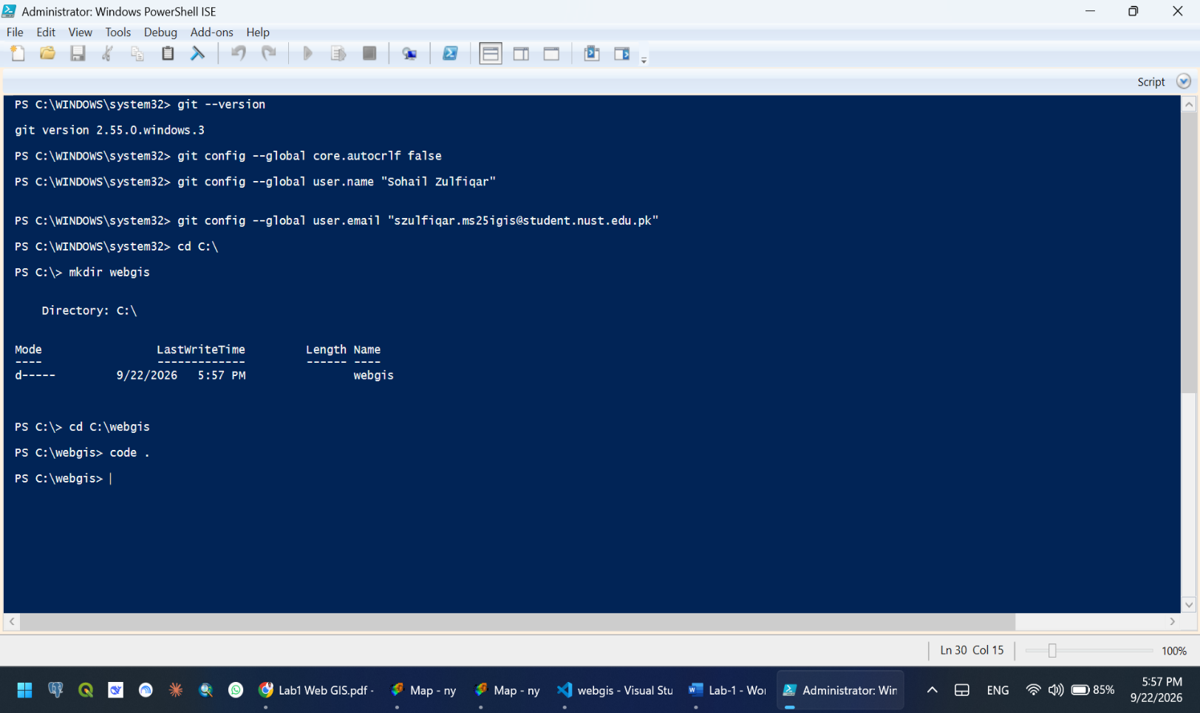
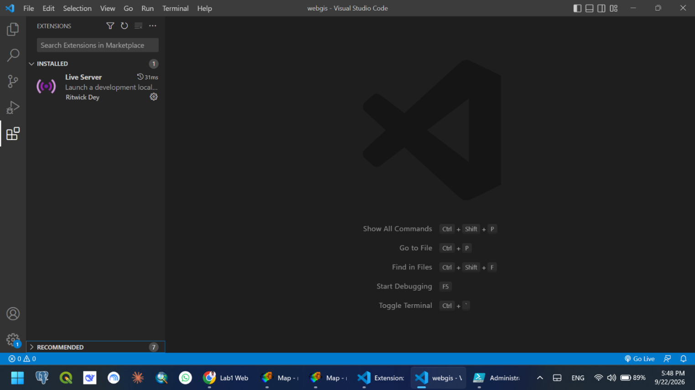
- Git Configuration and Project Folder
- Live Server Extension in Visual Studio

- CHECKPOINT-1
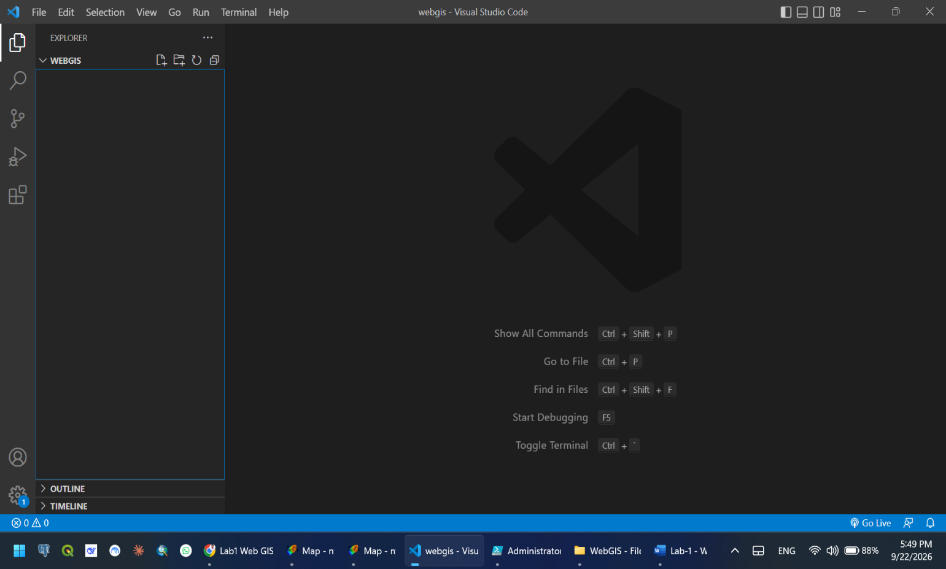
empty C:\webgis folder open in the Explorer
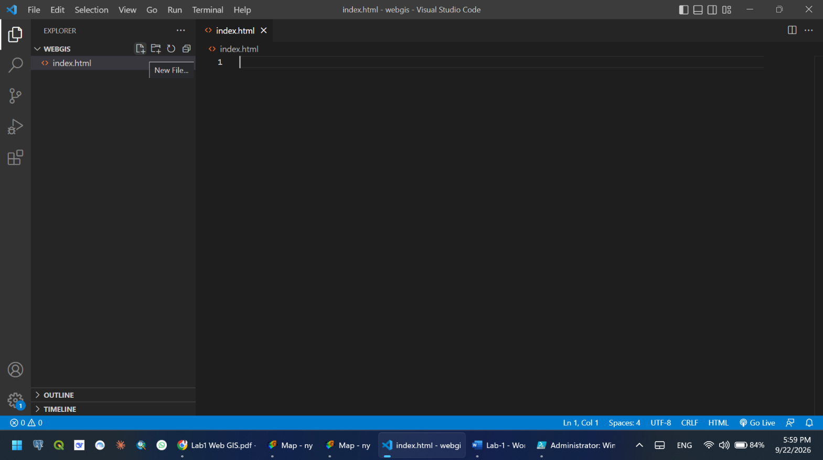
- Creating index.html file
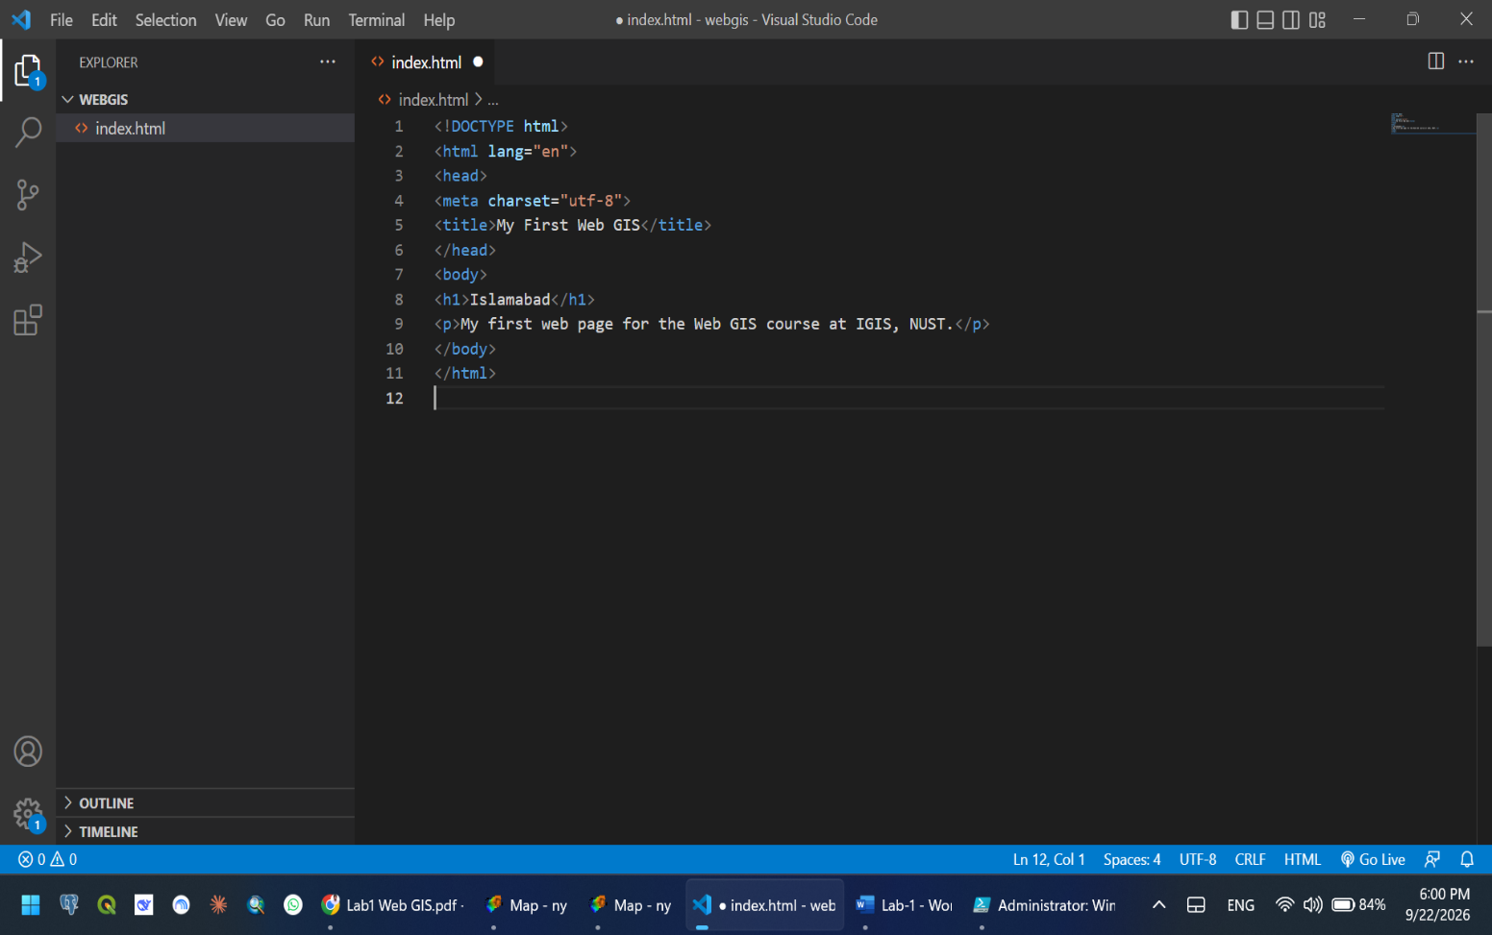
- Type the Code in the file.
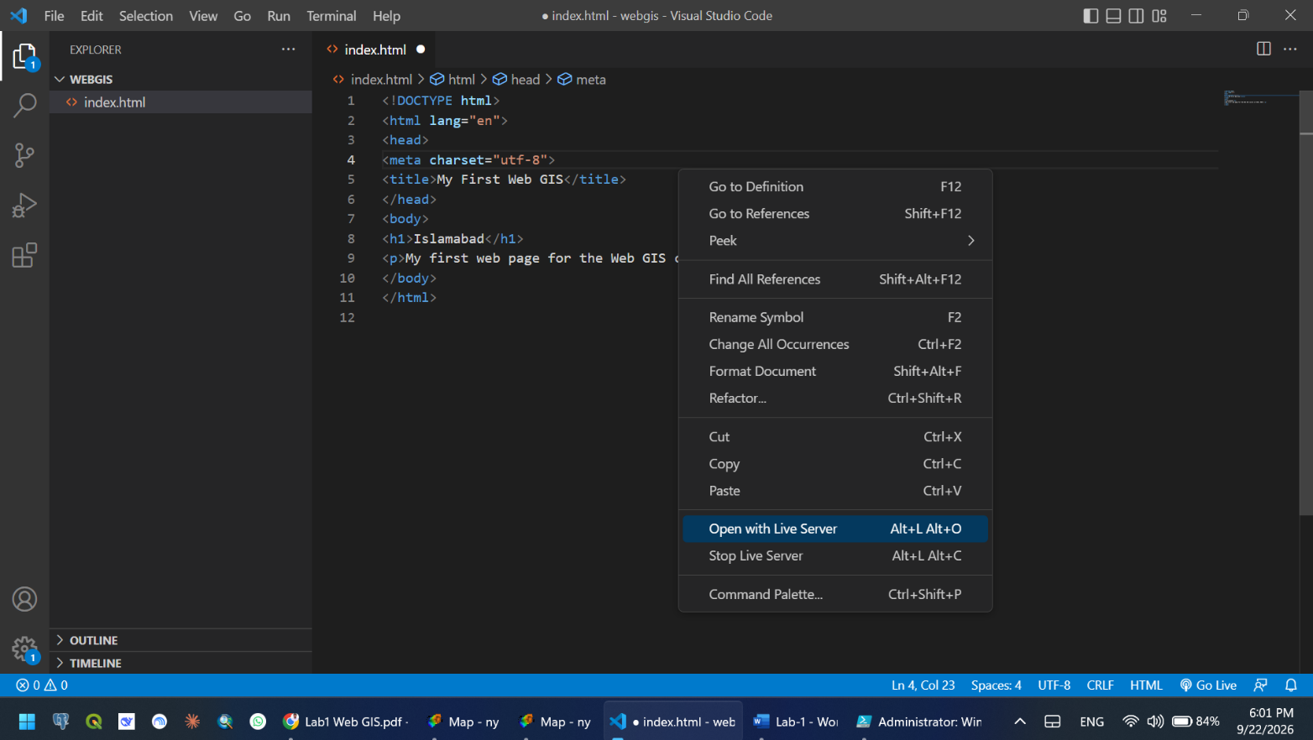
- Open with Live Server to view the page
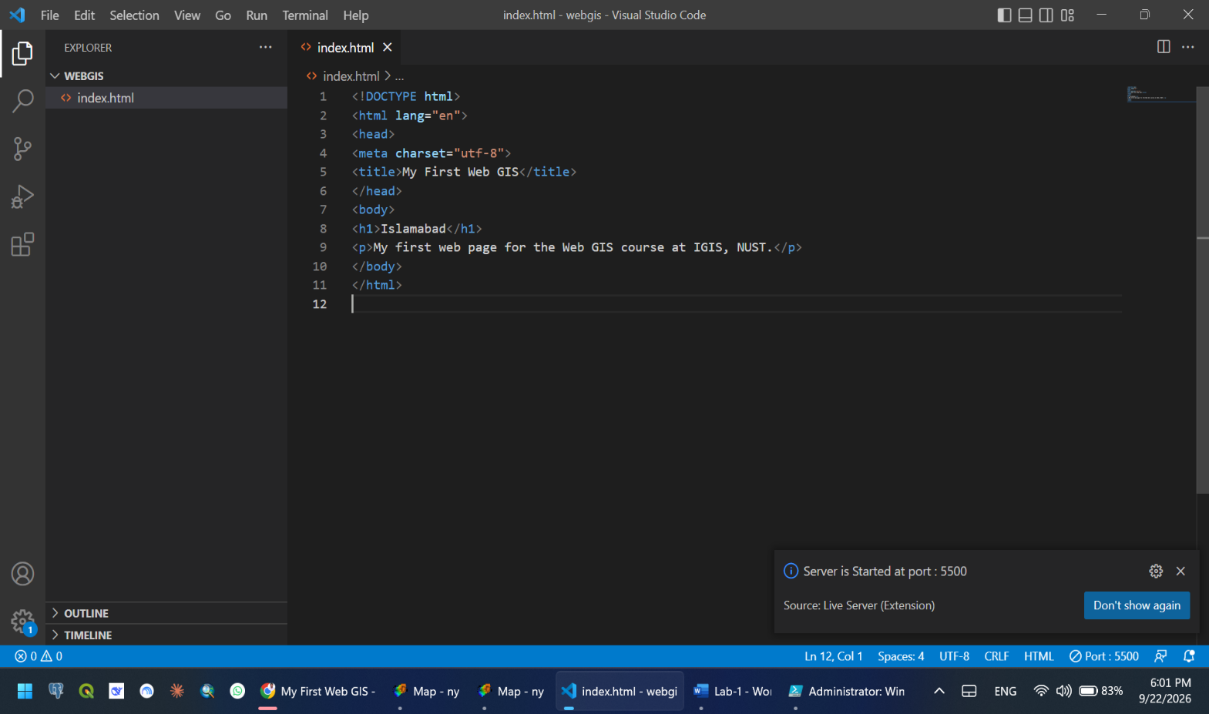
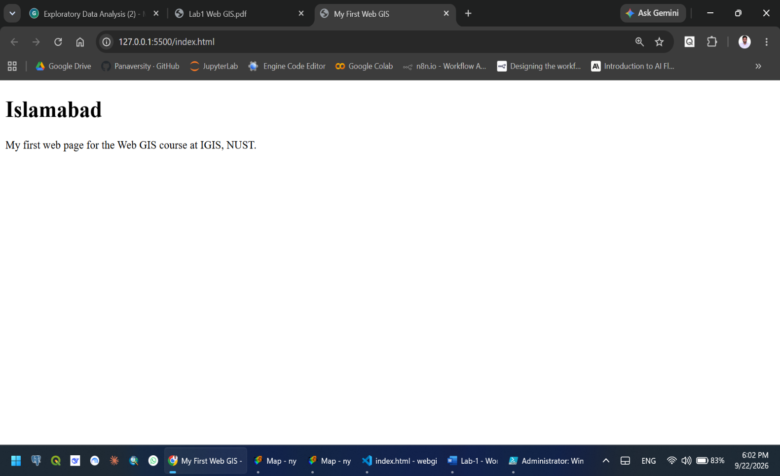
CHECKPOINT-2
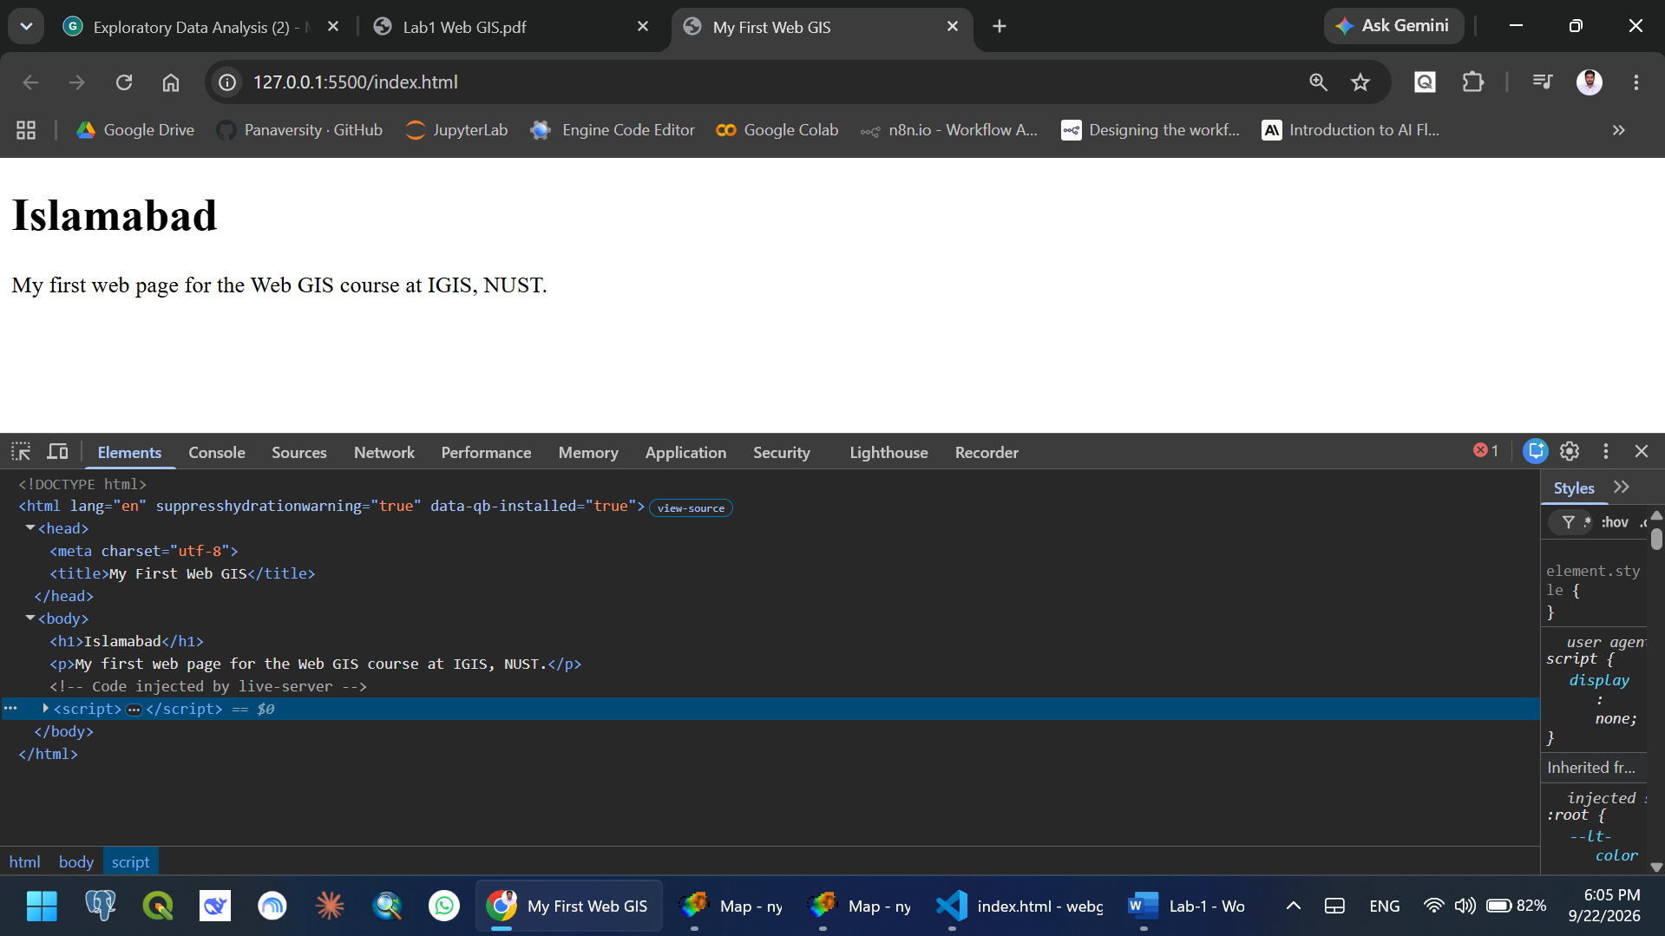
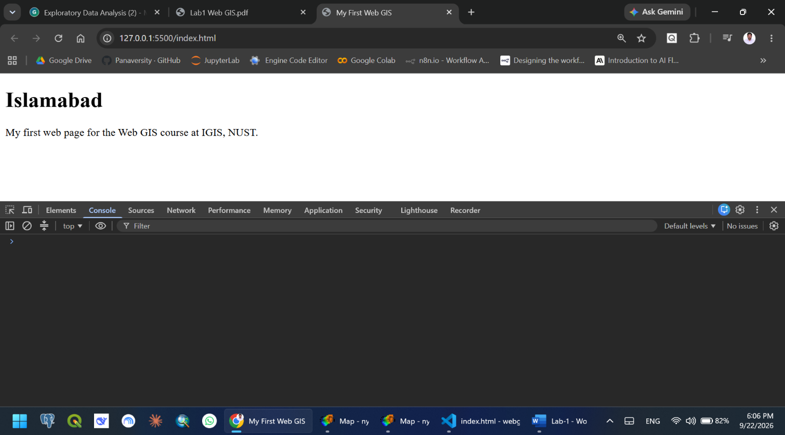
- Developers Tools – Elements Tab

- Developers Tools – Console Tab
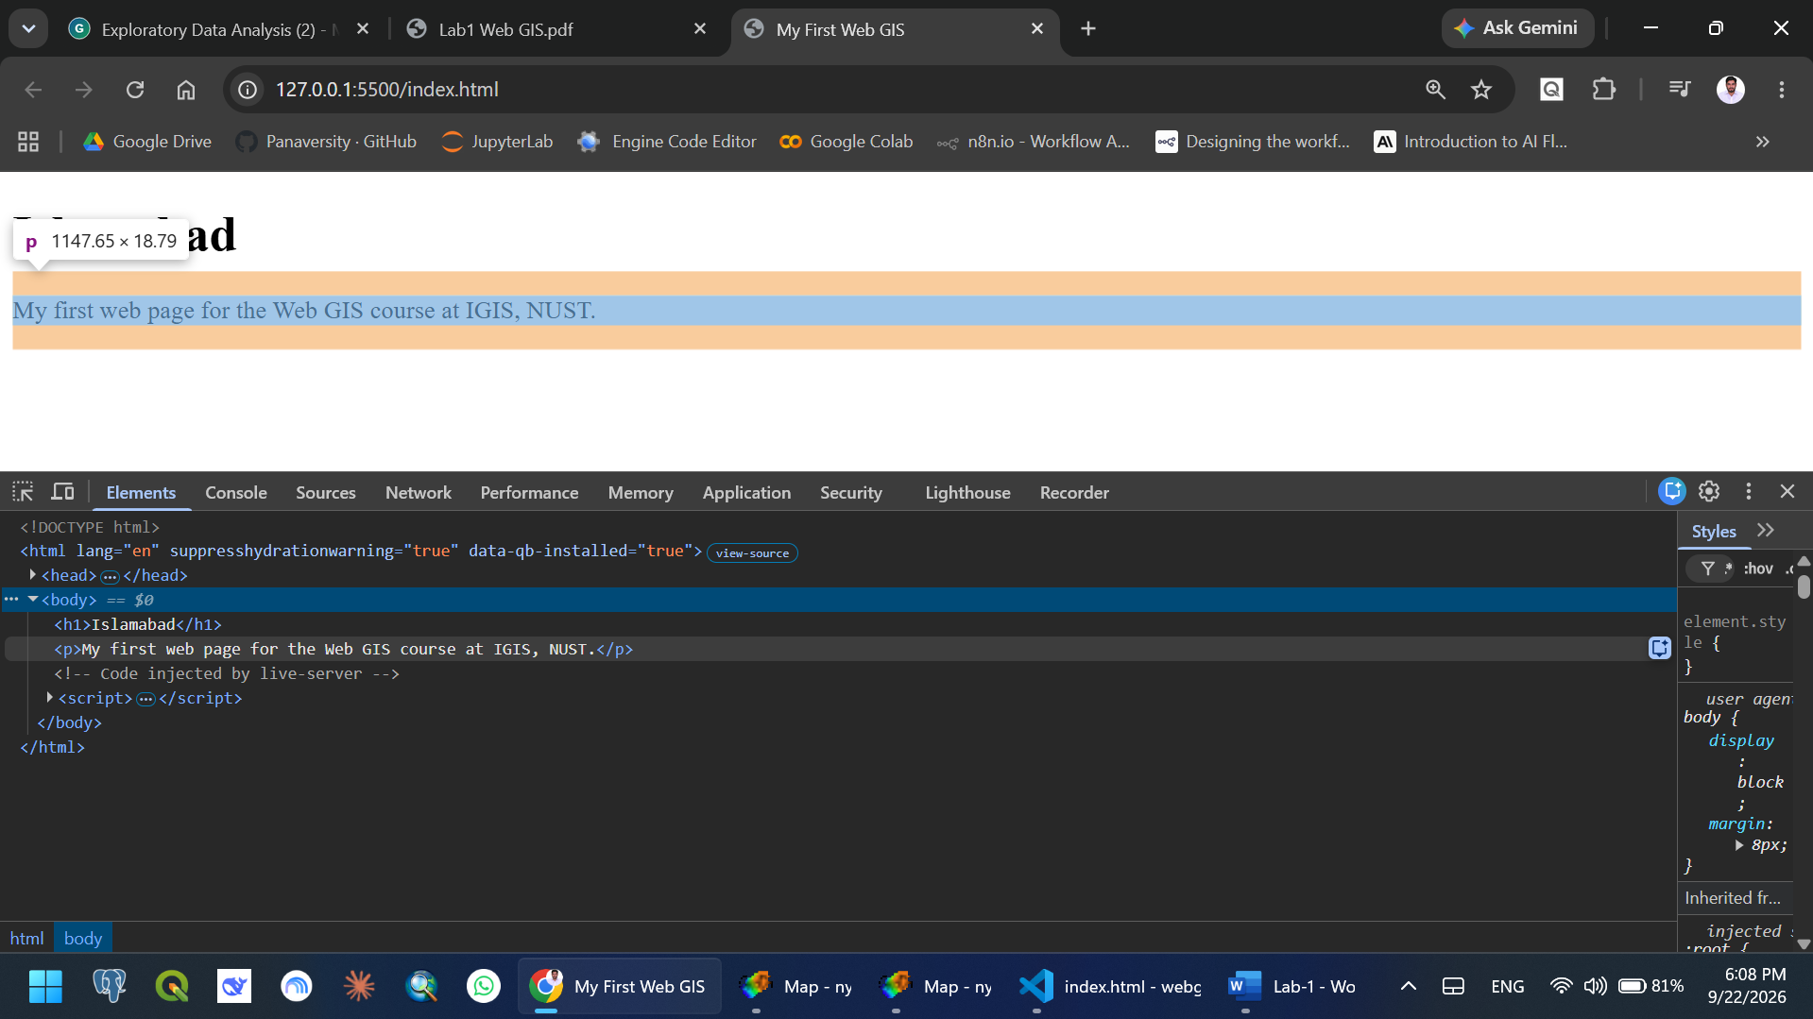
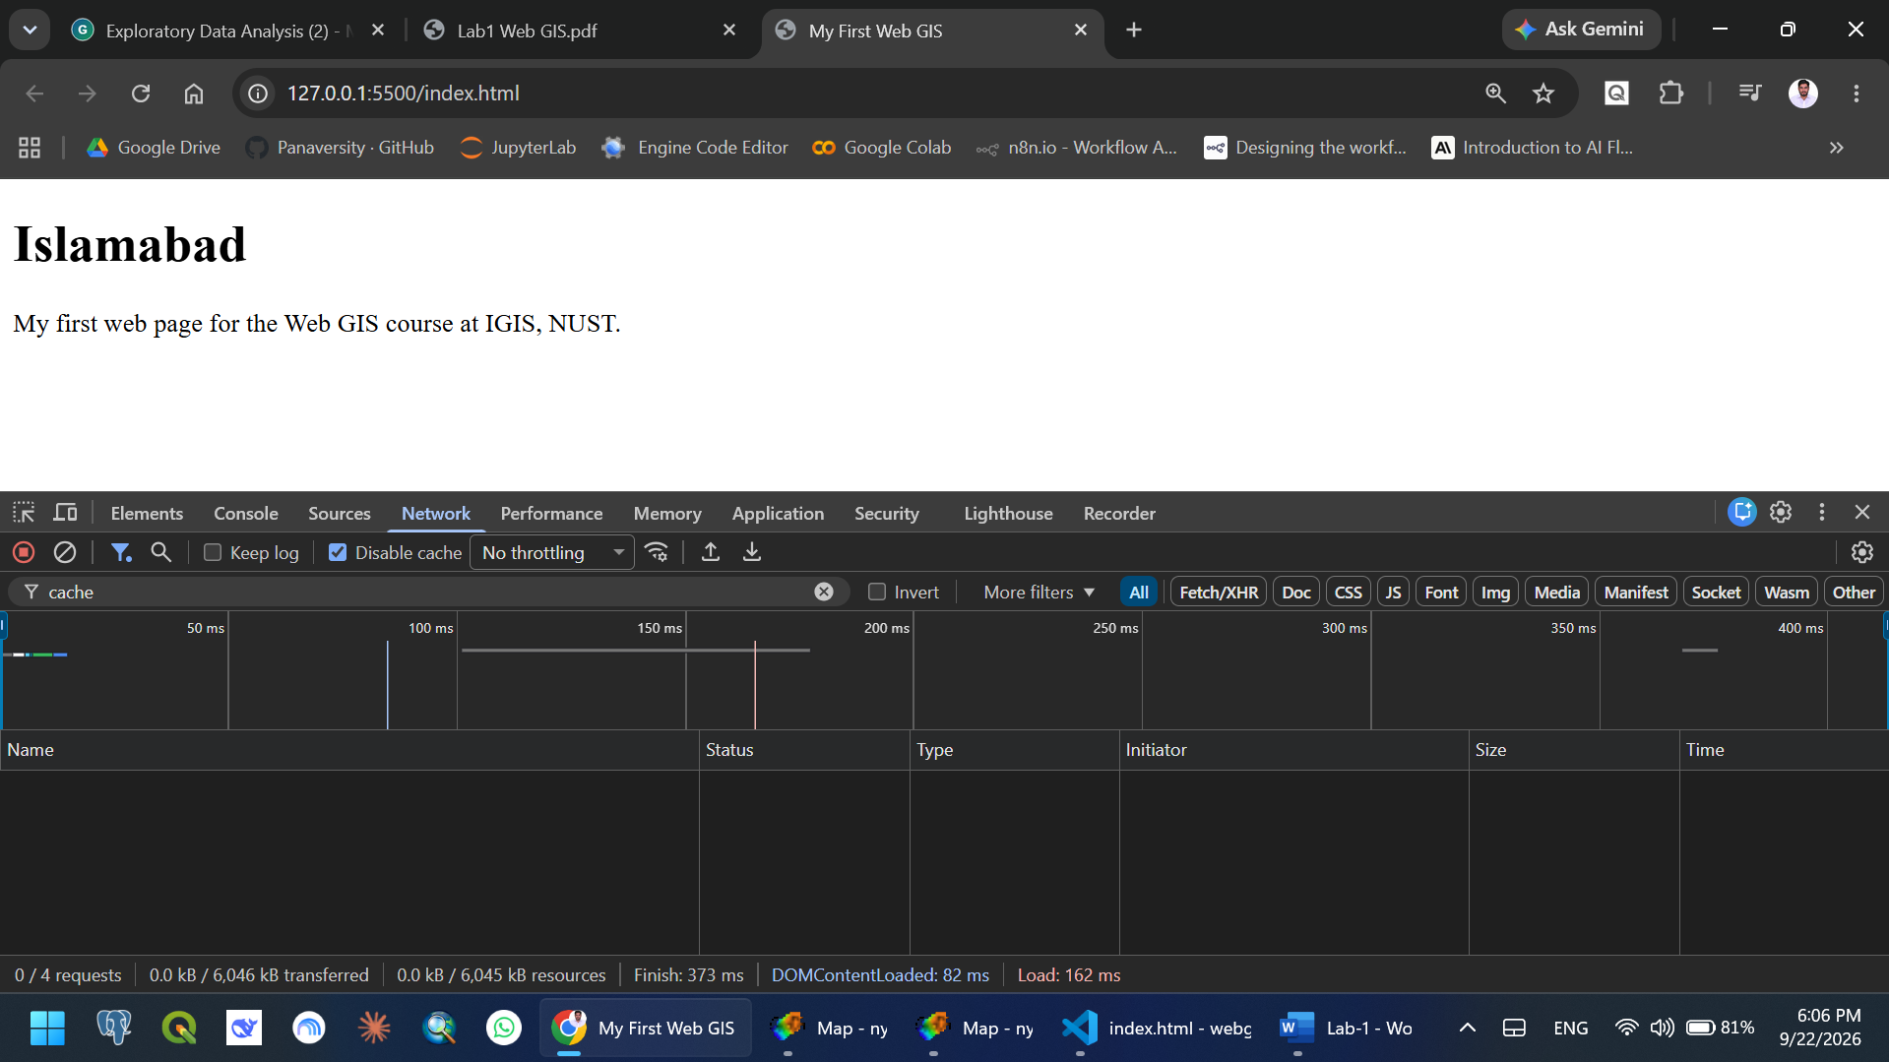
- Developers Tools – Network Tab

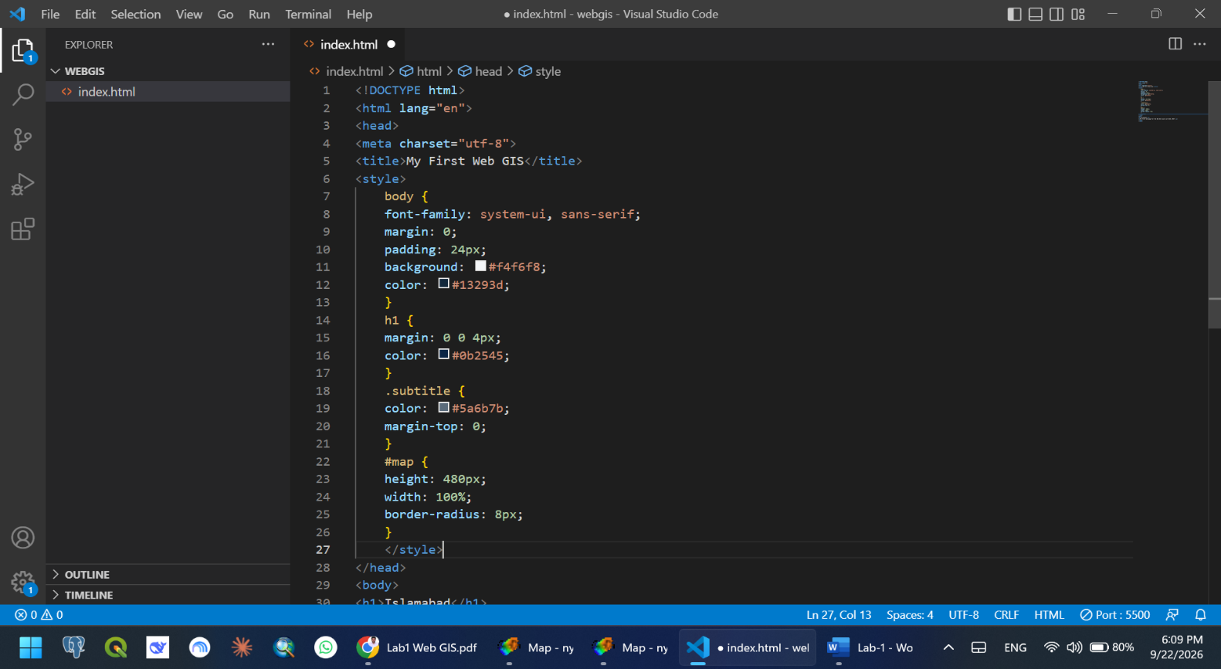
- Styling with CSS

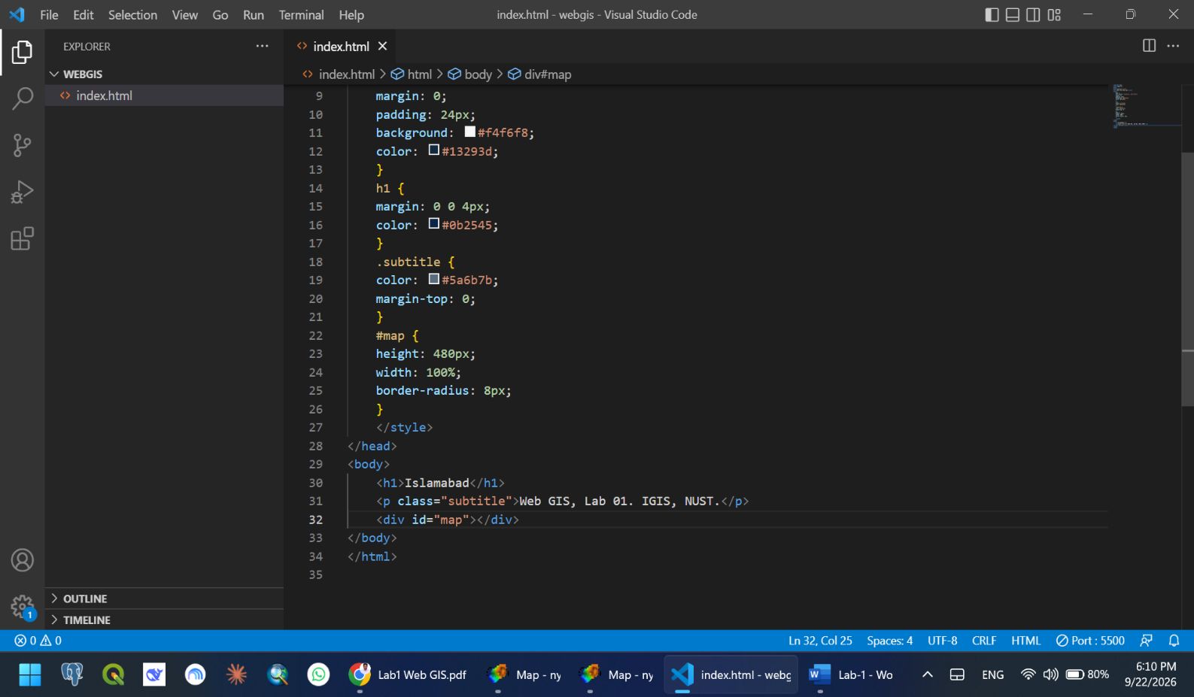
- Add Map Container
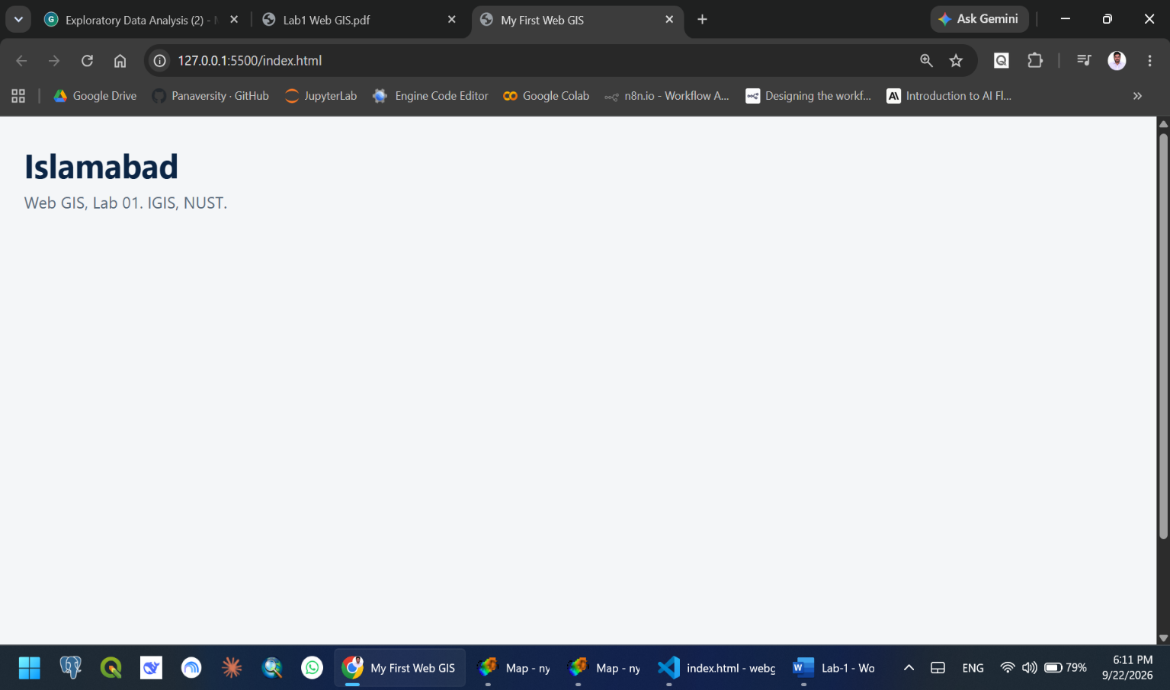
CHECKPOINT 3
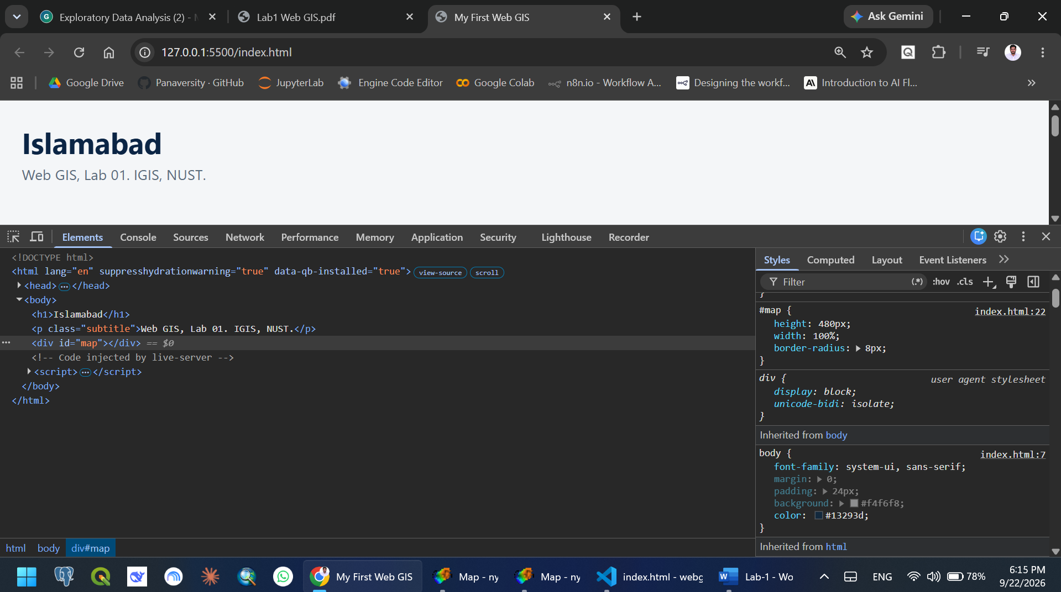
- Inspect Your Own CSS
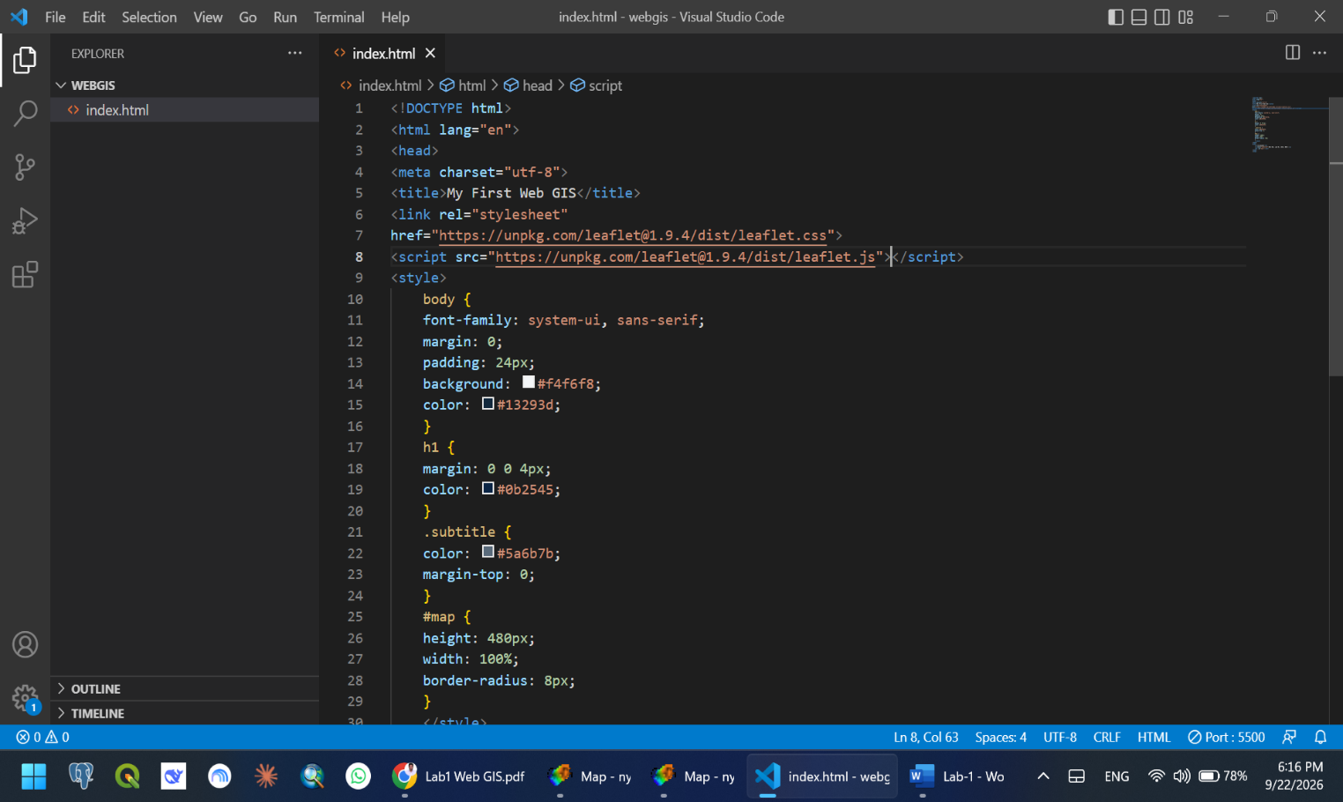
- Load the Leaflet Library
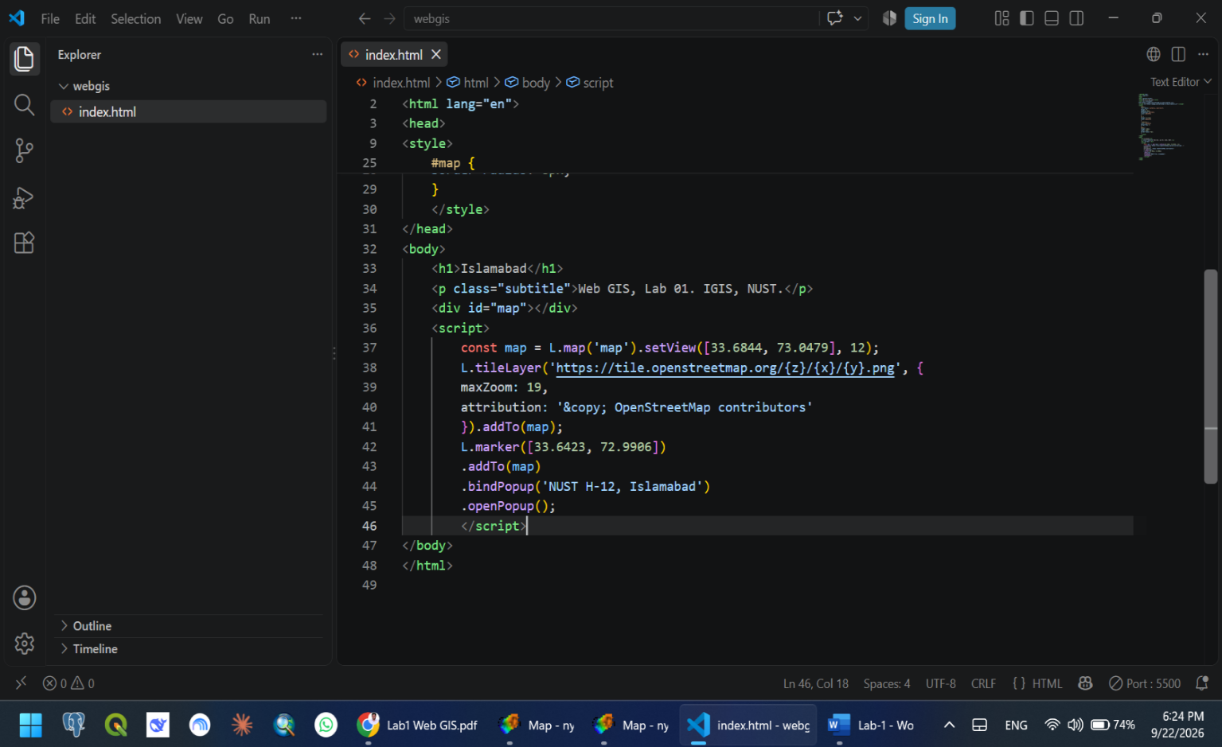
- Add the Script
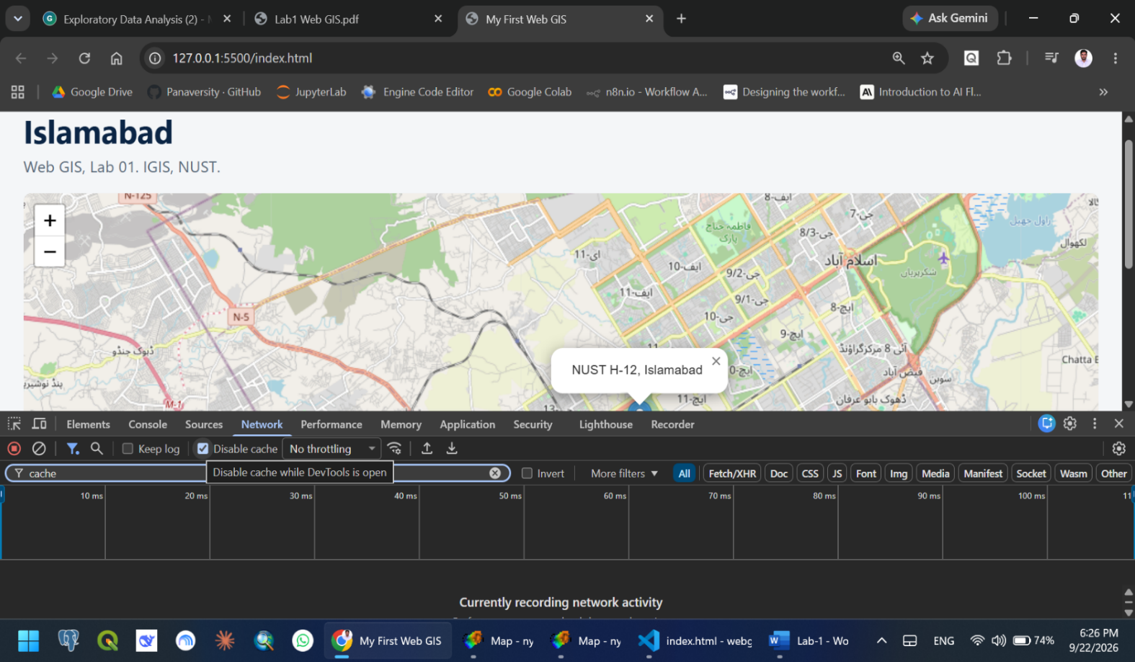
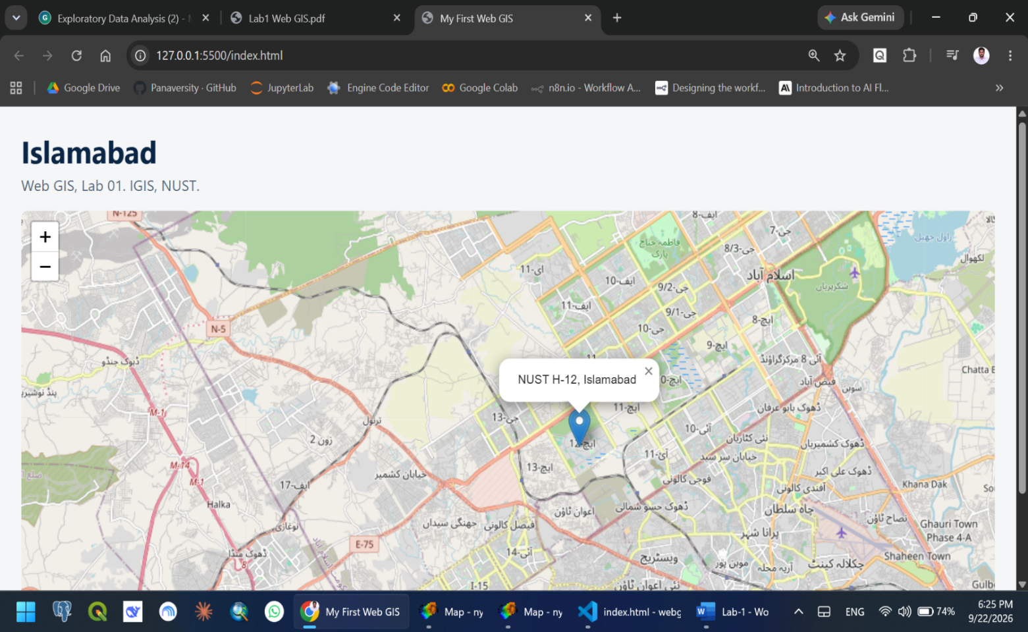
- Viewing the Map
CHECKPOINT-4
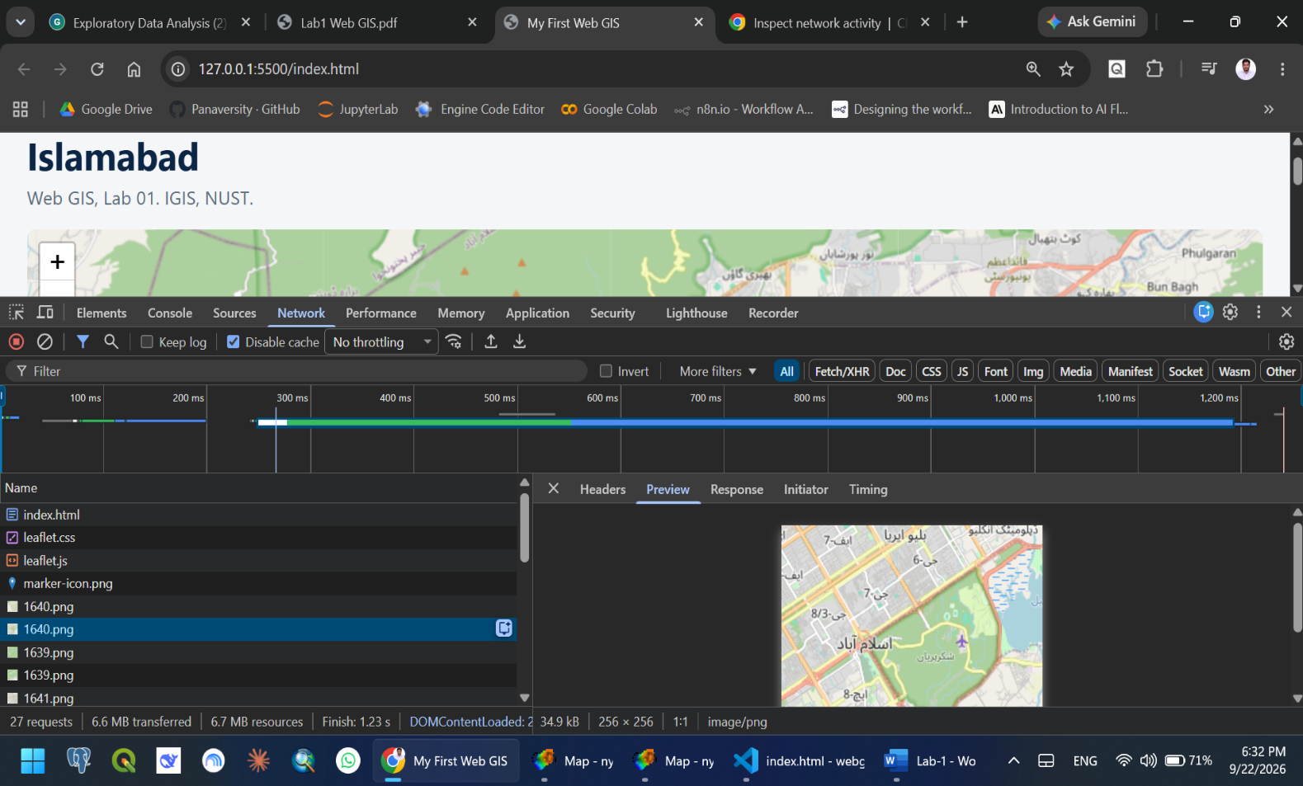
- Developer ToolsNetwork Tab Preview PNG
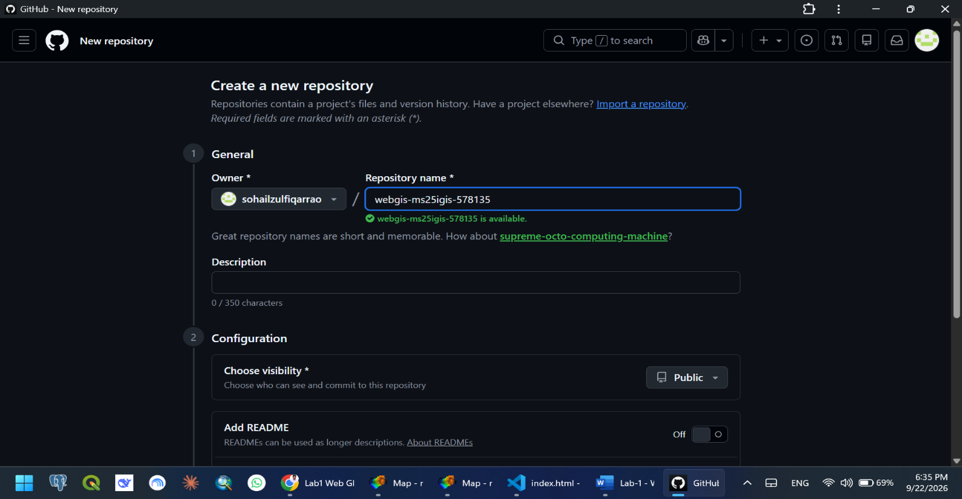
- Creating a Repository on GitHub.
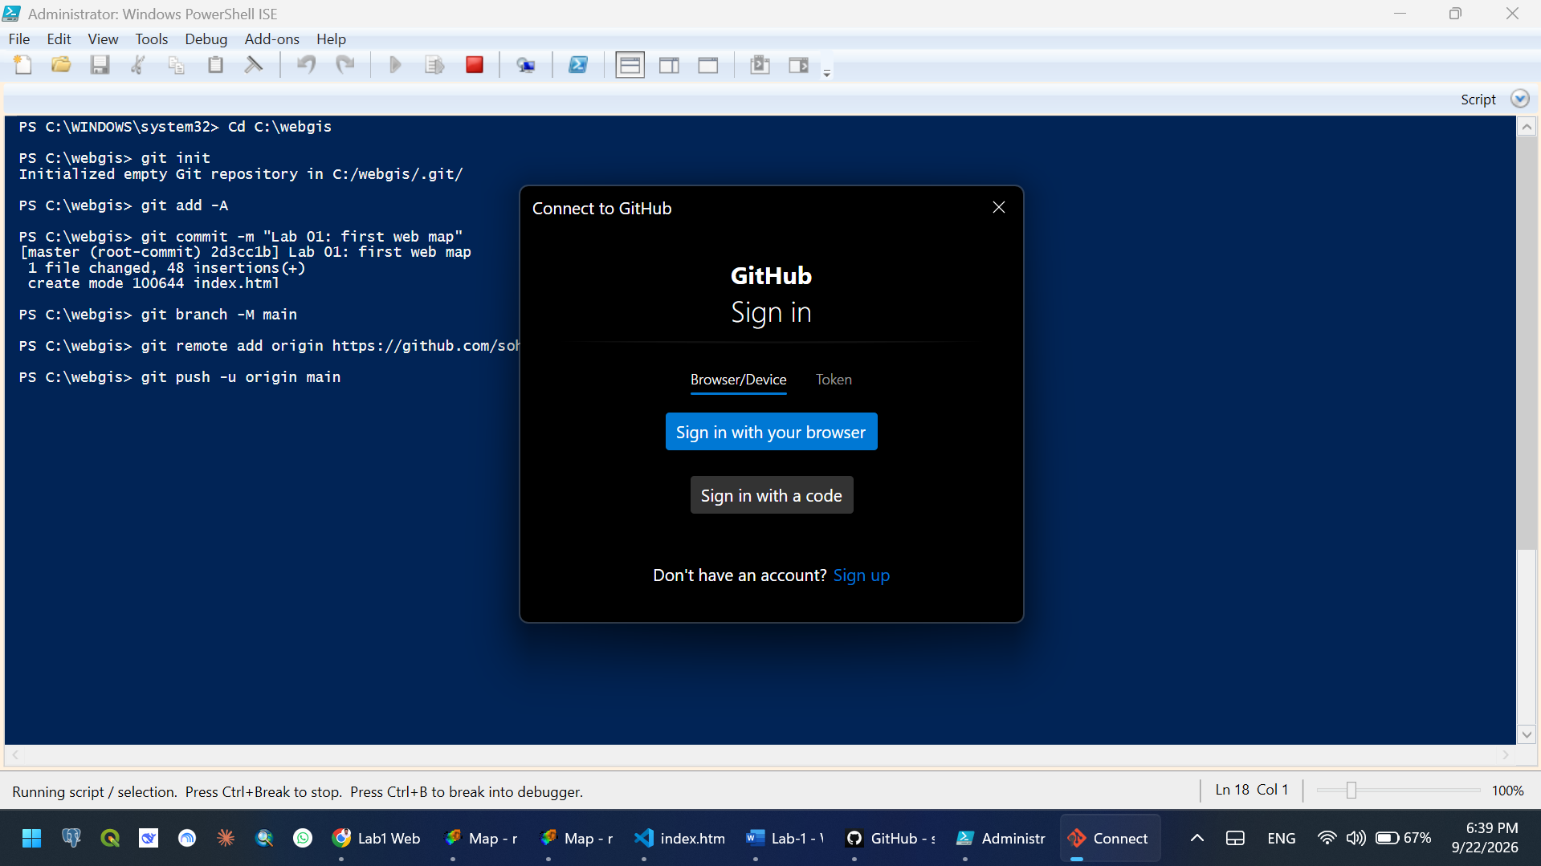
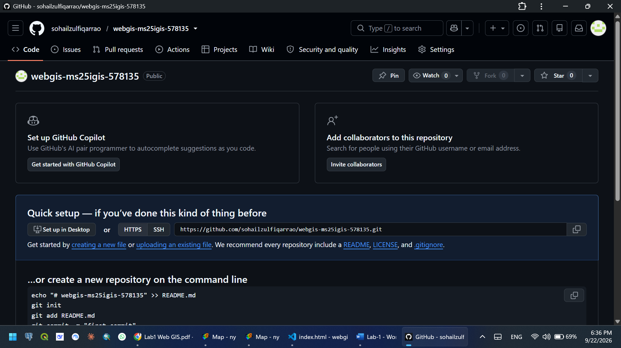
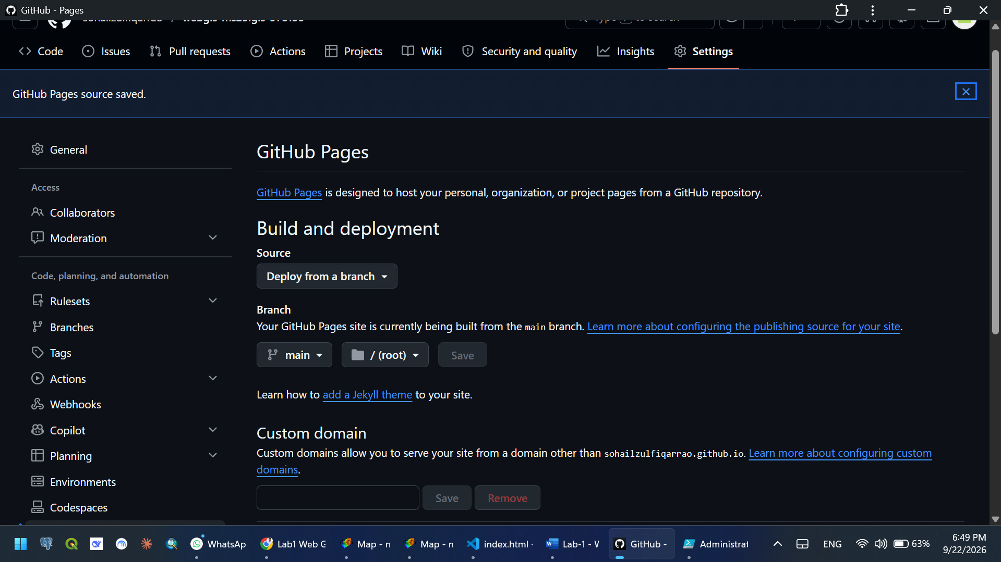
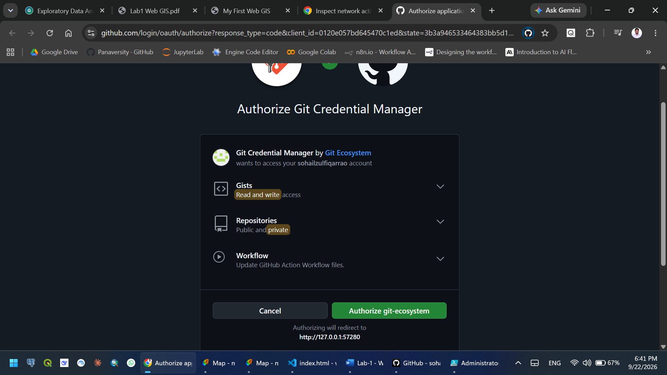
CHECKPOINT-5
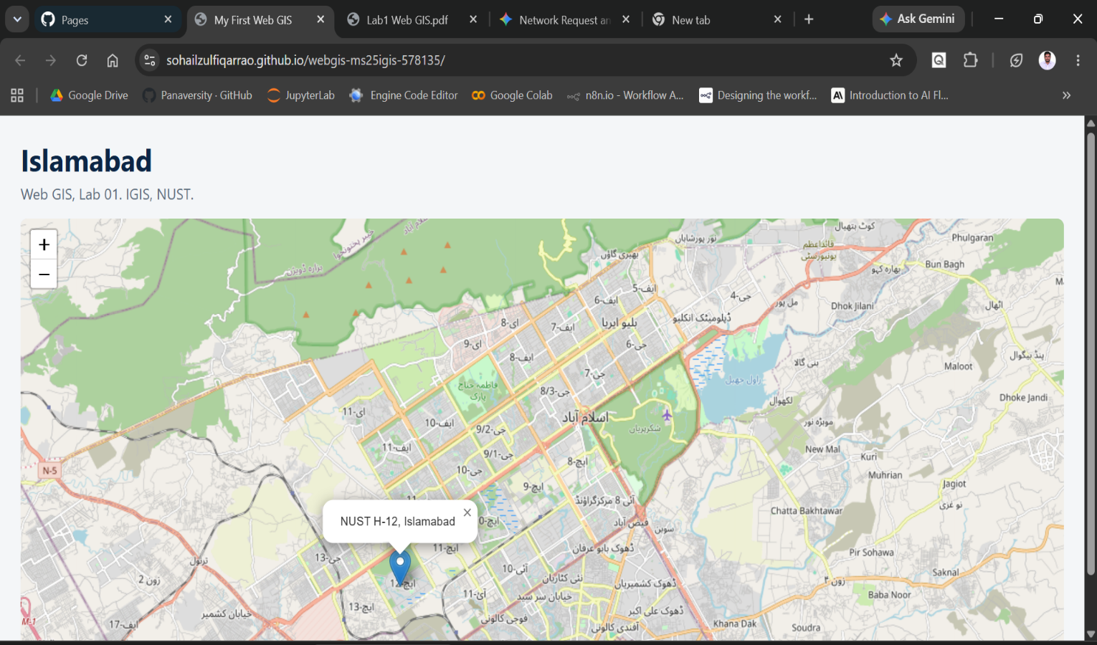
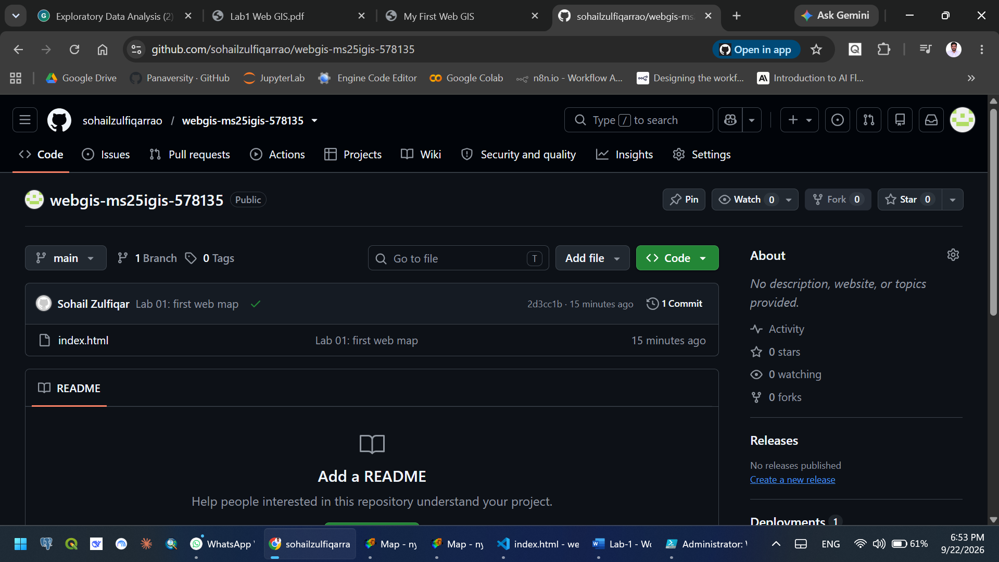
- GitHub Personal Repository URL

QUESTIONS
- Change in network requests: Initially, the browser only made a single request for the index.html file. After adding the Leaflet script, the browser makes dozens of requests to fetch individual 256 by 256 pixel background map tile images. This happens because the map is not a static picture, but rather an ongoing conversation with a server that loads new tiles as the map is viewed or panned.
- HTML vs. CSS: HTML dictates what content exists on the page, whereas CSS controls how that content looks. An example of HTML is <h1>Islamabad</h1>, which structuralizes text as a top-level heading. An example of CSS is the #map rule (height: 480px; width: 100%;), which defines the dimensions and appearance of the map container.
- Height requirement for #map: An empty <div> tag has a default height of zero. If the #map CSS rule does not specify a height, Leaflet will draw the map into a box that is zero pixels tall, making it completely invisible on the page.
- Using Live Server: Browsers have security measures that block data file requests for pages opened directly from the local file system. Running the page through Live Server provides a real local web environment, ensuring map data loads properly instead of silently failing.
- Marker in the sea: The latitude and longitude coordinates are swapped. Leaflet's functions expect coordinates in (latitude, longitude) order. To fix this, reverse the order of the two coordinate numbers provided to the marker.

Git Repository
https://github.com/sohailzulfiqarrao/webgis-ms25igis-578135
Git Live Pages
https://sohailzulfiqarrao.github.io/webgis-ms25igis-578135/

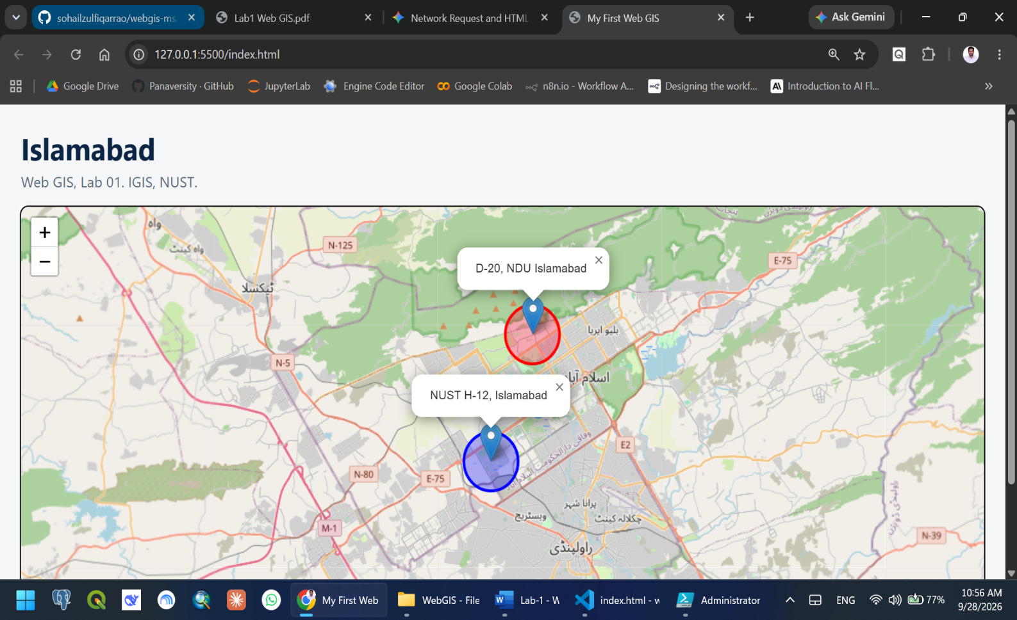
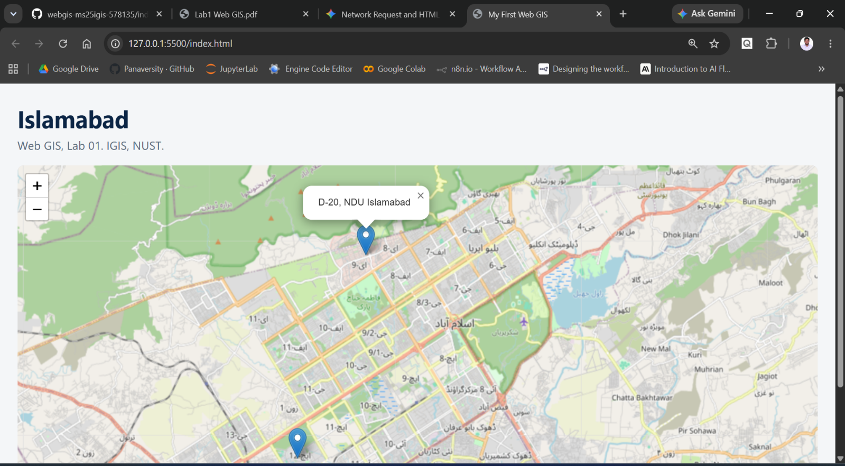
Additional Task

