SQL EXERCISE

Practice and practice we can improve our skills.

Retrieve the required information using SQL language.
Part I. Give a database schema for a library management system as the following picture.
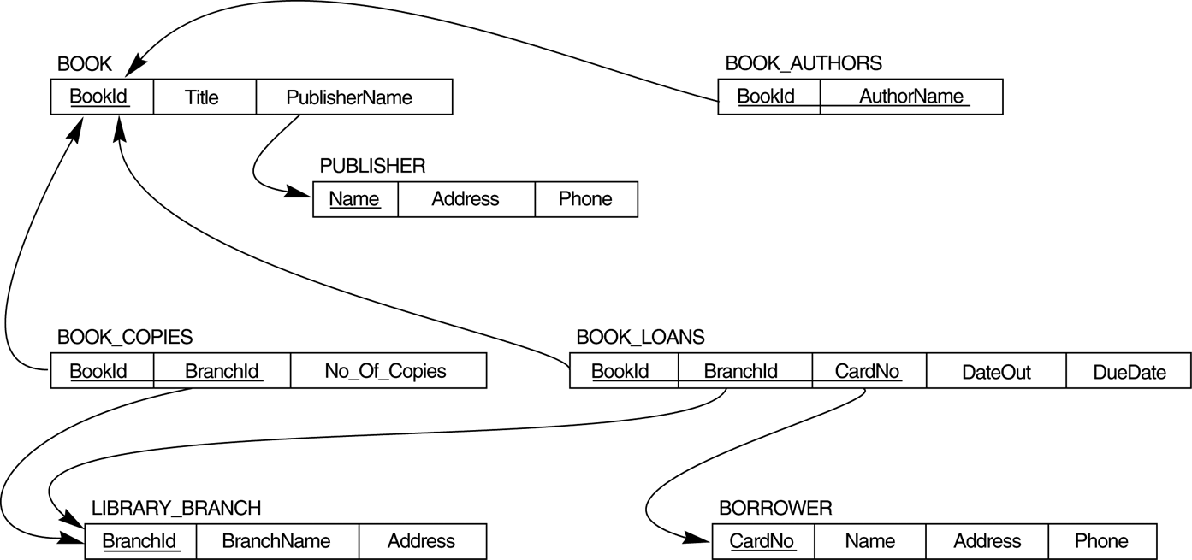

- How many copies of the book titled The Lost Tribe are owned by the library branch whose name is "Sharpstown"?
- How many copies of the book titled The Lost Tribe are owned by each library branch?
- Retrieve the names of all borrowers who do not have any books checked out .
- For each book that is loaned out from the "Sharpstown" branch and whose DueDate is today, retrieve the book title, the borrower's name, and the borrower's address.
- For each library branch, retrieve the branch name and the total number of books loaned out from that branch.
- Retrieve the names, addresses, and number of books checked out for all borrowers who have more than five books checked out.
- For each book authored (or co-authored) by "Stephen King", retrieve the title and the number of copies owned by the library branch whose name is "Central"

Part II Give a database schema of a company as the following picture.
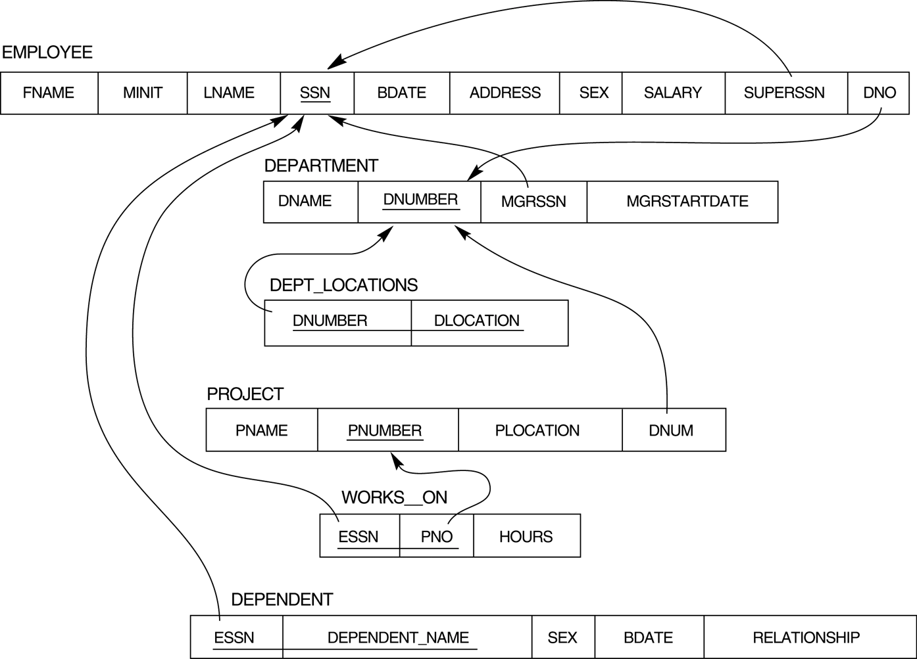

- Retrieve the names of employees in department 5 who work more than 10 hours per week on the 'ProductX' project.
- For each project, list the project name and the total hours per week (by all employees) spent on that project.
- Retrieve the names of employees who work on every project.
- Retrieve the names of employees who do not work on any project.
- Find the names and addresses of employees who work on at least one project located in Houston but whose department has no location in Houston.
- List the last names of department managers who have no dependents.
- Find details of those employees whose salary is > the average salary for all employees. Output salary in descending order.
- Find details of those employees whose salary is > the average salary for all employees in his/her department. Output salary in ascending order.

Answer:

- Should not refer to the answer before trying to write down your solutions
- The answer for each question is only one (or two) of the many other solutions

Solution 1:
SELECT bc.No_Of_Copies
FROM BOOK b, BOOK_COPIES bc, LIBRARY_BRANCH bl
WHERE b.BookId = bc.BookId AND
bc.BranchId = bl.BranchId AND
Title='The Lost Tribe' AND BranchName='Sharpstown';

Solution 2:
SELECT No_Of_Copies
FROM ((BOOK NATURAL JOIN BOOK_COPIES ) NATURAL JOIN LIBRARY_BRANCH )
WHERE Title='The Lost Tribe' AND BranchName='Sharpstown';

- SELECT BranchName, No_Of_Copies
FROM ((BOOK NATURAL JOIN BOOK_COPIES ) NATURAL JOIN LIBRARY_BRANCH )
WHERE Title='The Lost Tribe';

Solution 1:
SELECT Name
FROM BORROWER B
WHERE CardNo NOT IN (SELECT CardNo
FROM BOOK_LOANS );
Solution 2:
SELECT Name
FROM BORROWER B
WHERE NOT EXISTS (SELECT *
FROM BOOK_LOANS L
WHERE B.CardNo = L.CardNo );

- SELECT B.Title, R.Name, R.Address
FROM BOOK B, BORROWER R, BOOK_LOANS BL, LIBRARY_BRANCH LB
WHERE LB.BranchName='Sharpstown' AND LB.BranchId=BL.BranchId AND
BL.DueDate='today' AND BL.CardNo=R.CardNo AND BL.BookId=B.BookId

- SELECT L.BranchName, COUNT(*)
FROM LIBRARY_BRANCH L, BOOK_LOANS BL
WHERE BL.BranchId = L.BranchId
GROUP BY L.BranchName;

- SELECT B.Name, B.Address, COUNT(*)
FROM BORROWER B, BOOK_LOANS L
WHERE B.CardNo = L.CardNo
GROUP BY B.CardNo, B.Name, B.Address
HAVING COUNT(*) > 5;

Solution 1:
SELECT Title, No_Of_Copies
FROM (((BOOK_AUTHORS NATURAL JOIN BOOK) NATURAL JOIN BOOK_COPIES) NATURAL JOIN LIBRARY_BRANCH)WHERE Author_Name='Stephen King' AND BranchName='Central';

Solution 2: Student should write the another solution not using the natural join.

- SELECT LNAME, FNAME
FROM EMPLOYEE, WORKS_ON, PROJECT
WHERE DNO=5 AND SSN=ESSN AND PNO=PNUMBER AND PNAME='ProductX' AND HOURS>10;

- SELECT PNAME, SUM (HOURS)
FROM PROJECT, WORKS_ON
WHERE PNUMBER=PNO
GROUP BY PNAME;

Note: The Group By clause should be replaced as GROUP BY (PNUMBER, PNAME) since there may be some projects have the same name.

Solution 1:
SELECT E.LNAME, E.FNAME
FROM EMPLOYEE E
WHERE NOT EXISTS (SELECT PNUMBER
FROM PROJECT
WHERE PNUMBER NOT IN (SELECT PNO
FROM WORKS_ON
WHERE ESSN=E.SSN ) );

Solution 2:
SELECT LNAME, FNAME
FROM EMPLOYEE
WHERE NOT EXISTS (SELECT PNUMBER
FROM PROJECT
WHERE NOT EXISTS (SELECT *
FROM WORKS_ON
WHERE PNUMBER=PNO AND ESSN=SSN ) );

Solution 1:
SELECT LNAME, FNAME
FROM EMPLOYEE
WHERE SSN NOT IN ( SELECT ESSN
FROM WORKS_ON);

Solution 2:
SELECT LNAME, FNAME
FROM EMPLOYEE
WHERE NOT EXISTS ( SELECT *
FROM WORKS_ON
WHERE ESSN=SSN );

Solution 1:
SELECT LNAME, FNAME, ADDRESS
FROM EMPLOYEE
WHERE EXISTS ( SELECT *
FROM WORKS_ON W, PROJECT P, DEPT_LOCATIONS DL
WHERE W.PNO = P.PNUMBER AND
P.DNUM = DL.DNUM AND
DL.DLOCATION <> ‘Houston’);
Solution 2:
SELECT LNAME, FNAME, ADDRESS
FROM EMPLOYEE
WHERE EXISTS ( SELECT *
FROM WORKS_ON, PROJECT
WHERE SSN=ESSN AND PNO=PNUMBER AND PLOCATION='Houston' )
AND
NOT EXISTS ( SELECT *
FROM DEPT_LOCATIONS
WHERE DNO=DNUMBER AND DLOCATION='Houston' );

Solution 1:
SELECT E.LNAME, E.FNAME
FROM EMPLOYEE E, DEPARTMENT D
WHERE E.SSN = D.MRGSSN AND
NOT EXISTS ( SELECT DEPENDENT_NAME
FROM DEPENDENT
WHERE ESSN=E.SSN )

Solution 2:
SELECT LNAME, FNAME
FROM EMPLOYEE
WHERE EXISTS ( SELECT *
FROM DEPARTMENT
WHERE SSN=MGRSSN )
AND
NOT EXISTS ( SELECT *
FROM DEPENDENT
WHERE SSN=ESSN );

- SELECT *
FROM Employee
WHERE Salary > (SELECT AVG (Salary)
FROM Employee )
ORDER BY Salary DESC;

Solution 1:
SELECT E.*
FROM EMPLOYEE E, (SELECT DNO, AVERAGE(SALARY) AS LTB
FROM EMPLOYEE
GROUP BY DNO) AS A
WHERE E.DNO = A.DNO AND
E.SALARY > LTB;

Solution 2:
SELECT E.*
FROM EMPLOYEE E
WHERE E.SALARY > (SELECT AVERAGE(SALARY)
FROM EMPLOYEE
WHERE DNO = E.DNO);

Note: if we want to display the average of the salary we should employ the solution 1 and put the “field name” LTB in the select clause.

