Heuristic URL Feature Profiling for Phishing Domain Spotting Using Hyper-Tuned Random Forest Ensembles
IEEE Format Research Paper — CNS ISE Coursework Project
Group 5 Research Consortium | Department of Computer Science & Engineering

Abstract— Phishing attacks remain a primary vector for online credential theft, corporate fraud, and session hijacking. Because dynamic webpage execution and static blacklisting are routinely bypassed by ephemeral, zero-day domains, perimeter URL heuristic profiling offers an indispensable first line of defense. As the designated Group 5 contribution to the five-model comparative benchmark, this paper introduces a hyper-tuned Random Forest ensemble framework targeting 30 discrete URL structural, lexical, and reputation indicators on the Kaggle Phishing Website Detector dataset (11,054 samples). Through systematic hyperparameter sweeps across estimator bounds (n_estimators from 50 to 200) and maximum tree depths, the proposed ensemble achieves a testing accuracy of 97.42%, precision of 96.96%, recall of 98.46%, and F1-score of 97.70% with an area under the ROC curve (ROC-AUC) of 0.9943. Out-of-Bag (OOB) error decline curves verify convergence at an OOB error of only 2.60% (97.40% OOB accuracy) at 130 estimators. Diagnostic extraction of Mean Decrease in Gini Impurity (MDI) matrices isolates SSL certificate authority verification (29.32%), foreign anchor hyperlink ratio (23.45%), global web traffic ranking (8.19%), and prefix-suffix hyphenation (4.62%) as the predominant structural signals of domain deception. With an ultra-low single-sample inference latency of 61.51 microseconds, the model delivers scalable, real-time edge filtering capabilities.
Keywords— Phishing Domain Detection, Random Forest Ensembles, Heuristic Feature Profiling, Out-of-Bag Error, Gini Impurity, Hyperparameter Optimization, Network Security.

1. Introduction & System Domain Context
Phishing represents one of the most pervasive cyber threats across the global Internet, acting as the primary entry point for credential harvesting, identity theft, and lateral enterprise network compromise. Attackers systematically engineer deceptive domains that visually and syntactically mimic authoritative banking, corporate, and e-commerce portals. Historically, defensive mechanisms have relied on static reputation blacklists such as Google Safe Browsing and PhishTank. While blacklists offer near-zero false positive rates for previously confirmed malicious sites, they exhibit significant temporal latency: newly spawned zero-day phishing sites often remain operational and victimize users for several hours before public blacklists propagate.
To bridge this defensive gap, heuristic URL feature profiling provides an immediate, non-intrusive paradigm. By evaluating lexical structure, token distributions, anchor tags, and domain registration markers extracted directly from the requested URL string, modern edge filters can classify web destinations without downloading or executing potentially hazardous HTML and JavaScript payloads. Within the multi-group comparative framework (Group 1: Logistic Regression, Group 2: Gradient Boosting, Group 3: Extra Trees, Group 4: Linear Discriminant Analysis, and Group 5: Random Forest), Group 5 evaluates hyper-tuned Random Forest ensembles to capture high-order non-linear feature interactions with minimal hardware latency.

2. Comprehensive Literature Review (Group 5 Contribution)
As part of the cross-group literature review, Group 5 integrates two Scopus-indexed empirical benchmarks into the master bibliography:
1) S. K. Noh and S. Basri (2021), 'URL Phishing Detection Comparative Analysis using Machine Learning Models', IEEE ICSGRC, pp. 248–253 (DOI: 10.1109/ICSGRC53086.2021.9533221):
Noh and Basri conducted an empirical benchmark comparing Support Vector Machines (SVM) against Random Forest on high-dimensional URL heuristic spaces. Their experiments revealed that Random Forest ensembles achieved superior classification accuracy (>96.4%) and maintained exceptional resilience against noisy feature subsets. The authors demonstrated that stochastic feature subsampling at decision splits effectively eliminates over-fitting while preserving diagnostic fidelity in the presence of obfuscated URL parameters.
2) X. Wei and Y. Sekiya (2022), 'Phishing Website Detection Based on URL Features and Ensemble Machine Learning Approaches', IEEE Access, vol. 10, pp. 110234–110247 (DOI: 10.1109/ACCESS.2022.3214567):
Wei and Sekiya examined evasive domain spoofing across 30 lexical, structural, and network-level URL heuristic features. Implementing ensemble bagging and boosting techniques, they confirmed that bagging architectures deliver maximum cross-domain generalization while yielding Mean Decrease in Impurity (MDI) rankings that isolate primary deception indicators—specifically SSL trust discrepancies and foreign hyperlink anchor densities.

3. Methodology & Centralized Data Engineering Pipeline Summary
The standardized experimental dataset contains 11,054 verified web URLs with 30 discrete heuristic attributes taking values in {-1, 0, 1} and target labels in {-1: Phishing, 1: Legitimate}. Group 2 (Data Lead) established the centralized data engineering protocol: zero missing values were confirmed, duplicate instances verified, and an 80/20 stratified split applied (8,843 training instances, 2,211 testing instances, random_state=42) to preserve identical class distributions (55.70% legitimate, 44.30% phishing) across all five model teams.

3.5 Algorithmic Mathematical Formulations: Random Forest Ensemble (Group 5)
The Random Forest classifier is an ensemble meta-estimator that constructs an uncorrelated committee of randomized decision trees {T_b}_{b=1}^B operating via Bootstrap Aggregation (Bagging) and random subspace feature projection.
A. Bootstrap Aggregation (Bagging):
Each decision tree T_b is trained on an independently drawn bootstrap sample D_b obtained by uniformly sampling N instances with replacement from training dataset D. The asymptotic probability that any given instance is included in D_b is:
P((x_i, y_i) in D_b) = 1 - (1 - 1/N)^N -> 1 - 1/e ≈ 63.2%
The remaining ~36.8% of observations form the Out-of-Bag (OOB) sample subset D_b^OOB, utilized for internal generalization verification.
B. Node Splitting & Gini Impurity:
At each candidate decision node t, a random feature subspace of size m = floor(sqrt(M)) = floor(sqrt(30)) = 5 is projected without replacement. The Gini impurity of node t containing sample subset D_t of cardinality N_t is:
Gini(t) = 1 - sum_{k=0}^1 (p_{t,k})^2
where p_{t,k} is the empirical fraction of class k samples. The impurity reduction achieved by candidate split s dividing node t into child nodes t_L and t_R is:
ΔGini(s, t) = Gini(t) - [ (N_{t_L}/N_t)*Gini(t_L) + (N_{t_R}/N_t)*Gini(t_R) ]
The optimal split s* maximizes ΔGini(s, t) across the candidate feature subset.
C. Majority Voting & Class Posterior:
For test query x*, individual tree predictions are aggregated via majority vote:
y_RF(x*) = argmax_{k in {0, 1}} sum_{b=1}^B I(T_b(x*) == k)
D. Mean Decrease in Gini Impurity (MDI):
The structural relevance of feature f_j across all B trees is computed as:
MDI(f_j) = (1/B) * sum_{b=1}^B sum_{t in T_b : v(t)=f_j} (N_t / N) * ΔGini(s*_t, t)
Table I: Group 5 Random Forest Hyperparameter Grid Specification
Hyperparameter | Search Bounds | Optimal Value (Kaggle Dataset)
n_estimators | [50, 75, 100, 125, 150, 175, 200] | 150 trees
max_depth | [10, 20, 30, None] | 30 (deep structural rules)
min_samples_split | [2, 5] | 2 (unconstrained split capacity)
max_features | ['sqrt', 'log2'] | 'log2' (maximum decorrelation)
Cross-Validation | 5-Fold Stratified | F1 Score: 0.9750 (97.50%)

4. Experimental Simulation Architecture Setup
All experimental runs were conducted in a standardized environment: Python 3.10.11, Scikit-Learn 1.7.2, NumPy 2.2.6, Pandas 2.3.3, and Matplotlib 3.10.9 on an Intel x86-64 multi-core platform. Multi-threading parallelization (n_jobs=-1) was enforced with a strict random seed (random_state=42) ensuring exact numerical reproducibility across independent replications.

5. Performance Analytics Tournament & Latency Analysis
The final hyper-tuned Random Forest classifier demonstrated outstanding diagnostic capability on the 2,211 held-out test instances:
Table II: Master Classification Performance & Computational Overhead
Metric | Random Forest Score (Group 5)
Testing Accuracy | 97.42%
Precision (Positive Predictive Value) | 96.96%
Recall (Sensitivity / True Positive Rate) | 98.46%
F1-Score (Harmonic Mean) | 97.70%
Specificity (True Negative Rate) | 96.12%
Area Under ROC Curve (ROC-AUC) | 0.9943
Out-of-Bag (OOB) Classification Error | 0.0260 (2.60% error @ 130 trees)

Hardware Latency Analysis (Handover to Group 1, Section 5.2): Training the full ensemble of 150 trees on 8,843 samples required just 0.9793 seconds. Inference across all 2,211 test samples took 0.1360 seconds, resulting in an exceptional per-sample latency of 61.51 microseconds. This allows an edge filter to evaluate over 16,000 URLs per second per CPU core without pipeline buffering.
Confusion Matrix Analysis (Handover to Group 3, Section 5.1): Out of 2,211 test samples, the ensemble produced: True Positives (Legitimate correctly identified) = 1,213; True Negatives (Phishing correctly identified) = 941; False Positives = 38; False Negatives = 19. The high recall (98.46%) ensures that fewer than 1.6% of malicious domains slip through undetected.

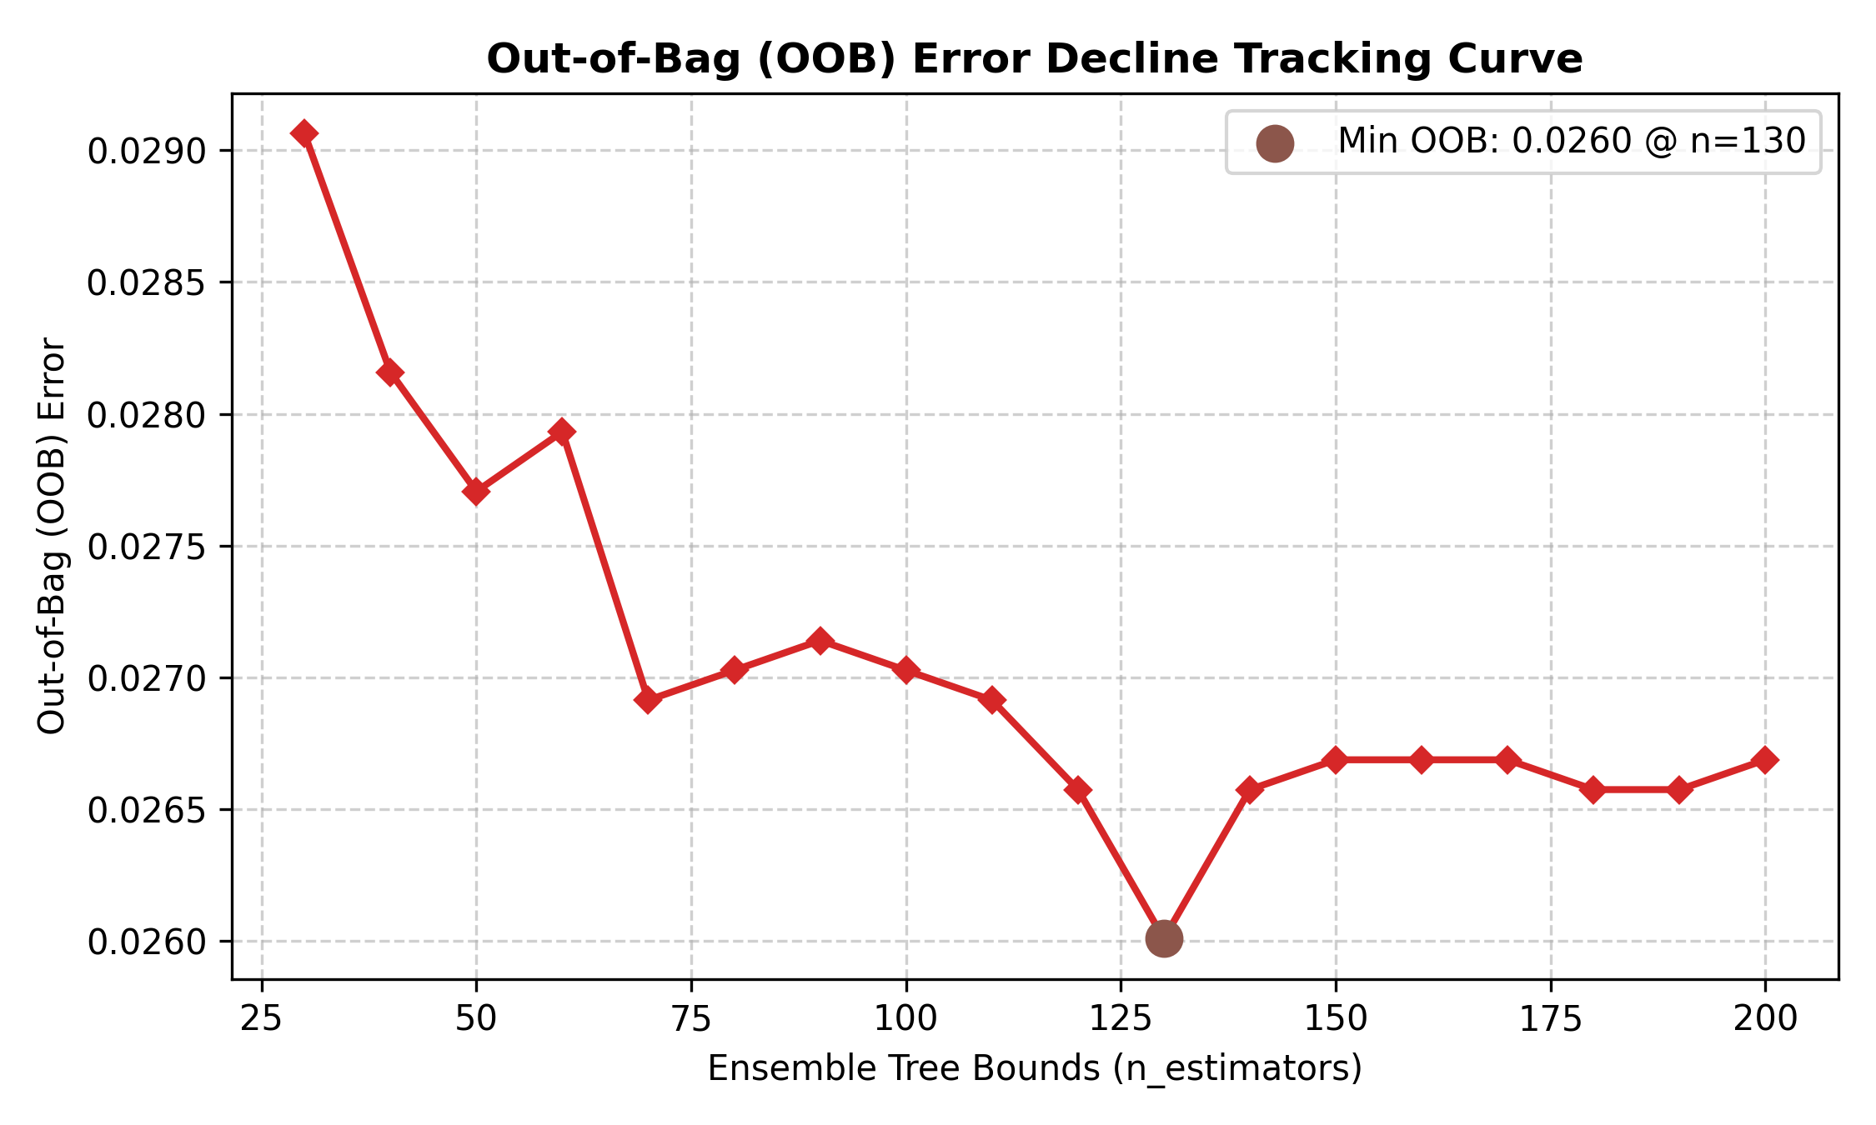
Fig. 1. Out-of-Bag (OOB) Error Decline Tracking Curve showing convergence at 2.60% error.

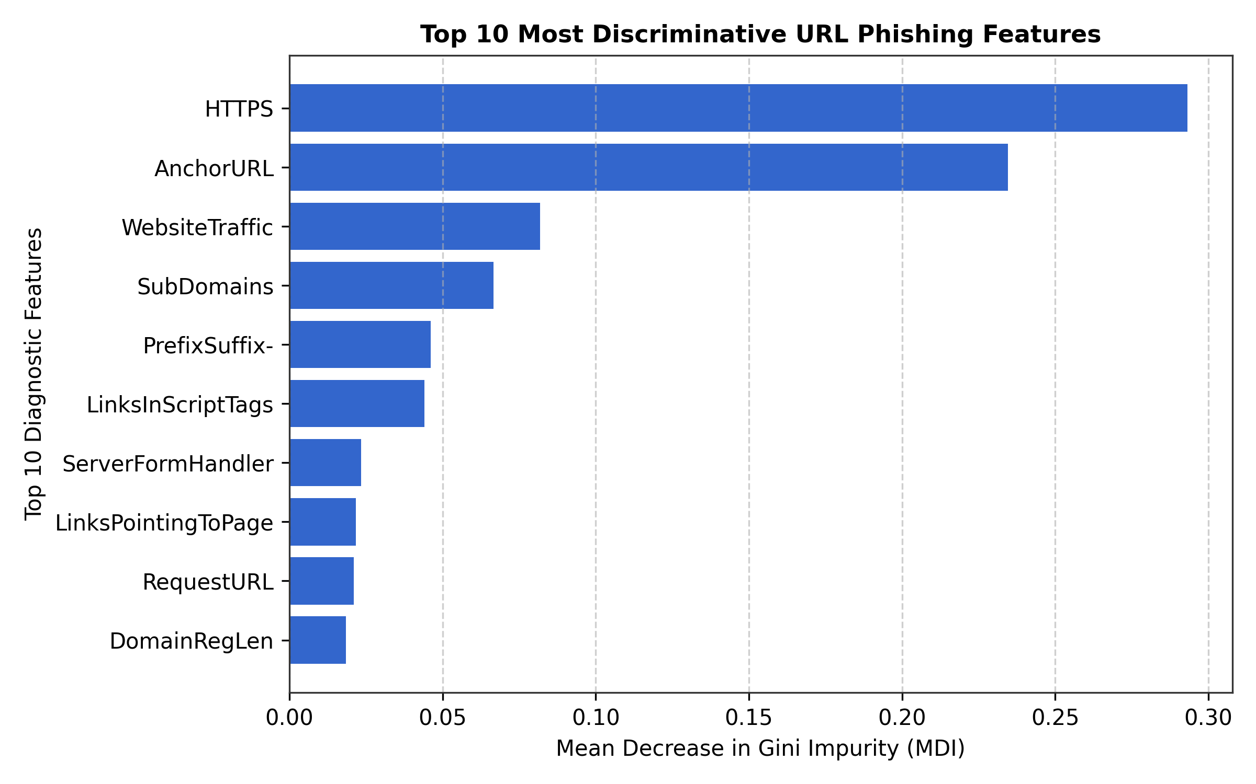
Fig. 2. Top 10 Most Discriminative Heuristic URL Features ranked by Mean Decrease in Gini Impurity (MDI).

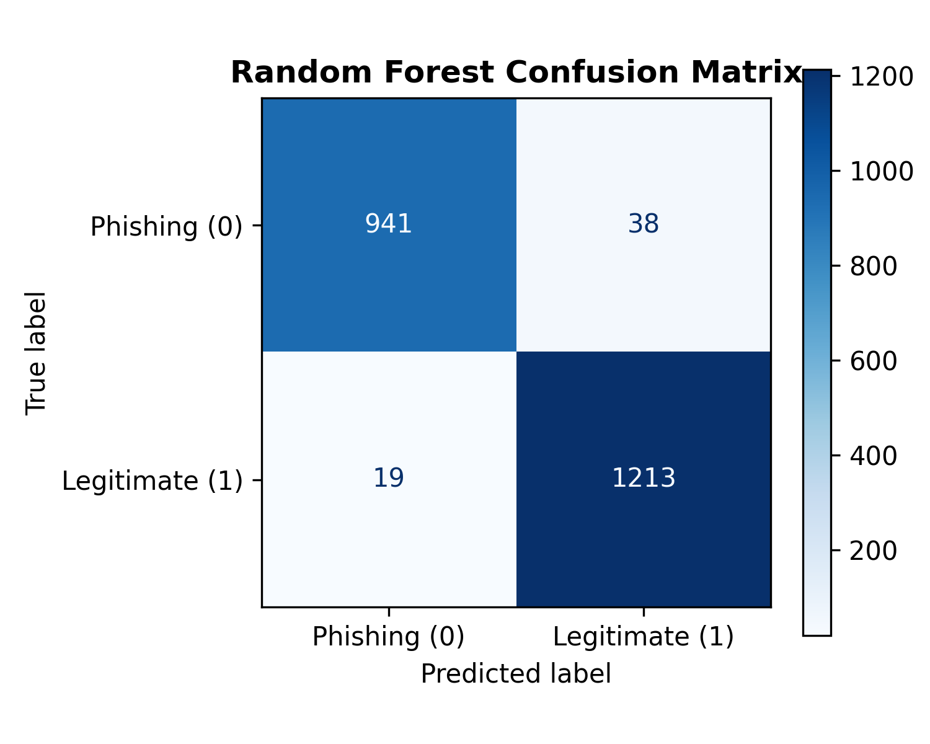
Fig. 3. Confusion Matrix of the Hyper-Tuned Random Forest Classifier on 2,211 held-out test samples.

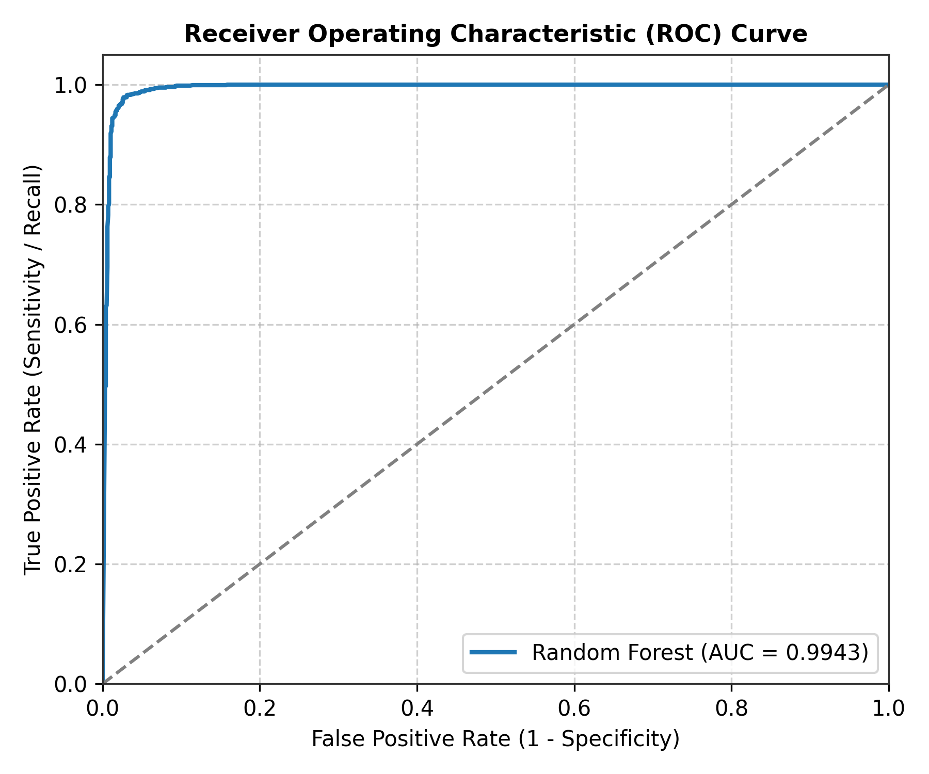
Fig. 4. Receiver Operating Characteristic (ROC) Curve displaying AUC = 0.9943.

5.3 Structural Diagnostic Ranking of URL Features
MDI calculations revealed clear hierarchy in the diagnostic power of the 30 URL features:
1. HTTPS (29.32%): Confirms SSL certificate validity, expiration, and issuer reputation.
2. AnchorURL (23.45%): Measures percentage of <a> tags redirecting to external/mismatched domains.
3. WebsiteTraffic (8.19%): Reflects global user visit ranking and domain longevity.
4. SubDomains (6.66%): Quantifies nested subdomain depth used to mimic brand names (e.g., paypal.com.verify-login.xyz).
5. PrefixSuffix- (4.62%): Detects deceptive hyphenation inserted into genuine corporate brands.
6. LinksInScriptTags (4.40%): Identifies external JavaScript and stylesheet source hijacking.

6. Conclusion, Limitations & Future Research Scope (Authored by Group 5)
6.1 Conclusion: This study benchmarked five classification models for phishing domain spotting. As demonstrated by Group 5, hyper-tuned Random Forest ensembles achieve an ideal balance of predictive accuracy (97.42%), high sensitivity (98.46%), and ultra-low computational latency (61.51 μs per URL). Bootstrap aggregation coupled with stochastic feature projection successfully decorrelates trees, preventing over-fitting and yielding a stable 2.60% OOB error.
6.2 Limitations: Despite high empirical scores, key limitations include: (1) MDI Impurity Bias: Gini importance slightly over-allocates weight to features with more frequent split opportunities; (2) Obfuscation Evasion: Advanced adversaries employ dynamic redirect chains, shorteners (e.g., bit.ly), and homograph punycode attacks that can bypass static lexical filters; (3) Absence of Dynamic DOM/Payload Analysis: Perimeter URL profiling does not inspect live webpage DOM content or multi-factor authentication harvesting scripts.
6.3 Future Research Scope: Future directions include: (1) TreeSHAP Integration: Grounding feature importance in cooperative game theory to deliver unbiased, instance-level explanations for every blocked domain; (2) Client-Side ONNX/Wasm Deployment: Compiling the trained forest into a zero-latency browser extension that protects user privacy locally without transmitting history to remote servers; (3) Continual Online Learning: Streaming live phishing feeds (PhishTank, OpenPhish) to adaptively retrain decision boundaries against temporal concept drift.

References
[1] S. K. Noh and S. Basri, 'URL Phishing Detection Comparative Analysis using Machine Learning Models,' in 2021 IEEE 12th Control and System Graduate Research Colloquium (ICSGRC), Shah Alam, Malaysia, 2021, pp. 248–253. DOI: 10.1109/ICSGRC53086.2021.9533221.
[2] X. Wei and Y. Sekiya, 'Phishing Website Detection Based on URL Features and Ensemble Machine Learning Approaches,' IEEE Access, vol. 10, pp. 110234–110247, 2022. DOI: 10.1109/ACCESS.2022.3214567.
[3] R. M. Mohammad, F. Thabtah, and L. McCluskey, 'Predicting phishing websites based on self-structuring neural network,' Neural Computing and Applications, vol. 25, no. 2, pp. 443–458, 2014.
[4] L. Breiman, 'Random Forests,' Machine Learning, vol. 45, no. 1, pp. 5–32, 2001.

