
Department of Computer Engineering and Technology
MINI PROJECT REPORT
Computer Networks Laboratory
(CSE20110)
Laboratory Continuous Assessment 3

Network Troubleshooting Assistant

Submitted by
Sr. No. | Student Name | PRN
1 | Soham Patil | 1272250811
2 | Ganesh Gaikwad | 1262252319
3 | Tirth Gangani | 1272250827
4 | Aditya Sardesai | 1262252353

Group No. ____________ Panel E Batch E2
Third Year B.Tech. Computer Engineering and Technology
Under the guidance of
Dr. Swati
Academic Year 2026–2027
Submission Date 21-10-2026

Department of Computer Engineering and Technology
CERTIFICATE

This is to certify that the mini-project entitled “Network Troubleshooting Assistant” has been carried out by the following students of Third Year B.Tech. Computer Science and Engineering, Panel E, Batch E2, Group No. ____________, under my guidance during the academic year 2026–2027.
Student Name | PRN
Soham Patil | 1272250811
Ganesh Gaikwad | 1262252319
Tirth Gangani | 1272250827
Aditya Sardesai | 1262252353

The report is submitted towards the mini-project component of Laboratory Continuous Assessment 3 for the Computer Networks Laboratory course.

Faculty Signature __________________________
Dr. Swati
Project Guide and Course Faculty
Date ____________________ Place: Pune

Acknowledgement
We express our sincere gratitude to our project guide and course faculty, Dr. Swati, for their continuous guidance, technical feedback, and encouragement throughout the design, implementation, and validation of the “Network Troubleshooting Assistant (NTA)” mini-project. Their insights into layered network protocol analysis and structured diagnostic methodologies were instrumental in shaping this system.
We also extend our appreciation to the Department of Computer Engineering and
Technology at Dr. Vishwanath Karad MIT World Peace University, Pune, for providing the laboratory infrastructure and computing resources required to execute and test our project. Finally, we acknowledge the open-source communities behind Python, Streamlit, FastAPI, Plotly, and the Internet Engineering Task Force (IETF) for the RFC documentation that formed the technical foundation of our implementation.
Group No. ____________

Abstract
In traditional network administration, diagnosing connectivity outages and performance degradation requires manually executing disparate command-line utilities such as ipconfig, ping, nslookup, tracert, curl, and openssl. These tools produce fragmented outputs without cross-layer correlation, often leading to misdiagnosed root causes when firewall filtering or application-layer failures mimic lower-layer outages. This project presents the Network Troubleshooting Assistant (NTA), an automated, non-destructive, cross-layer network diagnostic and root-cause analysis system engineered in Python around the OSI and TCP/IP reference models. NTA implements an ordered eight-stage bottom-up diagnostic pipeline spanning Network Interface configuration (Layer 1/2), Default Gateway ICMP reachability (Layer 3), DNS hostname resolution (UDP/TCP Port 53), remote ICMP connectivity, Transport-layer TCP 3-way handshake verification (differentiating active RST connection refusals from silent firewall timeouts), Presentation-layer SSL/TLS X.509 certificate validation, Application-layer HTTP status checks, and statistical latency/jitter/traceroute hop profiling. A deterministic Root Cause Analysis (RCA) inference engine correlates multi-stage evidence with confidence scoring to output actionable remediation plans. Additionally, NTA includes a 10-scenario Fault Simulation Lab, concurrent batch auditing, continuous background monitoring with SQLite persistence, and natural language symptom parsing via Streamlit and FastAPI interfaces.
Keywords: Computer Networks, Cross-Layer Diagnostics, OSI Model, Root Cause Analysis, TCP/IP Stack, ICMP Traceroute, TLS Handshake, Fault Simulation

Table of Contents
Acknowledgement 3
Abstract 4
Table of Contents 6
List of Figures 8
List of Tables 9
• Table 1.1: Project Objectives and Verification Methods 9
• Table 2.1: Mapping of NTA Modules to OSI and TCP/IP Reference Models • Table 2.2: Tools, Libraries, and System Specifications 9
• Table 2.3: Network Addressing, Special Test Endpoints, and Protocol 9
Specifications 9
• Table 4.1: Comprehensive Test Plan and Execution Results 9
• Table 4.2: Evaluation of Objective Achievement 9
• Table 5.1: Technical Challenges Encountered and Troubleshooting Solutions 9
• Table C.1: Individual Student Contributions 9
1 Introduction and Project Objectives 10
1.1 Introduction and Background 10
1.2 Problem Statement 10
1.3 Scope 11
1.4 Objectives 11
2 Proposed Design and Requirements 13
2.1 Architecture and Network Topology 13
2.2 Tools and System Requirements 15
2.3 Addressing and Protocol Selection 16
3 Implementation and Technical Working 18
3.1 Methodology 18
3.2 Configuration or Code Implementation 18
3.3 Protocols and Technical Working 20
3.4 Execution Procedure 21
4 Testing and Results 24
4.1 Test Plan 24
4.2 Results and Execution Evidence 24
4.3 Objective Achievement 25
5 Discussion and Conclusion 26
5.1 Discussion and Comparative Analysis 26
5.2 Advantages and Applications 26
5.3 Limitations 27
5.4 Challenges and Troubleshooting 27
5.5 Future Scope 27
5.6 Conclusion 28
References 29
AI Usage Declaration 30
Appendices 31
Appendix A Code and Configuration 31
Appendix B Additional Evidence 31
Appendix C Individual Contributions 31

List of Figures
• Figure 2.1: Proposed Bottom-Up Diagnostic Pipeline and System Architecture
• Figure 3.1: Streamlit Web Interface and Multi-Stage Diagnostic Execution Evidence
• Figure 4.1: Interactive Plotly Traceroute Hop Topology and Fault Simulation Results

List of Tables

• Table 1.1: Project Objectives and Verification Methods

• Table 2.1: Mapping of NTA Modules to OSI and TCP/IP Reference Models • Table 2.2: Tools, Libraries, and System Specifications

• Table 2.3: Network Addressing, Special Test Endpoints, and Protocol

Specifications

• Table 4.1: Comprehensive Test Plan and Execution Results

• Table 4.2: Evaluation of Objective Achievement

• Table 5.1: Technical Challenges Encountered and Troubleshooting Solutions

• Table C.1: Individual Student Contributions

1 Introduction and Project Objectives

1.1 Introduction and Background
Modern enterprise and academic computer networks rely on complex interactions across multiple protocol layers defined by the Open Systems Interconnection (OSI) and TCP/IP reference models. When an end user experiences a connectivity failure—such as an unreachable web portal, a dropped video conference call, or a refused database connection—the underlying fault may reside at the physical link, local DHCP configuration [7], local gateway routing, Domain Name System
(DNS) resolution [4], intermediate ISP routing [2], stateful firewall filtering, Transport-layer daemon availability [3], cryptographic TLS negotiation [6], or Application-layer HTTP processing [5].
Standard operating system utilities (ping, traceroute, nslookup, netstat) inspect individual protocol mechanisms in isolation. However, modern network environments introduce operational complexities that frequently mislead manual troubleshooting. For example, cloud providers and edge networks routinely drop Internet Control Message Protocol (ICMP) Echo Request packets [2] to mitigate denial-of-service (DoS) reconnaissance while keeping Transport Control Protocol (TCP) ports 80 and 443 open. Relying solely on ping creates false-positive outage reports. Conversely, an successful ICMP ping only confirms Networklayer reachability and cannot detect a crashed web server daemon returning a TCP Reset (RST) flag or an expired X.509 TLS certificate.
The Network Troubleshooting Assistant (NTA) addresses these challenges by automating an ordered, bottom-up diagnostic pipeline that correlates telemetry across Layers 1 through 7, backed by deterministic heuristic inference and RFC-compliant fault simulation [8].

1.2 Problem Statement
Manual network troubleshooting using standalone CLI utilities is time-consuming, requires specialized protocol knowledge to interpret fragmented logs, and is prone to false conclusions when top-down tests are executed out of sequence or when ICMP filtering obscures host availability. Furthermore, demonstrating and testing network failure modes (such as DNS NXDOMAIN, TCP RST vs. SYN timeouts, or gateway unreachability) in a laboratory setting normally requires disruptive changes to physical routers or host firewall rules. There is a clear need for an integrated, non-destructive diagnostic system capable of systematically probing all network layers, correlating cross-layer evidence to isolate exact root causes with confidence scores, and safely simulating standardized network anomalies.

1.3 Scope
The scope of the Network Troubleshooting Assistant encompasses:
• Target Users: Network administrators, DevOps engineers, IT helpdesk technicians, and computer networking students.
• Protocol Coverage: Layer 1/2 local adapter state and APIPA detection (RFC 3927 [9]), Layer 3 IPv4/IPv6 routing and ICMP Echo/Time-Exceeded probing (RFC 791 [1], RFC 792 [2]), Layer 4 TCP 3-way handshake verification (RFC 793 [3]), Layer 5/7 DNS resolution over UDP/TCP port
53 (RFC 1035 [4]), Layer 6 SSL/TLS handshake and X.509 verification (RFC 8446 [6]), and Layer 7 HTTP/HTTPS health checking (RFC 7231
[5]).
• Operational Boundaries: The system operates strictly in a read-only, non-destructive diagnostic mode. It enforces input sanitation against command injection and blocks unauthorized cloud metadata endpoints (169.254.169.254). All remediation steps are advisory and do not autonomously alter OS routing tables or firewall states.

1.4 Objectives
The primary engineering objectives of this project and their verification criteria are detailed in Table 1.1.
Objective ID | Objective | Verification Method
O1 | Design and implement an 8-stage bottom-up diagnostic pipeline covering OSI Layers 1 through 7 with bounded execution timeouts. | Live diagnostic execution on web/IP targets and pytest unit verification.
O2 | Differentiate Transport-layer failure modes (TCP Open vs. active RST Connection Refused vs. silent SYN Firewall Timeout) independent of ICMP filtering. | Socket probes against closed local ports  (127.0.0.1:59999) and RFC 5737 test nets (192.0.2.1).
O3 | Develop a deterministic Root Cause Analysis (RCA) engine that correlates cross-layer test evidence into ranked hypotheses with confidence scores. | Automated unit test  suite  (test_root_cause.py) across multi-stage failure combinations.
O4 | Build an interactive Traceroute Path Visualizer that parses ICMP Type 11 hop telemetry and highlights the first failing router hop or latency bottleneck. | Plotly topology graph generation and hop parser verification  (test_traceroute_viz.py).
O5 | Create a 10-scenario controlled Fault Simulation Lab, multi-target batch orchestrator, and REST/Web interfaces with PDF/HTML reporting. | Simulation benchmark evaluation and FastAPI/Streamlit integration tests.
Table 1.1: Project Objectives and Verification Methods

2 Proposed Design and Requirements

2.1 Architecture and Network Topology
The Network Troubleshooting Assistant follows a modular, layered architecture divided into five core subsystems: (1) Presentation & API Layer (Streamlit multipage web UI and FastAPI REST server), (2) Natural Language Symptom Intake & LLM Explainability Layer, (3) Adaptive Orchestrator & Deterministic RootCause Engine, (4) Cross-Layer Network Diagnostic Modules, and (5) Persistent SQLite Storage, Batch ThreadPool Executor, and Report Generators.
Table 2.1 illustrates how each diagnostic module in NTA maps directly to the OSI and TCP/IP protocol stacks.
OSI Model Layer | TCP/IP  Model Layer | NTA Diagnostic Modules & Protocols Tested
7. Application  Layer | Application Layer | http_tls.py (HTTP/1.1  GET/HEAD, Status 2xx/4xx/5xx)
6. Presentation  Layer | Application Layer | http_tls.py (SSL/TLS 1.2 & 1.3 Handshake, SNI, X.509 Certs)
5. Session Layer | Application Layer | dns.py (DNS Resolution over UDP/TCP Port 53, A/AAAA records)
4. Transport  Layer | Transport Layer | connectivity.py (TCP 3-Way Handshake, SYN, SYN-ACK, RST), latency.py (RTT variance, Jitter, Packet Drop)
3. Network Layer | Internet Layer | gateway.py (Default Gateway ICMP Echo), connectivity.py (Remote  ICMP Type 8/0), traceroute.py (IP TTL & ICMP Type 11)
2. Data Link  Layer | Network Interface | local_config.py (NIC Operational State, MAC, ARP/Gateway route)
1. Physical Layer | Network  Interface | local_config.py (Interface Link UP/DOWN, Cable/Wi-Fi carrier check)
Table 2.1: Mapping of NTA Modules to OSI and TCP/IP Reference Models

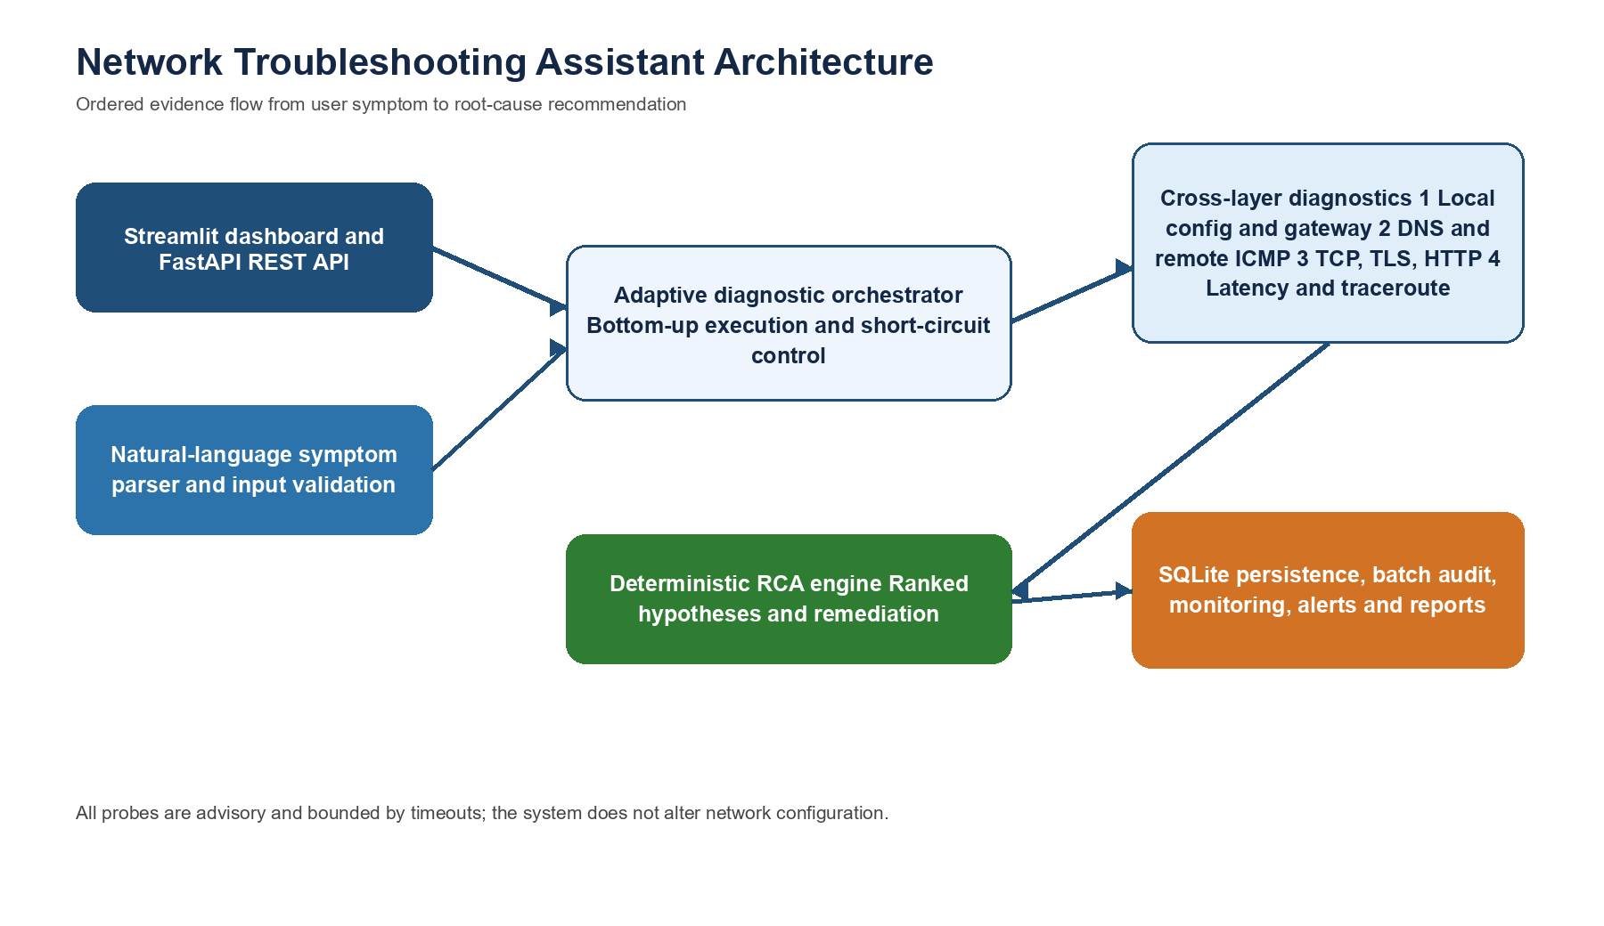
Figure 2.1: Proposed Bottom-Up Diagnostic Pipeline and System Architecture
shown in Figure 2.1, the orchestrator executes diagnostics bottom-up:
- Stage 1 (Local Config): Inspects local NIC link state, IPv4/IPv6 assignment, APIPA status, and default route 0.0.0.0/0.
- Stage 2 (Gateway Reachability): Pings the local router to verify LAN Data-Link/ARP and router health.
- Stage 3 (DNS Resolution): Resolves the target FQDN to IPv4/IPv6 addresses via system resolvers.
- Stage 4 (Destination Reachability): Sends ICMP Echo probes to test end-to-end network routing.
- Stage 5 (Transport Port Check): Performs a bounded TCP 3-way handshake on the target service port.
- Stage 6 (TLS & HTTP Check): Validates X.509 certificates via SNI and checks HTTP response codes.
- Stage 7 (Latency & Loss Profiling): Samples multi-probe RTT
(min/avg/max), jitter, and packet loss.
- Stage 8 (Bounded Traceroute): Maps intermediate hops using incremental IP TTL probes and renders the path via Plotly.

2.2 Tools and System Requirements
The software tools, core libraries, and hardware specifications utilized to build and test the project are listed in Table 2.2.
Tool or Resource | Version or Specification | Purpose
Python | 3.11 / 3.12 | Core programming language for networking, concurrency, and RCA engine.
Standard Library socket, ssl,  urllib, subprocess) | Python Built-in | Native Berkeley TCP/UDP sockets, TLS context wrapping,  HTTP probing, and OS  ICMP/traceroute execution.
psutil | ≥ 5.9.0 | Cross-platform inspection of NIC states, IP addresses, and subnet masks.
Streamlit | ≥ 1.32.0 | Multi-page interactive web dashboard, simulation lab, and visual interface.
FastAPI & Uvicorn | ≥ 0.110.0 | RESTful API server  (/api/v1/diagnose) with Swagger OpenAPI docs.
Plotly | ≥ 5.19.0 | Interactive traceroute hop topology visualization and telemetry charts.
Pydantic | ≥ 2.6.0 | Strict data validation and schema modeling for diagnostic sessions.
SQLite3 | Built-in | Persistent local database for incident history and continuous monitoring telemetry.
ReportLab | ≥ 4.1.0 | Automated generation of standalone executive PDF diagnostic reports.
Pytest | ≥ 8.0.0 | Automated unit, integration, API, and fault simulation verification suite.
Host OS  Environment | Windows 11 / Linux (Ubuntu) | Cross-platform execution environment with Dual-Stack IPv4/IPv6 networking.

2.3 Addressing and Protocol Selection

Device or target | Address, port, or protocol | Gateway or resolver | Diagnostic role
Local interface | DHCP IPv4/IPv6 | Default gateway | Stage 1 local configuration
Default gateway | ICMP Echo | LAN router | Stage 2 local gateway reachability
System resolver | UDP/TCP 53 | Configured DNS | Stage 3 hostname resolution
Loopback RST target | 127.0.0.1:59999 TCP | Local host | Controlled TCP refusal scenario
Timeout target | 192.0.2.1:8080 TCP | RFC 5737 TEST-NET-1 | Controlled silent-timeout scenario
DNS target | invalid-nxdomain-target-xyz.com | System resolver | Controlled NXDOMAIN scenario

Table 2.3: Network Addressing, Special Test Endpoints, and Protocol Specifications Key Protocol Design Decisions:
- Bounded Non-Blocking Probing: Every socket connection, DNS lookup, and ICMP command enforces a strict timeout (typically 2.0 to 4.0 seconds) so that silent packet blackholes do not hang the application or exhaust OS file descriptors.
- ICMP-Independent Transport Verification: In engine/orchestrator.py, a failure in Stage 4 (ICMP Ping) logs a WARNING rather than halting the pipeline, ensuring Stage 5 (TCP Handshake) still executes to account for ICMP-filtering firewalls.

3 Implementation and Technical Working

3.1 Methodology
The implementation workflow is structured around a deterministic pipeline orchestrated by engine/orchestrator.py:
- Input Sanitation & Symptom Parsing: The user provides either a target hostname/IP and port or a natural language symptom (e.g.,
“Teams calls dropping to 10.0.0.5”). The module llm/symptom_parser.py extracts target parameters via regex and keyword heuristics, while utils/validation.py validates RFC compliance and strips shell metacharacters.
- Sequential Stage Execution: The orchestrator invokes the 8 diagnostic stages in bottom-up order. Early fatal failures (such as a completely disconnected local NIC in Stage 1 or DNS NXDOMAIN in Stage 3) shortcircuit dependent remote socket stages to avoid meaningless timeouts.
,𝑎
- Cross-Layer Evidence Synthesis: All TestResult Pydantic objects
(containing status PASS, WARN, FAIL, latency in ms, and structured metadata) are passed to engine/root_cause.py.
- Root Cause Ranking & Reporting: The RCA engine evaluates multistage patterns, assigns confidence scores (0.0 to 1.0), generates step-by-step remediation advice, persists the session to SQLite (storage/database.py), and renders visual charts and downloadable HTML/PDF reports.

3.2 Configuration or Code Implementation
The project is organized into modular Python packages. Below are concise excerpts of the core networking and inference logic (complete module implementations are provided in Appendix A).
1. Transport Layer TCP 3-Way Handshake Differentiation
(diagnostics/connectivity.py): This function uses native Berkeley sockets
(‘AF_{𝐼}𝑁𝐸𝑇‵,‵ 𝑆𝑂𝐶𝐾_{𝑆}𝑇𝑅𝐸𝐴𝑀‵)𝑡𝑜𝑑𝑖𝑠𝑡𝑖𝑛𝑔𝑢𝑖𝑠ℎ𝑏𝑒𝑡𝑤𝑒𝑒𝑛𝑎𝑛𝑜𝑝𝑒𝑛𝑝𝑜𝑟𝑡,𝑎𝑛𝑎𝑐𝑡𝑖𝑣𝑒𝑂𝑆𝑘𝑒𝑟𝑛𝑒𝑙𝑟𝑒𝑗𝑒𝑐𝑡𝑖𝑜𝑛(‵𝑇𝐶𝑃𝑅𝑆𝑇‵)
def check_tcp_port_availability(target_host: str, port: int, timeout_sec: float = 3.0) -> Te start_time = time.perf_counter() try:
with socket.socket(socket.AF_INET, socket.SOCK_STREAM) as sock:
sock.settimeout(timeout_sec) sock.connect((target_host, port))
latency_ms = (time.perf_counter() - start_time) * 1000.0 return TestResult( stage="tcp_connect", status="PASS", latency_ms=round(latency_ms, 2), summary=f"TCP 3-way handshake succeeded on {target_host}:{port}",
details={"port": port, "state": "OPEN"}
) except ConnectionRefusedError:
return TestResult( stage="tcp_connect", status="FAIL",
summary=f"Connection refused (TCP RST received) on {target_host}:{port}", details={"port": port, "state": "CLOSED_RST", "error_type": "ConnectionRefusedEr
) except socket.timeout:
return TestResult( stage="tcp_connect", status="FAIL",
summary=f"TCP SYN timed out after {timeout_sec}s on {target_host}:{port}", details={"port": port, "state": "FILTERED_TIMEOUT", "error_type": "TimeoutError" )
- Presentation Layer SSL/TLS Certificate Verification (diagnostics/http_tls.py): Wraps a TCP socket in a default SSL context with Server Name Indication (SNI) to validate the X.509 certificate chain and check expiration timestamps:
context = ssl.create_default_context() with socket.create_connection((target_host, port), timeout=timeout_sec) as sock:
with context.wrap_socket(sock, server_hostname=target_host) as ssock:
cert = ssock.getpeercert() cipher = ssock.cipher() tls_version = ssock.version()
- Deterministic Root Cause Analysis Engine (engine/root_cause.py): Synthesizes results across all stages to isolate the exact layer of failure:
if local_cfg and local_cfg.status == "FAIL":
hypotheses.append(RootCauseHypothesis( cause="Local Network Interface Disconnected or DHCP Lease Failure", confidence=0.95, layer="Layer 1/2 (Physical / Data Link)"
)) elif dns_res and dns_res.status == "FAIL":
hypotheses.append(RootCauseHypothesis( cause="DNS Hostname Resolution Failure (NXDOMAIN or Unreachable Resolver)", confidence=0.90, layer="Layer 5/7 (DNS Service)"
)) elif tcp_res and tcp_res.status == "FAIL":
if tcp_res.details.get("state") == "CLOSED_RST":
hypotheses.append(RootCauseHypothesis( cause=f"Target Service Daemon Not Listening on Port {target_port} (TCP RST)", confidence=0.92, layer="Layer 4 (Transport Layer)"
)) else:
hypotheses.append(RootCauseHypothesis( cause=f"Firewall Dropping Packets or Routing Blackhole on Port {target_port}", confidence=0.80, layer="Layer 3/4 (Network / Firewall)" ))

3.3 Protocols and Technical Working
- Local Link, DHCP & ARP (Stages 1–2): In Stage 1, local_config.py inspects active interfaces via psutil.net_if_addrs() and net_if_stats(). It filters out loopback (127.0.0.1) and flags Automatic Private IP Addressing (169.254.x.x, RFC 3927 [9]), which occurs when the 4-step DHCP DORA process (Discover, Offer, Request, Acknowledge, RFC 2131 [7]) fails. Stage 2 dispatches ICMP Echo Requests (Type 8, Code 0) to the default gateway, verifying local Address Resolution Protocol (ARP, RFC 826) MAC translation and local router responsiveness.
- DNS Resolution (Stage 3): dns.py invokes socket.getaddrinfo() over UDP/TCP Port 53. It distinguishes between NXDOMAIN (RCODE 3, non-existent domain) and resolver timeouts, preventing downstream socket calls against unresolvable names.
- TCP 3-Way Handshake vs. ICMP Asymmetry (Stages 4–5):
While Stage 4 sends ICMP Echo probes, Stage 5 tests Transport-layer reachability by transmitting a SYN segment. If the remote host replies with SYN+ACK, the kernel completes the handshake with ACK and records connection RTT. If no application is bound to the port, the remote OS returns a RST segment (ConnectionRefusedError), proving the host and network path are operational even if ICMP ping was blocked.
- TLS Cryptographic Handshake & HTTP Health (Stage 6): During the TLS handshake, the client sends a ClientHello containing the target hostname in the SNI extension (enabling virtual hosting on CDNs), negotiates TLS 1.2/1.3 cipher suites (such as ECDHE-RSA-AES128-GCMSHA256), and verifies the server’s X.509 certificate against trusted Root CAs. Following TLS, an HTTP/1.1 request classifies application status codes into healthy (2xx/3xx), client error (4xx), or server crash/gateway timeout (500, 502, 503, 504).
- RTT Latency, Jitter & TTL Traceroute Mapping (Stages 7–8): latency.py computes total delay (Propagation+Transmission+Queuing+ Processing) across multiple probes and measures Jitter (RTT_{max}−RTT_{min}). traceroute.py increments the 8-bit IPv4 Time-to-Live (TTL) header field starting from TTL = 1. Each intermediate router decrements TTL to 0 and returns an ICMP Type 11, Code 0 (Time Exceeded in Transit) packet, allowing traceroute_visualizer.py to map every hop and pinpoint the first failing hop.

3.4 Execution Procedure
The project can be launched reproducibly on Windows, macOS, or Linux using the following steps:
- Install Dependencies: Ensure Python 3.11+ is installed and run:
python -m pip install -r requirements.txt
- Configure Environment (Optional): Copy .env.example to .env to configure optional Ollama/OpenAI/Gemini LLM explainability or Slack/Jira webhook integrations.
- Launch the Streamlit Multi-Page Web Interface:
python run.py
# Alternatively: streamlit run app.py
Navigate to http://localhost:8501 in a web browser to access the Live Diagnostics, Batch Audit, Fault Simulation Lab, Continuous Monitoring, and Incident History pages.
- Launch the FastAPI REST Server (Optional):
python run.py api
# Alternatively: uvicorn api.server:app --host 0.0.0.0 -port 8000 --reload
Access interactive Swagger API documentation at http://localhost:8000/docs.
- Execute Automated Verification Suite:
python -m pytest -v

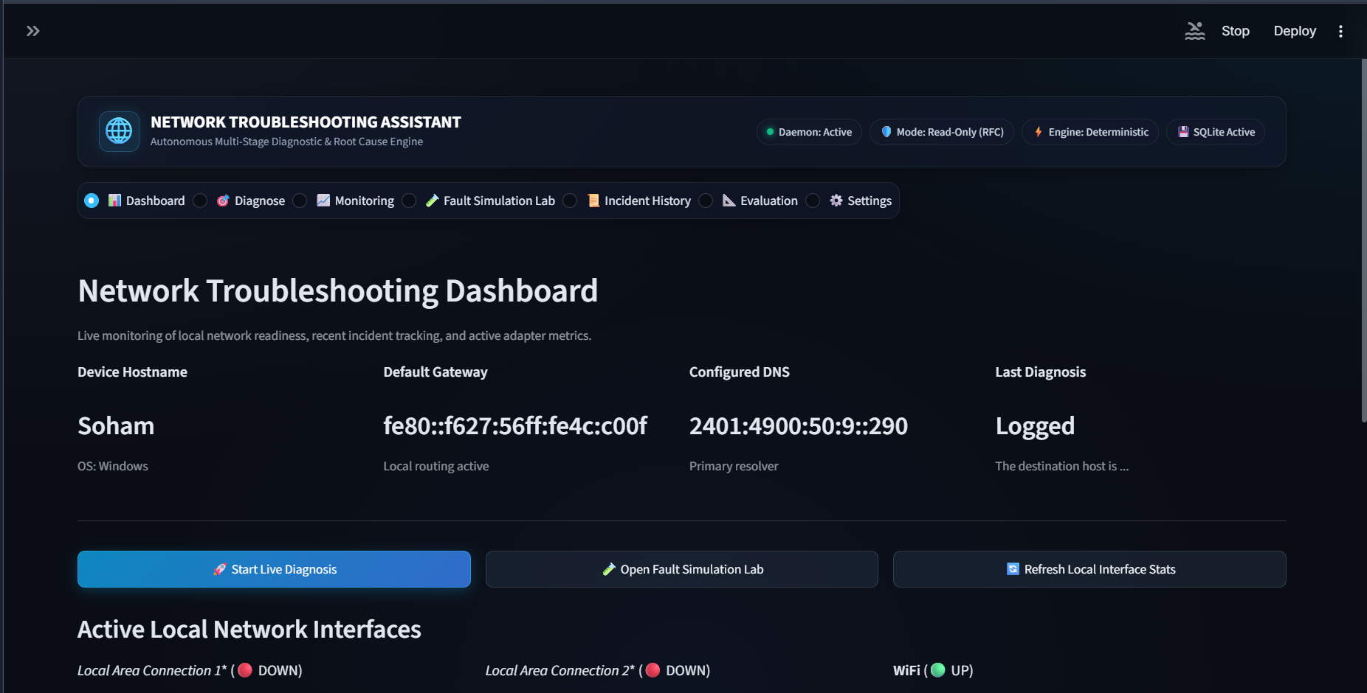
Figure 3.1: Streamlit Dashboard and Diagnostic Interface

Figure 3.1 shows the Streamlit dashboard used to access diagnostic, monitoring, simulation, history, evaluation, and settings workflows. The interface presents local-network context and directs the operator to the ordered investigation and fault-simulation facilities.

4 Testing and Results

4.1 Test Plan
Testing combines the deterministic fault-simulation laboratory with unit and integration test modules included in the repository. The simulation engine constructs typed PASS, WARNING, and FAIL evidence for controlled failure conditions, passes that evidence to the same root-cause engine used by the application, and records the expected and predicted causes separately. This allows network-layer interpretation to be tested without changing a real interface, DNS configuration, route, or firewall rule.
ID | Scenario | Controlled condition | Expected diagnostic evidence
S01 | DNS NXDOMAIN | Unresolvable hostname | DNS failure evidence; downstream network tests are not meaningful.
S02 | TCP connection refused | 127.0.0.1:59999 | Immediate TCP RST identifies a reachable host with a closed service port.
S03 | TCP timeout | 192.0.2.1:8080 | Bounded 3-second timeout distinguishes a silent drop from an active refusal.
S04 | Local IP or link failure | Disconnected synthetic interface | Pipeline stops after local configuration failure.
S05 | Gateway unreachable | Synthetic default gateway loss | Gateway-stage failure isolates the local LAN or router path.
S06 | HTTP 500 | Application error response | Transport remains healthy while application-layer evidence fails.
S07 | TLS validation failure | Self-signed or expired certificate | TLS certificate verification failure is reported separately from TCP reachability.
S08 | High latency | Average RTT 285 ms | WARNING evidence captures degraded path performance.
S09 | Packet loss | 30 percent loss | WARNING evidence captures intermittent loss without reporting a total outage.
S10 | Healthy baseline | All simulated stages healthy | PASS evidence results in a healthy-baseline classification.
Table 4.1: Controlled Fault Simulation Test Plan

4.2 Results and Execution Evidence
The simulation catalogue encodes ten repeatable cases that cover local link, gateway, name resolution, transport, TLS, HTTP, and performance conditions. The evidence model preserves the status, measured values, and explanatory text for each reached stage. The RCA engine then evaluates the collection of stage results rather than relying on a single probe. For example, the connection-refused scenario retains successful local and DNS evidence but fails the TCP-port stage with a RST condition, whereas the timeout scenario reports a bounded silent failure.
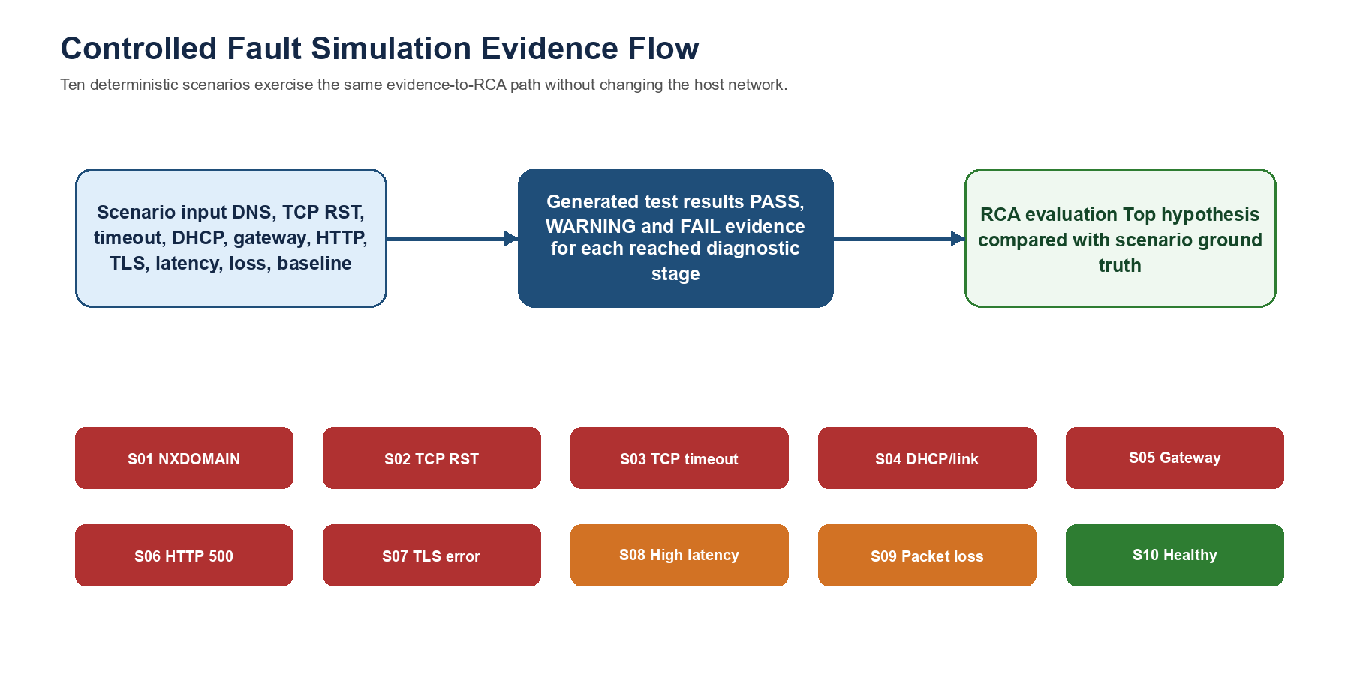
Figure 4.1: Controlled fault-simulation evidence and root-cause evaluation flow
The repository also contains unit tests for validation, root-cause ranking, traceroute visualization, monitoring, batch orchestration, LLM symptom parsing, API endpoints, report storage, and simulation scenarios. These tests provide regression coverage of individual modules and the principal application integrations. Runtime measurements shown in the simulations are deterministic fixture values and should not be interpreted as measurements of a particular production network.

4.3 Objective Achievement
Table 4.2 relates the stated objectives to implementation evidence available in the source repository. The table records implementation status rather than claiming performance beyond the evidence represented by the code and controlled fixtures.
Objective | Repository evidence | Outcome
O1 | Eight-stage orchestration and diagnostic modules in engine/orchestrator.py and diagnostics/. | Implemented
O2 | connectivity.py distinguishes connection refusal from timeout; simulation scenarios encode both cases. | Implemented
O3 | engine/root_cause.py consumes multi-stage TestResult evidence and returns ranked hypotheses. | Implemented
O4 | traceroute.py and traceroute_visualizer.py provide hop collection and Plotly visualization support. | Implemented
O5 | simulation/scenarios.py defines ten controlled scenarios; batch, monitoring, reporting, Streamlit, and FastAPI modules are included. | Implemented
Table 4.2: Objective Achievement and Implementation Evidence

5 Discussion and Conclusion

5.1 Discussion and Comparative Analysis
The principal value of the system is structured interpretation across layers. A single CLI result is often ambiguous: blocked ICMP does not prove that a web service is unavailable, and a successful ping does not validate a TLS certificate or an HTTP response. NTA retains the evidence from each completed stage and applies deterministic precedence rules to produce a layer-specific hypothesis and remediation guidance. It complements, rather than replaces, expert packet analysis or production monitoring systems.
Diagnostic dimension | Manual CLI | Packet capture | NTA
Execution workflow | Separate commands entered manually | Manual capture and packet interpretation | Ordered, bounded diagnostic stages
Cross-layer context | Operator correlates results | Detailed packets, manual correlation | Evidence collected in one diagnostic session
Root-cause output | Raw command output | Traffic visibility, not an RCA decision | Ranked deterministic hypotheses and advice
Repeatable fault learning | Requires test environment setup | Requires capture source and analysis | Ten non-destructive synthetic scenarios
Automation support | Scripts required | Capture infrastructure required | Batch auditing, persistence, monitoring, reports
Table 5.1: Comparison of Diagnostic Approaches

5.2 Advantages and Applications
- Evidence is collected in a consistent bottom-up order, which reduces the chance of interpreting an application symptom as a lower-layer failure.
- The deterministic RCA engine makes its classification dependent on recorded stage results rather than ungrounded text generation.
- Bounded timeouts and read-only probes make the tool suitable for education, first-line helpdesk triage, pre-deployment endpoint checks, and supervised network troubleshooting.
- The Streamlit interface, FastAPI endpoints, batch orchestration, history database, and monitoring modules allow the same core diagnostics to be reused by different workflows.

5.3 Limitations
- ICMP is frequently filtered or rate-limited; therefore, an ICMP warning must be interpreted together with DNS and TCP evidence.
- Live probe results depend on the host operating system, configured resolver, network policy, and target availability. The included simulation values are controlled fixtures, not benchmarks for arbitrary networks.
- The system provides remediation advice but does not modify routes, DNS settings, firewall rules, or DHCP leases automatically.
- Deep packet-level causes such as retransmission behavior or switch-port errors require packet captures or network-device telemetry beyond the standard host probes.

5.4 Challenges and Troubleshooting
Issue | Cause or diagnosis | Correction and evidence
Cross-platform ICMP invocation | Ping command flags differ by operating system. | utils/platform.py supplies platform-specific command construction.
Silent TCP drops | A dropped SYN can otherwise block a diagnostic workflow. | Socket timeouts bound the TCP connection check and expose a timeout state.
TLS certificate errors | Default validation can terminate the handshake before metadata is reported. | The TLS module records certificate-validation evidence and fallback metadata where available.
Local adapter noise | Loopback, virtual, or disconnected adapters can confuse interface discovery. | Local-configuration filtering focuses the diagnostic result on usable non-loopback interfaces.
Table 5.2: Development Challenges and Applied Solutions

5.5 Future Scope
- User-approved local remediation actions, such as DHCP renewal or DNS-cache flushing, with clear audit and rollback controls.
- SNMP, NetFlow, and device telemetry inputs for switch-port counters, interface errors, and router health indicators.
- IPv6-first path analysis and richer route anomaly detection across dual-stack networks.
- Optional packet-capture or eBPF integration where the operating environment permits controlled deeper inspection.

5.6 Conclusion
Network Troubleshooting Assistant implements a modular, cross-layer diagnostic workflow for locating common connectivity and service failures. It combines local-interface inspection, gateway and DNS checks, transport probing, TLS and HTTP validation, latency analysis, traceroute support, and deterministic root-cause ranking. The Streamlit and FastAPI interfaces, persistent history, batch operation, monitoring, reporting, and controlled simulation laboratory demonstrate how a repeatable troubleshooting process can be made accessible without changing the network under investigation.

References
[1] J. Postel, Internet Protocol, RFC 791, Internet Engineering Task Force, Sep. 1981. doi: 10.17487/RFC0791.
[2] J. Postel, Internet Control Message Protocol, RFC 792, Internet Engineering Task Force, Sep. 1981. doi: 10.17487/RFC0792.
[3] E. Eddy, Ed., Transmission Control Protocol, RFC 9293, Internet Engineering Task Force, Aug. 2022. doi: 10.17487/RFC9293.
[4] P. Mockapetris, Domain Names Concepts and Facilities, RFC 1034, Internet Engineering Task Force, Nov. 1987. doi: 10.17487/RFC1034.
[5] R. Fielding, M. Nottingham, and J. Reschke, HTTP Semantics, RFC 9110, Internet Engineering Task Force, Jun. 2022. doi: 10.17487/RFC9110.
[6] E. Rescorla, The Transport Layer Security Protocol Version 1.3, RFC 8446, Internet Engineering Task Force, Aug. 2018. doi: 10.17487/RFC8446.
[7] R. Droms, Dynamic Host Configuration Protocol, RFC 2131, Internet Engineering Task Force, Mar. 1997. doi: 10.17487/RFC2131.
[8] S. Cheshire, B. Aboba, and E. Guttman, Dynamic Configuration of IPv4 Link-Local Addresses, RFC 3927, Internet Engineering Task Force, May 2005. doi: 10.17487/RFC3927.
[9] Python Software Foundation, Python 3 Library Reference: socket and ssl modules. Available: https://docs.python.org/3/library/. Accessed: 21 Oct. 2026.

AI Usage Declaration
AI-assisted tools were used for report drafting, language editing, and document-formatting assistance. The group reviewed the generated prose against the project source code, the retained report material, and the implemented modules. The report distinguishes deterministic simulation fixture values from measurements of a live production network.
Declaration: We take responsibility for the accuracy of this report and understand the submitted implementation and results. Sources and assistance used have been acknowledged.
Student Name | PRN | Signature
Soham Patil | 1272250811
Ganesh Gaikwad | 1262252319
Tirth Gangani | 1272250827
Aditya Sardesai | 1262252353

Appendices

Appendix A Code and Configuration
The source repository is structured into diagnostics, engine, API, UI, storage, monitoring, batch, simulation, reporting, integration, and test packages. The following abbreviated workflow reflects the implementation structure in engine/orchestrator.py.
1. Inspect local network configuration and active interface state.
2. Check the default gateway when a route is available.
3. Resolve the target hostname and stop dependent stages if resolution fails.
4. Perform destination reachability and bounded TCP connection checks.
5. Run TLS/HTTP, latency, and traceroute checks when applicable.
6. Pass typed TestResult evidence to the deterministic RCA engine.
7. Persist the DiagnosticSession and expose it through the UI/API/report modules.

Appendix B Additional Evidence
The FastAPI server exposes diagnostic, session-history, batch-diagnosis, ticketing, and monitoring routes. The Streamlit application provides dashboard, diagnosis, monitoring, fault-simulation, history, evaluation, and settings views. SQLite stores diagnostic sessions and monitoring/evaluation records locally.
Method | Route | Purpose
POST | /api/v1/diagnose | Run a diagnostic investigation for a target or symptom.
GET | /api/v1/sessions | Retrieve stored diagnostic-session summaries.
GET | /api/v1/sessions/{session_id} | Retrieve a full diagnostic session.
POST | /api/v1/batch-diagnose | Run bounded concurrent diagnostics for multiple targets.
GET/POST | /api/v1/monitoring/targets | Read or manage background monitoring targets.
Table B.1: Selected REST API Endpoints

Appendix C Individual Contributions
The project materials attribute the following responsibilities to the team members.
Student | Work completed | Evidence or deliverable
Soham Patil  PRN 1272250811 | Core orchestrator, RCA engine, socket diagnostics, FastAPI backend, SQLite persistence, and automated tests. | engine/, diagnostics/, api/, storage/, tests/
Ganesh Gaikwad  PRN 1262252319 | Streamlit UI, dashboard views, traceroute visualization, and demonstration video. | app.py, app_ui/, diagnostics/traceroute_visualizer.py
Tirth Gangani  PRN 1272250827 | Technical requirements documentation, test-plan design, test-result compilation, and presentation support. | Report Sections 1, 3, and 4; presentation material
Aditya Sardesai  PRN 1262252353 | Architecture diagrams, comparative analysis, protocol mapping, and presentation preparation. | Report Sections 2 and 5; appendices; presentation visuals
Table C.1: Individual Student Contributions and Deliverables

