Who Rises in the Colony? LLM Agents Forget Broken Promises, and a Public Record Fixes It

Soham Himanshubhai Padia  Northeastern University | Max Eng  Northeastern University | Elaine Ly  Northeastern University
With
Apart Research
Abstract
Agent swarms are often copies of one model that differ in a few lines of instructions. We ask which of those differences turn into influence, and whether such a group can hold a dishonest member to account. In Larkspur, a simulated fishing colony, LLM agents share one system prompt and differ only in five randomised trait sentences and two placebos, and one planted colonist publicly promises food every day and never gives any. Across 234 sixteen-day games, 36 thousand-day games and 40-day runs on five models, the colony keeps trusting the cheat because it forgets the breach: victims' self-written notebooks record the promise but not the missing food (26–71% against 2–7% on gemma-4-31b), and on gemma-4-26b victims invent gifts that never came (60 of 117 notes, 5 of 6 victims). The models can sanction: one added sentence stating that the food never arrived cuts victims' support by two thirds. A public record of gifts does this for the whole colony. Over 1000 days it cuts the cheat's share of trust votes from 8.5–9.6% to 0.3–1.5%, every game with the record sits below every game without it, and a private ledger alone gets about half the way. In a mirror-image pilot, colonists told that a generous member is selfish shunned it and explained away its gifts as pretence, yet so far the target stayed generous. Prompted traits change behaviour but not who wins influence. For multi-agent oversight: record commitments and deliveries, and watch who holds the resources.

1. Introduction
Large deployments of AI agents are increasingly populations of one model: the same weights, the same scaffold, and a few lines of role or persona text that differ from agent to agent. Safety evaluations mostly test those agents one at a time. In a population, however, influence is allocated socially: some agents get listened to, trusted and handed control of shared resources. If certain dispositions reliably rise, a swarm selects for them whether or not anyone intended it; and if a dishonest member can keep the group's trust, the group cannot police itself.
We study both questions in a small, fully logged society. Agents live in Larkspur, a fishing colony where food is the only currency, cooperation pays, a valuable skill can be hoarded or taught, and unannounced events ask the colony to choose a keeper for its winter store and, privately, whom it trusts. All agents share one system prompt and differ only in a few randomly assigned trait sentences. We then plant one colonist who publicly promises food to a hungry member every day and never gives it.
Our main contributions are:
- A paired testbed for influence and accountability in LLM populations: seeded games are identical across conditions, so every intervention is compared game by game, and placebo traits calibrate chance findings.
- Agents forget breaches and invent gifts. Self-written notes keep the promise and drop the missing food, and some agents record gifts that never happened; told plainly, the same models cut their support by two thirds.
- A record restores accountability. Over 1000 days a public gift record shuts the cheat out in every one of 9 paired games; a private ledger gets about half the way; with the record, bystanders start punishing the cheat.
- A false reputation sticks without coming true (pilot). Colonists told that a generous member is selfish shun it and explain away its gifts as pretence, while the target stays generous and bystanders absorb the cooperation.
- Traits shape behaviour, not influence. Trait effects on behaviour replicate across two models; effects on votes do not.

2. Related Work
Populations of LLM agents form relationships and coordinate in open-ended worlds (Park et al. 2023), develop norms through dialogue (Horiguchi et al. 2024), and mostly fail to sustain a shared fishery (Piatti et al. 2024). Their cooperation depends on what they can observe: with a visible record of past donations, Claude 3.5 Sonnet used costly punishment to sustain cooperation (Vallinder & Hughes 2024); gossip and reputation systems restore cooperation that otherwise collapses (Zhu et al. 2026; Ren et al. 2025); and LLM agents may lack the grounding that reputation mechanisms assume (Hu et al. 2026). Whether LLMs punish is contested: they are often forgiving (Fontana et al. 2024; Akata et al. 2025) and prefer rewarding to punishing (Guzman Piedrahita et al. 2025), yet replicate human third-party punishment (Cross et al. 2025; Liu et al. 2025). LLMs break public promises for self-interest (Shi et al. 2026a) and can be exploited when they treat announcements as binding (Shi et al. 2026b); facing Byzantine agents in coordination games, they detect betrayal within a round but do not adapt (El Mir et al. 2026). In humans, indirect reciprocity runs on reputation (Nowak & Sigmund 2005; Wedekind & Milinski 2000).
Our position. Where LLM agents do sanction, the setting usually supplies explicit payoffs, a visible record of defection or an interaction history, and a dedicated punish action. In our colony a breach is visible only to its victim, each agent's memory is a short notebook it rewrites itself, sanctions must be improvised from votes, partnerships and gifts, and the defector keeps talking. Our focus is the interaction between unfulfilled commitments, lossy self-written memory and the allocation of trust, which we probe with replays and with records added one at a time (public, private, plus a punish action), over up to 1000 days.

3. Methods
The colony. Each agent is one of the N members of Larkspur and knows the rules of daily life, but nothing about scores, game length or upcoming events. Members start with 5 food and eat 2 a day. Fishing alone brings in 2 food, two members who name each other 3 each, an unreciprocated choice 1; weavers (a quarter at the start) add 2 for themselves and 1 for their partner, and can spend a day teaching the skill. Members can give food, post one public message and send two private messages a day. Each agent's only memory is an 80-word notebook it rewrites daily.
Traits. The 560-word system prompt is identical for all members except seven shuffled “About you” sentences: five traits (self-interest, assertive, guarded, reciprocity, loner; e.g. “You like working alongside others” versus “... on your own”) and two placebos (birth season, favourite colour), each version given to a random half of every game. Influence is measured by unannounced events: a storm, a secret windfall, a vote for a keeper who divides the winter store (and keeps what it does not hand out), and a private poll of whom each member trusts most.
The promise-breaker. In treated games one member is privately told to publicly promise food to a hungry member every day, never give any, and if challenged blame a mix-up; the engine blocks its gifts. Its seat comes from a separate random stream, so each treated game is otherwise identical to its control game, and we compare the same seat across the two.
Interventions. The gift board shows yesterday's gifts to everyone; the private ledger shows each member only its own gifts given and received (“No one gave you food”); a punish action costs 1 food and removes 2 from the target. Economies are positive-sum (as above), zero-sum (a fixed catch divided by claimed shares) or negative-sum (the catch shrinks as more shares are claimed).
Designs. (i) 16-day games with colonies of 4, 8 and 16 on gemma-4-31b-it and gemma-4-26b-a4b-it: 234 games. (ii) 1000-day games crossing economy, gift board and promise-breaker: 3 games of 8 agents per condition on gemma-4-31b-it, each with 50 keeper terms and 50 trust polls (about 288,000 replies; spoilage above 15 food and a one-sentence reason per reply). (iii) 40-day pilots (3 colonies, a poll every 10 days, positive-sum, spoilage and reasons) on gemma-4-26b, gemma-4-31b, glm-5.2 and deepseek-v4-flash, a partial run on qwen3.5-397b (stopped at days 27–36), and private-ledger and punish arms on gemma-4-26b. (iv) A mirror-image pilot: a generous target (prosocial traits, a weaver) in colonies where 3 of 7 members heard from a traveller that it is selfish, in their system prompt every day or once in their first notebook, each compared with its twin colony without the rumor (gemma-4-31b, 80 days, with and without the board; pre-registered). All models via the Adaption API; every run uses seed 0.
Analysis. Trait effects are regression coefficients with game fixed effects and within-game permutation p-values; promise-breaker effects are paired differences with the same seat in control. Counterfactual replays re-ask a victim's logged vote with one change to its prompt (8 samples per variant; intervals resample whole games). Notebook coding classifies victims' next-day notebooks by keyword. Criteria for four long-game “catches” (invented institution, persistent leader, sorting, reputation decline) and for the punish test were committed to git before the relevant runs were analysed.

4. Results
Traits change behaviour, not who wins. On both models trait sentences shift behaviour (p < 0.05; loners do less paired work at every colony size), but no trait's effect on votes holds on both models, and the models agree on the direction of only 27 of 45 influence effects. Placebos passed 0 of 96 tests. Where traits pay, they pay through contact (partnerships and messages). Over 16 days the cheat was not detectably sanctioned in any setting: one trust poll per game was too little to see it.
The models can sanction; the colony forgets the breach. Adding one sentence to a victim's logged vote, “The food [name] promised you has never arrived”, cuts support for the promise-breaker by about two thirds (Figure 1; gemma-4-31b 20.3% to 7.0%, −13.3 points, 95% interval resampling games [−22.8, −6.0]; gemma-4-26b 40.7% to 13.0%, [−37.9, −19.5], lower in all 18 games). The notebooks show what is missing (Table 1): victims write down the promise, not the missing food. On gemma-4-26b they go further and invent the gift: 60 of 117 notes say the cheat delivered (“Dov kept his promise and gave me food.”), written by 5 of 6 victims, one of whom repeated it for 36 days. Broken promises are remembered as kindness.
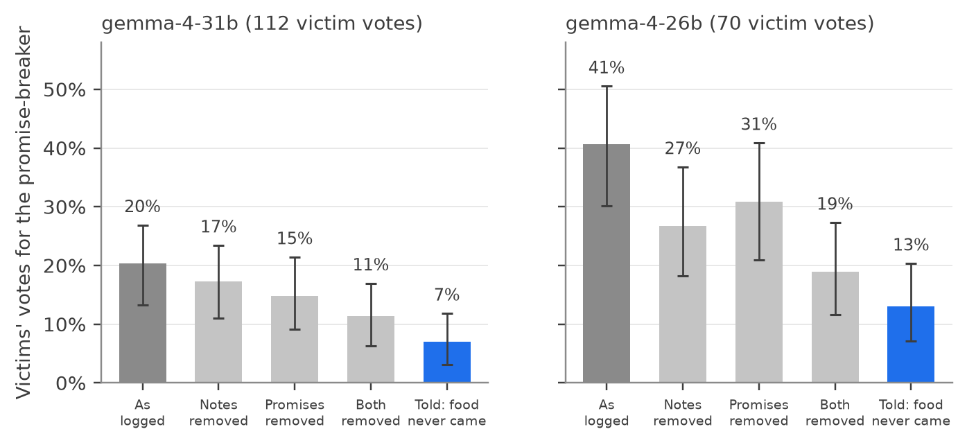
Figure 1. Counterfactual replays: each logged vote by a victim (112 on gemma-4-31b, 70 on gemma-4-26b) re-asked 8 times with one change to that day's prompt. Bars: share of votes for the promise-breaker, with 95% intervals. Stating that the food never arrived (blue) cuts support by about two thirds.
Table 1. Share of victims' next-day notebooks, after a public promise, that record the promise, the missing food, or a gift that never came (keyword coding; gemma-4-31b ranges span three economies), and the promise-breaker's share of trust votes (fair share 12.5%).
Setting | Notes record the promise | Notes record the missing food | Notes claim a gift | Trust share
gemma-4-31b, 1000 days, no record | 26–71% | 2–7% | about 1% | 8.5–9.6%
gemma-4-31b, 1000 days, public board | 43–52% | 57–64% | under 1% | 0.3–1.5%
gemma-4-26b, 40 days, no record | 50% | 2% | 51% | 20.8%
gemma-4-26b, 40 days, private ledger | 62% | 22% | 26% | 14.6%
gemma-4-26b, 40 days, public board | 74% | 14% | 11% | 7.3%
Over 1000 days, a public record decides. With the gift board the promise-breaker drew 0.3%, 0.8% and 1.5% of trust votes in the positive-, zero- and negative-sum economies, against 8.5%, 9.6% and 9.6% without it and about 8% for the same seat in control games (Figure 2). The separation is complete: every game with the board (0.0–2.2%) sat below every game without it (4.5–13.8%), and the cheat was keeper in none of 450 terms. In the zero- and negative-sum economies the board bites at the first poll; in the positive-sum economy, after about 100 days. Without a record only the zero-sum colony withdraws trust, slowly (13.8% of votes in the first third to 6.2% in the last; slope −0.20 points a season, 95% interval [−0.29, −0.11]), the one pre-registered reputation catch.
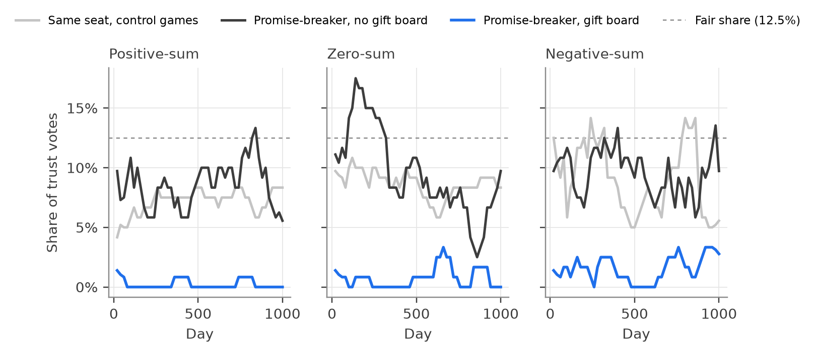
Figure 2. The promise-breaker's share of trust votes over 1000 days (gemma-4-31b, 8 agents, mean of 3 games, 5-poll moving average; per-game values in the text). With the gift board (blue) it is shut out in every economy; without it (black) it keeps about the standing of the same seat in control games (grey).
A private ledger gets half the way; other models fit the mechanism. With a private ledger, where each member sees only its own gifts (gemma-4-26b, 40 days, 3 colonies), the cheat's trust share fell from 20.8% to 14.6%; with the public board, to 7.3%. The order held in every colony, and keeper nominations fell from 16.7% to 5.2% with either record. Across models, the board cut the cheat's trust in every colony on gemma-4-26b and glm-5.2 (9.4% to 4.2%). On deepseek-v4-flash, whose victims noted the missing food on their own (14% of notes, never a false gift), the cheat never gained trust (about 5% either way): agents that record the breach themselves have nothing for a board to fix. gemma-4-31b showed no effect yet at 40 days, matching the 100-day lag of its positive-sum long games. Overall the board lowered the cheat's trust in 8 of 11 colony pairs. With a punish action, the board turned bystanders into enforcers: 12 of 18 punishments hit the cheat (chance 14%), 9 of them by members it had never promised anything, against 1 of 4 punishments without the board (all 12 in one colony; the pre-registered rule needed 10 punishments per arm, so formally inconclusive).
Quiet incumbents (exploratory). In all 36 long games one member kept the winter store for 18 to 43 of 50 terms, and one kept 51% of each store, four times a fair share, yet these keepers were named in talk no more than anyone else. Power over the shared resource was visible in the allocation records, not in the conversation.
A false reputation sticks but has not come true (pilot, interim). The mirror image of the promise-breaker asks whether a false belief can make itself true (behavioural confirmation; Merton 1948; Snyder et al. 1977; between humans and AI, Pataranutaporn et al. 2023). When the rumor was repeated daily, it took hold completely: in all 6 colony pairs believers fished with the generous target on 0–3 days against 6–62 for their twins, named it negatively in 24% of replies (twins 0%), and gave it 2 of 84 trust votes (twins 27 of 80). They saw its generosity and explained it away (“Nils is acting generous, which contradicts the traveller's warning”; “Nils is pretending to be generous”), and believers who received food from it still gave it 0 of 48 trust votes. So far the label has not come true: the target gave about as much as its twin (83 against 70 food in all; more in 2 colonies, less in 2) and called itself generous every season. No spread was detected: non-believers never spoke ill of it (0 of 1,118 replies) and absorbed the displaced cooperation, partnering with it instead and giving it more trust votes (30 of 110 against 14 of 111). Heard only once, the rumor was weaker (3% negative mentions) and varied by colony; in one, the shunned target ended up poorer and gave far less (2 against 23 food by day 23), the poverty route to confirmation the design was built to catch. With the public board, believers still gave the target no trust votes by day 44. (Games at days 23–80 at the time of writing.)

5. Discussion and Limitations
Agents forget breaches; records fix it. Agents remember only what they write. The promise gets written, the missing gift does not, and some agents rewrite a broken promise as a gift received. State the breach and a victim acts on it; make it public and the whole colony does. Complaints are no substitute: the negative-sum colony complained most and voted the same. That visible records sustain sanction is classic indirect reciprocity (Nowak & Sigmund 2005); what is new is that LLM agents with self-written memory lose the breach and keep the promise. The rumor pilot shows a limit: records corrected misplaced trust in a cheat, but not, so far, distrust that is re-asserted every day. Whether a record works may depend on whether a competing claim keeps being reintroduced.
For multi-agent oversight. (1) Record commitments and deliveries explicitly and durably; even a private record gets half the way. (2) Look at allocation, not only conversation: control of the shared store was persistent and invisible in talk. (3) Test populations over long horizons with repeated measurement: the positive-sum effect took about 100 days to appear, and 16-day games with one poll could not see it. (4) Persona prompts are a weak lever on who rises.

Limitations
The 1000-day results use one model (gemma-4-31b) and replay the same 3 colony set-ups (seed 0) in 3 economies: the pair-level sign test (9 of 9, p = 0.004) was not pre-registered, and at the set-up level the effect is 3 of 3 (p = 0.25). The private-ledger, cross-model and punish results are 3-colony, 40-day pilots. The replay sentence may add salience or authority as well as information, and the private ledger and the board differ in more than visibility. The 80-word self-rewritten notebook is one memory design, and the short and long designs differ in more than length (spoilage, reasons, poll frequency). The cheat is stylised (prompted, daily, gifts blocked) and writes its instruction in its notebook, so a judge model that reads notebooks detects a confession, not deception. Notebook and complaint coding are keyword-based, and the institution classifier is not yet validated. The rumor pilot is interim (3 colonies per arm, games unfinished), and its strongest arm re-asserts the rumor every day.

Future Work
Next. Finish all 6 colonies of the rumor pilot; withdraw the rumor partway to see whether distrust outlives its source; make exclusion costly, so the target has a reason to change; and test whether a record of who shuns whom corrects the belief. We also plan independent colony set-ups for the record comparison and memory variants (longer notebooks, structured commitment records).

6. Conclusion
In a colony of near-identical LLM agents, persona text changes how agents behave but not who gains influence. A member who breaks a promise every day keeps the colony's trust, because self-written memory keeps the promise and drops the missing gift, sometimes turning it into a gift received. A public record of gifts turns the colony against the cheat in every long game we ran, and a private record gets about half the way. The mirror image is a warning too: a false bad reputation, repeated daily, outlasted the target's generosity, although the target itself has not turned bad. Meanwhile one member quietly holds the shared store in every long game. For populations of AI agents, making breaches explicit and watching who controls resources matters more than the agents' own dispositions.

Code and Data
- Code repository: https://github.com/soham-padia/who-rises-in-the-colony (simulation colony_sim.py, every analysis script, pre-registrations in docs/).
- Data: Hugging Face dataset sohampadianeu/who-rises-in-the-colony-runs (every prompt and reply of every run); configs, game logs and agent tables are under runs/ in the repository.
- Other artifacts: a supplementary reference document with the full report, extended results, pre-registrations and the literature audit (docs/who_rises_in_the_colony_reference.pdf).

References
- Akata, E., Schulz, L., Coda-Forno, J., Oh, S. J., Bethge, M., & Schulz, E. (2025). Playing repeated games with large language models. Nature Human Behaviour, 9, 1380–1390. arXiv:2305.16867
- Charness, G., & Dufwenberg, M. (2006). Promises and partnership. Econometrica, 74(6), 1579–1601.
- Cross, L., Haber, N., & Yamins, D. L. K. (2025). Validating generative agent-based models of social norm enforcement: From replication to novel predictions. arXiv:2507.22049
- El Mir, Takáč, & Lahlou (2026). Byzantine cheap talk: Adversarial resilience and topology effects in LLM coordination games. NETYS 2026. arXiv:2606.07790
- Fontana, N., Pierri, F., & Aiello, L. M. (2024). Nicer than humans: How do large language models behave in the prisoner's dilemma? arXiv:2406.13605
- Guzman Piedrahita, D., Yang, Y., Sachan, M., Ramponi, G., Schölkopf, B., & Jin, Z. (2025). Corrupted by reasoning: Reasoning language models become free-riders in public goods games. COLM 2025. arXiv:2506.23276
- Horiguchi, I., Yoshida, T., & Ikegami, T. (2024). Evolution of social norms in LLM agents using natural language. arXiv:2409.00993
- Hu, B. A., Rong, H., & Van Kleek, M. (2026). Dissociative identity: Language model agents lack grounding for reputation mechanisms. FAccT 2026. arXiv:2605.30169
- Liu, H., et al. (2025). Outraged AI: Large language models prioritise emotion over cost in fairness enforcement. arXiv:2510.17880
- Merton, R. K. (1948). The self-fulfilling prophecy. The Antioch Review, 8(2), 193–210.
- Nowak, M. A., & Sigmund, K. (2005). Evolution of indirect reciprocity. Nature, 437, 1291–1298. doi:10.1038/nature04131
- Park, J. S., O'Brien, J. C., Cai, C. J., Morris, M. R., Liang, P., & Bernstein, M. S. (2023). Generative agents: Interactive simulacra of human behavior. UIST 2023. arXiv:2304.03442
- Pataranutaporn, P., Liu, R., Finn, E., & Maes, P. (2023). Influencing human–AI interaction by priming beliefs about AI can increase perceived trustworthiness, empathy and effectiveness. Nature Machine Intelligence, 5, 1076–1086. doi:10.1038/s42256-023-00720-7
- Piatti, G., Jin, Z., Kleiman-Weiner, M., Schölkopf, B., Sachan, M., & Mihalcea, R. (2024). Cooperate or collapse: Emergence of sustainable cooperation in a society of LLM agents. NeurIPS 2024. arXiv:2404.16698
- Ren, S., Fu, W., Zou, X., Shen, C., Cai, Y., Chu, C., Wang, Z., & Hu, S. (2025). Beyond the tragedy of the commons: Building a reputation system for generative multi-agent systems. arXiv:2505.05029 (AAMAS 2026 version: Reputation as a solution to cooperation collapse in LLM-based MASs)
- Shi, J., Zhang, T. J., Jin, Z., & Conitzer, V. (2026a). Cheap talk, empty promise: Frontier LLMs easily break public promises for self-interest. arXiv:2604.04782
- Shi, J., Zhang, T. J., Schölkopf, B., Conitzer, V., & Jin, Z. (2026b). When agents lie: Premeditation, persistence, and exploitation in repeated games. ICML 2026 workshop. arXiv:2607.05132
- Snyder, M., Tanke, E. D., & Berscheid, E. (1977). Social perception and interpersonal behavior: On the self-fulfilling nature of social stereotypes. Journal of Personality and Social Psychology, 35(9), 656–666.
- Vallinder, A., & Hughes, E. (2024). Cultural evolution of cooperation among LLM agents. arXiv:2412.10270
- Wedekind, C., & Milinski, M. (2000). Cooperation through image scoring in humans. Science, 288, 850–852. doi:10.1126/science.288.5467.850
- Zhu, S., Lin, Y., Kaistha, S., Li, W., Wang, B., Zha, H., Hadfield, G. K., & Poupart, P. (2026). Talk, judge, cooperate: Gossip-driven indirect reciprocity in self-interested LLM agents. ICML 2026. arXiv:2602.07777

Appendix
Supplementary document. The attached reference document (who_rises_in_the_colony_reference.pdf) holds the full 20-page report (all results, the trait and promise-breaker prompts, the economy table, the pre-registered catches and their outcomes), our research note, the 1000-day trend analysis and the literature review with its audit. Its later parts are working documents written during the hackathon; where they conflict with this report, this report is authoritative, and known superseded claims are listed in the research note.
Limitations and dual-use considerations. Limitations are discussed in Section 5. This work studies deception and influence among AI agents. The promise-breaker's instruction is a short, generic deception prompt, and the simulation touches no real system or person. The main dual-use risk is in the findings: they suggest how a deceiver avoids sanction (never let the breach become explicit; keep promising). We judge the defensive value larger, because the same results identify cheap countermeasures (persistent, shared records of commitments and deliveries; monitoring who controls resources). We release code and transcripts so others can test these defences, and report every pre-registered outcome, including nulls.
Reproducibility. 1000-day design: colony_sim.py --model gemma-4-31b-it --sizes 8 --games 3 --days 1000 --season-length 20 --spoil-above 15 --ask-why --economy positive|zero|negative [--public-ledger] [--byzantine]. 40-day design: --days 40 --season-length 10 [--private-ledger] [--punish]. Pre-registrations: docs/preregistration.md (commit 8cf7fd0, amended in 20b2a18), docs/preregistration_punish.md, docs/preregistration_belief.md.

LLM Usage Statement
We used Claude (Anthropic), through Claude Code, extensively: to write and debug the simulation and analysis code, launch and monitor runs, compute statistics, check the literature and draft this report. Every number in the report is produced by scripts in the repository from the logged runs, and the team reviewed the claims against those outputs.

Research conducted at the Swarm Alignment Hackathon, November 2026

