<Image_288pxW_MainModel/>
  <Label_Simulationof/> <Model_Name/>
  <Label_Date/>: <Published_Date/>
  <Label_Designer/>: <Designer_Name/>
  <Label_StudyName/>: <Study_Name/>
  <Label_StudyType/>: <Study_Type/>
  Table of Contents
  Description 1
  Assumptions 2
  Model Information 2
  Study Properties 3
  Units 4
  Material Properties 4
  Loads and Fixtures 5
  Connector Definitions 6
  Contact Information 6
  Mesh information 7
  Sensor Details 8
  Resultant Forces 8
  Beams 9
  Study Results 10
  Conclusion 14

Description
No Data

Assumptions

Model Information

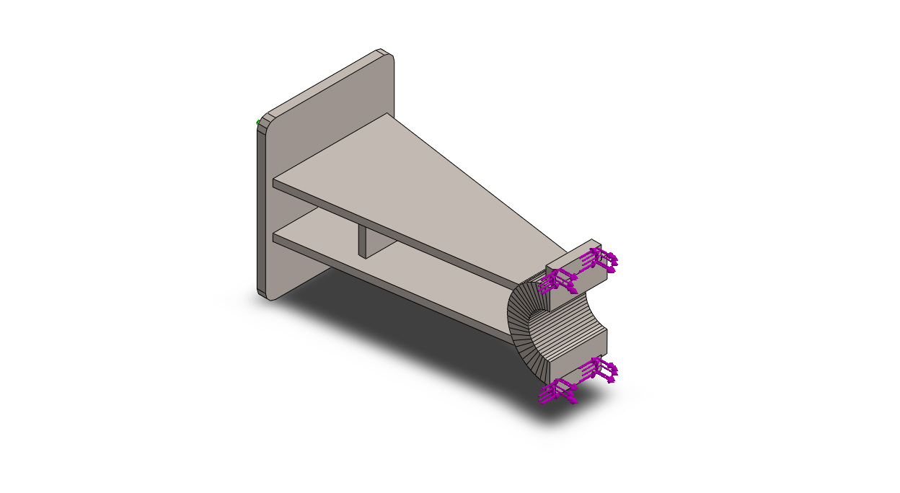
Model name: AquaSentinel_Pier_Bracket_Simulation
Current Configuration: Default
Solid Bodies
Document Name and Reference | Treated As | Volumetric Properties | Document Path/Date Modified
Pier bracket weldment (AS3-101), welded for FEA  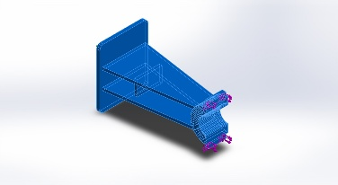 | Solid Body | Mass:12.6766 kg  Volume:0.00157924 m^3  Density:8,027 kg/m^3  Weight:124.23 N | C:\Users\dell\.gemini\antigravity\scratch\AquaSentinel_AAKRUTI\FDC_Submission\3_Simulation\AquaSentinel_Pier_Bracket_Simulation.SLDPRT  Oct 5 13:53:40 2026

Study Properties
Study name | Bracket pole reaction
Analysis type | Static
Mesh type | Solid Mesh
Thermal Effect: | On
Thermal option | Include temperature loads
Zero strain temperature | 298 Kelvin
Include fluid pressure effects from SOLIDWORKS Flow Simulation | Off
Solver type | FFEPlus
Inplane Effect: | Off
Soft Spring: | Off
Inertial Relief: | Off
Incompatible bonding options | Automatic
Large displacement | Off
Compute free body forces | On
Friction | Off
Use Adaptive Method: | Off
Result folder | SOLIDWORKS document (C:\Users\dell\.gemini\antigravity\scratch\AquaSentinel_AAKRUTI\FDC_Submission\3_Simulation)

Units
Unit system: | SI (MKS)
Length/Displacement | mm
Temperature | Kelvin
Angular velocity | Rad/sec
Pressure/Stress | N/m^2

Material Properties
Model Reference | Properties | Components
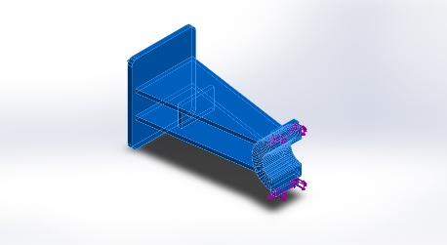 |  | SolidBody 1(Pier bracket weldment (AS3-101), welded for FEA)(AquaSentinel_Pier_Bracket_Simulation)
  Name: | AISI Type 316L stainless steel
  Model type: | Linear Elastic Isotropic
  Default failure criterion: | Max von Mises Stress
  Yield strength: | 1.7e+08 N/m^2
  Tensile strength: | 4.85e+08 N/m^2
  Elastic modulus: | 2e+11 N/m^2
  Poisson's ratio: | 0.265
  Mass density: | 8,027 kg/m^3
  Shear modulus: | 8.2e+10 N/m^2
  Thermal expansion coefficient: | 1.65e-05 /Kelvin
Curve Data:N/A

Loads and Fixtures
Fixture name | Fixture Image | Fixture Details
Fixed-1 | 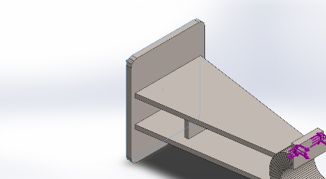
  Entities: | 1 face(s)
  Type: | Fixed Geometry
Resultant Forces
Components | X | Y | Z | Resultant
Reaction force(N) | -430.003 | 0.0012731 | 161.004 | 459.157
Reaction Moment(N.m) | 0 | 0 | 0 | 0

Load name | Load Image | Load Details
Force-1 | 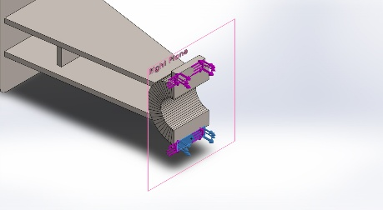
  Entities: | 1 face(s), 1 plane(s)
  Reference: | Right Plane
  Type: | Apply force
  Values: | ---, ---, 215 N
Force-2 | 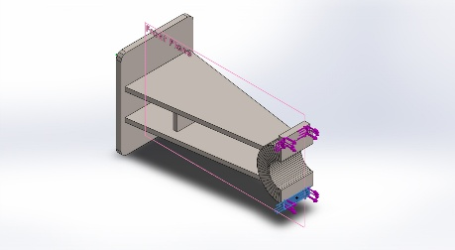
  Entities: | 1 face(s), 1 plane(s)
  Reference: | Front Plane
  Type: | Apply force
  Values: | ---, ---, -80.5 N
Force-3 | 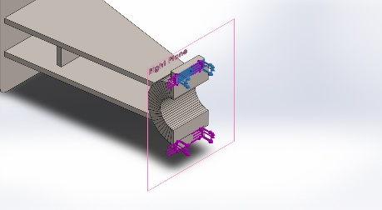
  Entities: | 1 face(s), 1 plane(s)
  Reference: | Right Plane
  Type: | Apply force
  Values: | ---, ---, 215 N
Force-4 | 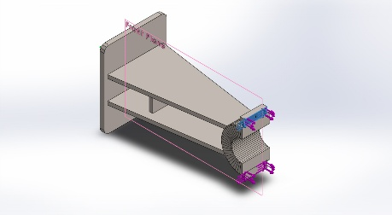
  Entities: | 1 face(s), 1 plane(s)
  Reference: | Front Plane
  Type: | Apply force
  Values: | ---, ---, -80.5 N

Connector Definitions
No Data

Contact Information
No Data

Mesh information
Mesh type | Solid Mesh
Mesher Used: | Standard mesh
Automatic Transition: | Off
Include Mesh Auto Loops: | Off
Jacobian points | 4 Points
Element Size | 4 mm
Tolerance | 0.2 mm
Mesh Quality Plot | High

Mesh information - Details
Total Nodes | 268389
Total Elements | 174305
Maximum Aspect Ratio | 16.824
% of elements with Aspect Ratio < 3 | 99.8
% of elements with Aspect Ratio > 10 | 0.0625
% of distorted elements(Jacobian) | 0
Time to complete mesh(hh;mm;ss): | 00:00:07
Computer name:
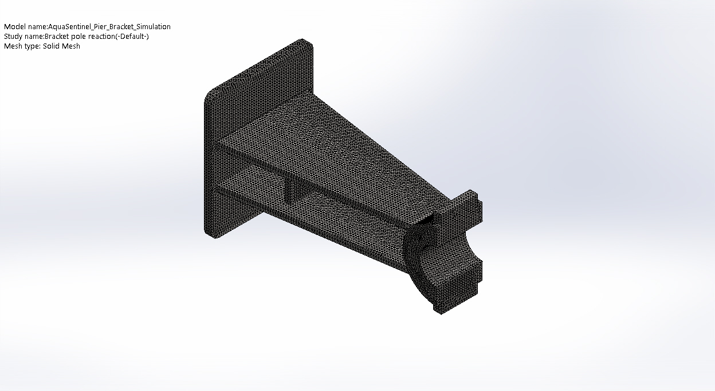

Sensor Details
No Data

Resultant Forces

Reaction forces
Selection set | Units | Sum X | Sum Y | Sum Z | Resultant
Entire Model | N | -430.003 | 0.0012731 | 161.004 | 459.157

Reaction Moments
Selection set | Units | Sum X | Sum Y | Sum Z | Resultant
Entire Model | N.m | 0 | 0 | 0 | 0

Beams
No Data

Study Results

Name | Type | Min | Max
Stress1 | VON: von Mises Stress | 7.098e+00 N/m^2  Node: 108 | 3.651e+06 N/m^2  Node: 161657
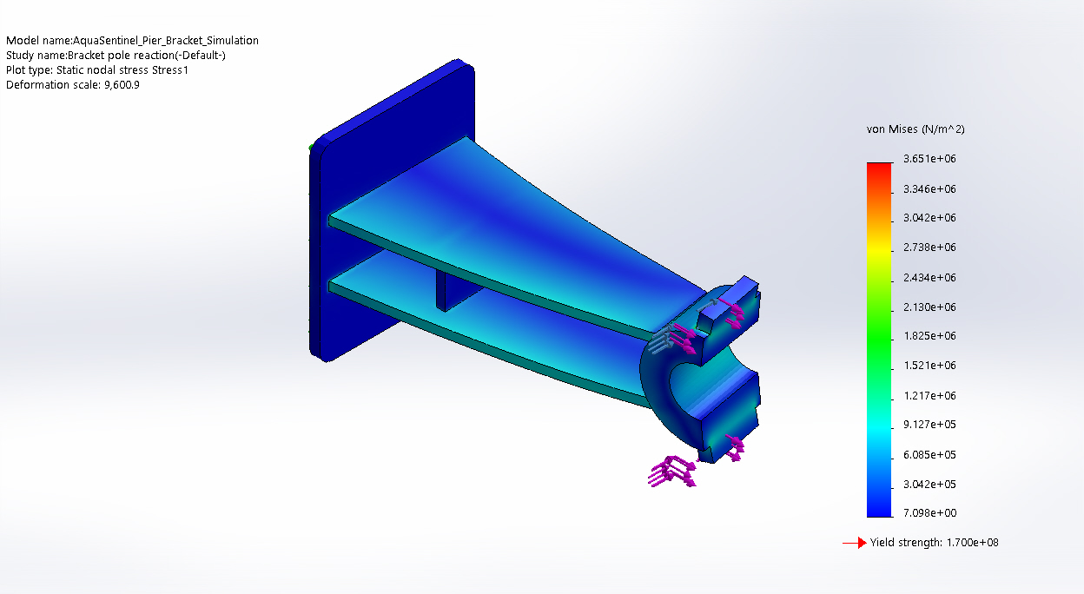
AquaSentinel_Pier_Bracket_Simulation-Bracket pole reaction-Stress-Stress1

Name | Type | Min | Max
Displacement1 | URES: Resultant Displacement | 0.000e+00 mm  Node: 19 | 4.110e-03 mm  Node: 17749
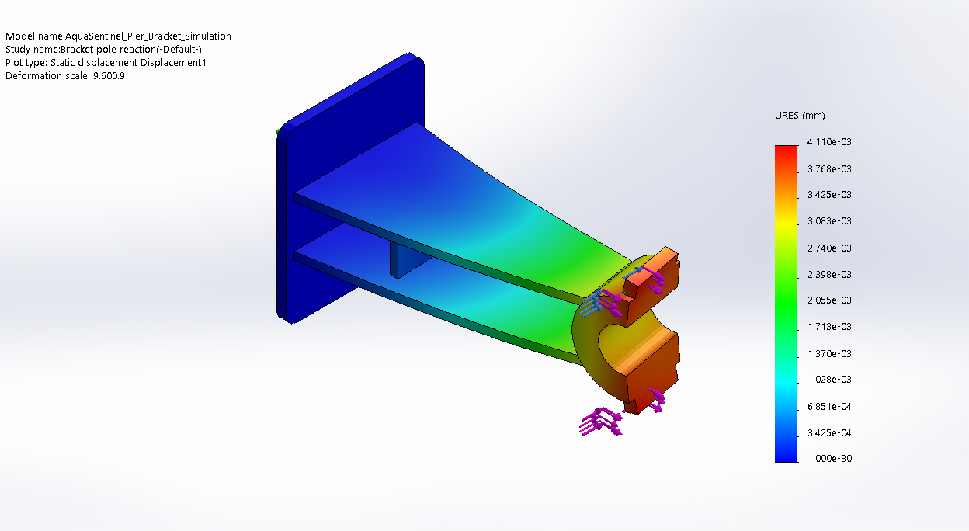
AquaSentinel_Pier_Bracket_Simulation-Bracket pole reaction-Displacement-Displacement1

Name | Type | Min | Max
Strain1 | ESTRN: Equivalent Strain | 3.956e-11  Element: 172385 | 1.090e-05  Element: 1160
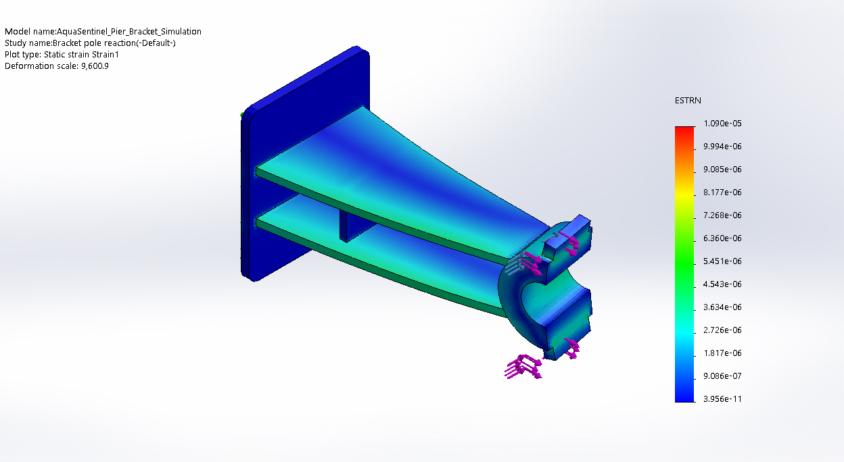
AquaSentinel_Pier_Bracket_Simulation-Bracket pole reaction-Strain-Strain1

Name | Type | Min | Max
Stress2 | VON: von Mises Stress | 7.098e+00 N/m^2  Node: 108 | 3.651e+06 N/m^2  Node: 161657
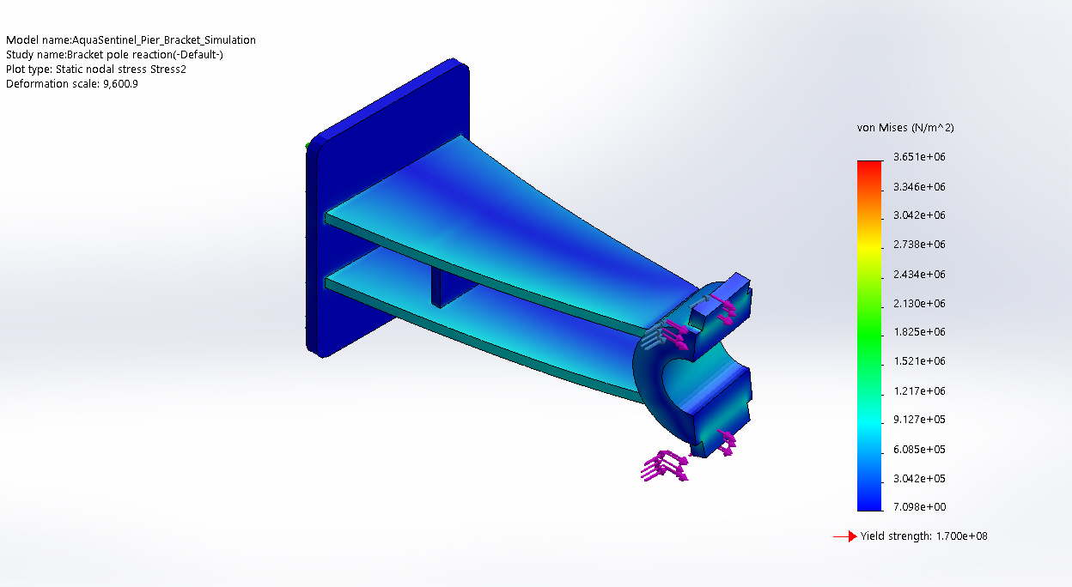
AquaSentinel_Pier_Bracket_Simulation-Bracket pole reaction-Stress-Stress2

Name | Type | Min | Max
Displacement2 | URES: Resultant Displacement | 0.000e+00 am  Node: 19 | 4.110e+04 am  Node: 17749
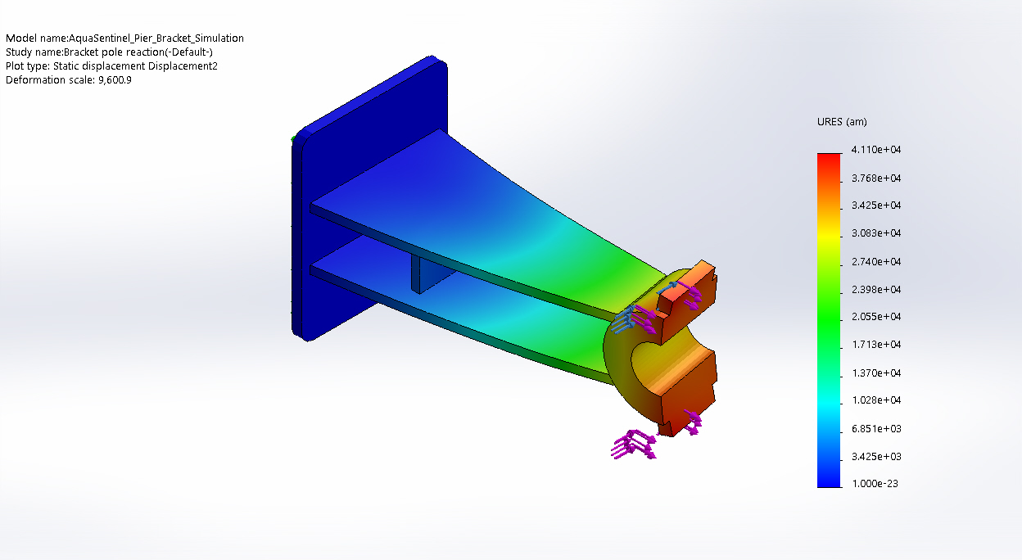
AquaSentinel_Pier_Bracket_Simulation-Bracket pole reaction-Displacement-Displacement2

Conclusion

