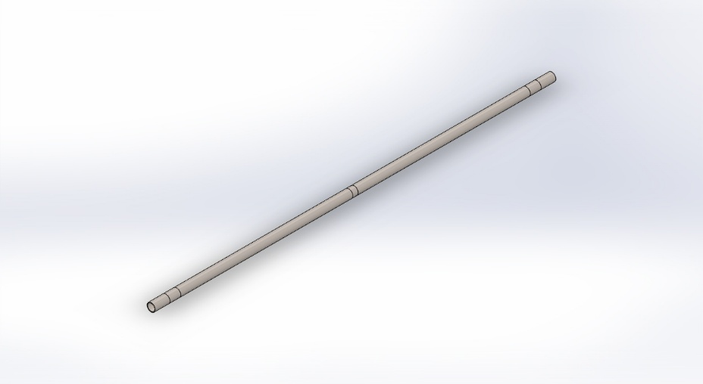
  Simulation of AquaSentinel_Guide_Pole_Simulation
  Date: 05 October 2026
  Designer: Solidworks
  Study name: Pole flood and debris
  Analysis type: Static
  Table of Contents
  Description 1
  Assumptions 2
  Model Information 2
  Study Properties 3
  Units 4
  Material Properties 4
  Loads and Fixtures 5
  Connector Definitions 6
  Contact Information 6
  Mesh information 7
  Sensor Details 8
  Resultant Forces 8
  Beams 8
  Study Results 9
  Conclusion 14

Description
No Data

Assumptions

Model Information

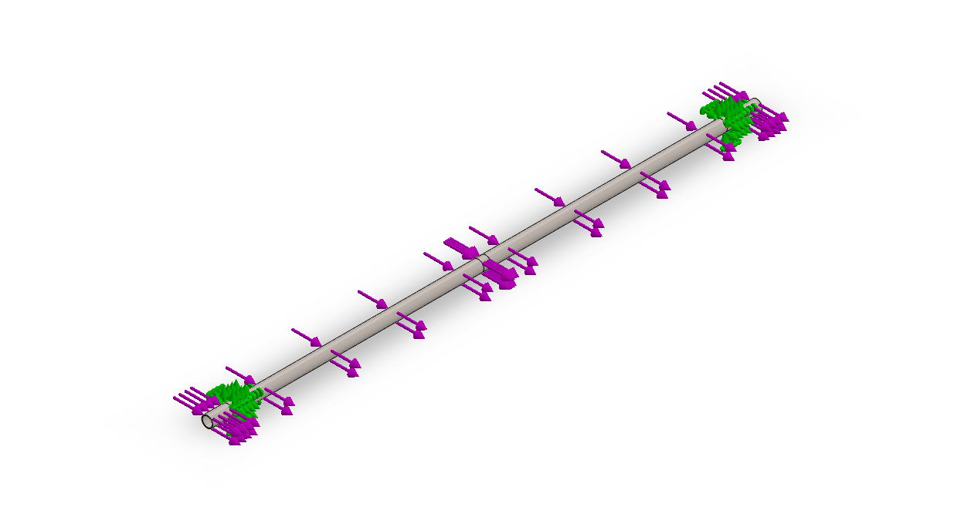
Model name: AquaSentinel_Guide_Pole_Simulation
Current Configuration: Default
Solid Bodies
Document Name and Reference | Treated As | Volumetric Properties | Document Path/Date Modified
Split Line1  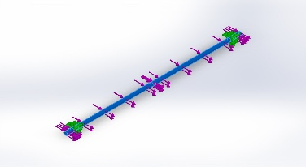 | Solid Body | Mass:16.558 kg  Volume:0.00206278 m^3  Density:8,027 kg/m^3  Weight:162.268 N | C:\Users\dell\.gemini\antigravity\scratch\AquaSentinel_AAKRUTI\FDC_Submission\3_Simulation\AquaSentinel_Guide_Pole_Simulation.SLDPRT  Oct 5 13:46:07 2026

Study Properties
Study name | Pole flood and debris
Analysis type | Static
Mesh type | Solid Mesh
Thermal Effect: | On
Thermal option | Include temperature loads
Zero strain temperature | 298 Kelvin
Include fluid pressure effects from SOLIDWORKS Flow Simulation | Off
Solver type | FFEPlus
Inplane Effect: | Off
Soft Spring: | Off
Inertial Relief: | Off
Incompatible bonding options | Automatic
Large displacement | Off
Compute free body forces | On
Friction | Off
Use Adaptive Method: | Off
Result folder | SOLIDWORKS document (C:\Users\dell\.gemini\antigravity\scratch\AquaSentinel_AAKRUTI\FDC_Submission\3_Simulation)

Units
Unit system: | SI (MKS)
Length/Displacement | mm
Temperature | Kelvin
Angular velocity | Rad/sec
Pressure/Stress | N/m^2

Material Properties
Model Reference | Properties | Components
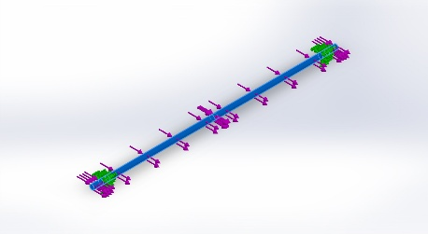 |  | SolidBody 1(Split Line1)(AquaSentinel_Guide_Pole_Simulation)
  Name: | AISI Type 316L stainless steel
  Model type: | Linear Elastic Isotropic
  Default failure criterion: | Max von Mises Stress
  Yield strength: | 1.7e+08 N/m^2
  Tensile strength: | 4.85e+08 N/m^2
  Elastic modulus: | 2e+11 N/m^2
  Poisson's ratio: | 0.265
  Mass density: | 8,027 kg/m^3
  Shear modulus: | 8.2e+10 N/m^2
  Thermal expansion coefficient: | 1.65e-05 /Kelvin
Curve Data:N/A

Loads and Fixtures
Fixture name | Fixture Image | Fixture Details
Fixed-1 | 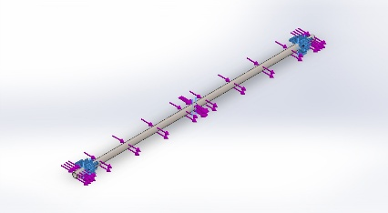
  Entities: | 2 face(s)
  Type: | Fixed Geometry
Resultant Forces
Components | X | Y | Z | Resultant
Reaction force(N) | -871.283 | 0.0621969 | -0.0211442 | 871.283
Reaction Moment(N.m) | 0 | 0 | 0 | 0

Load name | Load Image | Load Details
Force-1 | 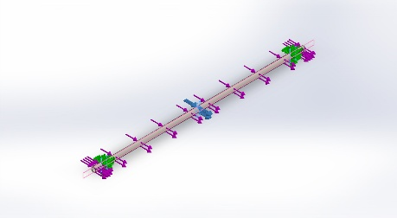
  Entities: | 1 face(s), 1 plane(s)
  Reference: | Right Plane
  Type: | Apply force
  Values: | ---, ---, 645.256 N
Force-2 | 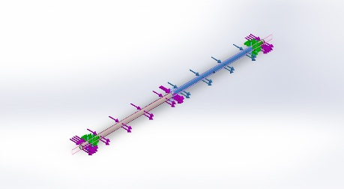
  Entities: | 1 face(s), 1 plane(s)
  Reference: | Right Plane
  Type: | Apply force
  Values: | ---, ---, 104.111 N
Force-3 | 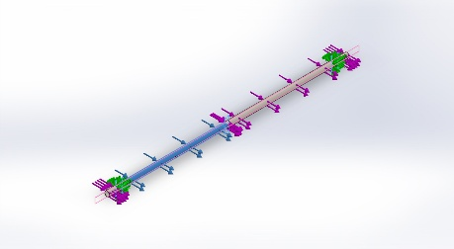
  Entities: | 1 face(s), 1 plane(s)
  Reference: | Right Plane
  Type: | Apply force
  Values: | ---, ---, 104.111 N
Force-4 | 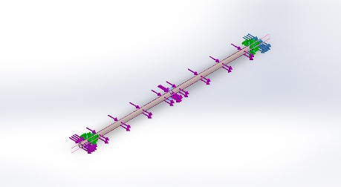
  Entities: | 1 face(s), 1 plane(s)
  Reference: | Right Plane
  Type: | Apply force
  Values: | ---, ---, 8.954 N
Force-5 | 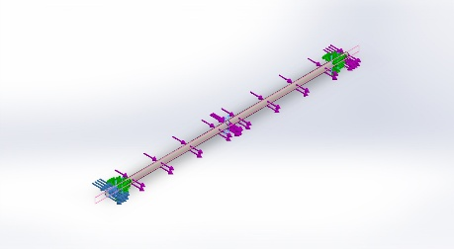
  Entities: | 1 face(s), 1 plane(s)
  Reference: | Right Plane
  Type: | Apply force
  Values: | ---, ---, 8.954 N

Connector Definitions
No Data

Contact Information
No Data

Mesh information
Mesh type | Solid Mesh
Mesher Used: | Standard mesh
Automatic Transition: | Off
Include Mesh Auto Loops: | Off
Jacobian points | 4 Points
Element Size | 6 mm
Tolerance | 0.3 mm
Mesh Quality Plot | High

Mesh information - Details
Total Nodes | 179650
Total Elements | 89812
Maximum Aspect Ratio | 4.8992
% of elements with Aspect Ratio < 3 | 99.8
% of elements with Aspect Ratio > 10 | 0
% of distorted elements(Jacobian) | 0
Time to complete mesh(hh;mm;ss): | 00:00:36
Computer name:
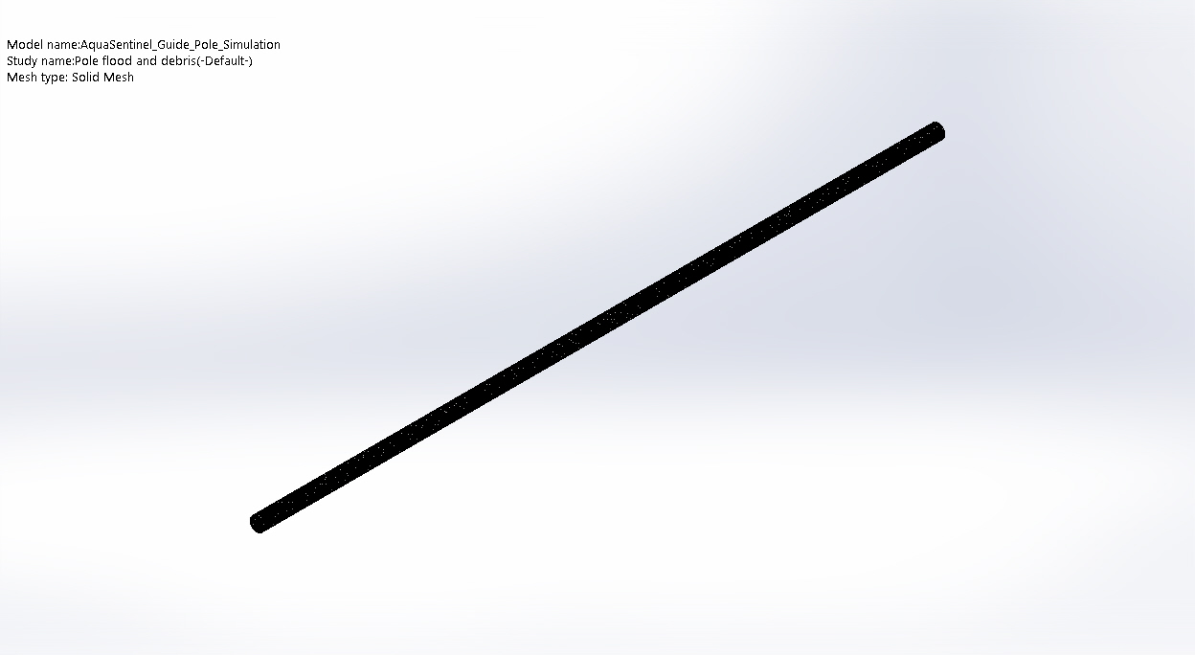

Sensor Details
No Data

Resultant Forces

Reaction forces
Selection set | Units | Sum X | Sum Y | Sum Z | Resultant
Entire Model | N | -871.283 | 0.0621969 | -0.0211442 | 871.283

Reaction Moments
Selection set | Units | Sum X | Sum Y | Sum Z | Resultant
Entire Model | N.m | 0 | 0 | 0 | 0

Beams
No Data

Study Results

Name | Type | Min | Max
Stress1 | VON: von Mises Stress | 1.296e+01 N/m^2  Node: 78267 | 3.832e+07 N/m^2  Node: 103421
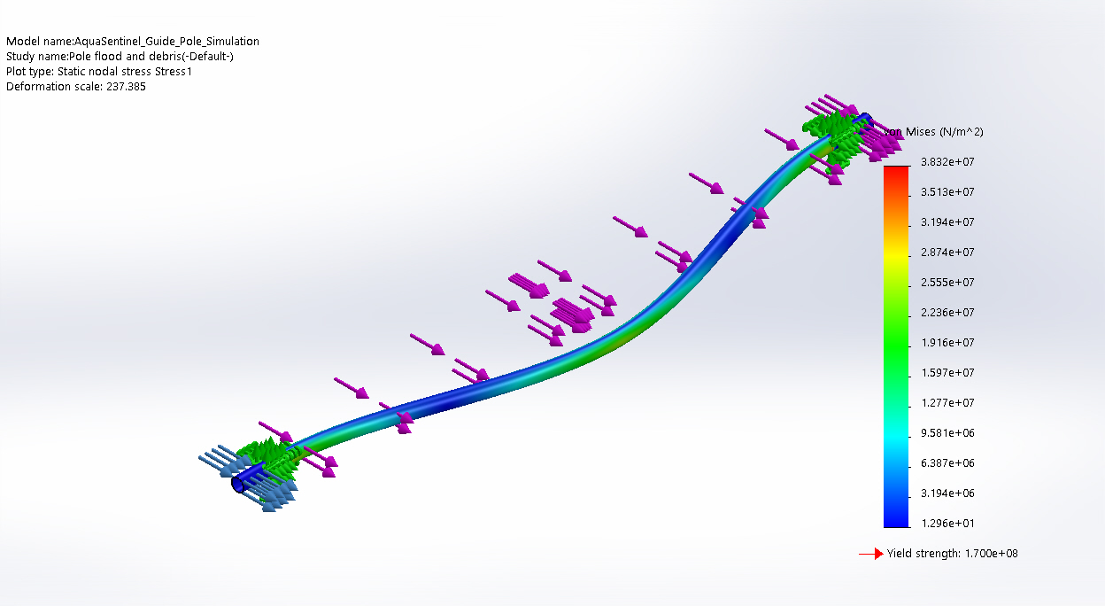
AquaSentinel_Guide_Pole_Simulation-Pole flood and debris-Stress-Stress1

Name | Type | Min | Max
Displacement1 | URES: Resultant Displacement | 0.000e+00 mm  Node: 9485 | 1.255e+00 mm  Node: 54763
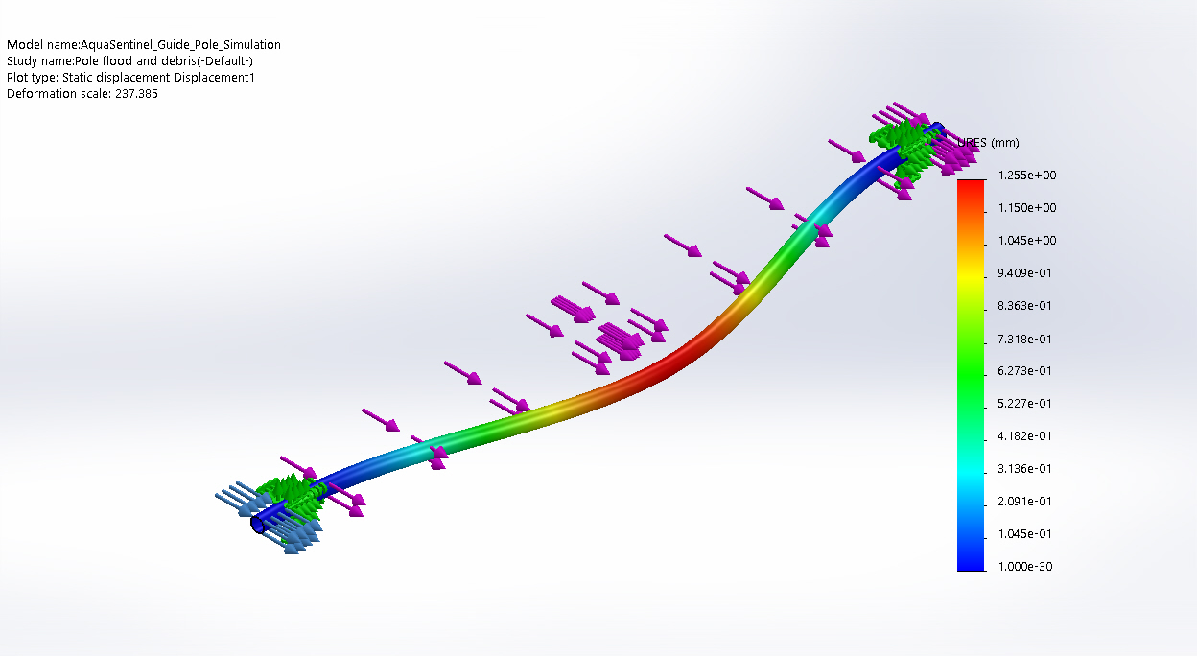
AquaSentinel_Guide_Pole_Simulation-Pole flood and debris-Displacement-Displacement1

Name | Type | Min | Max
Strain1 | ESTRN: Equivalent Strain | 1.036e-10  Element: 7690 | 1.323e-04  Element: 38188
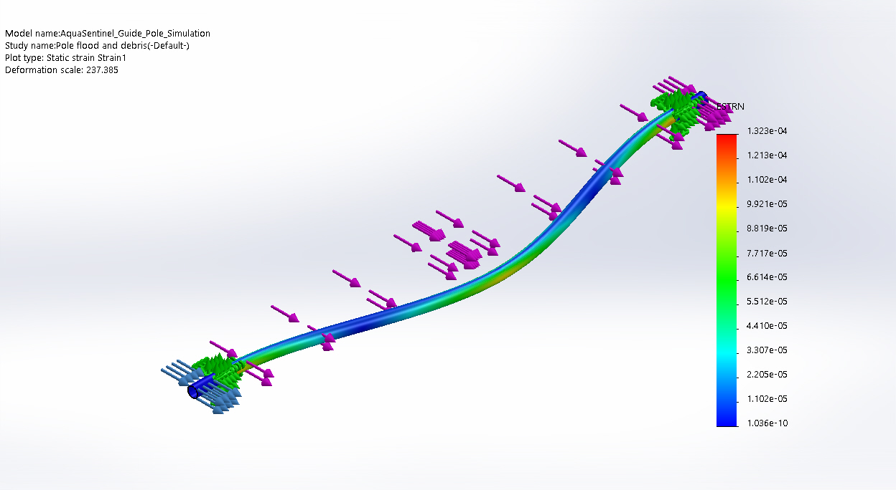
AquaSentinel_Guide_Pole_Simulation-Pole flood and debris-Strain-Strain1

Name | Type | Min | Max
Stress2 | VON: von Mises Stress | 1.296e+01 N/m^2  Node: 78267 | 3.832e+07 N/m^2  Node: 103421
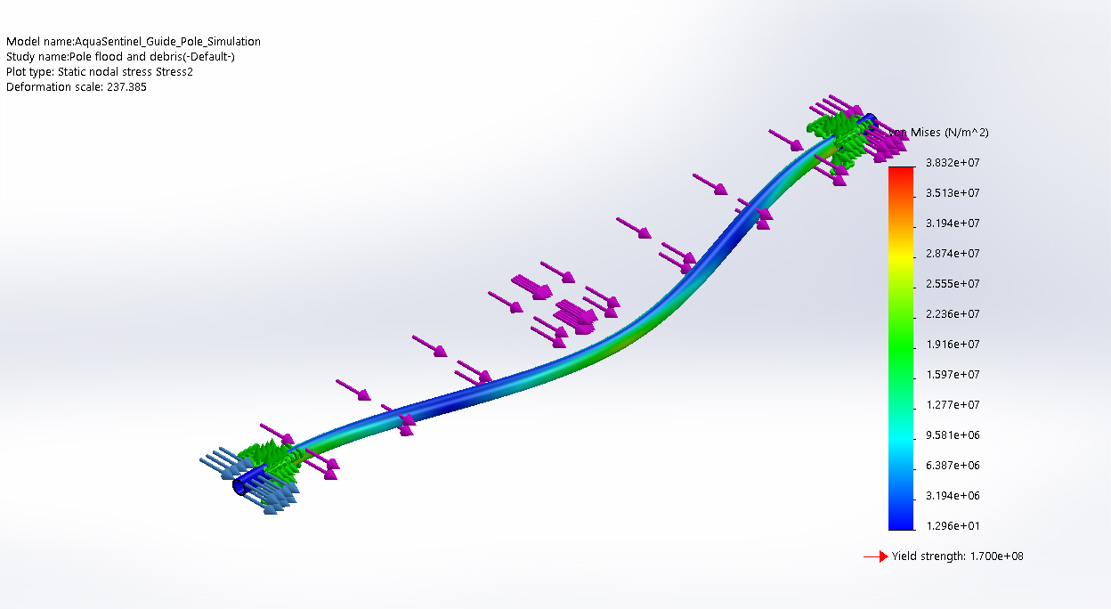
AquaSentinel_Guide_Pole_Simulation-Pole flood and debris-Stress-Stress2

Name | Type | Min | Max
Displacement2 | URES: Resultant Displacement | 0.000e+00 am  Node: 9485 | 1.255e+07 am  Node: 54763
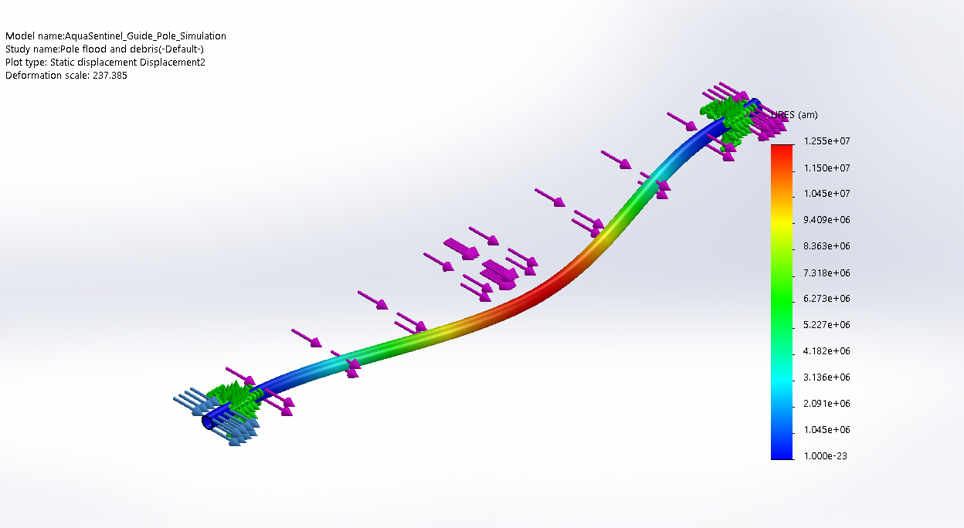
AquaSentinel_Guide_Pole_Simulation-Pole flood and debris-Displacement-Displacement2

Name | Type | Min | Max
Displacement3 | UX: X Displacement | -2.085e+03am  Node: 550 | 1.255e+07 am  Node: 54763
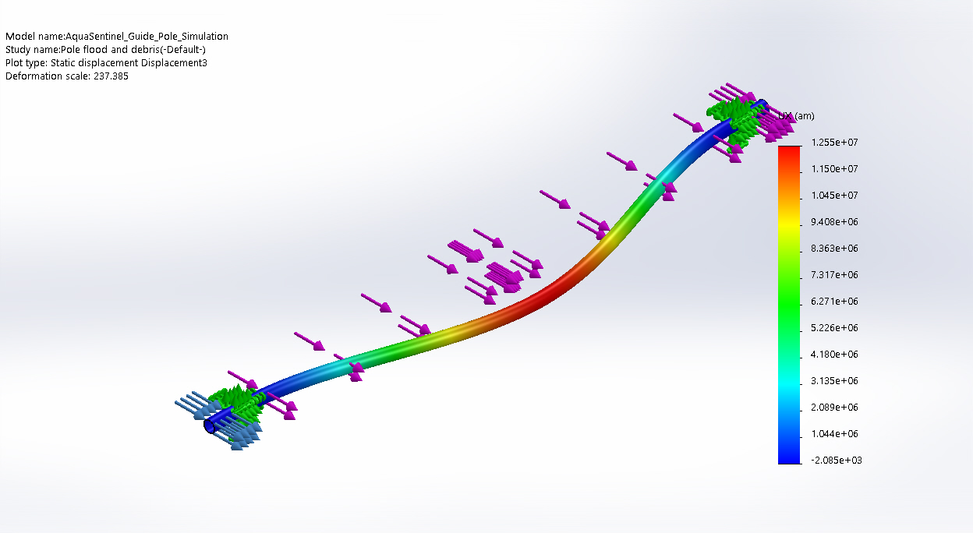
AquaSentinel_Guide_Pole_Simulation-Pole flood and debris-Displacement-Displacement3

Conclusion

