SUMMARY

It is increasingly common to encounter data from dynamic processes captured by static cross-sectional measurements over time, particularly in biomedical settings. Recent attempts to model individual trajectories from this data use optimal transport to create pairwise matchings between time points. However, these methods cannot model continuous dynamics and non-linear paths that entities can take in these systems. To address this issue, we establish a link between continuous normalizing flows and dynamic optimal transport, that allows us to model the expected paths of points over time. Continuous normalizing flows are generally under constrained, as they are allowed to take an arbitrary path from the source to the target distribution. We present Trajectory Net, which controls the continuous paths taken between distributions to produce dynamic optimal transport. We establish a link between continuous normalizing flows (CNF) and dynamic optimal transport allowing us to efficiently solve the transport problem using a Neural ODE framework

Model :

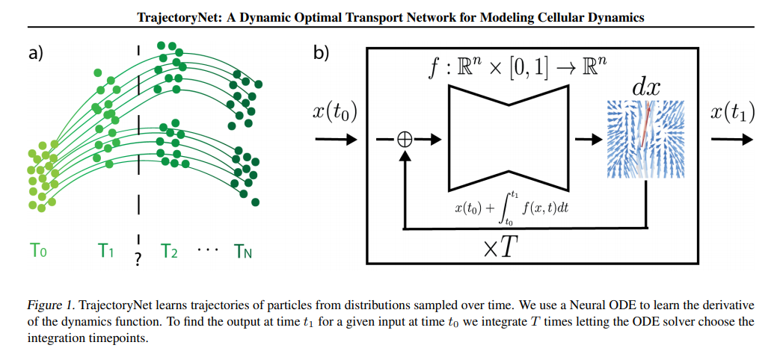

Results:

