Name: Rahul Kumar Ranjan Admission No:25SCSE2150054 Course Name: Introduction to IT [Bridge Course] Section: 11

Lab Practical No.: 11
Aim:
- Verify network connectivity to another host using ping.
- Display active network connections, routing tables, and interface statistics using netstat.

Required Tools:
- Two hosts connected to the same network (LAN/Wi-Fi).
- Knowledge of the target host’s IP address or hostname.
- System connected to a network.
- Administrative privileges (for some options).

Commands Covered:
Procedure
  - Open the terminal.
- Type the following commands one by one:
  - ping→ to check connectivity.
Syntax:
Ping <hostname or IP>

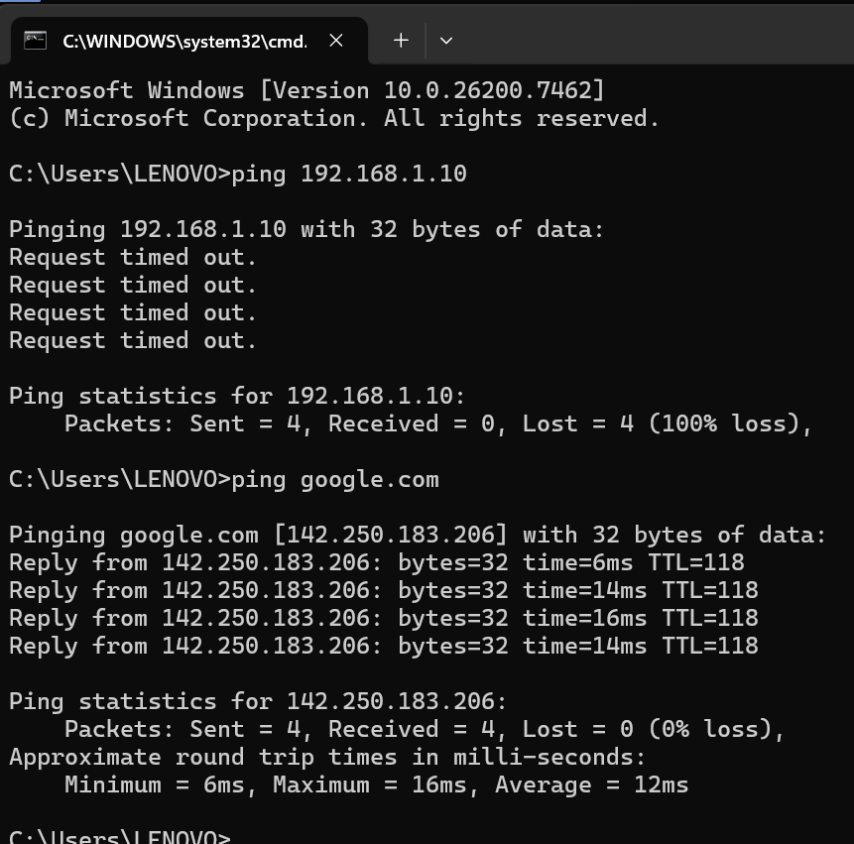
Output:

- Type the following commands one by one:
- netstat→ to display network information.

Syntax:
netstat

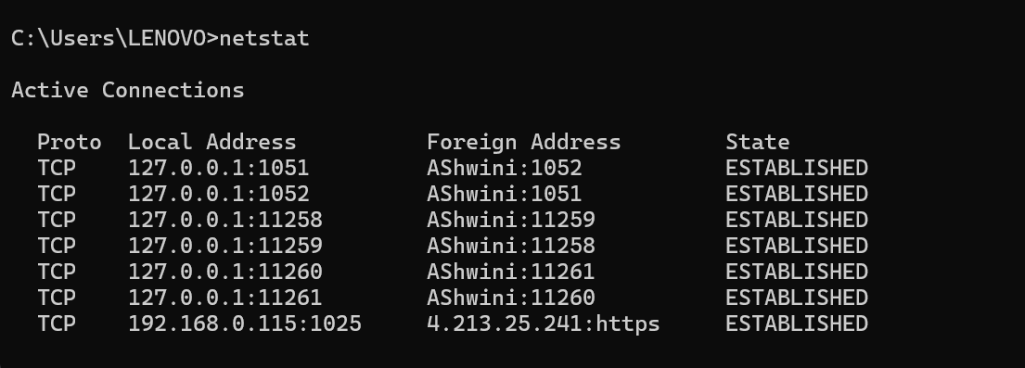
Output:

  - netstat -a → shows all connections and listening ports.

Syntax:
netstat -an

Output:
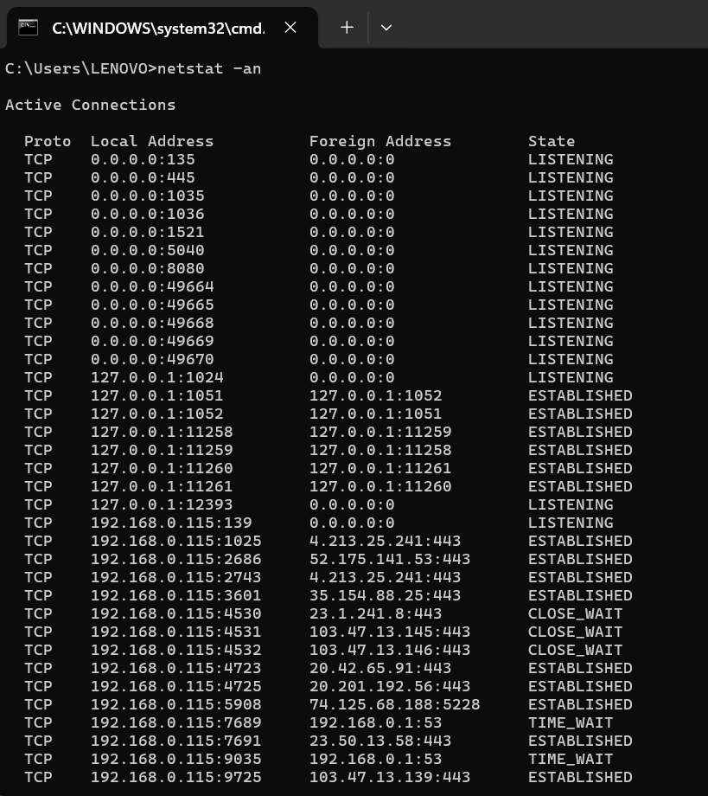

  - netstat -r → Displays routing table.
Syntax:
netstat -r
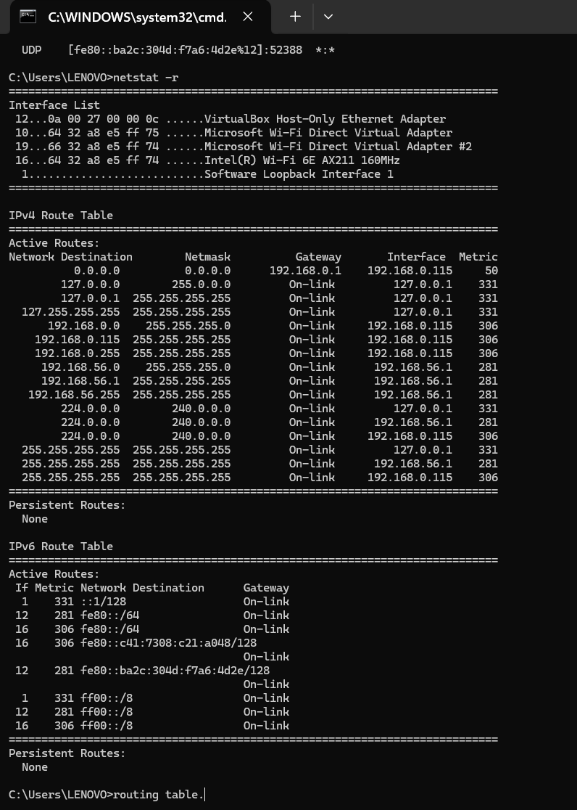
Output:

  - netstat -e -s -p -IP → Show interface statistics.
Syntax:
netstat -e -s -p -IP
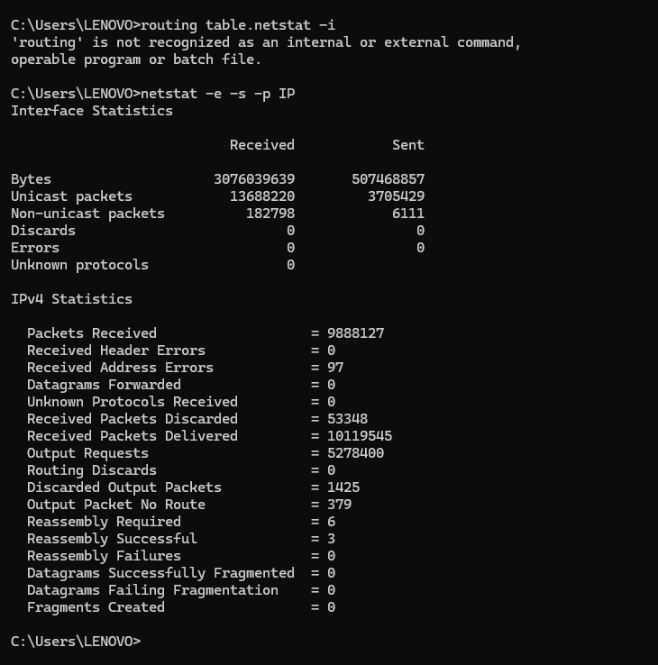
Output:

Conclusion
- The netstat command provides a snapshot of network activity, helping diagnose connectivity and routing issues.
- The ping command confirms whether a host is reachable and provides latency information.

