Cs164: Aritificial Intelligence

**Tic Tac Toe**

AI Project made in java by Soham Purandare

horizontal line

# 

# Introduction

Tic-tac-toe also known as noughts & crosses is a simple Turn based 2 player game played on a 3x3 grid. The player who succeeds in placing three of their marks in horizontal, vertical or diagonal row wins the game.

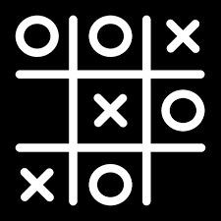

The **solution approach** to the problem at hand is by using minimax algorithm. We will go in more details about the PEAS ahead.

## PEAS

Performance Measure: not letting the user win the game(computer must either win or settle for a draw).

Environment: The 3x3 tic tac toe grid

# 

Actuators & sensors: mouse clicks and mouse.

## Problems faced

Attempts to make a 4x4 grid with a viable and presentable time became difficult due to the large amount of probabilities that had to be considered by the computer before making the first move(1307674368000 to be precise) , otherwise the minimax algorithm works smooth as butter on tic tac toe and the end result is flawless.

### In Conclusion

The output is as expected, the computer does not let the user win.

The output is as follows:

