**Instructions for setting YFinance Project:**

**Requirements : Pycharm, python and pip installed in the PC.**

1. Unzip the codebase folder and open Pycharm code editor.
2. Importing YFinance Django Project and opening up the code:
   1. Start PyCharm and click File —> Open menu item to open the Django project selection window.
   2. Select the Django project saved folder, then click the OK button.
   3. Now the existing Django project has been opened in PyCharm correctly.
3. Enable Django Support For YFinance PyCharm Project.
   1. Create a virtual environment and install dependencies by typing following commands in the terminal from bottom:
      1. mkvirtualenv yfinance
      2. pip install -r requirements.txt
   2. Initialize your database.
      1. python ./manage.py syncdb
      2. python ./manage.py migrate

Note: If the above steps doesn’t work, try to run the below steps directly.

* 1. Create a superuser for managing admin side database:
     1. python ./manage.py createsuperuser.

Note: Enter all the details asked in the terminal like name, email and password for creating admin superuser.

1. Run the development server to verify everything is working (in the Terminal).
   1. python ./manage.py runserver
   2. go to the browser link and add - <http://127.0.0.1:8000/admin> in the url to view the database and admin side database by entering the username and password that we created in 3(c).
2. congratulations your YFinance project is now running.

Screenshots and explanation of the Project:

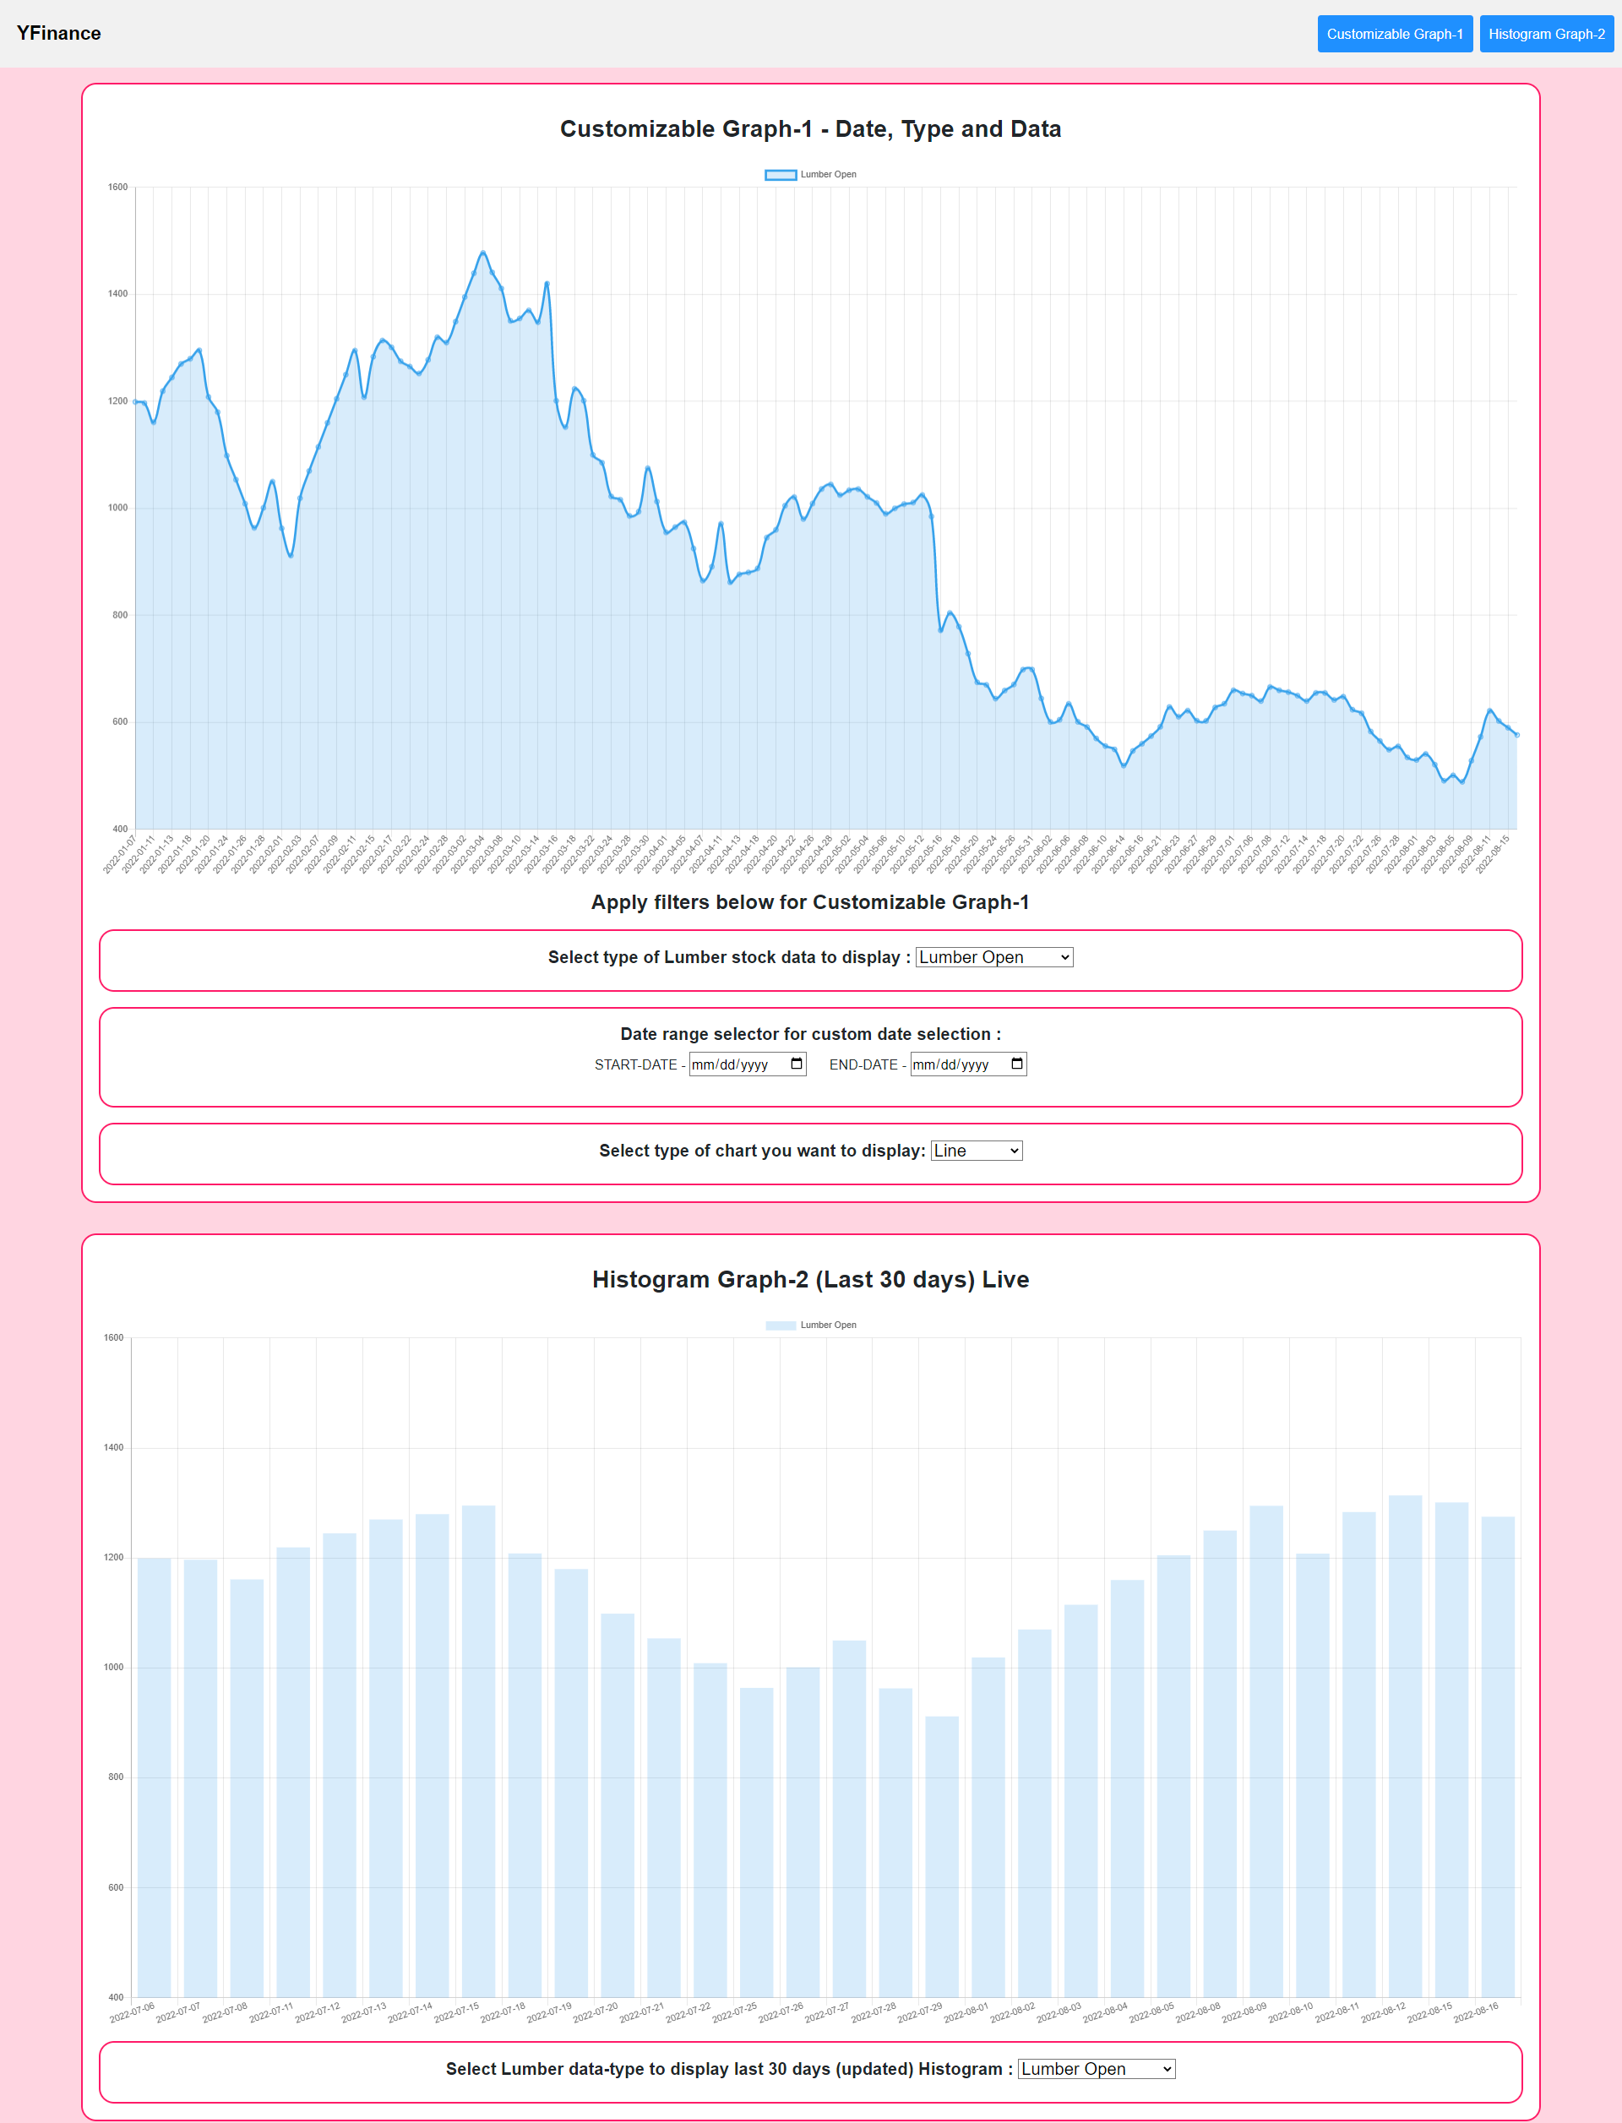

1. Navigation Bar:
   1. **Logo** – Yfinance Logo
   2. **Button** – Customizable Graph-1 : This button will take you to the filter section below the graph-1 where you can select different type of the Lumber data to display, select a date range for viewing specific dates of data and type of the chart you want to display.
2. **Graph-1 Chart**: Display the data selected in the below filter section of the Graph-1.

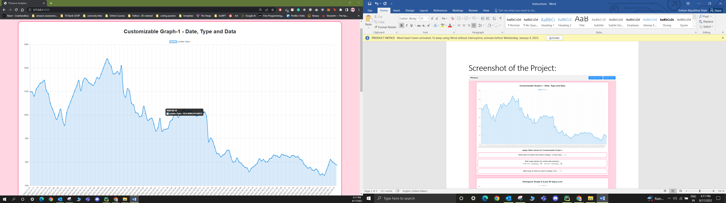

* 1. **Filters Graph -1:** (All the below filters works in a synchronization, i.e. no specific order to apply filters in a manner.)
     1. **Data Filter**: Select type Select type of Lumber stock data to display: you can select different type of data from the dropdown.

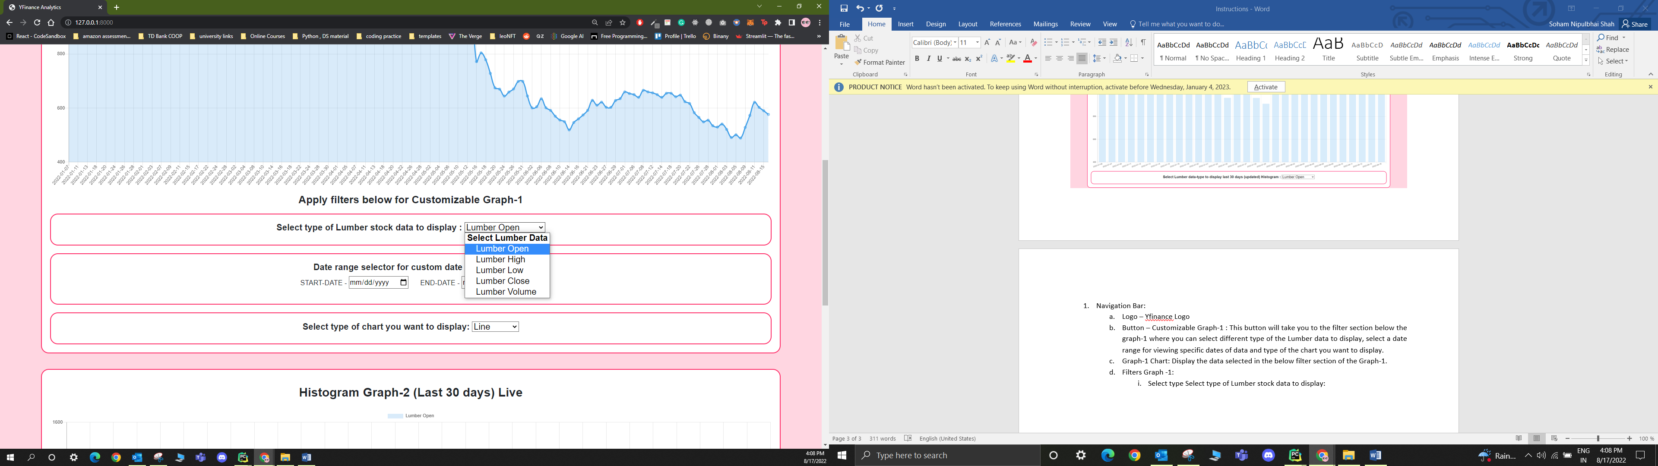

* + 1. **Date Filter (customized Input)**: Select the date range and the Graph-1 will display the data for that specific date range. It will not include the weekends, as the stock values for the weekends are not possible.

Note: Please select bot the dates (start date & end date to view the graph.

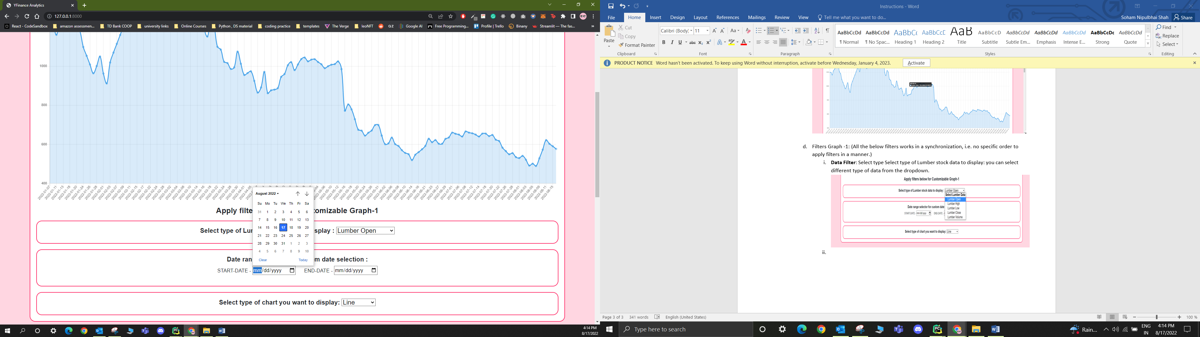

* + 1. **Chart type Filter (Additional Feature)**: Select the type of chart you want to see from the dropdown.

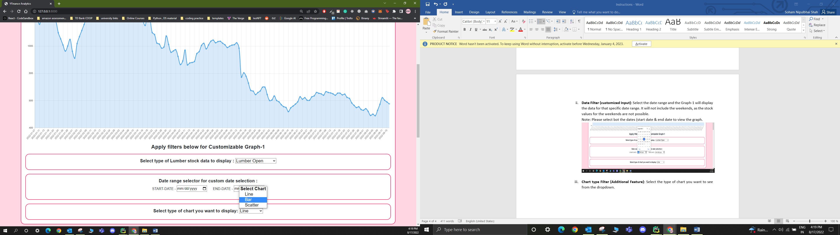

1. **Graph-2 Chart**: Displays the data in the form of Histogram, the data is of last 30 days and in an updated manner such that every day the data is updated in the database.

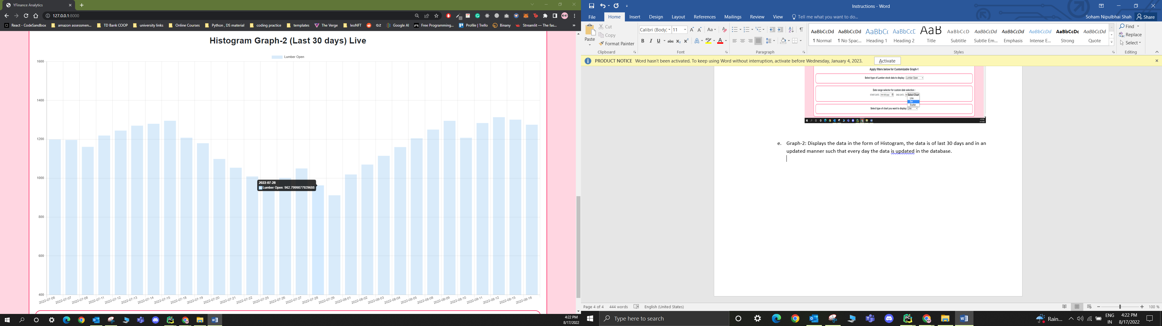

* 1. **Filters for Graph-2**:
     1. **Type of Lumber data:** select the type of lumber data to view. The lumber datatypes are High, Low, open, close and volume of last 30 days and updated daily in the database, thus live daily data.

