**REPORT ON** **Water Retention and Slow-Release Mechanism of Super Absorbent Polymers in Agriculture**

*Amidst the parched fields of a remote farming village, a farmer anxiously watched his wilting crops under a relentless sun. Each drop of water he poured into the dry soil seemed to vanish before reaching the roots. Frustration grew as his efforts failed to sustain his livelihood. However, hope arrived in the form of a tiny polymer crystal—a Super Absorbent Polymer (SAP).*

*Once introduced to his fields, these crystals transformed the soil, holding onto water like tiny reservoirs and releasing it gradually as the plants needed it. The farmer's crops thrived even during droughts, and his yields improved dramatically. This simple yet groundbreaking innovation not only saved his farm but also demonstrated how science could empower agriculture to meet the challenges of water scarcity and food security.* (Story by Sohel)

*This report explores the remarkable mechanisms, applications, and challenges of SAPs, the technology that is* *revolutionizing water management in agriculture.*

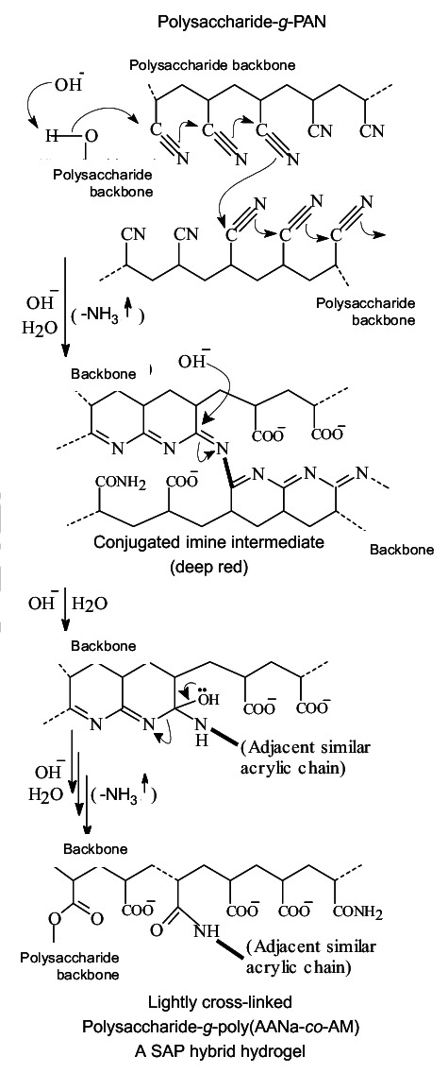

1.Introduction:-

Super Absorbent Polymers (SAPs) represent an advanced class of functional materials distinguished by their hydrophilic groups, such as carboxyl (-COOH), amino (-NH₂), and hydroxyl (-OH). These groups facilitate extensive hydrogen bonding with water molecules, enabling SAPs to absorb and retain water quantities many times their own weight. This exceptional capacity for water sequestration and gradual release has revolutionized their use in agriculture. SAPs not only mitigate soil moisture deficits but also act as reservoirs that optimize water availability to plants over extended periods.

2. Water Retention Mechanism:-

**How SAPs Absorb Water:-**

When exposed to water, SAPs' hydrophilic groups (-COOH, -OH) ionize, attracting water into their network. The interaction between ions inside the polymer and surrounding water creates an osmotic gradient, allowing water to move into and swell the polymer.

**Swelling and Storage:-**

As water enters, negative ions fixed on the polymer repel each other, expanding the network. This allows SAPs to absorb water hundreds to thousands of times their weight, depending on the water's salinity…...(1&2)

3. Water Release Mechanism:-

The encapsulation and controlled release properties of SAPs play a critical role in enhancing nutrient delivery.

**Encapsulation and Slow Release:-**

In their swollen state, SAPs encapsulate soluble fertilizers and release them gradually as water is discharged. This controlled release reduces nutrient leaching and ensures a steady nutrient supply over time, improving fertilizer utilization.

**Diffusion and Utilization:-**

Nutrients absorbed into the SAP network diffuse slowly into the soil, aligning with plant uptake. This controlled diffusion prevents nutrient overload and wastage, fostering balanced plant growth.

**Enhanced Fertilizer Efficiency:-**

By regulating nutrient release, SAPs increase fertilizer efficiency, reduce environmental pollution from over-fertilization, and support sustainable agricultural practices focused on optimal crop productivity. …...(1&2)

**4. Application in Agriculture:-**

SAPs have extensive applications in agriculture, where their water and nutrient retention capabilities provide numerous advantages.

**Drought Resistance:-**  
 SAPs enhance drought resistance by increasing soil moisture retention and extending irrigation cycles. During dry periods, they release stored water gradually, reducing the need for frequent irrigation.

**Sustainable Agriculture:-**  
SAPs contribute to sustainable agriculture by optimizing water and nutrient use. This is especially important in regions facing water scarcity, as SAPs enable more efficient resource utilization and mitigate the environmental impact of intensive farming practices.  
  
**Current Problems in SAPs** :-

Although Super Absorbent Polymers (SAPs) offer significant benefits in water and nutrient management, several challenges limit their effectiveness and sustainability.

**1. Storage Issues:-**

SAPs are challenging to store for extended periods due to their high water absorption and retention capabilities, which can compromise their stability during storage. When exposed to moisture over time, the ability of SAPs to retain water diminishes.

**Proposed model for finding the volume occupied by SAPs :-  
(3)… Brooks Corey Model:-**

$$θ\left(h\right)= θ_{s}- \left(θ_{s}- θ_{r}\right){\left(\frac{h}{h_{b}}\right)}^{λ}$$

**The Brooks-Corey model describes soil water retention by linking water content (θ) to suction pressure (h). It emphasizes coarse-textured soils and uses parameters like:**

* **h (pressure head): Suction required to remove water (cm).**
* **h_b (bubbling pressure head): Suction at air-entry point.**
* **λ (pore-size distribution parameter): Describes pore uniformity.**
* **θ_s: Saturated water content.**
* **θ_r: Residual water content.**
* **θ(h) is the value of θ at height h.  
    
  Graph for the above relation:-** [**https://colab.research.google.com/drive/1UPRquYVXn8Wj9ZhWzgsJiKbqhAjSBziN#scrollTo=45Lra5Lb7D3A**](https://colab.research.google.com/drive/1UPRquYVXn8Wj9ZhWzgsJiKbqhAjSBziN#scrollTo=45Lra5Lb7D3A)

**Methodology:-**1.Nanomaterials can coat Super Absorbent Polymers (SAPs), creating a protective barrier that prevents moisture absorption. This enhances SAP stability while maintaining its ability to absorb liquids.2.Applying biodegradable coatings to SAP granules may help protect them from moisture while also being environmentally friendly. These coatings could dissolve under specific conditions, allowing the SAP to function as intended when needed.  
3.Encapsulating SAPs in a polymer shell could prevent them from absorbing moisture during storage.  
4.Using reflective mulches can reduceevaporation rates and maintain optimal conditions for SAP performance.

**2. Decreased Mechanical Strength :-**

When Super Absorbent Polymers (SAPs) absorb water, they swell and form a gel-like structure within the soil. This swelling reduces the polymer's mechanical strength, making the gel prone to deformation under pressure. As a result, soil surfaces may develop cracks, disrupting the even distribution of moisture and nutrients.

A critical issue arises from the "burst release" of nutrients stored within the SAP network. When the weakened gel structure collapses, it releases nutrients rapidly instead of gradually. This uneven nutrient release can lead to localized nutrient overload, reduced fertilizer efficiency, and poor plant growth, ultimately failing to achieve the intended slow-release effect of SAPs..

**METHODOLOGY:-**1.Development of Hybrid SAP :

This combination can improve tensile strength and reduce the formation of voids that lead to decreased compressive strength.The fibers can provide additional reinforcement, helping to maintain structural integrity even when water is absorbed.

2.Creation of Delayed Absorption of SAPs :-

Use acrylic acid (AA) and its sodium or potassium salts, along with acrylamide (AM) and Crosslinkers like:-N,N-methylene bisacrylamide (MBA) . It can help prevent excessive swelling and cracking,by creating a network structure that controls the absorption rate.

3.Integrate nanomaterials such as graphene or carbon nanotubes into SAP formulations to enhance their mechanical properties.   
  
REFERENCES:-  
  
1. [Water Retention Characteristics of Superabsorbent Polymers (SAPs) Used as Soil Amendments](https://www.mdpi.com/2571-8789/7/2/58)  
2. [Research of Water Absorption and Release Mechanism of Superabsorbent Polymer in Cement Paste](https://www.mdpi.com/2073-4360/15/14/3062)  
3. [Brooks-Corey capillary pressure model — GEOS documentation](https://geosx-geosx.readthedocs-hosted.com/en/latest/coreComponents/constitutive/docs/BrooksCoreyCapillaryPressure.html)