House Price Prediction — Summary of Findings
Dataset: Housing Prices Dataset (Kaggle) — 545 properties, 13 features, no missing values or duplicates.

Model Performance
Model | MAE | RMSE | R² Score
Linear Regression | 970,043 | 1,324,507 | 0.653
Random Forest Regressor | 1,013,969 | 1,398,116 | 0.613
Linear Regression slightly outperformed Random Forest on this dataset, likely because price scales fairly linearly with area and amenities, and the dataset is small enough that Random Forest's added complexity didn't pay off.

Top Features Influencing Price
Based on Random Forest feature importance:
1) Area (≈47% of importance) — by far the strongest driver of price. 2) Bathrooms (≈15%). 3) Air conditioning, parking, and stories each add a smaller but noticeable premium.
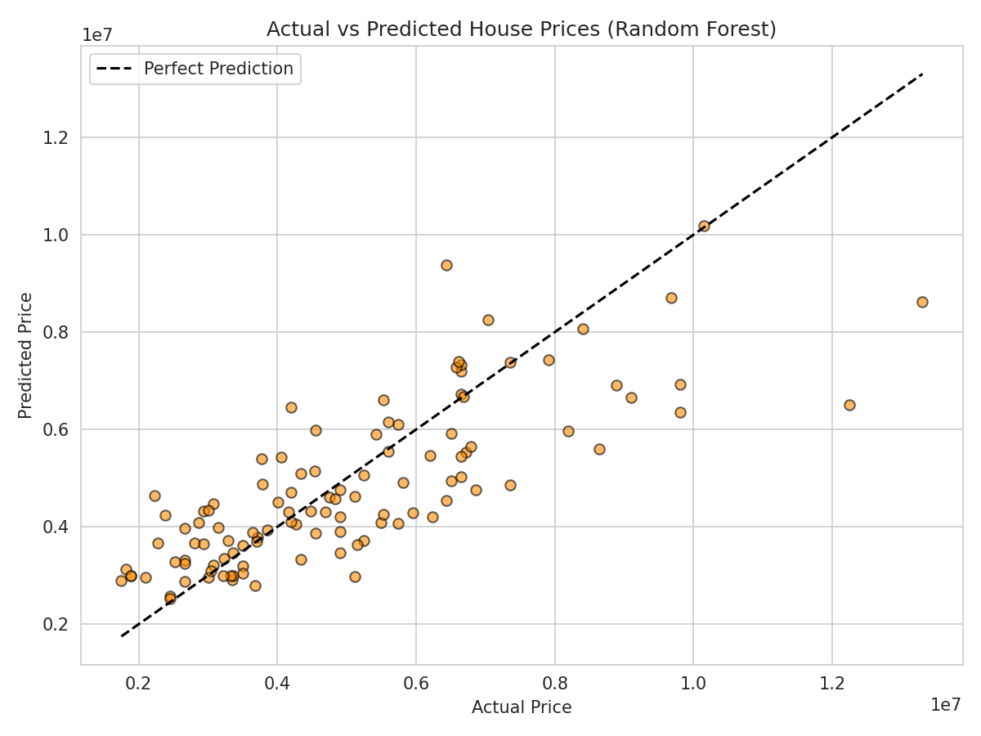

Insights & Recommendation
Area is the single biggest price driver, followed by bathrooms and air conditioning — together these explain most of the price variation. Both models place predictions within roughly ₹1 million of the actual price on average, meaning they're useful for a quick first-pass estimate rather than a precise final valuation. A genuine surprise was how much amenities like air conditioning and parking shift price even after accounting for size, suggesting buyers pay a real premium for comfort and convenience, not just square footage.
Recommendation: A real estate business should price and market listings primarily around area plus a small set of high-impact amenities (air conditioning, parking, preferred location), and can use a simple linear model as a fast, low-maintenance first-pass valuation tool ahead of a human appraiser's final review.

