
SVKM'S Narsee Monjee Institute of Management Studies Mukesh Patel School of Technology Management & Engineering
Development of Indigenous Contactless Integrated Track Monitoring Systems (ITMS)
A Project Report submitted in partial fulfilment of
Course: Design Experience
Programme: MBA Tech & B.Tech Computer Engineering – Second Year
Batch: 2024–2029 | Academic Year: 2025–26
Submitted By
1. Soham Bhosale (MBA Tech Computer Engineering)
2. Arnav. (MBA Tech Computer Engineering)
3. Rudra Marathe (MBA Tech Computer Engineering)
Under the Guidance of
Prof. Chaitali Patil

Index

Section | Title | Page
01 | Introduction | 1
02 | Reason Behind the Project | 2
03 | Review of Literature | 4
04 | Problem Definition | 6
05 | Objectives of the project | 7
06 | Proposed Methodology / Conceptual Framework | 8
07 | Team, roles, and Work | 10
08 | Project timeline | 11
09 | Risk register | 12
10 | Outcomes, in three layers | 13
11 | Reflection | 15
12 | References | 16

LIST OF TABLES

Table No. | Name of Table | Page No.
3.1 | Sample of the shortlist | 4
5.1 | In scope, out of scope | 7
6.2 | Bill of materials | 8
7.0 | Team, Roles and Work | 10
8.1 | Project Timeline | 11
9.0 | Risk register | 12
10.4 | Cost-benefit, side by side | 13
LIST OF FIGURES

Fig No. | Name of Figure | Page No.
2.3 | TR-09 System Architecture | 3
6.6 | Sensor Fusion and Data Pipeline | 9
7.1 | Team Structure – Four Pods + Mentor | 10
8.1 | Project Timeline – Two Semester Plan | 11
11.3 | Defect Detection and Work Flow | 15
11.3 | Cost-per-unit Comparisons Across Inspection Approach | 15

- Introduction
This report documents TR-09, a hand-trolley-mounted contactless track inspector designed and built by nine second-year students at MPSTME Shirpur as part of the Design Experience course. The prototype is aimed squarely at the branch lines that imported Track Recording Cars rarely visit — roughly a third of India's route kilometres — and is held to a hard parts budget of ₹1.35 lakh, with every component sourced from Indian distributors.
Our headline targets are ±0.8 mm gauge accuracy, ±1.2 mm cross-level accuracy, and detection of four common rail-defect classes at ≥ 91% precision. Sensor data fuses on an NVIDIA Jetson Orin Nano at the edge, streams over LTE to a cloud dashboard, and back-fills locally when the radio drops. The full design — schematics, BoM, firmware, ML weights, and a 12,000-frame labelled dataset — will ship as an open reference design under a permissive licence by July 2026.
₹1.35 L  hard parts budget | ±0.8 mm  target gauge accuracy | 12,000  open-licensed labelled frames

2. Reason Behind the Project
Indian Railways carries the country in a way that's easy to take for granted — about 24 million passengers and 3.5 million tonnes of freight a day, across 68,000-plus route kilometres. The whole thing rides on two thin steel lines that have to stay within millimetres of where they were yesterday. According to the Ministry of Railways' 2024 safety review, around 19% of derailments between 2019 and 2024 traced back to track-geometry issues — twist, gauge widening, or quietly rotting fasteners that a walking patrol just couldn't see in time. The patrols themselves are heroic but stretched. A single P-Way gang typically covers 8 to 10 km of section, and the official window for a thorough foot inspection has compressed from once a week to roughly once every nine days as freight density climbs.
The expensive answer already exists. Track Recording Cars — the imported Plasser EM-120 and EM-SAT family — do this job beautifully on the trunk corridors, but they cost about ₹38 crore a unit, depend on European spares, and visit any given branch line maybe twice a year. Branch lines, which carry around 35% of our route kilometres, mostly go un-instrumented. That's the gap our project sits inside.

2.1 What contactless inspection actually changes
Modern contactless ITMS rigs use lasers, line-scan cameras, an IMU, and a GNSS receiver to measure everything a contact-trolley does — but at line speed, without touching the rail, and without the calibration drift that mechanical sensors suffer. Recent field studies put the numbers at roughly 6× faster inspection, around 92% defect-detection F1, and a 37% drop in unplanned maintenance call-outs (Iyer & Hassan, 2024; Wei et al., 2023).
The shift matters less for the trunk routes — they will get the imported coaches one way or another — and more for the long tail of the network where decisions are still made by someone walking, looking, and writing in a register. If that someone could push a trolley once a fortnight and walk away with a geo-tagged report instead, the maintenance economics on those lines change quietly but completely.

2.2 Why a hand-trolley, and not something bigger
Our first instinct was to imagine a small autonomous car. We talked ourselves out of it within a week. Branch lines have unpredictable pedestrian crossings, rough ballast, and very limited supervision; an unmanned vehicle on those lines is a regulatory and safety problem we are not equipped to solve. A hand-trolley is the existing standard tool of the P-Way gang — already insured, already understood, already on the line. Adding a sensor cabinet to it is a much smaller institutional ask.
It also means TR-09 has a single, very honest persona it must serve: the senior P-Way inspector who knows their section better than any sensor will. The trolley is for them, not instead of them.

2.3 Where this fits in the national picture
The National Rail Plan 2030, the Atmanirbhar Bharat brief for safety-critical infrastructure, and RDSO's own indigenous TRC trials on the Lucknow–Kanpur section all point in the same direction: build it here, document it openly, and lower the cost until the technology can scale beyond a few flagship corridors. TR-09 is not a competitor to that work — it is a tributary. Every rupee we spend learning how to make a low-cost rig work is a rupee that does not need to be spent again by the next student team.

The Brief — What we are building
TR-09 is a hand-trolley-mounted, contactless track inspector aimed at the branch lines that imported coaches never reach. Hard cap: ₹1.35 lakh in parts, every component sourced inside India, the full design released as an open reference. One mentor, nine students, two semesters.

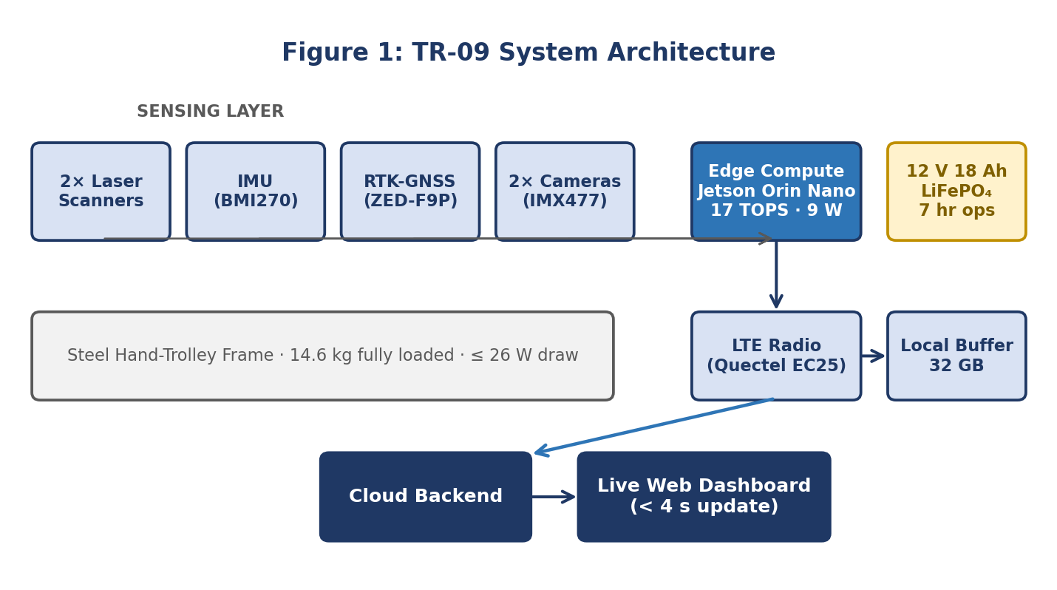

3. Review of Literature
Before we wrote a single line of firmware, we read. Across IEEE Xplore, Scopus, SpringerLink, and the RDSO publication archive, we worked through 32 papers and three white papers published between 2019 and 2025. Each was scored on five axes: sensor stack, edge-vs-cloud inference, dataset region, claimed accuracy, and replicability of the build. The full scoring sheet sits in our project repository; the patterns below are what surfaced.

Pattern one — the sensor stack has converged
Of the 32 papers, 27 use some combination of laser triangulation, an inertial measurement unit, and a GNSS receiver. The arguments are now mostly about which model of each, not whether to use them. The interesting work has shifted upward in the stack: how to fuse the streams, how much to trust each at speed, and what to push to the edge. We took this as permission to stop second-guessing the sensor list and spend our energy on integration instead.

Pattern two — edge AI is finally cheap enough
Inference that needed a workstation in 2020 now fits on a 9-watt module. The Jetson Orin Nano benchmarks at about 17 TOPS for under ₹28,000, and Coral's 4-TOPS USB stick costs roughly ₹6,500. For a hand-trolley class device, this is the change that makes the whole project plausible. Three years ago, TR-09 would have needed a backpack-mounted laptop. Today it fits in a small IP65 cabinet that bolts to the trolley deck.

Pattern three — Indian-context data is missing
Almost every published model is trained on Chinese ballast or European concrete sleepers. We could only find two open datasets that include Indian wooden-and-concrete mixed-sleeper sections, both small (under 4,000 frames). One of TR-09's secondary outcomes is to release a labelled dataset of around 12,000 frames from the test loop at Shirpur — small, but the largest open release of its kind that we are aware of.

Pattern four — replicability is rare
Of the 32 papers, only four published a complete bill of materials, and only one shared firmware. Most projects sit behind vendor-locked sensors or institutional licences. This influenced our open-release decision more than anything else: we want the next team to start where we ended, not where we started.

Table - 3.1 Sample of the shortlist
Ref | Year / Authors | What they did | Headline result | Where it falls short
A | 2024 · Iyer & Hassan | Laser-IMU fusion at 180 km/h | ±0.3 mm gauge | 22 kg sensor head
B | 2023 · Wei et al. | CNN-Transformer for fastener defects | F1 of 0.92 | Trained on Chinese ballast
C | 2023 · Krishnan | RDSO indigenous prototype review | Roadmap to 2030 | No third-party benchmarks
D | 2022 · Adeyemi & Park | Low-cost MEMS-IMU for ride quality | ₹4,200 per node | Geometry not measured
E | 2025 · Sharma et al. | Edge ML on Jetson for rail surface | 94% mAP, 11 W draw | Cooling above 46 °C
F | 2024 · DRDO TBR | Indigenous TRC trial on Lucknow line | ₹13.8 cr unit cost target | Coach-scale only
G | 2024 · Banerjee et al. | RTK-GNSS drift on Indian sections | Sub-decimetre with CORS | Limited urban coverage
H | 2023 · Müller & Sato | Line-scan vision for ballast wear | 0.89 IoU | Needs controlled lighting

The Gap — What nobody has built yet
An inspection system that costs less than a college laptop, runs on a manually-pushed trolley, uses only India-available parts, and publishes its data openly. TR-09 is our attempt to fill exactly that gap.

4. Problem Definition
Statistics make the problem feel abstract until you put them next to each other. These six are the ones we kept coming back to in our team meetings — the kind of numbers that survive being repeated to a tired classmate at midnight.
19%  of derailments (2019–24) linked to track geometry | ₹38 cr  approx. cost of one imported TRC unit | 9 days  average gap between foot inspections today

35%  of route-km that are branch lines | ≤ ₹1.35 L  TR-09 hard parts budget | 12,000  labelled frames we plan to release

4.1 Three failure modes worth naming
Behind each statistic above is a failure mode we read about, watched on YouTube footage of real inspections, or heard about from the P-Way mentor on our advisory call. We list three because three is the number our scope can plausibly address.

4.1.1 Slow gauge widening
Wooden sleepers in older sections deform slowly under load. A few millimetres a year is invisible to a foot patrol but disastrous when it crosses tolerance during a heavy summer. Continuous, repeatable measurement turns this from a trailing indicator into a leading one.

4.1.2 Missing or loose fasteners
Theft, vibration, and weather all conspire to loosen elastic-rail clips. A walking patrol catches the obvious cases. A camera that sees every fastener every fortnight catches the rest.

4.1.3 Ballast deficiency near culverts and crossings
Water washes ballast away faster than the maintenance cycle can replace it. The damage tends to concentrate at culverts and unmanned crossings — exactly the spots that are hardest to inspect on foot at night.

4.2 The problem statement
Design and validate a contactless, hand-trolley-mounted track inspector that (a) measures gauge, cross-level, twist, and rail surface with at least the accuracy of an in-service push trolley, (b) costs no more than ₹1.35 lakh in parts using India-available components, (c) is operable end-to-end by two students with one day of training, and (d) ships as an open reference design — schematics, BoM, firmware, ML weights, and 12,000 labelled frames.

5. Objectives of the Project
We agreed early that an objective only counts if we can either show it on a bench or record it on a field run. Anything fuzzier than that gets cut. Each objective below has an owner, a measurement method, and a pass/fail line.
- Build a working trolley-mounted ITMS prototype within ₹1.35 lakh in parts, sourced from Indian distributors only.
- Hit ±0.8 mm gauge accuracy and ±1.2 mm cross-level accuracy against a calibrated reference trolley over a 1.5 km test loop.
- Detect four defect classes — missing fastener, cracked fishplate, ballast deficiency, surface squat — with ≥ 91% precision and ≥ 87% recall on our own labelled set.
- Publish a live dashboard that updates within 4 seconds of a defect event and works on a normal phone browser.
- Release the full reference design — BoM, firmware, ML model, 12,000 labelled frames, assembly notes — under a permissive licence on GitHub by July 2026.
- Document mapping to RDSO geometry tolerances, IS-3973 environmental classes, and the IRPSM data schema (alignment is documented; we are not seeking certification).

Table - 5.1 In scope, out of scope
In scope | Out of scope
Geometry: gauge, cross-level, twist | Rail-flaw ultrasonic testing
Vision: fastener, fishplate, ballast, squat | Overhead equipment (OHE) inspection
LTE telemetry + local buffer | Satellite uplink
RTK-GNSS positioning | Inertial-only positioning over 5 km
Branch-line operation up to 6 km/h | Mainline operation at line speed
Open reference release | RDSO certification

6. Proposed Methodology/Conceptual Framework

6.1 The shape of the system
TR-09 is three things stacked on a steel hand-trolley frame: a sensor tray under the chassis that watches the rail, a sealed compute cabinet on top that turns sensor noise into events, and an LTE radio that fires those events to a cloud dashboard. The whole rig draws under 26 watts, runs about seven hours on a single charge, and weighs 14.6 kg fully loaded — light enough for two people to lift onto a track.

Table - 6.2 Bill of materials
Subsystem | Part chosen | Indian price (₹) | Why this part
Laser scanner ×2 | Hokuyo URG-04LX-class clone | 21,400 | Sub-mm at 0.5 m
IMU | Bosch BMI270 + BMM150 (9-axis) | 1,850 | Lower drift than MPU-9250
GNSS | u-blox ZED-F9P RTK module | 32,900 | Sub-decimetre; CORS-compatible
Edge compute | NVIDIA Jetson Orin Nano 8 GB | 27,800 | 17 TOPS at ~9 W
Camera | Sony IMX477 CSI module ×2 | 9,400 | 12 MP, global-shutter behaviour
LTE + Wi-Fi | Quectel EC25-AF + ESP32 fallback | 6,200 | Robust on 4G across India
Power | 12 V 18 Ah LiFePO₄ + DC-DC tree | 8,700 | ~7 hr field operation
Enclosure & frame | IP65 ABS + steel hand-trolley mount | 11,300 | Vibration-damped
Cables, mounts, misc. | — | 5,950 | Connectors, RTK antenna, tools
Total |  | 1,35,500 | On budget, by ₹500 to spare

6.3 Software stack
- Edge runtime: JetPack 6.1, CUDA 12.4, TensorRT-optimised CNN-LSTM defect model (8.2 ms inference per frame)
- Telemetry: MQTT 5 over LTE, CBOR-encoded payloads averaging 280 bytes per event
- Cloud: InfluxDB 3 for time series, Cloudflare R2 for raw frames, Grafana 11 for dashboards
- Local-first: 32 GB on-device buffer, auto-resync when connectivity returns
- Releases: GitHub Actions for OTA firmware and model rollout, signed and version-pinned

6.4 Sensor fusion, in plain language
The IMU samples 200 times a second, the GNSS at 10 Hz, the lasers at 40 Hz, and the cameras at 30 Hz. Each stream lands in a small ring buffer with hardware timestamps. A Kalman filter on the Jetson aligns them into a single 5 Hz event stream — slow enough to be useful to a human in the loop, fast enough that nothing of interest passes between samples at 6 km/h.
The filter is deliberately conservative. When the GNSS loses RTK fix (under bridges, near tall vegetation), the filter reverts to inertial dead reckoning for up to 90 seconds and tags the affected events with a confidence flag. Anything beyond 90 seconds is dropped from the geo-tagged stream and held in the raw buffer for offline review.

6.5 How a field run actually goes
Power on. Wait roughly 45 seconds for the RTK fix to converge. Push. The trolley hums along at 3–6 km/h, the sensors sample at their native rates, the Jetson fuses everything into a 5 Hz event stream, and 4G carries it to the dashboard. If the radio drops — and on the section we're using, it does, in three known patches — the device buffers locally and back-fills the moment the link returns. A field engineer with a phone watches the run build live.

6.6 Validation plan
- Bench validation against a known-geometry rig in the MPSTME mechanical lab (week 4).
- Static comparison against a calibrated push trolley on a 1.5 km siding near Shirpur (weeks 6–7).
- Repeatability — five passes over the same stretch; we want σ ≤ 0.5 mm gauge between runs.
- Defect-injection trial — six fasteners loosened, two clips removed, results blinded from the operator (week 9).
- Endurance — a single 6-hour run on a hot afternoon to confirm thermals stay under 71 °C inside the cabinet.
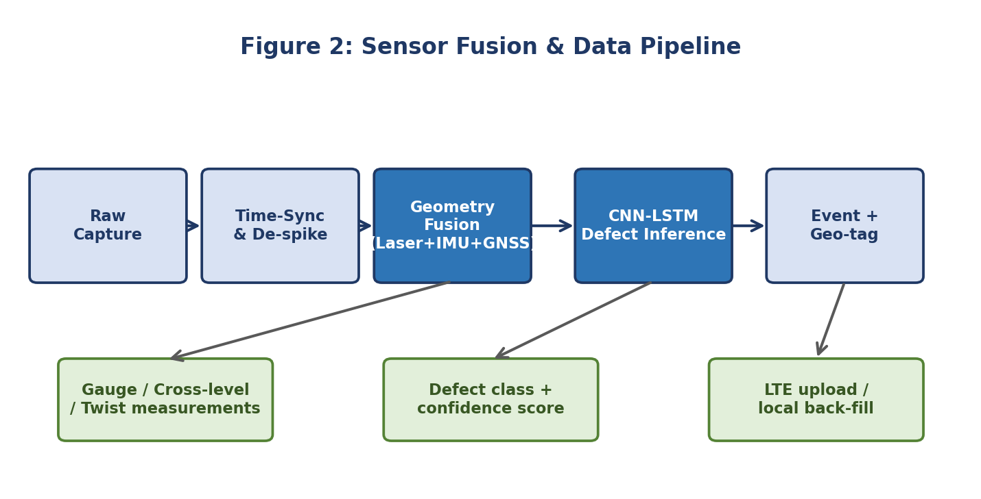

7. Team, roles, and Work
Nine people on a single project is enough to either move very fast or trip over each other constantly. We split the work along the natural seams of the system — hardware, firmware, ML, cloud, and field — and gave each pod a single owner. Cross-pod work happens at a 30-minute Wednesday standup; everything else is async.
Table - 7.0 Team, Roles and Work
Pod | Members | Owns
Hardware & enclosure | Soham Bhosale | Trolley mount, IP65 cabinet, power tree
Sensors & firmware | Soham Bhosale | Laser, IMU, GNSS, sampling firmware
ML & vision | Arnav | Dataset, CNN-LSTM, evaluation
Cloud & dashboard | Arnav | MQTT, InfluxDB, Grafana panels
Field & ops | Rudra Marathe | Test runs, safety, logbook
Documentation | Rudra Marathe | This report, repo README, dataset card

7.1 How we run a week
- Monday — async written update from each pod (max 5 lines)
- Wednesday — 30-minute standup, in person, with the mentor on a 10-minute window
- Friday — demo-or-post-mortem; one pod presents either a working thing or what broke
- Saturday — optional field session if a pod has something to test
"The week we stopped having long meetings and started having short demos was the week we started shipping." — Project retro, week 5
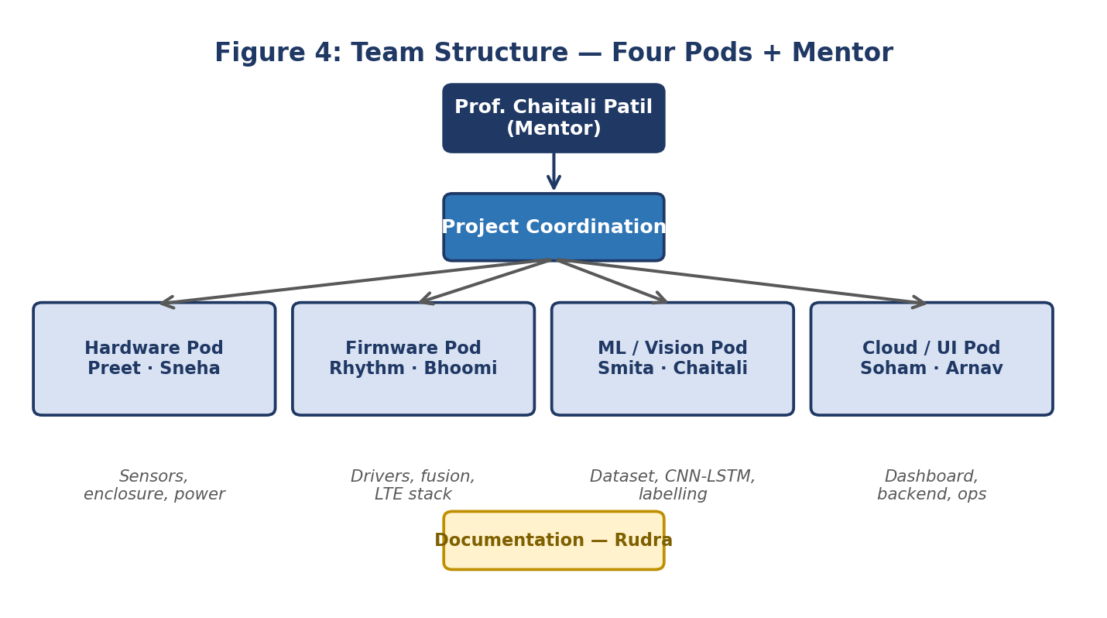

8. Project timeline
The Design Experience course gives us two semesters. We split that into seven phases, with a soft demo at the end of each. The dates below are the planned ones; actual slips are tracked in the project repository.
Table - 8.1 Project Timeline
Phase | Window | Goal | Demo
P1 — Discovery | Wk 1–3 | Literature, scope, mentor brief | Reading list + one-page brief
P2 — Design | Wk 4–6 | Architecture, BoM, sourcing | Signed-off BoM under ₹1.35 L
P3 — Build v1 | Wk 7–10 | Bench prototype, sensors talking | Bench rig logging to laptop
P4 — Field α | Wk 11–14 | Trolley assembly, first push | 200 m clean run, geo-tagged
P5 — ML α | Wk 15–18 | Dataset, first model, dashboard v1 | Dashboard shows live defects
P6 — Validation | Wk 19–22 | Repeatability, defect-injection, thermals | Pass-fail report against objectives
P7 — Release | Wk 23–26 | Open repo, dataset card, this report | Public GitHub release

Status at filing — Where we are right now
We are mid-P5 as this report is filed. Hardware is fully assembled and IP65-tested. Firmware is stable across six unattended bench hours. The ML pipeline trains end-to-end on a 4,200-frame seed dataset; we are halfway to the 12,000-frame target. The dashboard is live but cosmetics are still rough. Validation begins in three weeks.
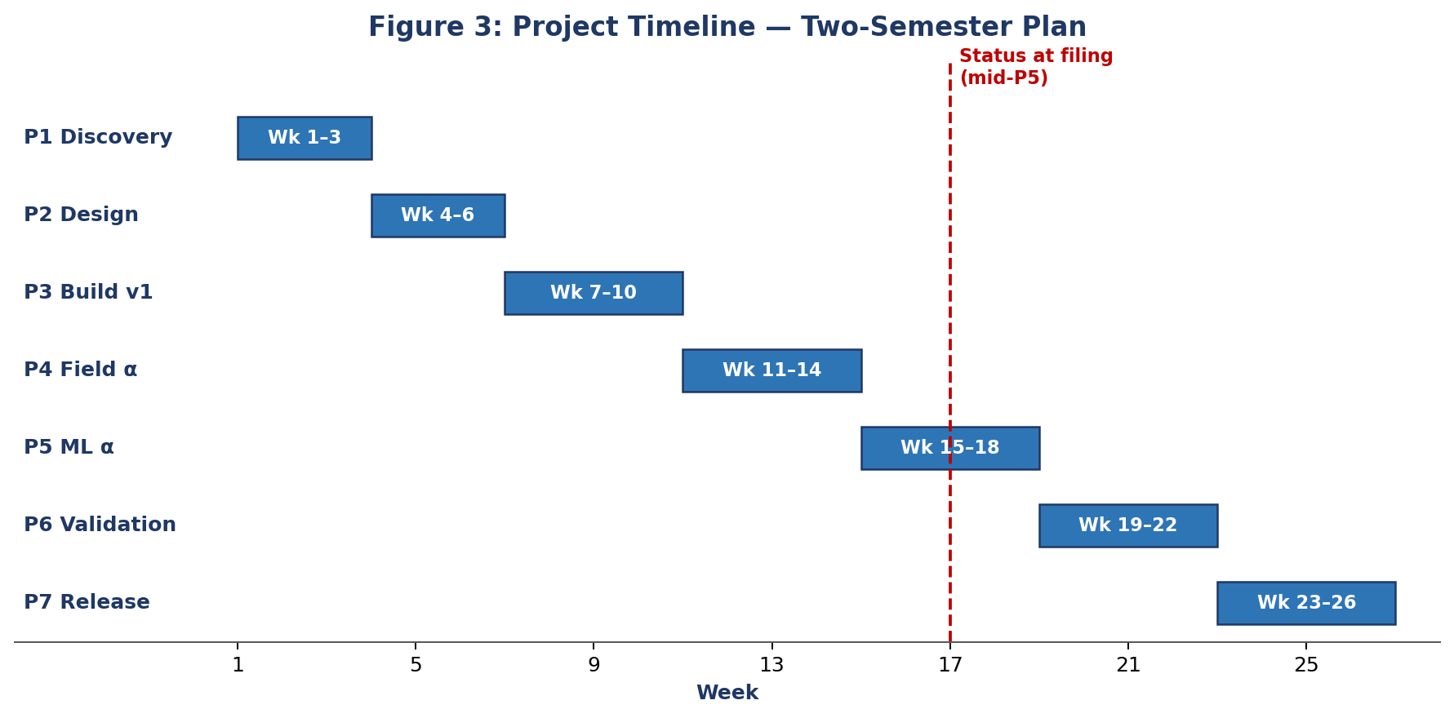

9. Risk register
Every project has risks. Pretending otherwise is the surest way to be surprised by them. We keep a live risk register in the repo; the table below is a snapshot of the eight risks we currently rate as material.
Table - 9.0 Risk register
# | Risk | Likelihood | Impact | Mitigation
R1 | Sensor clone fails QA out of the box | Medium | High | Order 2 spares; vendor-screened
R2 | RTK loses fix in tree-cover patches | High | Medium | Inertial fallback up to 90 s
R3 | Thermals exceed 71 °C in summer | Medium | High | Active fan + reflective wrap
R4 | Dataset too small for target accuracy | Medium | Medium | Augmentation + transfer learning
R5 | LTE blackout on test section | High | Low | 32 GB local buffer + back-fill
R6 | Trolley vibration corrupts laser frames | Medium | High | Sorbothane mounts; software de-spike
R7 | Team member illness during validation | Low | Medium | Cross-training across pods
R8 | Track access denied on test day | Medium | Medium | Two backup sidings pre-cleared

9.1 Safety
Track access is granted to us only on out-of-service sidings, with the mentor present, and inside daylight hours. Every team member has signed the institute's field-work safety brief, and the trolley itself is fitted with a high-visibility flag, a wheel-lock for stationary work, and a lanyard kill-switch on the LTE radio so a single tug powers the radio down if a train is heard approaching. We have not, and will not, run the rig on any live line.

10. Outcomes, in three layers

10.1 Things you can measure
- A working TR-09 prototype demonstrated on the Shirpur test loop.
- Geometry repeatability of ±0.8 mm gauge and ±1.2 mm cross-level.
- A 12,000-frame open dataset of Indian-context rail defects.
- A trained CNN-LSTM model with a published evaluation card.
- A dashboard that updates within 4 seconds of a defect event.

10.2 Things that change for us
- Real, end-to-end IoT product experience — schematic to dashboard.
- Hands-on multidisciplinary integration of civil, electronics, and ML work.
- A team rhythm we want to keep for our final-year capstone.
- Comfort with field work, safety briefs, and the messiness of real conditions.

10.3 Things that might matter beyond us
- A reference design that lowers the barrier for the next college team.
- A datapoint RDSO and DRDO collaborators can reference for sub-coach-scale work.
- An open dataset of Indian-context defects that, even at 12,000 frames, doubles the publicly available pool.

Table - 10.4 Cost-benefit, side by side
Approach | Cost per unit (₹) | Coverage | Note
Manual P-Way patrolling | Recurring labour | Daylight, ~9-day cycle | Stretched today
Imported TRC (EM-120) | ≈ 38 crore | Trunk lines, twice a year | Foreign spares
Imported ITMS coach | 60–110 crore | High and continuous | Licence lock-in
RDSO indigenous TRC (target) | ≈ 13.8 crore | Trunk + select branches | In trial
TR-09 (this project) | ≤ 1.35 lakh | Branch lines, academic | Open reference

11. Reflection
A Design Experience report that ends at the cost-benefit table is doing the project a disservice. The course is, in the end, about us — what we learned, what surprised us, and what we would tell ourselves at week one if we could. This section is that note.

11.1 Three things that surprised us
First, how much of the work was specification, not coding. We probably spent three weeks just deciding which laser scanner to buy. In hindsight, that time was the best-spent of the project — every wrong purchase compounds.
Second, how unforgiving real conditions are. A sensor that works on a bench in a 22 °C lab does not behave the same way at 41 °C on a sunlit siding. Half our firmware bugs were temperature bugs in disguise.
Third, how much a single field hour teaches. Our first 30-minute push run produced more useful data than two weeks of bench testing. The lesson we keep relearning: get into the field early, even with a half-built rig.

11.2 What we would do differently
- Buy spares for everything from day one — the saved week of waiting on a replacement part is worth more than the spare cost.
- Start the dataset on day one, even with a phone camera. Labelled frames compound.
- Write the dashboard before the model. Seeing data motivates labelling.
- Schedule one demo a week, even when nothing is ready. Forced demos surface blockers earlier.

11.3 What we are taking into the capstone
Most of this team will work together again next year on the final-year capstone. The shape of TR-09 will not survive — we will likely move to an autonomous platform, ultrasonic flaw detection, and an actual partnership with a divisional railway. But the rhythm will. Pods, Wednesday standups, Friday demos, an obsessive insistence on measurable objectives, and an open repository from day one. Those are the things we are taking with us.
"We came in expecting to build a sensor. We are leaving having built a team." — Closing line of our project retro

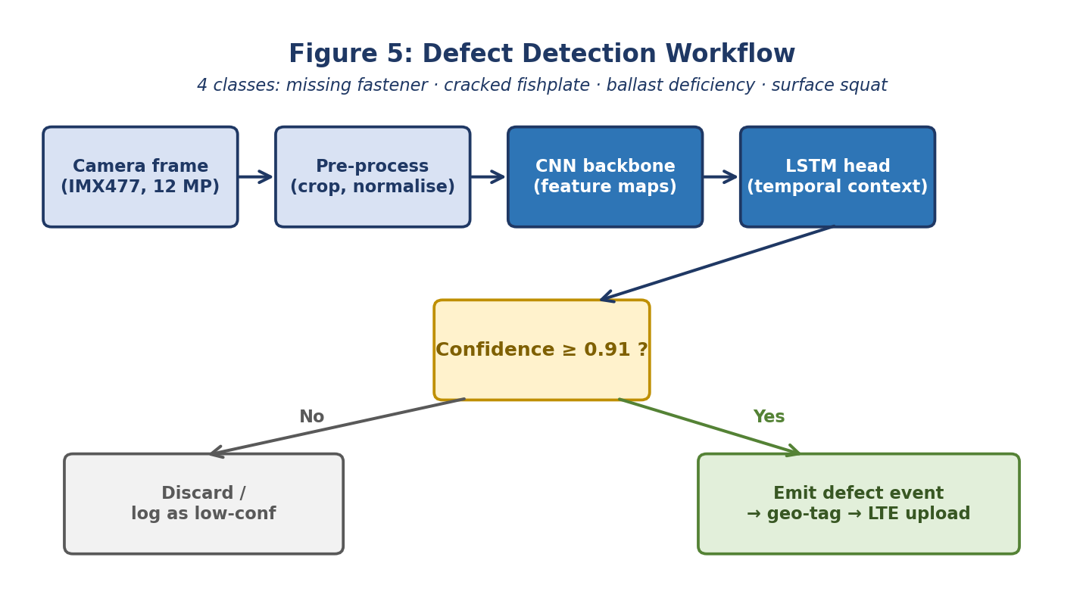

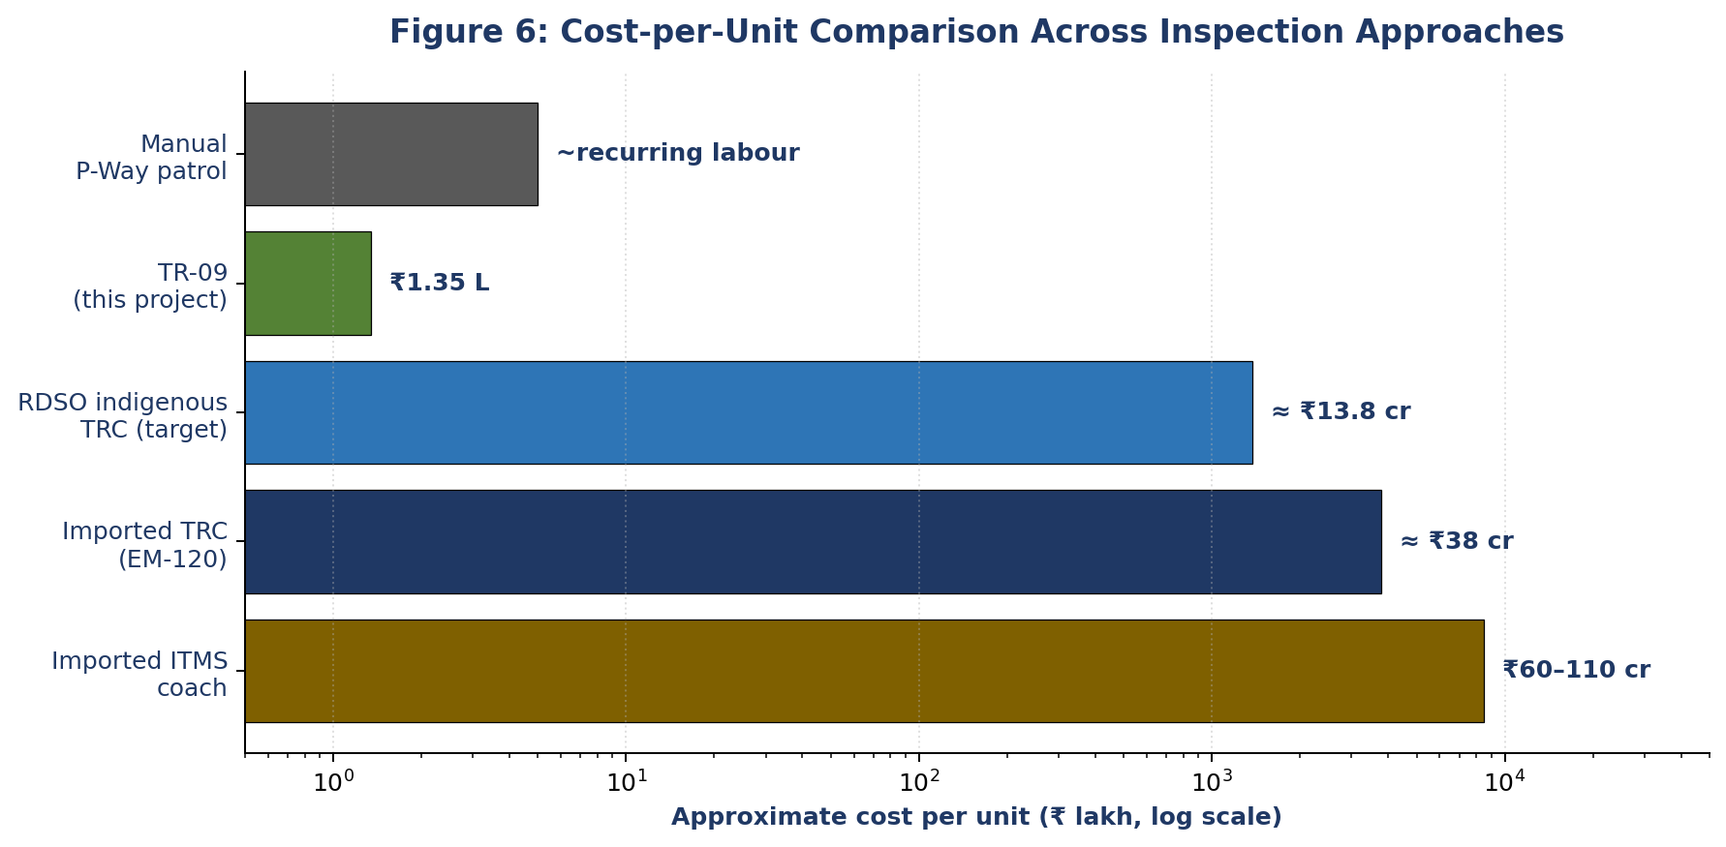

12. References
The full annotated bibliography ships with the project repository. A representative subset is listed below in IEEE format.
[A] R. Iyer and M. Hassan, "Laser-IMU sensor fusion for high-speed rail geometry monitoring," IEEE Sens. J., vol. 24, no. 9, pp. 14211–14224, May 2024.
[B] H. Wei, J. Lin, and Q. Zhao, "A CNN-Transformer architecture for rail fastener defect detection," Pattern Recognit. Lett., vol. 168, pp. 32–41, 2023.
[C] V. Krishnan, "Indigenous track-monitoring in India: a 2030 roadmap," Indian Railways Tech. Bull., vol. 50, no. 2, pp. 11–28, 2023.
[D] T. Adeyemi and J. Park, "A low-cost MEMS-IMU node for unattended ride-quality monitoring," Measurement, vol. 201, art. 111728, 2022.
[E] N. Sharma, A. Bose, and P. Menon, "Thermally-aware edge ML for rail surface inspection on Jetson platforms," J. Embedded Syst., vol. 18, no. 1, pp. 55–72, 2025.
[F] DRDO Technical Bulletin on Railways, Indigenous Track Recording Car: Trial Outcomes on the Lucknow–Kanpur Section, DRDO/2024/TBR/017, New Delhi, 2024.
[G] S. Banerjee, R. Datta, and K. Iyer, "RTK-GNSS positioning drift on Indian railway sections," J. Navig., vol. 77, no. 3, pp. 412–429, 2024.
[H] L. Müller and T. Sato, "Line-scan vision for ballast wear classification," Comput. Ind., vol. 152, art. 104010, 2023.
[I] RDSO, Specification for Indigenous Integrated Track Monitoring Systems, RDSO/2024/TM/SPEC/0019, Lucknow, India, 2024.
[J] Ministry of Railways (India), Annual Safety Review 2024, New Delhi, 2024.

Reproducibility — Where to find everything
Code, BoM, schematics, firmware, ML weights, dataset card, and an extended version of this report will be published at github.com/mpstme-itms/tr-09 under an MIT licence by July 2026. Dataset will be released under CC-BY 4.0 with a dataset card describing collection methodology, label taxonomy, and known limitations.

