Lab Practical #01:
Research and find out what are the current UI/UX design trends. Study of various templates. E.g. Metronic, Unify, AdminLTE, etc.
Practical Assignment #01:
Choose one of the example templates (Metronic/Unify/AdminLTE, etc.) and analyze it.
Fill out a worksheet with these headings:
- First Impression: What is this template's primary goal?
- Target User: Who do you think this was designed for?
- Key UI Pattern: Identify one UI pattern (e.g., the sidebar navigation) and describe how it works.
- A/B Opinion: What is one thing you think it does well, and one thing you would improve?

Description:

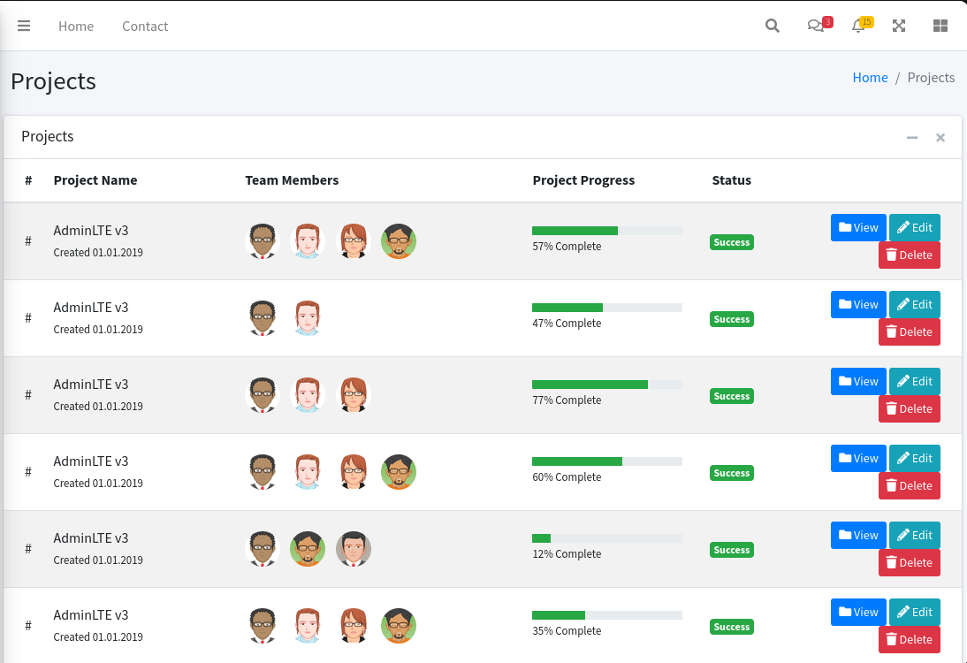

1. First Impression:
- it’s a project listing dashboard meant to show multiple projects, their progress, team members, and quick actions. Example: a CRUD-heavy admin view for managing projects

2. Target Users:
- People running internal tools project managers, team leads, or admins who need a clean overview of projects and easy access to view/edit/delete actions

3. Key UI Pattern:
- Each table row ends with a compact set of colored buttons. Blue = View, Green = Edit, Red = Delete. it’s a standard “row-level actions” pattern: clear, predictable, and always in the same spot so your eyes immediately know where to click to manage a specific item

4. A/B Opinion:

A (Good):
- The progress bars + status tags make the data reading fast. You can scan down the column and instantly see project health/progress

B (Needs Improvement):
- The design is way too repetitive. all rows look identical, so the page becomes visually boring and slow to parse. Add sorting, filtering, or at least more differentiated info (e.g., categories, deadlines) to make it useful instead of a pretty spreadsheet

