Lab Practical #03:
Design a simple Music App (3 screens) using Basic Tools Position, Size, Rotation, Color Styles, Masks.
Practical Assignment #03:
Design the 'Login Screen'. Focus on tools from Position, Size, Rotation, Color Styles, Masks

Description:
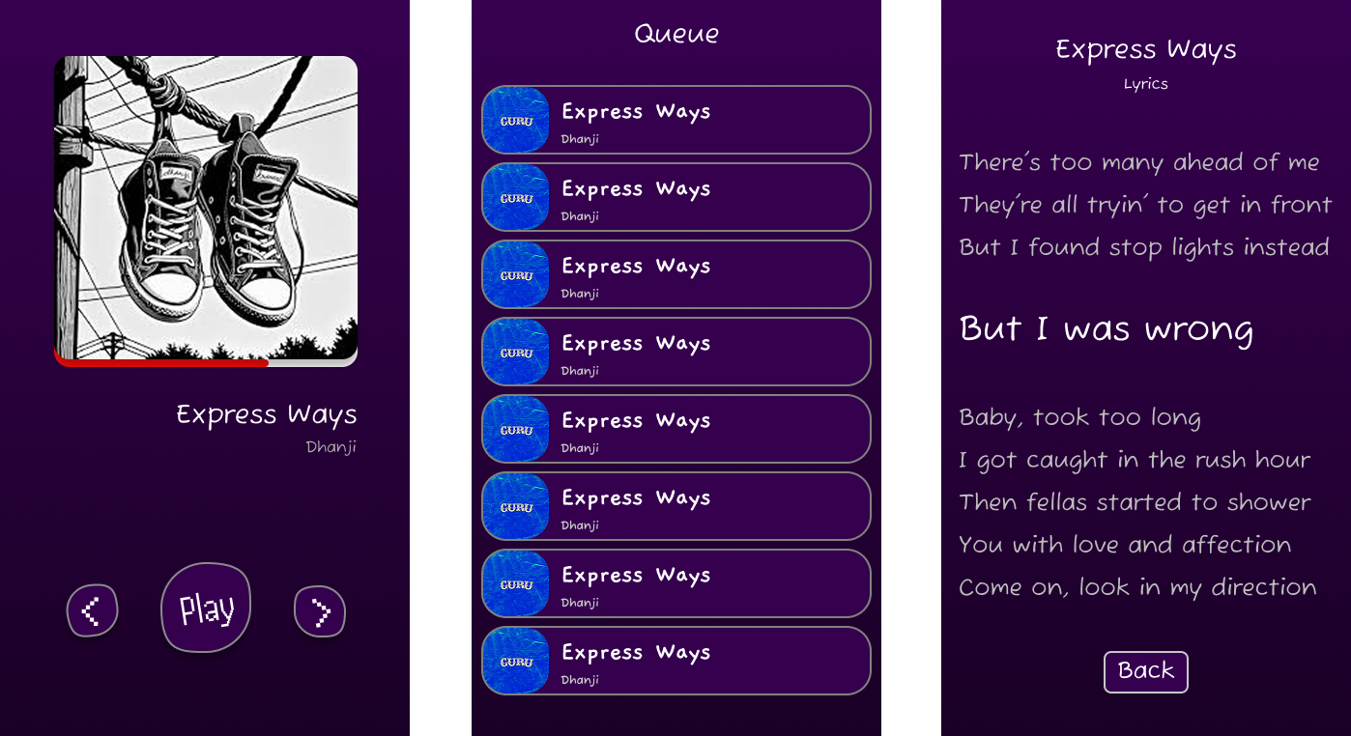
Now Playing Queue Lyrics

