Lab Practical #2:
- Write a program to reverse a string using pointers.
- Implement string functions like strlen, strcat, and strcmp.
- Implement a program to read and write a text file.
- Write a C program to test whether a number is prime or composite.
- Write a C program to generate prime numbers in a given range.

Program-1:
#include <stdio.h>
#include <string.h>

void reverseString(char *str) {
char *start = str;
char *end = str + strlen(str) - 1;
char temp;

while (start < end) {
temp = *start;
*start = *end;
*end = temp;
start++;
end--;
}
}

int main() {
char str[100];
printf("Enter a string: ");
fgets(str, sizeof(str), stdin);
str[strcspn(str, "\n")] = '\0';
printf("Original string: %s\n", str);
reverseString(str);
printf("Reversed string: %s\n", str);
return 0;
}

Output:
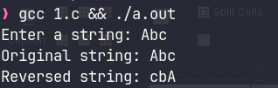

Program-2:
#include <stdio.h>

int myStrlen(const char *str) {
int len = 0;
while (*str++) len++;
return len;
}

void myStrcat(char *dest, const char *src) {
while (*dest) dest++;
while ((*dest++ = *src++));
}

int myStrcmp(const char *str1, const char *str2) {
while (*str1 && *str2 && *str1 == *str2) { str1++; str2++; }
return *str1 - *str2;
}

int main() {
char str1[100], str2[100];
printf("Enter first string: ");
fgets(str1, sizeof(str1), stdin);
str1[myStrlen(str1) - 1] = '\0';
printf("Enter second string: ");
fgets(str2, sizeof(str2), stdin);
str2[myStrlen(str2) - 1] = '\0';
printf("Length of first string: %d\n", myStrlen(str1));
printf("Length of second string: %d\n", myStrlen(str2));
printf("Comparison result: %d\n", myStrcmp(str1, str2));
myStrcat(str1, " ");
myStrcat(str1, str2);
printf("Concatenated string: %s\n", str1);
return 0;
}

Output:
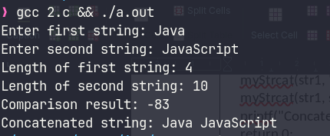

Program-3:
#include <stdio.h>
#include <stdlib.h>
#include <string.h>

int main() {
FILE *f;
char fn[100], t[1000];
int c;

scanf("%s%d", fn, &c);

if (c == 1) {
f = fopen(fn, "w");
if (!f) return 1;

getchar();
while (fgets(t, sizeof(t), stdin) && strcmp(t, "END\n"))
fputs(t, f);

fclose(f);
}
else if (c == 2) {
f = fopen(fn, "r");
if (!f) return 1;

while (fgets(t, sizeof(t), f))
printf("%s", t);

fclose(f);
}

return 0;
}

Output:
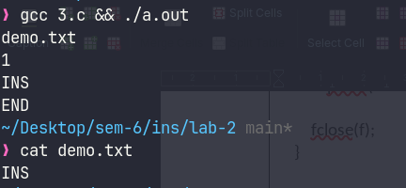

Program-4:
#include <stdio.h>
#include <math.h>

int isPrime(int n) {
if (n <= 1) return 0;
if (n == 2) return 1;
if (n % 2 == 0) return 0;
for (int i = 3; i <= sqrt(n); i += 2)
if (n % i == 0) return 0;
return 1;
}

int main() {
int n;
scanf("%d", &n);
printf(isPrime(n) ? "%d is a PRIME number.\n" : "%d is a COMPOSITE number.\n", n);
return 0;
}

Output:
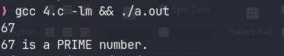

Program-5:
#include <stdio.h>
#include <math.h>

int isPrime(int n) {
if (n <= 1) return 0;
if (n == 2) return 1;
if (n % 2 == 0) return 0;
for (int i = 3; i <= sqrt(n); i += 2)
if (n % i == 0) return 0;
return 1;
}

int main() {
int s, e, c = 0;
scanf("%d%d", &s, &e);
for (int i = s; i <= e; i++)
if (isPrime(i)) {
printf("%d ", i);
if (++c % 10 == 0) printf("\n");
}
if (c) printf("\nTotal prime numbers: %d\n", c);
else printf("No prime numbers found in this range.\n");
return 0;
}

Output:
