

GROUP 5:
SOHAM ADGOKAR (A2-B2-28)
MOHIT AGRAWAL (A2-B2-33)
KUNAL NAYAK (A2-B4-53)

https://github.com/sohamadgokar06/DAA_GroupProject-LA2 (Git-hub Link)

https://site-generator-38.preview.emergentagent.com/ (Website Link)

TITLE: SMART LOGISTICS SYSTEM

Objectives:

1.To design a cost-effective road network connecting all cities using Kruskal’s algorithm.

2.To find the shortest and fastest delivery route between any two cities using Dijkstra’s algorithm.

3.To maximize delivery profit by efficiently selecting parcels using the fractional knapsack algorithm.

4.To integrate multiple optimization algorithms into a single smart logistics system.

5.To minimize total transportation cost, distance, and time for logistics operations.
Introduction:

The Smart Logistic System is a C-based project designed to optimize delivery operations by integrating multiple algorithms from graph theory and greedy methods. The system focuses on building the most efficient transportation network, determining the shortest delivery route, and maximizing profit through effective parcel selection. It demonstrates how classical algorithms like Kruskal’s, Dijkstra’s, and Fractional Knapsack can solve real-world logistics and transportation challenges.

Algorithms/Technique used:

1. Kruskal’s Algorithm (Minimum Spanning Tree)
Purpose: To design the most cost-effective road network connecting all cities.
Explanation: Kruskal’s algorithm selects edges in increasing order of weight and ensures no cycles are formed. It uses the Union–Find technique to manage connected components efficiently.
Algorithm Steps:
- Sort all roads by distance.
- Pick the smallest edge that doesn’t form a cycle.
- Repeat until all cities are connected.
Use in project: Builds an optimal road map with minimum total distance.

2. Dijkstra’s Algorithm (Shortest Path)
Purpose: To find the fastest or shortest route between two cities.
Explanation: Dijkstra’s algorithm calculates the minimum distance from a source city to all others by progressively updating the shortest known path.
Algorithm Steps:
- Assign distance 0 to the source and infinity to all others.
- Pick the city with the smallest distance.
- Update distances of its neighboring cities.
- Repeat until all cities are processed.
Use in project: Determines the fastest delivery route between selected cities.

3. Fractional Knapsack Algorithm (Greedy Optimization)
Purpose: To maximize profit by loading parcels based on weight and value ratio.
Explanation: The algorithm sorts parcels by profit/weight ratio and takes full or fractional parts until the vehicle capacity is filled.
Algorithm Steps:
- Calculate profit/weight ratio for each parcel.
- Sort parcels in descending order of ratio.
- Pick parcels until the vehicle reaches capacity.
Use in project: Selects the most profitable parcels under weight limits.

Time Complexity and its explanation:

Kruskal’s Algorithm:
The time complexity of Kruskal’s algorithm is O(E log V), where E is the number of edges and V is number of vertices(cities). This is because all edges are sorted based on their weights, and the Union–Find operations for cycle detection are performed in almost constant time. The sorting step dominates the overall runtime.

Dijkstra’s Algorithm:
The time complexity of Dijkstra’s algorithm in this program is O(V²), where V is the number of cities (vertices). This is due to the use of an adjacency matrix and a linear search to find the vertex with the minimum distance in each iteration. Using a priority queue could reduce it to
O((V + E) log V), but that approach is not implemented here.

Fractional Knapsack Algorithm:
The time complexity of the fractional knapsack algorithm is O(n log n), where n is the number of parcels. The most time-consuming operation is sorting the parcels based on their profit-to-weight ratio, after which the selection process runs in linear time.

RESULTS:

- City Addition: Users enter all cities to define nodes of the logistics network.

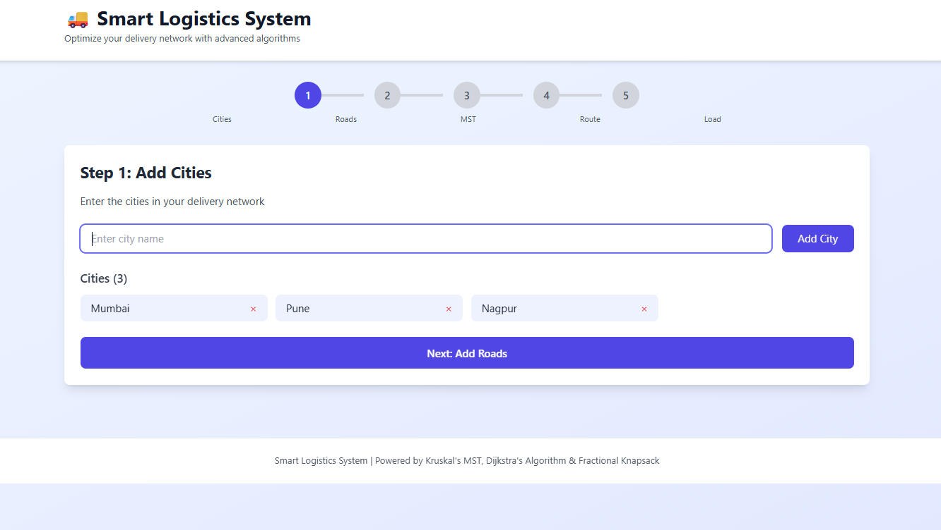

- Road Connections: Roads between cities with distances are added to form graph edges.

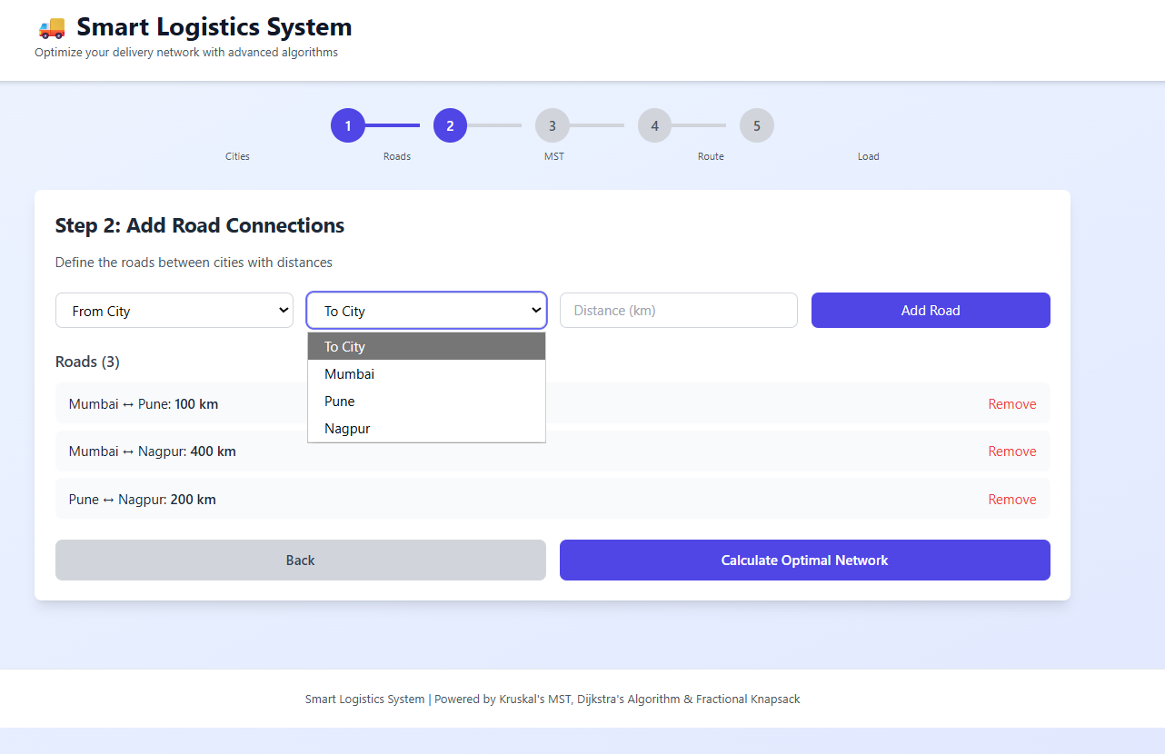

3.Optimal Network (Kruskal’s): The system generates a Minimum Spanning Tree showing the least total road distance connecting all cities.

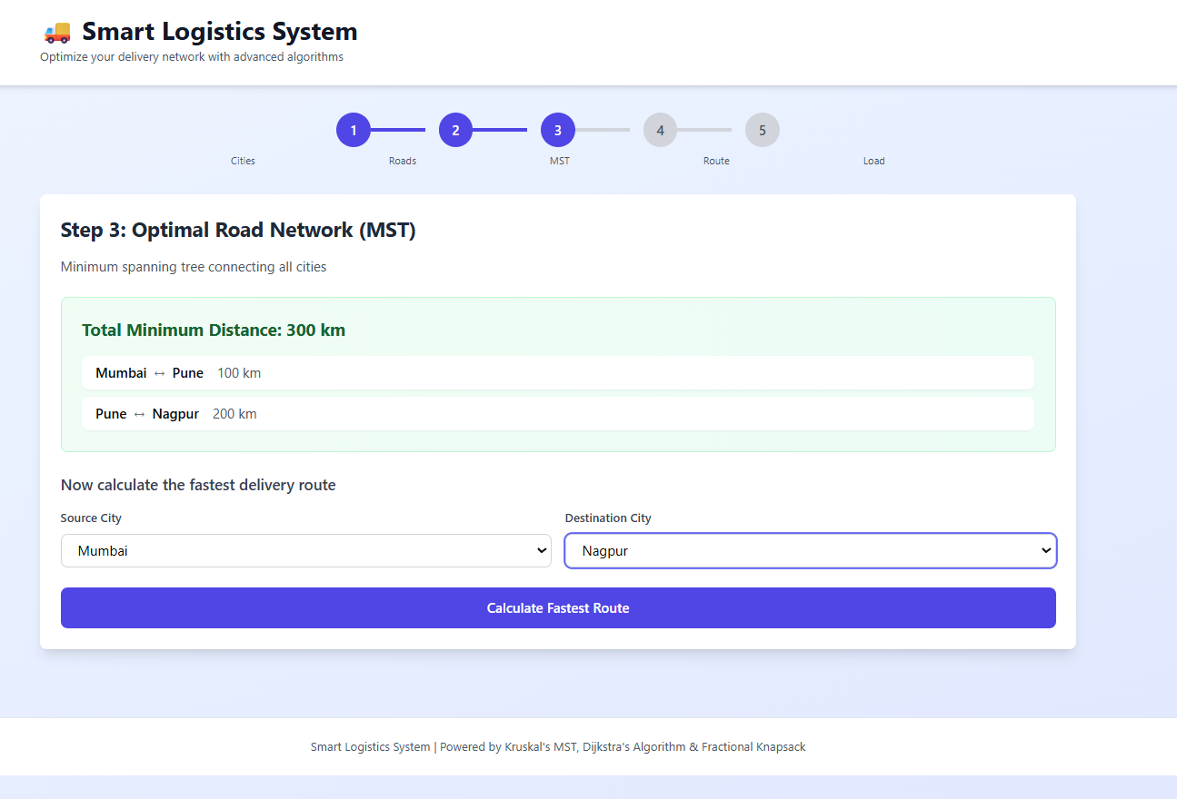

- Shortest Route (Dijkstra’s): Finds the fastest delivery path between selected cities with total distance displayed.

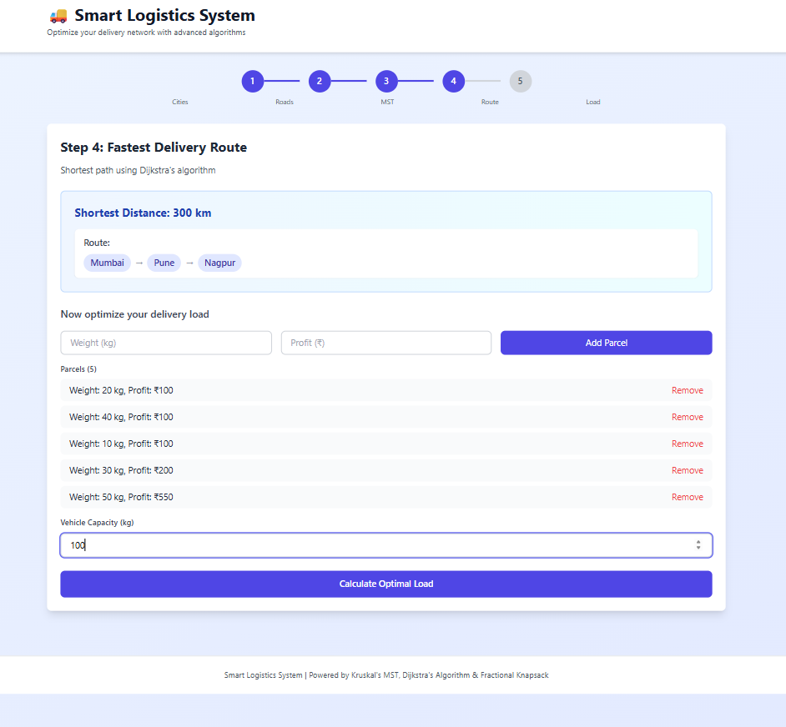

5.Profit Optimization (Fractional Knapsack):
Calculates the maximum profit by selecting parcels based on weight and profit ratio.
The combined results display the minimum network cost, fastest route, and highest profit, achieving overall logistics optimization.

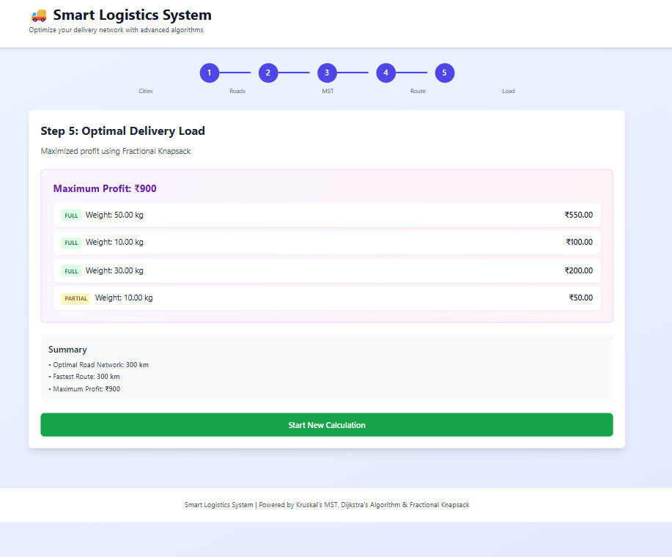

Conclusion:
- The Smart Logistic System effectively applies Kruskal’s, Dijkstra’s, and Fractional Knapsack algorithms to solve logistics problems.
- It finds the minimum cost road network, shortest delivery path, and maximum delivery profit.
- The project shows how algorithms can be combined to achieve cost, distance, and profit optimization in logistics.
- It helps understand the real-world use of graph and greedy algorithms in transportation and delivery systems.

Future Scope:
- Integration of real-time traffic and map data for accurate route optimization.
- Development of a Graphical User Interface (GUI) for better user interaction.
- Implementation of multi-vehicle and multi-depot routing for large-scale logistics.
- Use of AI and machine learning to predict delivery times and optimize routes dynamically.
- Expansion to include warehouse and inventory management modules.

