[COLLEGE NAME]
A Project Report on
Resume Screening Panel
A Multi-Agent System for Fair and Explainable Resume Screening
Coursera On-the-Job Training (OJT) Project - Multi-Agent Systems

Submitted by
Name | [YOUR NAME]
SAP ID | [YOUR SAP ID]
Roll Number | [YOUR ROLL NO]
Course / Batch | [COURSE NAME]
Guide / Mentor | [GUIDE NAME]

Date of submission: 22 October 2026

Index
1. Introduction 3
1.1 What is an AI agent? 3
1.2 What is a multi-agent system? 3
1.3 Why multi-agent instead of one large prompt? 3
1.4 Multi-agent frameworks 3
1.5 Project overview 4
2. Problem Definition 4
2.1 Background 4
2.2 Bias in hiring 4
2.3 Problem statement 4
2.4 Objectives 4
2.5 Scope 5
3. System Design 6
3.1 System architecture 6
3.2 Agent roles 6
3.3 Agent workflow and hand-offs 6
3.4 Data flow 7
3.5 Scoring model 8
3.6 Key design decisions 8
4. Development Details 9
4.1 Technology stack 9
4.2 Folder structure 9
4.3 Key code 9
4.4 User interface and execution 11
4.5 Testing 17
5. Deployment Architecture 18
5.1 Deployment diagram 18
5.2 Proof of multiple agents 18
5.3 Running locally 20
5.4 Deploying on Streamlit Community Cloud 20
5.5 Security and privacy 20
6. Results and Discussion 20
6.1 Sample run 20
6.2 Bias cases caught 21
6.3 Discussion 21
6.4 Limitations 21
7. Conclusion and Future Scope 21
7.1 Conclusion 21
7.2 Future scope 22
8. Demo and Repository Links 22
References 22

1. Introduction

1.1 What is an AI agent?
An AI agent is a software program that perceives its environment, reasons about a goal and takes actions to reach that goal with some degree of autonomy. Modern agents are usually built on a Large Language Model (LLM), which gives them the ability to read instructions in natural language, plan the steps needed, call tools and produce structured output. An agent is more than a single prompt: it has a defined role, a goal, background knowledge (its backstory or system prompt), access to tools or data, and a clear contract for what it must hand back.

1.2 What is a multi-agent system?
A multi-agent system (MAS) is a group of agents that each own one part of a larger problem and collaborate by passing information to one another. Agents can be arranged in different patterns: a sequential pipeline (each agent works on the previous agent's output), a hierarchical structure (a manager agent delegates to workers) or a conversational group that debates until it agrees. This project uses a sequential pipeline coordinated by an orchestrator, which is the easiest pattern to trace and audit.

1.3 Why multi-agent instead of one large prompt?
- Separation of concerns: each agent has one job and a short, focused prompt, which makes its output more reliable than one prompt that must do everything.
- Checks and balances: one agent can review another's work. Here, the Bias Checker Agent audits the Screener Agent, which a single prompt cannot do to itself in a transparent way.
- Explainability: every hand-off produces a JSON artefact that can be logged, displayed and tested, so it is clear which agent made which decision.
- Modularity: an agent can be improved, replaced or given a different model without touching the others.
- Scalability: per-resume tasks (screening and auditing) can be run in parallel in future.

1.4 Multi-agent frameworks
Table 1: Comparison of popular multi-agent frameworks
Framework | Developer | Core idea | Best suited for
CrewAI | CrewAI Inc. (open source) | Agents with role, goal and backstory work on Tasks inside a Crew; sequential or hierarchical processes | Role-based business workflows (used here)
AutoGen | Microsoft Research | Agents talk to each other in a multi-turn conversation; supports human-in-the-loop | Conversational problem solving, code generation
LangGraph | LangChain | Agents are nodes in a stateful graph with explicit edges, loops and checkpoints | Complex branching or long-running workflows

CrewAI was chosen because its role/goal/backstory model maps directly onto an HR panel, it is simple to read, and it works with any OpenAI-compatible model provider such as Groq.

1.5 Project overview
The Resume Screening Panel imitates a real interview panel. A recruiter uploads one job description and several resumes (PDF or TXT). Four agents then work in sequence: the JD Analyst Agent turns the job description into structured criteria, the Screener Agent scores each resume, the Bias Checker Agent removes unfair influences from those scores, and the HR Summary Agent produces a ranked shortlist with Hire / Maybe / Reject recommendations and tailored interview questions. Results are shown in a Streamlit web app and can be downloaded as CSV, PDF or JSON.

2. Problem Definition

2.1 Background
Entry-level job postings in India routinely attract hundreds of applications. During my OJT I observed that first-round screening is usually done manually by recruiters who spend well under a minute on each resume. This creates several problems:
- Time and cost: screening hundreds of resumes by hand takes days of recruiter time.
- Inconsistency: two recruiters (or the same recruiter at different times) score the same resume differently, because the criteria are applied from memory.
- Little explanation: rejected candidates and hiring managers rarely see why a decision was made.
- Keyword filters are too rigid: simple applicant tracking systems reject good candidates who describe a skill with different words (for example, PostgreSQL instead of SQL).

2.2 Bias in hiring
Studies of hiring repeatedly show that factors unrelated to the job influence screening decisions. Common examples are penalising career breaks (often taken for maternity or caregiving), age, marital status, a foreign-sounding name or overseas background, and the prestige of the college attended (in both directions: a top-tier brand can hide weak skills, and a lesser-known college can hide strong ones). Automated systems can copy these same biases if nothing checks them. A fair screening tool therefore needs an explicit step that looks for, removes and explains such influences.

2.3 Problem statement
To design and build a multi-agent AI system that screens resumes against a job description quickly and consistently, detects and corrects biased reasoning, and gives recruiters a ranked, explainable shortlist with tailored interview questions.

2.4 Objectives
- Extract structured hiring criteria (must-have skills, nice-to-have skills, experience, qualifications) from any job description.
- Score every resume from 0 to 100 with a per-skill breakdown that quotes evidence from the resume.
- Audit each scoring decision for bias across eight protected or job-irrelevant categories and correct the score where bias is found.
- Rank candidates, recommend Hire / Maybe / Reject and generate 3-5 tailored interview questions.
- Prove the multi-agent behaviour with timestamped hand-off logs, a live status UI and tests.
- Keep API keys secure and make the project runnable offline for evaluation (demo mode).

2.5 Scope
Table 2: Project scope
In scope | Out of scope
PDF and TXT resumes and job descriptions | Scanned image resumes (OCR)
One job description per run, any number of resumes | Comparing one resume against many jobs
English-language documents | Other languages
Decision support for a human recruiter | Fully automatic hiring decisions
Groq (Llama 3.3 70B) live mode and an offline demo mode | Fine-tuning a custom model

3. System Design

3.1 System architecture
The system is organised in four layers. The presentation layer (Streamlit web UI and a command-line runner) collects files and displays results. The orchestration layer parses the documents and runs the four CrewAI agents in order. The model layer supplies the language model: Groq's Llama 3.3 70B in live mode, or a deterministic offline engine in demo mode. The output layer stores the hand-off log and the final results.
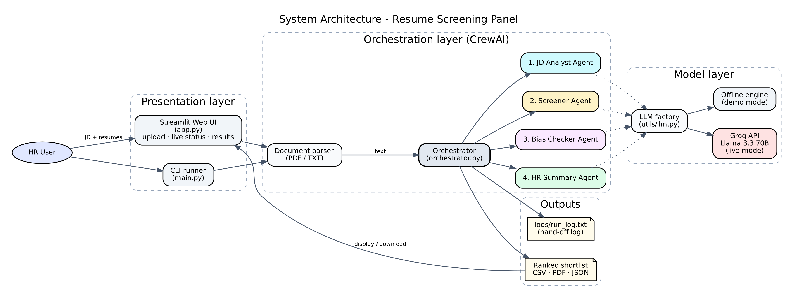
Fig 1: System architecture of the Resume Screening Panel

3.2 Agent roles
Table 3: The four agents and their contracts
# | Agent | Role / goal | Input | Output (JSON)
1 | JD Analyst Agent | Senior technical recruiter. Turns the job description into structured hiring criteria without inventing requirements. | Job description text | job_title, must_have_skills, nice_to_have_skills, experience, qualifications
2 | Screener Agent | First-pass screener. Scores each resume 0-100 with evidence for every skill and lists any other factors that affected its impression. | Criteria + one resume | skill_score, adjustments, score, skill_breakdown, justification
3 | Bias Checker Agent | Fair-hiring compliance officer. Flags adjustments based on protected or job-irrelevant factors and reverses them. | Resume + screening result | original_score, adjusted_score, bias_flags, verdict
4 | HR Summary Agent | HR business partner. Ranks candidates, recommends and writes interview questions based on each person's evidence and gaps. | Criteria + all corrected results | ranking, shortlist, summary

3.3 Agent workflow and hand-offs
Figure 2 shows the order of work. Each arrow labelled 'hand-off' is logged by the orchestrator. The Screener and Bias Checker agents run once per resume, so a run with six resumes executes 2 + 2 x 6 = 14 agent tasks.
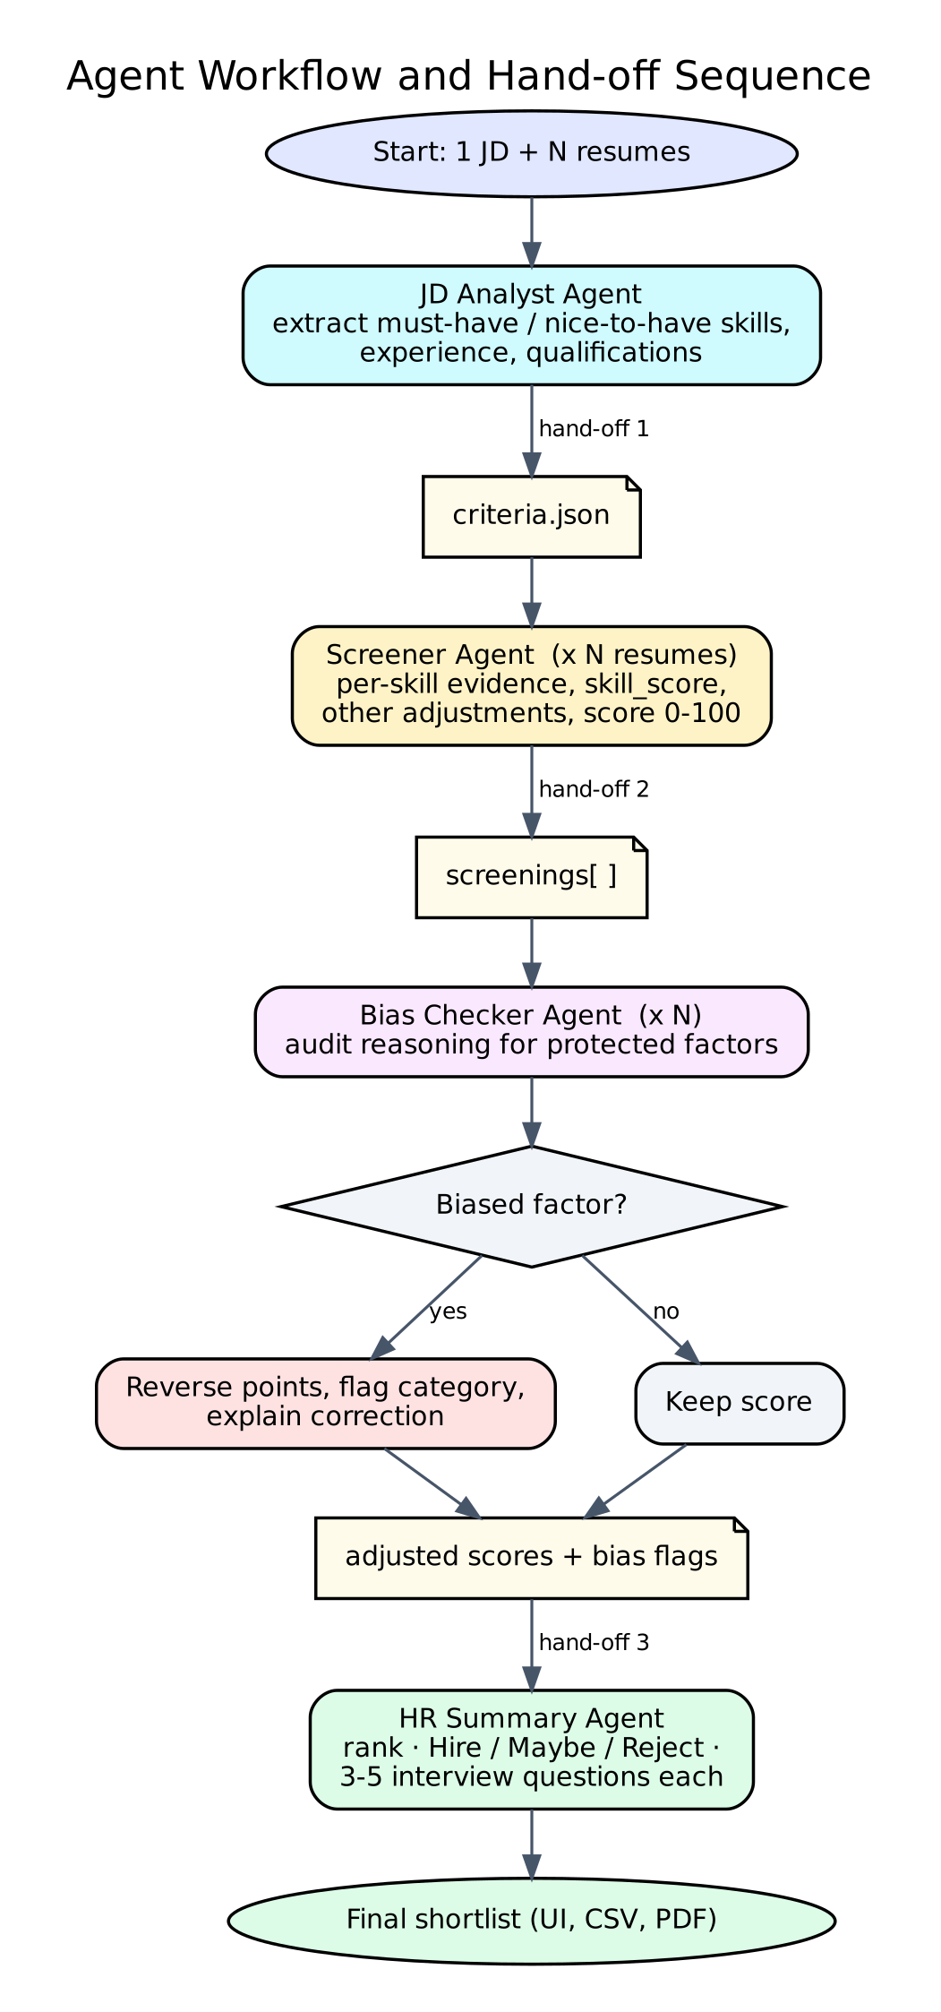
Fig 2: Agent workflow and hand-off sequence

3.4 Data flow
- The user uploads files; utils/parser.py extracts plain text from PDF (pypdf) or TXT.
- The orchestrator wraps each task's input as JSON between <<<INPUT_JSON markers and sends it to an agent through a one-agent CrewAI Crew.
- Each agent must reply with JSON only. extract_json() reads the reply (even if wrapped in code fences) and the orchestrator retries once if the JSON is invalid.
- The criteria JSON goes to the Screener; screening JSON goes to the Bias Checker; corrected scores and skill evidence go to the HR Summary Agent.
- The final result is shown in the UI, saved to outputs/ and exported as CSV / PDF / JSON. Every step is written to logs/run_log.txt.

3.5 Scoring model
Table 4: Scoring and recommendation rules
Component | Weight | Rule
Must-have skills | 70 | 70 x (matched must-have skills / total must-have skills)
Nice-to-have skills | 20 | 20 x (matched nice-to-have skills / total)
Relevant experience | 10 | 10 if the candidate has 6+ months of experience, otherwise 6
Other adjustments | +/- | Anything else the Screener noted; audited by the Bias Checker
Recommendation | - | Hire >= 75, Maybe 55-74, Reject < 55 (bias-corrected score)

3.6 Key design decisions
- One Crew per stage: running each agent as its own Crew lets the orchestrator log every hand-off and update the UI live, while CrewAI still builds the prompts and runs the agents.
- JSON contracts: fixed schemas between agents make outputs testable and easy to display.
- Screener lists its adjustments openly: instead of hiding gut-feel judgements inside one number, the Screener must list them, so the Bias Checker can audit each one.
- Demo mode: a CrewAI BaseLLM subclass answers with each agent's offline engine when no API key is present, so the same code path runs for tests, evaluation and recordings.
- Secrets in .env: the Groq key is read from .env (ignored by Git) and never hard-coded.

4. Development Details

4.1 Technology stack
Table 5: Technology stack
Layer | Technology | Purpose
Language | Python 3.10+ | All code
Multi-agent framework | CrewAI 1.15 | Agents, tasks, crews
LLM | Groq API - Llama 3.3 70B (via OpenAI-compatible endpoint) | Live reasoning
Web UI | Streamlit 1.66 | Upload, live status, results, downloads
Documents | pypdf, reportlab | Read PDF resumes; export PDF results
Data | pandas | Results tables and CSV export
Terminal output | rich | Coloured, timestamped agent logs
Testing | pytest | 15 unit and end-to-end tests
Documentation | Playwright, Graphviz, python-docx, ffmpeg | Screenshots, demo video, diagrams, this report
Version control | Git + GitHub | Source code hosting

4.2 Folder structure
resume-screening-panel/
|-- agents/ one file per agent
| |-- jd_analyst.py Agent 1: JD Analyst Agent
| |-- screener.py Agent 2: Screener Agent
| |-- bias_checker.py Agent 3: Bias Checker Agent
| `-- hr_summary.py Agent 4: HR Summary Agent
|-- tasks/prompts.py task descriptions and JSON contracts
|-- utils/
| |-- llm.py Groq LLM / offline DemoLLM factory
| |-- logger.py timestamped hand-off logger
| |-- parser.py PDF/TXT reading, JSON extraction
| |-- skills.py skill synonyms and evidence finder
| `-- exporter.py CSV and PDF export
|-- orchestrator.py runs the four agents in sequence
|-- app.py Streamlit web UI
|-- main.py command-line runner
|-- config.py settings from .env
|-- sample_data/ 1 JD + 6 fictional resumes (TXT and PDF)
|-- tests/ pytest test suite
|-- scripts/ screenshots, video, diagrams, report
|-- docs/ report, screenshots, diagrams, demo video
|-- logs/run_log.txt agent hand-off log (created at run time)
|-- requirements.txt .env.example .gitignore README.md

4.3 Key code

Agent definition (agents/bias_checker.py)
Every agent file defines the CrewAI agent's role, goal and backstory, plus an offline engine with the same JSON output used in demo mode.
NAME = "Bias Checker Agent"
ROLE = "Bias Checker Agent"
GOAL = (
"Audit every screening decision for bias based on name, gender, age, "
"religion, college prestige, location / national origin, marital status "
"or employment gaps, and correct the score so it reflects job fit only."
)
BACKSTORY = (
"You are a fair-hiring and diversity compliance officer. You know that "
"career breaks (e.g. maternity), age, marital status, origin and college "
"brand do not predict job performance. You leave legitimate skill-based "
"reasoning untouched and only reverse unfair adjustments."
)

# Protected / job-irrelevant categories and the words that reveal them
PROTECTED = {
"Employment gap": r"career break|employment gap|gap\b|maternity|sabbatical|skill decay",
"Age": r"\bage\b|years old|\bis \d{2}\b|junior team|too old|young",
"College prestige": r"college|institute|tier|university brand",
"Marital status": r"married|marital|spouse|family commitments",
"Location / national origin": r"overseas|abroad|foreign|nationality|relocation|origin",
"Gender": r"\bgender\b|\bfemale\b|\bmale\b|\bwoman\b|pregnan",
"Religion": r"religion|religious|caste",
"Name": r"\bname\b|sounding",
}

Task with JSON contract (tasks/prompts.py)
def bias_task(agent, candidate: str, resume: str, screening: dict) -> Task:
return Task(
agent=agent,
description=(
"Audit the Screener Agent's decision below for bias.\n"
"Flag any adjustment or reasoning based on: name, gender, age, religion, college "
"prestige (positive OR negative), location / national origin, marital status, or "
"employment gaps (including maternity/parental leave).\n"
"For each flag, reverse its points. adjusted_score = skill_score + the points of the "
"adjustments that are NOT biased (0-100). Skill-based reasoning must stay unchanged.\n\n"
+ _wrap({"candidate": candidate, "resume": resume, "screening": screening})
),
expected_output=(
"ONLY a JSON object with keys: candidate, original_score (int), adjusted_score (int), "
"bias_found (bool), bias_flags (list of {category, evidence, points_reversed, "
"explanation}), verdict (string)."
),
)

def summary_task(agent, criteria: dict, candidates: list[dict]) -> Task:

Orchestrator: running an agent and logging the hand-off (orchestrator.py)
def _kickoff(self, agent_name: str, task) -> dict | list:
"""Run one agent on one task and return its parsed JSON answer."""
crew = Crew(agents=[self.agents[agent_name]], tasks=[task],
process=Process.sequential, verbose=config.CREW_VERBOSE)
last_error = None
for attempt in range(2): # one retry if JSON is malformed
try:
return extract_json(crew.kickoff().raw)
except ValueError as err:
last_error = err
self.logger.warn(agent_name, f"invalid JSON (attempt {attempt + 1}), retrying")
raise RuntimeError(f"{agent_name} did not return valid JSON: {last_error}")

# 1. JD Analyst Agent --------------------------------------------------
t0 = self._stage(jd_analyst.NAME, "extracting hiring criteria")
criteria = self._kickoff(jd_analyst.NAME,
prompts.jd_task(self.agents[jd_analyst.NAME], job_description))
timings[jd_analyst.NAME] = self._finish(
jd_analyst.NAME, t0,
f"{len(criteria.get('must_have_skills', []))} must-have, "
f"{len(criteria.get('nice_to_have_skills', []))} nice-to-have skills",
screener.NAME)

# 2. Screener Agent ----------------------------------------------------
t0 = self._stage(screener.NAME, f"scoring {len(resumes)} resumes")
screenings = []
for i, (name, text) in enumerate(resumes, start=1):
self.on_status(screener.NAME, "running", f"scoring {name} ({i}/{len(resumes)})")
result = self._kickoff(screener.NAME, prompts.screen_task(
self.agents[screener.NAME], criteria, name, text))
result["candidate"] = name
screenings.append(result)
log.info(screener.NAME, f"scored {name}: {result.get('score')}/100")

Model selection: live Groq model or offline demo engine (utils/llm.py)
def get_llm():
if config.DEMO_MODE:
return DemoLLM(model="demo-offline-engine")
return LLM(
model=f"openai/{config.GROQ_MODEL}",
base_url=config.GROQ_BASE_URL,
api_key=config.GROQ_API_KEY,
temperature=0.1,
)

Bias audit logic used by the offline engine (agents/bias_checker.py)
def demo_respond(payload: dict) -> dict:
screening, resume = payload["screening"], payload["resume"]
flags, kept = [], []
for adj in screening.get("adjustments", []):
category = classify(adj["reason"])
if category:
note = ""
if category == "Employment gap" and re.search(r"maternity", resume, re.I):
note = " The break was for maternity leave, which is legally protected."
flags.append({
"category": category,
"evidence": adj["reason"],
"points_reversed": -adj["points"],
"explanation": f"'{adj['reason']}' is not related to the job requirements, "
f"so its {adj['points']:+d} point effect is removed.{note}",
})
else:
kept.append(adj)

original = screening["score"]
adjusted = max(0, min(100, screening["skill_score"] + sum(a["points"] for a in kept)))
return {

4.4 User interface and execution
The Streamlit app is started with streamlit run app.py. The screenshots below were captured automatically with Playwright during a real run on the sample data.
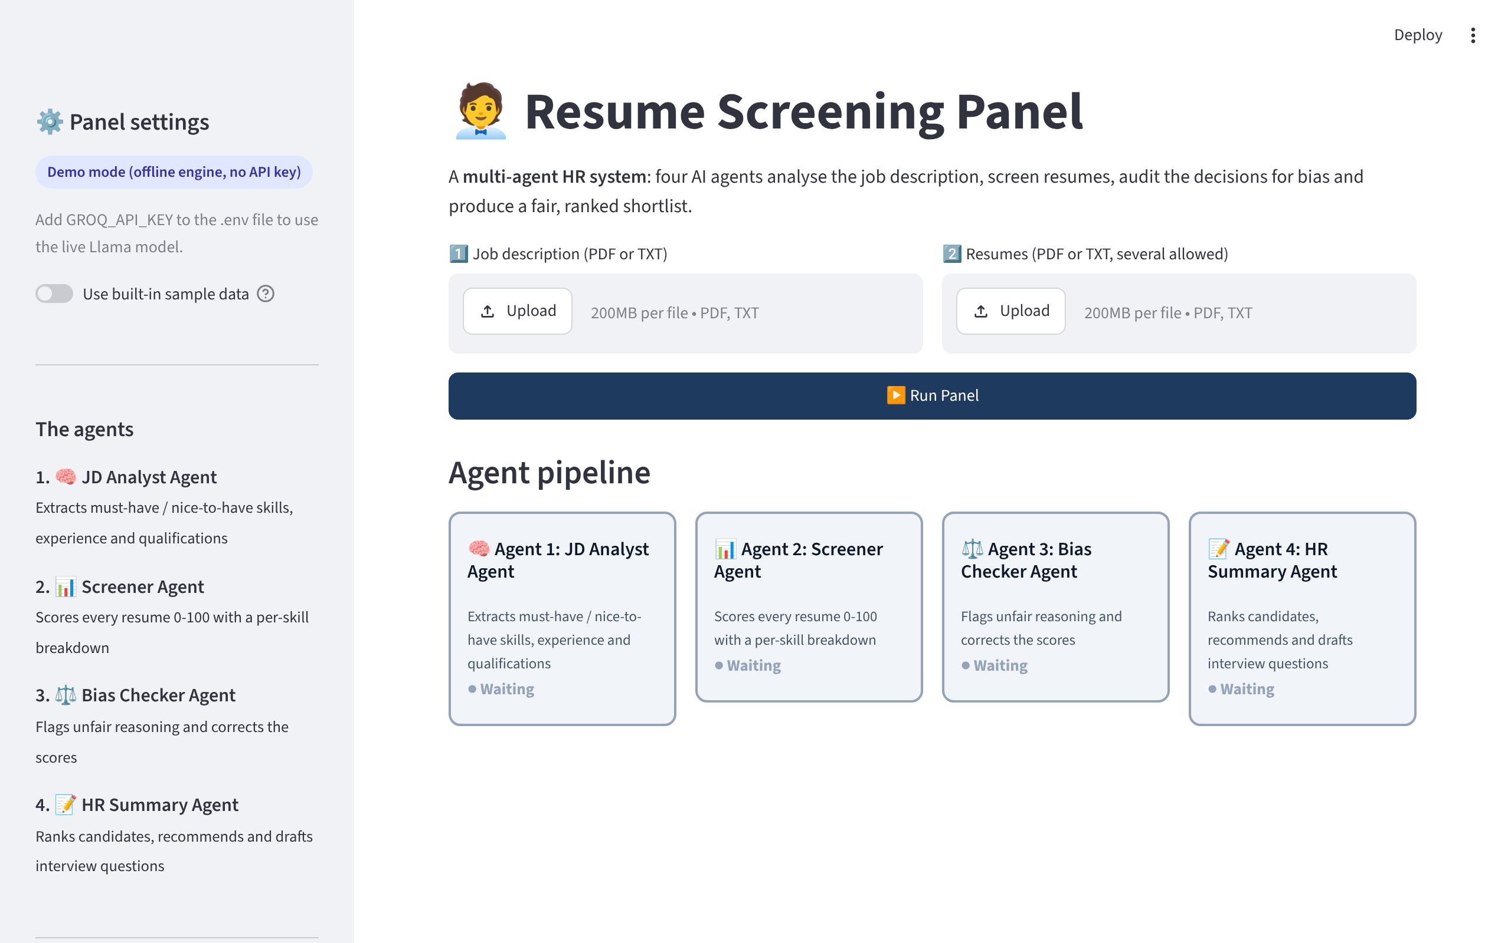
Fig 3: Home screen with upload areas and the four agent cards
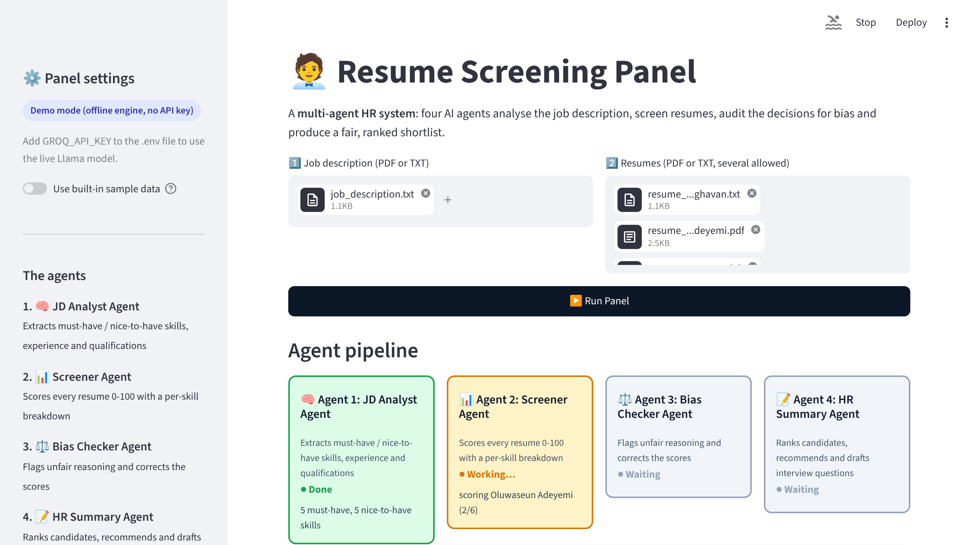
Fig 4: Live status during a run: JD Analyst done, Screener Agent working on resume 2 of 6
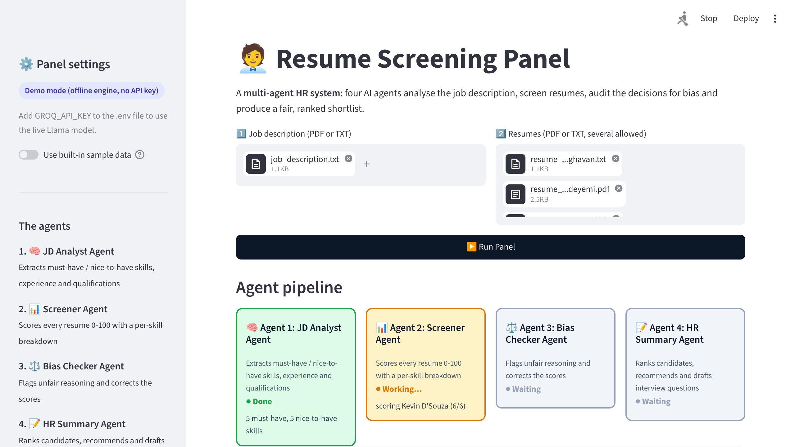
Fig 5: Live status: Bias Checker Agent auditing decisions
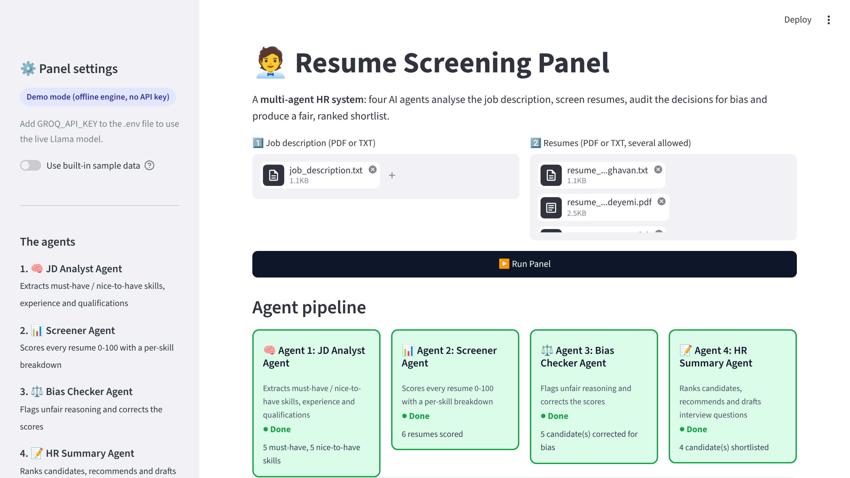
Fig 6: All four agents completed
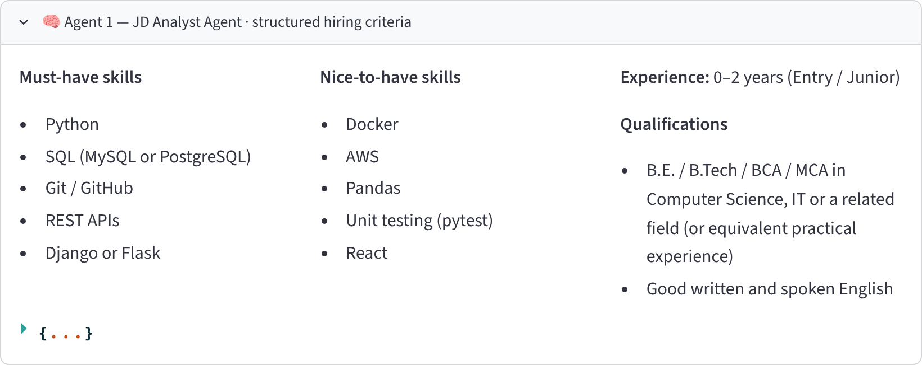
Fig 7: Agent 1 output: structured hiring criteria
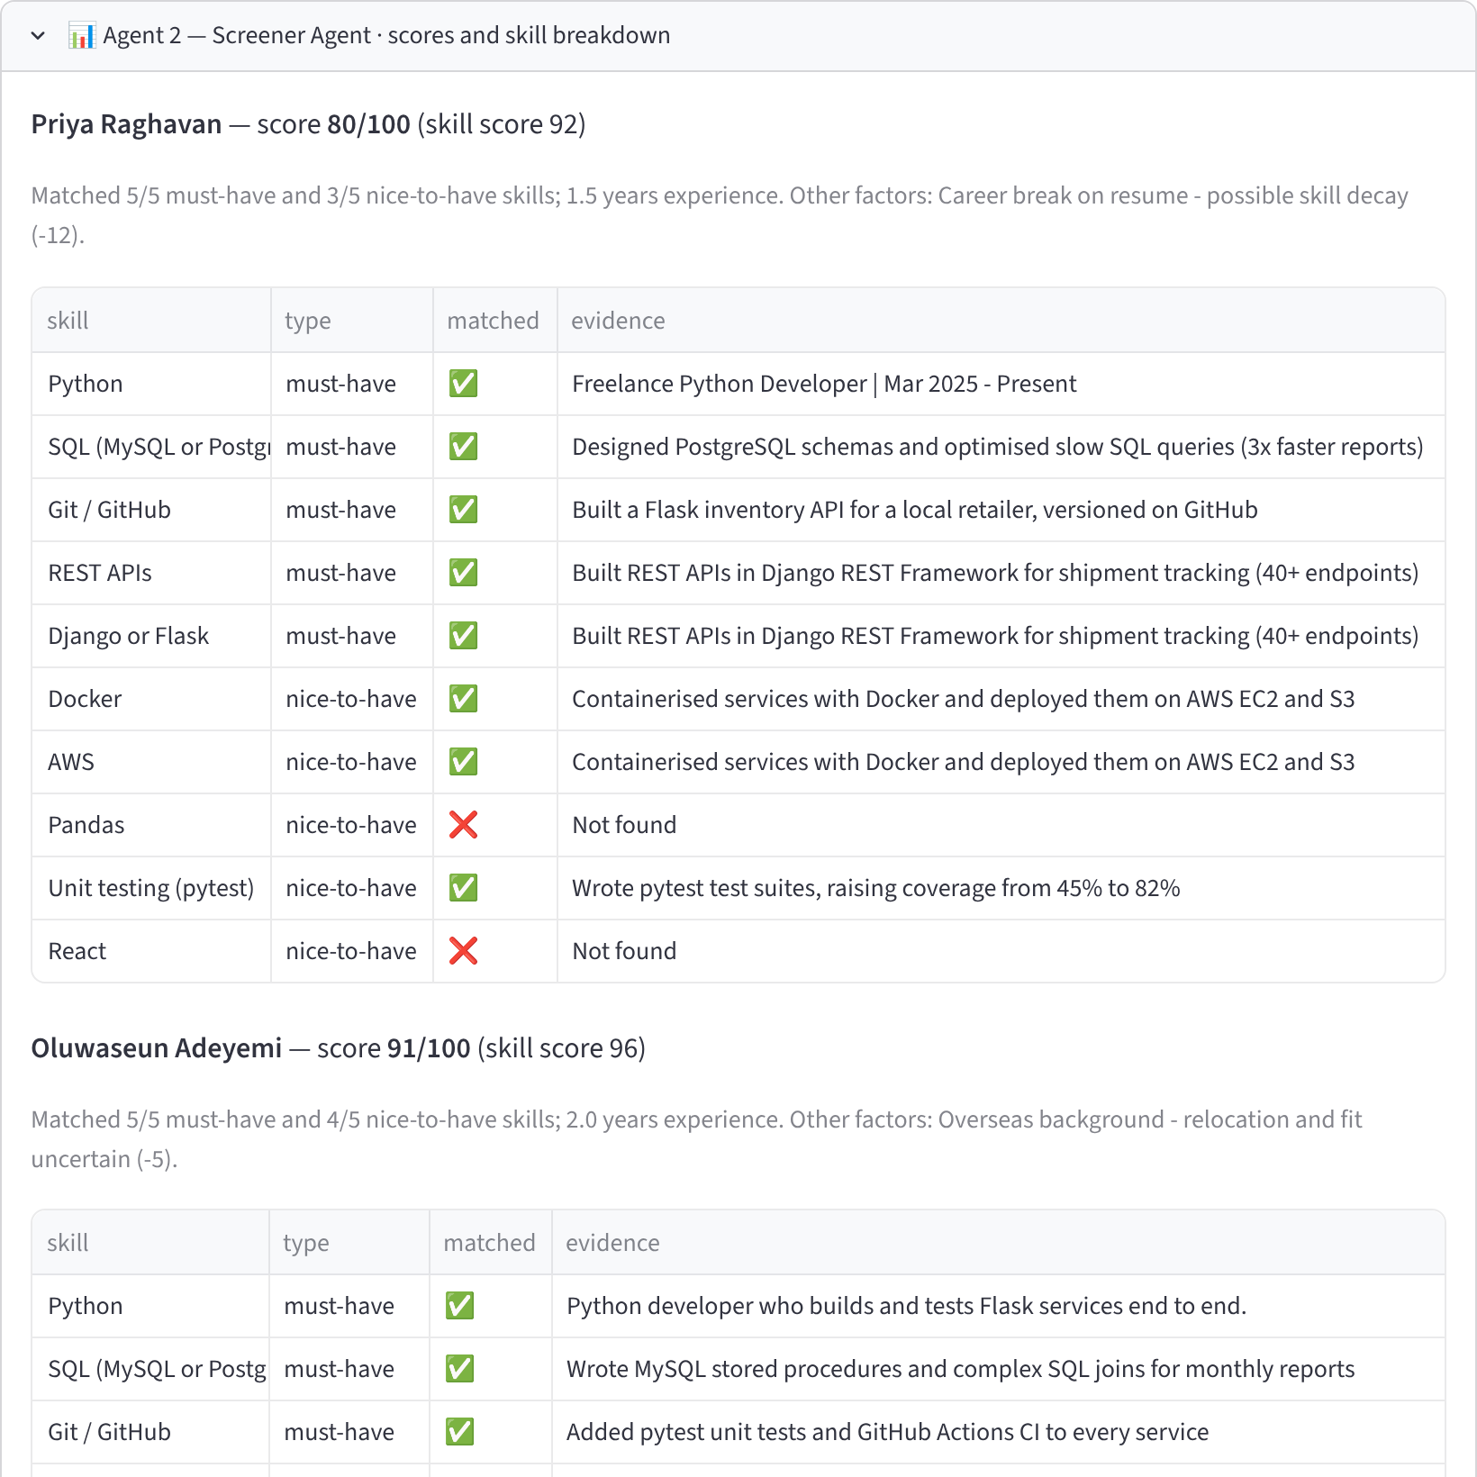
Fig 8: Agent 2 output: score and per-skill evidence table (first candidates shown)
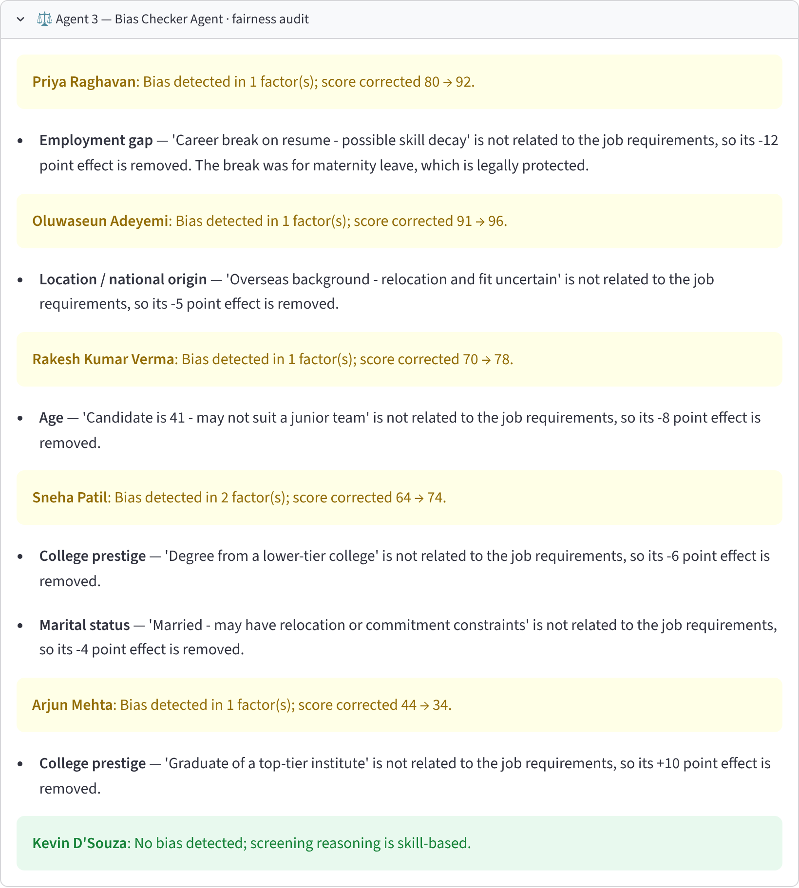
Fig 9: Agent 3 output: bias flags and corrected scores
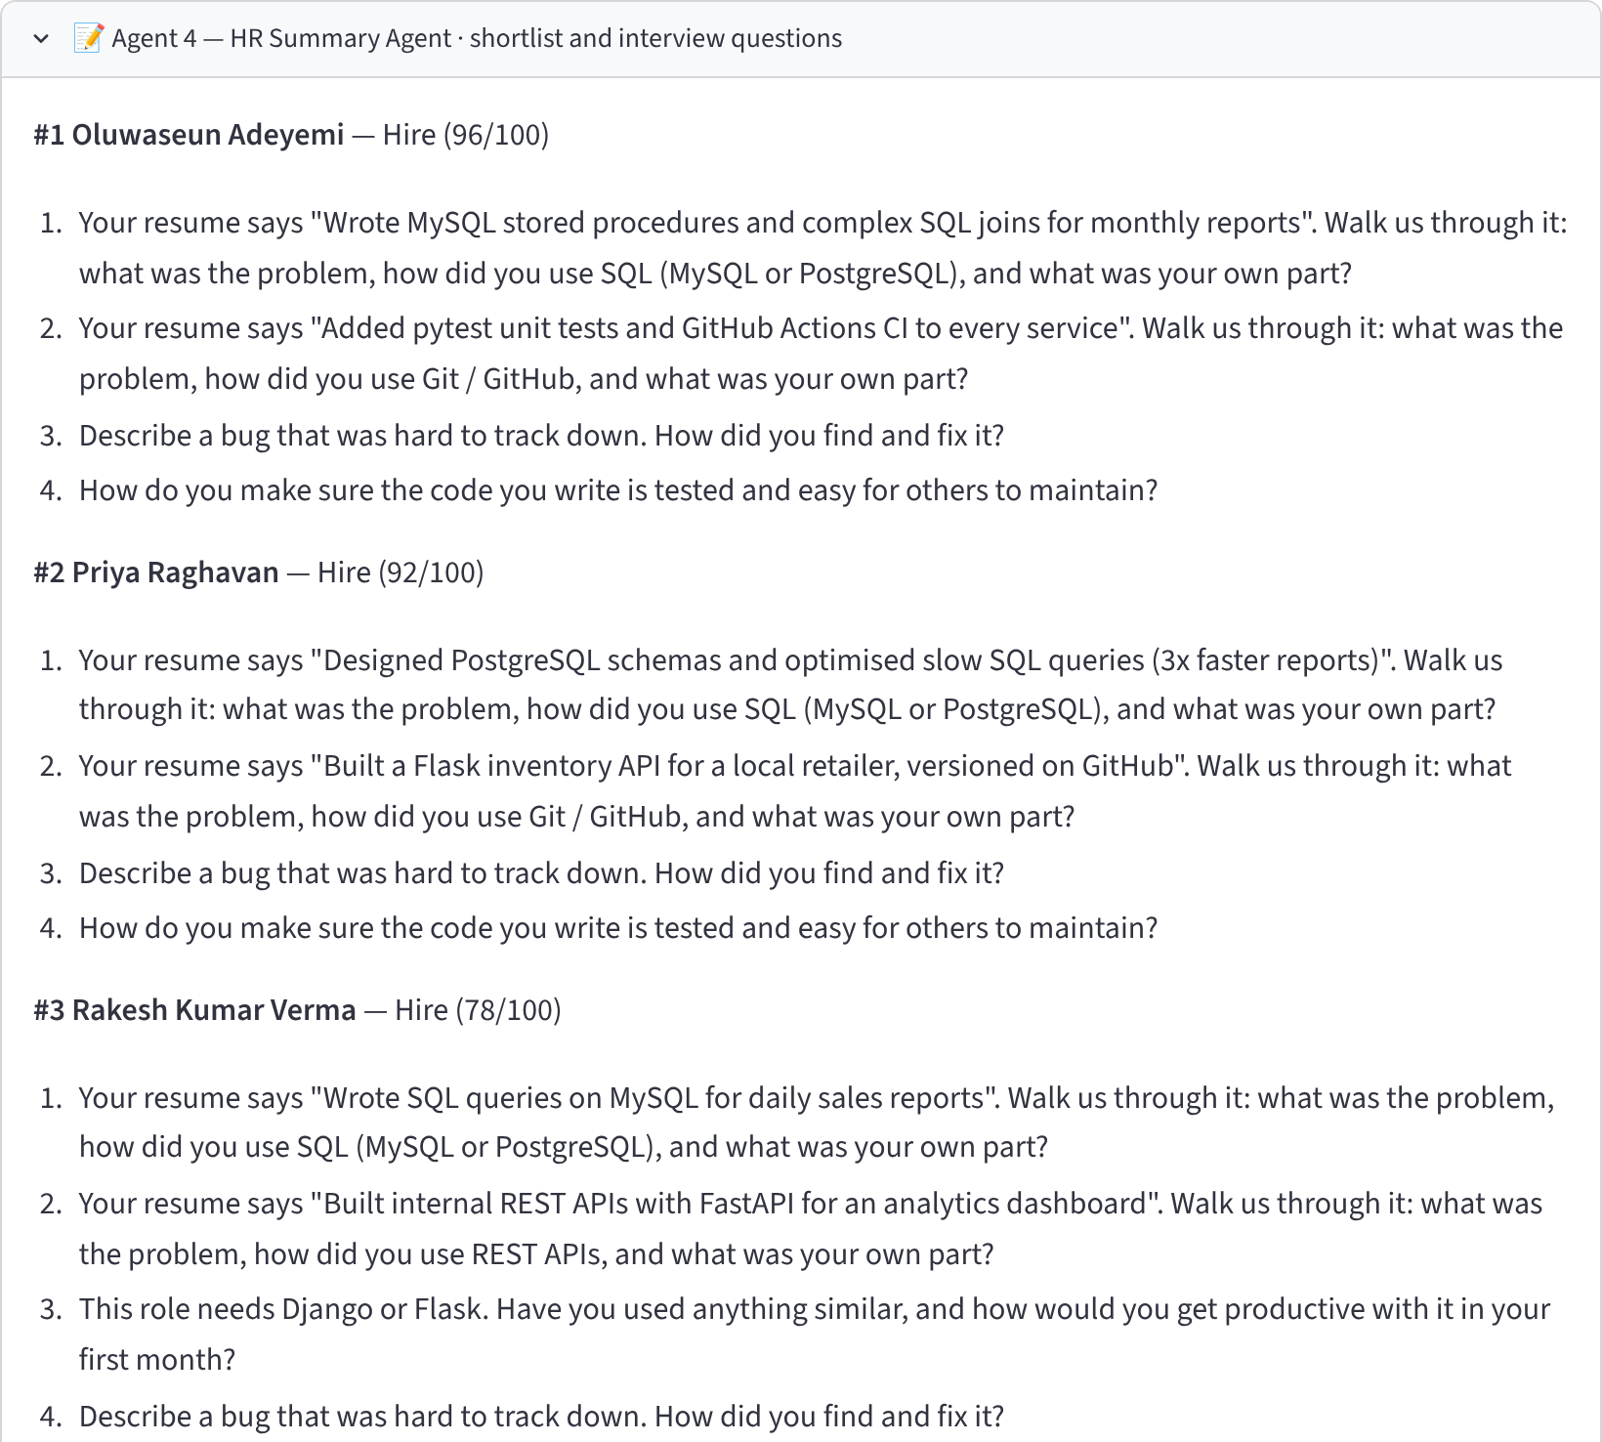
Fig 10: Agent 4 output: recommendations and tailored interview questions
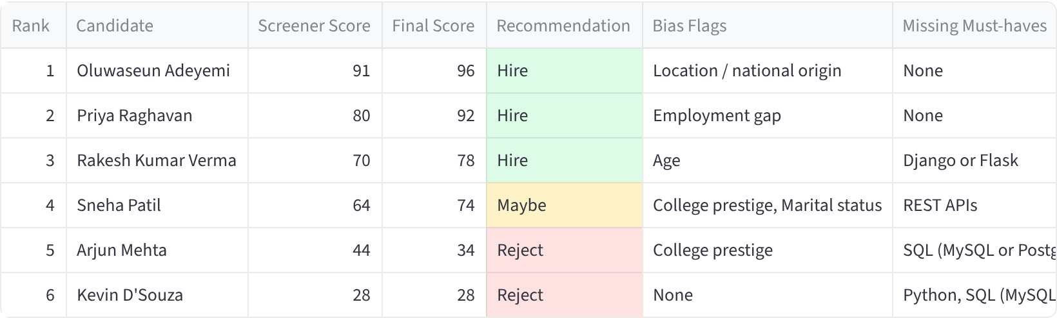
Fig 11: Final ranked shortlist with downloads

Command-line execution
The same pipeline runs from the terminal with python main.py. Figure 12 is a recording of that run made with the rich library.
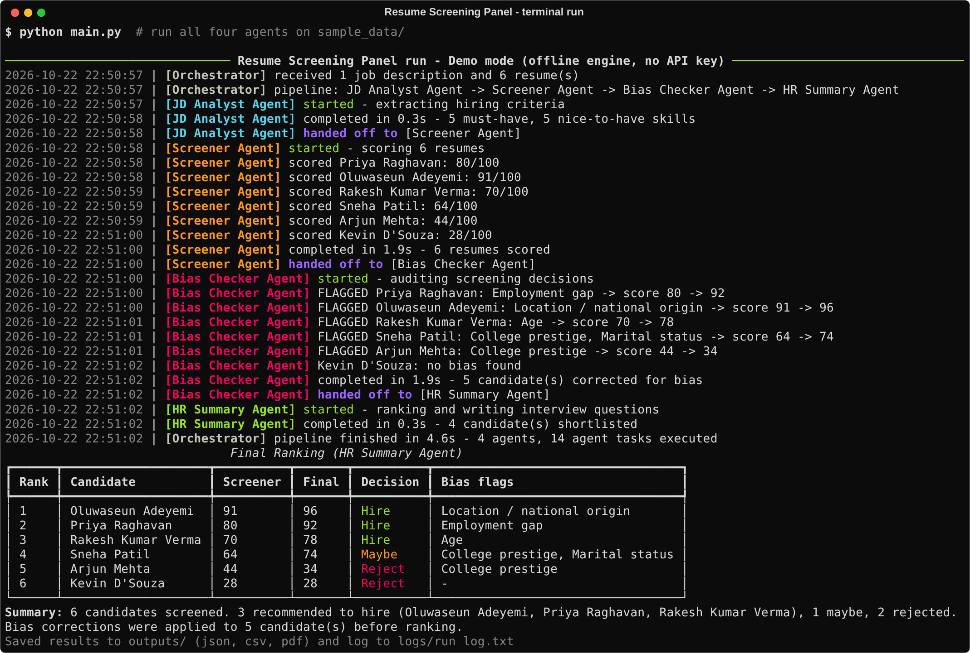
Fig 12: Terminal run showing each agent starting, finishing and handing off

4.5 Testing
The project has 15 automated tests written with pytest (run with python -m pytest). They always use demo mode, so they never call a paid API. The tests check document parsing, the JSON format of each agent, and a complete end-to-end run of all four agents through CrewAI on the sample data, including that every bias trap is caught and that the hand-offs happen in the right order.
Table 6: Automated test results (15 passed)
Test file | Test | Result
test_agents | jd analyst schema | PASSED
test_agents | screener schema and range | PASSED
test_agents | bias checker reverses maternity gap | PASSED
test_agents | bias checker leaves clean screening alone | PASSED
test_agents | hr summary schema and thresholds | PASSED
test_parser | reads txt | PASSED
test_parser | reads pdf | PASSED
test_parser | sample pdf resume is readable | PASSED
test_parser | extract json from fenced block | PASSED
test_parser | extract json with surrounding text | PASSED
test_parser | extract json raises on garbage | PASSED
test_parser | skill aliases and evidence | PASSED
test_pipeline | all candidates ranked | PASSED
test_pipeline | bias traps are caught | PASSED
test_pipeline | every agent ran in order | PASSED

5. Deployment Architecture

5.1 Deployment diagram
The application runs as a single Streamlit service, either on a local machine or on Streamlit Community Cloud. Inside the service, the orchestrator runs four independent CrewAI agents in sequence. In live mode each agent sends its prompt to the Groq Cloud LLM API over HTTPS; the API key is read from a secrets store (.env locally, st.secrets in the cloud).
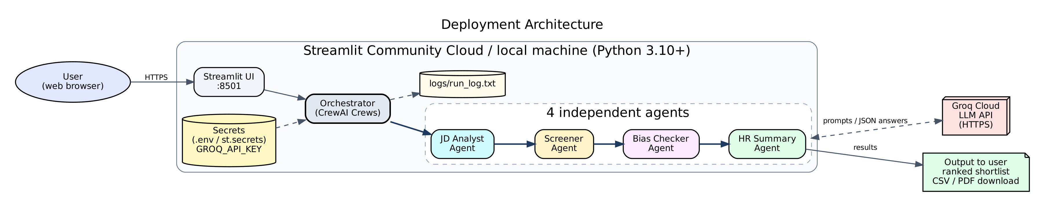
Fig 13: Deployment architecture

5.2 Proof of multiple agents
Three independent pieces of evidence show that four separate agents run and hand work to each other:
- Hand-off log: logs/run_log.txt records a timestamped 'started', 'completed' and 'handed off to' line for every agent (Figure 14 and the excerpt below).
- Live status cards: the UI highlights the agent that is currently working and what it is doing (Figures 4 and 5).
- Per-agent outputs: each agent's JSON result is shown in its own labelled section (Figures 7-10) and saved in outputs/results.json.
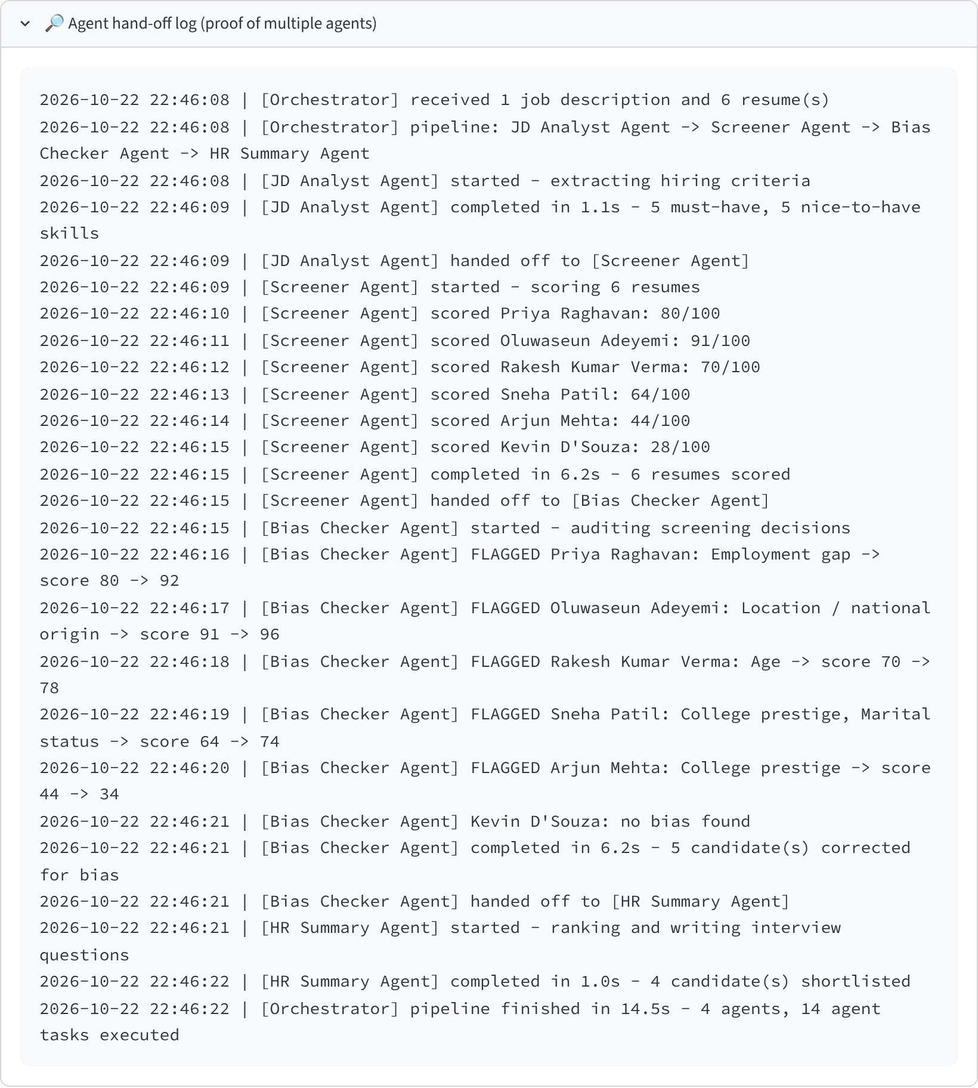
Fig 14: Agent hand-off log shown in the app
2026-10-22 22:53:38 | [JD Analyst Agent] started - extracting hiring criteria
2026-10-22 22:53:39 | [JD Analyst Agent] handed off to [Screener Agent]
2026-10-22 22:53:39 | [Screener Agent] started - scoring 6 resumes
2026-10-22 22:53:39 | [Screener Agent] handed off to [Bias Checker Agent]
2026-10-22 22:53:39 | [Bias Checker Agent] started - auditing screening decisions
2026-10-22 22:53:39 | [Bias Checker Agent] handed off to [HR Summary Agent]
2026-10-22 22:53:39 | [HR Summary Agent] started - ranking and writing interview questions
2026-10-22 22:53:39 | [Orchestrator] pipeline finished in 0.3s - 4 agents, 14 agent tasks executed
Listing: excerpt of logs/run_log.txt

5.3 Running locally
git clone https://github.com/<your-username>/resume-screening-panel.git
cd resume-screening-panel
python -m venv .venv
.venv\Scripts\activate # Windows (macOS/Linux: source .venv/bin/activate)
pip install -r requirements.txt
copy .env.example .env # then put GROQ_API_KEY=gsk_... in .env
python -m pytest # run the tests
python main.py # command-line run on sample data
streamlit run app.py # web app at http://localhost:8501

5.4 Deploying on Streamlit Community Cloud
- Push the repository to GitHub (the .env file is excluded by .gitignore).
- Sign in at share.streamlit.io with GitHub and click 'Create app'.
- Select the repository, branch main and main file app.py.
- Under 'Advanced settings' -> 'Secrets', add GROQ_API_KEY = "gsk_..." (config.py also reads environment variables, which Streamlit fills from secrets).
- Click Deploy. The app receives a public URL that can be shared with evaluators.

5.5 Security and privacy
- API keys are never hard-coded; .env is listed in .gitignore and .env.example has no key.
- Resumes are processed in memory and are not stored by the app (only results and logs).
- All sample resumes describe fictional people with example.com email addresses.
- The system supports a human recruiter; it does not make final hiring decisions on its own.

6. Results and Discussion

6.1 Sample run
The panel was run on the sample data: a Junior Python Developer job description and six fictional resumes (two strong, two average and two weak), three in TXT and three in PDF format. Several resumes deliberately contain bias traps. The run shown here used demo mode, in which each agent's answer comes from its offline engine; with a Groq key the same pipeline uses Llama 3.3 70B and the exact numbers will vary between runs.
Table 7: Final ranking produced by the HR Summary Agent
Rank | Candidate | Screener score | Final score | Decision | Bias flags
1 | Oluwaseun Adeyemi | 91 | 96 | Hire | Location / national origin
2 | Priya Raghavan | 80 | 92 | Hire | Employment gap
3 | Rakesh Kumar Verma | 70 | 78 | Hire | Age
4 | Sneha Patil | 64 | 74 | Maybe | College prestige, Marital status
5 | Arjun Mehta | 44 | 34 | Reject | College prestige
6 | Kevin D'Souza | 28 | 28 | Reject | None

6.2 Bias cases caught
Table 8: Bias traps and how the Bias Checker handled them
Candidate | Bias trap in resume | Flag raised (screener points) | Score change
Priya Raghavan | Career break for maternity leave | Employment gap (-12) | 80 -> 92
Oluwaseun Adeyemi | Overseas background / foreign-sounding name | Location / national origin (-5) | 91 -> 96
Rakesh Kumar Verma | Age stated on resume (41) | Age (-8) | 70 -> 78
Sneha Patil | Tier-3 college and marital status stated | College prestige (-6); Marital status (-4) | 64 -> 74
Arjun Mehta | Tier-1 'premier institute' (positive halo bias) | College prestige (+10) | 44 -> 34
Kevin D'Souza | None (control candidate) | No flag (correct) | 28 -> 28

6.3 Discussion
- All five bias traps were caught and the control candidate was correctly left unchanged.
- Bias correction changed a decision: Rakesh Kumar Verma's score rose from 70 to 78 once the age penalty was removed, moving him from Maybe to Hire.
- Bias works in both directions: Arjun Mehta's top-tier college had added 10 points that his skills did not justify. The Bias Checker removed this halo effect (44 -> 34).
- Explainability: every score is backed by a per-skill evidence table, and interview questions quote the candidate's own resume lines and probe their missing must-have skills.
- Speed: the complete 14-task pipeline finishes in a few seconds in demo mode; in live mode speed depends on the Groq API (typically well under a minute for six resumes).

6.4 Limitations
- The offline demo engine uses keyword matching and rules; it is a stand-in for the LLM, not a replacement, and cannot understand skills described in unusual words.
- Live LLM output can vary between runs; the orchestrator re-orders the ranking and applies the recommendation thresholds itself to keep the results consistent.
- Only text-based PDFs are supported (no OCR for scanned resumes).
- The sample data is small and synthetic; a real evaluation would need many real, anonymised resumes and comparison with expert recruiters.

7. Conclusion and Future Scope

7.1 Conclusion
This project built a working multi-agent HR system with CrewAI in which four specialised agents analyse a job description, screen resumes, audit the screening for bias and produce a ranked, explainable shortlist. Dividing the work between agents made each step simpler, testable and visible, and adding a dedicated reviewer agent made it possible to catch and correct unfair reasoning that a single model would hide inside one score. The system is packaged with a web UI, a command-line runner, automated tests, timestamped hand-off logs and a deployment guide.

7.2 Future scope
- Run the per-resume Screener and Bias Checker tasks in parallel for large applicant pools.
- Add OCR (for example Tesseract) to support scanned resumes.
- Add a fifth 'Skill Verifier' agent that checks GitHub or portfolio links.
- Blind screening: hide names, photos and personal details before the Screener sees the resume.
- Connect to an applicant tracking system or Google Drive to fetch resumes automatically.
- Measure fairness over many real runs (for example, score differences between groups).

8. Demo and Repository Links
Google Drive Demo Link: [PASTE LINK HERE]
GitHub Repository: https://github.com/[your-username]/resume-screening-panel
The demo video (docs/demo/demo.mp4, about 2 minutes) shows the six sample resumes being uploaded, the four agents working in sequence with live status, each agent's output, the final ranked shortlist and the hand-off log.

References
- CrewAI documentation - https://docs.crewai.com
- Groq API documentation - https://console.groq.com/docs
- Meta Llama 3.3 model card - https://www.llama.com
- Streamlit documentation - https://docs.streamlit.io
- Microsoft AutoGen - https://microsoft.github.io/autogen
- LangGraph documentation - https://langchain-ai.github.io/langgraph
- Wooldridge, M. (2009). An Introduction to MultiAgent Systems (2nd ed.). Wiley.
- Bertrand, M. and Mullainathan, S. (2004). Are Emily and Greg More Employable than Lakisha and Jamal? A Field Experiment on Labor Market Discrimination. American Economic Review, 94(4), 991-1013.
- Raghavan, M., Barocas, S., Kleinberg, J. and Levy, K. (2020). Mitigating Bias in Algorithmic Hiring: Evaluating Claims and Practices. Proceedings of ACM FAT* 2020.

