B.M.S. COLLEGE OF ENGINEERING
(Autonomous Institute, Affiliated to VTU)
Bull Temple Road, Basavanagudi, Bengaluru - 560019

Presentation Report under Alternate Assessment Tool (AAT)
ReliCast: NACK-Suppressed Reliable Multicast for LAN Content Distribution with SNTP-Synchronised Measurement
Course: 23CS7PCNWP - Network Programming
Submitted in partial fulfilment of the requirements for the award of degree
BACHELOR OF ENGINEERING
IN
COMPUTER SCIENCE AND ENGINEERING
By
NAME 1 | USN 1
NAME 2 | USN 2
NAME 3 | USN 3
NAME 4 | USN 4
Under the guidance of
Dr. Anitha H M
Associate Professor
Department of Computer Science and Engineering
2026-2027

B.M.S. COLLEGE OF ENGINEERING
( Autonomous Institute, Affiliated to VTU )
Bull Temple Road, Basavanagudi,
Bengaluru – 560019
Department of Computer Science and Engineering
C E R T I F I C A T E
This is to certify that the Presentation Report under Alternate Assessment Tool entitled “*ReliCast: NACK-Suppressed Reliable Multicast for LAN Content Distribution with SNTP-Synchronised Measurement” is a bona-fide work carried out by NAME 1 (USN 1), NAME 2 (USN 2), NAME 3 (USN 3), NAME 4 (USN 4)* in partial fulfilment for the award of degree of Bachelor of Engineering in Computer Science and Engineering from Visvesvaraya Technological University, Belagavi during the year 2026-2027. It is certified that all corrections/suggestions indicated for Internal Assessments have been incorporated in the report deposited in the departmental library. The Presentation Report has been approved as it satisfies the academic requirements in respect of AAT prescribed for the Bachelor of Engineering Degree.

Dr. Anitha H M | Dr. Shubha Rao V
Course Coordinator | Professor and HOD

TABLE OF CONTENTS
1. ABSTRACT 1
2. OBJECTIVES 2
3. INTRODUCTION 3
3.1 Network programming and the application 3
3.2 TCP, UDP and multicast 3
3.3 System calls and socket options 3
3.4 Clock synchronisation with SNTP 4
3.5 Tools and environment 4
4. LITERATURE REVIEW 5
4.1 SRM: Scalable Reliable Multicast (Floyd et al., 1997) 5
4.2 NORM: NACK-Oriented Reliable Multicast (RFC 5740, 2009) 5
4.3 Comparison 6
5. RESEARCH GAP 7
6. PROBLEM STATEMENT 8
7. METHODOLOGY AND IMPLEMENTATION 9
7.1 Proposed architecture 9
7.2 Network communication model 9
7.3 Mathematical model 10
7.4 Proposed algorithm 12
7.5 Socket programming implementation 13
7.6 Real-world mode, discovery and fallback 13
8. PERFORMANCE EVALUATION 15
8.1 Experimental setup 15
8.2 Performance metrics 16
9. OUTPUT AND RESULTS 17
9.1 Console output 17
9.2 Comparative analysis 18
9.3 Validation of the proposed approach 20
9.4 Real-world validation 20
9.5 Observations: delay, jitter and throughput 21
10. CONCLUSION 22
11. REFERENCES 23

1. ABSTRACT
Distributing one file to many hosts on a local network is usually done with N separate TCP transfers, which makes the sender transmit N copies, or with raw UDP multicast, which is cheap but silently loses data. This work presents ReliCast, a Python socket-level tool that sends one multicast copy and recovers losses with receiver-driven negative acknowledgements. As in SRM and NORM, receivers delay NACKs by a random timer in [0, W) and cancel them when another receiver asks for the same data, and the sender aggregates repairs. A TCP channel carries control data, and an SNTP client and server (RFC 4330) synchronise clocks so one-way delay and jitter are measurable. A real-file mode adds broadcast discovery and a TCP fallback for receivers that cannot hear multicast. Four modes were compared for up to 16 receivers and up to 20% loss. With 16 receivers ReliCast needed 0.39 s against 2.28 s for TCP, with an overhead ratio of 1.72x against 18.30x, and every ReliCast transfer was verified with SHA-256. At the demonstration point it sent 130 NACKs where the naive scheme sent 322, and SNTP recovered injected clock skews of up to 360 ms to within 0.42 ms.
Keywords: reliable multicast, NACK suppression, SRM, NORM, SNTP, socket programming, UDP, one-way delay.

2. OBJECTIVES
The assessment aimed to apply the Network Programming syllabus to one realistic problem, delivering a file to many receivers on a LAN, and to evaluate the result quantitatively. The specific objectives were:
1. To understand and use the BSD socket API (socket, bind, listen, accept, connect, sendto, recvfrom, setsockopt, select) for both stream and datagram communication.
2. To implement a TCP control channel for session metadata and final statistics, and a UDP multicast data path using IP_ADD_MEMBERSHIP, TTL scoping and the related socket options.
3. To study the two reference designs for scalable reliable multicast, SRM and NORM, and extract the mechanisms (randomised NACK timers, suppression, repair aggregation) that avoid ACK/NACK implosion.
4. To implement a NACK-oriented reliable multicast protocol (ReliCast) with an adaptive suppression window and verify every transfer end to end with SHA-256.
5. To implement SNTP (RFC 4330) client and server over UDP and use them to synchronise receiver clocks, so that one-way delay and jitter can be measured on real sockets.
6. To build comparable baselines (TCP unicast, raw UDP unicast, naive immediate-NACK multicast) and analyse duration, overhead ratio, delivery ratio, NACK and repair traffic, delay and jitter under varying receiver counts and loss rates.
7. To extend the system into a usable file-transfer tool for real devices (broadcast discovery, multicast reachability probe with automatic TCP fallback, SHA-256 verified saving), with a live web dashboard and a reproducible experiment harness.

3. INTRODUCTION

3.1 Network programming and the application
Network programming is the discipline of writing programs that communicate across a network through the operating system’s transport services. The application studied here is one-to-many content distribution on a local area network: a teacher pushes lecture slides, or an administrator pushes an update package, to every laptop in a laboratory. When the sender opens a separate TCP connection to each of N machines it must put N copies of the file on its uplink, so the transfer time grows linearly with N. IP multicast removes this cost by sending one copy that the network replicates to every member of a group address, but multicast uses UDP, which offers no retransmission, ordering or flow control. A practical tool therefore has to add reliability on top of multicast without recreating the scalability problem, which is exactly the design space of the two papers reviewed in Chapter 4.

3.2 TCP, UDP and multicast
TCP provides a reliable, ordered byte stream with connection set-up, acknowledgements, retransmission and congestion control. It is the right choice for small, important messages, and ReliCast uses it for the session metadata and the final per-receiver statistics. UDP is connectionless and preserves datagram boundaries; it adds only ports and a checksum to IP, so the application owns reliability, ordering and pacing. Unicast addresses one host, broadcast addresses everybody on a subnet whether interested or not, and multicast (RFC 1112) addresses a group of interested hosts that join through IGMP. A sender transmits a single datagram to a class D address, here the administratively scoped range 239.0.0.0/8 (RFC 2365), and its TTL limits how far the datagram travels. The price of multicast is that the sender no longer has a per-receiver connection on which to learn about loss.

3.3 System calls and socket options
Every capability above is reached through system calls exposed by Python’s socket module. socket() creates an endpoint, bind() attaches it to an address and port, listen() and accept() implement the server side of TCP, and connect() the client side. For UDP, sendto() and recvfrom() carry individual datagrams. setsockopt() configures behaviour: SO_REUSEADDR and SO_REUSEPORT let several receiver processes share one multicast port on a host, SO_RCVBUF enlarges the kernel receive queue so bursts are not dropped, IP_MULTICAST_TTL, IP_MULTICAST_IF and IP_MULTICAST_LOOP control scope, interface and loopback delivery, IP_ADD_MEMBERSHIP joins a group, and SO_BROADCAST permits sending to the broadcast address. select() multiplexes several sockets and a timer in one thread, and struct.pack with the ‘!’ prefix produces network byte order headers. Section 7.5 maps each call to its use in ReliCast.

3.4 Clock synchronisation with SNTP
One-way delay cannot be measured between two machines whose clocks disagree, which is why most reliable-multicast evaluations report round-trip time or simulated time. The Simple Network Time Protocol (RFC 4330) estimates the offset between a client and a server clock from four timestamps carried in a 48-byte UDP packet. ReliCast embeds an SNTP server in the sender and an SNTP client in every receiver, so that data packets can carry sender timestamps in a common time base.

3.5 Tools and environment
The system is written in Python 3 using only the standard library (socket, select, struct, threading, hashlib, json, http.server), so it runs unchanged on Windows, macOS and Linux. Receivers are real operating-system processes. A single-file dashboard served by http.server visualises transfers live. Packet formats and counters were inspected in the manner of a Wireshark session, by decoding the 24-byte header, and the analysis scripts use matplotlib, python-docx and python-pptx to turn the experiment output into the figures and this report.

4. LITERATURE REVIEW
This project is anchored on two foundational works on scalable reliable multicast: the SRM framework of Floyd et al. [1] and the NORM transport protocol of Adamson et al. [2]. Together they define the two classic ways, receiver-side and sender-side, of keeping negative acknowledgements from overwhelming a multicast session. RFC 4330 [3] and RFC 1112 [4] serve only as supporting specifications.

4.1 SRM: Scalable Reliable Multicast (Floyd et al., 1997)
Problem. Sender-driven reliability does not scale to large multicast groups because every receiver’s acknowledgement lands on the sender (ACK implosion), and the sender must track the state of every receiver. The authors argue for recovery in the application, following application level framing (ALF). Mechanism. In SRM each data unit has a persistent name, and receivers detect loss from gaps in sequence numbers or from periodic session messages. A receiver that detects a loss schedules a repair request at a random time drawn uniformly from [C1·d, (C1+C2)·d], where d is its estimated distance to the source. If it hears a request for the same data before the timer fires, it suppresses its own and backs off exponentially. Any member holding the data may answer after a random timer proportional to its distance from the requester, and a heard repair cancels the other pending repairs. Timer parameters adapt to observed duplicates and delay, and TTL-scoped local recovery limits the reach of repairs. Results. Using ns-2 simulations on chain, star and bounded-degree tree topologies, and the wb shared whiteboard as a driving application, the paper shows that deterministic suppression works in chains, probabilistic suppression in stars, and that the adaptive timers keep both duplicates and delay low as session size grows. Limitations. Every request and repair is multicast to the whole group; the distance estimates require session-message exchange that itself grows with group size; the study is simulation based and gives no measured one-way delay on real hosts; and the timer constants must be tuned or adapted per topology. Relevance. ReliCast adopts SRM’s randomised request timers, suppression on overheard requests and exponential back-off, and replaces the distance term with an adaptive window computed from SNTP-synchronised delay and jitter.

4.2 NORM: NACK-Oriented Reliable Multicast (RFC 5740, 2009)
Problem. Bulk-data and streaming applications need a reliable one-to-many transport that works over multicast and scales to large groups without positive acknowledgements. Mechanism. NORM is a NACK-oriented protocol with a single logical sender per session. The sender transmits objects as numbered coding blocks and symbols, advertises its state with heartbeat-style flush commands, and keeps a running estimate of the group round-trip time (GRTT) from receiver responses. A receiver that finds missing data waits for a random back-off whose range is scaled by the advertised GRTT before sending its NACK, and cancels the NACK if it overhears an equivalent or larger one. The sender does not answer each NACK immediately: it aggregates the requests arriving within a repair cycle and transmits the union once, optionally using forward-error-correction parity. Congestion control and positive acknowledgement are optional. Results. RFC 5740 is a standards-track specification, so it reports design rationale and protocol analysis rather than a measurement campaign. Limitations. Suppression timing depends on the GRTT estimate that the sender must maintain from feedback; the specification does not provide a method to measure one-way delay across unsynchronised hosts; and the full protocol with FEC and congestion control is considerably more complex than a LAN file-push tool needs. Relevance. ReliCast takes from NORM the sender-side repair aggregation (a 10 ms hold-off that merges ranges into a union), a repair guard against re-sending data that was just repaired, and the heartbeat that lets receivers find tail losses.

4.3 Comparison
Table 4.1: Comparison of the two reviewed protocols with ReliCast
Aspect | SRM [1] | NORM [2] | ReliCast (this work)
Reliability driver | Receiver (any member repairs) | Receiver NACK, sender repairs | Receiver NACK, sender repairs
Suppression | Random timer scaled by distance d | Random back-off scaled by GRTT | Random timer in [0, W), W adaptive
Repair handling | Multicast by any holder, random timer | Sender aggregation, optional FEC | Sender hold-off with union of ranges
Evaluation | ns-2 simulation | Specification (no measurements) | Real sockets, SNTP-synchronised OWD
Main limitation | Session messages, topology tuning | GRTT state, complexity | LAN scale, loss emulation, no FEC

5. RESEARCH GAP
Reading SRM and NORM together exposes several open points. First, both rely on timers whose range comes from a distance or round-trip estimate, and neither tunes the suppression window from measured one-way delay and delay variation. Second, SRM’s evidence comes from ns-2 simulations, and RFC 5740 contains no measurement section, so there are few published numbers for how many NACKs are really suppressed, or how much repair traffic the sender saves, on live operating-system sockets. Third, one-way delay and jitter, the quantities that actually determine how long a randomised timer can safely wait, are never reported because sender and receiver clocks are not synchronised, and round-trip time hides the direction in which a path is slow. Fourth, comparisons with the obvious baselines, one TCP connection per receiver and raw UDP, are usually only qualitative, which makes it hard for a practitioner to decide when reliable multicast is worth its complexity. Finally, both designs assume the full protocol machinery and say little about a small, portable, dependency-free implementation suitable for a campus laboratory.
Among these we narrow the work to a single gap: there is no real-socket study of NACK-suppressed reliable multicast that (a) adapts the suppression window from SNTP-synchronised one-way delay and jitter and (b) quantifies its benefit against TCP-unicast, raw-UDP and un-suppressed multicast baselines in the same experimental harness. The remaining points are noted as future work. This gap is well suited to a network programming assessment because closing it requires exactly the skills in the syllabus: TCP and UDP sockets, multicast group management, socket options, I/O multiplexing and an implementation of an Internet time protocol.

6. PROBLEM STATEMENT
Given a sender that must deliver a file of S bytes to N receivers on one multicast-capable LAN, where each receiver independently loses a fraction p of datagrams and an upstream fault may remove a fraction q of the transmissions for all receivers at once, design and implement, using only the standard socket API, a transfer protocol that:
1. delivers the complete, bit-exact file to every receiver (verified by SHA-256) without the sender transmitting N copies;
2. keeps feedback and repair traffic low by suppressing duplicate NACKs with randomised timers and by aggregating repair requests at the sender, even as N grows;
3. adapts the suppression window W to the measured one-way delay and jitter, which are obtained by synchronising receiver clocks with an SNTP exchange implemented from RFC 4330; and
4. can be evaluated fairly against three baselines (TCP unicast, raw UDP unicast, multicast with immediate un-suppressed NACKs) using the same pacing, file and loss model.
The measurable outcome is the set of metrics of Chapter 8: transfer duration, overhead ratio (total bytes on the wire divided by the file size), delivery ratio, NACK, suppressed-NACK and repair packet counts, SNTP-corrected one-way delay and jitter, and the accuracy of the SNTP offset estimate. The approach is considered successful if ReliCast delivers 100% of the data to every receiver while its overhead ratio grows much more slowly with N than that of the unicast baselines and its NACK and repair traffic is clearly below that of the naive multicast scheme.

7. METHODOLOGY AND IMPLEMENTATION

7.1 Proposed architecture
ReliCast has one sender process and N receiver processes (Figure 7.1). The sender chunks the file into 1 KB pieces, computes its SHA-256 digest, listens for TCP control connections, runs a tiny SNTP server, and finally paces the multicast transmission at a fixed packet rate. This rate models a shared uplink and also provides the flow control that UDP lacks. Every receiver is a separate operating-system process that talks to the sender over TCP, SNTP and the multicast group. The datagram format (Figure 7.2) follows Application Level Framing: each packet carries a 24-byte header with magic, type, flags, session id, sequence number, total chunk count and a sender timestamp in SNTP-corrected microseconds, so any packet can be interpreted without context. The packet types are DATA, REPAIR, HEARTBEAT (carries the highest sequence sent), NACK (receiver id and inclusive sequence ranges), FIN and PROBE.
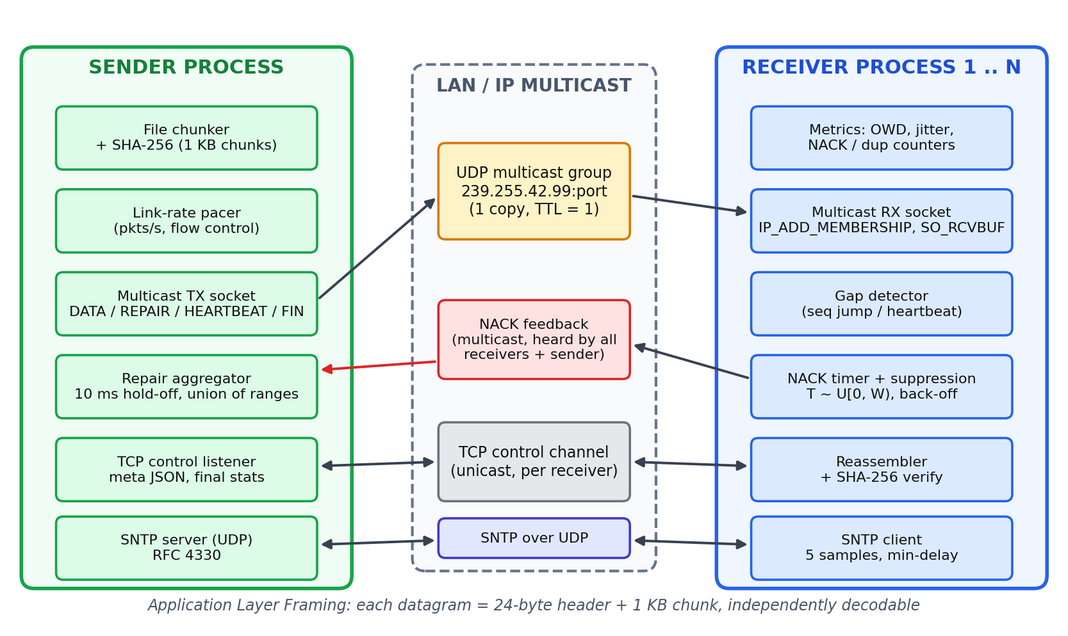
Figure 7.1: System architecture of ReliCast
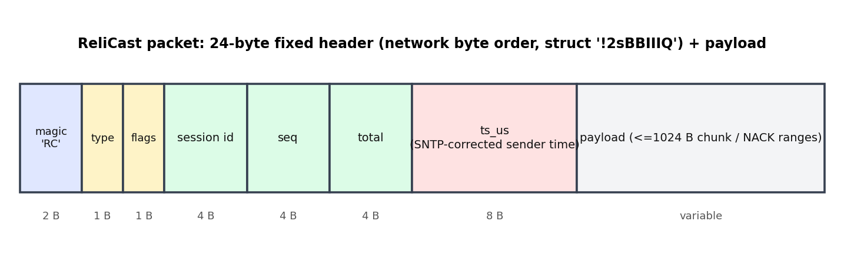
Figure 7.2: ReliCast datagram layout (network byte order)

7.2 Network communication model
A session proceeds as in Figure 7.3. (1) A receiver connects to the sender’s TCP control port and receives one JSON line containing the session id, file name, size, chunk size, chunk count, SHA-256, group, port, SNTP port and protocol parameters. (2) It performs five SNTP exchanges and keeps the sample with the smallest round-trip delay. (3) It joins the multicast group and reports ready over TCP. (4) When all N receivers are ready the sender multicasts DATA at the configured rate, interleaving HEARTBEATs so tail losses are noticed. (5) Receivers detect gaps, run the NACK timer of Section 7.4 (Figure 7.4), and the sender answers with REPAIR packets. (6) After verifying the digest each receiver returns its statistics over TCP and the sender multicasts FIN. The receiver passes through the states CONNECT, SYNC, JOINED, RECEIVING, REPAIRING and VERIFY.
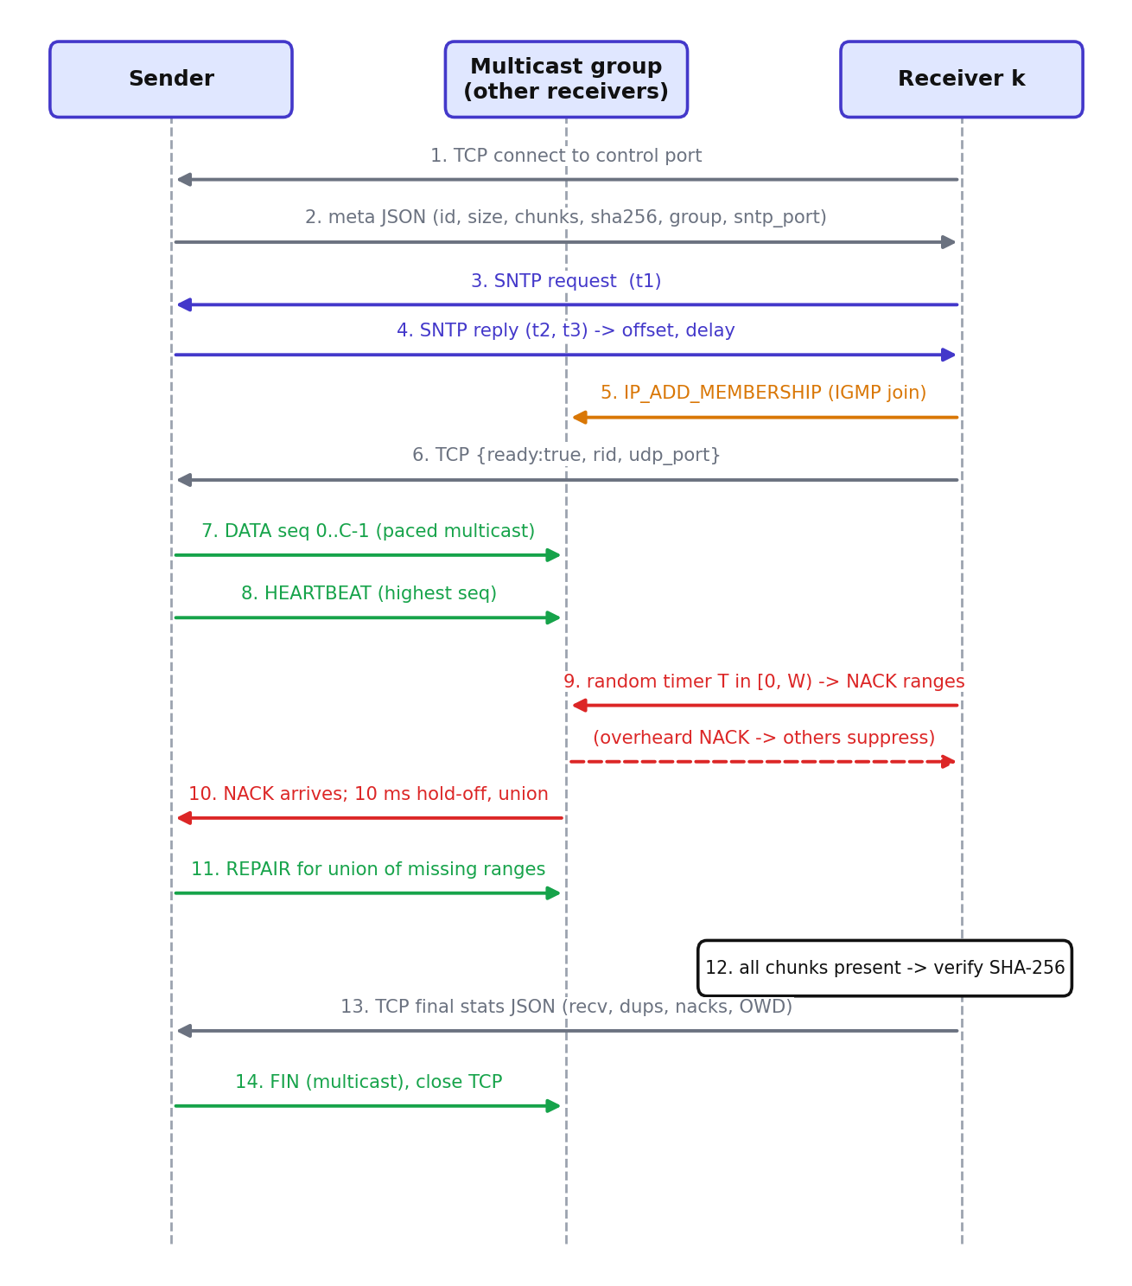
Figure 7.3: Sequence diagram of one ReliCast session

7.3 Mathematical model
Let the file have S bytes and the chunk payload L bytes, giving C = ⌈S/L⌉ chunks (1). Each receiver independently loses a datagram with probability p and an upstream fault removes a first transmission for everybody with probability q, so the probability that a given receiver misses a given chunk after the first pass is p′ = q + (1−q)p (2). For N receivers the expected number of (receiver, chunk) losses is C·N·p′, and the expected number of receivers missing a particular lost chunk is M = N·p′ (3).
C = ⌈ S / L ⌉ (1)
p′ = q + (1 − q) · p (2)
E[losses] = C · N · p′ , M = N · p′ (3)
NACK volume. Without suppression every receiver that misses a chunk sends a NACK at once, so the number of NACKs per round is about C·N·p′ and, because the naive sender answers each NACK, the repair count is of the same order (4). With ReliCast each of the M receivers draws a timer uniformly from [0, W). The earliest fires at about W/(M+1). Any other receiver whose timer expires within the propagation-plus-processing delay d of that moment has not yet heard the first NACK and also sends one, so the expected number of NACKs per lost chunk is approximately E[X] ≈ min(M, 1 + M·d/W) (5). The fraction of NACKs removed by suppression is therefore σ ≈ 1 − (1 + M·d/W)/M, which approaches 1 when d ≪ W and M is large. The delay d is exactly the quantity that SNTP-synchronised measurement makes observable. A retry after k failures draws from [0, 2ᵏ·W) (6).
E[NACK_naive] ≈ C · N · p′ , R_naive ≈ E[NACK_naive] (4)
E[X] ≈ min( M , 1 + M · d / W ) (5)
T_k ~ Uniform[ 0 , 2ᵏ · W ) (6)
Repair traffic. Because the ReliCast sender holds repair requests for 10 ms and sends the union of the requested ranges once, a chunk is repaired at most about once regardless of how many receivers missed it. The fraction of chunks missed by at least one receiver is u = 1 − (1−q)(1−p)^N, so R_relicast ≈ C·u (7), compared with R_naive ≈ C·N·p′. For the demonstration point (N = 6, p = 8%, q = 3%) the model gives p′ = 0.108, about 331 expected losses and u = 0.41, hence about 211 distinct chunks to repair against 331 repair packets for the naive scheme; the measured values are 241 and 319. Differences arise from retries and from NACK and repair packets that are themselves lost, which this first-order model ignores.
R_relicast ≈ C · u , u = 1 − (1 − q)(1 − p)^N (7)
Window adaptation. Each receiver keeps an exponentially weighted moving average of the SNTP-corrected one-way delay and of the delay variation, and sets W = min(200, max(20, 20 + 4(ô + 4ĵ))) milliseconds (8), where ô is the delay average and ĵ the jitter average, so a quiet LAN uses a short window (fast recovery) and a noisy one a longer window (fewer duplicates).
W = clamp( 20 ms + 4 ( ô + 4 ĵ ) , 20 ms , 200 ms ) (8)
Overhead and delivery. With B_data, B_rep, B_hb, B_nack the bytes on the wire for first transmissions, repairs, heartbeats and NACKs (payload + 24-byte header + 28 bytes of IP/UDP, or 40 bytes of IP/TCP headers), the overhead ratio is ρ = (B_data + B_rep + B_hb + B_nack)/S (9). An ideal multicast has ρ ≈ 1 + 52/L ≈ 1.05 for L = 1024, while N unicast transfers have ρ ≈ N. The delivery ratio is the mean over receivers of received chunks divided by C (10).
ρ = ( B_data + B_rep + B_hb + B_nack ) / S (9)
DR = (1/N) · Σ_k recv_k / C (10)
Clock model. SNTP records t1 (client send), t2 (server receive), t3 (server send) and t4 (client receive). The client clock offset and path delay are θ = ((t2 − t1) + (t3 − t4))/2 and δ = (t4 − t1) − (t3 − t2) (11), and |θ̂ − θ| ≤ δ/2 if the two directions are symmetric to within δ. Using the sample with minimum δ out of five minimises this bound. The one-way delay of data packet i at receiver k is OWD_i = (t_rx − θ̂_k) − ts_i, and jitter is the mean absolute difference of successive delays J = mean|OWD_i − OWD_(i−1)|, in the spirit of RFC 3550 (12).
θ = ((t2 − t1) + (t3 − t4)) / 2 , δ = (t4 − t1) − (t3 − t2) (11)
OWD_i = ( t_rx,i − θ̂_k ) − ts_i , J = mean | OWD_i − OWD_(i−1) | (12)

7.4 Proposed algorithm
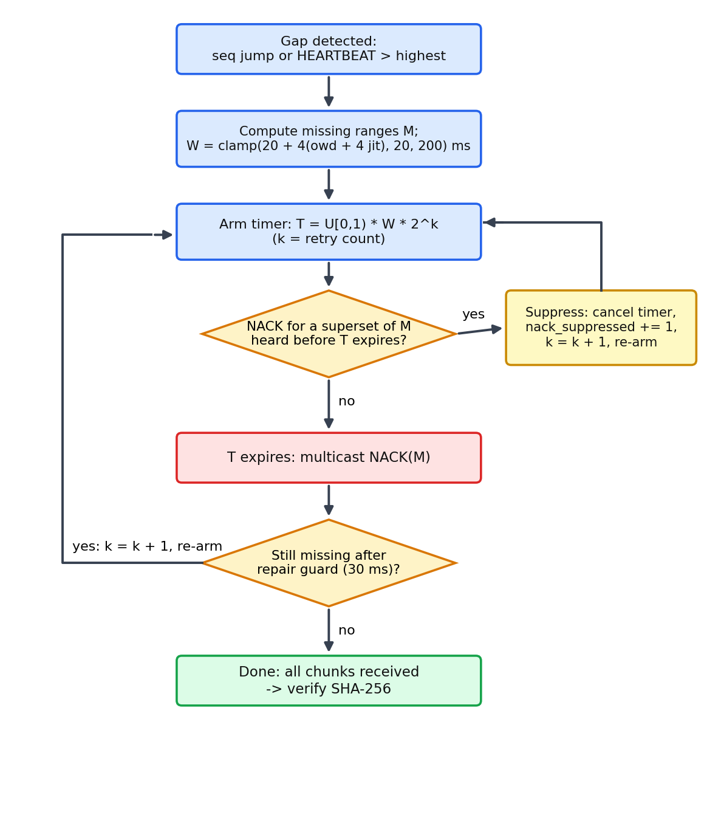
Figure 7.4: Receiver NACK timer and suppression flowchart
SENDER(file, N):
chunks <- split(file, L); digest <- SHA256(file)
start TCP listener, SNTP server; wait until N receivers READY
for seq in 0..C-1: send DATA(seq) to group; sleep to hold rate R
every 50 packets: send HEARTBEAT(highest = seq)
loop until all receivers DONE or timeout:
on NACK(ranges): add ranges to pending set; if no hold-off
running, start 10 ms hold-off timer
on hold-off expiry: for chunk in union(pending):
if now - last_repair[chunk] > 30 ms: send REPAIR(chunk)
clear pending
send FIN to group; collect stats over TCP
Algorithm 7.1: Pseudocode of the ReliCast sender
RECEIVER(k):
meta <- TCP_connect(); theta <- SNTP_sync(best of 5); join(group)
have <- empty bitmap; send READY
loop (select on UDP socket, timers):
on DATA/REPAIR(seq): store chunk; record OWD = rx - theta - ts
update owd_ewma, jitter_ewma, W; cancel timers for seq
on HEARTBEAT(h) or seq jump: missing <- ranges not in have
on NACK heard (from other receiver): remove covered ranges
from my timer; count nack_suppressed; k <- k + 1
on timer expiry: send NACK(missing); re-arm with 2^k * W
if have is full: verify SHA256 == meta.digest; send stats on TCP
Algorithm 7.2: Pseudocode of the ReliCast receiver

7.5 Socket programming implementation
The multicast receive socket is created with socket(AF_INET, SOCK_DGRAM, IPPROTO_UDP), SO_REUSEADDR (and SO_REUSEPORT where it exists) so that several receiver processes can share the port on one host, bound to the wildcard address (binding to the group address is not portable to Windows), and joined with IP_ADD_MEMBERSHIP using an ip_mreq structure built with inet_aton. The send socket sets IP_MULTICAST_TTL (1, so traffic stays on the link), IP_MULTICAST_LOOP and IP_MULTICAST_IF to select the interface, and pacing is done in user space because UDP has no flow control. Table 7.1 maps these calls to the syllabus units.
Table 7.1: Mapping of socket-programming concepts to syllabus units
Unit | Feature in ReliCast | Calls / options used
Unit 1 | Sockets, network byte order, buffers | socket(), struct.pack('!2sBBIIIQ'), SO_RCVBUF (4 MB, with fallbacks)
Unit 2 | TCP control channel (metadata, final stats), socket states | bind(), listen(), accept(), connect(), sendall(), recv(); SO_REUSEADDR; FIN/close
Unit 2 | Multicast socket options | SO_REUSEPORT, IP_MULTICAST_TTL, IP_MULTICAST_IF, IP_MULTICAST_LOOP
Unit 3 | UDP data path, no flow control, timeouts | sendto(), recvfrom(), user-space pacing, select.select(), settimeout()
Unit 4 | Broadcast service discovery | SO_BROADCAST, sendto() to 255.255.255.255:5599 and subnet .255; receivers bind(:5599)
Unit 4 | Multicast group join, TTL scope, reachability probe | IP_ADD_MEMBERSHIP (ip_mreq), group 239.255.42.99 (RFC 2365), TTL = 1, PROBE datagrams
Unit 5 | SNTP clock synchronisation | 48-byte NTP packet over UDP; client and server in clock.py; offset θ and delay δ

7.6 Real-world mode, discovery and fallback
Beyond the simulated comparison, ReliCast is a working file-transfer tool. The sender runs python run.py send <file> --mode relicast|naive|tcp|udp (or the dashboard Send tab) and receivers run python run.py receive (or the Receive tab). Discovery (Unit 4, broadcast). Every second the sender broadcasts a small JSON beacon (file name, size, mode, ip:port) to 255.255.255.255, the subnet broadcast address and loopback on UDP port 5599; receivers bind that port with SO_REUSEADDR, list the beacons heard in the last four seconds and let the user choose one (Figure 7.5). Lobby protocol. The chosen receiver opens a TCP connection and the two sides exchange JSON lines: meta, ready, an optional probe, start with the chosen transport, then progress and done messages (Figure 7.6). Reachability probe and hybrid fallback. Multicast is frequently dropped by Wi-Fi access points and hotspots (client isolation, no IGMP support). When the user starts the transfer the sender multicasts ten PROBE packets and each receiver answers over TCP with mcast_ok. A receiver that heard none is served the same file over a TCP stream while the others keep using multicast and NACK repair, so one blocked device cannot stall or fail the session. Saving and phones. After the SHA-256 check a receiver saves the file in ~/ReliCast/received under a unique name; with --lan, HTTP pages /download and /upload serve phone browsers while control APIs stay loopback-only. Portability. SO_REUSEPORT is used only where it exists (absent on Windows), multicast sockets bind the wildcard address, the clock is anchored to perf_counter because time.time() has coarse resolution on Windows, and ANSI colours are enabled explicitly in the Windows console.
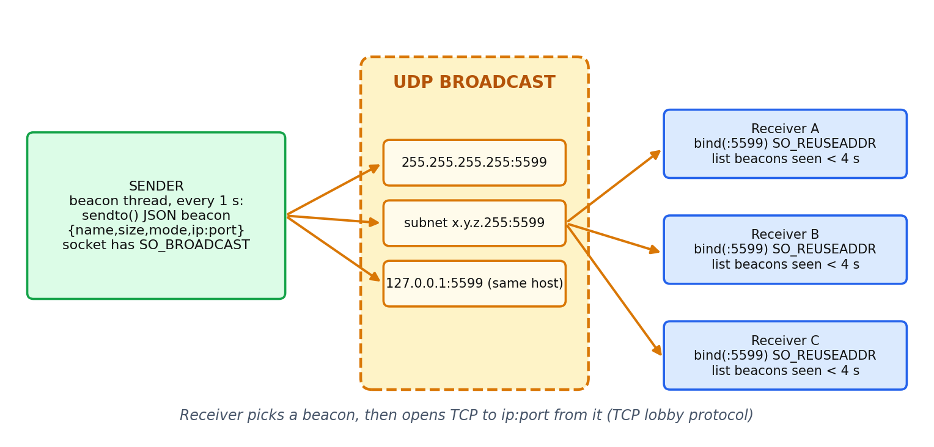
Figure 7.5: Service discovery with UDP broadcast beacons
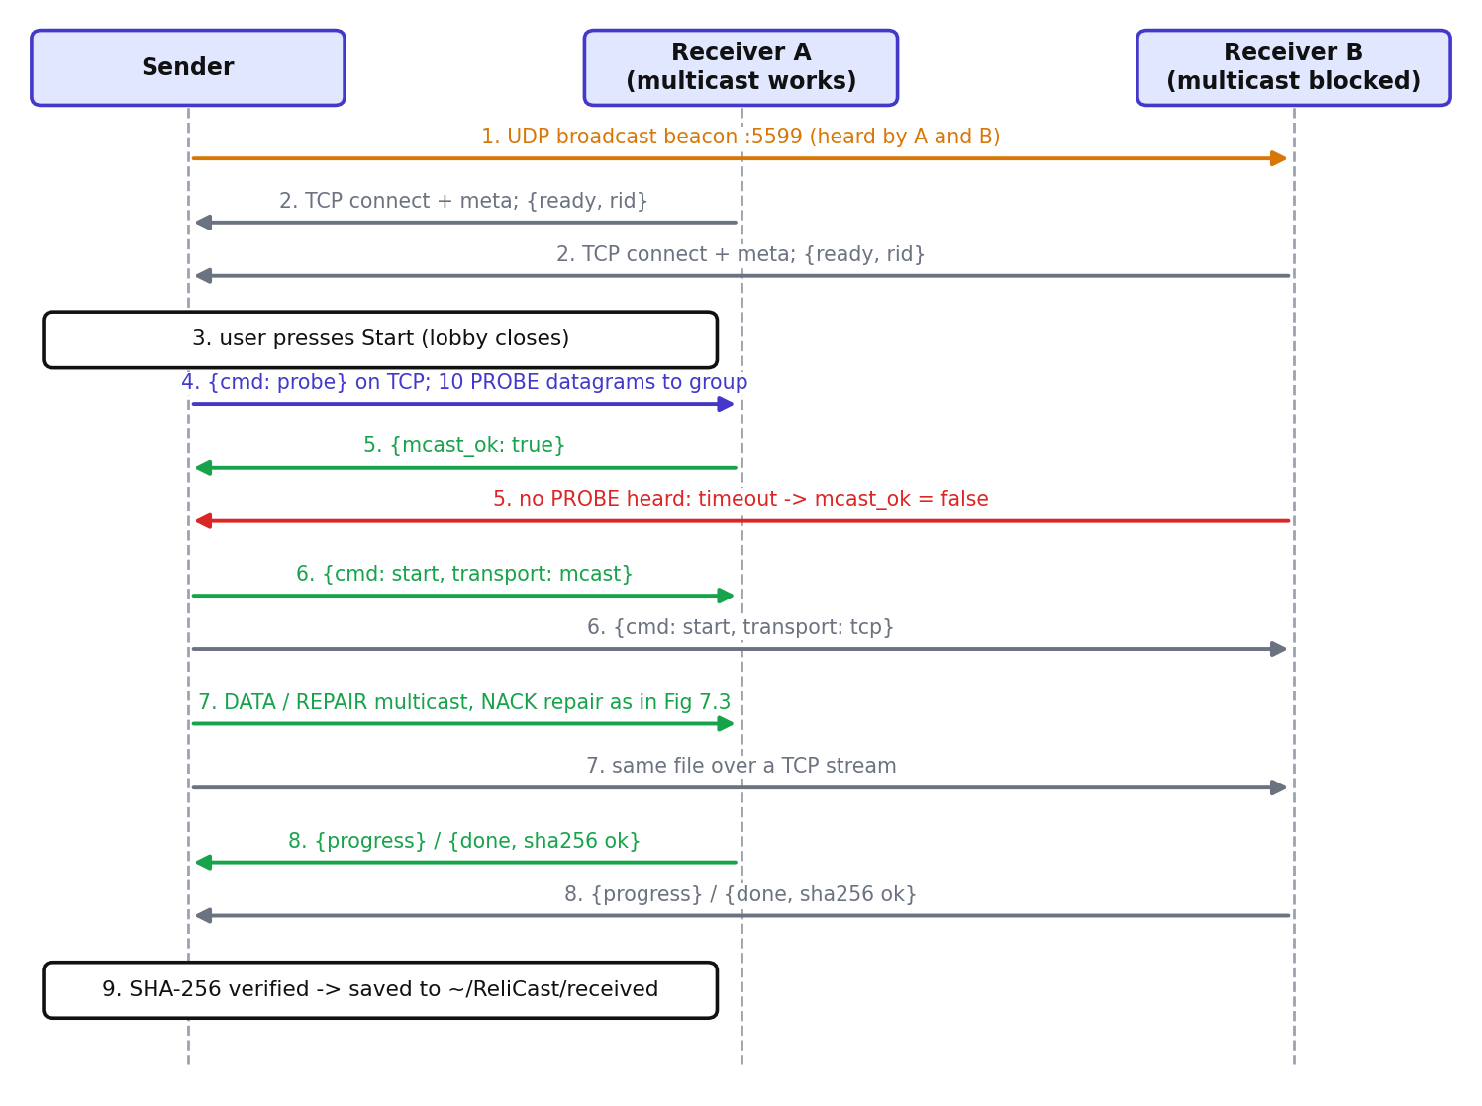
Figure 7.6: Lobby, multicast probe and TCP fallback sequence

8. PERFORMANCE EVALUATION

8.1 Experimental setup
All experiments run on one host (macOS-26.7.1-arm64-arm-64bit, Python 3.9.6, interface 10.232.205.94) with the sender and the N receivers as separate processes exchanging real UDP multicast and TCP traffic through the operating-system network stack. A 512 KB file is split into 1024-byte chunks (512 chunks). The sender is limited to 4000 packets per second, which models a shared uplink, so that the unicast baselines pay for sending N copies. Each configuration is repeated 3 times with different seeds and the mean is reported. Run date: 2026-10-24 07:56. Packet loss is emulated in software: a per-receiver probability p discards a datagram on arrival (applies to DATA, REPAIR and NACK), and a shared probability q makes the sender skip a first transmission for every receiver. Because there is no real loss on the loopback or a quiet LAN, this emulation gives a reproducible loss process. Receivers also carry an injected clock skew of up to ±500 ms to test the SNTP correction.
Table 8.1: The four transfer modes compared
Mode | Transport | Reliability | Loss model
TCP unicast | N TCP connections | Kernel TCP; a lost segment is re-sent after a 20 ms stall | per-segment Bernoulli
Raw UDP | N UDP copies | None (delivery ratio < 1) | per-copy Bernoulli
Naive multicast | 1 multicast copy | Immediate NACK from every receiver, fixed 80 ms retry, per-NACK repair | per-receiver + shared
ReliCast | 1 multicast copy | Randomised NACK timer, suppression, back-off, repair aggregation | per-receiver + shared

Three experiments were run. Sweep 1 varies the number of receivers over 1, 2, 4, 8, 16 with p = 5% and q = 2%. Sweep 2 varies the per-receiver loss over 0%, 1%, 2%, 5%, 10%, 20% for N = 8 and q = 0. The demonstration point uses N = 6, p = 8% and q = 3% and is the source of the console output, NACK counts and delay figures.
Controlled comparison. For each scenario every protocol transfers the byte-identical payload, generated deterministically from (size, seed), so that the SHA-256 is the same in all four modes (34 of 34 scenarios share file size, chunk count and seed). The receiver count, per-receiver loss, shared loss and sender link capacity (4000 packets per second, TCP paced to the same limit) are identical, and 3 repetitions are averaged. The only outcome that legitimately differs between modes is the number of bytes put on the wire, i.e. the overhead ratio ρ = total bytes / file size. Threats to validity. (1) The loss rate is equal across modes but the random drop sequences hit different packets. (2) The kernel cannot drop packets on a local link, so TCP loss is modelled: a lost segment is re-sent after a 20 ms stall. (3) The test bed is a single host with receivers as separate processes, so delivery is loopback-class and the CPU is shared. (4) In the dashboard’s real-send mode TCP is not paced, because it is a real transfer; only the Compare and Sweeps benchmarks use equal pacing.

8.2 Performance metrics
- Transfer duration (s): from the start of transmission until the last receiver completes or the timeout expires. Goodput = N·S·DR/duration.
- Overhead ratio ρ: total bytes on the wire (sender plus all NACK bytes) divided by the file size; 1 is a single ideal copy.
- Delivery ratio DR and the SHA-256 verification result per receiver.
- NACK packets, suppressed NACKs, repair packets, duplicate data summed over receivers.
- One-way delay (mean, p95, max) and jitter for first-transmission DATA packets, after SNTP correction, plus the raw delay without correction.
- SNTP accuracy: difference between the estimated offset and the injected skew for each receiver.

9. OUTPUT AND RESULTS

9.1 Console output
Figure 9.1 shows the terminal output of a demonstration run (python run.py demo); the complete sweep summary is produced by python run.py experiments. The demonstration run is a separate execution (its receiver count, file size and loss may differ from the experiment demo point), so its numbers differ from the repetition-averaged values used in the charts that follow.
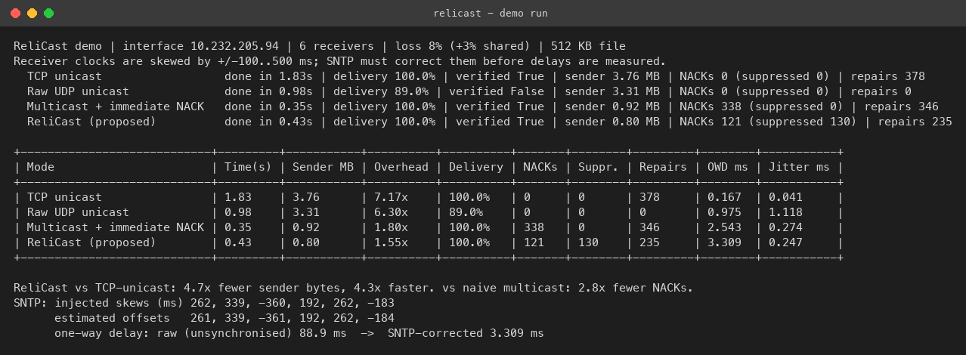
Figure 9.1: Console output of the demonstration run (output screenshot)
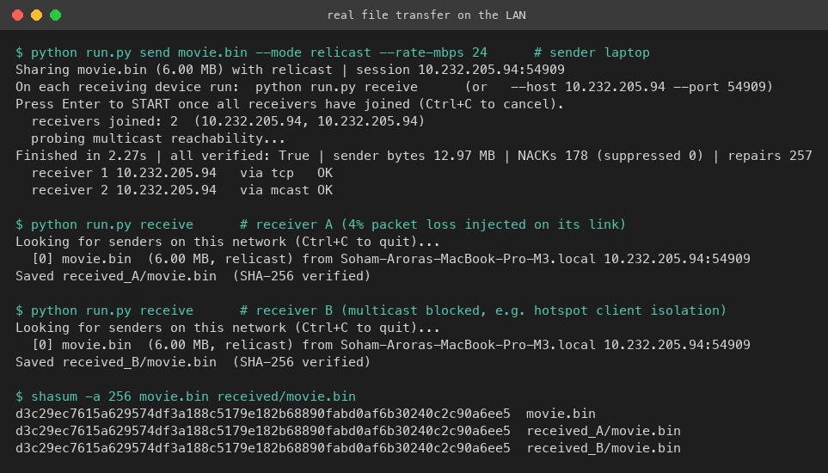
Figure 9.2: Real file transfer on the LAN: send and receive terminals (6 MB file, receiver A with 4% injected loss, receiver B with multicast blocked and served over the TCP fallback; the three SHA-256 digests are identical)

Figure 9.3: Dashboard, Compare tab: live chunk map per receiver, verdict, comparison charts, results table (SNTP panel below the crop)

9.2 Comparative analysis
Scalability with receivers. Figures 9.4 and 9.5 show how duration and overhead grow with N. With 16 receivers TCP unicast needed 2.28 s with an overhead ratio of 18.30x and raw UDP unicast 2.27 s (16.81x), because each additional receiver adds a full copy to the paced uplink. Naive multicast needed 0.43 s (2.45x) and ReliCast 0.39 s (1.72x), i.e. TCP/ReliCast ratios of 5.9 for duration and 10.6 for overhead. Across the sweep the ReliCast overhead ratio stayed between 1.13x and 1.72x, while the unicast overhead grew in proportion to N.
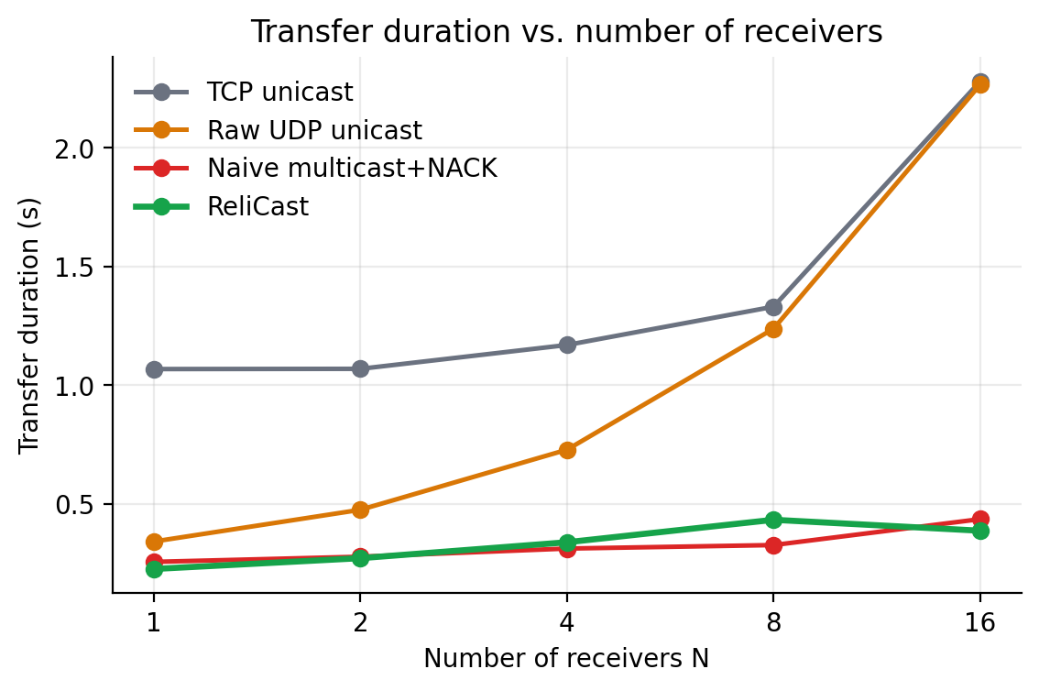
Figure 9.4: Transfer duration versus number of receivers (mean of repetitions)
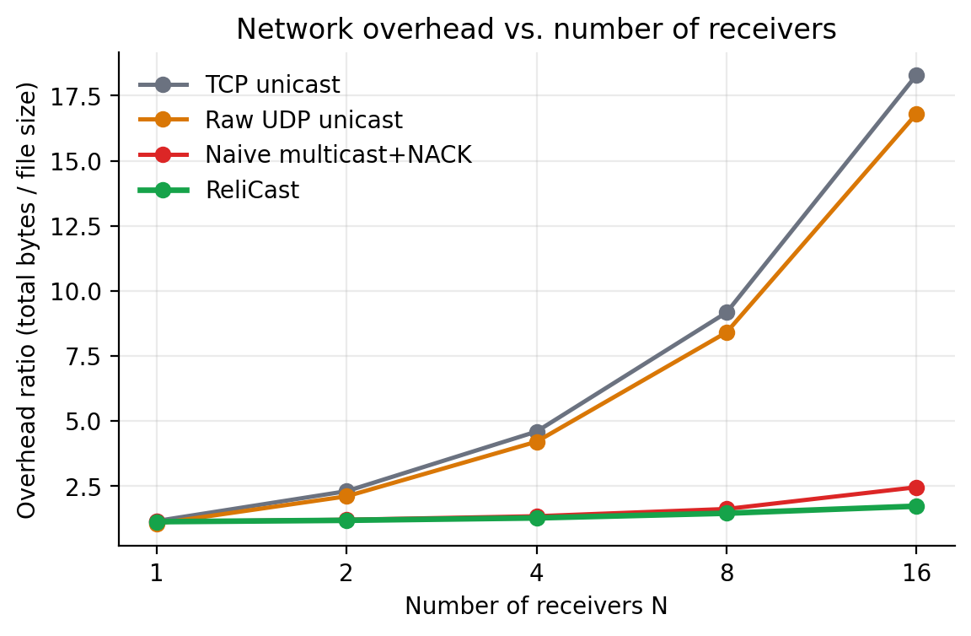
Figure 9.5: Overhead ratio versus number of receivers
Effect of loss. Figures 9.6 and 9.7 (also drawn in the dashboard Sweeps tab) vary the per-receiver loss at N = 8. At 20% loss raw UDP delivered only 79.3% of the data, because nothing recovers a lost datagram, whereas ReliCast and the naive scheme delivered 100.0% and 100.0%. Duration for ReliCast grew from 0.20 s at no loss to 1.16 s at 20% loss, against 0.20 s to 0.71 s for naive multicast and 1.03 s to 3.53 s for TCP. At the highest loss rates ReliCast was therefore slower than the naive scheme: with many receivers missing the same chunks, its back-off timers and the 30 ms repair guard most likely make it wait through several recovery rounds, which is the cost of the lower NACK and repair volume reported below. Duration is not the only criterion, because the naive scheme achieves its speed by sending more NACK and repair packets.
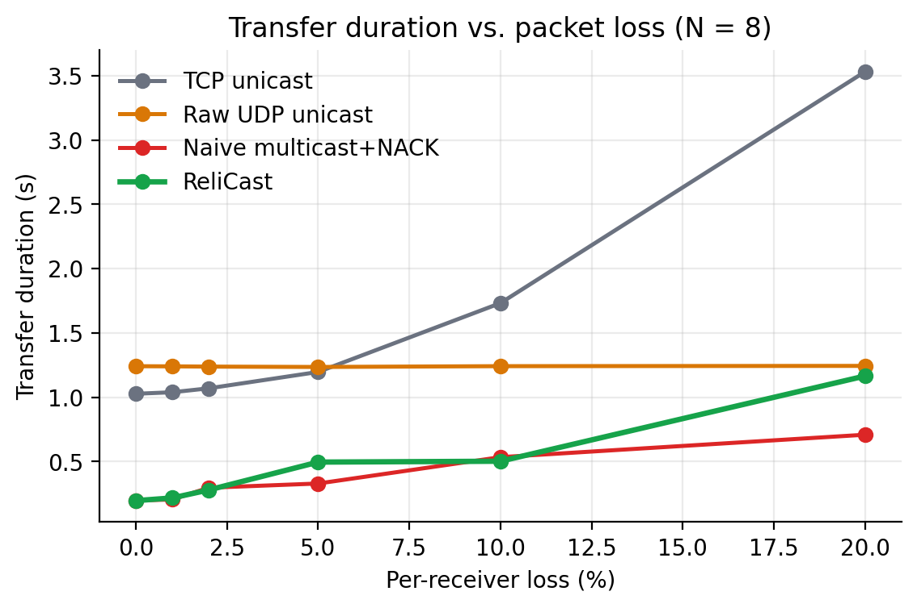
Figure 9.6: Transfer duration versus per-receiver loss
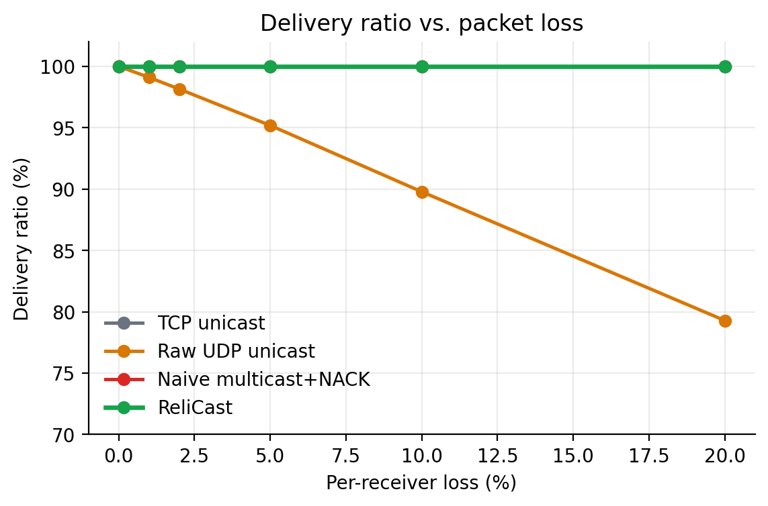
Figure 9.7: Delivery ratio versus per-receiver loss
Feedback and repair traffic. At the demonstration point (N = 6, p = 8%, q = 3%) the naive scheme produced 322 NACKs and 319 repair packets, whereas ReliCast sent 130 NACKs and 241 repairs while suppressing 134 NACKs (51% of all NACK attempts). That is 60% fewer NACKs and 24% fewer repair packets than the naive scheme (Figure 9.8), and total bytes on the wire were 0.82 MB for ReliCast, 0.92 MB for the naive scheme and 3.76 MB for TCP.
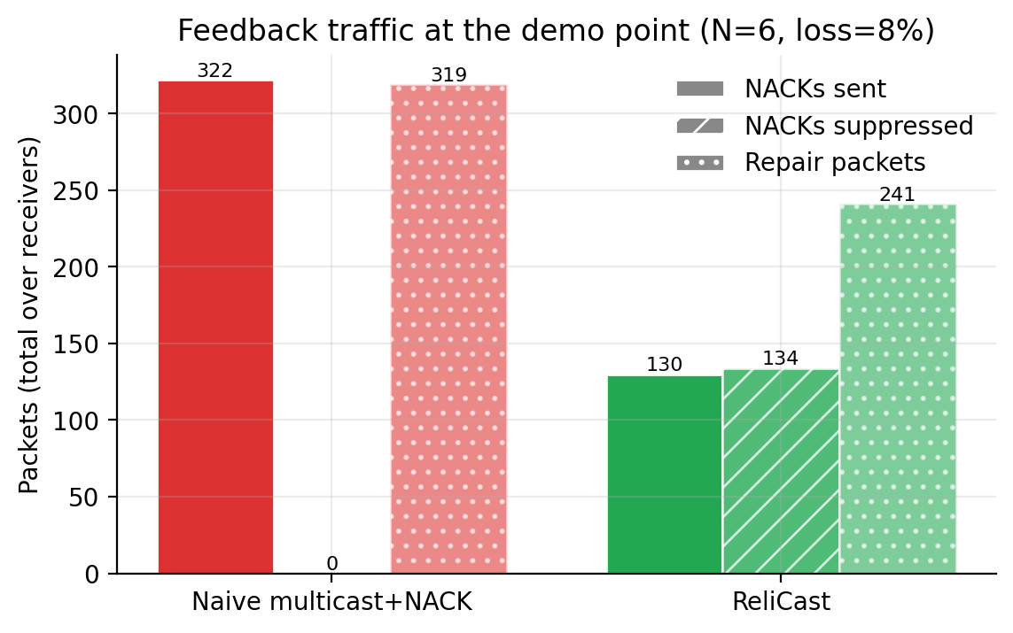
Figure 9.8: NACK and repair packets at the demonstration point

9.3 Validation of the proposed approach
Correctness was validated first by content: in 99 of 99 runs of the TCP, naive and ReliCast modes every receiver’s SHA-256 matched the sender’s digest (loss rates up to 20% were included). Second, the clock model was validated directly: the injected skews of up to 360 ms were estimated by SNTP to within 0.42 ms (Figure 9.9, left), and correcting by the estimate reduced the mean apparent delay from 89.47 ms to 2.89 ms, a factor of about 31 (Figure 9.9, right). Third, the analytical model of Section 7.3 predicts the right order of magnitude and, more importantly, the right ordering between the schemes: it predicts roughly C·N·p′ = 331 repair packets for the naive scheme against C·u = 211 for ReliCast, matching the measured ranking.
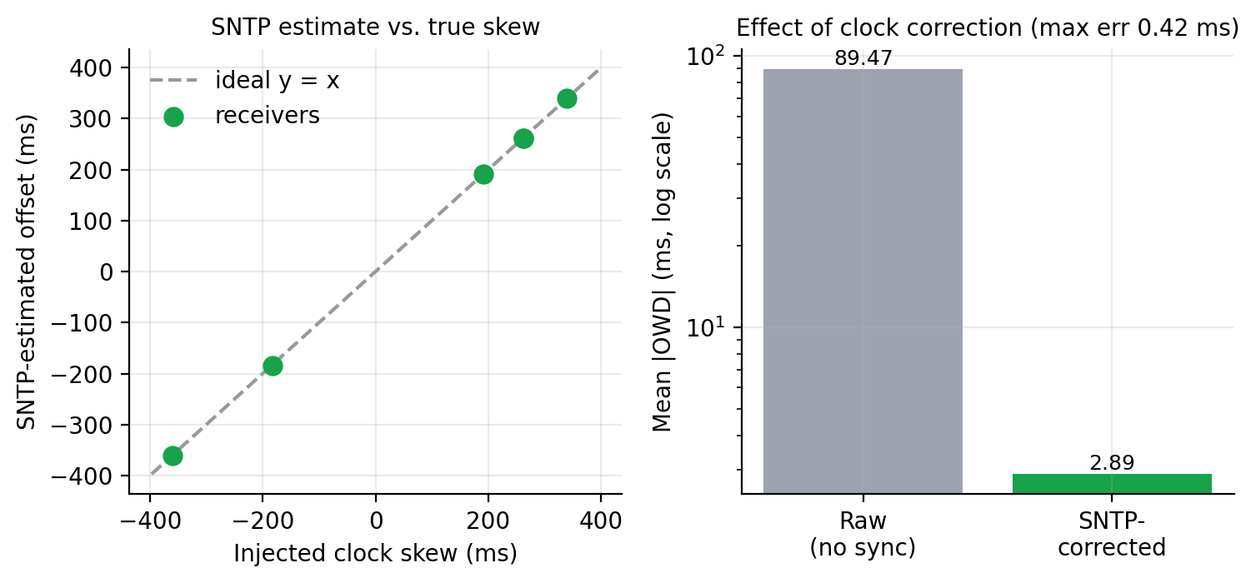
Figure 9.9: SNTP offset estimate versus injected skew (left) and effect on measured delay (right)

9.4 Real-world validation
The real-file mode was exercised once end to end (Figure 9.2): a 6 MB file was sent with python run.py send --mode relicast to 2 receivers that discovered it through the broadcast beacon. One receiver had 4% packet loss injected on its link and the other could not hear multicast, so the probe moved it to the TCP fallback. The sender reported completion in 2.27 s with all receivers verified, 178 NACKs and 257 repair packets (12.97 MB on the wire), and the SHA-256 of the sent file and of both saved copies were identical. A three-receiver run in the dashboard Send tab (Figure 9.10) finished with all receivers verified and a 2.16x overhead ratio. These runs are honest but limited: sender and receivers ran on one machine’s own network interface, so delivery was loopback-class rather than a congested Wi-Fi link, and the packet loss was emulated at the receivers. Testing on several physical devices over a hotspot is therefore left as future work.
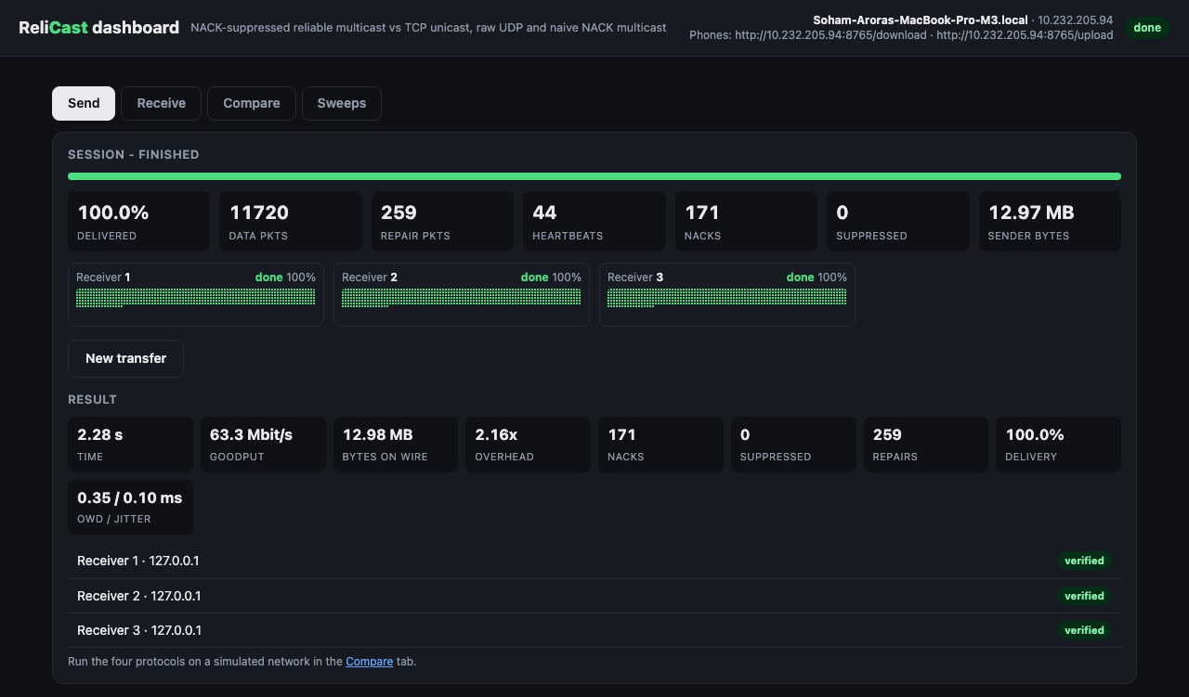
Figure 9.10: Dashboard, Send tab: finished three-receiver real transfer, all receivers verified

9.5 Observations: delay, jitter and throughput
Figure 9.11 gives the SNTP-corrected one-way delay and jitter per mode at the demonstration point. The mean delay was 2.89 ms for ReliCast (p95 11.74 ms, jitter 0.34 ms), 2.84 ms for naive multicast (jitter 0.32 ms), 0.99 ms for raw UDP (jitter 0.96 ms) and 0.19 ms for TCP (jitter 0.05 ms). Delays of the multicast modes and of the unicast modes are measured on different paths and under different sender load, and with all receiver processes sharing one machine part of the measured delay is receiver-side scheduling and queueing rather than network transit, so the numbers are best compared qualitatively. Goodput was 32.6 Mbit/s for ReliCast, 57.7 Mbit/s for naive multicast and 13.7 Mbit/s for TCP (counting the data delivered to all receivers). Overall, the experiments show that suppression and aggregation keep multicast reliability inexpensive in bytes, that raw UDP is unsuitable when completeness matters, and that SNTP makes one-way delay a usable measurement even with a clock skew of several hundred milliseconds.
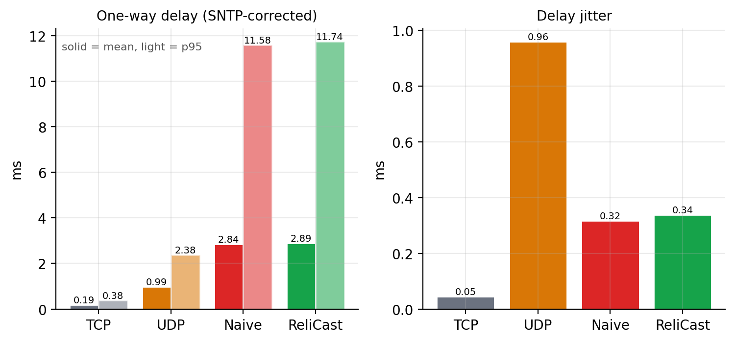
Figure 9.11: SNTP-corrected one-way delay and jitter by mode

10. CONCLUSION
This work implemented ReliCast, a NACK-oriented reliable multicast file-distribution protocol built directly on the socket API, together with TCP, raw-UDP and naive-multicast baselines and an SNTP client and server for synchronised delay measurement. Performance. With 16 receivers ReliCast completed the transfer in 0.39 s against 2.28 s for TCP unicast, and its overhead ratio was 1.72x against 18.30x. At the demonstration point it delivered the file to all 6 receivers with 130 NACKs and 241 repair packets, compared with 322 and 319 for naive multicast, and the one-way delay of 2.89 ms and jitter of 0.34 ms were measurable only because the clocks were synchronised, with a worst-case offset error of 0.42 ms. Raw UDP, the cheapest baseline, delivered only 79.3% of the data at 20% loss.
Contribution to the research gap. The study supplies what the SRM and NORM literature lacks: measurements from real sockets in a reproducible harness, a suppression window adapted from SNTP-synchronised delay and jitter, and a direct quantitative comparison with the three practical baselines. It demonstrates that the central mechanisms of SRM (random timers, suppression, back-off) and NORM (sender-side aggregation, heartbeats) carry over to a small, dependency-free Python implementation.
Limitations. Loss is emulated in software and the experiments run on a single host, so real switch behaviour, IGMP snooping and Wi-Fi multicast rate limits are not exercised; the TCP loss model is a documented approximation; the sender paces at a fixed rate with no congestion control; the repair mechanism has no forward error correction; and the group sizes are small. The real-file mode has no encryption or authentication, holds the whole file in RAM, supports IPv4 only, and was tested on one machine rather than across a real hotspot, where multicast is often rate-limited or blocked (hence the TCP fallback). ReliCast also trades recovery latency for feedback volume: the naive scheme can finish sooner, notably at the highest loss rates, so the suppression window and repair guard deserve further tuning. Future work. Natural extensions are a multi-host LAN and Wi-Fi measurement campaign, FEC-coded repairs, congestion control, authenticated sessions, local recovery as in SRM, and a comparison of the adaptive window against fixed windows over wider parameter ranges.

11. REFERENCES
[1] S. Floyd, V. Jacobson, C.-G. Liu, S. McCanne, and L. Zhang, “A reliable multicast framework for light-weight sessions and application level framing,” IEEE/ACM Transactions on Networking, vol. 5, no. 6, pp. 784–803, Dec. 1997.
[2] B. Adamson, C. Bormann, M. Handley, and J. Macker, “NACK-Oriented Reliable Multicast (NORM) Transport Protocol,” RFC 5740, Internet Engineering Task Force, Nov. 2009.
[3] D. Mills, “Simple Network Time Protocol (SNTP) Version 4 for IPv4, IPv6 and OSI,” RFC 4330, Internet Engineering Task Force, Jan. 2006.
[4] S. E. Deering, “Host Extensions for IP Multicasting,” RFC 1112, IETF, Aug. 1989.
[5] D. Meyer, “Administratively Scoped IP Multicast,” RFC 2365, IETF, Jul. 1998.
[6] H. Schulzrinne, S. Casner, R. Frederick, and V. Jacobson, “RTP: A Transport Protocol for Real-Time Applications,” RFC 3550, IETF, Jul. 2003 (interarrival jitter, Sec. 6.4.1).
[7] W. R. Stevens, B. Fenner, and A. M. Rudoff, UNIX Network Programming, Volume 1: The Sockets Networking API, 3rd ed. Boston, MA, USA: Addison-Wesley, 2003.
[8] Python Software Foundation, “socket — Low-level networking interface,” The Python Standard Library documentation, https://docs.python.org/3/library/socket.html.
[9] Python Software Foundation, “select — Waiting for I/O completion” and “struct — Interpret bytes as packed binary data,” The Python Standard Library documentation, https://docs.python.org/3/library/.
[10] getsockopt(2) / setsockopt(2), Linux Programmer’s Manual, man7.org, section 2.
[11] ip(7) — Linux IPv4 protocol implementation, Linux Programmer’s Manual, man7.org, section 7 (IP_ADD_MEMBERSHIP, IP_MULTICAST_TTL, IP_MULTICAST_IF, IP_MULTICAST_LOOP).

