**RabbitMQ Install**

Go this link : <https://www.erlang.org/downloads>

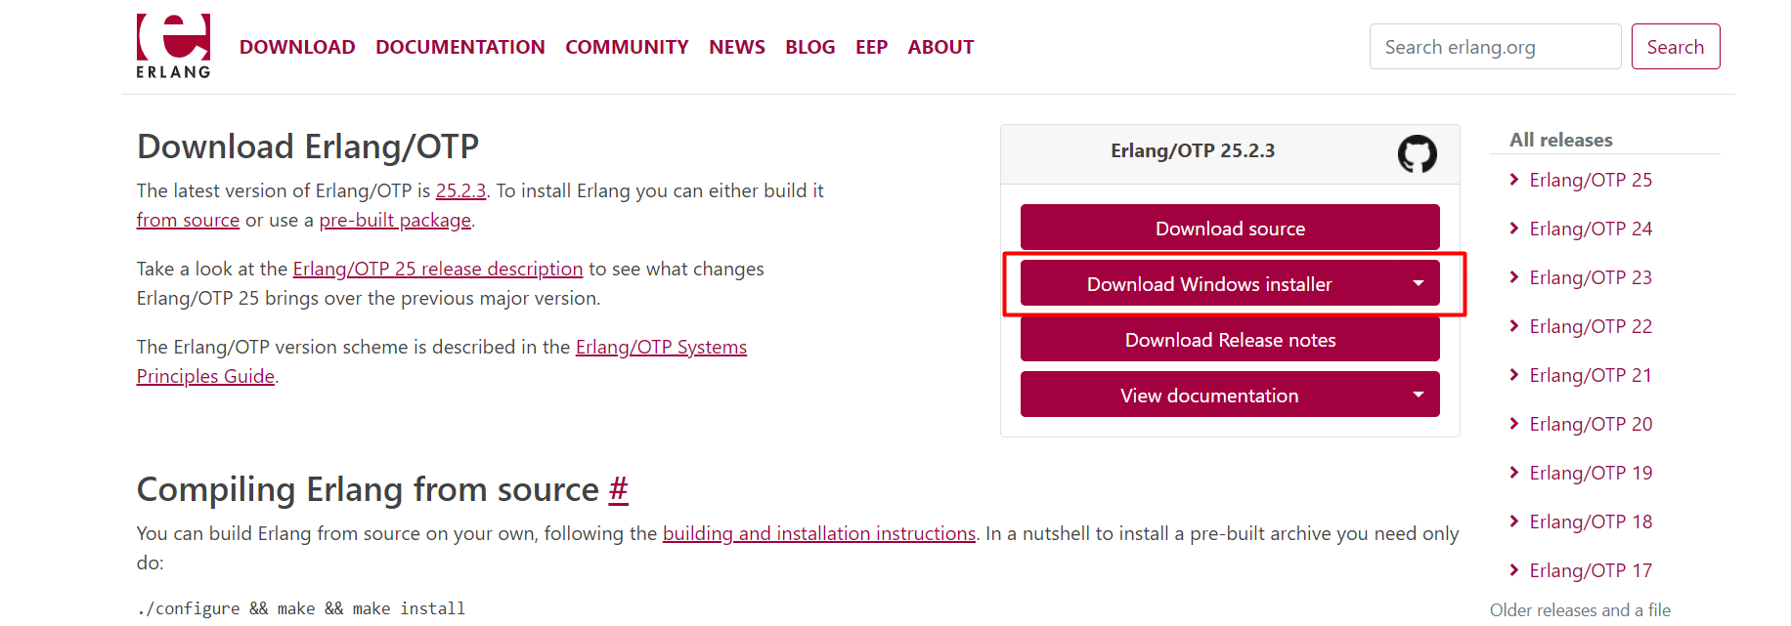

Install Erlang/OTP

Go to this Link : <https://www.rabbitmq.com/download.html>

Download the RabbitMQ windows Installer and install the software.

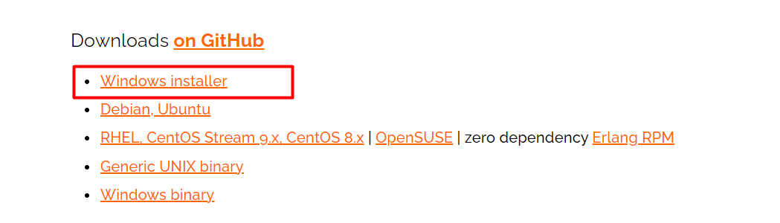

After Install software Go to the Win -> Services

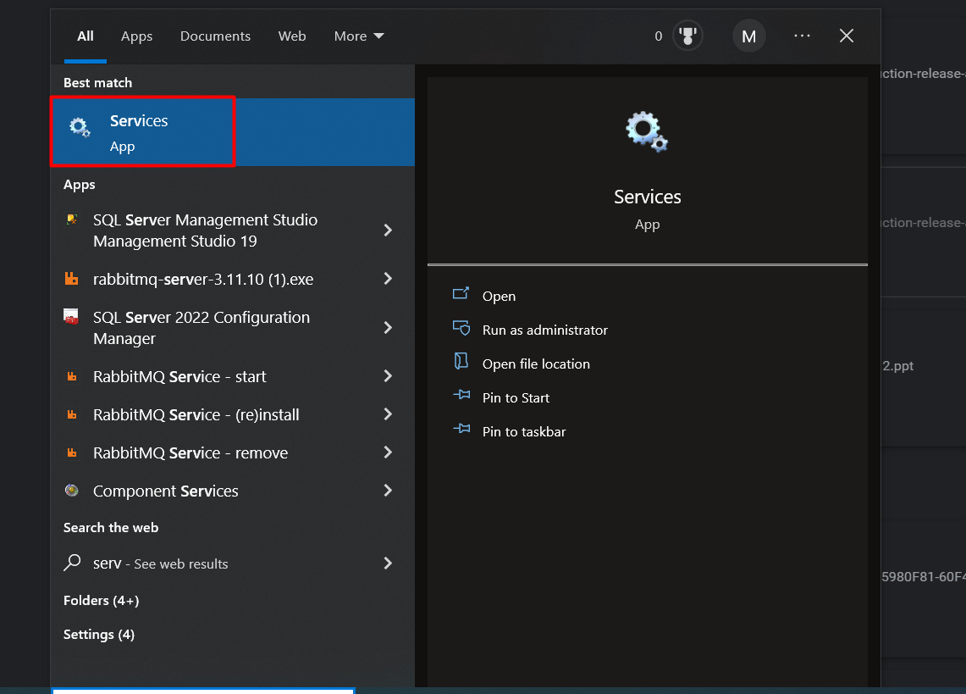

Find RabbitMQ service and check its on running mode .

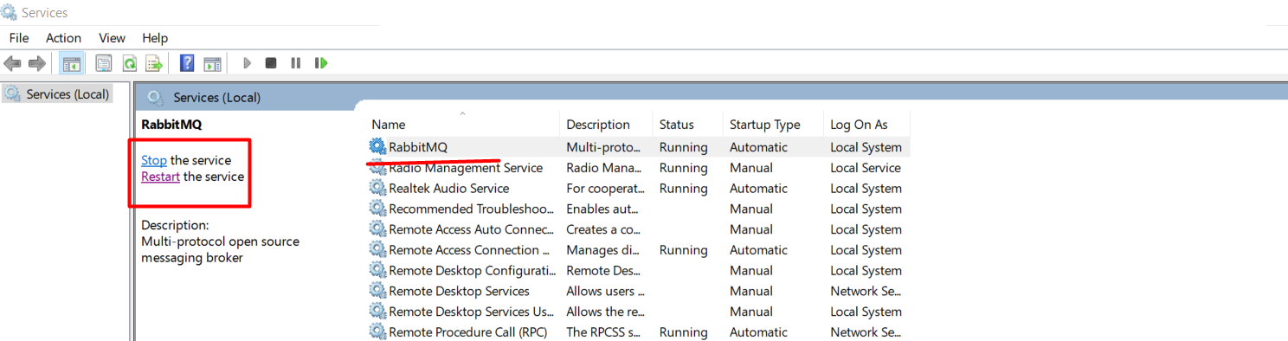

Open Any Browser and Enter the URL :- <http://localhost:15672/>

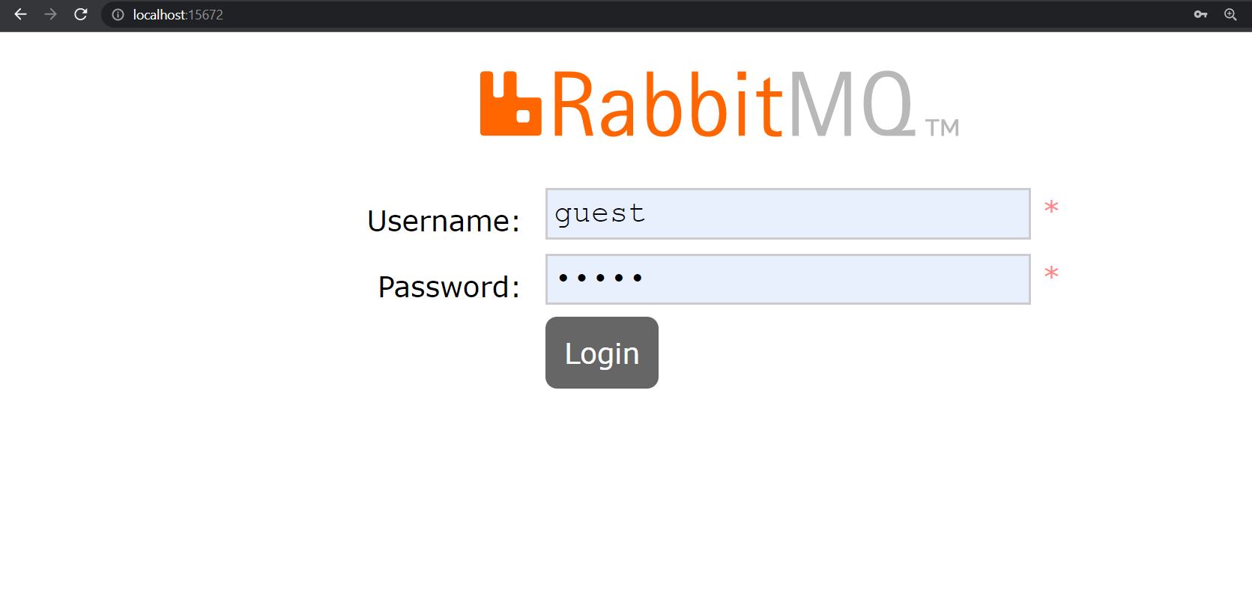

RabbitMQ Login page will appear. Enter Username and Password

Username : guest

Passworf : guest

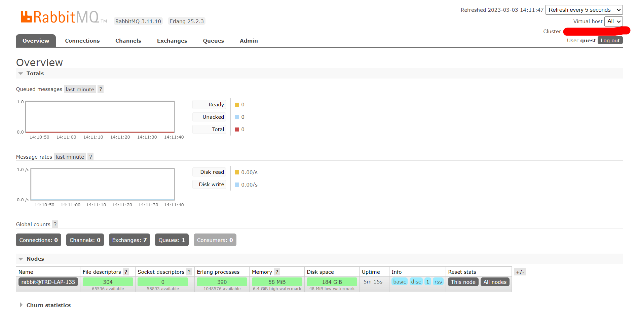

Dashboard will open, Setup is completed.