Q1]

1. Write a ‘C’ program to calculate the Area and circumference of a circle

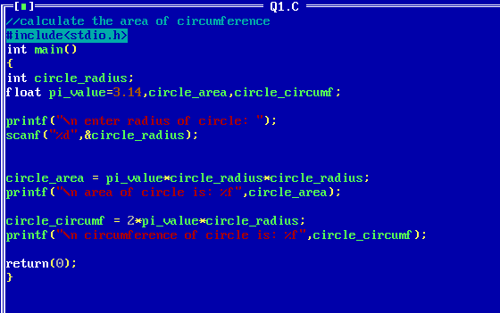

2. Write a ‘C’ program to calculate simple interest.

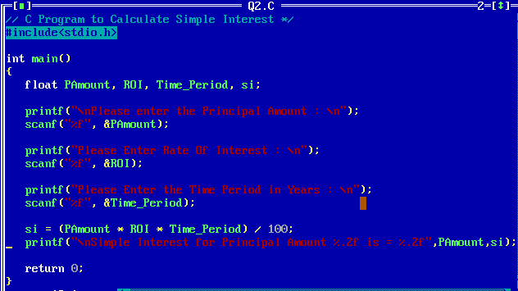

3. Write a ‘C’ program to convert temperature from degree centigrade to Fahrenheit

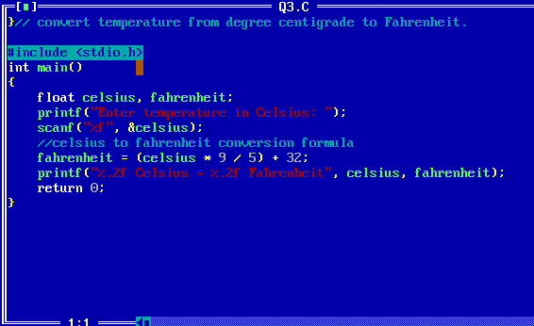

4. Write a ‘C’ program to calculate sum of 5 subjects and find percentage

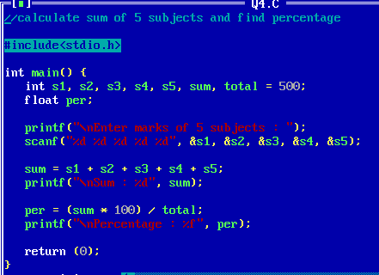

5. Write a ‘C’ program to swap two integers using temporary variable.

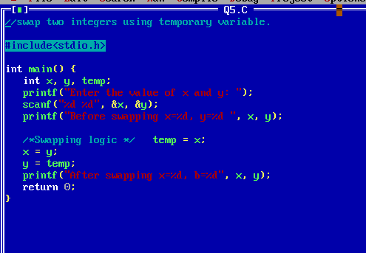

6. Write a ‘C’ program to find minimum of three numbers.

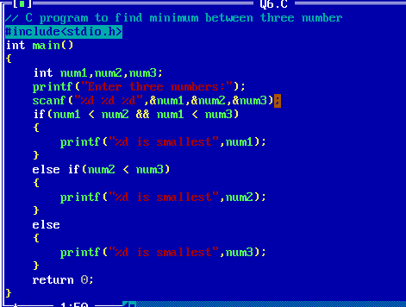

7. Write a ‘C’ program to find maximum of three numbers

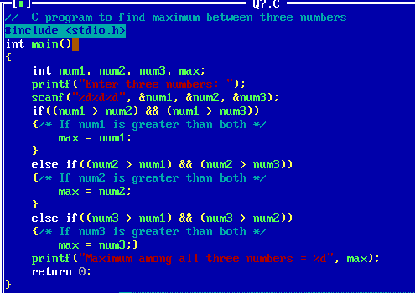

8. Write a ‘C’ program to swap two integers without using temporary variable.

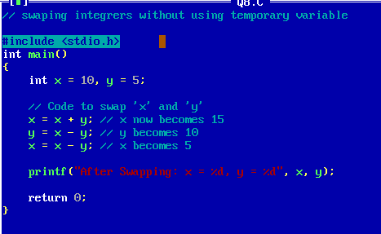

9. Write a ‘C’ program to accept character & display its ASCII value and its next & previous character.

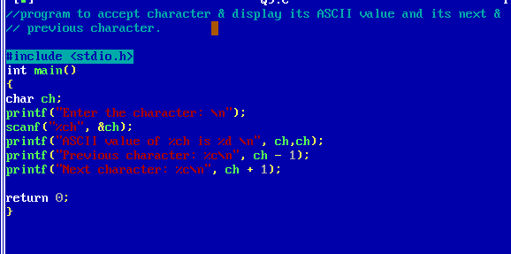

10. Write a ‘C’ program to calculate the sum of first n even numbers.

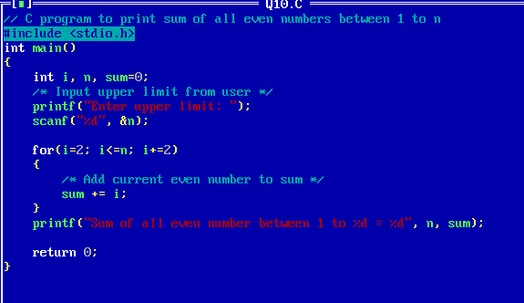

11. Write a ‘C’ program to print the ASCII value of any given character.

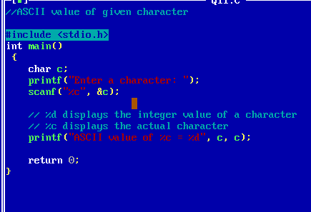

12. Write a ‘C’ program that takes two numbers as input from user and find maximum using if-else statement.

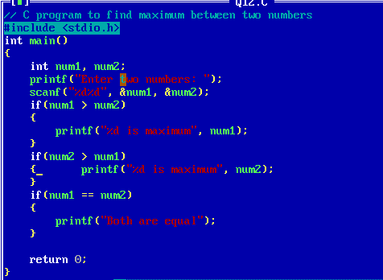

13. Write a ‘C’ program that takes two numbers as input from user and find maximum using conditional operator.

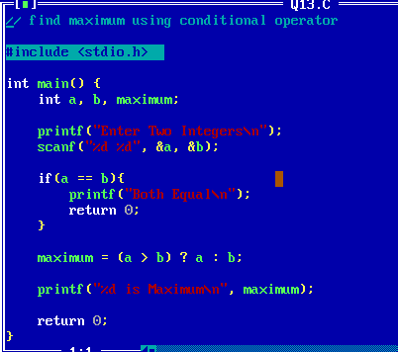

14. Write a ‘C’ program to take input student age and check whether given student can vote or not.

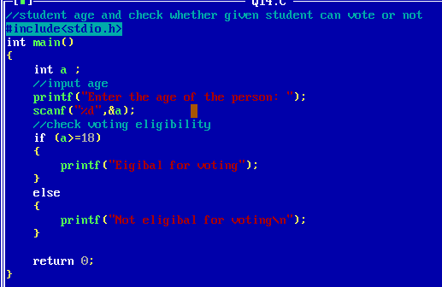

15. Write a ‘C’ program that takes a number as input from user and checks whether the number is even or odd using if-else statement.

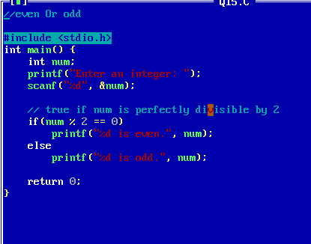

16. Write a ‘C’ program to check whether a given year is leap year or not using if-else statement

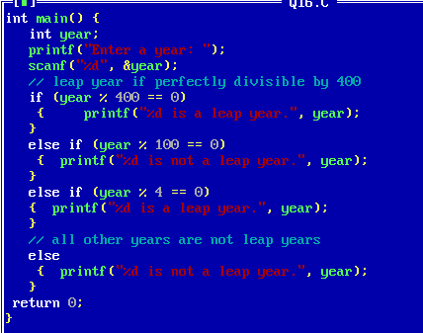

17. Write a ‘C’ program to check whether a given year is leap year or not using conditional operator.

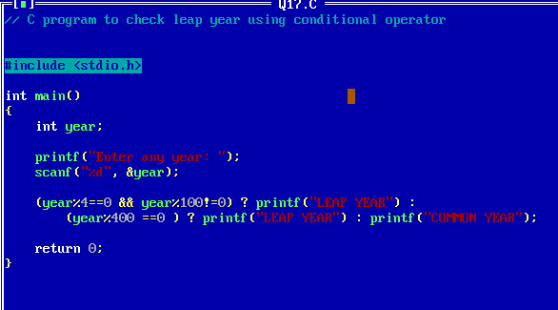

18. Write a ‘C’ program that takes a number as input from user and checks whether the number is even or odd using conditional operator

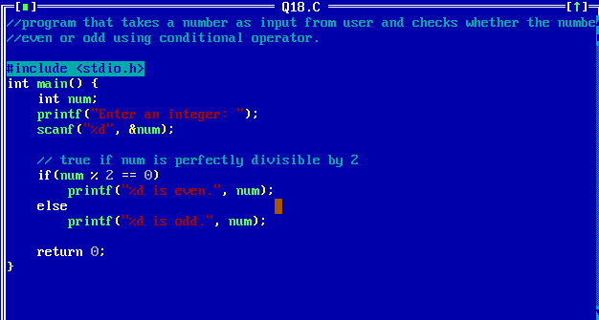

19. Write a ‘C’ program to display multiplication table of a given number.

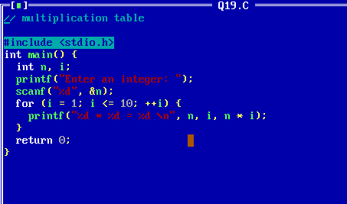

20. Write a ‘C’ program to check whether inputted character is digit or alphabet.

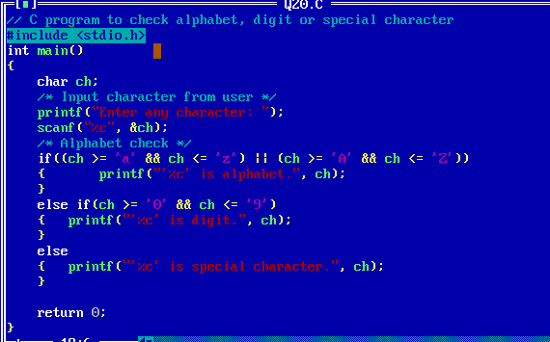

21. Write a ‘C’ Program to check whether given character is vowel or consonant.

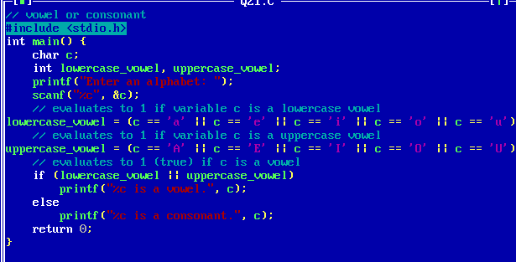

22. Write a ‘C’ Program to find factorial of a given number

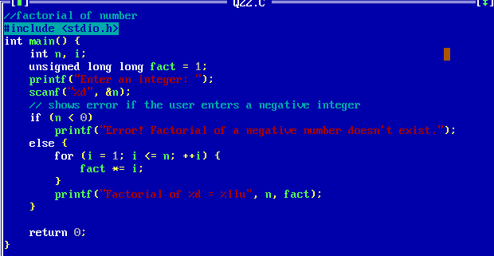

23. Write a ‘C’ Program to print the ASCII value of any given character.

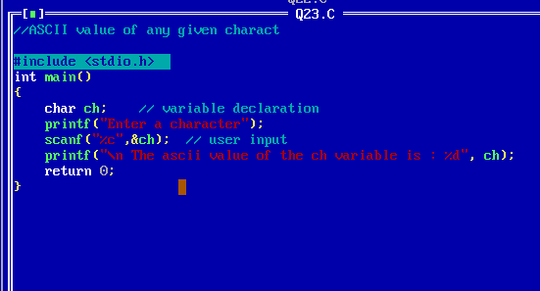

24. Write a ‘C’ program to accept one number and to calculate sum of digits

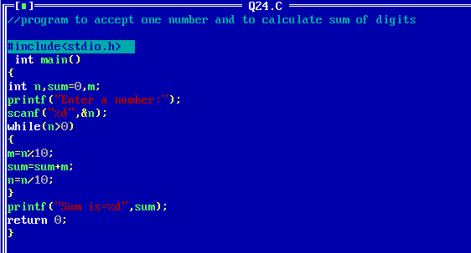

25. Write a ‘C’ Program to convert a given character into uppercase & vice versa.

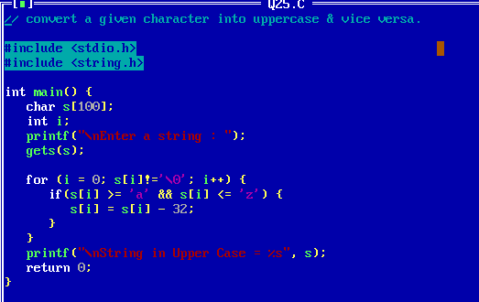

26. Write a ‘C’ Program to display reverse of a given number.

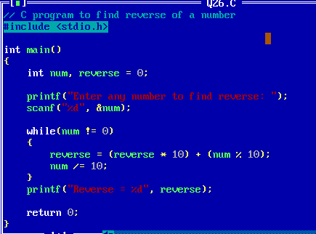

27. Write a ‘C’ Program to find power of a number (xn)

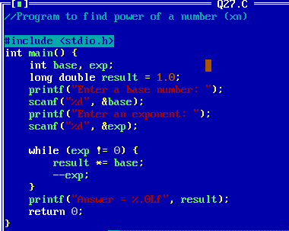

28. Write a ‘C’ Program to accept a number and check if is divisible by 5 and 7

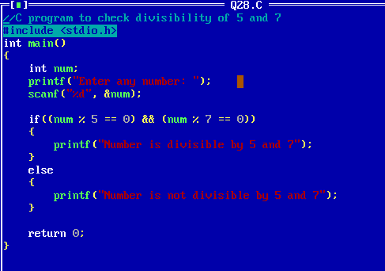

29. Write a ‘C’ Program to check whether a given character is a VOWEL or CONSONANT using switch-case statement.

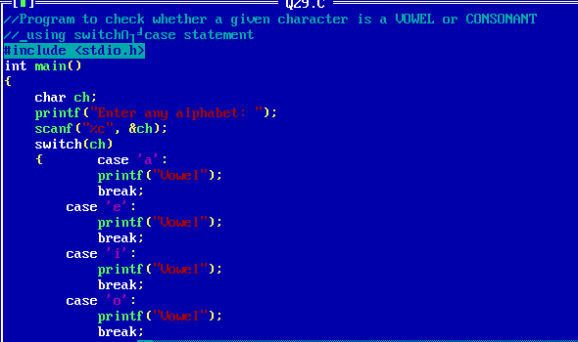

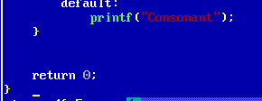

Q2]

1. Write a ‘C’ program to accept a number and check whether it is perfect or not using function.

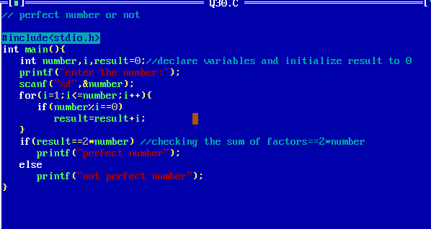

2. Write a ‘C’ program to find the sum of two matrices of order 3\*3 using multidimensional arrays.

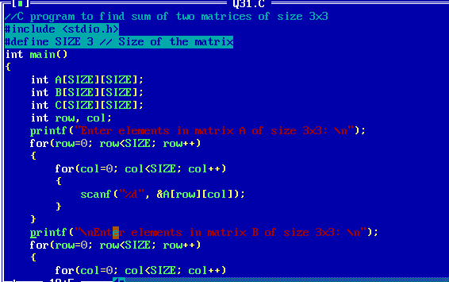

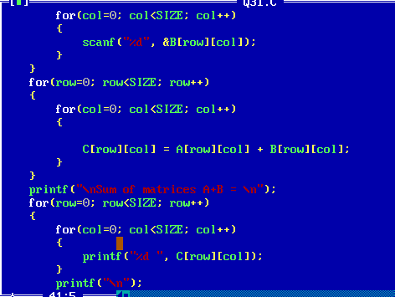

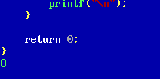

3. Write a ‘C’ program to find the transpose of a matrix.

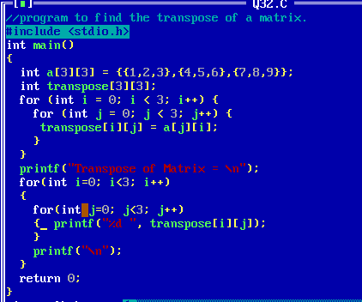

4. Write a ‘C’ program to store values entered by the user in a two-dimensional array and display it.

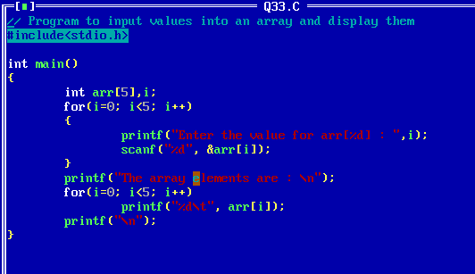

5. Write a ‘C’ program to read 5 integers in two arrays find the sum of these to array and store in third array and display it.

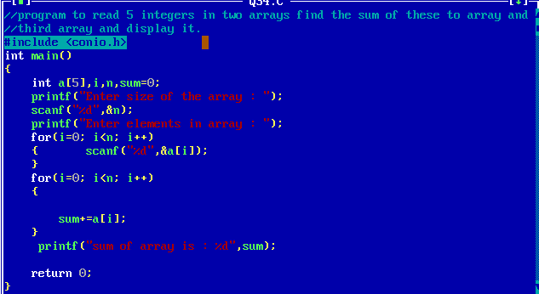

6. Write a ‘C’ program to accept n integers in an array. Display the given array in reverse order

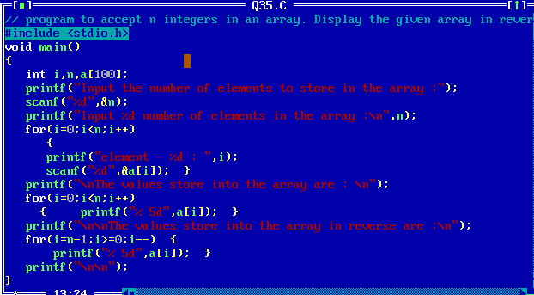

7. Write a ‘C’ program to read n integers in an array. Display alternate elements of that array.

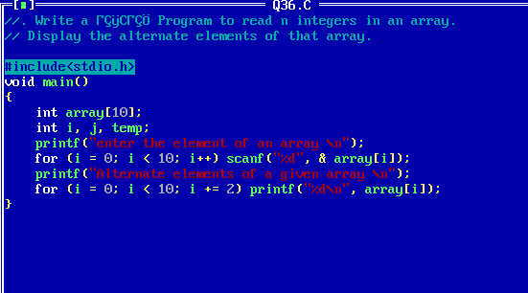

8. Write a ‘C’ program to find the factorial of an Integer using function.

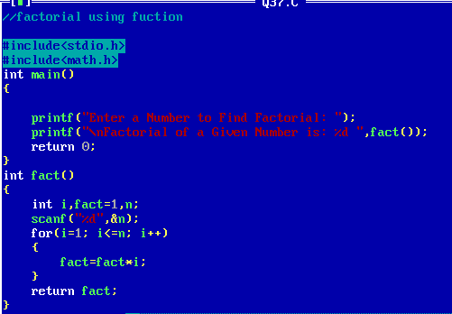

9. Write a ‘C’ program for a menu driven program which has following options:

1. Factorial of a number.

2. Odd or even

3. Exit

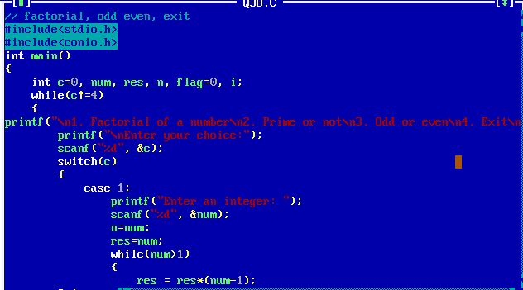

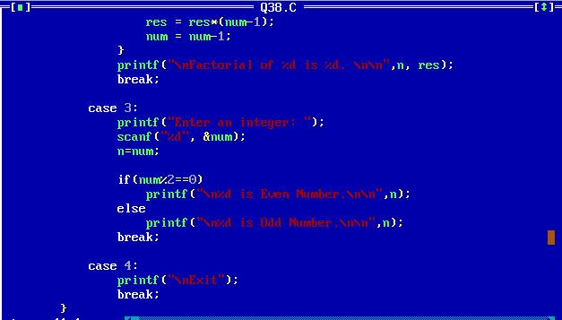

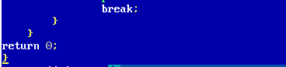

10. Write a ‘C’ program to find SUM and AVERAGE of two integer Numbers using function.

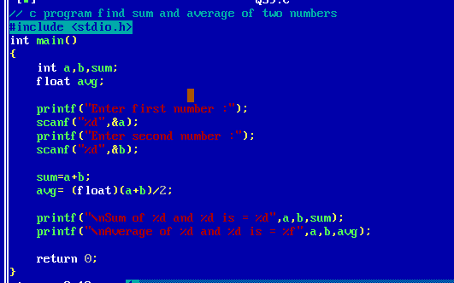

11. Write a menu driven program to perform the following operations on a character typevariable.

i. Check if it is an alphabet

ii. Check if it is a digit.

iii. Check if it is lowercase.

iv. Check if it is uppercase.

v. Convert it to uppercase.

vi. Convert it to lowercase.

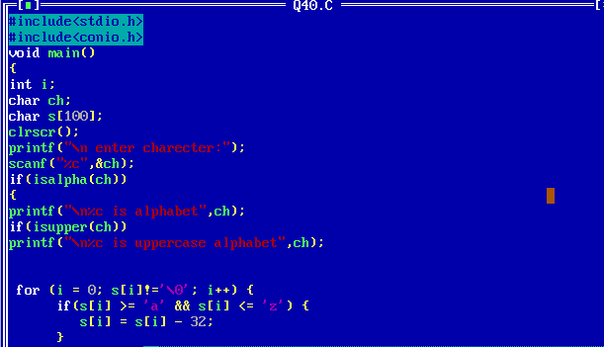

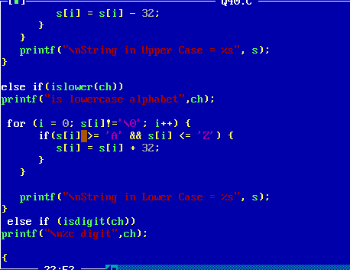

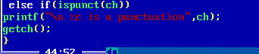

12. Write a menu driven program to create a simple calculator (Performs addition, subtraction, multiplication and division depending the input from user).

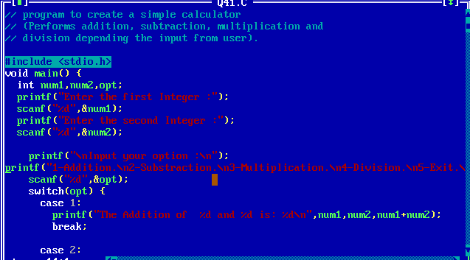

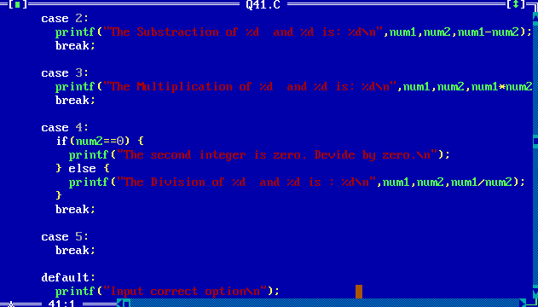

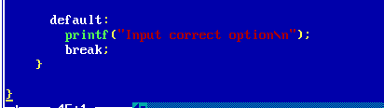

13. Write a ‘C’ program, which accepts a character from the user and checks if it is an alphabet, digit or symbol. If it is an alphabet, check if it is uppercase or lowercase and then change the case.

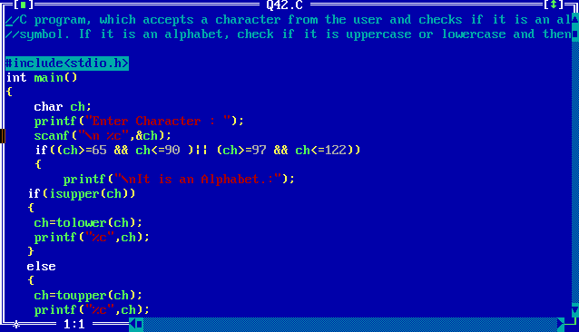

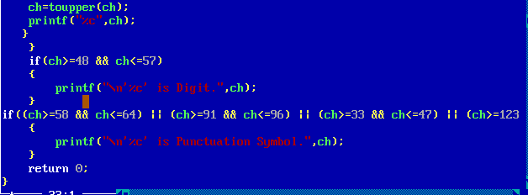

14. Write a menu-driven program using Switch case to calculate the following:

1. Area of circle

2. Area of square

3. Area of sphere

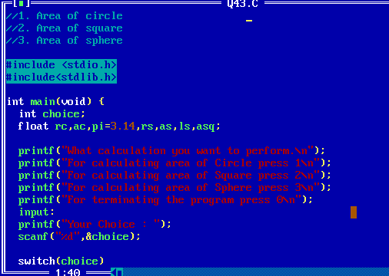

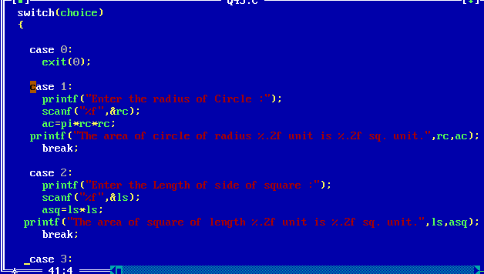

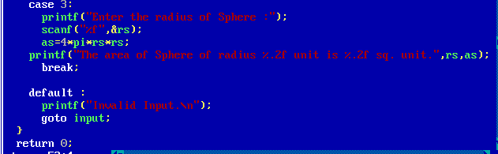

15. Write a ‘C’ program to check whether the enter number is Armstrong or not.

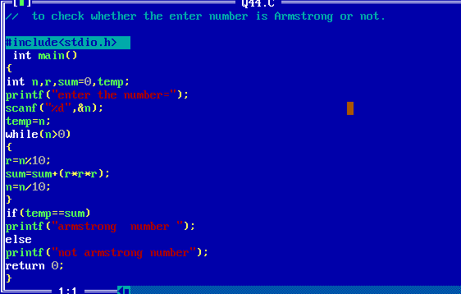

16. Write a ‘C’ program to check whether the enter number is palindrome or not.

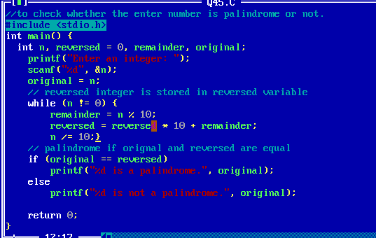

17. Write a ‘C’ program to print the number pattern.

1

1 2

1 2 3

1 2 3 4

1 2 3 4 5

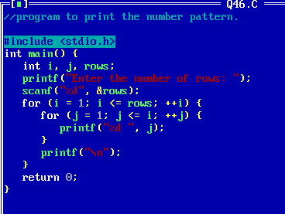

18. Write a ‘C’ program to check whether a given number is perfect number or not

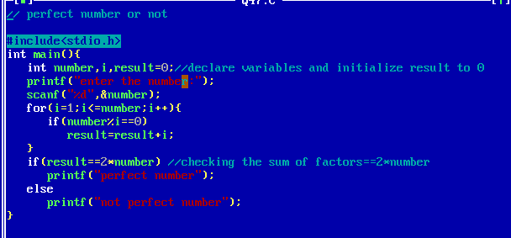

19. Write a ‘C’ program to check whether a given character is VOWEL or CONSONANT using switch-case.

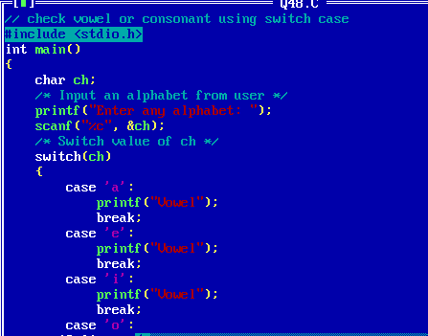

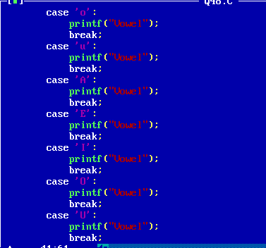

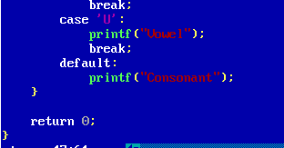

20. Write a ‘C’ program to find factorial of a number using Recursion.

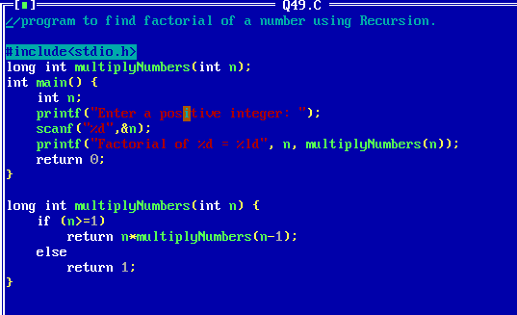

21. Write a ‘C’ program to print Fibonacci series of n numbers using recursion

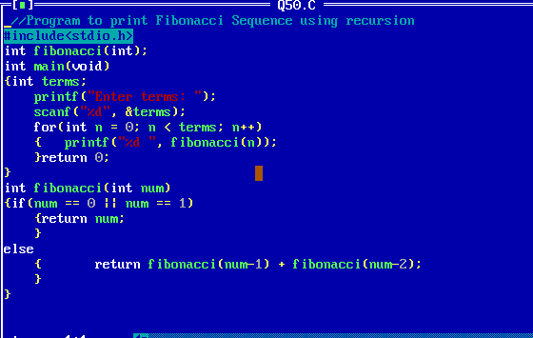

22. Write a ‘C’ Program to swap the values of two variables by using call by reference.

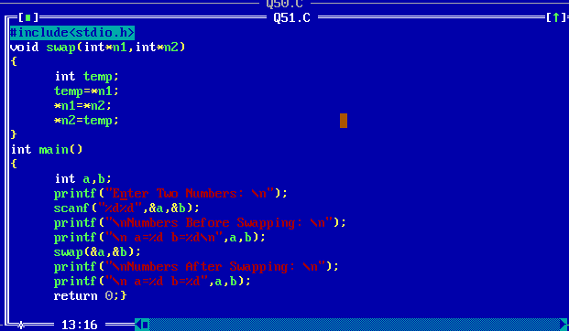

23. Write a ‘C’ Program to accept ‘n’ numbers from user, store these numbers into an array and sort the numbers of an array using function.

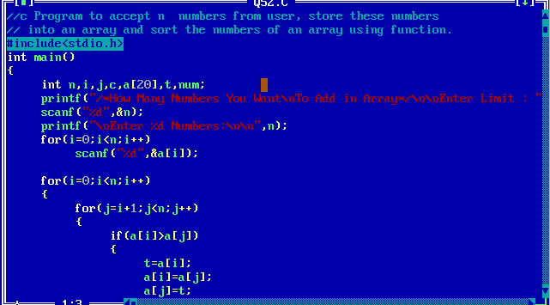

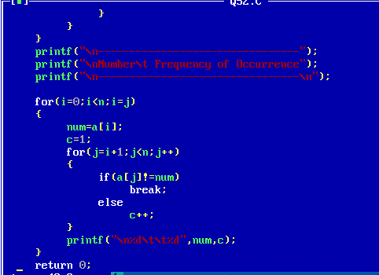

24. Write a ‘C’ Program to calculate the x to the power y without using standard function.

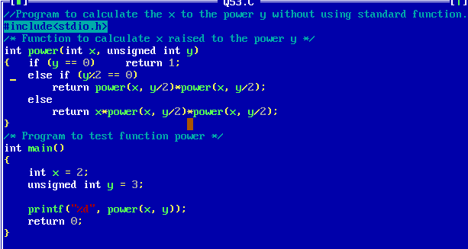

25. Write a ‘C’ Program to print the following pattern.

\* \* \* \* \*

\* \* \* \*

\* \* \*

\* \*

\*

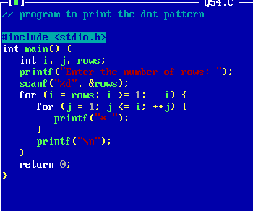

26. Write a ‘C’ Program to check whether a given number is prime number or not

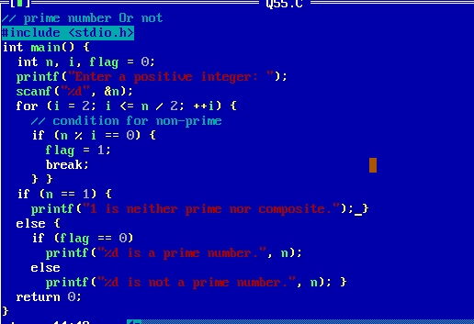

27. Write a ‘C’ Program to accept characters from the user and count total alphabet and digit till the user enters ‘$

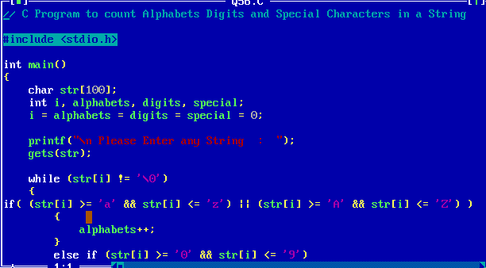

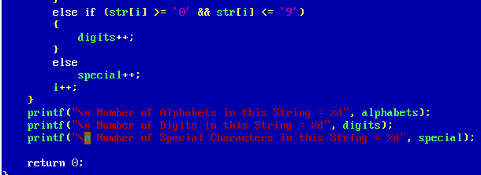

28. Write a ‘C’ Program to read n integers in an array. Display the alternate elements of that array.

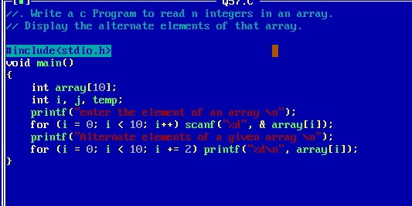

29. Write a menu driven program, accept two numbers and perform following options:

1. GCD of a number

2. LCM of a number

