VIRTUAL PAINT
MINI PROJECT 1A
BACHELOR OF COMPUTER SCIENCE AND DESIGN

By
Rohan Patil 12217042
Bhakti Patil 12217011
Soham S Bhere 12217012
Vaishali B Darwande 12317051

Guide:

Prof. Ms.Priyadarshini B.



Department of Computer Science & Design
New Horizon Institute of Technology and Management,
University of Mumbai

Department of Computer Science & Design
New Horizon Institute of Technology and Management,
University of Mumbai

CERTIFICATE

This is to certify that the mini-project entitled VIRTUAL PAINT, SECSD11 of

Sr.No. Name of the Student IEN No.
1 Rohan P. Patil 12217042
2 Bhakti A. Patil 12217011
3 Soham S. Bhere 12217012
4 Vaishali B. Darwande 12317051

Has satisfactorily completed the mini project -1A in partial fulfillment of the requirement for the award of the Degree of Bachelor of Engineering in “Computer Science & Design”.

Ms. Priyadarshini B.

Mini-Project Guide

Dr. Niranjan Kulkarni Dr. P. D. Deshmukh Head of Department
Principal

Department of Computer Science & Design
New Horizon Institute of Technology and Management,
University of Mumbai

Mini-Project -1AReport Approval for S.E.

This project report entitled “Virtual Paint” by Rohan Patil , Bhakti Patil , Soham Bhere and Vaishali Darwande is approved for the degree of Bachelors in Computer Science And Design,
2024-25.

Examiner Name Signature
1. Name

2. Name

Date:

Place:

Department of Computer Science & Design
New Horizon Institute of Technology and Management,
University of Mumbai

Declaration

We declare that this written submission represents my ideas in my own words and where others' ideas or words have been included, I have adequately cited and referenced the original sources. I also declare that I have adhered to all principles of academic honesty and integrity and have not misrepresented or fabricated or falsified any idea/data/fact/source in my submission. I understand that any violation of the above will be cause for disciplinary action by the Institute and can also evoke penal action from the sources which have thus not been properly cited or from whom proper permission has not been taken when needed.

Rohan Patil 12217042

Bhakti Patil 12217011

Soham Bhere 12217012

Vaishali Darwande 12317051

Date:

Department of Computer Science & Design
New Horizon Institute of Technology and Management,
University of Mumbai
Acknowledgement
We extend our sincere and heartfelt thanks to our esteemed guide Prof. Priyadarshini B., for providing us with the right guidance and advice at the crucial junctures and for showing me the right way. We also take this opportunity to express a deep sense of gratitude to our coordinator Ms. Priyadarshini B. for their cordial support, valuable suggestions and guidance. We extend our sincere thanks to our respected Head of department Dr. Niranjan Kulkarni, for allowing us to use the facilities available. We would like to thank the other faculty members also, at this occasion. Last but not the least, we would like to thank our friends and family for the support and encouragement they have given us during our work.

1.Rohan Patil
2.Bhakti Patil
3.Soham Bhere
4.Vaishali Darwande

Abstract

The Virtual Paint Project is an innovative digital platform designed to revolutionize the traditional art of painting by leveraging cutting-edge virtual reality (VR) technology. This project aims to provide a unique and immersive artistic experience for both novice and experienced painters, breaking the barriers between physical and digital art creation.
With the proliferation of VR hardware and the increasing popularity of digital art, the Virtual Paint Project bridges the gap by offering a virtual canvas that emulates the tactile sensations of real-world painting. Users can select from a wide range of digital brushes and mediums, creating a seamless transition from traditional to digital artistry. The project also integrates features like 3D painting, layering, and undo/redo functions, enhancing creative flexibility and making it suitable for artists of all levels.
Moreover, the Virtual Paint Project is designed for collaborative art creation. Artists can invite others to join their virtual canvas, enabling real-time collaboration and fostering a global artistic community. This project's potential applications span from recreational artistry and educational purposes to professional design and collaborative projects.
The Virtual Paint Project promises to redefine the boundaries of creativity, offering a groundbreaking and immersive experience for art enthusiasts while showcasing the incredible possibilities that virtual reality technology can bring to the world of visual art. This abstract outlines the project's key features and its potential impact on the art community and beyond

Table of Content

0.1 ……….………………………………………………….………………………………...1
0.2 Certificate……….………………………………………………….…………………….II
0.3 Certificate……….………………………………………………….……………………III
0.4 Declaration……….………………………………………………….…………………. IV
0.5 Abstract……….………………………………………………….…………………… . .V
1.0 Introduction……….………………………………………………….…………………..1
2.0 Literature Survey……………………………………..………………………………….2
2.1 Virtual Paint……………… ……………………………………………………….2

3.0 Problem Statement, Objectives and Scope …..……………….………………………..5
3.1 Problem Statement …………………………………………..…………...…...…..5
3.2 Objectives…………………………………………………….…………............…6
3.3 Scope…………………………………………………………..…………….......…6
4.0 Proposed System…………………………………………………………………...……...7
5.0 Implementation……………………………………………………………..……….11
5.1 Harware and software Requirment…………………………………………………11
5.2 Schedule Table……………………………………………………..……...........…..12
6.0 Expected Outcome………………………………………………………………...….…...13
7.0 Conclusion…………………………………………………………………………………15
7.1 Conclusion…..……………………………………………………………..........….15
7.2 Future Scope…..……………………………………………………………...…….15
8.0 References …………………………………………………………………..….…….16
List of Figures

Fig.No. Content Page No.
1. Fig 1-Table 2.1 3
2. Fig 2-Table 2.2 4
3 Fig 3-Flowchart 8
4. Fig 4-Workflow 9
5. Fig 5-Workflow 2 10

CHAPTER 1

INTRODUCTION

Introduction
In a rapidly evolving digital landscape, the fusion of art and technology has birthed a revolutionary concept: the Virtual Paint Project. This endeavor represents a pioneering leap into the world of digital artistry, where the lines between the physical and virtual realms blur, and artistic creativity knows no bounds. The Virtual Paint Project is an ambitious and innovative undertaking that leverages the power of virtual reality (VR) to reshape the art world as we know it.
As the realms of technology and art continue to converge, this project emerges as a beacon of creativity, offering artists, designers, and enthusiasts a groundbreaking platform to unleash their imaginations and craft immersive, digital masterpieces. With the proliferation of VR hardware and software, Virtual Paint opens up a realm of possibilities that transcend the limitations of traditional art forms.

CHAPTER 02

LITERATURE SURVEY

2.1 Virtual Paint

The concept of virtual painting has evolved through various digital art tools and technologies. Early tools like Microsoft Paint offered basic drawing functionalities, while more advanced software like Adobe Photoshop and CorelDRAW introduced layers, brushes, and image manipulation features. Recent innovations include gesture-based drawing systems using computer vision, such as OpenCV, enabling hands-free interaction. Virtual painting applications have also expanded into augmented and virtual reality, offering 3D drawing environments. Python libraries like Pygame, OpenCV, and Tkinter provide accessible frameworks for building interactive digital art platforms, allowing developers to create intuitive painting experiences with potential for advanced features.
Following task shows a review of various proposed hand motion and PC based ways to V Shiva Narayana Reddy 154 deal with dispose of equipment interfaces that costs less. Paint Using Hand Gesture: Machine Learning Approach , they examined about signal based paint tool stash which has 6 motions to define boundary, draw circle. This paper states different methodologies through which a paint tool compartment precision can be accomplished. They have Haar-Like classifier which is utilized to follow the hands and they have additionally involved edge identification for working out limit worth of the item which is before the camera. They execute this by utilizing straightforward hand motions and web cam of PC or woFollowing task shows a review of various proposed hand motion and PC based ways to V Shiva Narayana Reddy 154 deal with dispose of equipment interfaces that costs less. Paint Using Hand Gesture: Machine Learning Approach , they examined about signal based paint tool stash which has 6 motions to define boundary, draw circle. To accomplish more exactness than some other methodology they have utilized AI approach.

2.2Problem Statement
In the realm of contemporary art, the convergence of technology and creativity has ushered in a new era of artistic expression. The emergence of virtual painting, a fusion of traditional artistry with virtual reality, presents an exciting and transformative frontier. However, as this innovative approach gains momentum, several critical challenges and unaddressed issues need to be tackled to unlock its full potential. This problem statement encapsulates these challenges and paves the way for the Virtual Paint Project to address them effectively. The Virtual Paint Project aims to tackle these challenges head-on, providing innovative solutions to make virtual painting more accessible, engaging, and meaningful for a wide range of users, including artists, educators, therapists, and enthusiasts. By addressing these issues, the project strives to unlock the full potential of virtual painting as a powerful and transformative medium in the world of art and technology.

  - Objectives
The objective of this project is to develop virtual paint based automated system. Expected achievements in order to fulfill the objectives are:
- Enhance Accessibility: Make virtual painting accessible to a wide range of users, regardless of their technical expertise or economic constraints, by developing user-friendly interfaces and promoting affordable hardware options.
- Optimize User Experience: Create an immersive and intuitive virtual painting environment by improving user interface design, haptic feedback, and responsiveness, ensuring that users can seamlessly transition from traditional to virtual painting.
- Preserve Artistic Authenticity: Develop tools and techniques that maintain the emotional depth and authenticity of an artist's work, enabling artists to express themselves fully in the virtual realm while retaining their personal touch.
- Foster Collaboration and Sharing: Facilitate real-time collaboration among artists in virtual spaces, allowing for joint art creation and the establishment of a thriving online art community.

Scope
In Future It Will Help For Time-Saving For Your Workforce
- It Will Increased Efficiency and Capability
- It Will Be Cost Cutting And Will Save Money
- It Will Enhances Workplace Security
- It Will Help To Keep Automated Time Tracking
- It Will Easy To Manage Records

CHAPTER 3

PROPOSED SYSTEM

3.1 Proposed System

1. Virtual Painting Environment:
The core of the system is an immersive virtual painting environment, accessible through virtual reality (VR) headsets. This environment replicates the look and feel of a traditional art studio, offering a canvas, a variety of brushes, and an extensive color palette.

2. User Interface:
An intuitive and user-friendly interface is designed to ensure that artists can easily navigate the virtual painting environment. This includes menus for selecting tools, adjusting settings, and accessing resources.

3. Real-time Collaboration:
The system allows artists to collaborate in real-time within shared virtual spaces. Multiple artists can work on the same canvas simultaneously, making it possible to create collaborative artworks.

4. Haptic Feedback:
The proposed system incorporates haptic feedback to enhance the user experience. Artists will feel tactile responses when using different brushes and tools, closely simulating the sensation of real painting.

5. Diverse Brushes and Mediums:
A wide range of digital brushes and mediums is available, enabling artists to experiment with various artistic styles and techniques. These digital tools replicate the characteristics of traditional art supplies.

6. Artistic Expression Tools:
Tools that capture and preserve the artist's emotional depth and authenticity are integrated. These tools allow artists to infuse their virtual artworks with their unique style and personality.

WORKFLOW

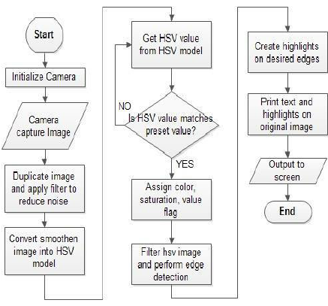

Fig 1: Flowchart

CHAPTER 4
IMPLEMENTATION

4.1 Hardware Software Requirment
1. Hardware
Windows Requirements
RAM: 4 GB
CPU: Intel Pentium
Web Browser: chrome, firefox, etc.
OS: Windows 8
Android Requirements
RAM: 4 GB
processor: Snapdragon 425
Network: Internet Connection 4g/5g.
OS: Android 10

2.Software
1.Integrated Development Environment (IDE): Visual Studio Code (VS Code) Version: 1.83.1.
2.Markup Language: Hypertext Markup Language (HTML5) Version: 4.01.
3.Scripting language: JavaScript (JS) Version: ES2024.
4.Styling: Cascading Style Sheets (CSS) Version W3.CSS.
5. Logic : Python 3.11.4

4.2 Implementation Plan

Week 1 | Discussion of topic
Week 2 | Gathering information & learning language
Week 3 | Confirmation of topic
Week 4 | Learning VScode
Week 5 | Working on Frontend
Week 6 | Linking the Database
Week 7 | Working on Backend
Week 8 | Final Touchup and testing

CHAPTER 6
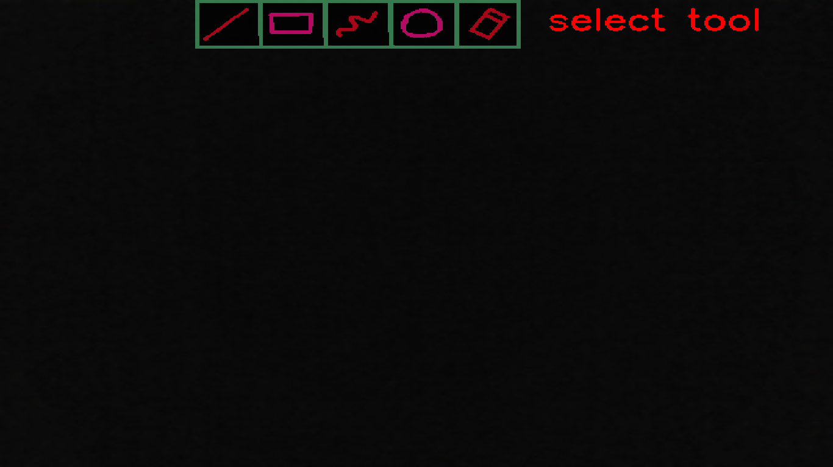
Expected Outcome
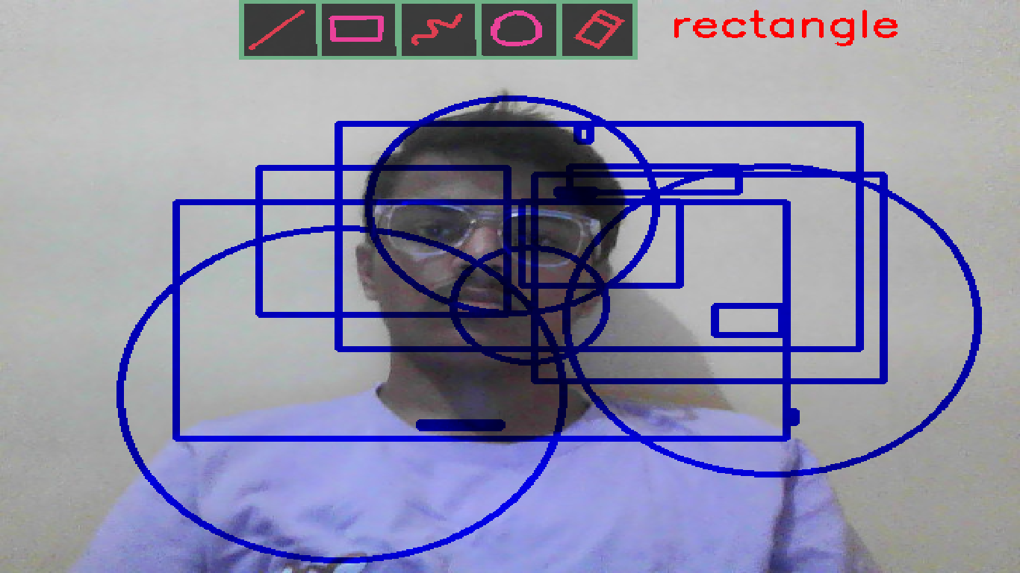

CONCLUSION

The Virtual Paint project, developed using Python, serves as an engaging platform for digital drawing and creativity. Its simplicity makes it accessible to users of all skill levels, while its potential for future enhancements—such as advanced drawing tools, AI integration, and collaboration features—ensures its relevance in both educational and professional contexts. By incorporating technologies like OpenCV for gesture recognition and network programming for real-time collaboration, the project could evolve into a versatile tool for artists, educators, and hobbyists. Overall, this project lays a solid foundation for creative exploration with extensive possibilities for growth and innovation.

The Virtual Paint Project represents an exciting and transformative journey into the world of virtual art creation, where traditional techniques merge seamlessly with cutting-edge technology to redefine the boundaries of artistic expression. As we conclude our exploration of this project, it becomes evident that it holds the promise of revolutionizing how we engage with art, connect with others, and nurture creativity in the digital age.
Through an in-depth analysis of the key features and objectives, we recognize the potential of this project to democratize art, making it more accessible and inclusive. The commitment to user experience, collaboration, and education ensures that artists, educators, and enthusiasts find a welcoming and vibrant community to explore their creative potential.
However, the journey does not end here. Challenges related to ethical considerations, intellectual property, and environmental sustainability remain, awaiting innovative solutions. The Virtual Paint Project recognizes the importance of ongoing research and development, remaining at the forefront of technology to continuously improve the user experience and expand the horizons of virtual artistry.

REFERENCE

[1]. David lee,Juon hub Lee,” virtualization of pen head for digital drawing”, Published: 07 October 2022
[2]. Nanditha G. Bharadwaj; Nanditha Pa, “Smartolight-pen and User Interface Screen enabled with URL detection” 2022 IEEE North Karnataka subsection flagship international conference (NK Con)
[3].Hanbit Park Minsoon Hahn , “Digital painting tool with shaking interaction”, INSPEC Date Added to IEEE Xplore: 03 August 2021.
[4]. Bruce Wands,,” Art of The Digital Age”, Thames and Hudson University of Brighton Publication status Published - 2021
[5]. D. Sobczyk, V. Boyer and J-J. Bourdin, “The Virtual Painting Paintbox”,Université Paris 8,2020
[6]. What is Virtual Paint and how sinister is it, Theguardian, IanSample, July, 2020. [Online]. Available: https://www.theguardian.com/technology/2019/jul/29/what-is-virtualpaint-and-how-sinister-is-it. [2020]
[7]. Kushsairy Kadir , Mohd Khairi Kamaruddin, Haidawati Nasir, Sairul I Safie, Zulkifli Abdul Kadir Bakti,"A comparative study between LBP and Haar-like features for Virtual Paint using OpenCV", 4th International Conference on Engineering Technology and Technopreneuship (ICE2T), DOI:10.1109/ICE2T.2014.7006273, 12 January 2021. [2021]
[8]. Virtual Paint: Understanding LBPH Algorithm,Towards Data Science90ec258c3d6b,Kelvin Salton do Prado, Nov 11, 2019.[Online]. Available : https://towardsdatascience.com/virtual-paint-how-lbph-works-90ec258c3d6b [2019]
[9]. A brief history of Virtual Paint, NEC, New Zealand,26 May 2012.[Online]. Available: https://www.nec.co.nz/market-leadership/publications-media/a-brief-history-of-virtualpaint/ [2012]
[10]. Virtual Paint,TechTarget Network, Corinne Bernstein, Feb, 2020.[Online]. Available: https://searchenterpriseai.techtarget.com/definition/virtual-paint [2016]

