Training #1 (showing utilization on two separate nodes)
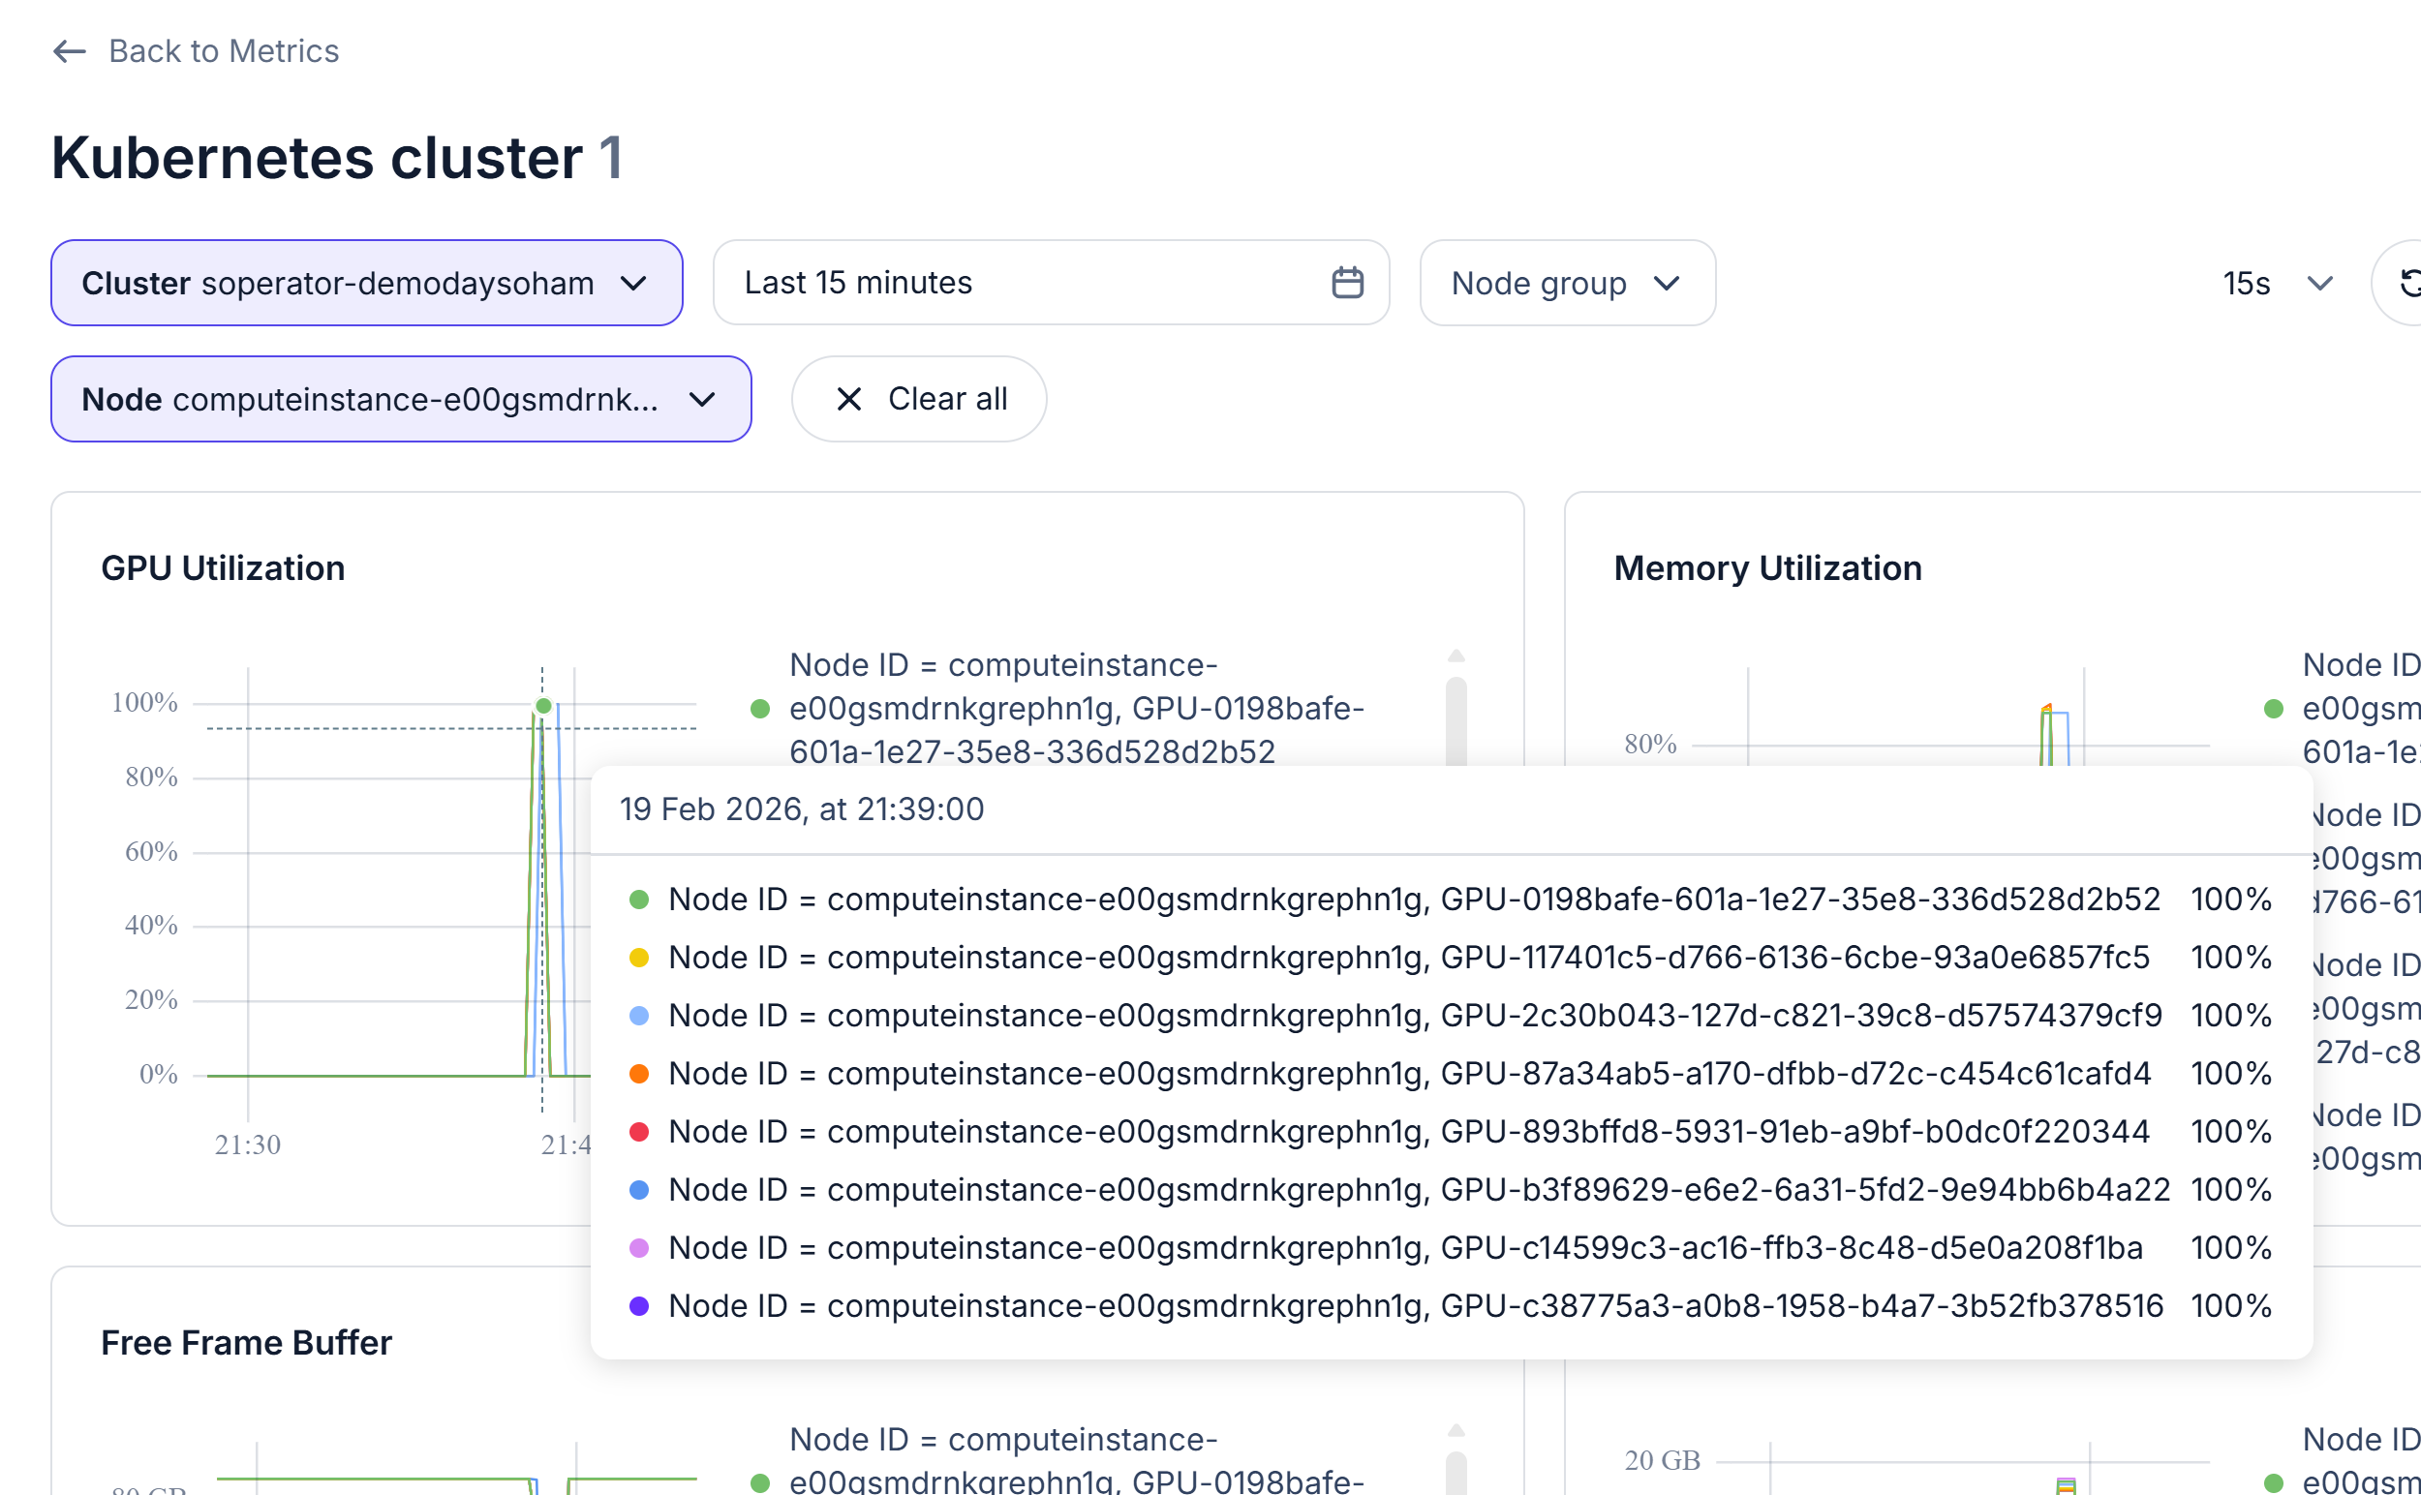

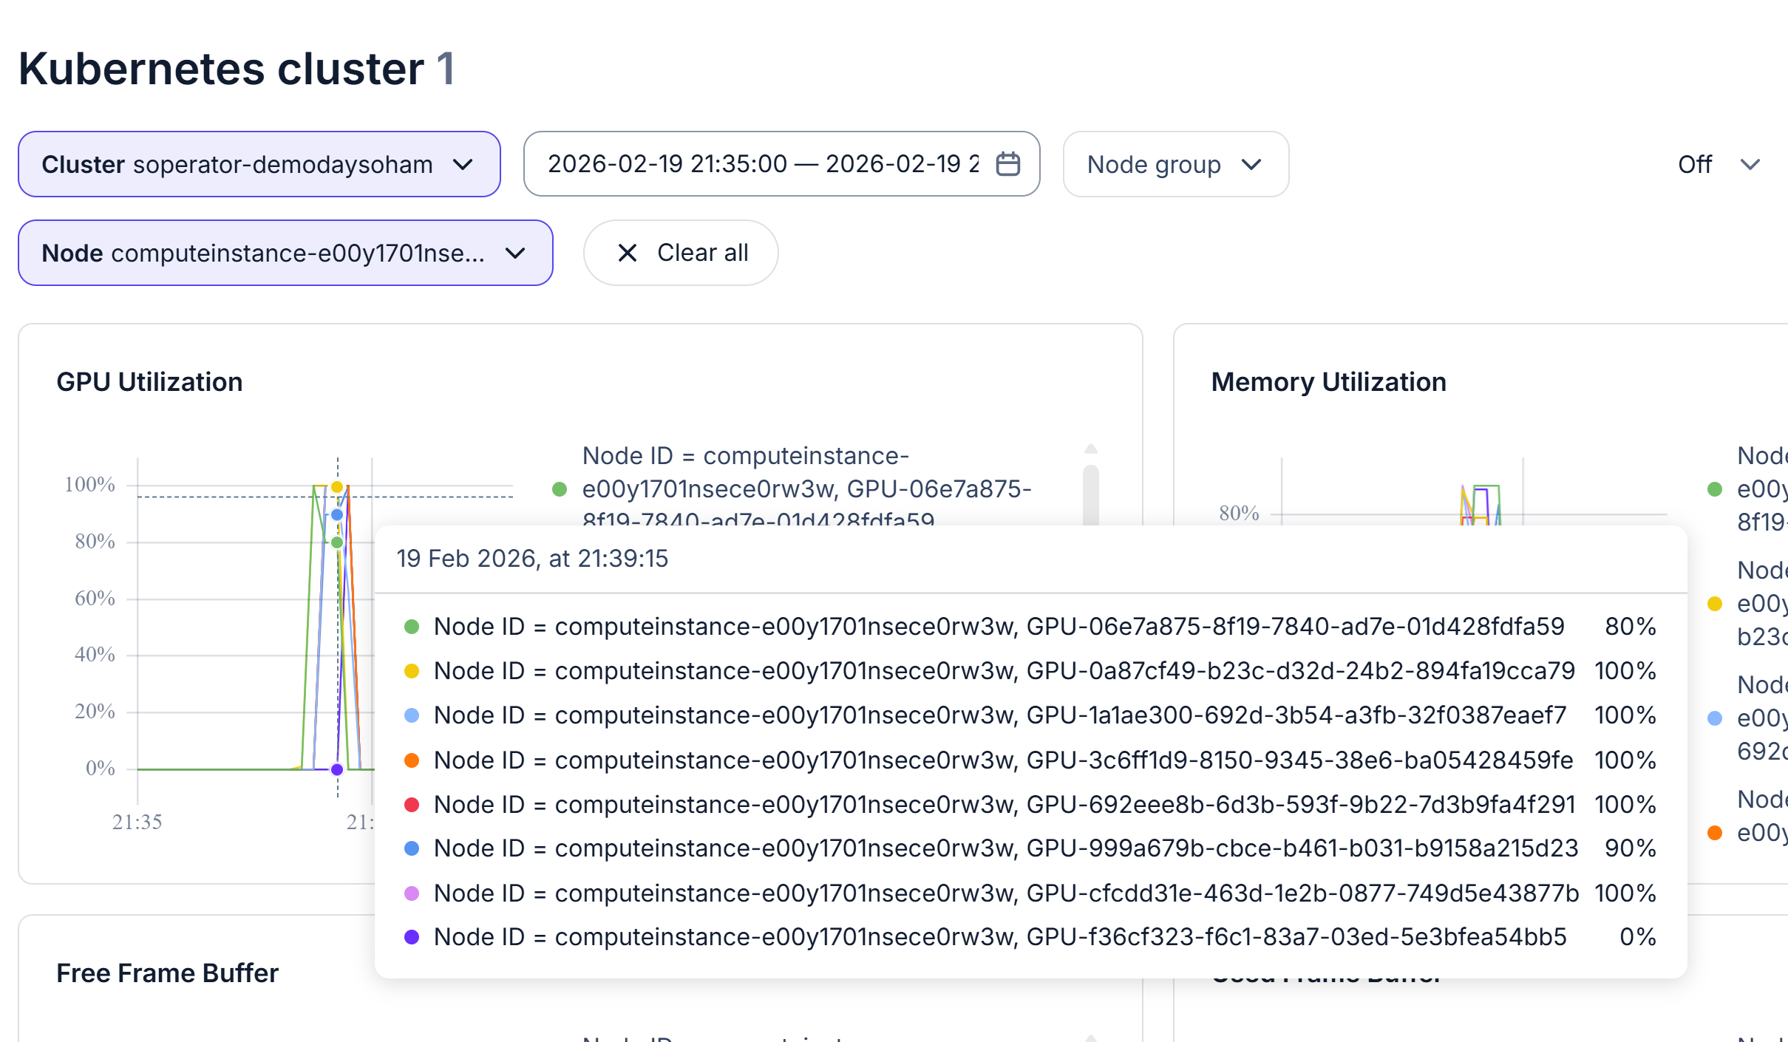

Training #2 (showing utilization on two separate nodes)

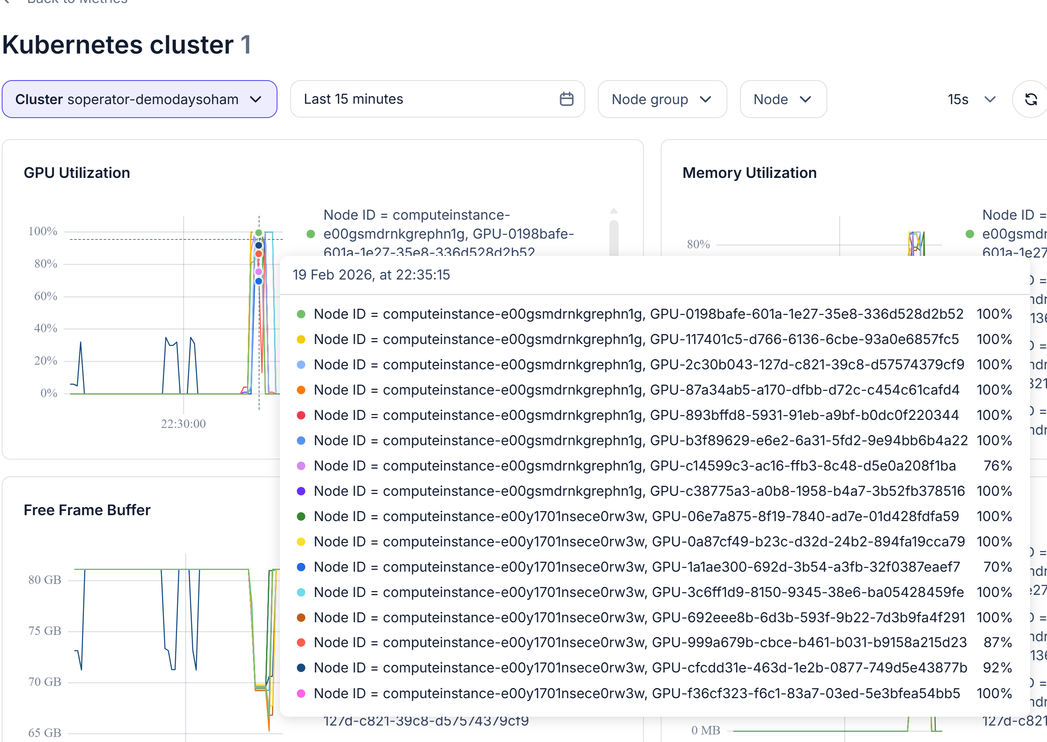

Training #3 (Mistral-7b with 15 epochs)
