**PROJECT REPORT**

(SUMMER TRAINING)

## NETWORK DESIGN PROPOSAL FOR A FICTIONAL

## UNIVERISTY

CDAC, Mohali

Submitted by

**Soham Ghosh**

**Roll No – 101403178**

**COE 8**

Under the Guidance of

Mr. Vijay Kumar

# Department of Computer Science and Engineering

**THAPAR UNIVERSITY, PATIALA**

**July 2016**

**ACKNOWLEDGEMENTS**

First of all, I would like to thank my esteemed mentor at The Centre for Development of Advanced Computing (CDAC), Mohali – Mr. Vijay Kumar – whose experience and knowledge is immense, but that does not detract from his willingness to help, and entertain even the smallest of doubts.

I would like to thank CDAC, Mohali for the training they provided me in the field of Networking – it has been heartening to see that everyone, whether it be the receptionists, and the support stuff, are equally humble. And the training was everything you could hope for, and then some more.

I would also like to thank the various creators of the websites and books I poured over while searching for more information on both the field and which projects to make. Although unnamed, your contributions cannot be denied.

Last, but not the least, I would like to thank the folks out there at Cisco Inc., for developing the piece of art that is the Cisco Packet Tracer (SE). The things you can do with this software never cease to astound me.

**DECLARATION**

I hereby declare that the project work entitled “Network Design Proposal for a University” is an authentic record of my own work carried out at “Centre for Development of Advanced Computing, Mohali” as requirements of 6 weeks’ summer training for the award of degree of B.E. (Computer Science & Engineering), Thapar University, Patiala, under the guidance of Mr. Vijay Kumar, during the period of 6th June, 2016 to 15th July, 2016.

I further declare that no part of this report is copied from Internet or any other source.

Date: 15th July, 2016

**Soham Ghosh**

**101403178**

**INDEX**

Introduction to Project

Abstract

Company Profile

Project Scope

University and Project Details

Devices used in Project

Network Topology Diagram

Screenshots

Requirement Analysis and Solution Explanation

Services and Features

Future Work

Conclusion

Certificate

Bibliography

**INTRODUCTION TO PROJECT**

**Introduction to Networking**

Each of the past three centuries was dominated by a single new technology. The highlight of the 18th century was the automation, bought about by the Industrial Revolution. The 19th century was the age of the steam engine, pioneered by James Watt 20th century, the key technology was gathering, processing, and distribution of information. Among other developments, we saw the installation of global telephone networks, the invention of both radio and TV, the birth and unforeseen (and exponential) growth of the Computer, the launching of communication satellites, and, of course, the Internet.

As a result of technological progresses, differences between collecting, transporting, storing, and processing information are quickly disappearing. Organizations with hundreds of offices spread over a wide geographical area can examine the current status of even their most remote outpost at the push of a button. The demand for ever more sophisticated information processing is growing even faster.

Although the computer industry is still young compared to other industries (e.g., automobiles and airline industry), computers have made amazing progress in a (relatively) short time-frame. During the first 20 years of their existence, computer systems were extremely centralized, usually within one large room. Not infrequently, this room had glass walls, through which visitors could gaze and marvel at the electronic wonder inside. A medium-sized company or university (for example, Dartmouth) *may* have had one or two computers, while very large institutions (for example, the Smithsonian Museum) had at *most* a few dozen. The idea that within less than 35 years, vastly more powerful computers smaller than the stamps used in postcards, would be mass produced by the *billions* was pure science fiction.

The merging of computers and communications has had a profound influence on the way computer systems are organized. The pre-dominant concept of the “computer center” as a single room with a large computer to which users brought their work, which an operator fed into the computer, is now obsolete. The old model of a single computer serving all of the organization’s needs has been replaced by one in which a large number of separate, but still interconnected computers, do the job.

These systems are called ***computer networks***. Two computers are said to be interconnected if they are able to exchange information. The connection need not be via a copper wire - fiber optics, microwaves, IR, and even satellites can be used (and are in use). They are usually connected together to make larger networks, with the Internet being the most well-known example of a network of networks.

**Introduction to Project**

Have you ever wondered *how* the networks you use daily – the ones supplied by BSNL, MTNL, Airtel, Cyberoam, Reliance, and so on – work the way they do?

Not the *software* part (HTML, CSS, MySQL, JS, PHP, etc.). The *hardware* part.

If the reader has read the introduction provided for a basic and brief understanding of networking, he may wonder about the *devices*, and the way the devices are *arranged* to form a network.

The networks used in almost all the universities around India are extremely inefficient (cost-bandwidth ratio is very high). So, keeping this in mind, the project is a basic design, a *template*, if you may, that is cost-efficient, while at the same time, supplies a decent bandwidth to the network.

It can be used both for designing a small to medium-sized network, and can even be used for upgrading a network. In case it is not obvious, the design is provided free-of-charge, with lifetime updates, under the GNU General Public License v3 – which means that if you want to supply the project under your own company, you can, but just include this report with the design.

Again, in case it is not obvious, the design is a PKT File – it can *only* be opened by Cisco Packet Tracer. You will need an account on <http://www.netacad.com/> , from where you can download Packet Tracer for your respective platform.

**ABSTRACT**

This project is based on the “trending” field of Networking and Data Communications. People nowadays use the term for almost new technology that comes out and slowly fizzles out.

But Networking is the only “real” trending field, along with Data Structures and Algorithms, and Machine Learning. Both have existed almost since the advent of Computer Science. Both have the best of the best in CS working in the fields, huge wads of cash are thrown at the fields, and even bigger wads of cash are the result.

I found, from various forums and site around India and abroad (for example – MNIT, UCB, Stanford, Dartmouth, BITS, etc.) that use up huge amounts of green paper on extremely inefficient networks, that could have been diverted elsewhere, for example, on purchasing commercial licenses for software (such as Packet Tracer, AutoCAD, Windows, etc.), improving the infrastructure, PR/Marketing, and so on.

This project is a result of not inconsiderable toil. I have attempted to create a template that can be applied to *all* universities that do not have a very large size. I have given all the basic information necessary for setting up a network – the devices used, the network topology diagram, requirement analysis and so on.

I hope that I have convinced the reader that the field is interesting, as is the idea behind the project. The rest, I leave up to you.

**ABOUT C-DAC**

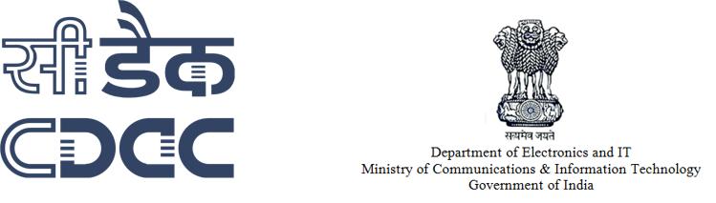

Centre for Development of Advanced Computing (C-DAC) is the premier R&D organization of the Ministry of Electronics and Information Technology for carrying out R&D in IT, Electronics and associated areas.

* The setting up of C-DAC in 1988 itself was to build Supercomputers in context of denial of import of Supercomputers by USA. Since then C-DAC has been undertaking building of multiple generations of Supercomputer starting from PARAM with 1 GF in 1988.
* Almost at the same time, C-DAC started building Indian Language Computing Solutions with setting up of GIST group (Graphics and Intelligence based Script Technology); National Centre for Software Technology (NCST) set up in 1985 had also initiated work in Indian Language Computing around the same period.
* Electronic Research and Development Centre of India (ER&DCI) with various constituents starting as adjunct entities of various State Electronic Corporations, had been brought under the hold of Department of Electronics and Telecommunications in around 1988. They were focusing on various aspects of applied electronics, technology and applications.
* With the passage of time as a result of creative echo system that got set up in C-DAC, more areas such as Health Informatics, etc., got created; while right from the beginning the focus of NCST was on Software Technologies, similarly C-DAC started its education & training activities in 1994 as a spin-off with the passage of time, it grew due to large efforts to meet the growing needs of Indian Industry for finishing schools.

C-DAC has today emerged as a premier R&D organization in IT&E (Information Technologies and Electronics) in the country working on strengthening national technological capabilities in the context of global developments in the field and responding to change in the market need in selected foundation areas.  In that process, C-DAC represents a unique facet working in close junction with MeitY to realize nation’s policy and pragmatic interventions and initiatives in Information Technology. As an institution for high-end Research and Development (R&D), C-DAC has been at the forefront of the Information Technology (IT) revolution, constantly building capacities in emerging/enabling technologies and innovating and leveraging its expertise, caliber, skill sets to develop and deploy IT products and solutions for different sectors of the economy, as per the mandate of its parent, the Ministry of Electronics and Information Technology, Ministry of Communications and Information Technology, Government of India and other stakeholders including funding agencies, collaborators, users and the market-place.

**PROJECT SCOPE**

The project is intended for small organizations, under the aegis of which both educational institutions, and corporate offices lie. Although the project boasts of only a small number of devices (both in quantity and variety), the project can easily be extended for a large number of client PCs and devices as well – just increase (proportionately) the number of devices used – add more devices attached to each router, switch, and so on.

The project has been made efficiently, keeping in mind the huge wads of cash small universities lack – the number of wires is kept to a minimum, which, due to their great amount of quantity, can cut a significant amount of the total budget – which is not at all desired.

Also, the project can be used both as a blank slate (when you are building the network of your university for the first time), and for upgrading the infrastructure of the network (or for upscaling).

So, one can safely say that the project is feasible, as well as cost-effective.

**UNIVERSITY & PROJECT DETAILS**

The Thapar Institute of Engineering and Technology (TIET) established in 1956, and inaugurated by Dr. Rajendra Prasad, the 1st president of India, is today recognized among the leading privately managed engineering institutions of the country and the best of its kind in the north western region of India.

NAAC, an Autonomous Institution of UGC, has reaccredited Thapar Institute of Engineering and Technology and awarded it an A grade.

A hypothetical list of requirements for any basic network would be like the one below –

* (Restricted) Network access for the students across all hotels,
* (Unlimited) Network access for staff,
* Network access for all the Departments,
* Special connection for the Reception, and the Director’s Office,
* Network access for the library,
* Network access for the Main Campus,
* Network access for the Guest House,
* Temporary Network access for the guests (example – parents coming for visiting their children or counselling)

You will find our detailed analysis of the requirements below.

**DEVICES USED IN PROJECT**

The devices used in the design can be broadly divided into four categories:

1. Routers
2. Switches
3. Clients
4. Servers
5. Connecting wires

We’ll shortly elaborate more on the (slightly) unfamiliar terms of “router” and “switch”. First, we’ll get the simpler components out of the way.

* Clients – This may include the PCs connected to the network through LAN wires. This may also include smartphones connecting to the network wirelessly, although that particular facet of information will not be mentioned here.
* Connecting wires – This includes
* DCE/DTE wires – used to connect routers to each other.
* Copper Straight-Through Wires – one of the most versatile wires ever invented, and are used for connecting
* Router-to-Switch
* Switch-to-Clients
* Router-to-Clients
* Servers – Basically, a server is a specialized PC, with huge bandwidth, that hosts all the files for the network, and also enable Internet functionality, by maintaining a seamless connection to the World Wide Web (WWW) through the Internet Service Provider (ISP).

Now we’ll see more about the other devices we mentioned earlier –

* Routers – To be concise, a router is simply used for inter-connection of devices – for example, a PC to a PC. In our design, a router performs the job of inter-connecting a department to another department.
* Switches – A switch is used for handling selective data units, termed as packets. For example, suppose a client from the Human Resources Department (say PC1) wants to send some confidential data to a client in the R&D Department (say PC9) – this is accomplished through a switch, since a router would forward the packets everywhere without rhyme or reason – hence breaking the confidentiality of the data.

To put it more simply, a department will consist of a group of computers (the PCs) to a switch, which will be connected to other departments through routers. This is a simple and easy-to-understand design.

**NETWORK TOPOLOGY DIAGRAM**

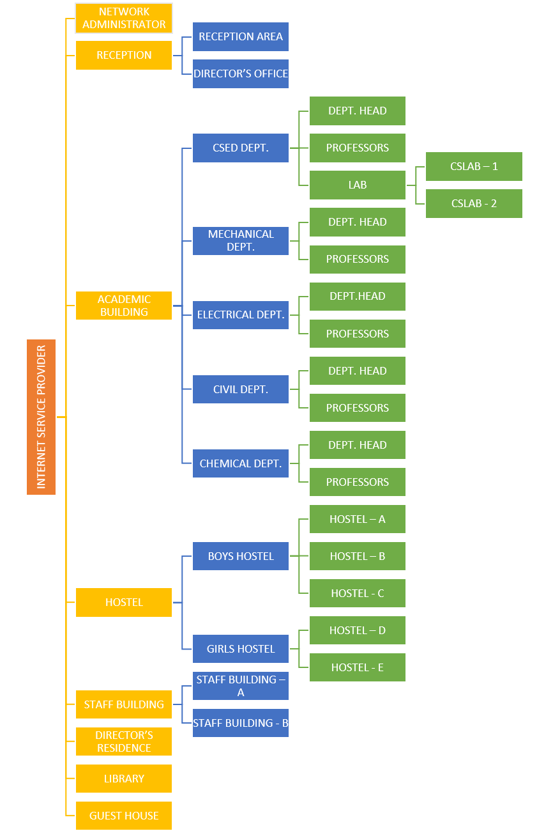

**SCREENSHOTS**

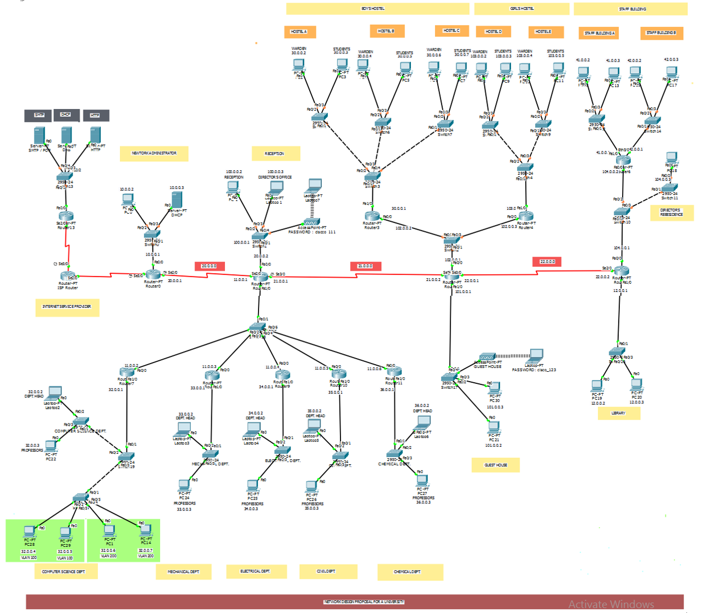

Complete Network Diagram

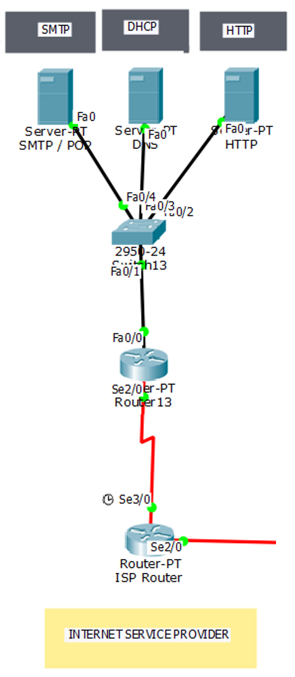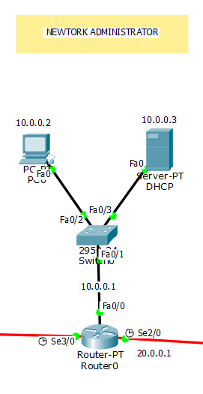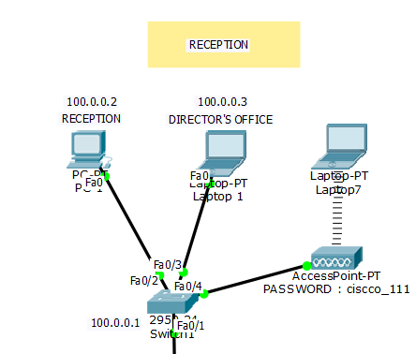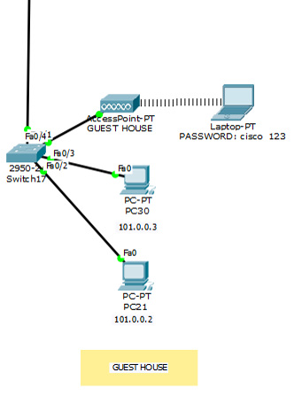

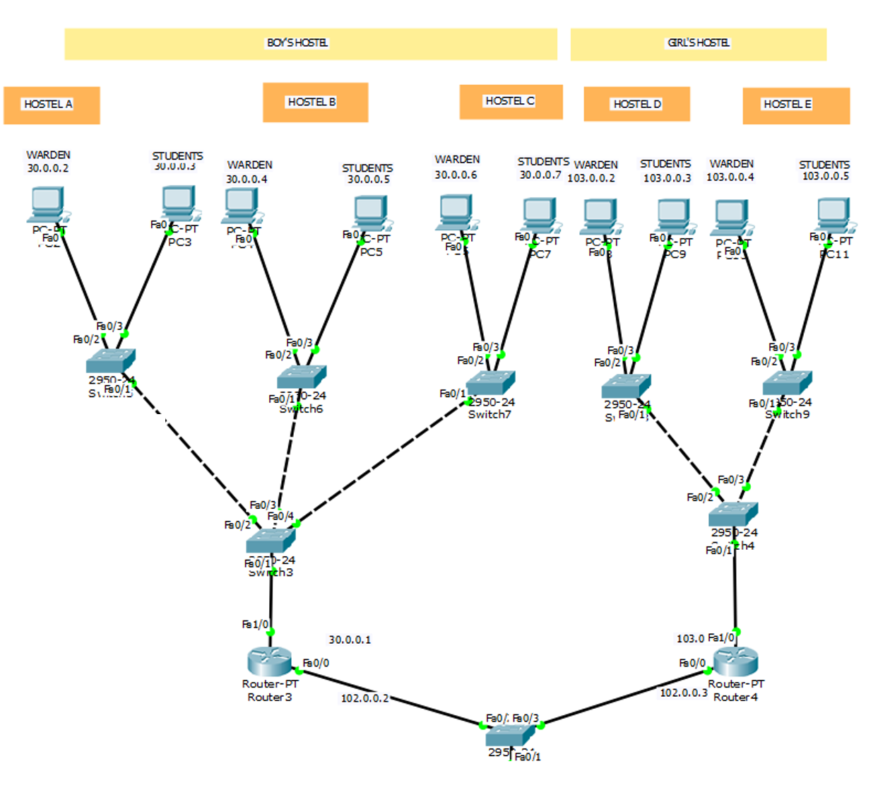

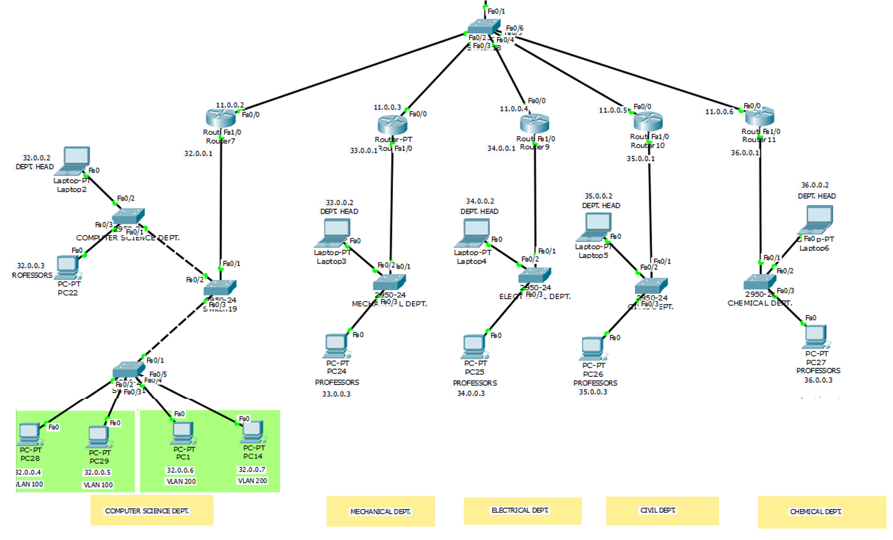

**REQUIREMENT ANALYSIS**

The analysis for the requirements are as follows:

* Network access for the hostels – this is implemented through a separate switch being implemented for the boy’s hostel, and similarly for the girl’s hostel. A separate switch is implemented for each of the hostels (for example, 3 switches for three boys’ hostels) – to ensure that the students of one hostel cannot access the Internet services of another hostel. This reduces system traffic.
* Unlimited network access for the Director’s Office – a reasonable proposal. The Director’s Office will not have any sites blocked, but will be provided the same speed by the ISP even after fair usage limit. This proposal is extremely simple to implement – just erase the rules that restrict some sites being opened.
* Network access only for all the departments – For all departments other than CSE, one PC is shown as the “HOD PC” – the one specifically reserved for the Head of the Dept. All other PCs are collectively shown as “Other”. For CSE, due to the number of labs, multiple switches are created, each switch providing access to one lab where devices in each lab are connected to a vlan.
* Unlimited network access for the staff – we have implemented this by assuming that although the staff will not get their speeds reduced after the fair usage limit, there will be still some restricted sites (the same sites restricted for the students).
* Network access for the library – Simply attach a switch to one of the main routers to enable Internet access.
* Network access for the campus – As above, but Wi-Fi access needs to be provided instead of a wired connection, so a DSL modem is a must.
* Network access for the guest house – Simply attach a switch to one of the main routers to enable Internet access.

**SERVICES AND FEATURES**

The various services provided by the network are detailed as follows:

* Instant network access –

We are not adding a portal for login – we felt it was too cumbersome. Instead, we are adding two Wi-Fi routers – one is for the guests (open access, 1/3rd the normal speed), and one for the students, staff, etc. (password protected WPA2/PSK, normal speed).

* Security –

We have also enabled a selective example to showcase the security measures we could possibly undertake in the future – for example, we have enabled a 256-bit password in the console for the router.

* The Internet Service Provider provides speed at a rate of 8 MB/s.
* There is also the provision for a Network Administrator added – the person(s) who can
  + Decrease, increase or otherwise modify the speeds of the network,
  + Shutdown or restart the entire network (only in cases of severe eventualities),
  + Add more sub-networks to the main networks (example – adding more users to a VLAN, in case a new department is established),
  + Sub-netting – although not done in our network due to complexity issues, it is possible for the network administrator(s) to establish sub-netting in case of lack of IP addresses.
  + It is also possible for the routers to get their firmware replaced, updated, etc. by the network administrator(s).

There may be other features added (or deleted) in the future which will be updated as necessary.

**FUTURE WORK**

Although it is difficult to say anything conclusive at this point of time, we can definitely say that we have much to improve upon in the future. They were not implemented in the final design. These suggestions may be taken at face value, depending upon the reader’s own discretion:

* Sub-netting – always a useful feature, although may increase congestion on a particular group of IPs – *not necessary/optional.*
* Sub-interfacing – again, a very useful feature, but will increase congestion on a particular group of interfaces (fast Ethernet, serial, etc.) – *not necessary/optional.*
* More PCs added to each VLAN/Switch – the network topology is for representation purposes only, as the PCs connected to each switch are only two in number, which is obviously not feasible for *any* institute – *strongly recommended (to the point of necessity).*

Other suggestions may be updated as necessary.

**CONCLUSION**

We are of the firm opinion that the template provided by this is applicable for *any* network – provided it is *not* large enough.

The network is fully featured with ISP, network administration, interconnection of various departments, VLANs for connection of Department Heads and wardens, network access for library, guesthouse, and an open Wi-Fi too.

This is the template that universities look for when building their first network. We hope you will too.

**CERTIFICATE**

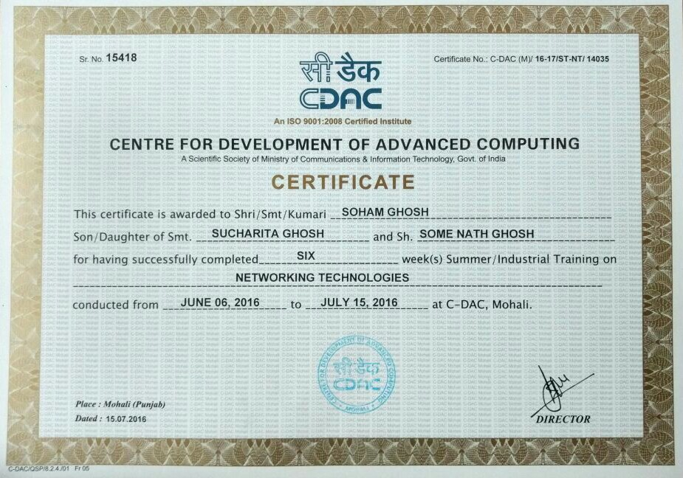

**BIBLIOGRAPHY**

1. Cisco Packet Tracer Documentation

<http://www.cisco.com/c/en/us/td/docs/security/asdm/6_1/user/guide/usergd.pdf>

1. Cisco NetAcad – Getting Started with Packet Tracer Courses

<https://www.netacad.com/c/portal/saml/sso?entityId=http://373583482.netacad.com/saml2&RelayState=/courses/394209>

<https://www.netacad.com/c/portal/saml/sso?entityId=http://373583482.netacad.com/saml2&RelayState=/courses/378346>

1. Data Communications and Network, 5th Edition – Forouzan

<http://highered.mcgraw-hill.com/sites/0073376221>

1. TCP/IP Protocol Suite, 4th Edition – Forouzan

<http://highered.mcgraw-hill.com/sites/0073376043>

1. Cryptography and Network Security – Forouzan

<http://highered.mheducation.com/sites/0072870222>

1. Computer Networking, 5th Edition – Tanenbaum

<https://www.flipkart.com/computer-networks-5th/p/itmdkzrvw2xcanwg>