AWS Infrastructure Setup – Completed Tasks & Evidence
AI-Powered Root Cause Analyzer for Cloud Failures
Prepared for: Sakshi Nagare
AWS Cloud Infrastructure Module
Status: Completed through CloudWatch log collection

1. Purpose of This Document
This document records the AWS infrastructure tasks completed during the project setup. It provides the exact resources configured, commands executed on the EC2 instance, verification results, and screenshot evidence captured during the setup.

2. Project Infrastructure Covered
Component | Configured Value | Status
EC2 | rootcause-analyzer-ec2 / Amazon Linux 2023 / t3.micro | Completed
RDS | rootcause-analyzer-db / MySQL 8.4.9 / db.t4g.micro | Completed
Database Connectivity | EC2 → RDS MySQL on port 3306 | Verified
CloudWatch Log Group | /rootcause-analyzer/app-logs | Created
IAM Role | RootCauseAnalyzerCloudWatchRole | Created & attached
CloudWatch Agent | amazon-cloudwatch-agent 1.300069.1 | Installed & running
Application Log Collection | /home/ec2-user/app.log → CloudWatch | Verified

3. Task 1 – EC2 Instance Setup
EC2 instance created for the Root Cause Analyzer infrastructure.
- Instance name: rootcause-analyzer-ec2
- Operating system: Amazon Linux 2023
- Instance type: t3.micro
- Key pair: rootcause-analyzer-key.pem
- VPC: vpc-0b852c117b60efcf9
- Availability Zone: ap-south-1b
- Instance ID: i-06aeecd5cd3398229
- Public IP used for SSH: 3.110.45.190
Verification: The instance was running and the user successfully connected through SSH as ec2-user.
SSH command used:
ssh -i "rootcause-analyzer-key.pem" ec2-user@ec2-3-110-45-190.ap-south-1.compute.amazonaws.com
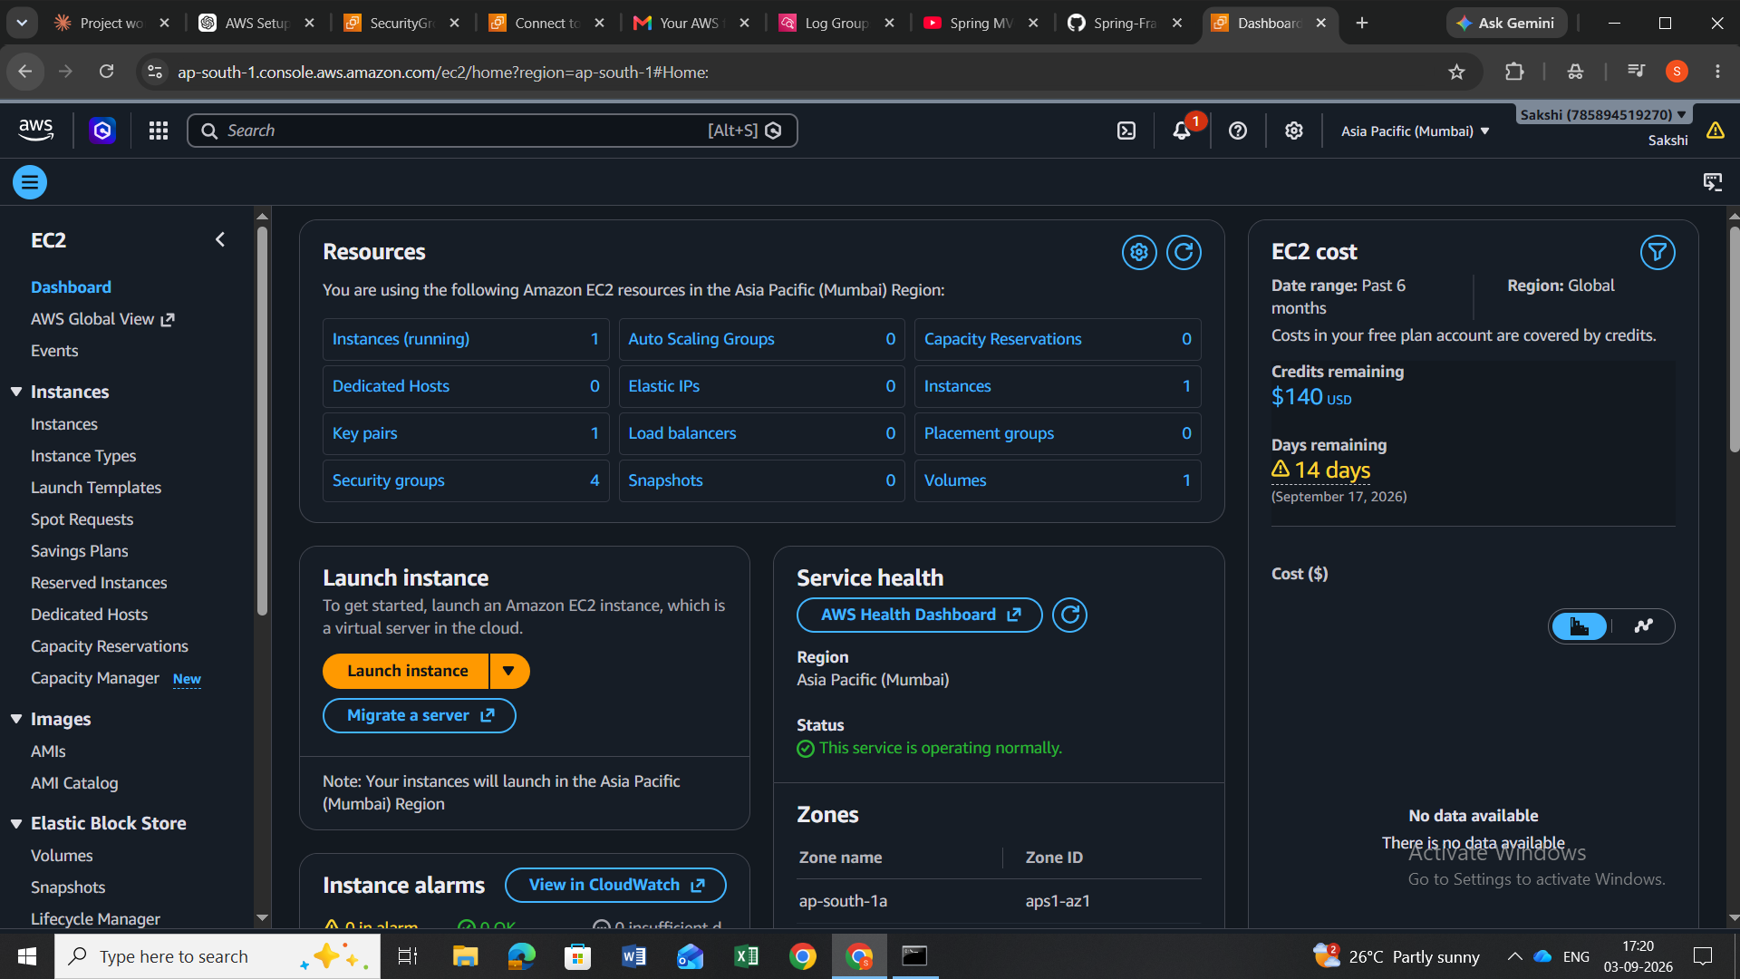
Evidence: EC2 console showing the project instance.

4. Task 2 – RDS MySQL Database Setup
A managed MySQL database was created in Amazon RDS for the project.
- DB identifier: rootcause-analyzer-db
- Engine: MySQL Community 8.4.9
- Instance class: db.t4g.micro
- Storage: 20 GiB
- Availability: Single-AZ
- Public access: No
- Port: 3306
- Master username: admin
- VPC: same project VPC as EC2
RDS endpoint used from EC2:
rootcause-analyzer-db.c9gsyq60k7ci.ap-south-1.rds.amazonaws.com

5. Task 3 – Verify EC2 to RDS Connectivity
The MariaDB/MySQL client was installed on the EC2 instance because the MySQL client command was initially unavailable.
sudo dnf install mariadb105 -y
After installation, the client was verified and used to connect to the RDS MySQL database:
mysql -h rootcause-analyzer-db.c9gsyq60k7ci.ap-south-1.rds.amazonaws.com -P 3306 -u admin -p
Verification result: The MySQL prompt opened successfully and the user exited with Bye, confirming EC2 → RDS connectivity.

6. Task 4 – Create CloudWatch Log Group
A dedicated CloudWatch log group was created for the application's logs.
Log group name:
/rootcause-analyzer/app-logs
Configuration used: Standard log class, retention left at Never expire during the project setup, no KMS key, and deletion protection left disabled.
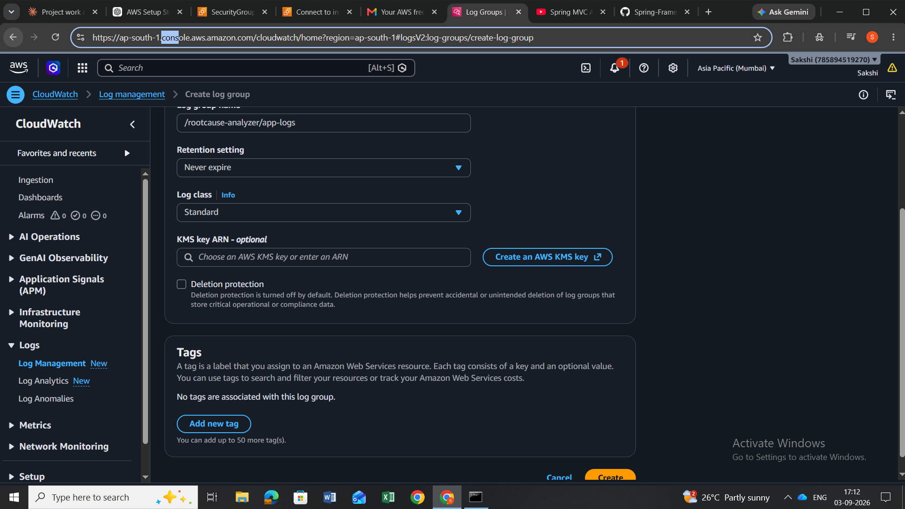
Evidence: CloudWatch Create log group page with /rootcause-analyzer/app-logs entered.
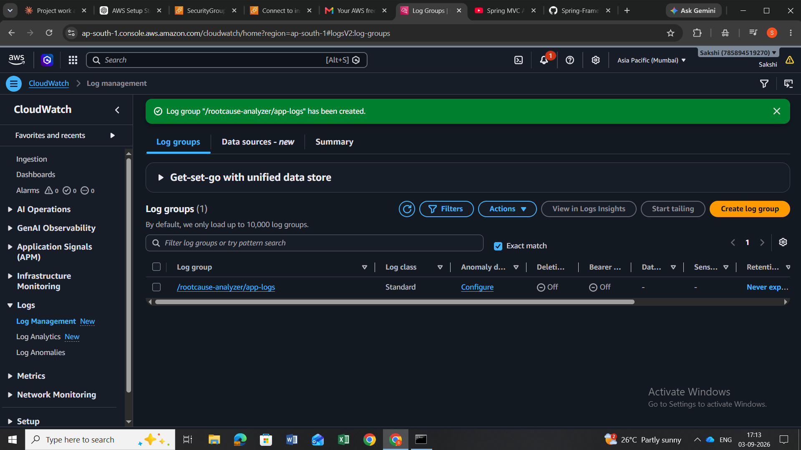
Evidence: CloudWatch Log Management page showing the created log group.

7. Task 5 – Create IAM Role for CloudWatch Agent
An IAM role was created so the EC2 instance could securely send application logs to CloudWatch. The role uses EC2 as the trusted AWS service.
IAM role name:
RootCauseAnalyzerCloudWatchRole
Permissions policy attached:
CloudWatchAgentServerPolicy
Important security decision: AdministratorAccess was not used; only the CloudWatch Agent policy required for log delivery was attached.
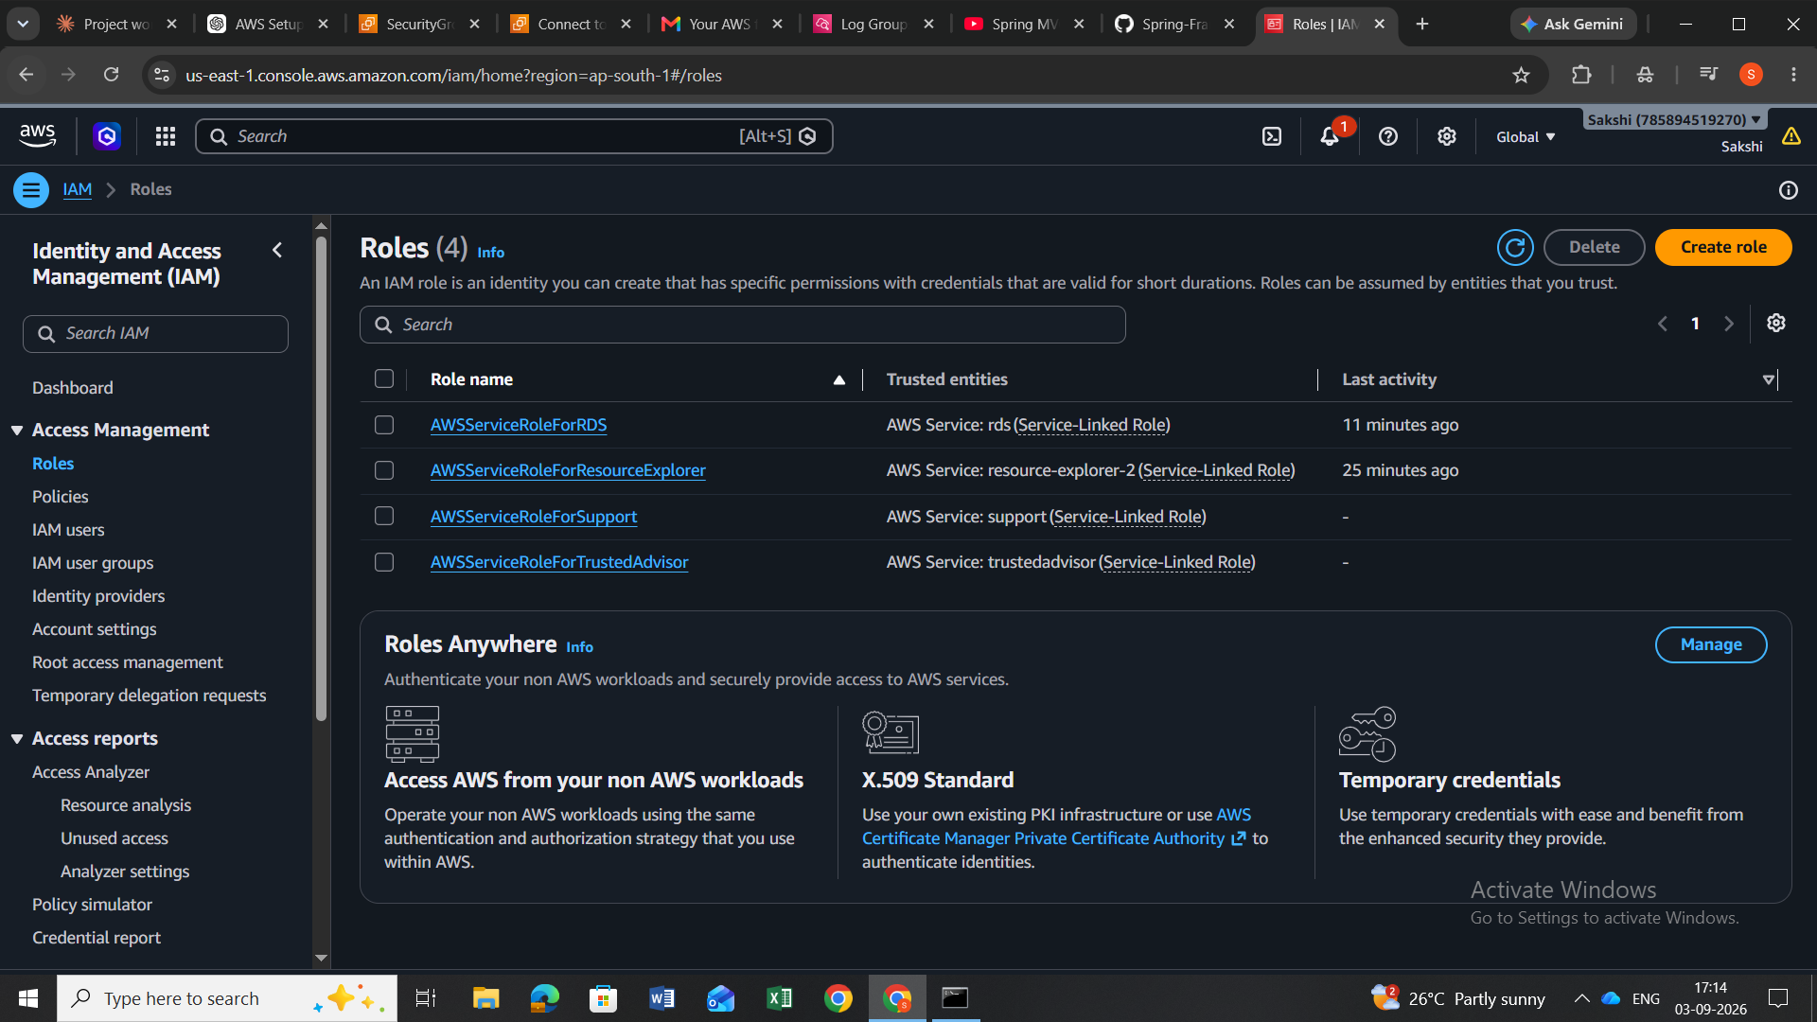
Evidence: IAM Roles page before creating the project-specific role.
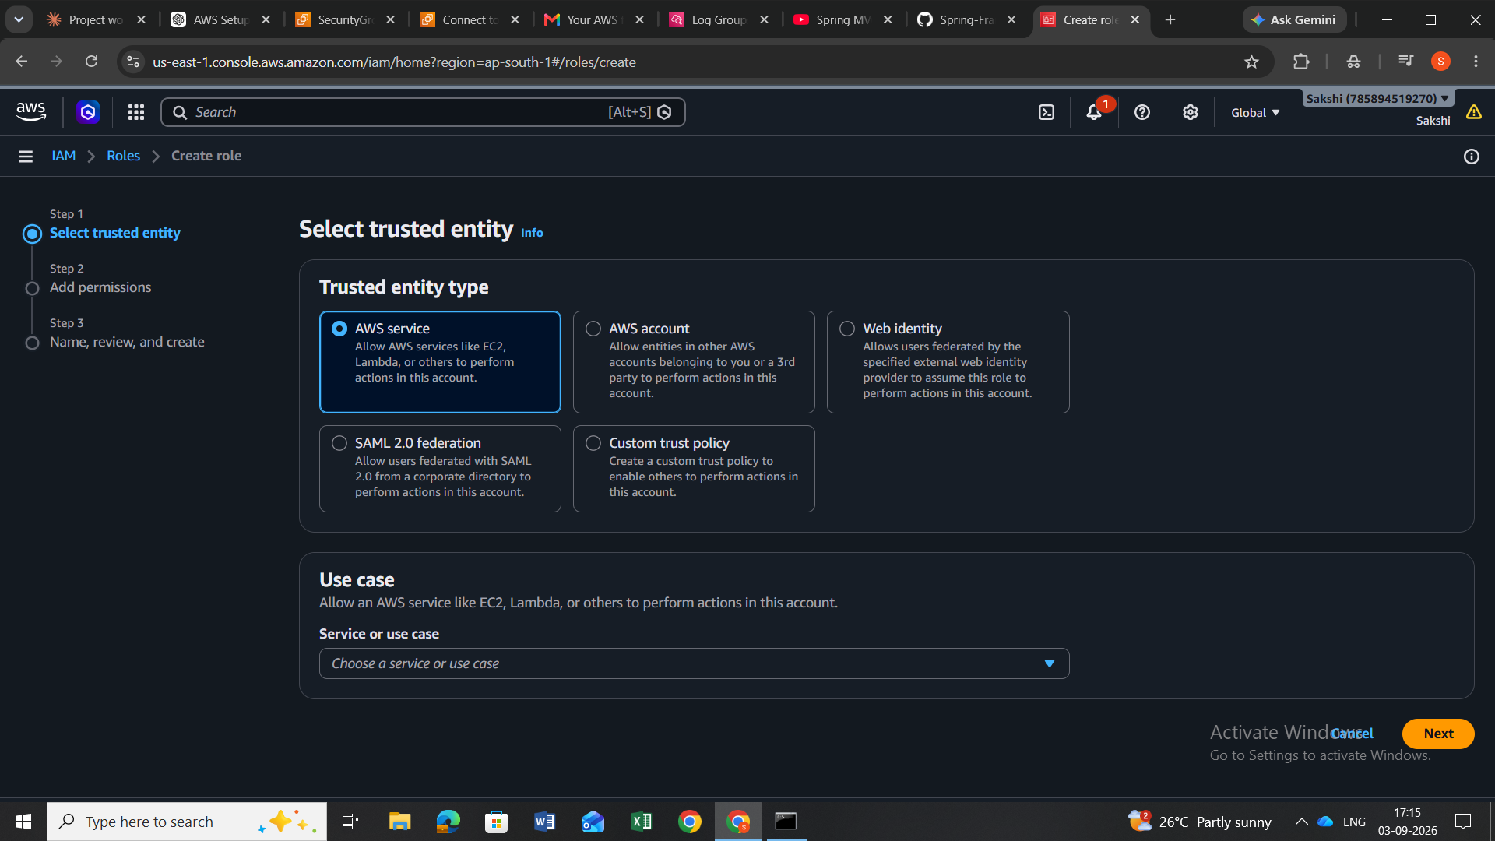
Evidence: IAM role creation flow with EC2 selected as the trusted service.

8. Task 6 – Attach IAM Role to EC2
The newly created IAM role was attached to rootcause-analyzer-ec2.
Console path used:
EC2 → Instances → rootcause-analyzer-ec2 → Actions → Security → Modify IAM role
Selected role: RootCauseAnalyzerCloudWatchRole
Verification: AWS displayed a successful attachment confirmation for the EC2 instance.
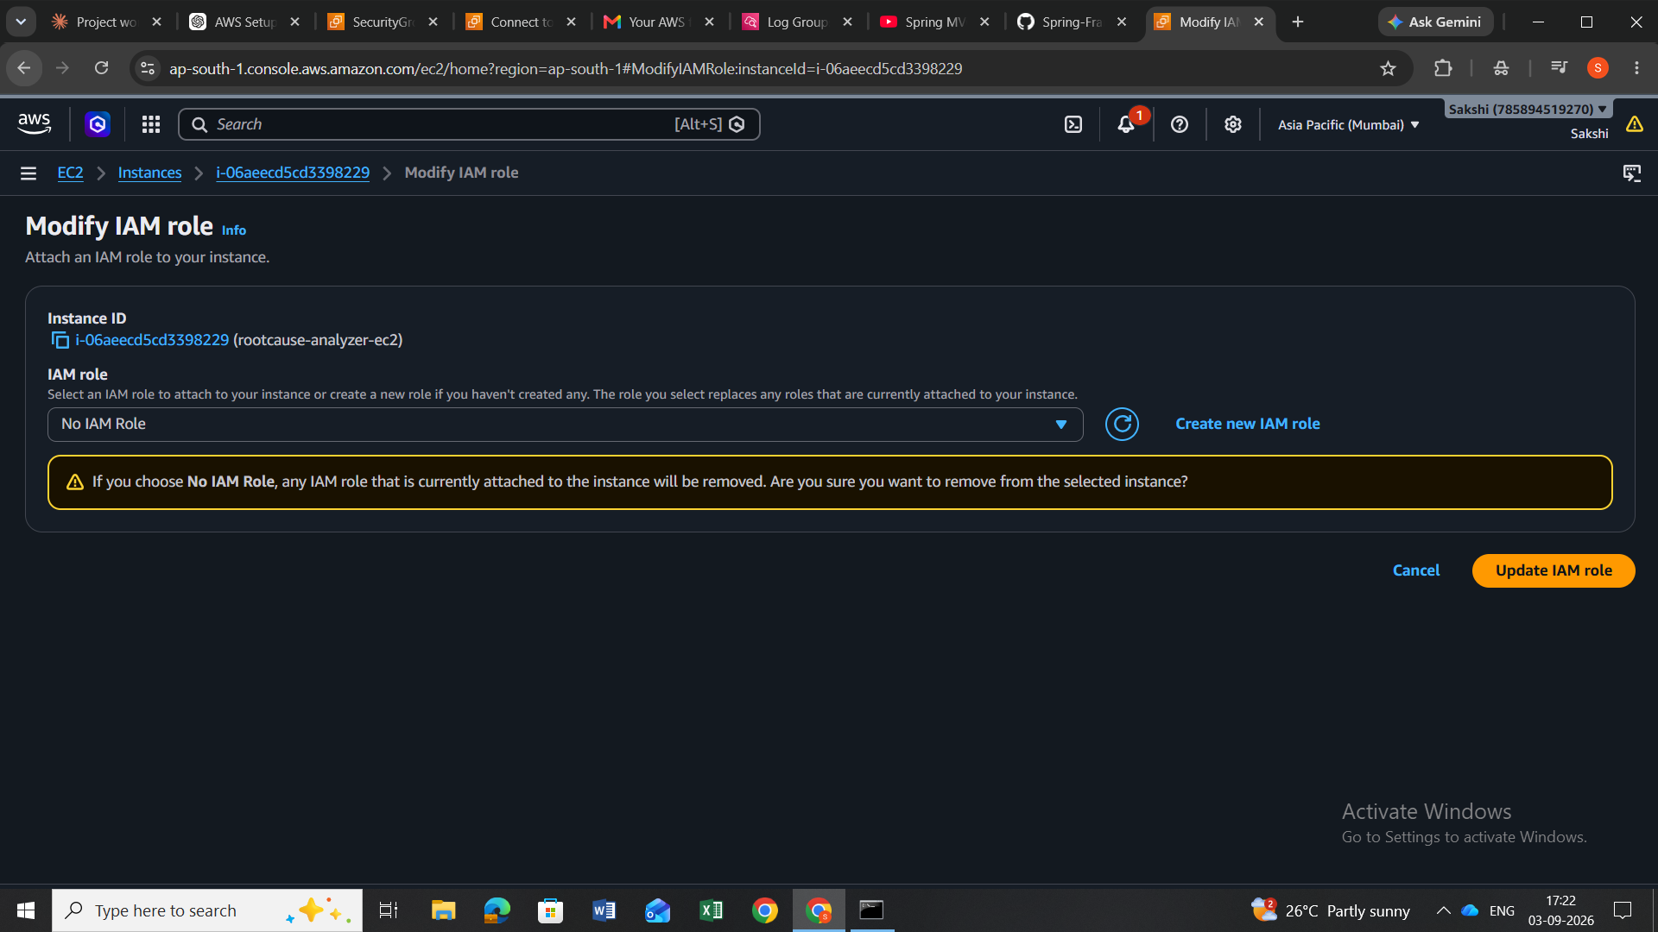
Evidence: Modify IAM role screen where the project role was selected.
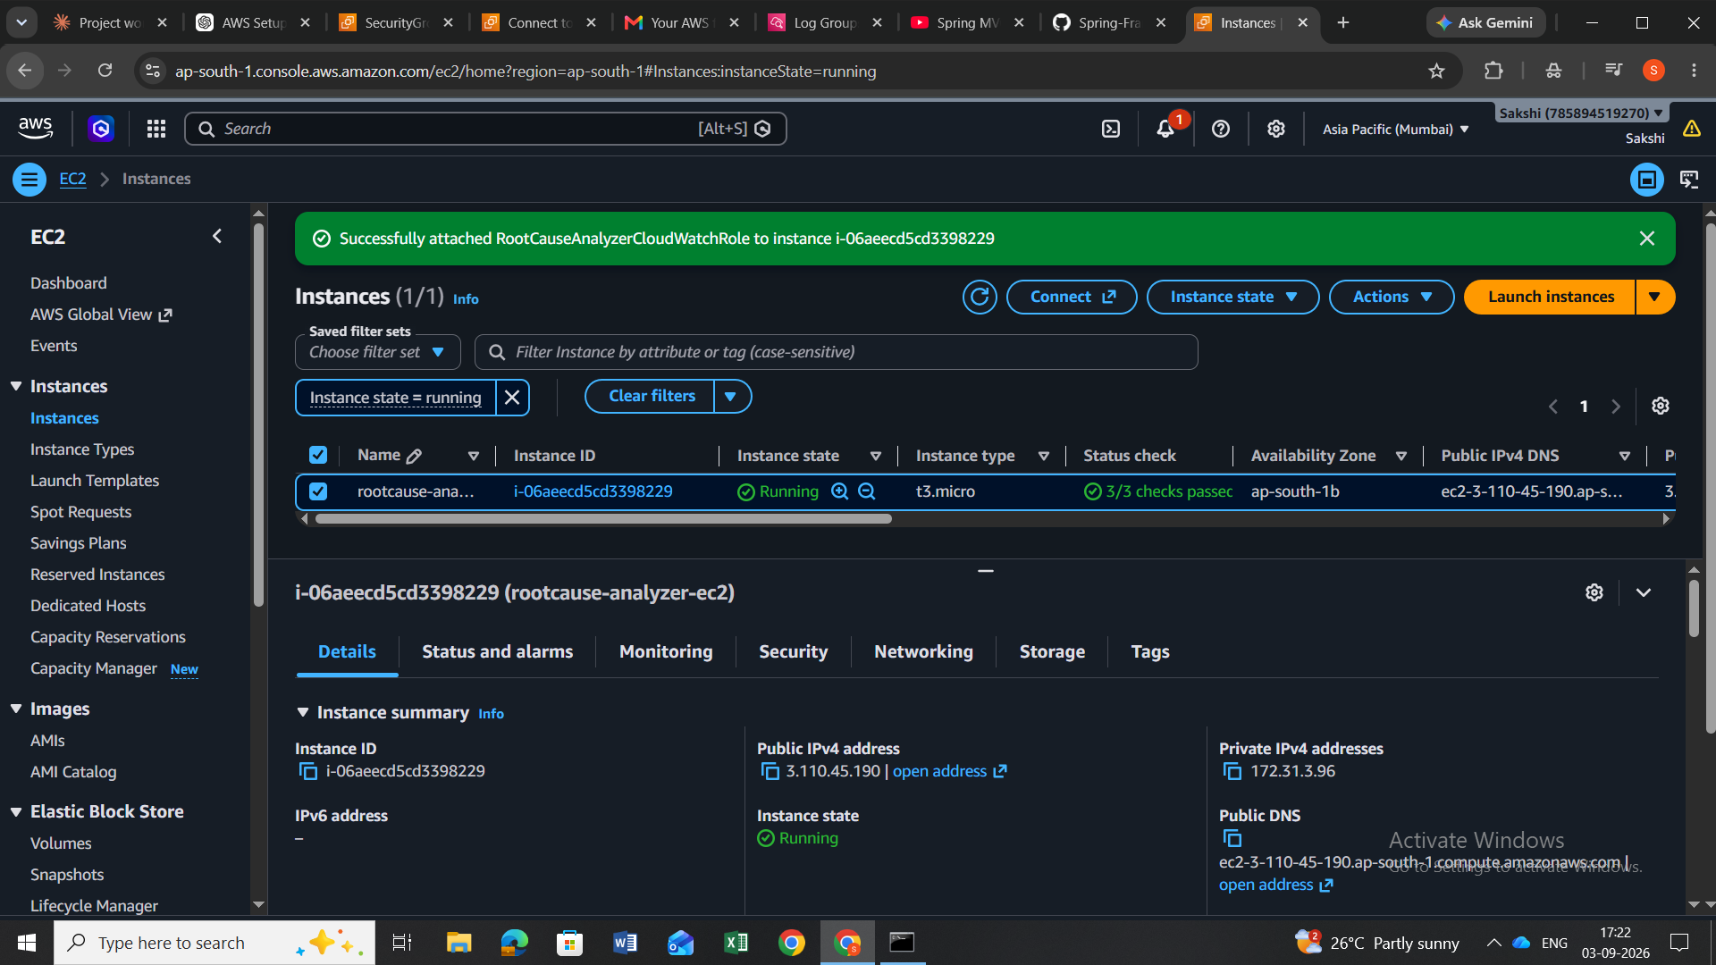
Evidence: EC2 console confirmation that RootCauseAnalyzerCloudWatchRole was successfully attached.

9. Task 7 – Install CloudWatch Agent on EC2
The Amazon CloudWatch Agent was installed on the Amazon Linux 2023 EC2 instance.
sudo dnf install amazon-cloudwatch-agent -y
Installation result: amazon-cloudwatch-agent 1.300069.1-1.amzn2023 was installed successfully and the transaction completed.

10. Task 8 – Configure CloudWatch Agent for Application Logs
The agent was configured to collect the project application's log file and send it to the previously created CloudWatch log group.
Log file monitored:
/home/ec2-user/app.log
Destination log group:
/rootcause-analyzer/app-logs
Log stream format:
{instance_id}/app
Configuration file:
/opt/aws/amazon-cloudwatch-agent/etc/amazon-cloudwatch-agent.json
The configuration was applied using fetch-config. AWS reported both JSON schema validation and second-phase configuration validation as successful.
sudo /opt/aws/amazon-cloudwatch-agent/bin/amazon-cloudwatch-agent-ctl -a fetch-config -m ec2 -c file:/opt/aws/amazon-cloudwatch-agent/etc/amazon-cloudwatch-agent.json -s

11. Task 9 – Verify CloudWatch Agent Status
The agent status was checked after applying the configuration.
sudo /opt/aws/amazon-cloudwatch-agent/bin/amazon-cloudwatch-agent-ctl -a status
Verified result:
"status": "running"
"configstatus": "configured"
"version": "1.300069.1"

12. Task 10 – Generate and Verify a Test Application Log
A test log entry was written to the monitored log file:
echo "$(date) - Root Cause Analyzer test log: CloudWatch connection successful" | tee -a /home/ec2-user/app.log
The CloudWatch log stream was then checked. The stream was created as:
i-06aeecd5cd3398229/app
The actual CloudWatch event displayed the test message, proving end-to-end log delivery:
Root Cause Analyzer test log: CloudWatch connection successful
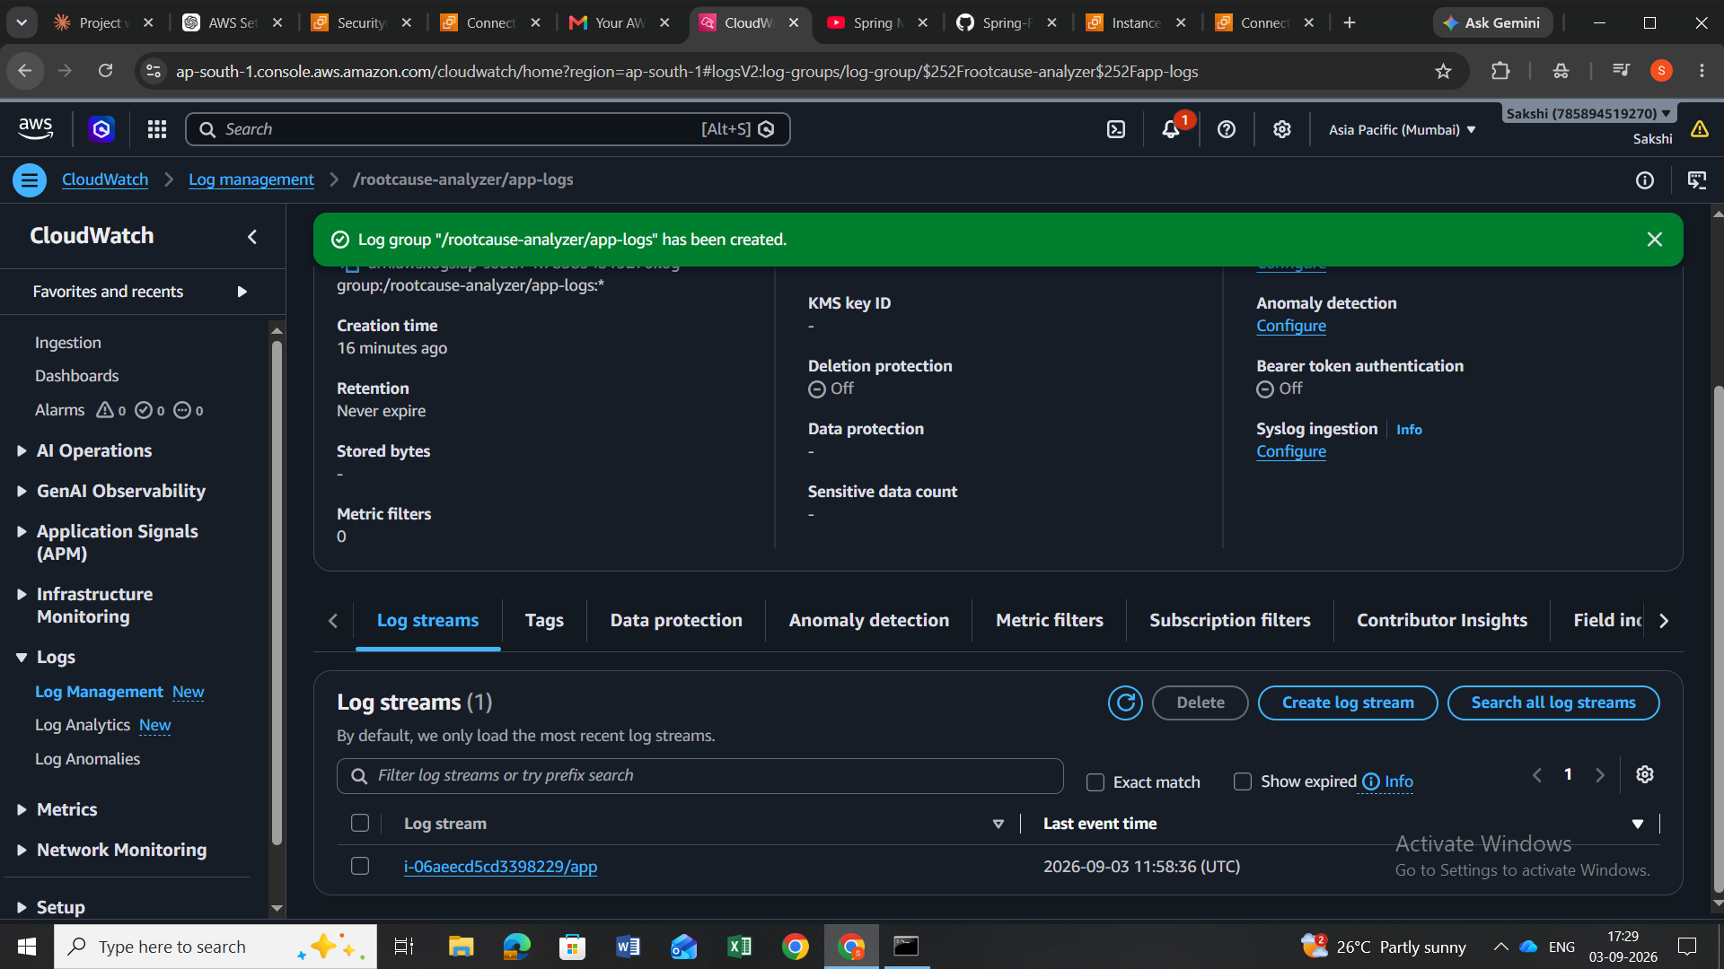
Evidence: CloudWatch Log streams page showing the instance/app stream.
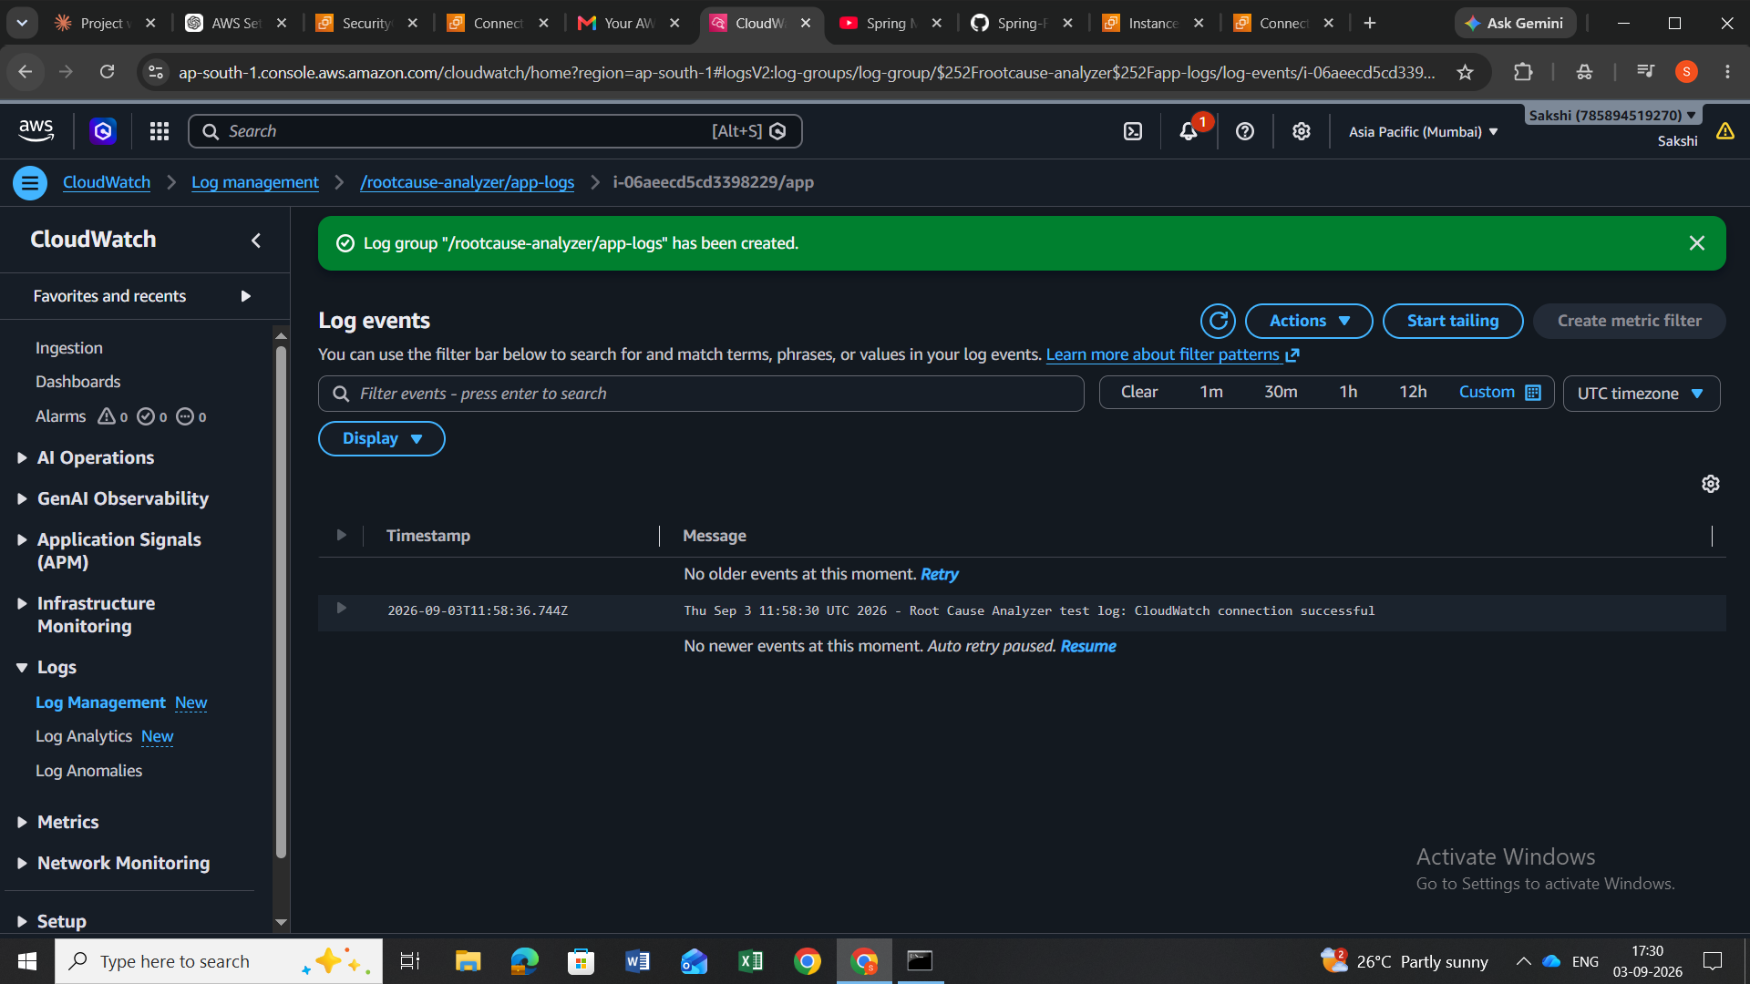
Evidence: CloudWatch log stream showing the actual test log event.

13. Overall Verification Status
Task | Result | Evidence
EC2 provisioning | Completed | EC2 instance configured and SSH access verified
RDS MySQL provisioning | Completed | RDS database created and available
EC2 → RDS connectivity | Verified | MySQL client connected successfully
CloudWatch log group | Completed | /rootcause-analyzer/app-logs created
IAM role | Completed | RootCauseAnalyzerCloudWatchRole created
IAM policy | Completed | CloudWatchAgentServerPolicy attached
IAM role attached to EC2 | Completed | AWS success confirmation
CloudWatch Agent | Running | Status returned running/configured
Log collection | Verified | Test event visible in CloudWatch
CPU alarm | In progress | Alarm configuration was started but not yet finalized

14. Current Position / Next Pending Work
The completed portion of the infrastructure setup is now documented. The next task in the original workflow is to finish the EC2 CPU utilization alarm and then proceed with CloudTrail and the planned failure simulations (CPU spike, database timeout, and HTTP 503), followed by log export/formatting for the backend/AI stage.
The CPU alarm is intentionally marked as 'In progress' because the SNS notification configuration was being handled when this documentation was requested. No claim is made that the alarm was fully created or tested.

15. Important Security / Cost Notes
The EC2 SSH rule should remain restricted to the user's current IP rather than 0.0.0.0/0 whenever possible. The RDS database was configured without public access, which keeps the database private inside the AWS networking setup.
The project currently uses small EC2/RDS instance classes and a single-AZ RDS configuration. Unused resources should be stopped or deleted when project work is finished to avoid unnecessary usage.

16. Conclusion
The core AWS foundation for the Root Cause Analyzer has been successfully established. EC2 and RDS are provisioned, EC2 can connect to the MySQL database, IAM permissions are configured, the CloudWatch Agent is running, and application logs are demonstrably reaching CloudWatch. This provides the required infrastructure base for the remaining monitoring, failure simulation, and backend handoff work.

