**Experiment No: 7**

***Title :*** Study & Implementation of

* Sub queries
* Views

***Objective*:**

* To perform nested Queries and joining Queries using DML command
* To understand the implementation of views.

**LAB PRACTICE ASSIGNMENT:**

**Consider the following schema:**

**Sailors (sid, sname, rating, age)**

**Boats (bid, bname, color)**

**Reserves (sid, bid, day(date))**

**Write subquery statement for the following queries.**

1. Find all information of sailors who have reserved boat number 101.

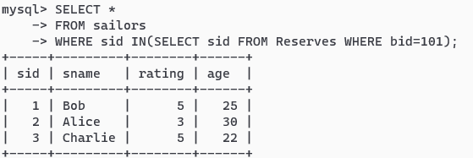

1. Find the name of boat reserved by Bob.

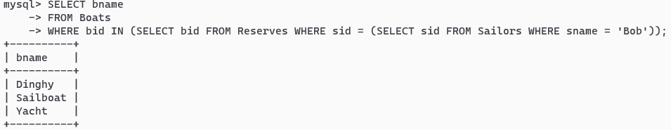

1. Find the names of sailors who have reserved a red boat, and list in the order of age.

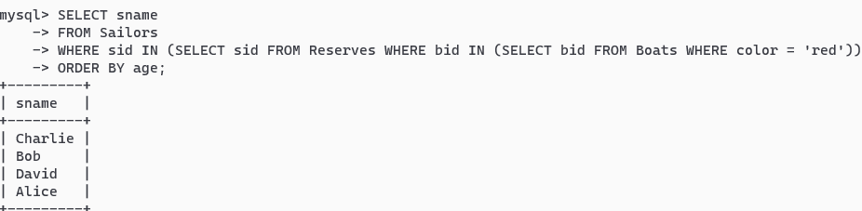

1. Find the names of sailors who have reserved at least one boat

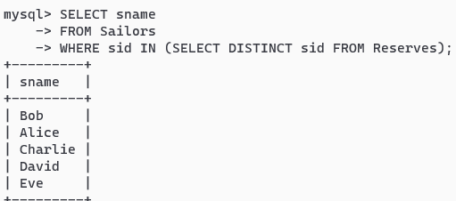

1. Find the ids and names of sailors who have reserved two different boats on the same day.

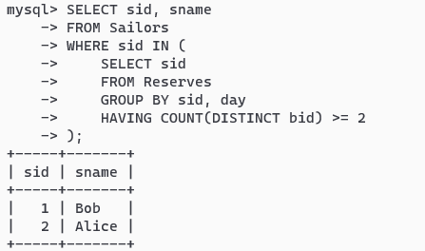

1. Find the ids of sailors who have reserved a red boat or a green boat.

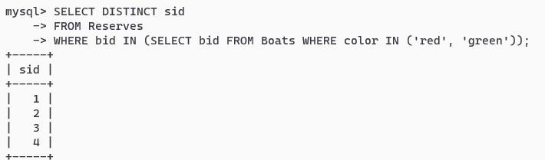

1. Find the name and the age of the youngest sailor.

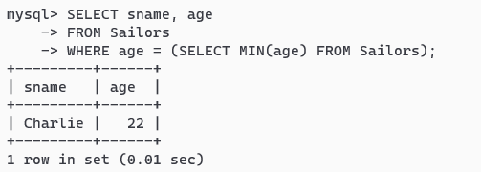

1. Count the number of different sailor names.

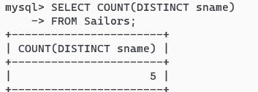

1. Find the average age of sailors for each rating level.

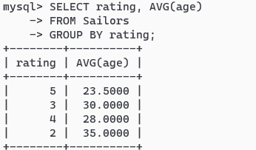

1. Find the average age of sailors for each rating level that has at least two sailors.

