**Experiment no: 08**

{name}

TE {classNo}

{roll_no}

**NAND USING STATIC CMOS**

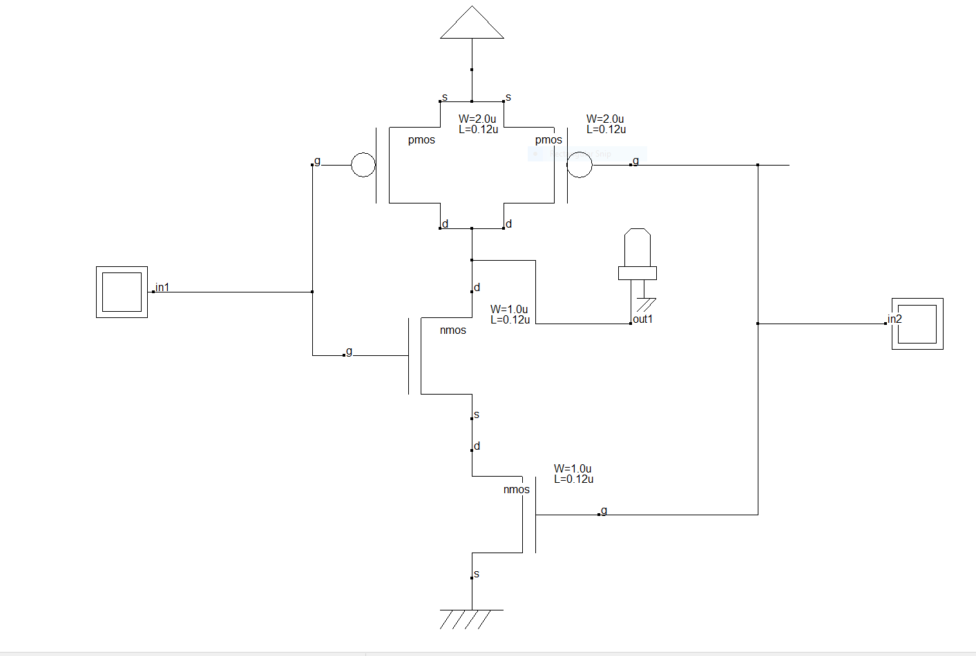

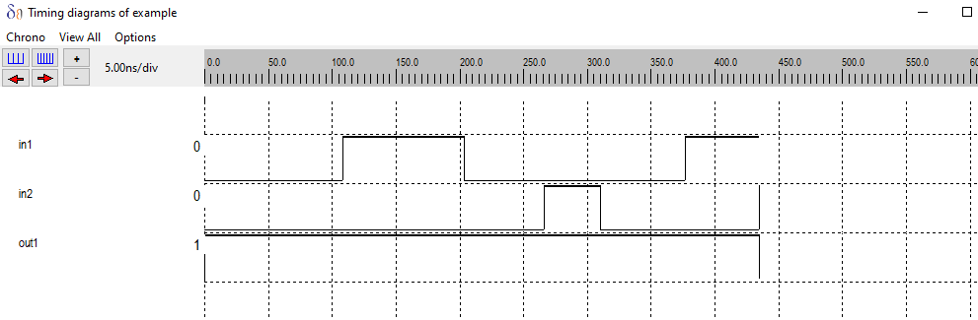

**NAND USING PSEUDO**

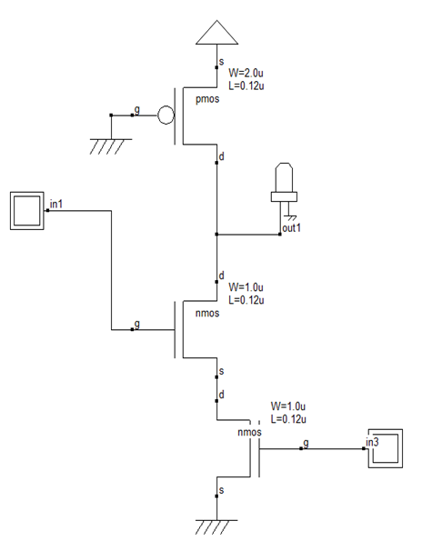

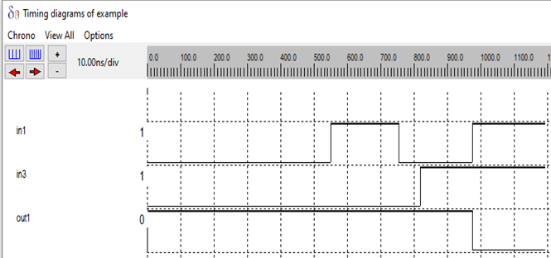

**NAND USING PASS TRANSISTOR LOGIC**

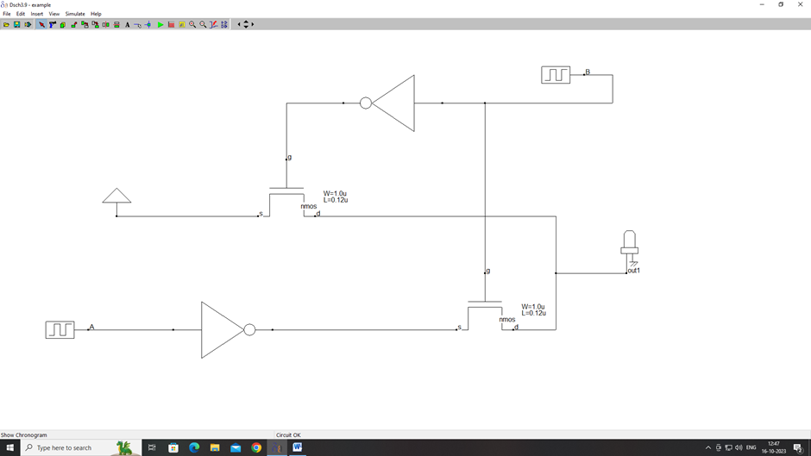

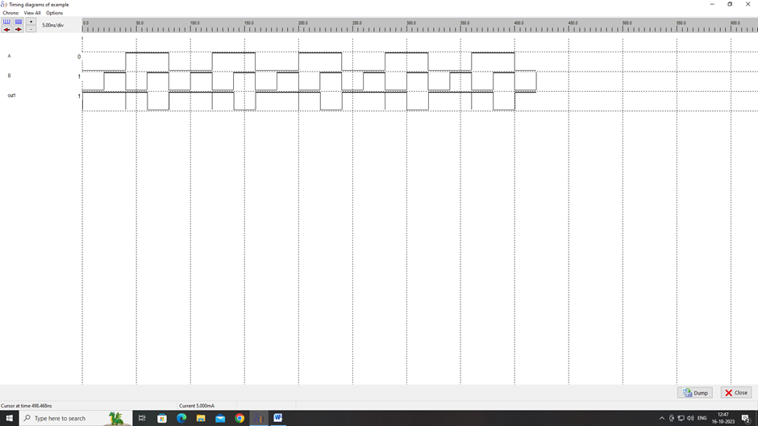

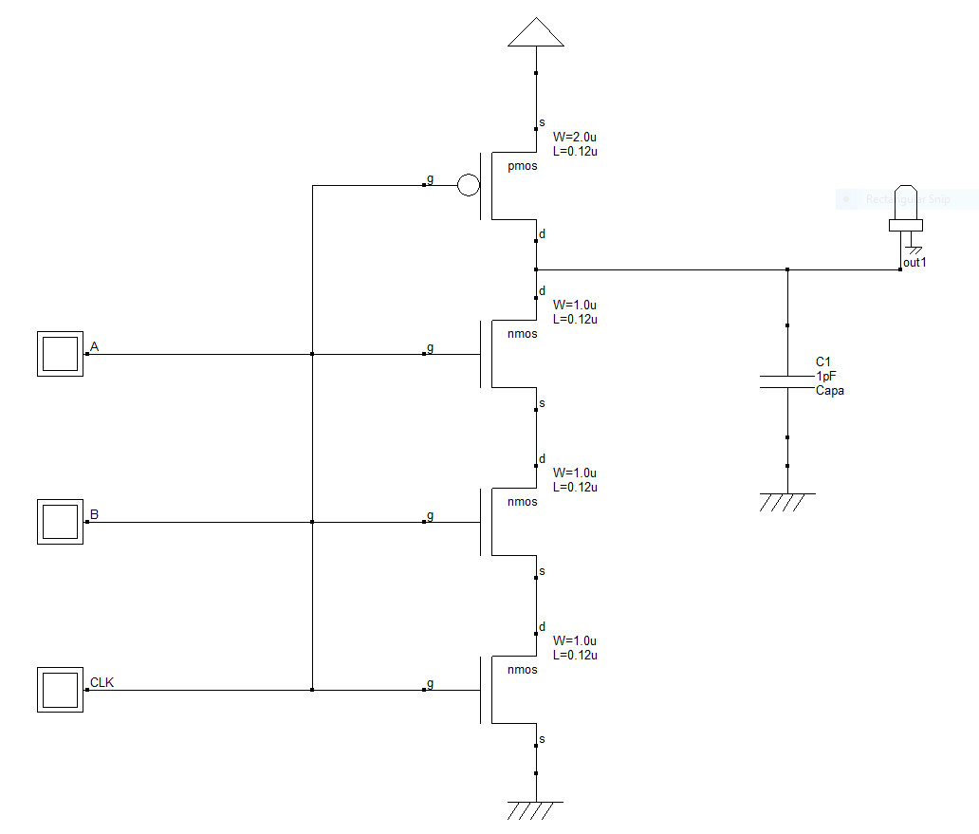**NAND USING DYNAMAIC LOGIC**

