Skill Lab - Experiment No.:-5

Name :- {name}

Roll no.:- {roll_no} {classNo} {batch}

1. Admin commands for users

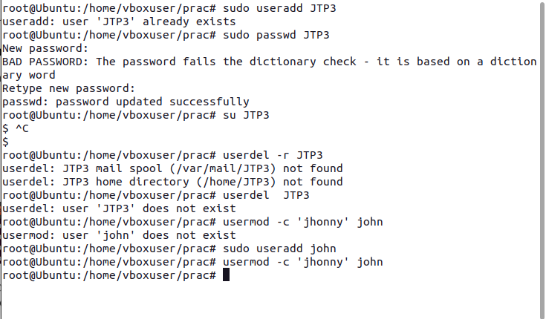

1. Admin commands for groups

