Skill Lab - Experiment No.:-8

Name :- {name}

Roll no.:- {roll_no} {classNo} {batch}

1. Shell script program to check whether given file is a directory or not

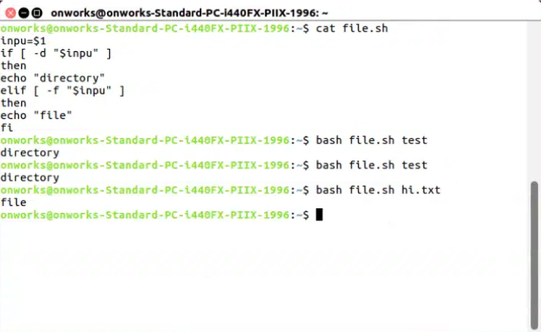

B) Shell script program to count number of files in a Directory

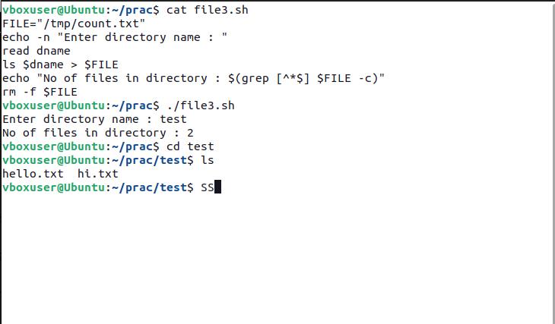

C) Shell script program to copy contents of one file to another

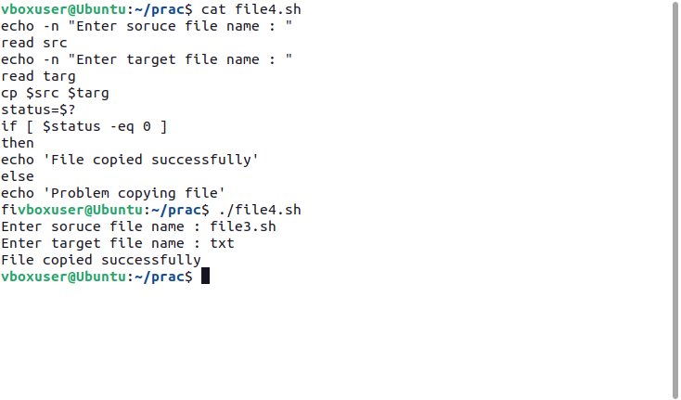

D) Create directory, write contents on that and Copy to a suitable location in your home

directory.

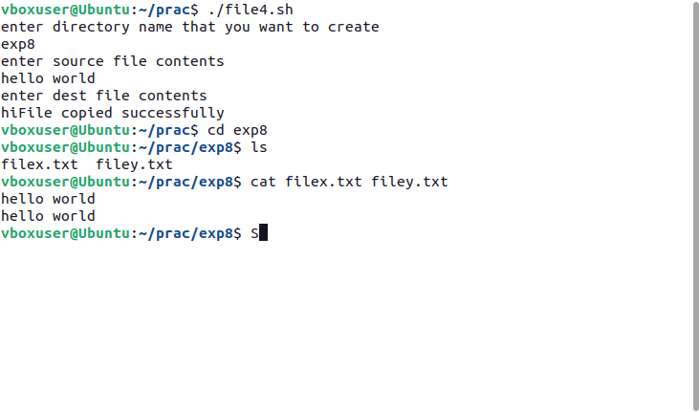

E) Use a pipeline and command substitution to set the length of a line in file to a

variable.

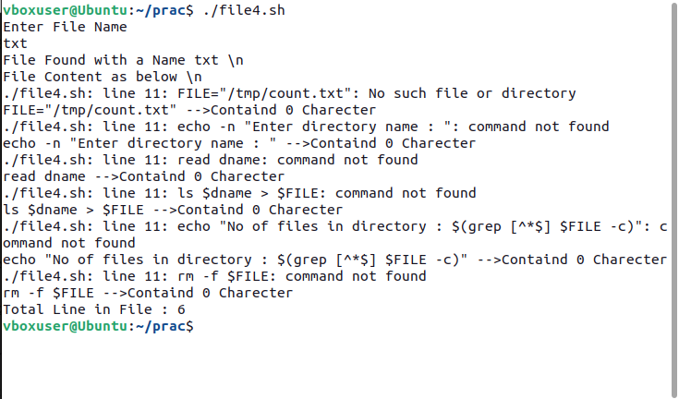

F) Write a program using sed command to print duplicate lines of Input.

