Skill Lab - Experiment No.:-9

Name :- {name}

Roll no.:- {roll_no} {classNo} {batch}

1. Process Management Commands

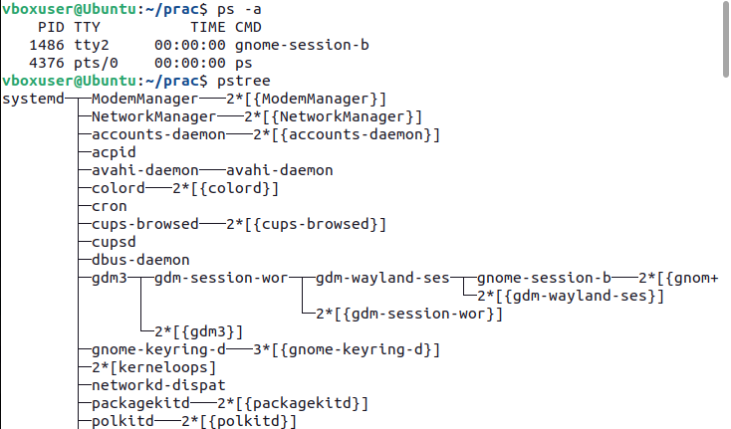

1. Memory Management Commands

