Experiment No.:-1

Name :- {name}

Roll no.:- {roll_no} {classNo}

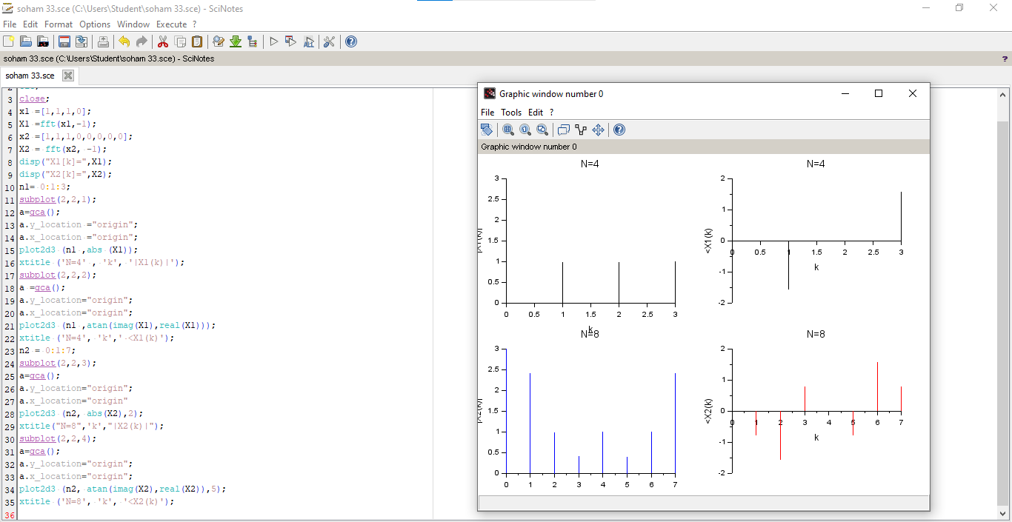

{roll_no}.sce