DTSP Experiment – 7

{name}

TE {classNo}

{roll_no}

clear all;

clc;

close;

M=7;

Wc=%pi/4;

Tuo=(M-1)/2

for n=1:M

if(n==Tuo+1)

hd(n)=1-Wc/%pi;

else

hd(n)=(sin(%pi*((n-1)-Tuo))-sin(Wc*((n-1)-Tuo)))/(((n-1)-Tuo)*%pi);

end

end

for n=1 M

W(n)=1;

end

h=hd*W;

disp('Filter Coefficients are')

h;

[hzm,fr]=frmag(h,256);

hzm_dB=20*log10(hzm)/max(hzm);

plot(fr,hzm_dB)

xlabel('Normalized Digital Frequency W');

ylabel('Magnitude in dB');

title('Frequency Response of FIR HPF using Rectangular window M=7')

{roll_no}

{roll_no}

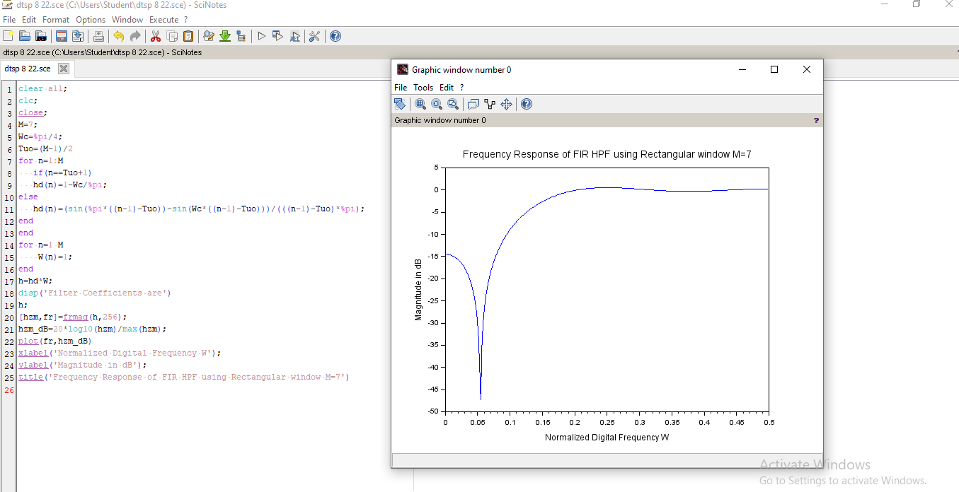

{roll_no}