EWMA VaR Independent Validation Report
Independent validation updated through Phase III sensitivity and stress testing
Model | EWMA VaR (lambda = 0.94) | Developer | Sai Vakkalagadda
Validator | Thomas Flaim | Report date | October 26, 2026

Purpose. This report independently validates the team's EWMA Value-at-Risk model for a hypothetical $1,000,000 long SPY portfolio. The review covers model familiarization, conceptual soundness, data and implementation checks, independent calculation verification, exception analysis, statistical backtesting, benchmarking, parameter sensitivity, and historical stress-period behavior.

1. Model Overview
Methodology. The model estimates 1-day, 99% VaR using an exponentially weighted moving average (EWMA) volatility forecast. Daily simple SPY returns are converted to portfolio P&L using a constant $1,000,000 exposure. The conditional mean is set to zero and next-day returns are assumed Normal conditional on the EWMA volatility estimate.
sigma_t^2 = 0.94 sigma_(t-1)^2 + 0.06 r_(t-1)^2
VaR_t = $1,000,000 x z_0.99 x sigma_t, z_0.99 ≈ 2.3263
Parameter | Value | Validation comment
Portfolio value | $1,000,000 | Project specification
Forecast horizon | 1 trading day | Project specification
Confidence level | 99% | Project specification
Decay factor | lambda = 0.94 | RiskMetrics daily baseline; not fitted to SPY
Conditional mean | 0 | Reasonable simplification for a 1-day horizon
Initialization | Mean squared return of first 250 returns | Uses pre-forecast information only
First forecast | December 31, 2010 | Aligned with the other baseline models

2. Conceptual Soundness
Overall assessment. EWMA is conceptually appropriate as a baseline short-horizon market-risk model because it allows volatility to vary through time and places greater weight on recent squared returns. This is useful when volatility clusters. The approach is transparent, computationally simple, reproducible, and naturally responsive to changing market conditions.
Assumption / feature | Validation assessment
Conditional Normality | Main conceptual concern. Fat-tailed equity returns can produce more extreme losses than a Normal 99% quantile implies.
Zero mean | Reasonable for one-day VaR because expected daily drift is small relative to daily volatility.
lambda = 0.94 | Defensible as the classic RiskMetrics daily baseline, but it is a convention rather than an SPY-specific estimate.
Recent information weighted more heavily | Appropriate for volatility clustering and fast adaptation after shocks.
Constant decay factor | A single decay rate may not be equally suitable in calm and stressed regimes.
Symmetric response | Positive and negative returns of equal size affect variance equally; downside asymmetry is not modeled.
No long-run variance anchor | Unlike mean-reverting GARCH specifications, EWMA has no explicit long-run variance level.
Constant $1M exposure | Appropriate for the stated hypothetical portfolio.
Parameter justification. RiskMetrics documents lambda = 0.94 as a standard daily EWMA decay factor. At this value, the weight on historical squared returns decays quickly, with an information half-life of roughly 11 trading days. This supports responsiveness but also means risk estimates can decline quickly after a shock. Sensitivity to lambda should therefore be tested before any final effectiveness conclusion.
Model-risk perspective. The validation approach is consistent with current model-risk guidance emphasizing independent understanding of conceptual soundness, data, implementation, outcomes, documentation, and effective challenge rather than merely confirming that code runs.

3. Data & Implementation Review
Check | Result
Project price sample | 2010-01-04 to 2026-08-31
SPY price observations | 4,190
Daily simple returns | 4,189
Out-of-sample VaR forecasts | 3,939
Duplicate model-period dates | 0
Missing Last Price values | 0
Return / P&L calculation | Verified: P&L = $1,000,000 x simple return
EWMA recursion | Verified
Look-ahead bias | None identified; day t forecast uses information through t-1
VaR output convention | Positive dollar loss threshold in standardized output
First forecast | 2010-12-31

Independent calculation checks
Date | Independent VaR | Model VaR | Result
2011-01-03 | $25,493.25 | $25,493.25 | Match
2018-02-06 | $29,190.03 | $29,190.03 | Match
2020-03-16 | $100,201.81 | $100,201.81 | Match
2020-03-25 | $118,677.25 | $118,677.25 | Match
2025-04-04 | $37,506.93 | $37,506.93 | Match
Implementation concern. The script explicitly enforces the January 1, 2010 start date but does not hard-code the project freeze date of August 31, 2026. The current raw file ends on the correct date, so current results are unaffected; however, a later data refresh could silently extend the evaluation period. This is a reproducibility/control weakness rather than a current calculation error.

4. Preliminary Findings from Initial Review
No material implementation error was identified. The main validation concerns are model assumptions and observed performance, not coding correctness.

- The Python implementation matches the documented EWMA methodology and parameters.
- Independent calculations reproduce the model output on five test dates, including March 2020 stress observations.
- The principal conceptual risks are conditional Normality, a fixed lambda, symmetric shock treatment, lack of a long-run variance anchor, and the model's reactive nature at the start of abrupt shocks.
- The unadjusted SPY Last Price convention excludes explicit dividend adjustment and should remain documented as a project limitation.

5. Initial Review Next Steps
At completion of the initial review, the planned next steps were quantitative exception analysis, Kupiec and Christoffersen backtesting, benchmarking, parameter sensitivity, and stress-period analysis. Those baseline validation steps have now been completed in Sections 6 and 7. Further work, if required, would focus on alternative distributional assumptions, additional stress periods, or volatility specifications beyond EWMA.

6. Backtesting & Benchmarking

6.1 Backtesting Results
Metric | EWMA result
Backtesting observations | 3,939
Expected exceptions at 99% VaR | 39.39
Actual exceptions | 91
Expected exception rate | 1.00%
Observed exception rate | 2.31%
Interpretation. The EWMA model produced 91 exceptions versus approximately 39 expected under a correctly calibrated 99% VaR model. The observed exception rate of 2.31% is more than double the target 1%, indicating material undercoverage over the full out-of-sample period. This does not by itself identify the cause, but it motivates formal statistical testing and investigation of stress-period behavior.
Year | Obs. | Expected | Actual | Rate
2010 | 1 | 0.01 | 0 | 0.00%
2011 | 252 | 2.52 | 6 | 2.38%
2012 | 250 | 2.50 | 5 | 2.00%
2013 | 252 | 2.52 | 5 | 1.98%
2014 | 252 | 2.52 | 10 | 3.97%
2015 | 252 | 2.52 | 5 | 1.98%
2016 | 252 | 2.52 | 2 | 0.79%
2017 | 251 | 2.51 | 4 | 1.59%
2018 | 251 | 2.51 | 8 | 3.19%
2019 | 252 | 2.52 | 5 | 1.98%
2020 | 253 | 2.53 | 12 | 4.74%
2021 | 252 | 2.52 | 10 | 3.97%
2022 | 251 | 2.51 | 3 | 1.20%
2023 | 250 | 2.50 | 2 | 0.80%
2024 | 252 | 2.52 | 6 | 2.38%
2025 | 250 | 2.50 | 6 | 2.40%
2026 | 166 | 1.66 | 2 | 1.20%
Annual pattern. Exceptions were especially elevated in 2020 (12; 4.74%), 2014 (10; 3.97%), 2021 (10; 3.97%), and 2018 (8; 3.19%). Annual counts are supplementary because each year contains only about 250 observations, but the concentration is consistent with the broader concern that EWMA can be vulnerable around abrupt or clustered market moves.
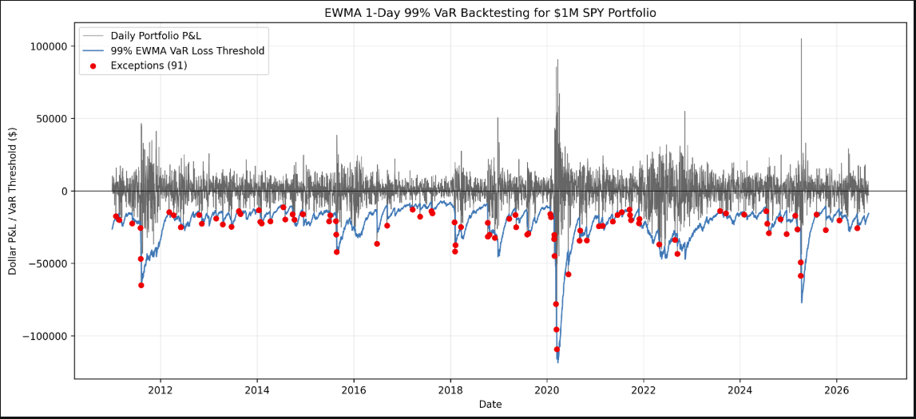
Figure 1. EWMA 1-day 99% VaR backtest. Red points identify days where realized P&L fell below the negative VaR threshold.

6.2 Statistical Test Results
Test | Statistic | p-value | Result at 5%
Kupiec POF | 49.8633 | 1.65 x 10^-12 | Reject H0
Christoffersen Independence | 7.5985 | 0.005842 | Reject H0
Kupiec POF. The null hypothesis that the exception probability equals 1% is rejected. The result confirms that the observed 2.31% exception rate is statistically inconsistent with the intended unconditional 99% coverage over the full evaluation period.
Christoffersen independence. The independence null is also rejected. Transition counts were n00 = 3,763, n01 = 84, n10 = 84, and n11 = 7. The estimated probability of an exception following a non-exception was about 2.18%, while the probability following an exception was about 7.69%. This provides evidence that exceptions cluster rather than occurring independently.
EWMA fails both unconditional coverage and independence at the 5% significance level. This is evidence of model weakness, not a standalone final effectiveness rating.

6.3 Benchmarking Results
Metric | Historical | Parametric | EWMA
Average VaR ($) | $28,603.45 | $23,187.73 | $21,915.04
Maximum VaR ($) | $68,076.17 | $48,837.90 | $118,677.25
Actual exceptions | 59 | 106 | 91
Exception rate | 1.50% | 2.69% | 2.31%
Kupiec p-value | 0.003448 | 1.15 x 10^-18 | 1.65 x 10^-12
Christoffersen p-value | 0.000021 | 0.000024 | 0.005842
Full-period comparison. Historical Simulation produced the highest average VaR and the fewest exceptions, while Parametric Normal VaR produced the most exceptions. EWMA had the lowest average VaR but by far the highest maximum VaR. This combination is consistent with an adaptive model that is relatively low in calm markets but can increase sharply once large recent returns enter the variance recursion. All three models reject both Kupiec coverage and Christoffersen independence over the common evaluation period, so lower exception counts should not be interpreted as proof of adequacy.
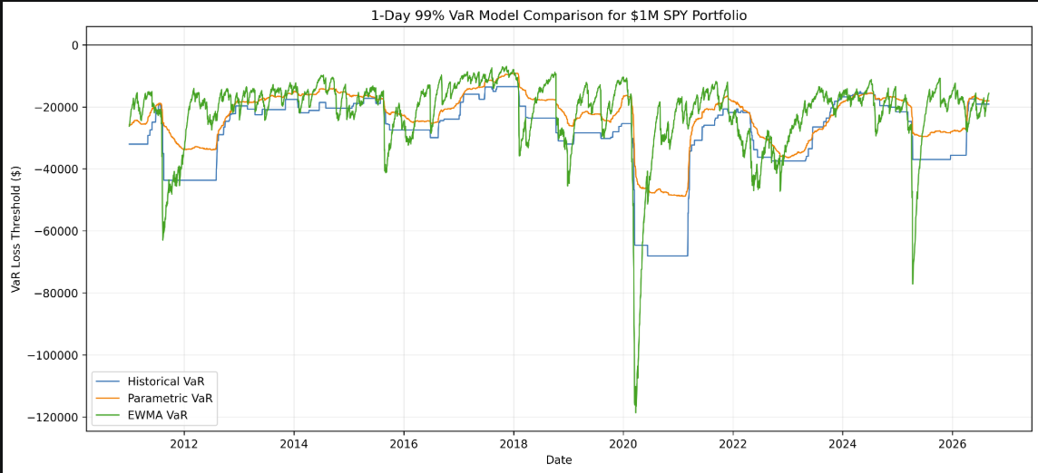
Figure 2. Full-period comparison. Historical VaR is blue, Parametric VaR is orange, and EWMA VaR is green; all are shown as negative loss thresholds.
COVID-19 stress period. The stress-period chart highlights the models' different dynamics. EWMA reacts fastest and most aggressively once large returns occur, moving to approximately -$119,000 in late March 2020 before declining as recent volatility fades. Historical Simulation adjusts in discrete steps as extreme observations enter and remain in its 250-day window. Parametric VaR rises more gradually and remains materially below the EWMA peak. This demonstrates EWMA's responsiveness, but also its reactive nature: the model only increases after extreme returns have already been observed.
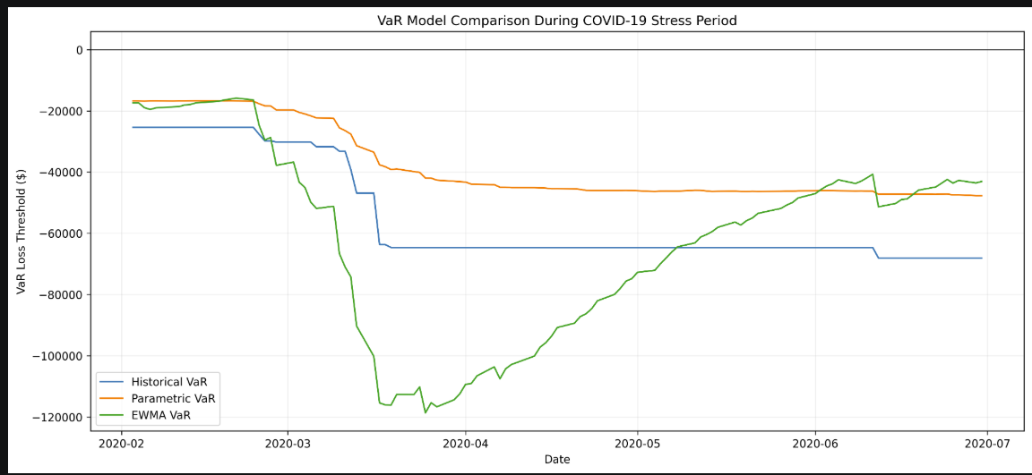
Figure 3. COVID-19 stress-period comparison, February through June 2020.

6.4 Preliminary Findings and Recommended Follow-up
- Coverage weakness: 91 exceptions and a 2.31% exception rate indicate that the EWMA model understates the frequency of tail losses relative to its 99% target.
- Clustering weakness: the Christoffersen rejection shows that exceptions are not independent, which is consistent with periods where risk changes faster than the model can fully adjust.
- Normal-tail limitation: dynamic volatility alone does not correct for fat-tailed return innovations; the 2.326 Normal multiplier may remain too small during severe market moves.
- Responsiveness tradeoff: EWMA adapts much faster than the rolling alternatives after shocks, but its fast decay can also reduce VaR quickly once recent volatility subsides.
- Benchmarking context: Historical Simulation is more conservative on average but also fails both statistical tests, while Parametric VaR performs worst on exception frequency. Benchmarking therefore does not identify a simple dominant model.
- Control improvement: explicitly freeze the model end date or version the input dataset so reruns cannot silently change the evaluation sample.
Recommended next validation work. Phase III sensitivity and COVID stress-period analysis is completed in Section 7. If additional testing is required, the next useful extensions would be heavier-tailed return innovations, alternative volatility models with asymmetry or mean reversion, and additional historical stress periods. No final model effectiveness rating is assigned in this report.

References
Christoffersen, P. F. (1998). Evaluating Interval Forecasts. International Economic Review, 39(4), 841-862.
Federal Reserve Board, FDIC, and OCC. (2026). Supervisory Guidance on Model Risk Management, SR 26-2, April 17, 2026.
J.P. Morgan / RiskMetrics. (1996). RiskMetrics Technical Document, Fourth Edition.
Kupiec, P. H. (1995). Techniques for Verifying the Accuracy of Risk Measurement Models. Finance and Economics Discussion Series 95-24, Board of Governors of the Federal Reserve System.
Project source files: EWMA model-development documentation, Python implementation, standardized EWMA output, common SPY dataset, and combined model comparison output.

7. Sensitivity & Stress Testing
Phase III evaluates whether the EWMA model is robust to reasonable changes in its decay factor and how it behaves during the February-April 2020 COVID-19 market disruption. The baseline remains lambda = 0.94; alternatives of 0.90, 0.97, and 0.99 are compared on the same 3,939-day evaluation period.
7.1 Parameter Sensitivity
A lower lambda places more weight on the latest squared return and therefore reacts faster to new information. A higher lambda produces slower updating and greater persistence. The tested values were lambda = 0.90, 0.94, 0.97, and 0.99.
Configuration | Latest wt. | Half-life | Avg VaR ($) | Max VaR ($) | Exceptions | Rate
lambda = 0.90 | 10% | 6.6 | $21,463.16 | $140,680.43 | 95 | 2.41%
lambda = 0.94 | 6% | 11.2 | $21,915.04 | $118,677.25 | 91 | 2.31%
lambda = 0.97 | 3% | 22.8 | $22,560.55 | $93,902.40 | 82 | 2.08%
lambda = 0.99 | 1% | 69.0 | $23,692.66 | $62,842.21 | 85 | 2.16%
Average VaR is relatively stable across the tested decay factors: the full-range spread is $2,229.50, about 10% of the baseline average VaR. Peak VaR is much more sensitive. Lower lambda values react faster and produce substantially larger stress-period peaks, while higher lambda values update more slowly and retain volatility for longer.
The lowest full-period exception rate is 2.08% at lambda = 0.97, compared with 2.31% at the baseline. However, every tested configuration remains well above the 1% target. Parameter tuning alone therefore does not resolve the model's coverage weakness.
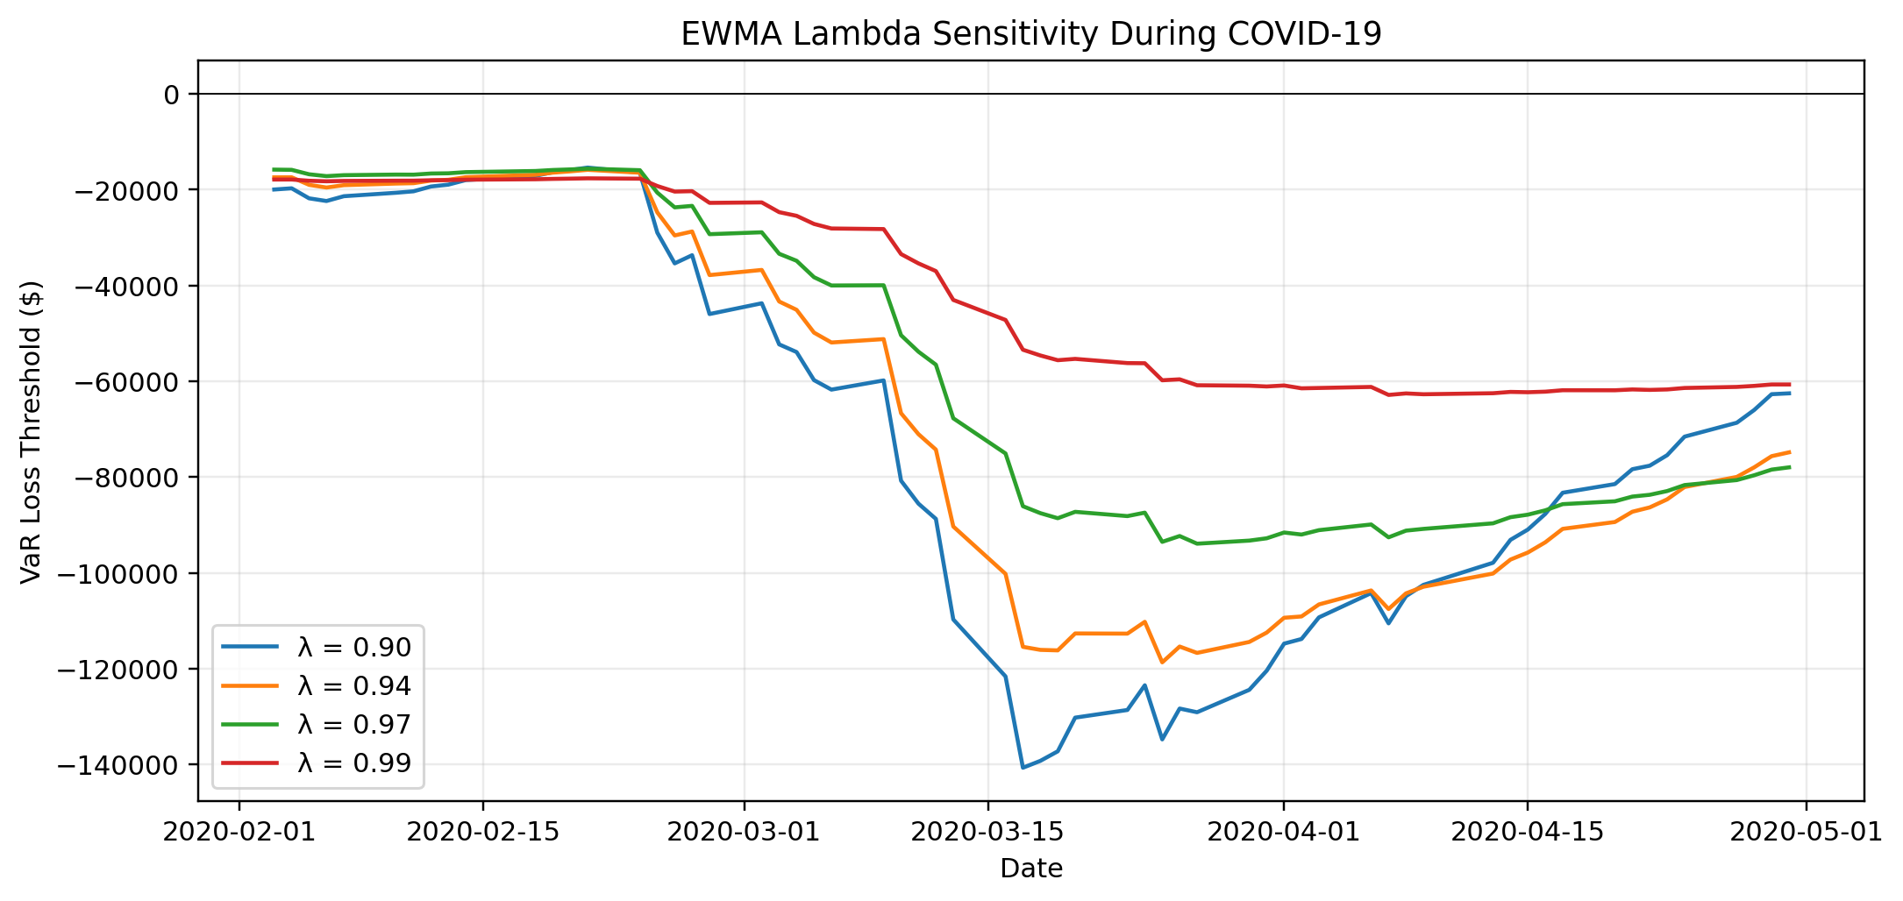
Figure 4. EWMA decay-factor sensitivity during the February-April 2020 COVID-19 stress period.
7.2 Stress Testing
The common historical stress period is February 1 through April 30, 2020. This is an observed historical stress-period analysis, not a hypothetical shock scenario.
Configuration | Avg COVID VaR | Max COVID VaR | Peak date | Exceptions | Rate
lambda = 0.90 | $73,203.68 | $140,680.43 | 2020-03-17 | 5 | 8.06%
lambda = 0.94 | $69,131.07 | $118,677.25 | 2020-03-25 | 6 | 9.68%
lambda = 0.97 | $59,082.25 | $93,902.40 | 2020-03-27 | 6 | 9.68%
lambda = 0.99 | $42,471.94 | $62,842.21 | 2020-04-07 | 9 | 14.52%
The results show the expected EWMA tradeoff. Lambda = 0.90 responds fastest and reaches the largest VaR peak ($140,680), while lambda = 0.99 reacts much more slowly, peaks at only $62,842, and records nine COVID exceptions. The baseline lambda = 0.94 produces six COVID exceptions and a maximum VaR of $118,677.
After the March 9 loss of $78,095, baseline next-day VaR rose about 30%. After the March 12 loss of $95,677, next-day VaR rose about 22%, and after the March 16 loss of $109,424 it rose about 15%. EWMA therefore adapts strongly after large moves, but it cannot raise the forecast until the shock has already occurred.
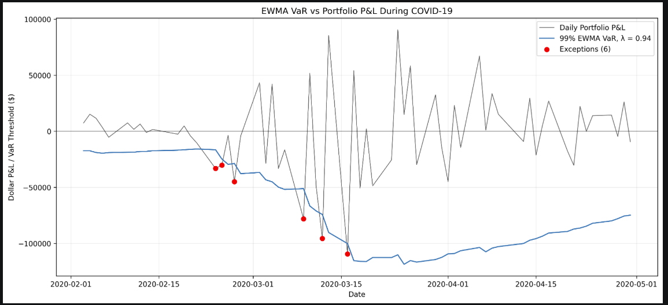
Figure 5. Baseline EWMA VaR versus realized P&L during February-April 2020. Six exceptions are marked in red.
Model | Avg COVID VaR | Max COVID VaR | Peak date | Exceptions | Rate
Historical | $47,563.33 | $64,638.34 | 2020-03-19 | 8 | 12.90%
Parametric | $32,171.19 | $46,039.00 | 2020-04-30 | 12 | 19.35%
EWMA | $69,131.07 | $118,677.25 | 2020-03-25 | 6 | 9.68%
During COVID, EWMA produces the highest average and maximum VaR and the fewest exceptions of the three baseline models. Historical Simulation adjusts in steps as extreme returns enter its rolling window. Parametric Normal VaR adjusts most gradually and records the highest COVID exception rate. This supports EWMA's relative responsiveness, but does not establish overall adequacy because full-period coverage remains weak.
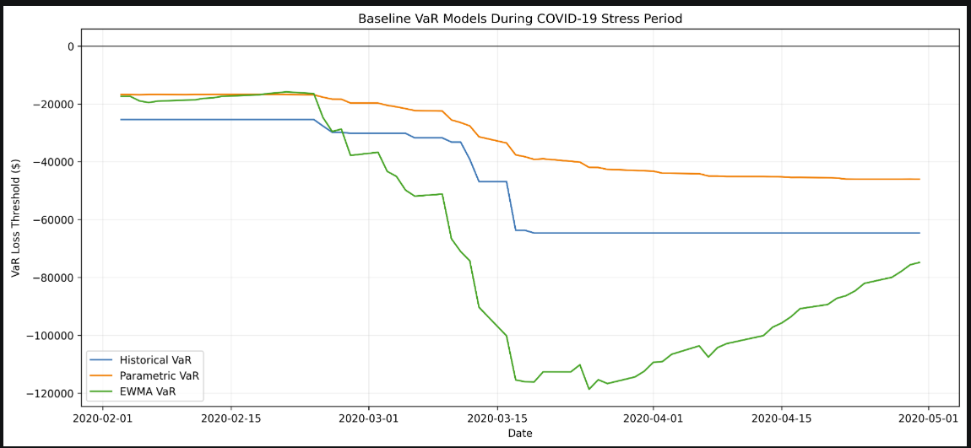
Figure 6. Historical, Parametric, and EWMA baseline VaR during February-April 2020.
7.3 Robustness Assessment
Dimension | Assessment
Parameter stability | Average VaR is reasonably stable, but peak VaR and short-run responsiveness are materially sensitive to lambda.
Stress responsiveness | EWMA responds strongly after large losses; lower lambda values react faster, while higher values lag and produce more COVID exceptions.
Coverage | No tested lambda produces exception coverage close to the intended 1%; the best tested full-period rate is 2.08%.
Methodology limitation | The model remains reactive and conditionally Normal. Changing lambda does not address fat tails or allow VaR to anticipate a sudden shock.
Implementation | No new implementation error was identified; the observed weaknesses are primarily methodological/performance issues.
7.4 Preliminary Validation Findings
- The baseline lambda = 0.94 is a reasonable compromise between speed and persistence, but the results do not show that it is uniquely optimal for SPY.
- Lower lambda values improve immediate stress responsiveness but create larger VaR spikes and do not improve full-period coverage.
- Higher lambda values smooth and prolong volatility estimates but react too slowly to abrupt shocks; lambda = 0.99 produces nine COVID exceptions.
- The full-period exception rate remains above 2% for every tested lambda, so the main coverage weakness is not solved by decay-factor tuning alone.
- The key remaining model-risk concern is the combination of reactive volatility updating and a Normal tail assumption.
Preliminary recommendation. Retain lambda = 0.94 as the project baseline for comparability unless the team has a documented reason to recalibrate it. Treat excessive exception frequency and exception clustering from Phase II as the more significant validation findings. Phase III shows that reasonable lambda changes alter responsiveness but do not eliminate those weaknesses. No final effectiveness rating is assigned at this stage.

