EWMA VaR Model Development Summary
Baseline Development Version
Model | EWMA VaR (λ = 0.94) | Developer | Sai Vakkalagadda
Version | 1.0 | Date | October 6, 2026

Methodology
The model estimates the 1-day 99% Value-at-Risk (VaR) of a hypothetical $1,000,000 long position in SPY. Daily simple returns are calculated from Bloomberg Last Price observations. Instead of weighting a fixed window equally, the model carries one variance estimate forward and updates it every day with the latest squared return, so recent moves count more than older ones (the RiskMetrics EWMA approach). The daily mean return is set to zero, the next-day return is assumed Normal with the EWMA volatility, and the resulting 99% loss threshold is converted into dollars.
$$r_{t}=\frac{P_{t}}{P_{t−1}}−1$$
The EWMA variance is updated each day as:
$$σ_{t}^{2}=λσ_{t−1}^{2}+(1−λ)r_{t−1}^{2}$$
EWMA VaR is calculated as:
$${VaR}_{t}=V z_{0.99}σ_{t}$$
where V = $1,000,000, z₀.₉₉ ≈ 2.326, λ = 0.94 is the decay factor, and σₜ is the volatility forecast for day t. The variance for day t uses returns only through day t−1, so each forecast uses information available before that day. The recursion starts from the mean squared return of the first 250 returns, and the first forecast is December 31, 2010, the same date as the Historical and Parametric models.
λ sets how quickly old information fades. A return k days old carries weight (1−λ)λᵏ, so the latest return receives 6% and the weights halve about every 11 trading days. λ = 0.94 is the RiskMetrics standard for daily data and is used here as the project baseline; it has not been fitted to SPY.

Key Assumptions
- Conditional normality: given σₜ, the next-day return is Normally distributed; this sets the 2.326 multiplier used in the VaR calculation.
- Zero mean: the expected daily return is treated as zero. Over 2010 to 2026 the mean daily SPY return was about 0.05%, small next to a daily volatility of about 1.1%.
- Recent information matters most: volatility clusters, so recent squared returns are treated as more informative than older ones, with weights declining geometrically at rate λ.
- Constant decay factor: λ = 0.94 is held fixed through both calm and stressed markets.
- Symmetric response: a gain and a loss of the same size raise the variance estimate by the same amount.
- Constant exposure: the portfolio is treated as a constant $1,000,000 long SPY position.
- Price convention: Bloomberg Last Price is unadjusted, so dividend effects are not explicitly incorporated into the return series.

Parameters
Parameter | Value | Rationale
Portfolio value | $1,000,000 | Project specification
Confidence level | 99% | Project specification
Forecast horizon | 1 trading day | Project specification
Decay factor (λ) | 0.94 | RiskMetrics daily standard; project baseline
Mean return | 0 | RiskMetrics convention
Variance initialization | Mean squared return, first 250 returns | Uses initialization data only
99% Normal quantile | 2.326 | One-sided 99% threshold
Return type | Simple daily return | Common model convention
First forecast | December 31, 2010 | Aligned with the other models

Rolling VaR Chart
The EWMA VaR series follows recent volatility closely. It rises within days of a shock, peaking at $118,677 on March 25, 2020, and falls back over a few weeks once markets calm down, as the 11-day half-life implies. Over the backtesting period it ranges from $6,914 (November 2017) to $118,677, with a mean of $21,915. Days where the loss exceeded VaR are marked in red for reference. The chart is descriptive only; formal assessment of model performance is reserved for the independent validation phase.
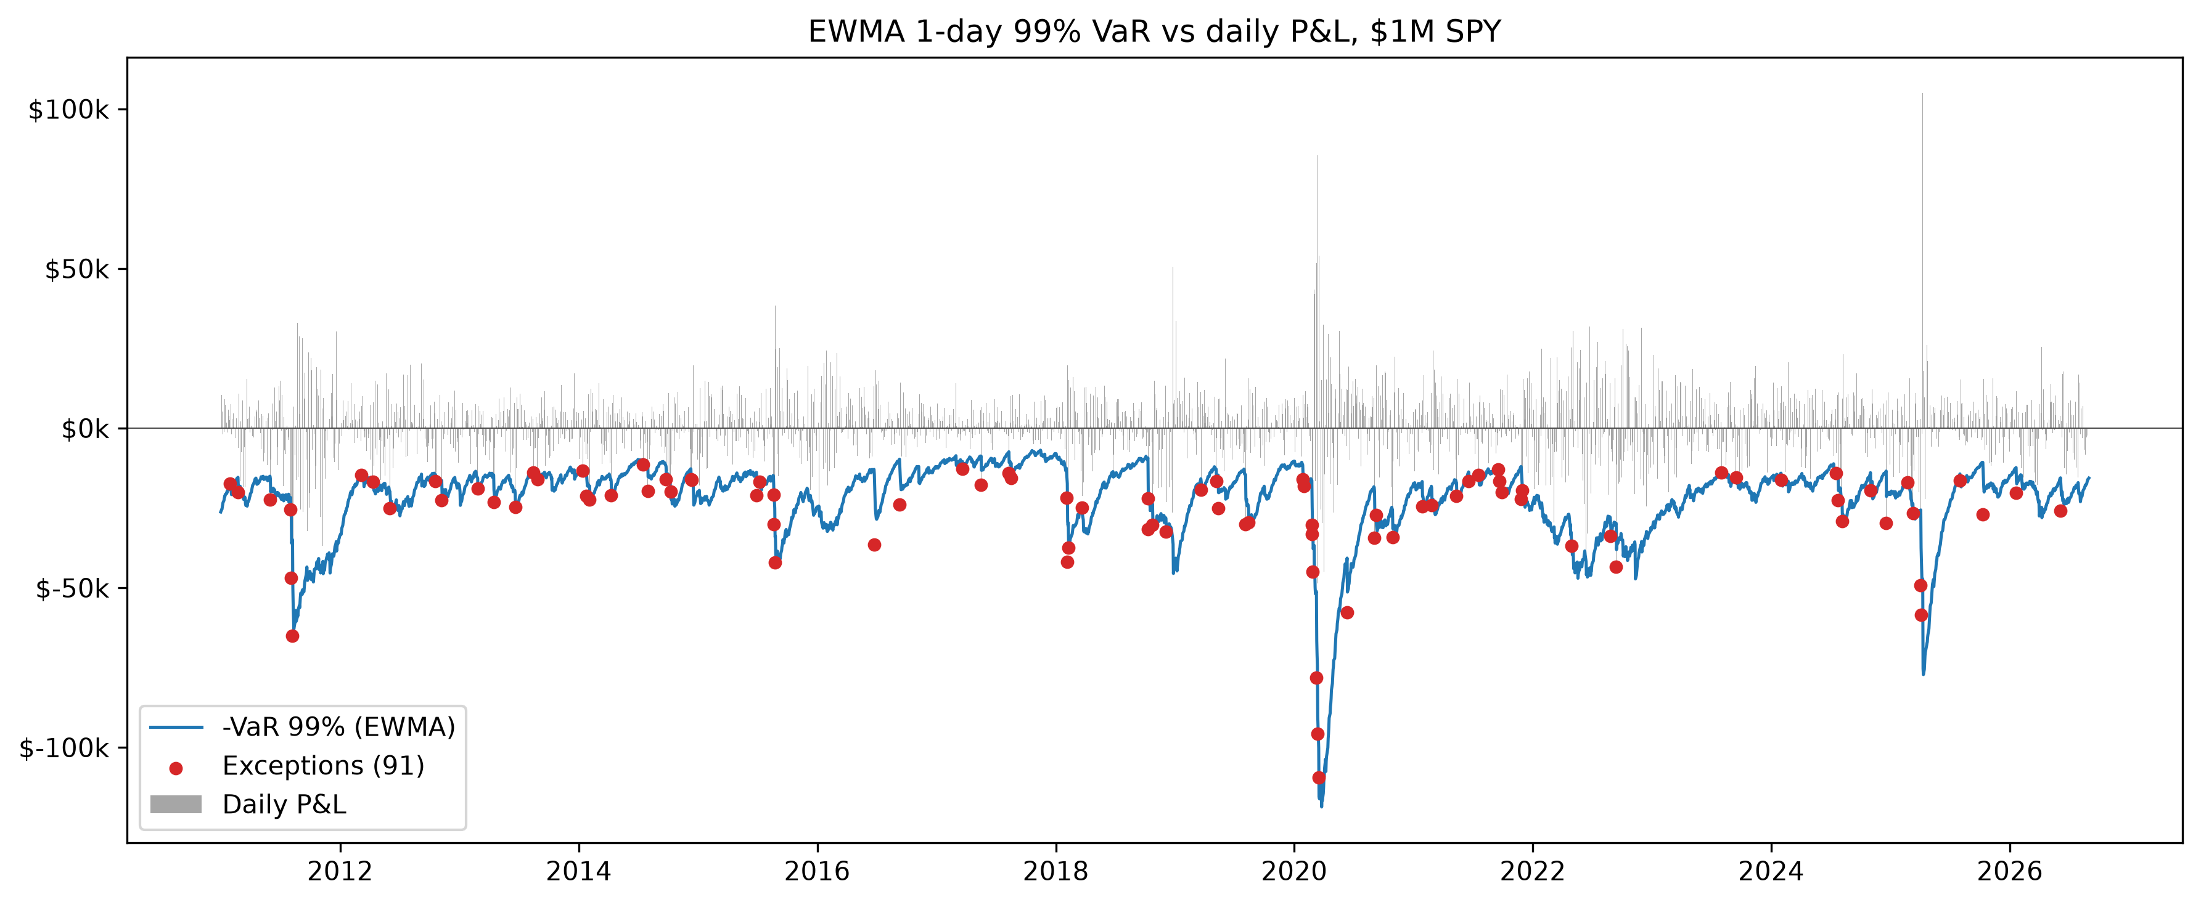
Figure 1. EWMA 1-Day 99% VaR vs Daily P&L for a $1M SPY Portfolio.

Implementation Checks
- No look-ahead: scrambling every return from day t onward leaves all forecasts up to day t unchanged.
- Initialization: the starting variance uses only the first 250 returns, and no forecast is produced before December 31, 2010.
- Hand check: σ = 1% and a −3% return give a next-day variance of 0.000148 (σ ≈ 1.217%), matching the worked example.
- Output: 3,939 forecast days with no missing values; VaR is positive and equals $1,000,000 × z × σ on every day.
- Reproducibility: python notebooks/03_ewma_var/ewma_var.py regenerates results/ewma_var_output.csv and the ewma_* figures, and runs all of these checks.

Known Limitations
- The Normal distribution may underrepresent fat tails, so the 2.326 multiplier can understate extreme losses even when σₜ is accurate.
- EWMA reacts to shocks rather than anticipating them: VaR rises only after large returns occur, so the first days of a stress episode can produce exceptions, and exceptions may cluster.
- Fast decay means VaR falls back quickly after a shock, so it can be low just before a new one, as in late 2017.
- λ = 0.94 is a convention, not an estimate for SPY, and results are sensitive to its value.
- There is no long-run variance anchor (unlike GARCH) and no asymmetry between gains and losses.
- The use of unadjusted SPY Last Price means dividends are not explicitly reflected in the return series.
- VaR estimates a loss threshold, not the severity of losses beyond that threshold.

