Historical Simulation VaR Model Development Summary
Baseline Development Version
Model | Historical Simulation VaR | Developer | Cassie Wan
Version | 1.0 | Date | October 6, 2026

Methodology
The model estimates the 1-day 99% Value-at-Risk (VaR) of a hypothetical $1,000,000 long position in SPY. Daily simple returns are calculated from Bloomberg Last Price observations. The model is a baseline, non-parametric risk model and instead uses the recent empirical distribution of SPY returns. For each forecast date, the model takes the past 250 trading-day returns, ranks them, and uses the empirical 1% quantile as the 99% loss threshold, which is converted into dollars.
$$r_{t}=\frac{P_{t}}{P_{t-1}}-1$$
Age-weighted variant: A secondary version applies exponentially declining weights to the same 250 returns, where i = 1 is the most recent day.
$$ω_{i}=\frac{1-λ}{1-λ^{250}}λ^{i}$$
$λ$=0.97 is the decay factor at determines how important recent returns are. $λ$ is either 0.97 or 0.99 according to the original paper by Boudoukh, Richardson, and Whitelaw. A decay factor of 0.97 places heavy emphasis on immediate history while 0.99 distributes weight more evenly. $λ$=0.97 is used here as a baseline.

Key Assumptions
- Historical relevance: the previous 250 trading days are treated as informative for the next trading day's risk.
- No distributional assumption: tail losses come directly from observed returns, so fat tails and skewness are captured, but only to the extent they occurred in the window.
- Equal weighting: every observation in the 250-day estimation window receives the same weight (does not apply to the age-weighted variant).
- Constant decay factor: $λ$=0.97 is held fixed through the timeframe.
- Volatility: not modeled explicitly, volatility clustering enters only through which days fall inside the window.
- Constant exposure: the portfolio is treated as a constant $1,000,000 long SPY position.
- Price convention: Bloomberg Last Price is unadjusted, so dividend effects are not explicitly incorporated into the return series.

Parameters
Parameter | Value | Rationale
Portfolio value | $1,000,000 | Project specification
Confidence level | 99% | Project specification
Forecast horizon | 1 trading day | Project specification
Estimation window | 250 trading days | Common baseline
Decay factor $(λ)$ | 0.97 | BRW standard, project baseline
Return type | Simple daily return | Common model convention
First forecast | December 31, 2010 | After 250 prior returns

Rolling VaR Chart
The rolling VaR series changes as the 250-day window of returns rolls forward. The chart below is descriptive only; formal assessment of model performance is reserved for the independent validation phase.
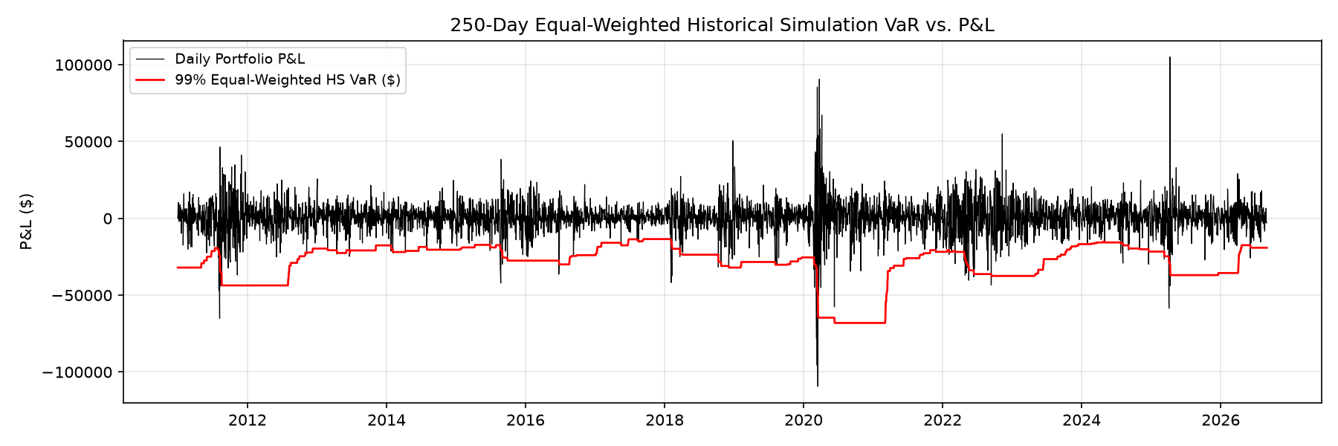
Figure 1. Equal-Weighted Historical Simulation 1-Day 99% VaR vs Daily P&L for a $1M SPY Portfolio.

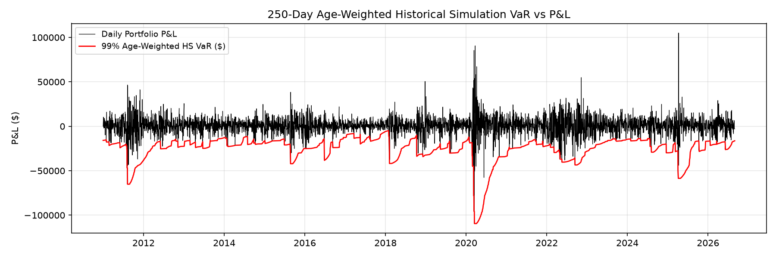
Figure 1. Age-Weighted Historical Simulation 1-Day 99% VaR vs Daily P&L for a $1M SPY Portfolio.

Implementation Checks
- No look-ahead bias: each VaR uses only returns dated before the day being forecast; window is lagged correctly
- Initialization: no VaR before the first full 250-day window (December 31, 2010); early rows are NaN, not filled
- Output: P&L is scaled correctly, VaR is reported as a positive loss
- Reproducibility: re-running notebooks/01_historical_var/historical_var.py on the same input produces identical output

Known Limitations
- The 99% estimate is determined by only the two or three worst returns in a 250-day window, so it is sensitive to individual observations.
- A 250-day equally weighted window can respond gradually to sudden changes in volatility and can change abruptly when extreme observations roll out of the window.
- The model cannot produce a loss larger than the worst return in the window; a calm window can omit severe but plausible events.
- The use of unadjusted SPY Last Price means dividends are not explicitly reflected in the return series.
- VaR estimates a loss threshold, not the severity of losses beyond that threshold.
- Results depend on the selected 250-day lookback window and the assumption that recent historical behavior is informative for the next day.

