Parametric VaR Model Validation Report
Model | Parametric (Normal) VaR | Developer | Thomas Flaim
Validator | Cassie Wan | Date | October 23, 2026

Model Overview
The model estimates the 1-day 99% Value-at-Risk (VaR) of a hypothetical $1,000,000 long position in SPY. Daily simple returns are calculated from Bloomberg Last Price observations. For each forecast date t, the model uses the prior 250 trading-day returns through t-1, estimates the rolling sample mean $μ_{t}$ and standard deviation $σ_{t}$, assumes returns follow a Normal distribution, and converts the 99% loss threshold into dollars.
$$r_{t}=\frac{P_{t}}{P_{t-1}}-1$$
Parametric VaR is calculated as:
$${VaR}_{t}=1,000,000*\left(z_{0.99}*σ_{t}-μ_{t}\right) z_{0.99}≈2.326$$
Parameter | Value | Validation Comment
Portfolio value | $1,000,000 | Project specification
Confidence level | 99% | Project specification
Forecast horizon | 1 trading day | Project specification
Estimation window | 250 trading days | Project specification
Distribution | Normal | Parametric model specification
99% Normal quantile | 2.326 | One-sided 99% threshold
Return type | Simple daily return | Common model convention
First forecast | December 31, 2010 | After 250 prior returns

Conceptual Soundness
For a single, linear, liquid long position the variance-covariance approach is appropriate and well. There is no nonlinearity or aggregation problem to handle, so the method is fit for the stated hypothetical portfolio. The approach is transparent, easy to reproduce, needs only two estimated parameters, and gives smooth, stable estimates in calm markets.
Assumption | Validation Assessment
Normality | Ignores tail events which may cause model to underestimate tail risk and losses
Equal-weighted returns | Reacts slowly to volatility shocks and ignores volatility clustering
Constant $1M exposure | Appropriate for the project specifications
Estimated mean
250-day window | Project specification, note that there is a trade-off between responsiveness and noise
The model is reasonable in stable, moderate-volatility periods but less reliable at volatility regime shifts, during fat-tailed gap events, and in the period after a crisis when old extreme returns remain in the window.

Data & Implementation Review
Check | Result
Project price sample | 2010-01-04 to 2026-08-31
First forecast | 2010-12-31
SPY price observations | 4,190
VaR forecasts | 3,939
Duplicate model-period dates | 0
Missing Last Price values | 0
Return / P&L calculation | Verified: P&L = 1,000,000 * simple return
Look-ahead bias | None: day t forecast uses information through t-1
VaR output convention | Positive dollar loss threshold in standardized output

Independent Calculation Checks
Date | Window | Independent VaR | Model VaR | Context | Result
2013-06-24 | 2012-06-22 to 2013-06-21 | $17,567 | $17,567 | Calm | Match
2015-08-24 | 2014-08-26 to 2015-08-21 | $18,579 | $18,579 | Flash-crash day | Match
2018-02-05 | 2017-02-07 to 2018-02-02 | $10,035 | $10,035 | Volatility spike | Match
2020-03-16 | 2019-03-19 to 2020-03-13 | $33,529 | $33,529 | High volatility | Match
2025-04-10 | 2024-04-11 to 2025-04-09 | $27,622 | $27,622 | Tariff volatility | Match

The output CSV is written before the final assertions run, so a failed check still leaves an output file. The NaN and duplicate checks also run after pct_change() instead of before it.

Preliminary Findings
The principal concerns are conceptual. Python implementation matches the documented methodology and parameters. Independent calculations also reproduce the model output on five test dates, including high volatility events. The Normal assumption does not capture fat tails or negative skew in SPY returns, so 99% VaR is likely understated. The equal-weighted 250-day volatility estimate also responds slowly to shocks and keeps old extremes in the window afterward, so the model tends to under-forecast when volatility rises and over-forecast for months after it falls.

Next Steps
At completion of the initial review, the next planned steps were quantitative exception analysis, Kupiec and Christoffersen backtesting, benchmarking against the two other baseline models, and stress-period analysis. Those steps are completed below. Remaining future work includes sensitivity analysis and additional stress testing.

Backtesting & Benchmarking
Exception Analysis
Metric | Parametric Results
Backtesting observations | 3939
Expected exceptions at 99% VaR | 39.39
Actual exceptions | 106
Expected exception rate | 0.01
Observed exception rate | 0.02691

Year | Observations | Actual Exceptions | Expected Exceptions | Rate
2010 | 1 | 0 | 0.01 | 0.000000
2011 | 252 | 10 | 2.52 | 0.039683
2012 | 250 | 1 | 2.50 | 0.004000
2013 | 252 | 3 | 2.52 | 0.011905
2014 | 252 | 10 | 2.52 | 0.039683
2015 | 252 | 8 | 2.52 | 0.031746
2016 | 252 | 4 | 2.52 | 0.015873
2017 | 251 | 3 | 2.51 | 0.011952
2018 | 251 | 17 | 2.51 | 0.067729
2019 | 252 | 4 | 2.52 | 0.015873
2020 | 253 | 14 | 2.53 | 0.055336
2021 | 252 | 3 | 2.52 | 0.011905
2022 | 251 | 17 | 2.51 | 0.067729
2023 | 250 | 0 | 2.50 | 0.000000
2024 | 252 | 6 | 2.52 | 0.023810
2025 | 250 | 5 | 2.50 | 0.020000
2026 | 166 | 1 | 1.66 | 0.006024

Exceptions are concentrated in stress episodes: August 2011 (7 exceptions in 44 trading days), August 2015 (5 in 32), February to March 2018 (7 in 40), February to April 2020 (12 in 52), and April 2025 (3 in 21). They are not limited to crashes, though. 2014 (10) and 2022 (17) also far exceeded the roughly 2.5 expected per year, which is consistent with a trailing window that lags when volatility changes gradually.
When the model fails, it can fail badly. The average exception loss is 1.48 times the VaR. The worst case is 2018-02-05, when the loss was $41.8k against a VaR of only $10.0k (4.2 times), because the window’s volatility was just 0.46%. In March 2020, three days (Mar 9, 12 and 16) exceeded 3.2 times VaR.
The model also errs in the opposite direction. 2023 had no exceptions and 2012 had one, which is consistent with high-volatility days staying in the window after a stress period and keeping VaR elevated. A rate well above 1% suggests understated risk, and a rate well below 1% suggests overly conservative estimates. This model shows both patterns in different periods.
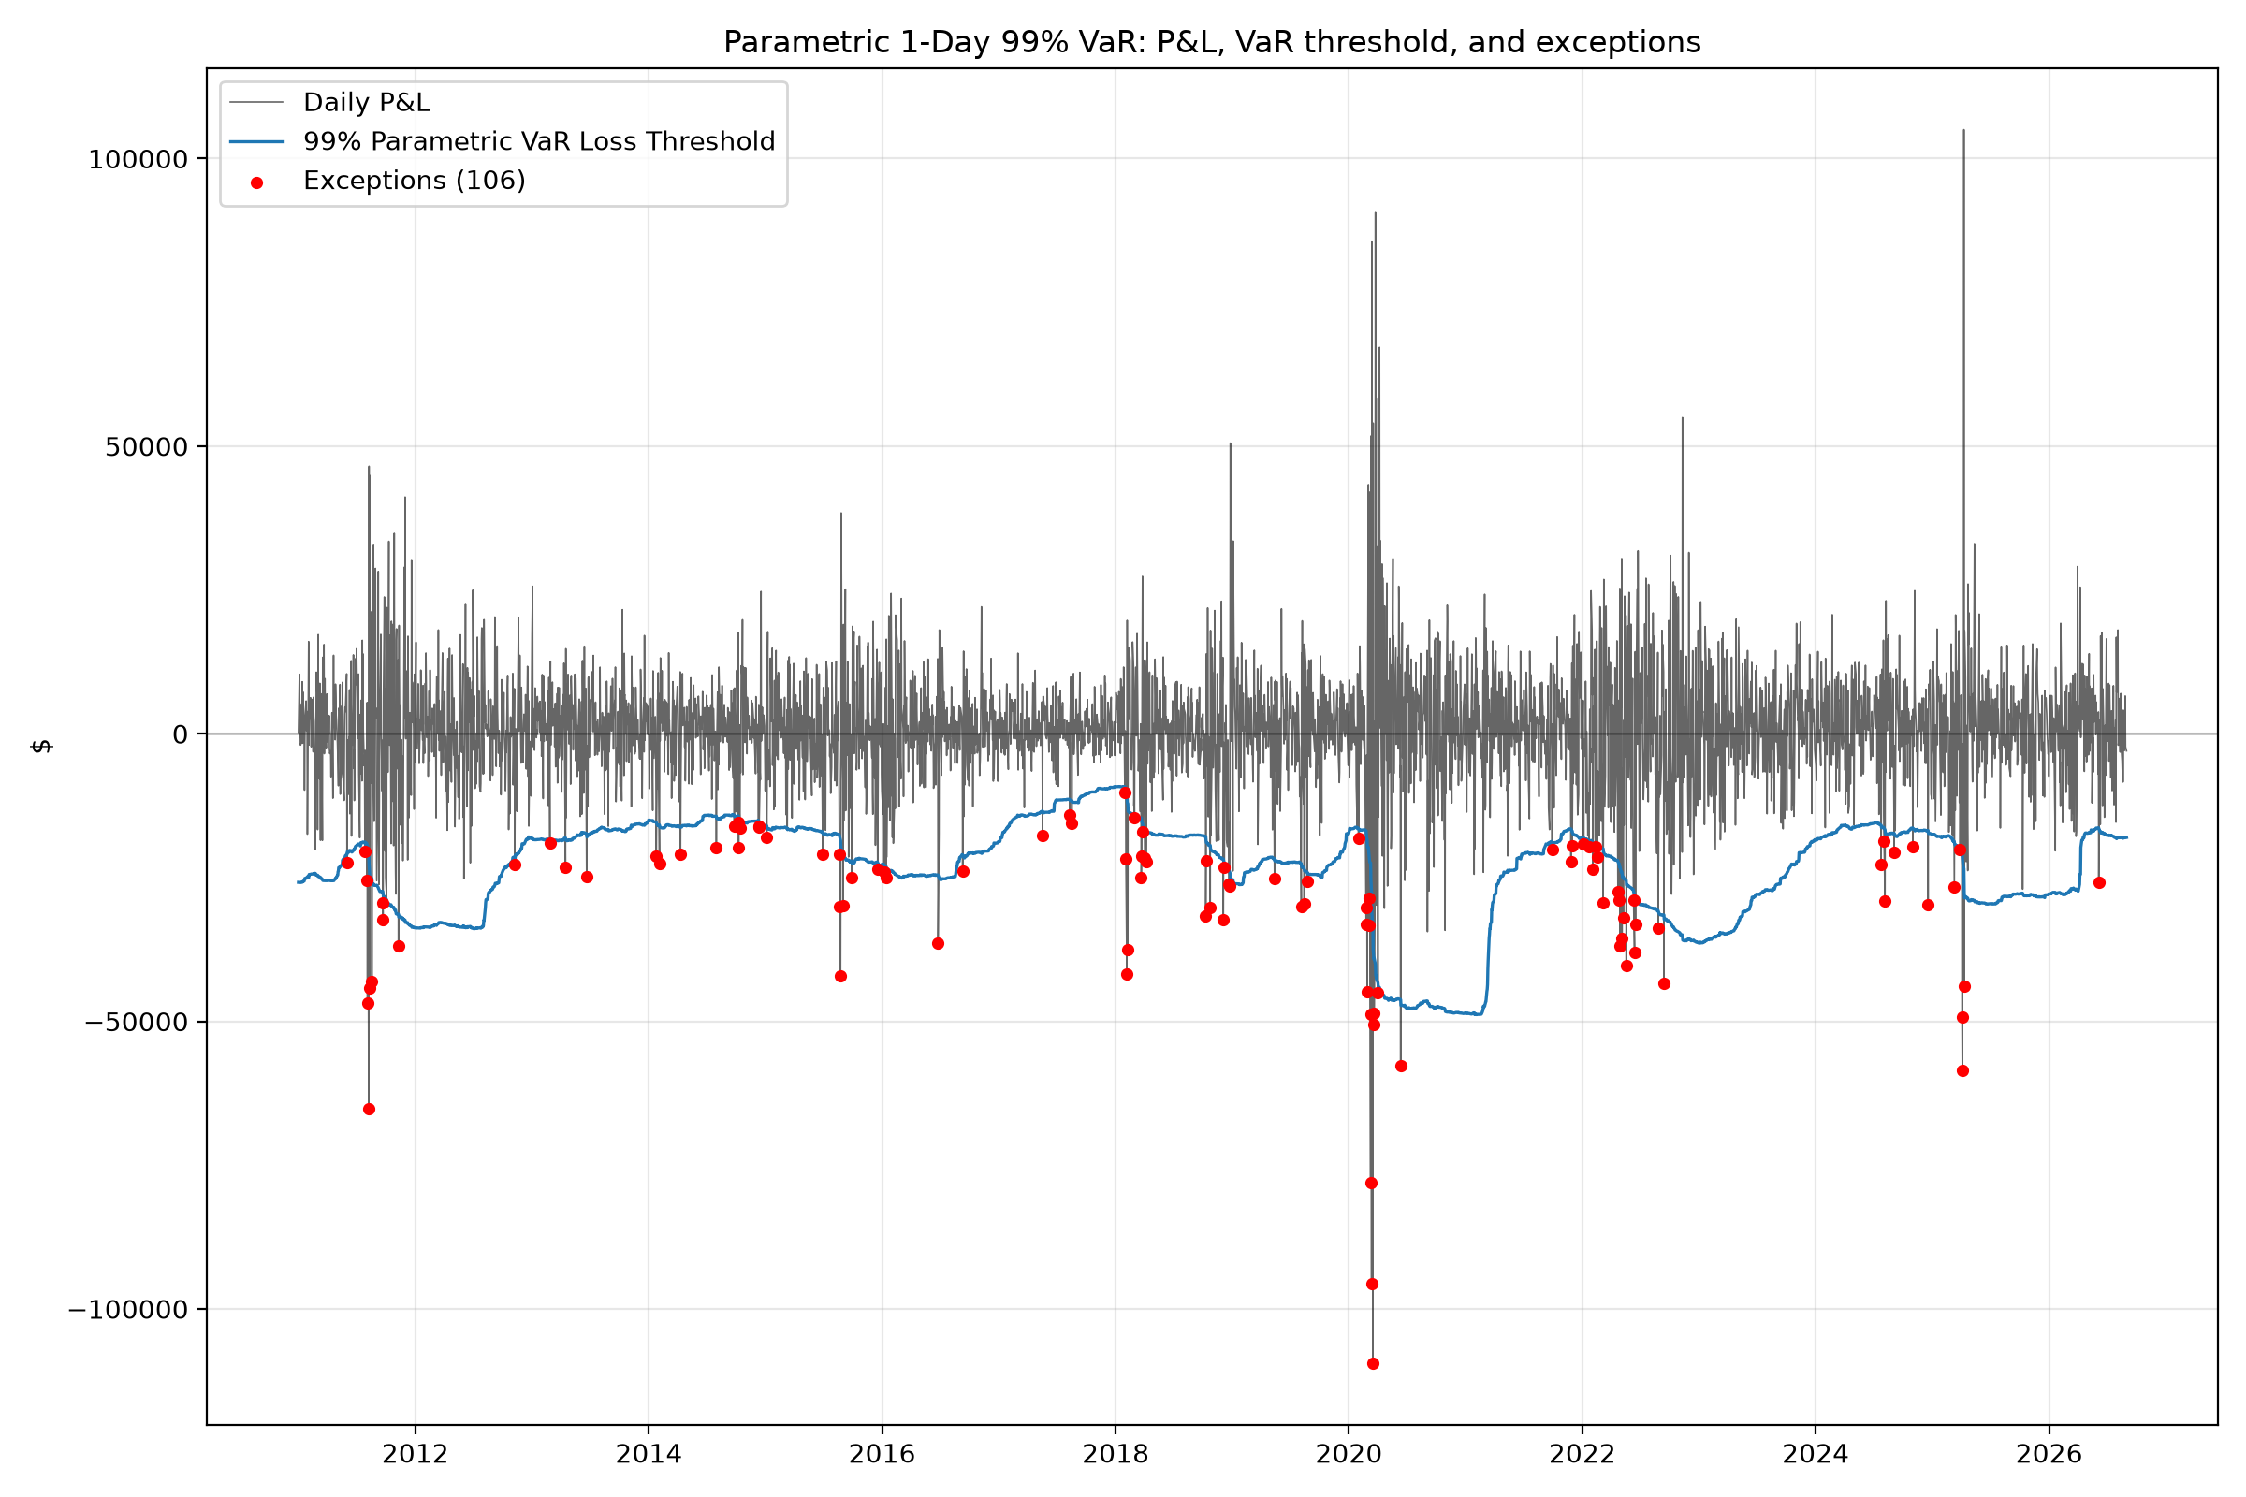
Figure 1. Parametric 1-day 99% VaR backtest. Red points identify days where realized P&L fell below the negative VaR threshold.
Statistical Backtesting
Test | Statistic | p-value | Result at 5%
Kupiec POF | 77.788861 | 1.146650e-18 | Reject
Christoffersen Independence | 17.876250 | 2.357449e-05 | Reject
Conditional coverage (UC + IND) | 95.665111 | 1.684942e-21 | Reject

Kupiec: The null of a 1% exception probability is rejected. The observed exception rate of 2.69% is statistically inconsistent with the intended 99% coverage.
Christoffersen: The null of independent exceptions is rejected. Transition counts are n00=3,738, n01=94, n10=94, and n11=12. The probability of an exception is 2.45% after a non-exception day and 11.3% after an exception day, which is clear evidence of clustering.
Together they indicate that the model both under-covers and fails to adapt to changes in volatility. A rejection is a reason to investigate rather than a complete assessment, and the tests do not describe how large the exceptions are.
Benchmarking Results
Metric | Historical | Parametric | EWMA
Average VaR ($) | 28,603.45 | 23,187.73 | 21,915.04
Maximum VaR ($) | 68,076.17 | 48,837.90 | 118,677.25
Actual exceptions | 59 | 106 | 91
Exception rate | 0.01498 | 0.02691 | 0.0231
Kupiec p-value | 0.003448 | 1.146650e-18 | 1.648372e-12
Christoffersen p-value | 0.000021 | 0.000024 | 0.005842
Mean loss / VaR on exceptions | 1.442881 | 1.478568 | 1.423312
Max loss / VaR | 2.812955 | 4.167596 | 3.392838

All three models reject the independence test. EWMA clusters the least: the probability of an exception the day after an exception is 7.7%, against 11.9% for Historical and 11.3% for parametric. Historical has the fewest exceptions, but its average VaR is 23% above parametric. Fewer exceptions are partly paid for with higher capital, so exception counts alone should not be used to rank the models.
Historical VaR is the highest on average ($28.6k). Parametric VaR averages 19% lower even though both use the same 250-day window, which is consistent with a Normal quantile sitting below the empirical 1% quantile. The two track each other closely (a correlation of 0.96 in levels). EWMA has the lowest average ($21.9k) but the highest maximum ($118.7k on 2020-03-25)..
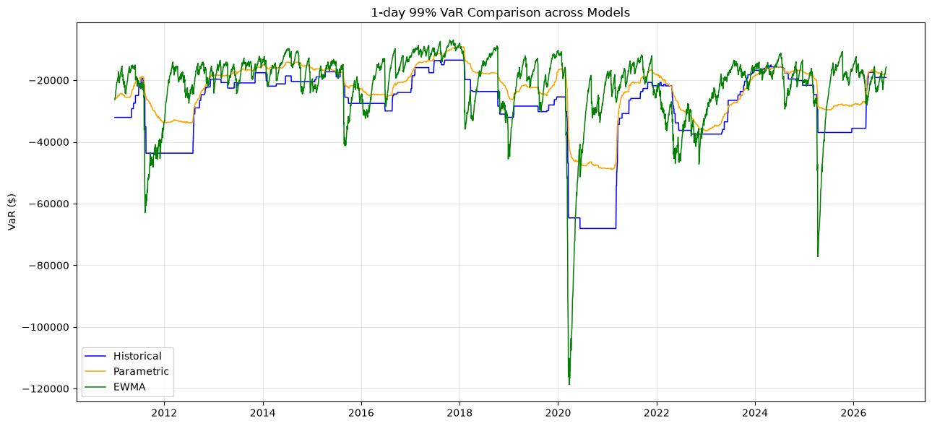
Figure 2. Full period VaR comparison across all three models.
The models differ most in how fast they react to volatility. Measured from 2020-02-19, EWMA VaR reached 1.5 times its starting level on 2020-02-25, parametric on 2020-03-10 and Historical on 2020-03-12. By 2020-03-16, VaR had risen 6.1 times for EWMA, 2.0 times for parametric and 1.8 times for Historical (Figure 2 shows this period alongside the daily losses). In the 52 trading days from 2020-02-15 to 2020-04-30, the exception counts were 8 for Historical, 12 for parametric and 6 for EWMA. EWMA also recovers fastest: by 2021-02-04 it had fallen back to $24.6k, while Historical stayed at $68.1k and parametric at $48.8k.
The rankings change by period. EWMA had 10 exceptions in 2021, against 3 for parametric and 1 for Historical, because its VaR dropped quickly after the 2020 crash. In 2022 it had only 3, against 17 for parametric and 10 for Historical. Parametric was worst in 2018 (17 exceptions against 7 and 8). All three models reject the independence test, but EWMA clusters the least: the probability of an exception the day after an exception is 7.7%, against 11.9% for Historical and 11.3% for parametric.
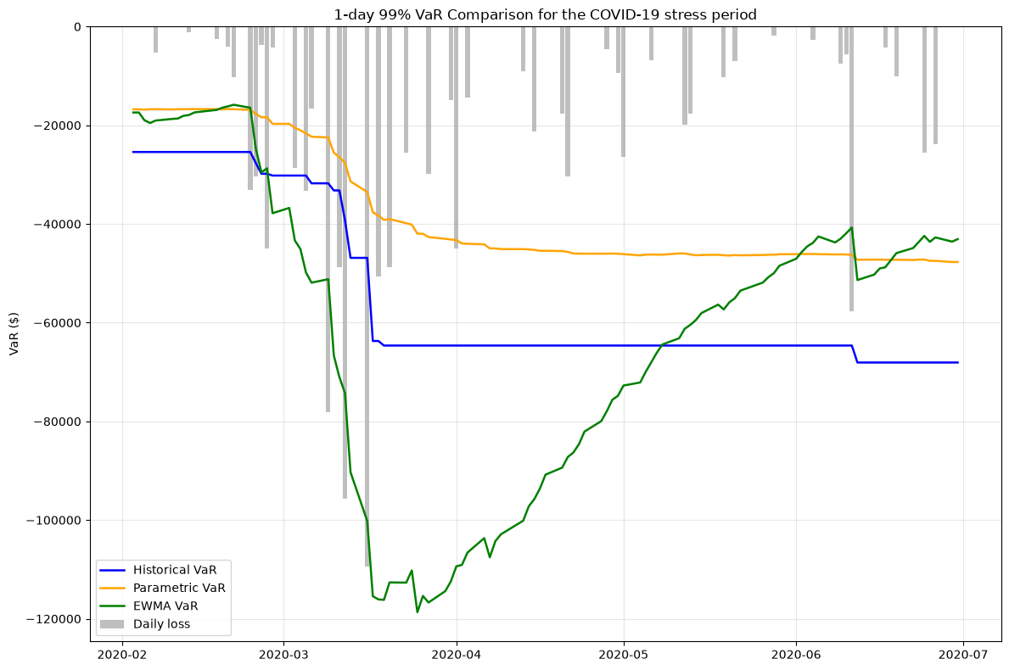
Figure 3. COVID-19 stress period (2020-02 to 2020-07) VaR comparison across all three models.

Preliminary Findings & Next Steps
The main finding is that the parametric model underestimates risk, recording 106 exceptions against 39.4 expected. Exceptions cluster, with an 11.3% probability of an exception following another, compared with 2.45% otherwise. This may reflect the Normal distribution’s failure to capture heavy tails (excess kurtosis of 12.6; empirical 1% return quantile of −3.01% versus −2.45% under the Normal) and the slow response of the equal-weighted 250-day volatility estimate.
Losses on exception days average 1.48 times VaR, reaching 4.2 times VaR on 2018-02-05, when VaR was only $10.0k. Exceptions also occurred outside major crashes, including 10 in 2014 and 17 in 2022, suggesting the model may miss gradual volatility changes. Further analysis should examine expected shortfall, stress scenarios, and exceptions across volatility regimes.
The model can also become overly conservative after market stress. No exceptions occurred in 2023, while maximum VaR ($48.8k) occurred on 2021-02-04, as March 2020 extremes remained in the estimation window. However, average VaR is below Historical VaR and close to EWMA VaR, indicating that excessive conservatism is not persistent.
Benchmarking shows that the parametric model has the most exceptions and the largest single-day loss relative to VaR. Its VaR series is also the smoothest (coefficient of variation 0.38, versus 0.44 for Historical and 0.56 for EWMA), indicating a slower response to shocks. Since all three models fail both backtesting tests, the limitations likely extend beyond the Normality assumption to weaknesses shared by trailing-window methods.
Recommended further investigation: Run sensitivity tests on window length (125, 250, 500 days) and compare zero versus estimated mean; and repeat the tests on subperiods. No final model effectiveness rating is assigned at this stage.

References
Board of Governors of the Federal Reserve System and Office of the Comptroller of the Currency (2011). SR 11-7: Supervisory Guidance on Model Risk Management. April 4, 2011.
Christoffersen, P. F. (1998). Evaluating interval forecasts. International Economic Review, 39(4), 841–862.
J.P. Morgan/Reuters (1996). RiskMetrics Technical Document (4th ed.). New York.
Kupiec, P. H. (1995). Techniques for verifying the accuracy of risk measurement models. Journal of Derivatives, 3(2), 73–84.
Project materials: Parametric VaR model development documentation, Python implementation, standardized output, common SPY dataset, and combined model comparison output.

