Parametric VaR Model Development Summary
Baseline Development Version
Model | Parametric (Normal) VaR | Developer | Thomas Flaim
Version | 1.0 | Date | October 2, 2026

Methodology
The model estimates the 1-day 99% Value-at-Risk (VaR) of a hypothetical $1,000,000 long position in SPY. Daily simple returns are calculated from Bloomberg Last Price observations. For each forecast date, the model uses the prior 250 trading-day returns to estimate the rolling mean return (μₜ) and standard deviation (σₜ), assumes a Normal return distribution, and converts the resulting 99% loss threshold into dollars.

Parametric VaR is calculated as:

where V = $1,000,000, z₀.₉₉ ≈ 2.326, μₜ is the rolling 250-day mean return, and σₜ is the rolling 250-day standard deviation. The rolling estimates are shifted by one trading day so the forecast for day t uses only information available through day t−1.

Key Assumptions
- Normality: daily SPY returns are modeled as Normally distributed; this determines the 99% quantile used in the VaR calculation.
- Historical relevance: the previous 250 trading days are treated as informative for the next trading day's risk.
- Equal weighting: every observation in the 250-day estimation window receives the same weight.
- Constant exposure: the portfolio is treated as a constant $1,000,000 long SPY position.
- Price convention: Bloomberg Last Price is unadjusted, so dividend effects are not explicitly incorporated into the return series.

Parameters
Parameter | Value | Rationale
Portfolio value | $1,000,000 | Project specification
Confidence level | 99% | Project specification
Forecast horizon | 1 trading day | Project specification
Estimation window | 250 trading days | Common baseline
Distribution | Normal | Parametric model specification
99% Normal quantile | 2.326 | One-sided 99% threshold
Return type | Simple daily return | Common model convention
First forecast | December 31, 2010 | After 250 prior returns

Rolling VaR Chart
The rolling VaR series changes as the 250-day estimates of mean and volatility change. The chart below is descriptive only; formal assessment of model performance is reserved for the independent validation phase.
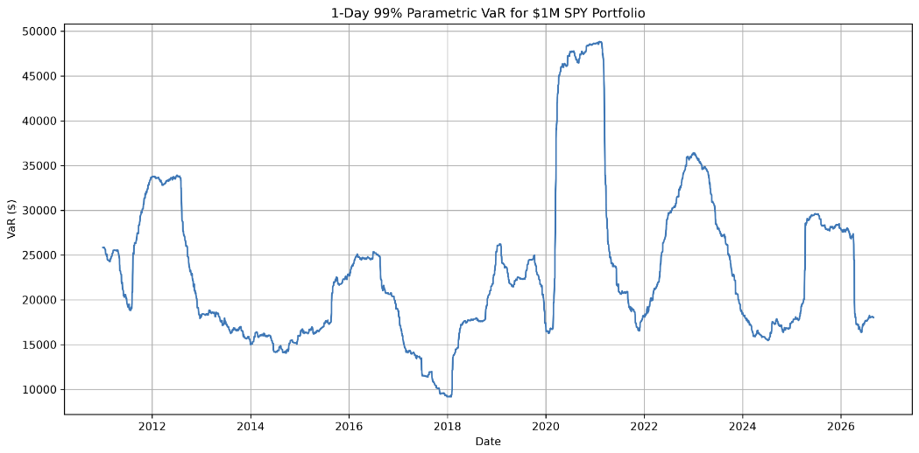
Figure 1. 1-Day 99% Parametric VaR for a $1M SPY Portfolio.

Known Limitations
- The Normal distribution may underrepresent fat tails, skewness, and extreme market moves.
- A 250-day equally weighted window can respond gradually to sudden changes in volatility and can change abruptly when extreme observations roll out of the window.
- The use of unadjusted SPY Last Price means dividends are not explicitly reflected in the return series.
- VaR estimates a loss threshold, not the severity of losses beyond that threshold.
- Results depend on the selected 250-day lookback window and the assumption that recent historical behavior is informative for the next day.

