# In-Class Programming 2

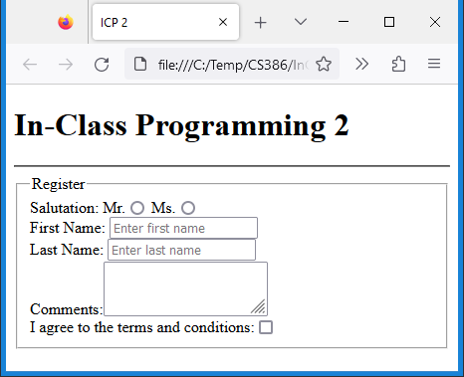

Create the following html page:

* Include a title tag as shown
* Include meta tags:
  + Character set
* Use fieldset element as shown
* Use labels for all controls
* Use name attributes for all controls
* Use placeholders as shown

Upload the following files to Canvas:

* Screenshot of the browser window showing your html page (either pasted into a Word document or as an image)
* Your html file icp2.html (html extension)

**Notes:**

* Upload the files individually (no zipping, compressing)
* Your code should contain some meaningful comments
* Your code should be well organized and formatted