Agentic AI Powered Intelligent Web Application Testing Platform
Software Design Document (SDD) & High-Level Design (HLD)
Revision: 5-Agent MVP Architecture
Document Type | Project | Audience | Status | Delivery Philosophy
Software Design Document + High-Level Design | Agentic AI Powered Intelligent Web Application Testing Platform | Engineering Managers, Architects, CTOs | Draft v2.0 — MVP Agent Consolidation Revision | Phased — MVP (5 Agents) → Phase 2 → Production (12 Agents)

0. How to Read This Document
Every module in this document is broken into three delivery tiers so that scope is never ambiguous:
- MVP (Phase 1) — the smallest thing that proves the concept end-to-end, using a single application, single user, local execution, and the cheapest possible infrastructure. Nothing here is optional; everything here is required to ship.
- Phase 2 (Enhancement) — hardening, multi-user support, resilience, and the features that turn a working prototype into a tool a QA team will trust daily.
- Production — enterprise-grade: scale, security, observability, multi-tenant isolation, and integration with the wider SDLC toolchain.
The guiding rule of this document: do not build Phase 2 or Production capability inside the MVP. The MVP must be shippable by a small team in weeks, not quarters. Every section below states explicitly what is postponed and why.
Revision note: this edition additionally re-scopes MVP AGENT OWNERSHIP (not feature richness) — the MVP ships the same responsibilities described throughout this document, but consolidated under 5 executable AI agents instead of the original 12. Phase 2 begins splitting merged agents apart; Production restores the full original enterprise architecture unchanged. See §2 for the new architecture, §4.0 for the ownership mapping, and §23.7 for the full rationale.

1. Executive Summary

1.1 Vision
A tester provides three inputs — an application URL, credentials, and a natural-language prompt (“Test Login Module”, “Test Employee Management”, “Test Complete Application”) — and the platform autonomously understands the application, generates test cases, writes Playwright automation code, executes it, and produces a report. No manual scripting, no manually maintained locators, minimal human intervention.

1.2 Why This Is Not a Chatbot and Not “Just Playwright”
A chatbot answers questions. A Playwright project runs pre-written scripts. This platform is an agentic system: a set of cooperating, specialized AI agents that each own a slice of the problem (crawling, understanding, reasoning, generating, executing, reporting), coordinate through a shared state machine, make decisions under uncertainty (which pages matter, which scenarios to test, how to recover from a broken selector), and act autonomously — with human checkpoints only where policy requires it (e.g., approving generated test cases before execution in Production mode).
“Specialized agents” describes the responsibilities in this system, not a fixed headcount of running services. At MVP tier, five agents jointly own all twelve responsibility areas described throughout this document; at Production tier, each responsibility area is its own independently deployable agent, exactly as originally designed. See §2 for the full picture.

1.3 Core Design Philosophy
- Crawl once, test many times. The expensive step (understanding the app) is decoupled from the cheap step (testing it) via a persisted Application Inventory.
- Small model, narrow prompts. DeepSeek R1 Distill Qwen 8B is a capable but modest local model — the architecture compensates with tight context curation (RAG-style retrieval over the inventory) rather than dumping the whole DOM into every prompt.
- Agents are boring, replaceable services. Each agent has one job, a typed input/output contract, and can be swapped, versioned, or replaced by a bigger model or a hosted API later without touching the others.
- Deterministic where possible, generative only where necessary. DOM parsing, selector extraction, and report rendering are plain code. LLM calls are reserved for reasoning, scenario design, and code synthesis — the parts that genuinely need judgment.

1.4 MVP Delivers the Same Architecture Under Consolidated Ownership
A design goal added in this revision, sitting alongside §1.3's four principles: agent count is a delivery-tier decision, not an architecture decision. The responsibilities described across this document — trigger validation, crawling, DOM/API analysis, inventory building, reasoning, test case generation, script generation, POM generation, execution, reporting, self-healing, and credential vaulting — do not change between tiers. What changes is how many independently-versioned AI agents own them:
- MVP — 5 agents. Ownership consolidates so a small team can ship in weeks: one agent absorbs crawling+analysis+inventory-building duties conceptually split across the same code module, one absorbs reasoning+test design, one absorbs script+POM generation.
- Phase 2 — merged agents begin splitting back into their specialized originals as usage justifies the added operational surface, and Self-Healing is introduced.
- Production — the full, original 12-agent enterprise architecture, unchanged from the initial design, plus Credential Vault.
This lets the MVP ship with a fraction of the orchestration/deployment overhead while guaranteeing that nothing has to be re-architected later — Phase 2 and Production are a decomposition of the MVP's code, not a rewrite of it. The full walkthrough is in §2.

2. Multi-Agent Architecture — Overview
This is explicitly not a monolithic “one big prompt” design. It is a directed graph of specialized agents orchestrated by LangGraph, each with a narrow contract. This section presents the architecture in the order a reader needs it: what ships in the MVP (§2.1), how it evolves (§2.2), exactly how responsibilities map from the original 12-agent design onto the MVP's 5 agents (§2.3), the full original enterprise architecture that Production restores (§2.4), supplementary diagrams (§2.5), and the engineering principles that govern every tier (§2.6).

2.1 MVP Architecture (5 AI Agents)
The MVP is a straight-line pipeline of five AI agents plus six deterministic services. Every responsibility from the original twelve-agent design still exists — nothing has been cut — but ownership is consolidated so a small team can ship an end-to-end run in weeks rather than quarters, while the platform stays accurate, low-latency, scalable, and maintainable from day one.
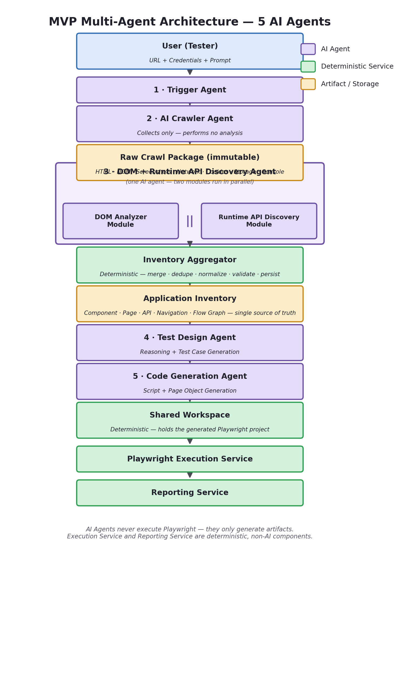
Figure 2.1 — MVP Multi-Agent Architecture (5 AI Agents)

2.1.1 Raw Crawl Package
This revision introduces the Raw Crawl Package as a first-class, named architecture component. The AI Crawler Agent's only job is to collect — it performs no analysis — and its output is this single immutable package, containing:
- HTML
- DOM snapshots
- Screenshots
- Network logs (request/response traffic captured via Playwright interception)
- Cookies
- Storage state (localStorage/sessionStorage)
- Console logs
- Visited URLs
- Assets
Because the package is immutable, the crawler never needs to run again unless a recrawl is explicitly required (§8.5) — the DOM + Runtime API Discovery Agent, and later the Self-Healing Agent (Phase 2), can all consume the same package without re-touching the live browser. This is the architectural expression of Principle 1 in §2.6: Collect Once, Process Many.

2.1.2 Parallel Analysis Inside a Single Agent
The DOM + Runtime API Discovery Agent remains one AI agent in the MVP catalog, but internally it fans out into two modules that execute in parallel against the same Raw Crawl Package:
- DOM Analyzer Module — component discovery, form discovery, selector extraction, navigation graph, flow graph, page metadata.
- Runtime API Discovery Module — API discovery, request/response mapping, authentication mapping, API dependency graph, all derived from observed network traffic (never from source code — see §4.3 for the full black-box discussion).
Both modules' outputs are handed to the Inventory Aggregator — a deterministic service, not an AI agent — which merges the DOM and API inventories, removes duplicates, normalizes data, validates schema, and persists the result as the Application Inventory.
- Merge DOM inventory
- Merge API inventory
- Remove duplicates
- Normalize data
- Validate schema
- Save Application Inventory
This is a refinement over this document's prior revision, which described inventory-building as an internal module of the Analyzer agent. It is corrected here: the Inventory Aggregator was always deterministic (no LLM call, per §4.4's original Prompt Strategy), so it is more accurately modeled as its own standalone service present at every delivery tier — MVP included — rather than something that gets “internalized then externalized” across phases. See §2.2 and §4.4.
The five MVP agents, and what each one absorbs from the original design:
MVP Agent | Absorbs (Original Agent(s)) | Core Responsibility
1. Trigger Agent | Trigger Agent | Validates request, parses prompt, validates credentials, decides inventory reuse vs. recrawl, initializes run state, creates the Run ID.
2. AI Crawler Agent | AI Crawler Agent | Logs in, crawls the application, and produces the Raw Crawl Package. Collects only — performs no analysis.
3. DOM + Runtime API Discovery Agent | DOM + API Analyzer Agent | Runs the DOM Analyzer Module and Runtime API Discovery Module in parallel against the Raw Crawl Package; hands both outputs to the Inventory Aggregator service.
4. Test Design Agent | Reasoning Agent  + Test Case Generator Agent | Retrieves relevant inventory, infers business intent, generates test intents, test cases, expected results, test data, and the test_cases.xlsx artifact.
5. Code Generation Agent | Script Generator Agent  + POM Generator Agent | Reads test_cases.xlsx and the Application Inventory, generates Playwright specs and Page Objects, validates the result, and writes an executable Playwright project to the Shared Workspace.
The Application Inventory itself is completely unchanged in schema by this revision — same five sub-layers (Component, Page, API, Navigation, Flow Graph), same JSON structure (§8.4). The Inventory Builder Agent (§4.4) — referred to as the Inventory Aggregator throughout the MVP/Phase 2 architecture — has always performed this merge deterministically.

2.1.3 Non-AI Services (MVP)
These are not AI agents. They are deterministic services, present from MVP tier onward:
- LangGraph Orchestrator — the state machine controller (§3); routes work between the 5 agents and 6 services instead of 12 agents, but its job is otherwise identical.
- Inventory Aggregator — merges, dedupes, normalizes, validates, and persists the Application Inventory from the DOM Analyzer and Runtime API Discovery modules' outputs (§2.1.2, §4.4).
- Inventory Database — SQLite-backed persistence for the Application Inventory and run metadata.
- Shared Workspace — the deterministic hand-off point that holds the Code Generation Agent's output (the generated Playwright project) so the Execution Service can run it without any AI agent ever touching Playwright directly.
- Playwright Execution Service — runs the generated Playwright project (npx playwright test).
- Reporting Service — generates HTML, JSON, and Excel reports. No LLM required.
Execution and Reporting were always non-AI, infrastructure-level services in the original design (see the original “Supporting agents” note in §2.4) — this revision does not change their nature, only makes explicit (via Inventory Aggregator and Shared Workspace) that every deterministic hand-off in the pipeline is modeled as its own named component rather than folded silently into an agent's internals.

2.2 Phase Evolution — How the MVP Grows Into the Enterprise Architecture
The delivery-tier philosophy from §0 still governs this axis: MVP ships the minimum agent count that proves the concept; Phase 2 begins splitting merged agents apart as usage and reliability data justify the added operational surface; Production restores the full, original enterprise architecture. No responsibility is ever removed on this path — only re-distributed across more, narrower agents. The deterministic services (Inventory Aggregator, Shared Workspace, Execution Service, Reporting Service, Orchestrator) do not “evolve” in this sense — they are architecturally stable from MVP through Production; only their deployment footprint (in-process module vs. independently scaled service) changes, per §11 and §15.
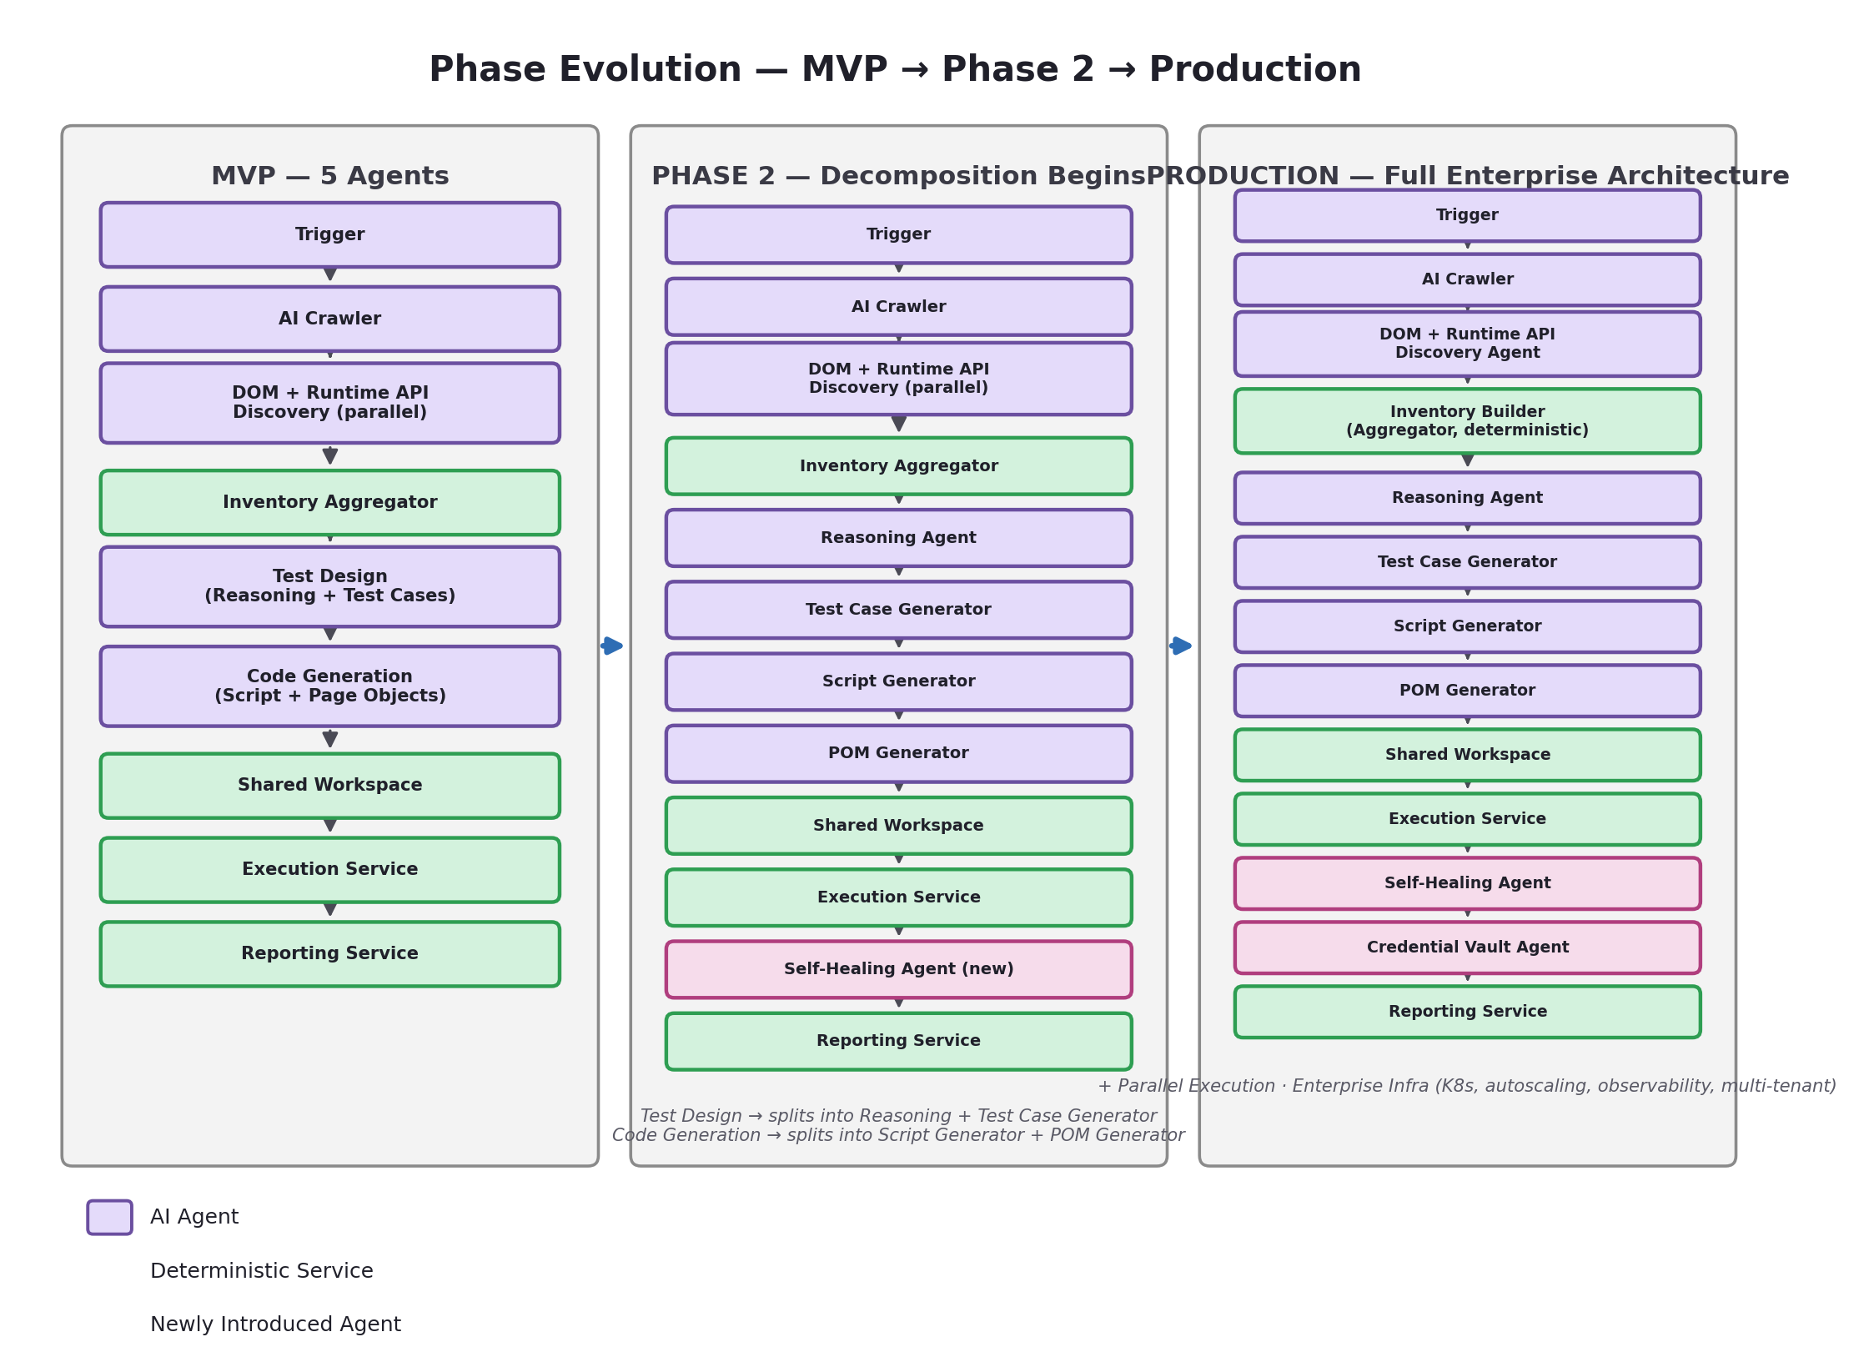
Figure 2.2 — Phase Evolution: MVP (5 agents + 6 services) → Phase 2 (decomposition begins) → Production (12 agents + services)

2.2.1 MVP → Phase 2
- Test Design Agent splits into the original Reasoning Agent + Test Case Generator Agent — separated once scenario reasoning and test-case authoring need independent iteration speed or different model sizes.
- Code Generation Agent splits into the original Script Generator Agent + POM Generator Agent — separated once POM reuse/versioning becomes a first-class concern.
- Self-Healing Agent is introduced for the first time, exactly as in the original design (§4.11), now also able to read directly from the Raw Crawl Package (in addition to the Application Inventory) when diagnosing a stale selector, since the package is retained and immutable.
- Trigger, AI Crawler, and the DOM + Runtime API Discovery Agent's two parallel modules remain as-is through Phase 2; they only gain the capability upgrades already described per-agent in §4 (e.g., parallel crawling, shadow-DOM traversal).
- Inventory Aggregator and Shared Workspace are unchanged — they were never merged into an AI agent to begin with.

2.2.2 Phase 2 → Production
- Credential Vault Agent is introduced, exactly as in the original design (§4.12).
- Parallel execution, enterprise infrastructure (Kubernetes, autoscaling, observability, multi-tenant isolation) come online per §11.2, §15, §17–§19 — unchanged from the original document.
- The Inventory Aggregator is extracted into its own independently deployable service (inventory-service/, §11.2) — a deployment change, not an architectural one, since it was always a separate deterministic component.
By Production tier, the architecture is — by design — indistinguishable from the original 12-agent enterprise design this document was built around. The MVP is a genuine subset of that design's code, not a separate implementation.

2.3 Agent Responsibility Mapping
The diagram below makes the MVP consolidation concrete: every original agent's responsibilities land inside exactly one MVP agent or deterministic service.
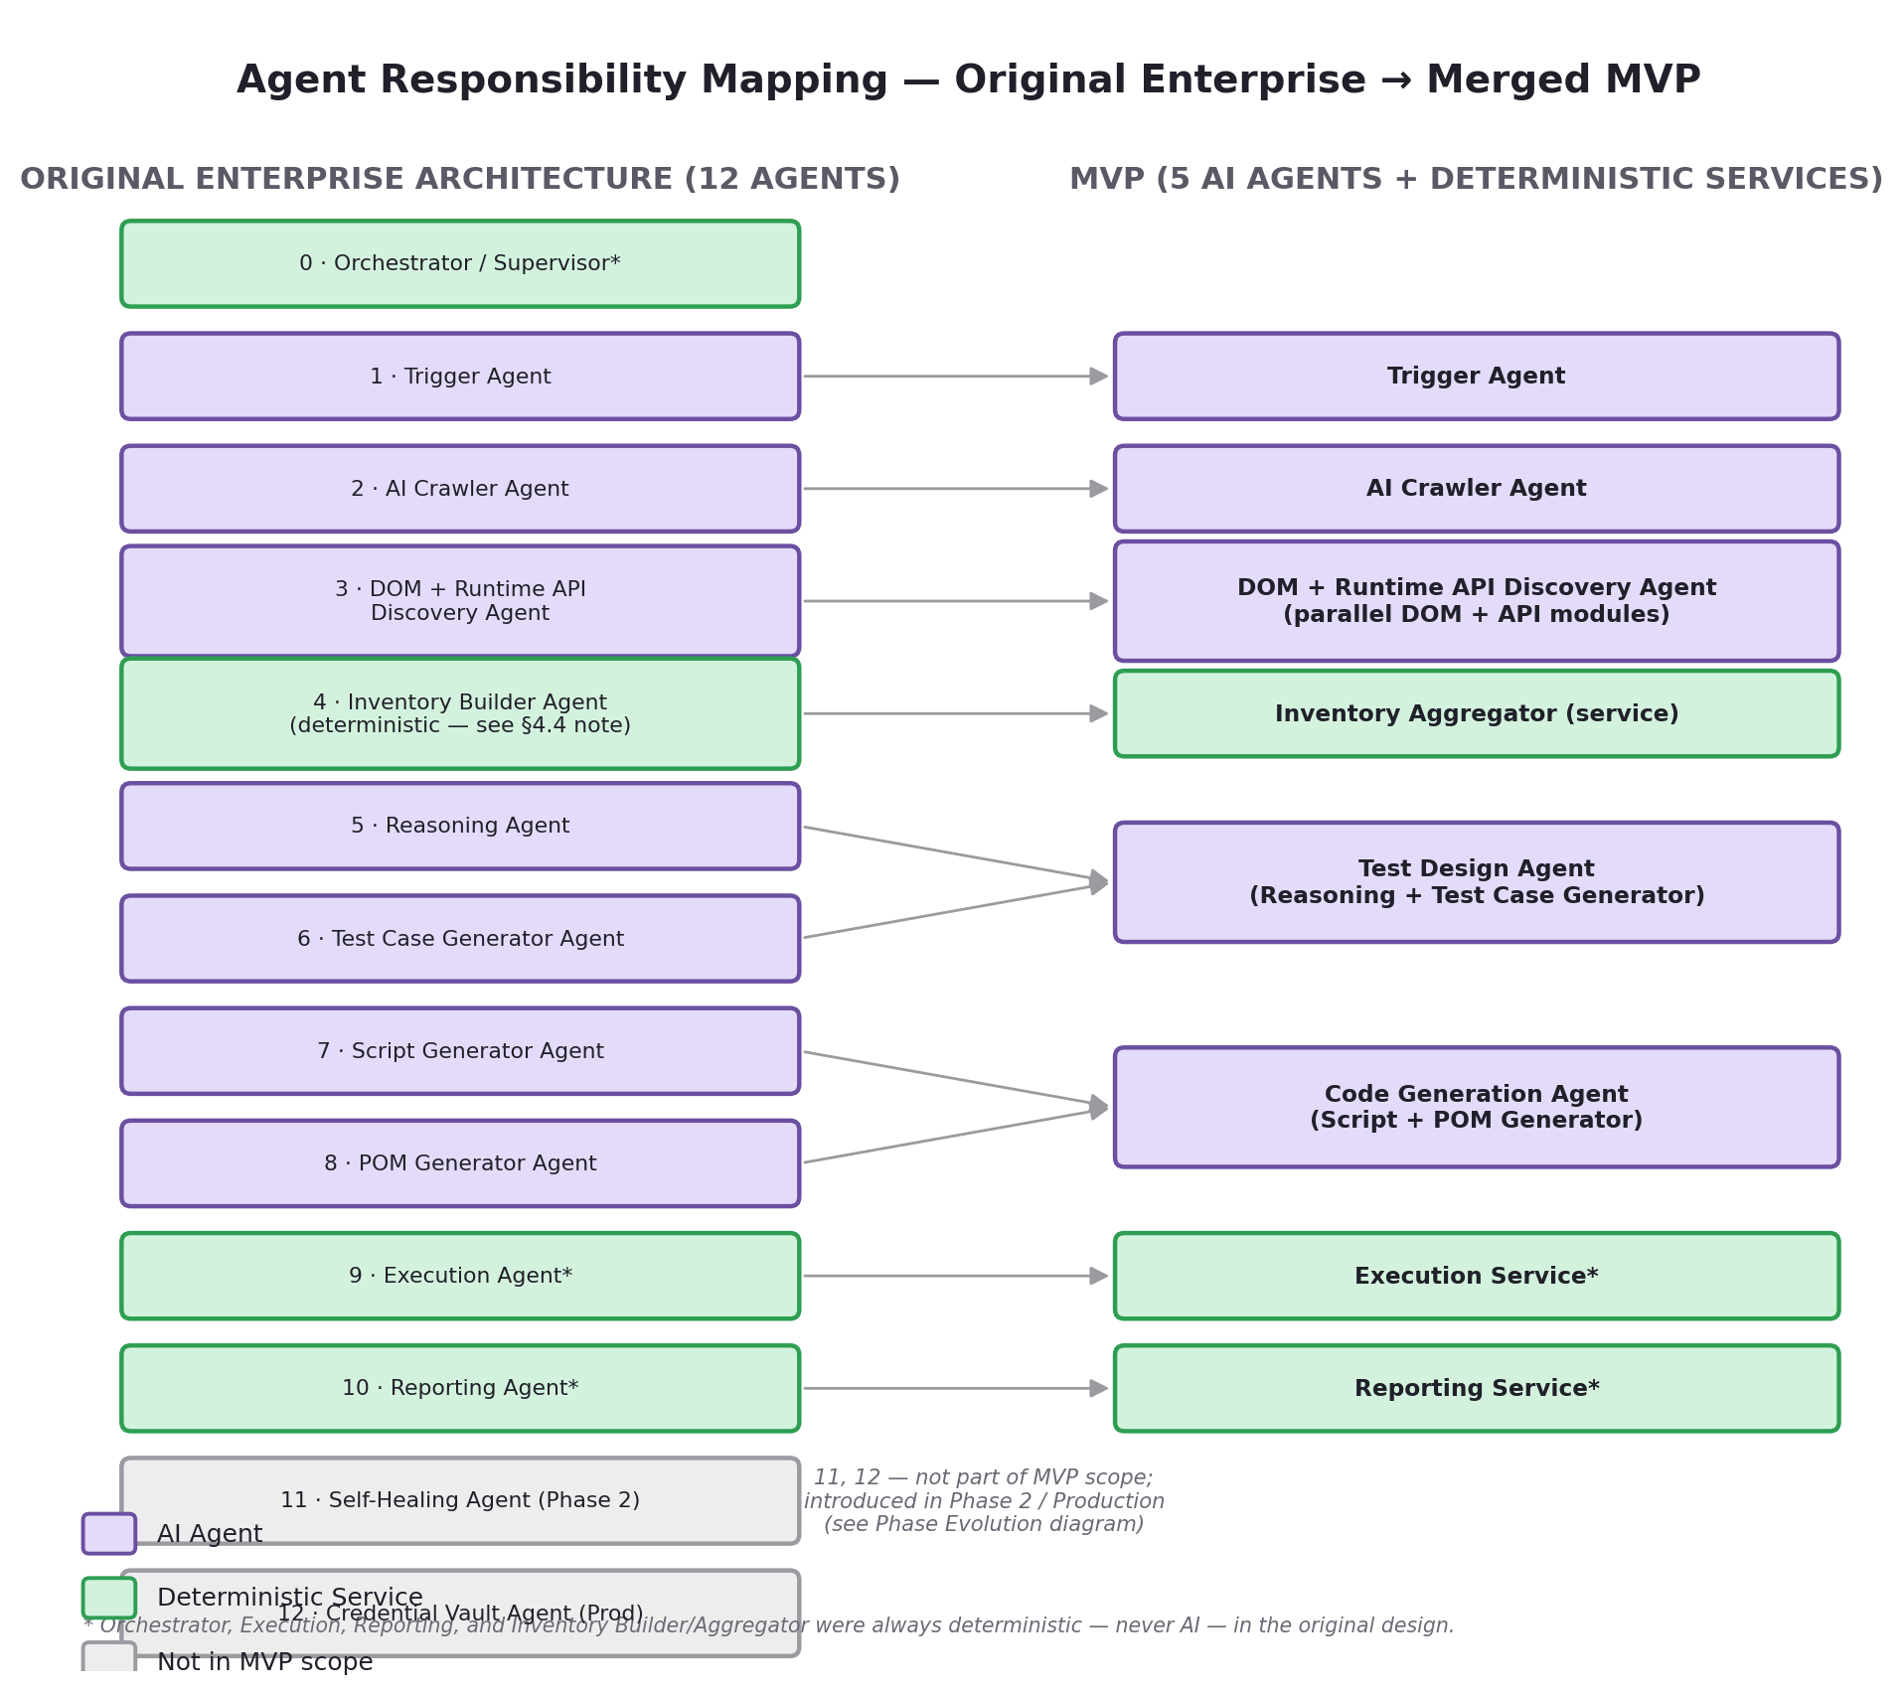
Figure 2.3 — Agent Responsibility Mapping: Original Enterprise (12 agents) → MVP (5 agents + services)
Agent 4 (Inventory Builder) maps to the Inventory Aggregator service rather than being folded into Agent 3 — this is the key correction in this revision versus the prior one. Agents 11 (Self-Healing) and 12 (Credential Vault) remain Phase 2 and Production introductions respectively, exactly as in the original document.

2.4 Production Architecture (Original Enterprise Design)
The following is the original enterprise architecture this platform was designed around, preserved as the Production-tier target. Every capability, agent, and data flow described here is unchanged from the initial design; the only correction applied uniformly across every tier — including this Production view — is terminology: the agent formerly described as performing “API analysis” is renamed the DOM + Runtime API Discovery Agent, because this platform is black-box (§4.3.1–§4.3.2) and was never analyzing source code — it was always observing runtime traffic. Nothing about its position in the pipeline, its inputs, or its outputs changes.
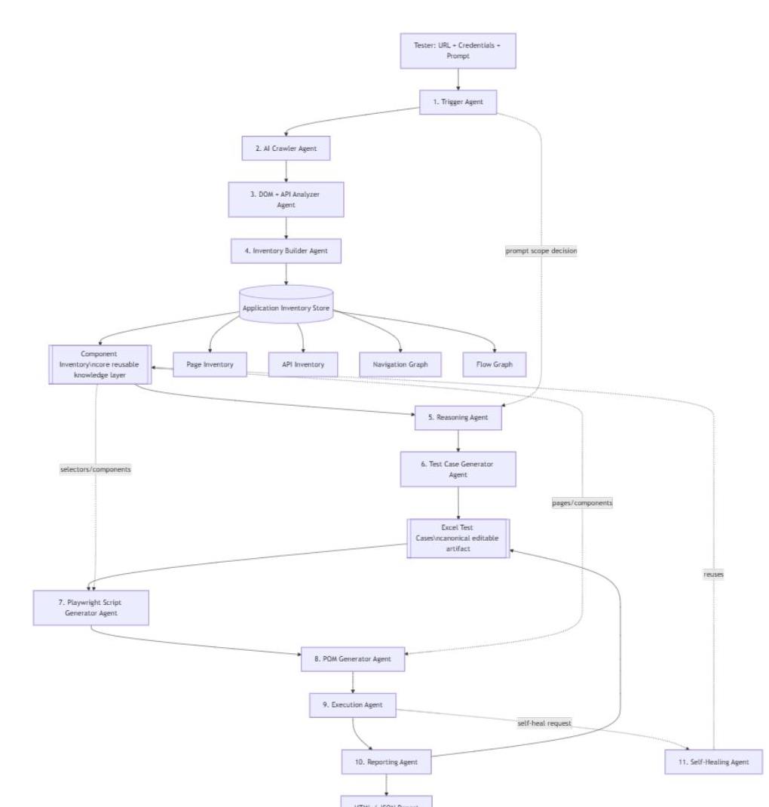
Figure 2.4 — Original 12-Agent Production Architecture (unchanged in structure from the initial design; diagram predates the Runtime API Discovery terminology correction)
Supporting (non-negotiable but not in the original 9) agents introduced in this design:
- 0. Orchestrator / Supervisor Agent — the LangGraph state machine controller that routes work between agents, persists checkpoints, and enforces retries/timeouts. Not a “reasoning” agent — it is infrastructure, described in §3.
- 8. POM Generator Agent (new, core pipeline stage) — sits between the Script Generator and the Execution Agent, converting Component Inventory data into reusable Playwright Page Object Model classes shared by every generated spec, rather than leaving each spec to embed its own raw selectors.
- 11. Self-Healing Agent (Phase 2) — repairs broken selectors when the app changes, instead of failing the run, drawing on the shared Component Inventory and the retained Raw Crawl Package (rather than a one-off DOM re-scan) to find the best replacement.
- 12. Credential Vault Agent (Production) — isolates all secret handling from the reasoning agents so no credential ever enters an LLM prompt in plaintext.
Architecture note (alignment update, carried over unchanged): this revision aligns the document with the latest architecture diagram in three ways, without altering the overall delivery phases, technology stack, or agent workflow described elsewhere in this document: (1) the former “DOM Analyzer Agent” is now the DOM + Runtime API Discovery Agent, performing combined UI and runtime backend discovery; (2) the Component Inventory is introduced as the central, reusable knowledge layer inside the existing Application Inventory (which now also explicitly contains a Page Inventory, API Inventory, Navigation Graph, and Flow Graph); and (3) test cases now flow through a canonical Excel Test Cases artifact between the Test Case Generator and the Script Generator, and a dedicated POM Generator Agent now sits between the Script Generator and the Execution Agent.
All previously existing agents, phases, and infrastructure (LangGraph, Trigger Agent, Crawler, Reasoning Agent, Inventory Builder / Aggregator, Execution Agent, Reporting Agent, Self-Healing, Credential Vault, SQLite→PostgreSQL, Ollama, DeepSeek, Playwright, Next.js, FastAPI) remain unchanged and are only extended below — and, per this revision, are also exactly what the MVP's 5 agents and 6 services decompose back into by the time a deployment reaches Production tier.

2.5 Supplementary MVP Diagrams
Three additional diagrams support implementation planning for the MVP: a component/layering view, a data-exchange view showing exactly what typed payload crosses each hand-off, and a focused view of the black-box Runtime API Discovery data flow.

2.5.1 Component Diagram
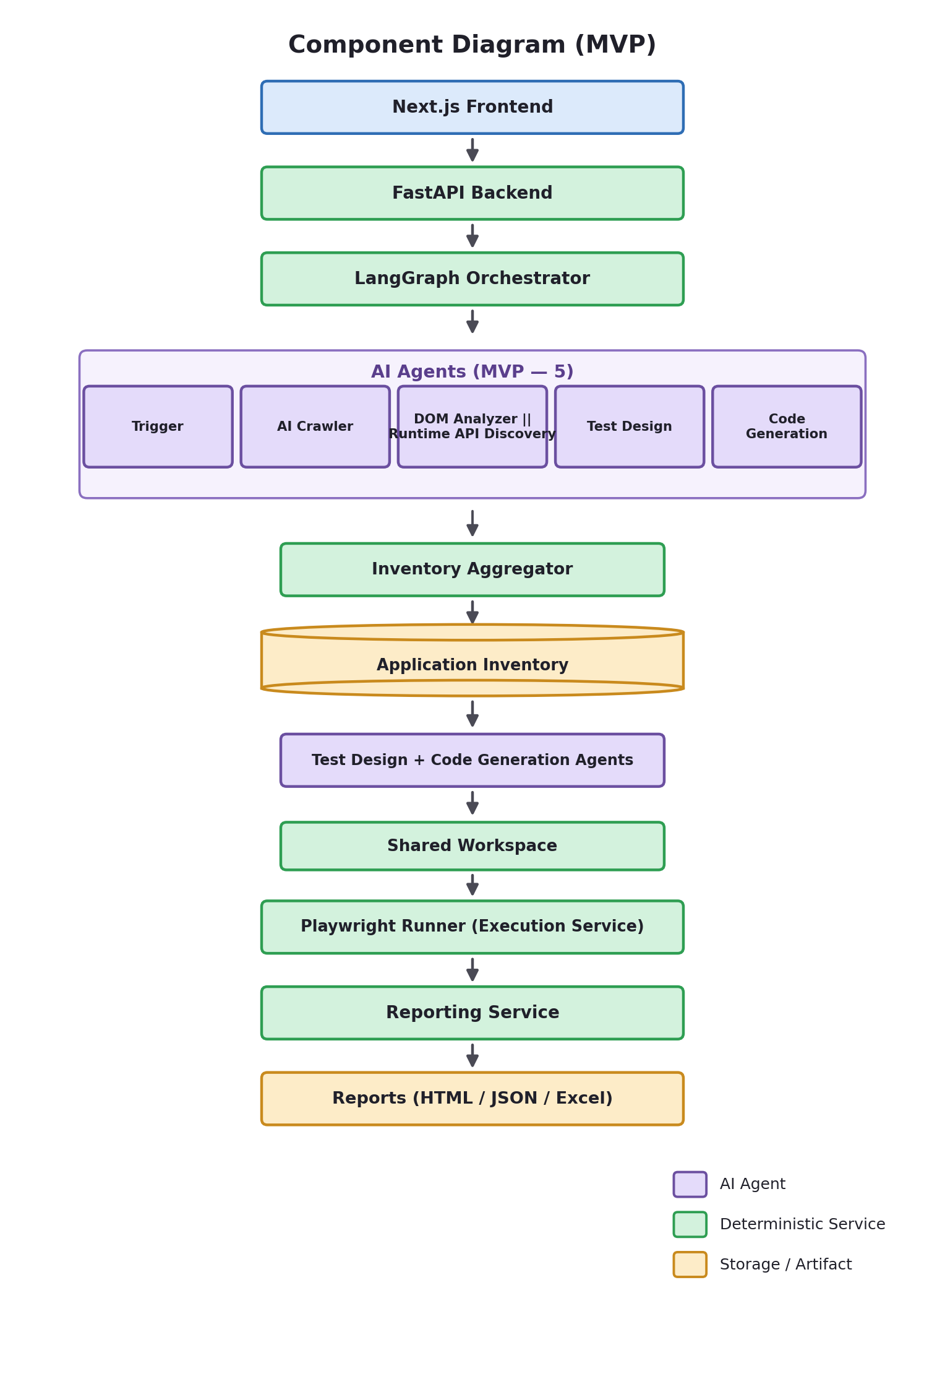
Figure 2.5 — MVP Component Diagram (layered view)

2.5.2 Agent Interaction / Data Flow Diagram
This view exists to make code review and contract testing concrete: each arrow below is a typed JSON object, not a vague hand-off. Agents never exchange raw HTML or free-form English descriptions (§2.6, Principles 6–7).
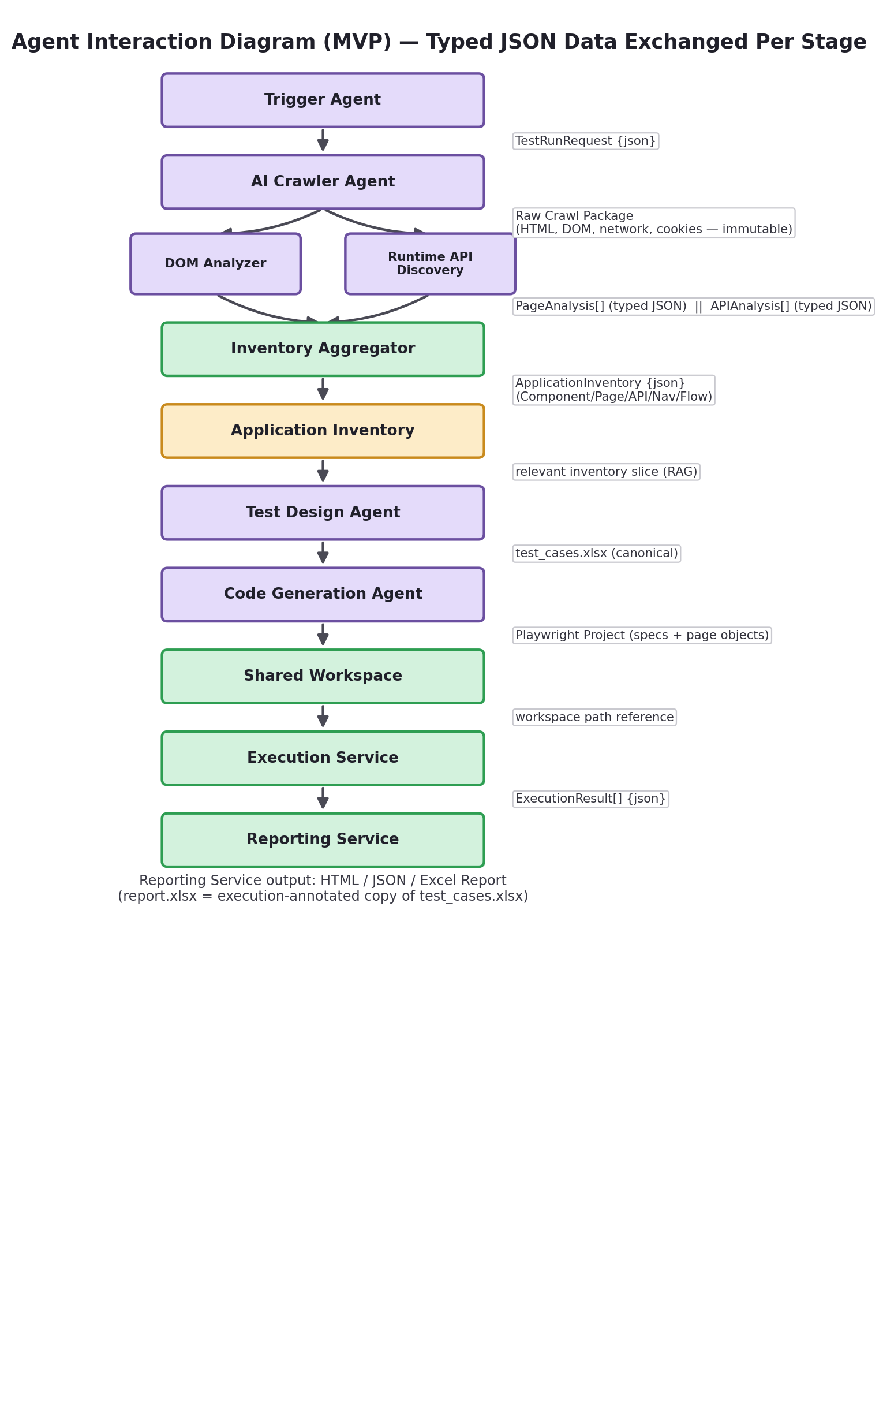
Figure 2.6 — MVP Agent Interaction Diagram (typed JSON data exchanged per stage)

2.5.3 Runtime API Discovery Data Flow
This diagram isolates the black-box discovery path to make explicit what this platform does and does not have access to — see §4.3.1–§4.3.2 for the full advantages/limitations discussion.
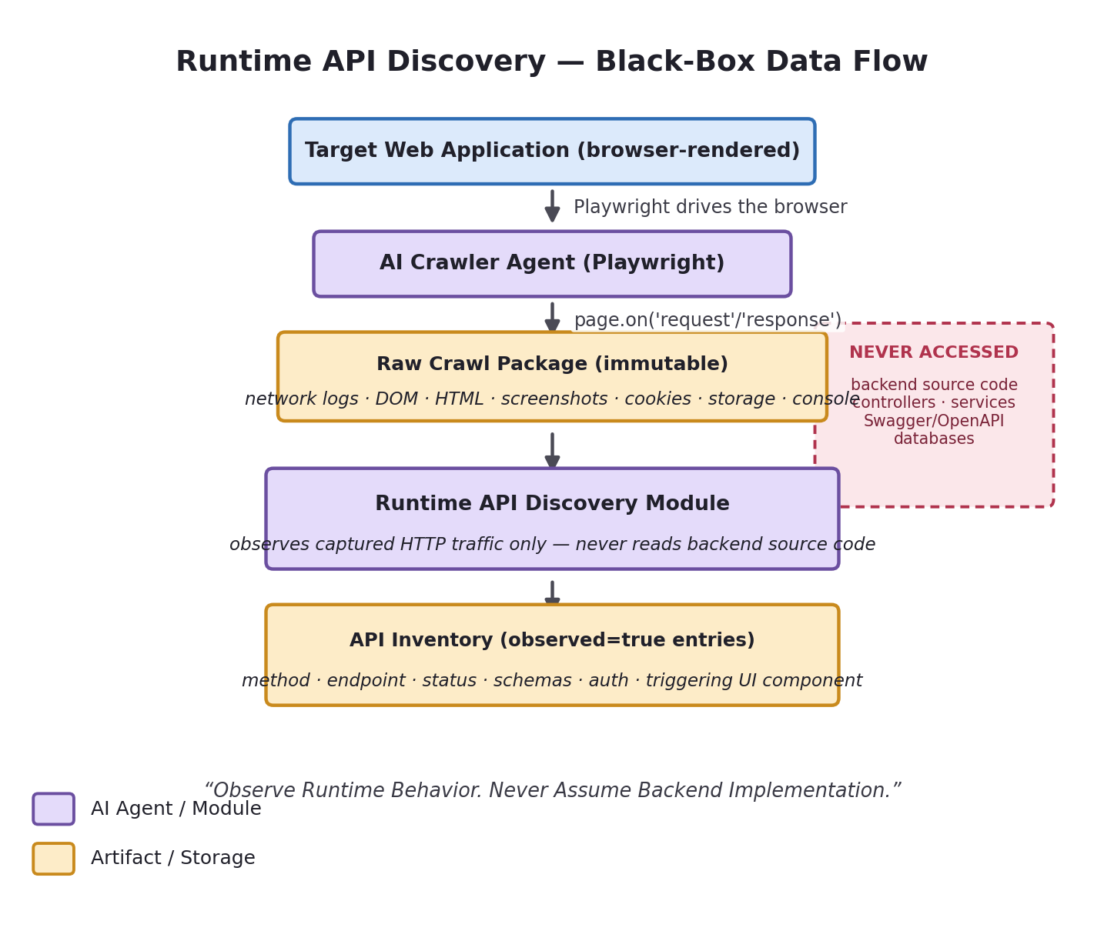
Figure 2.7 — Runtime API Discovery: Black-Box Data Flow

2.6 Architecture Principles
These principles are new in this revision and govern every tier of the platform, from MVP through Production:
- Collect Once, Process Many. The crawler executes once per crawl decision; all downstream processing reuses the collected Raw Crawl Package.
- Never parallelize browser crawling. Parallelize independent analysis. A single browser session crawls sequentially and reliably; the DOM Analyzer and Runtime API Discovery modules, which don't touch the browser, run in parallel against the already-collected package.
- AI should perform reasoning. Deterministic services should perform deterministic work. Selector ranking, inventory merging, code execution, and report rendering are plain code; LLM calls are reserved for intent, scenario design, and code synthesis.
- AI generates artifacts. Normal services execute artifacts. No AI agent ever calls npx playwright test — that is exclusively the Execution Service's job (§10).
- Application Inventory is the single source of truth. Every downstream agent retrieves from it rather than re-deriving knowledge independently.
- Typed JSON contracts between agents. Every hand-off in §2.5.2 is a schema-validated object.
- No raw HTML exchange between agents. Only the Crawler ever sees raw HTML/DOM; everything downstream consumes structured JSON derived from it.
- Minimize hallucinations using structured inventory. Narrow, schema-bound context beats dumping raw markup into a prompt (§9).
- Reuse inventory whenever possible. Crawl-once-test-many (§8.1) is the system's single highest-leverage performance decision.
- Performance should never reduce accuracy. Parallelizing analysis, caching the inventory, and reusing the Raw Crawl Package are all latency wins that do not trade away selector or test-case correctness.
- Observe runtime behavior. Never assume backend implementation. The platform is a black-box testing tool: it discovers application behavior through browser interaction and never depends on backend source code, controllers, services, DTOs, Swagger/OpenAPI specs, or databases (§4.3.1–§4.3.2).

3. Orchestrator / Supervisor (LangGraph State Machine)
Purpose: Own the run lifecycle. Nothing else is allowed to call another agent directly — every hand-off goes through the graph so state, retries, and audit trail stay centralized. This is unchanged by the MVP agent consolidation: the Orchestrator simply routes between 5 nodes at MVP tier instead of 10–12, per the LangGraph definitions in §16.1.
Responsibilities: maintain the RunState object (see below), decide the next node based on state + conditional edges, persist a checkpoint after every node (so a crashed run can resume), enforce per-node timeouts, and expose run status to the API layer for polling/streaming.
RunState (conceptual shape, shared across the graph):
{
"run_id": "uuid",
"application_id": "uuid",
"prompt": "Test Employee Management",
"scope": ["employee_management"],
"credentials_ref": "vault://cred/123",
"inventory_version": 4,
"phase": "reasoning | generating | executing | reporting | done | failed",
"test_cases": [ "..." ],
"scripts": [ "..." ],
"execution_results": [ "..." ],
"errors": [ "..." ]
}
MVP in-process LangGraph run, state checkpointed to SQLite after each node, single worker, synchronous execution, no resume-after-crash (a failed run is simply re-run from scratch). The graph has 7 nodes (§16.1), matching the 5 AI agents plus Execution and Reporting services.
PHASE 2 checkpoint-and-resume (LangGraph's built-in persistence), one worker per run via a task queue (Celery/RQ or LangGraph's own async runtime), run cancellation. The graph grows toward 10 nodes as Test Design and Code Generation split apart and Self-Healing is added.
PRODUCTION distributed workers, horizontal autoscaling, per-tenant run quotas, full run audit log shipped to observability stack (see §17). The graph reaches its full original node count, one per specialized agent.

4. Agent Catalog (Detailed)
This catalog is organized in two layers. §4.0 is new in this revision: it specifies the 5 MVP agents exactly as they ship — each one a merger of the original agents' responsibilities, with nothing dropped — plus the deterministic services that sit alongside them. §4.1–4.12 is the original, unchanged catalog of all 12 specialized agents; it remains the authoritative capability specification (Purpose, Responsibilities, Inputs, Outputs, Internal Workflow, Tools Used, Prompt Strategy, Error Handling, Future Enhancements, MVP/Phase 2/Production scoping) that §4.0's MVP agents draw from and that Phase 2/Production decompose back into. Each entry in §4.1–4.12 now carries a short MVP Ownership line pointing to its §4.0 owner.

4.0 MVP Agent Catalog — 5 Agents
Each MVP agent below is a genuine merge, not a rename: its Responsibilities/Inputs/Outputs/Internal Workflow sections are the union of the original agents it absorbs, and its Tools Used / Prompt Strategy / Error Handling sections are likewise inherited unchanged from §4.1–10. Internally, a merged agent may run multiple reasoning steps or multiple LLM prompts in sequence (e.g., Test Design Agent still does one LLM call per intent, exactly as the original Test Case Generator did) — from the architecture's perspective, each merge is still a single deployable AI agent.

4.0.1 MVP Agent 1 — Trigger Agent
Absorbs: Trigger Agent (§4.1) — unchanged, no merge. Purpose: the single entry point; turns a tester's loose natural-language request into a structured, validated TestRunRequest that the rest of the graph can consume deterministically.
- Validate request and credential format (not correctness — that's discovered at login time).
- Parse the free-text prompt into a structured scope: target module(s), test depth (smoke / functional / full regression), and any constraints.
- Decide whether an existing Inventory can be reused or a fresh crawl is required.
- Initialize the workflow: create the Run ID and initial RunState, then hand off to the Orchestrator.
Inputs: URL, credentials, free-text prompt, optional force_recrawl flag. Outputs: TestRunRequest {application_id, scope[], depth, inventory_action}. Full internal workflow, tools, prompt strategy, and error handling: identical to §4.1, unchanged.
MVP URL + basic auth only, prompt mapped to a hardcoded/discovered module list, no clarification loop.

4.0.2 MVP Agent 2 — AI Crawler Agent
Absorbs: AI Crawler Agent (§4.2) — unchanged, no merge. Purpose: physically visit the application with a real browser and collect everything a later stage might need — nothing more. This agent performs collection only. It never performs analysis.
- Log in using provided credentials; discover navigable routes; visit each in a controlled, bounded manner.
- Capture HTML, DOM snapshots, screenshots, network traffic, storage state, and cookies for every visited page.
- Package everything into the Raw Crawl Package — a single immutable artifact — and hand it off. The crawler makes no judgment about what any of it means; that is exclusively the next agent's job.
Inputs: application_id, credentials reference, scope, crawl depth/budget. Outputs: the Raw Crawl Package: {html[], dom_snapshots[], screenshots[], network_logs[], cookies[], storage_state, console_logs[], visited_urls[], assets[]} — per-page detail preserved in the CrawlResult[] schema described in §4.2. Full internal workflow, tools, prompt strategy, and error handling: identical to §4.2, unchanged.
The Raw Crawl Package is immutable once produced. It is retained (not discarded after analysis) so the DOM + Runtime API Discovery Agent, and later the Self-Healing Agent (Phase 2), can consume it without triggering a new crawl — see §2.1.1 and Principle 1 in §2.6.
MVP single-tab sequential crawl, simple heuristic login, hard page-count cap (30 pages), one scope-filter classifier call per crawl.

4.0.3 MVP Agent 3 — DOM + Runtime API Discovery Agent
Absorbs: DOM + Runtime API Discovery Agent (§4.3), which internally runs two modules in parallel. Purpose: convert the Raw Crawl Package into a clean, structured representation of the UI and the runtime API traffic observed during the crawl — never source code. This remains one AI agent in the MVP catalog.
- DOM Analyzer Module — component discovery, form discovery, selector extraction, navigation graph, flow graph, page metadata.
- Runtime API Discovery Module — API discovery, request mapping, response mapping, authentication mapping, API dependency graph — all derived from observed network traffic, exactly as described in §4.3.1.
Both modules execute in parallel against the same Raw Crawl Package (Principle 2, §2.6) — there is no sequencing dependency between DOM analysis and API discovery, so running them concurrently is a pure latency win with no accuracy trade-off.
Inputs: the Raw Crawl Package (§4.0.2), optional OpenAPI/GraphQL endpoint (used only as a supplementary hint — never a requirement, since the platform is black-box). Outputs: PageAnalysis[] (from the DOM Analyzer Module) and APIAnalysis[] (from the Runtime API Discovery Module), both typed JSON, handed to the Inventory Aggregator service (§4.0.6) — not persisted by this agent itself. Full internal workflow, tools, prompt strategy, and error handling for both modules: identical to §4.3, unchanged.
Unlike the prior revision of this document, the Inventory Builder's merge/persist responsibilities are **not** folded into this agent. They are performed by the Inventory Aggregator — a separate deterministic service — because that merge step never used an LLM call to begin with (§4.4). This agent's boundary ends at producing the two typed module outputs.
MVP rule-based selector ranking (unchanged); network capture logs matched endpoint URL + method only; Swagger/OpenAPI ingestion only if a spec URL is explicitly supplied by the tester (never required).

4.0.4 MVP Agent 4 — Test Design Agent
Absorbs: Reasoning Agent (§4.5) + Test Case Generator Agent (§4.6). Purpose: decide what should be tested, then expand each decision into a concrete, reviewable test case — the full path from business intent to test_cases.xlsx, in one agent.
- (from the Reasoning Agent) Retrieve the relevant Component/API/Flow Graph slice for the requested scope from the Application Inventory; infer business intent; identify positive, negative, and edge-case scenarios; produce a TestIntentList.
- (from the Test Case Generator) Expand each TestIntent into Given/When/Then-style steps referencing real inventory elements, assign test data, validate every target_ref against the inventory, and render the canonical test_cases.xlsx.
Inputs: TestRunRequest.scope, Component/API/Flow Graph inventory slices (retrieved from the Application Inventory, as persisted by the Inventory Aggregator). Outputs: TestIntentList (internal, not persisted) → TestCase[] → test_cases.xlsx. Internally this is still one LLM call for scenario reasoning followed by one LLM call per intent for step generation, exactly as the two original agents ran them — only the deployable boundary changes. Full internal workflow, tools, prompt strategy, and error handling: identical to §4.5 and §4.6, unchanged.
MVP simple keyword/module-name filtering for retrieval, single-pass prompt with one retry, CRUD-style deterministic fallback; one test case per intent; test_cases.xlsx handed directly to Code Generation Agent with no review pause.

4.0.5 MVP Agent 5 — Code Generation Agent
Absorbs: Script Generator Agent (§4.7) + POM Generator Agent (§4.8). Purpose: turn the canonical test_cases.xlsx into a complete, executable Playwright project. This agent never executes Playwright — it only generates artifacts (Principle 4, §2.6); execution is exclusively the deterministic Execution Service's job (§4.9, §10).
- (from the Script Generator) Read test_cases.xlsx and the Application Inventory; resolve every target_ref to its top-ranked selector deterministically; prompt the LLM only for procedural glue (steps + resolved selectors/POM references → idiomatic Playwright spec code).
- (from the POM Generator) Emit one page object class per in-scope page from the Component Inventory, plus common/ helpers, so specs call into POM methods rather than embedding raw selectors.
- Validate the generated code (lint/format) and write the finished, executable Playwright project to the Shared Workspace (§4.0.6) — the deterministic hand-off point the Execution Service reads from.
Inputs: test_cases.xlsx, Application Inventory / Component Inventory selector map. Outputs: scripts/.spec.ts + pages/.ts + components/.ts + common/.ts, written to the Shared Workspace as one coherent Playwright project. Full internal workflow, tools, prompt strategy, and error handling for both halves: identical to §4.7 and §4.8, unchanged.
MVP one flat .spec.ts file per test case, TypeScript only; one page class per in-scope page with basic locator getters; no shared-component deduplication; common/ limited to a login helper.

4.0.6 Non-AI Services (MVP Detail)
None of the four components below are AI agents. They perform deterministic work only, and none of them ever makes an LLM call.
Inventory Aggregator
Purpose: merge the parallel outputs of MVP Agent 3 into one coherent, versioned Application Inventory. Responsibilities: merge DOM inventory, merge API inventory, remove duplicates, normalize data, validate schema, save the Application Inventory. Inputs: PageAnalysis[] and APIAnalysis[] (from §4.0.3). Outputs: the versioned ApplicationInventory object (schema in §8.4), persisted to the Inventory Database. Full detail (internal workflow, error handling, tiering): §4.4, where it is catalogued under its original name, Inventory Builder Agent.
Shared Workspace
Purpose: completely decouple Playwright execution from AI agents. Responsibilities: hold the Playwright project written by the Code Generation Agent; expose it, unmodified, to the Execution Service. Inputs: the generated Playwright project. Outputs: a stable filesystem/workspace path the Execution Service reads from. No AI agent, and no LLM call, is ever involved in this hand-off (§10).
Execution Service and Reporting Service are unchanged, non-AI services in both the original and revised architectures — see §4.9 and §4.10 for their full specification, which this revision does not alter in any way.

4.1 Agent 1 — Trigger Agent
MVP Ownership: this is MVP Agent 1 (§4.0.1), unchanged — no merge.
Purpose: The single entry point. Turns a tester's loose natural-language request into a structured, validated TestRunRequest that the rest of the graph can consume deterministically.
Responsibilities:
- Validate URL reachability and credential format (not correctness — that's discovered at login time).
- Parse the free-text prompt into a structured scope: target module(s), test depth (smoke / functional / full regression), and any constraints (“only test the Add Employee form”).
- Decide whether an existing Inventory can be reused or a fresh crawl is required.
- Create the run_id and initial RunState, then hand off to the Orchestrator.
Inputs: URL, credentials (username/password or token), free-text prompt, optional force_recrawl flag.
Outputs: TestRunRequest object: {application_id, scope[], depth, inventory_action: "reuse"|"recrawl"|"partial_refresh"}.
Internal Workflow:
- Normalize URL (strip trailing slash, resolve to canonical host).
- Look up application_id by URL hash in the DB; create a new Application record if unseen.
- Send the prompt to the LLM with a small classification prompt: “map this instruction to one or more known module names from [known_modules], or return UNKNOWN.”
- If inventory exists and is younger than a configurable TTL (e.g., 24h) and covers the requested scope → reuse. Otherwise → recrawl or partial_refresh.
Tools Used: FastAPI request validation (Pydantic), lightweight LLM classification call, SQLite lookup.
Prompt Strategy: Short, single-purpose classification prompt with a closed set of candidate module names (few-shot examples of prompt → module mapping) rather than open-ended generation — minimizes hallucinated scope.
Error Handling: Unreachable URL → fail fast with a clear user-facing error before any agent work starts. Ambiguous prompt (UNKNOWN scope) → ask the tester to pick from a list of discovered modules (MVP: return an error asking for a more specific prompt instead of a back-and-forth clarification loop).
Future Enhancements: conversational clarification loop (“did you mean X or Y?”), multi-language prompts, prompt templates/favorites per user.
MVP URL + basic auth only, prompt mapped to a hardcoded/discovered module list, no clarification loop — unknown prompt = error message.
PHASE 2 SSO/OAuth login support, clarification loop via a follow-up question, prompt history per user.
PRODUCTION natural-language scope refinement with confidence scoring, org-level prompt templates, policy gating (e.g., block prompts targeting out-of-scope environments like production).

4.2 Agent 2 — AI Crawler Agent
MVP Ownership: this is MVP Agent 2 (§4.0.2), unchanged — no merge.
Purpose: Physically visit the application with a real browser and collect everything downstream agents might need — pages, navigation, raw DOM, and runtime traffic — under AI guidance on where to go next. This agent collects only. It performs no analysis; analysis is exclusively the DOM + Runtime API Discovery Agent's job (§4.3).
Responsibilities: log in using provided credentials, discover navigable routes (menus, links, buttons that navigate), visit each in a controlled, bounded manner, and capture HTML, DOM snapshots, screenshots, network traffic, storage state, and cookies for every visited page. All of this is packaged into the Raw Crawl Package — a single immutable artifact — for the next agent.
Inputs: application_id, credentials reference, TestRunRequest.scope, crawl depth/budget.
Outputs: the Raw Crawl Package, composed of per-page CrawlResult entries: {url, title, dom_snapshot, screenshot_path, discovered_links[], discovered_via, network_log[]}, plus package-level cookies[], storage_state, and console_logs[]. The network_log field captures request/response pairs observed during navigation, feeding the DOM + Runtime API Discovery Agent's runtime discovery module — the Crawler Agent's own responsibilities (login, page/menu discovery, DOM/screenshot capture) are otherwise unchanged. The package is immutable once produced (§2.1.1).
Internal Workflow:
- Launch Playwright (headless Chromium), navigate to login page.
- Perform login using a detected login form (heuristic: form with a password-type input); confirm success via URL change or presence of a logout/profile element.
- Maintain a frontier queue of URLs/actions to explore, seeded from the home page's nav/menu elements.
- For each frontier item: navigate, wait for network idle, snapshot the DOM, extract further links/menu items, screenshot, push new same-origin links onto the frontier if within scope and not yet visited.
- AI involvement: an LLM call classifies which discovered links are “in scope” for the given prompt, instead of blindly crawling the entire app every time.
- Stop when frontier is empty, scope pages are covered, or a page/action budget is hit.
- Attach a Playwright page.on('request')/page.on('response') listener pair for the lifetime of the crawl, recording method, URL, headers (redacted of secrets), and status/timing for every network call — including fetch/XHR calls and GraphQL POSTs — and attach the resulting network_log to the corresponding page's CrawlResult entry. This is pure capture; no interpretation happens here — the DOM + Runtime API Discovery Agent (§4.3) is what turns this raw log into structured API knowledge, entirely from observed traffic (§4.3.1).
Tools Used: Playwright (Chromium), a visited-URL set (dedupe), an in-scope classifier LLM call, screenshot capture.
Prompt Strategy: The classifier prompt receives only link labels + destinations (not full DOM) to decide relevance — keeps the crawl-time LLM calls cheap and fast; full DOM/API reasoning is deferred to the DOM + Runtime API Discovery Agent.
Error Handling: login failure → abort run with a clear diagnostic (screenshot + captured error banner text); page timeout → skip page, log a warning, continue crawl; infinite-loop protection via max-pages and max-depth budgets.
Future Enhancements: multi-tab parallel crawling, JS-heavy SPA route detection via intercepted client-side routing, visual diffing to detect app changes since last crawl, handling MFA/CAPTCHA-gated logins.
MVP single-tab sequential crawl, simple heuristic login, hard page-count cap (e.g., 30 pages), scope filter via one classifier call per crawl (batch link list), no parallelism.
PHASE 2 parallel tab crawling, SPA-aware route discovery (listen for history.pushState), incremental/partial recrawl (only revisit changed areas), configurable crawl budgets per module.
PRODUCTION MFA-aware login flows, anti-bot-detection evasion policy (rate limiting, human-like delays), distributed crawling across multiple browser workers, visual regression baseline capture during crawl.

4.3 Agent 3 — DOM + Runtime API Discovery Agent
MVP Ownership: this is MVP Agent 3 (§4.0.3). Terminology note: this agent was previously described in this document as the “DOM + API Analyzer Agent.” That name is corrected here — see §4.3.1 — because the platform never analyzes APIs from source code; it discovers them by observing runtime browser traffic. The rename is applied consistently across every section, table, and diagram in this document; nothing about the agent's position, inputs, or outputs changes.
Purpose: Convert the Raw Crawl Package (§4.0.2) into a clean, structured representation of both the UI and the runtime API traffic the application generated during crawling — the bridge between “what the browser saw and called” and “what the AI can reason about.” This agent was originally a DOM-only analyzer; it is extended to also perform runtime API discovery so that the Application Inventory captures full-stack knowledge of the application, not just its UI — entirely from observed behavior, never from backend source code.
Responsibilities — two modules, executed in parallel (§2.1.2, Principle 2 in §2.6):
- DOM Analyzer Module (unchanged UI responsibilities): parse each page's DOM, identify semantic regions (header, nav, main, forms, tables, modals), extract interactive elements (inputs, buttons, links, dropdowns) with their attributes and best-available stable selector, and flag ambiguous/duplicate elements for later resolution.
- Runtime API Discovery Module (also referred to as the Runtime API Discovery Engine or Network Traffic Analyzer): discover backend API endpoints from the Crawler's captured network_log (fetch/XHR calls, GraphQL POSTs), from an OpenAPI/Swagger document only if one is explicitly supplied, and from GraphQL introspection where available; map each observed UI action to the backend call(s) it triggered by correlating action timestamps with the network log; detect request/response schemas; and identify multi-step page flows. This module never reads backend source code — see §4.3.1.
Inputs: the Raw Crawl Package (DOM snapshots, screenshots, and network_log[] per page), an optional Swagger/OpenAPI spec URL, an optional GraphQL endpoint URL — both purely supplementary, never required.
Outputs: PageAnalysis[] per page (from the DOM Analyzer Module): {page_id, forms[], tables[], buttons[], inputs[], nav_elements[], modals[], selector_candidates{}}; and APIAnalysis[] per page (from the Runtime API Discovery Module): {endpoints[{endpoint_id, method, url_pattern, status_code, request_schema, response_schema, authentication_type, triggered_by_ui_action, confidence, observed}], graphql_operations[], page_flow[]}. Both outputs are typed JSON handed to the Inventory Aggregator (§4.4) — this agent does not persist the Application Inventory itself.
Internal Workflow:
- Parse HTML with a DOM library (e.g., cheerio/playwright's own accessibility tree, or lxml on the Python side) — DOM Analyzer Module, unchanged from the original design.
- Walk the accessibility tree preferentially (roles, labels) over raw tag soup — more stable and closer to how Playwright's recommended locators work.
- For every interactive element, compute a ranked list of selector candidates: data-testid > aria-label/role+name > stable id > CSS path > text content.
- Group elements into forms and tables as first-class objects, not flat element lists.
- (Runtime API Discovery Module, running in parallel with the four steps above) Parse the Raw Crawl Package's network_log for fetch/XHR/GraphQL calls captured via Playwright's request/response interception (§4.3.1); attempt to correlate against an OpenAPI/Swagger document only if the tester explicitly supplied one; where no spec exists, infer a best-effort schema from the observed JSON shape.
- Correlate UI actions to API calls by matching the timestamp of a captured click/submit event against the network log's request timestamps within a short window, producing the triggered_by_ui_action mapping.
- Chain the resulting endpoint calls per page, in observed order, into a page_flow sequence — raw material for the Flow Graph (§8).
- Emit PageAnalysis[] and APIAnalysis[] as separate typed JSON outputs and hand both to the Inventory Aggregator.
Tools Used: Playwright accessibility snapshot API, an HTML parser, a deterministic selector-ranking algorithm, a Playwright network-interception listener (request/response events — §4.3.1), an OpenAPI/Swagger parser (optional), a GraphQL introspection client (optional), and a timestamp-correlation utility. DOM parsing and selector ranking remain rule-based/non-LLM.
Prompt Strategy: Selector extraction and raw schema parsing remain deterministic, non-LLM code. The only LLM involvement is a narrow, structured disambiguation prompt used when an observed API call can't be confidently mapped to a UI action, or a schema must be inferred from an ambiguous payload with no OpenAPI backing.
Error Handling: malformed/partial DOM → retry snapshot once after an extra wait; elements with no stable selector → mark low_confidence; no Swagger document supplied or reachable → fall back to network-observed schemas only (this is the default path, not a failure); ambiguous UI-to-API mapping → mark low_confidence and store the relationship anyway.
Future Enhancements: visual-layout-based element grouping for non-semantic markup, shadow-DOM and iframe traversal, cross-page component fingerprinting, GraphQL query batching/fragment support, automated contract-drift detection between successive crawls' API Inventories.
MVP rule-based selector ranking and form/table grouping (unchanged); network capture logs matched endpoint URL + method only (no deep schema inference); Swagger/OpenAPI ingestion only if a spec URL is explicitly supplied by the tester; both modules run in parallel from day one.
PHASE 2 shadow-DOM/iframe traversal; automatic Swagger/OpenAPI discovery at common well-known paths (still optional, never required); request/response schema capture from observed traffic; UI-action-to-API mapping via timestamp correlation plus the disambiguation LLM call; low-confidence element/mapping flagging fed into a human-review queue.
PRODUCTION component fingerprinting for UI reuse detection; visual-bounding-box-assisted parsing for legacy/non-semantic apps; GraphQL introspection support; full multi-step Flow Graph construction across entire user journeys; schema-drift detection integrated with Inventory versioning and the Self-Healing Agent.

4.3.1 Runtime API Discovery — Why the Platform Observes Instead of Analyzes
This platform is a black-box testing platform. It receives only a URL, a username, and a password, and interacts with the target application exclusively through the browser. It has no access to backend source code, controllers, services, DTOs, Swagger/OpenAPI specifications, databases, or business logic. It therefore cannot analyze APIs the way a source-code static-analysis tool would — instead, it discovers and observes APIs at runtime, by watching what the browser actually sends and receives while Playwright drives it.
How this is implemented: the AI Crawler Agent launches a browser using Playwright. During crawling, Playwright's network interception listens for every request and response generated while interacting with the application — this is the same page.on('request')/page.on('response') mechanism described in §4.2. The platform observes runtime browser traffic; it does not, and cannot, inspect backend source code. The Runtime API Discovery Module (§4.3) then reads this captured traffic from the Raw Crawl Package and turns it into structured, typed API knowledge.

Figure 4.1 — Runtime API Discovery: Black-Box Data Flow
Advantages of this approach:
- Works with any technology stack — the backend could be Java, .NET, Node, Python, or anything else; the platform never needs to know.
- No backend source code required.
- No Swagger/OpenAPI dependency — a spec helps when available but is never assumed.
- Technology independent — one platform architecture covers every application under test.
- Better suited to third-party applications, where source access is never available.
- Suitable for SaaS testing, where the platform is testing someone else's hosted product.
- Black-box testing compliant — matches how a real end user (and a real attacker) experiences the application.
New architecture principle (§2.6, Principle 11): **“Observe Runtime Behavior. Never Assume Backend Implementation.”** The platform discovers application behavior through browser interaction and never depends on backend implementation details.

4.3.2 Runtime API Discovery — Limitations
Because discovery is runtime-observed rather than source-derived, the platform cannot determine, and must not claim to understand:
- Backend business logic.
- Database queries.
- Hidden APIs — any endpoint that is never actually triggered during crawling remains unknown to the platform, regardless of whether it exists in the backend.
- Controller / service-layer implementation.
- Internal validation rules that never surface as an observable response difference.
An endpoint only enters the API Inventory once it has actually been executed during crawling — see the observed field in §8.4. This is a deliberate, disclosed limitation, not a defect: it is the necessary consequence of black-box, runtime-only discovery, and it is why the Application Inventory records observed: true rather than silently presenting every entry as equally certain.

4.4 Agent 4 — Inventory Builder Agent (Inventory Aggregator)
MVP Ownership: referred to as the **Inventory Aggregator** throughout the MVP/Phase 2/Production architecture sections of this document (§2.1.2, §4.0.6). This is the same functional component described below — it has never made an LLM call (see Prompt Strategy) and is therefore modeled as a deterministic service rather than an AI agent at every tier, including MVP. It appears here, numbered as “Agent 4,” only for continuity with the original enterprise catalog's numbering.
Purpose: Merge the DOM Analyzer Module's and Runtime API Discovery Module's outputs (§4.3) into one coherent, versioned Application Inventory — the reusable “map” of the application (see §8 for full schema) — structured so that its core reusable knowledge, the Component Inventory, can be shared cleanly by every downstream agent.
Responsibilities: merge DOM inventory, merge API inventory, remove duplicates, normalize data, validate schema, and save the Application Inventory — concretely: deduplicate components seen across pages, build the navigation graph and the Flow Graph, assign stable IDs to pages/components/forms/APIs so future crawls can diff against them, and persist the Application Inventory as a layered structure containing five explicit sub-sections — Component Inventory, Page Inventory, API Inventory, Navigation Graph, and Flow Graph — with a single version number.
Inputs: PageAnalysis[] and APIAnalysis[] from the current crawl (produced in parallel by §4.3's two modules), previous inventory version (if any).
Outputs: ApplicationInventory (versioned JSON, persisted to DB + file store), internally composed of ComponentInventory, PageInventory, APIInventory, NavigationGraph, and FlowGraph (full schema in §8.4).
Internal Workflow:
- Assign each page a stable page_id (hash of normalized URL/path pattern); assign each endpoint a stable endpoint_id (hash of method + normalized path pattern).
- Diff against the previous inventory version, if any: new/removed pages, changed forms/selectors, new/removed/changed API endpoints.
- Build the Navigation Graph as an adjacency list (page_id -> [linked page_ids]).
- Build the Flow Graph by chaining each page's page_flow with its Navigation Graph edges, producing end-to-end journey sequences.
- Roll up the Component Inventory — all forms, tables, buttons, inputs, dropdowns, and unique selectors across the whole app, deduplicated into a single reusable registry.
- Roll up the API Inventory similarly — all endpoints, their schemas, their observed status, and their UI-trigger mappings, deduplicated by endpoint_id.
- Persist as inventory_version = previous + 1, keep prior versions for audit/rollback.
Tools Used: hashing/diff utilities, SQLite (MVP) / PostgreSQL (Production), JSON schema validation.
Prompt Strategy: No LLM call required, at any tier — this is, and has always been, a deterministic merge/diff step.
Error Handling: conflicting selector or endpoint schema for the same logical element/endpoint across versions → keep both, mark the old one deprecated, don't delete; partial crawl → merge into the existing Component/API Inventory rather than overwriting it wholesale.
Future Enhancements: semantic versioning of inventory changes, automatic change-impact report.
MVP full inventory rebuild per crawl; Component Inventory and API Inventory populated but API Inventory limited to endpoint URL + method + status code only; simple version counter; JSON file + SQLite row. Runs as its own deterministic service node, invoked immediately after MVP Agent 3's parallel modules complete.
PHASE 2 true diffing against prior version for both UI and API elements, partial-refresh merge, change-impact awareness for existing test cases, Flow Graph construction enabled.
PRODUCTION semantic versioning, automatic notification to test owners when underlying inventory changes affect their suites, full cross-referenced Component/API/Flow graph used for contract-drift detection; extracted into its own independently deployable service (inventory-service/, §11.2) — a deployment-scale change only.

4.5 Agent 5 — Reasoning Agent
MVP Ownership: merged into MVP Agent 4 (Test Design Agent, §4.0.4), alongside the Test Case Generator (§4.6).
Purpose: The “brain” of the system. Takes the tester's scope + the Application Inventory and decides what should be tested — the functional intent, not yet the concrete test cases or code.
Responsibilities: retrieve the relevant slice of the Component Inventory for the requested scope (RAG-style, not the whole inventory), optionally cross-reference the API Inventory and Flow Graph when a scenario spans multiple pages/calls, infer business intent behind UI elements, identify positive, negative, and edge-case scenarios worth testing, and pass a structured “test intent” list to the Test Case Generator.
Inputs: TestRunRequest.scope, relevant ComponentInventory slice (plus APIInventory/FlowGraph slices where the scope spans a multi-step journey).
Outputs: TestIntentList: [{intent_id, module, description, priority, related_page_ids, related_form_id}].
Internal Workflow:
- Retrieve inventory nodes matching the requested scope (module name match, or nav-graph proximity if the module isn't an exact label match).
- Summarize each relevant form/table/page into a compact natural-language description (deterministic templating, not LLM, to save tokens) before it ever reaches the LLM.
- Prompt DeepSeek with: the scope, the summarized structures, and a fixed instruction schema asking it to enumerate test intents with priority (P0 smoke / P1 functional / P2 edge case).
- Parse the LLM's structured (JSON) response; reject and retry once on invalid JSON.
Tools Used: Ollama-hosted DeepSeek R1 Distill Qwen 8B, retrieval layer over the inventory (initially simple filtering, later vector search).
Prompt Strategy: Strict structured-output prompting, context limited to only the in-scope subset of the inventory to stay within the small model's effective context window and reduce hallucination surface area.
Error Handling: invalid/malformed JSON → one automatic retry with a corrective prompt; if still invalid, fall back to a deterministic template-based intent list (basic CRUD scenarios) so the run doesn't hard-fail.
Future Enhancements: vector-embedding-based retrieval over large inventories, cross-module scenario reasoning, learning from past run results to prioritize historically flaky/important areas.
MVP simple keyword/module-name filtering for retrieval, single-pass prompt with one retry, CRUD-style deterministic fallback.
PHASE 2 embedding-based retrieval (e.g., SQLite + sqlite-vss or a lightweight vector store), priority weighting informed by past execution history.
PRODUCTION cross-module dependency-aware reasoning, continuous learning loop from execution outcomes, human-in-the-loop approval gate for generated intents before they proceed.

4.6 Agent 6 — Test Case Generator Agent
MVP Ownership: merged into MVP Agent 4 (Test Design Agent, §4.0.4), alongside the Reasoning Agent (§4.5).
Purpose: Turn each test intent into a concrete, human-readable test case with explicit steps and expected results — the artifact a QA lead would review and sign off on. This revision changes the hand-off downstream to a canonical, editable Excel Test Cases artifact, making test case review a first-class step of the pipeline rather than an implicit one.
Responsibilities: expand each TestIntent into structured Given/When/Then-style steps referencing actual Component Inventory elements, assign test data (valid/invalid/boundary), tag each case with priority/module/type, and render the resulting TestCase[] into a canonical Excel workbook that becomes the artifact every subsequent stage reads from and writes back to.
Inputs: TestIntentList, relevant Component Inventory elements (form fields, buttons, validation hints if scraped).
Outputs: TestCase[] ({test_case_id, title, module, priority, preconditions, steps[{action, target_ref, test_data}], expected_result}), plus test_cases.xlsx with columns: Test ID, Module, Priority, Preconditions, Test Steps, Expected Result, Test Data.
Internal Workflow:
- For each intent, prompt the LLM with the intent description plus the exact field list of the relevant form/page.
- Ask for structured steps that reference fields by their inventory ID, not by free-text guesses.
- Generate test data appropriate to field types via templated data generation, with the LLM only choosing which data category applies per field.
- Validate that every target_ref in the output actually exists in the Component Inventory; drop/flag steps that reference non-existent elements.
- (New) Render the validated TestCase[] into test_cases.xlsx, with hidden metadata/columns so the Script Generator can round-trip it back into structured steps.
- (New — Phase 2+) Pause for tester review/edit of the Excel file before handing off to the Script Generator, when the approval workflow is enabled.
Tools Used: DeepSeek via Ollama, a test-data templating library (Faker-style), Component Inventory lookup for validation, a spreadsheet library (openpyxl/exceljs), reused from the Reporting Agent (§4.10) rather than introducing a second dependency.
Prompt Strategy: One LLM call per intent to keep each prompt small and outputs verifiable independently; explicit instruction to only reference provided target_ref IDs, never invent new ones. Excel rendering itself is template-driven, not LLM-generated.
Error Handling: hallucinated element reference → validation step strips/flags the offending step; empty/trivial generation → intent is re-queued once with a more explicit field list; Excel rendering failure → falls back to rendering the row with a needs_review flag.
Future Enhancements: data-driven test case variants reflected as additional Excel rows, risk-based prioritization using historical defect data, tester-editable test cases with diff tracking before script generation.
MVP one test case per intent, basic valid/invalid data generation, test_cases.xlsx generated and handed directly to the Script Generator with no pause for review.
PHASE 2 data-driven variants, a tester review/edit pause on the Excel file before scripts are generated (approval workflow), reference validation with auto-repair retry, diff tracking between the Excel and the underlying TestCase[] if a tester edits it.
PRODUCTION risk-based prioritization from defect history, full approval workflow with sign-off audit trail recorded against the specific Excel version that was approved.

4.7 Agent 7 — Playwright Script Generator Agent
MVP Ownership: merged into MVP Agent 5 (Code Generation Agent, §4.0.5), alongside the POM Generator (§4.8).
Purpose: Convert each test case, read from the canonical Excel Test Cases workbook, into an executable Playwright spec file, using the actual, verified selectors from the Component Inventory — not selectors invented by the LLM. This agent produces test specs only — reusable page/component/locator code is the POM Generator's job (§4.8).
Responsibilities: read and parse test_cases.xlsx (re-hydrating each row back into a structured TestCase object), map each test step's target_ref to its concrete selector via the Component Inventory, produce a Playwright Test spec file per test case (or a suite file per module) that imports the corresponding Page Object Model classes rather than embedding raw selectors inline, include appropriate waits/assertions, and keep generated code idiomatic and lint-clean.
Inputs: test_cases.xlsx (the canonical, possibly tester-edited, artifact), Component Inventory selector map.
Outputs: Generated .spec.ts (or .py) test spec files, one per test case (MVP) or grouped per module (Phase 2+), stored in a versioned scripts directory — separate from the POM code (pages/, components/, common/) generated downstream.
Internal Workflow:
- Parse test_cases.xlsx, re-hydrating each row into a structured TestCase object; if a tester manually edited a step's free text without updating the corresponding metadata, flag the row needs_reconciliation.
- Deterministically resolve every target_ref to its top-ranked, still-valid selector from the Component Inventory (code, not LLM).
- Prompt the LLM only for the procedural glue: turning the ordered steps + resolved selectors/POM method references + expected result into idiomatic Playwright spec code that calls into Page Object Model methods rather than raw locators.
- Run the generated code through a linter/formatter automatically; syntax errors trigger one regeneration attempt with the linter error appended to the prompt.
- Save the final spec with metadata linking back to test_case_id for traceability.
Tools Used: DeepSeek via Ollama (code-generation prompt), an Excel-parsing library (openpyxl/exceljs), Playwright's official locator API conventions, a linter/formatter, template snippets for common patterns.
Prompt Strategy: Few-shot prompting with 2–3 canonical “steps → Playwright spec code” examples; selectors and POM method names are injected as literal strings, never re-derived by the model.
Error Handling: lint/syntax failure → regenerate once with the error message included; if still failing, mark the script generation_failed and exclude it from the execution batch; Excel row that can't be reconciled → exclude with a clear needs_reconciliation diagnostic.
Future Enhancements: generation in multiple languages (Python/Java), automatic API-mocking of flaky third-party calls, generated-spec diffing against previous versions for review.
MVP one flat .spec.ts file per test case, TypeScript only, reads test_cases.xlsx directly with no tester-edit reconciliation logic (edits are trusted as-is).
PHASE 2 module-level suite grouping, Python output option, reconciliation logic for tester-edited Excel rows.
PRODUCTION multi-language output, automatic mocking/stubbing of unstable dependencies, generated-spec diffing against previous script versions for review.
(Note carried over from the original design) Page Object Model generation, previously listed only as a Phase 2 “Future Enhancement” of this agent, is a dedicated agent — see §4.8 — because it is a core pipeline stage rather than an optional hardening step.

4.8 Agent 8 — POM Generator Agent
MVP Ownership: merged into MVP Agent 5 (Code Generation Agent, §4.0.5), alongside the Script Generator (§4.7).
Purpose: Convert the Component Inventory's pages/components/selectors into reusable Playwright Page Object Model (POM) classes — shared, versioned code that every generated spec calls into, rather than each spec independently embedding raw selectors.
Responsibilities: generate one page class per in-scope page (exposing typed locator getters and action methods such as fillEmployeeForm(), clickSave()), generate reusable component classes for widgets that recur across pages, generate common/ utility helpers (login helper, generic wait helpers, API-assertion helpers), and generate navigation methods (goToEmployeeList()) derived from the Navigation Graph and Flow Graph.
Inputs: the Component Inventory (pages, components, forms, buttons, tables, selectors), the Excel Test Cases / re-hydrated TestCase[] (to scope generation to only the pages/components actually exercised by the current run).
Outputs: pages/.ts, components/.ts, common/*.ts — a POM code tree stored alongside (and versioned with) the generated specs, imported by the Script Generator's spec files and consumed at runtime by the Execution Agent.
Internal Workflow:
- For each in-scope page in the Component Inventory, deterministically emit a page class with one typed locator getter per known element, resolved from the same ranked-selector data used by the Script Generator (code, not LLM).
- For elements recurring identically across multiple pages, emit a single component class instead of duplicating locator definitions per page.
- Prompt the LLM only for the same kind of narrow procedural glue used by the Script Generator: sensible, readable method naming, and assembling navigation-helper methods from the Flow Graph's known journeys — never for inventing selectors.
- Emit common/ helpers (e.g., a shared login helper reused by every spec) once, referenced by all generated page classes rather than duplicated.
- Run the generated POM code through the same linter/formatter pipeline as the Script Generator; regenerate once on failure.
Tools Used: DeepSeek via Ollama (naming/glue only), Component Inventory reader, the same linter/formatter used elsewhere, template snippets for common POM patterns.
Prompt Strategy: Few-shot examples of “Component Inventory element list → POM class”; selectors are injected literally, exactly as in the Script Generator, so the two agents share the same hallucination-mitigation guarantee.
Error Handling: a page/component with no confidently-resolved selectors → emit a minimal class containing only the elements that were detected, flagged incomplete; lint/compile failure → one regeneration attempt with the error appended.
Future Enhancements: automatic shared-component detection across pages that look structurally identical but weren't explicitly tagged, versioned POM diffing against Component Inventory changes to proactively flag which POM classes need regeneration.
MVP one page class per in-scope page with basic locator getters and action methods; no shared-component deduplication; common/ limited to a login helper.
PHASE 2 shared component classes for widgets recurring across pages, navigation-helper methods generated from the Flow Graph, expanded common/ utilities.
PRODUCTION versioned POM diffing against Component Inventory changes, proactive regeneration-need flagging integrated with the Self-Healing Agent, automatic structural-similarity detection for shared components.

4.9 Agent 9 — Execution Agent
MVP Ownership: this is the non-AI Execution Service referenced throughout §2 — unchanged in kind, and never merged since it was never an AI agent. It runs after MVP Agent 5 (Code Generation Agent).
Purpose: Actually run the generated Playwright scripts against the live application and capture raw results.
Responsibilities: execute scripts (isolated per test case), capture pass/fail, screenshots, traces and videos on failure, and collect raw timing/log data for the Reporting Agent — and, in Phase 2+, request selector self-healing when a run fails due to a stale locator rather than a genuine functional bug.
Inputs: the generated Playwright project (specs + Page Object Model modules), read from the Shared Workspace (§4.0.6) — never handed directly from an AI agent, so execution stays fully decoupled from every AI agent in the pipeline (Principle 4, §2.6); execution configuration (browser, parallelism, retries).
Outputs: ExecutionResult[]: {test_case_id, status, duration_ms, screenshot_paths[], trace_path, error_message, retry_count}.
Internal Workflow:
- Invoke the Playwright Test runner (npx playwright test) against the generated spec files, with tracing and screenshot-on-failure enabled.
- Capture the machine-readable JSON reporter output as the source of truth (not screen-scraped console text).
- On failure, inspect the error type: if it's a “selector not found/timeout” class of error, flag for the Self-Healing Agent (Phase 2) instead of immediately declaring a functional defect.
- Aggregate raw results and hand off to the Reporting Agent.
Tools Used: Playwright Test Runner, its built-in JSON/HTML reporters, trace viewer artifacts.
Prompt Strategy: No LLM call for execution itself — this step is pure automation. LLM only re-enters if self-healing is triggered.
Error Handling: flaky test detection via automatic single retry on failure; environment-level failures (app down) abort the batch early with a clear diagnostic.
Future Enhancements: parallel/sharded execution across multiple browser contexts or machines, cross-browser matrix, containerized execution for isolation, integration with BrowserStack/cloud grids.
MVP sequential execution, Chromium only, single retry on failure, local machine.
PHASE 2 parallel execution (Playwright's built-in sharding/workers), self-healing hook on selector failures, containerized runs (Docker).
PRODUCTION cross-browser matrix, cloud grid integration (BrowserStack/Sauce Labs), distributed execution across a worker fleet, execution result streaming to observability stack.

4.10 Agent 10 — Reporting Agent
MVP Ownership: this is the non-AI Reporting Service referenced throughout §2 — unchanged in kind, and never merged since it was never an AI agent.
Purpose: Turn raw execution results into reports humans actually read: a pass/fail summary, drill-down detail, screenshots, and exportable formats — and close the loop on the canonical Excel Test Cases artifact by writing execution outcomes back into it.
Responsibilities: aggregate ExecutionResult[] into a report model, render HTML (dashboard-style) and persist a JSON report as the canonical machine-readable record, and update the same Excel Test Cases workbook produced by the Test Case Generator with execution outcome columns.
Inputs: ExecutionResult[], TestCase[] (for titles/descriptions), the test_cases.xlsx produced earlier in the run, run metadata.
Outputs: report.html and report.json, stored per run_id; plus report.xlsx — the same Excel Test Cases workbook, copied for this run and annotated with new columns: Actual Result, Status, Execution Time, Screenshot, Failure Reason. The original test_cases.xlsx produced pre-execution is retained untouched for audit purposes.
Internal Workflow:
- Compute summary stats (pass/fail/skip counts, pass rate, duration, flaky count).
- Render an HTML report from a template (module-grouped, expandable rows, embedded screenshots for failures).
- Load the run's test_cases.xlsx, append the new result columns per row by matching on test_case_id, embed/link screenshot references for failed rows, and save as report.xlsx.
- Persist the canonical JSON so future dashboards/trend views can be built without re-parsing HTML.
Tools Used: a templating engine (Jinja2) for HTML, the same spreadsheet library (openpyxl/exceljs) already used to create test_cases.xlsx, static asset embedding for screenshots.
Prompt Strategy: No LLM call required for MVP report rendering; Phase 2+ introduces one LLM call to generate a short natural-language executive summary paragraph on top of the raw numbers.
Error Handling: missing screenshot/trace artifact → report renders a placeholder; partial results (run aborted mid-way) → report clearly marks the run as incomplete; a test_case_id present in ExecutionResult[] but missing from test_cases.xlsx → append as a new row rather than silently dropping the result.
Future Enhancements: trend dashboards across runs, natural-language executive summaries, Slack/Jira/email auto-distribution, PDF export, historical Excel-version comparison.
MVP HTML + JSON unchanged; report.xlsx = the canonical Excel annotated with Actual Result/Status/Execution Time/Screenshot/Failure Reason columns for a single run, no cross-run trends.
PHASE 2 LLM-generated executive summary, email/Slack delivery of the report link (including the annotated Excel).
PRODUCTION cross-run trend dashboards, automatic Jira bug creation for failures, PDF export, org-level analytics, historical Excel-version comparison.

4.11 Agent 11 — Self-Healing Agent (Phase 2)
MVP Ownership: not part of MVP scope in either the original or the revised architecture — introduced at Phase 2, exactly as in the original design (§2.2.1).
Purpose: When a script fails because the app changed (not because of a real defect), automatically repair the selector using the latest inventory rather than requiring a full manual rewrite.
Responsibilities: detect selector-class failures from the Execution Service, consult the retained Raw Crawl Package and/or re-run the DOM + Runtime API Discovery Agent against the current page to find the best current match for the same logical element, patch the affected Page Object Model class — rather than patching each spec individually, since specs now call into shared POM methods — and re-run only the affected test.
Inputs: failed ExecutionResult with selector-error classification, the retained Raw Crawl Package (§4.0.2 — consulted first, since it is immutable and already contains the last-known DOM/network state, avoiding an unnecessary recrawl), current page DOM if a fresh look is needed, the existing Component Inventory (as the baseline “what this element used to look like” reference).
Outputs: a patched POM class (with the underlying spec unchanged, since it only calls the POM's method) + a HealingReport entry describing what changed (old selector → new selector, confidence score), and a corresponding update queued for the Component Inventory itself.
Internal Workflow: consult the Raw Crawl Package first; if the discrepancy can't be resolved from retained data, re-analyze the live page → fuzzy-match the previous element's attributes (label text, role, nearby text, position), sourced from the shared Component Inventory rather than a one-off re-scan, against current elements → if confidence exceeds a threshold, patch the relevant POM class and re-run; otherwise, flag for human review rather than silently guessing.
Tools Used: the DOM + Runtime API Discovery Agent (reused), the retained Raw Crawl Package, the Component Inventory as the comparison baseline, a similarity-scoring function (string similarity + structural proximity), Playwright re-execution.
Prompt Strategy: primarily deterministic similarity scoring; LLM used only as a tie-breaker when multiple candidates score closely.
Error Handling: low-confidence match → do not auto-patch; surface to a human review queue.
Future Enhancements: learning which elements change often to proactively re-verify them, confidence-threshold tuning per application.
PHASE 2 basic similarity-based healing with a confidence threshold and human-review fallback.
PRODUCTION learned/tunable thresholds per app, healing audit trail feeding back into inventory versioning.

4.12 Agent 12 — Credential Vault Agent (Production)
MVP Ownership: not part of MVP scope — introduced at Production tier, exactly as in the original design (§2.2.2).
Purpose: Ensure no plaintext credential ever appears inside an LLM prompt, log line, or generated script.
Responsibilities: store credentials encrypted at rest, hand out short-lived, scoped access tokens to the Crawler/Execution Agents at runtime, and inject credentials into the browser session directly (never through the LLM context).
Inputs: credential creation/update requests (admin/tester), runtime credential requests from Crawler/Execution Agents.
Outputs: ephemeral session-injected credentials; agents receive only a credentials_ref, never the secret itself, in any state object an LLM might see.
PRODUCTION Production only — MVP/Phase 2 store credentials encrypted in the DB and inject them directly in backend code (never passed to the LLM), which is acceptable for internal/trusted environments but is upgraded to a real vault (HashiCorp Vault / cloud KMS) at Production tier. See §17 for full detail.

5. Technology Stack & Rationale
Layer | Technology | Why
Frontend | Next.js | Server-rendered React gives fast dashboards, good DX, built-in API routes useful for lightweight BFF needs, and a natural home for streaming run-status UIs (React Server Components / SSE).
Backend | FastAPI | Async-native Python, automatic OpenAPI docs, first-class Pydantic validation (matches the structured-JSON contracts every agent relies on), and the same language ecosystem as most LLM/agent tooling.
Agent Framework | LangGraph | Explicit state machine model fits a multi-agent pipeline far better than a linear chain library — built-in checkpointing, conditional edges (for self-healing loops, retries), and clear visualization of the agent graph itself.
LLM Runtime | Ollama | Zero-cost local inference, no data leaves the network (important for testing apps with real credentials/data), simple model-swap story later.
Model | DeepSeek R1 Distill Qwen 8B | Strong reasoning-per-parameter for its size, runs on modest/commodity GPU hardware, distillation gives better structured-output reliability than a same-size base model.
Browser Automation | Playwright | Auto-waiting, reliable selectors (getByRole, getByTestId), first-class tracing/screenshots/video, and a JSON reporter ideal for programmatic report generation.
Database | SQLite → PostgreSQL | SQLite needs zero setup for MVP; PostgreSQL is a drop-in upgrade for Phase 2/Production concurrency, JSONB support, and multi-user isolation.
Reports | HTML / Excel / JSON | HTML for humans, Excel because most QA/business stakeholders still live in spreadsheets, JSON as the canonical machine-readable record.
Future Infra | Docker, Azure, AWS | Containerization first (portable, cloud-agnostic), cloud deployment second — deliberately sequenced so the platform isn't cloud-locked before it's proven.
Explicit non-goals for MVP: Kubernetes, message queues, vector databases, multi-region deployment — all are real Phase 2/Production concerns but would be premature optimization before the core agent pipeline is proven against one real application.
This stack is unaffected by the MVP agent-count consolidation: the same 5 technologies run all 5 (or 12) agents. Fewer agents at MVP tier means fewer deployable units, not a different stack.

6. Application Flow

6.1 MVP Application Flow (Tester Clicks “Run Test” → Report)
The MVP flow is the same end-to-end journey as the original design, expressed across 5 agents instead of 9–12:
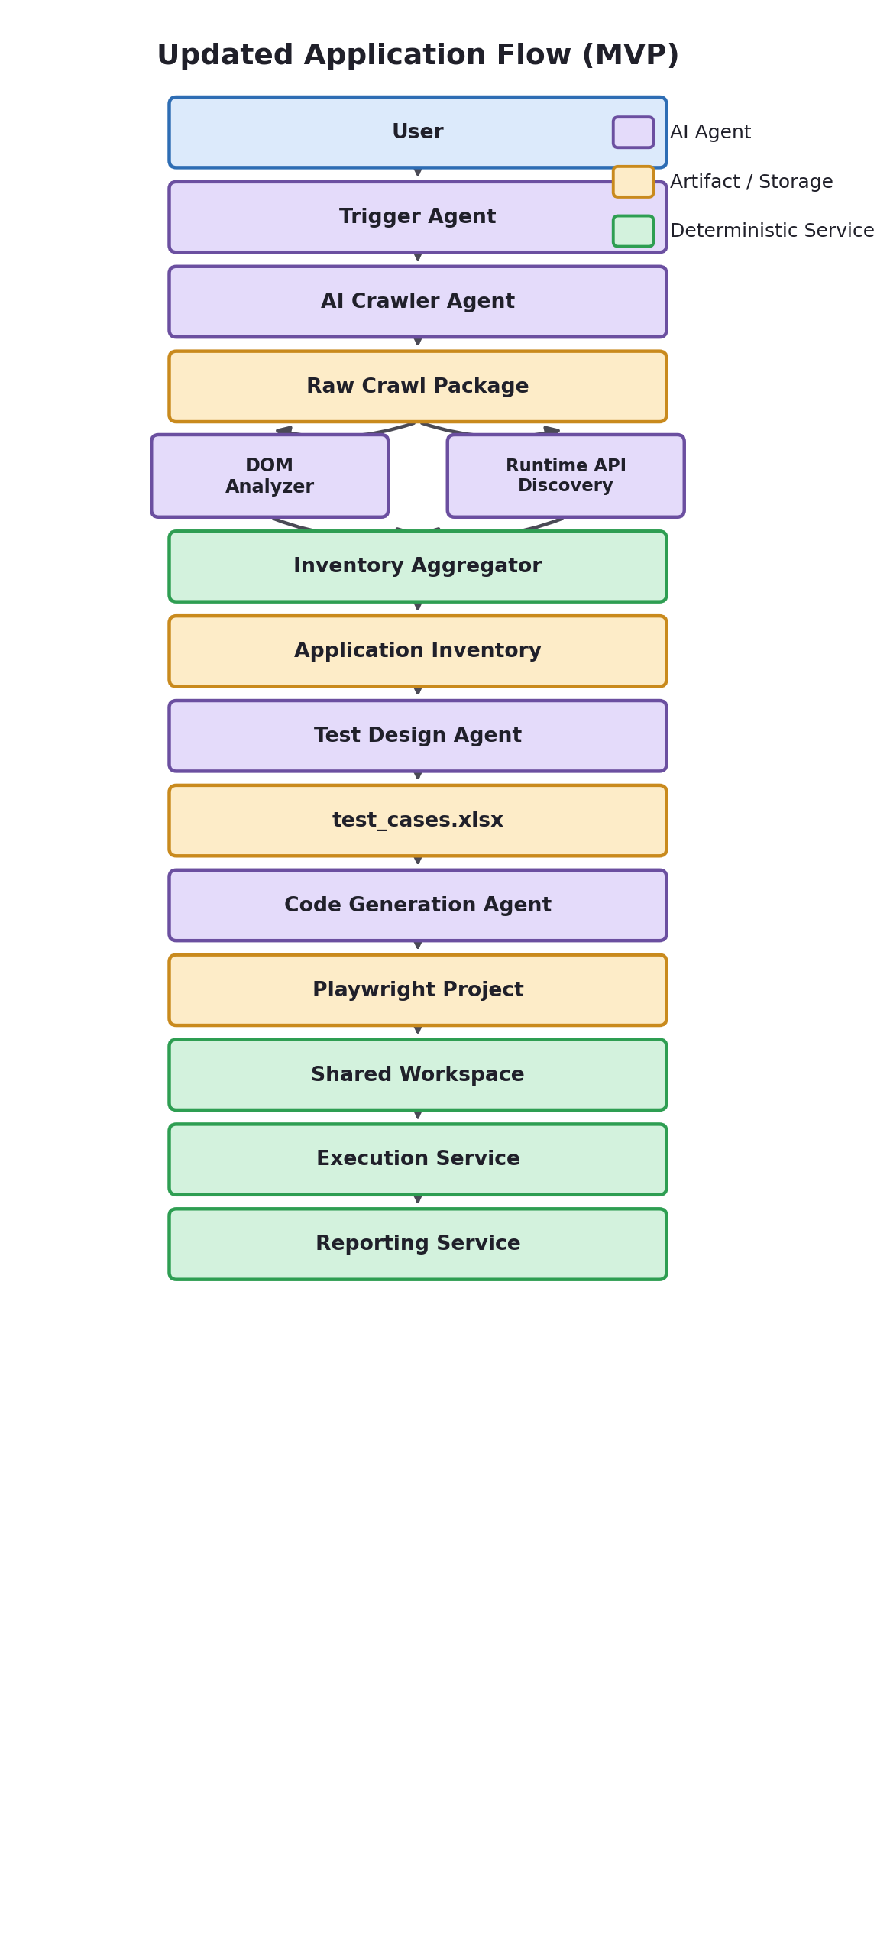
Figure 6.1 — Updated Application Flow Diagram (MVP)

6.1.1 MVP Sequence Diagram
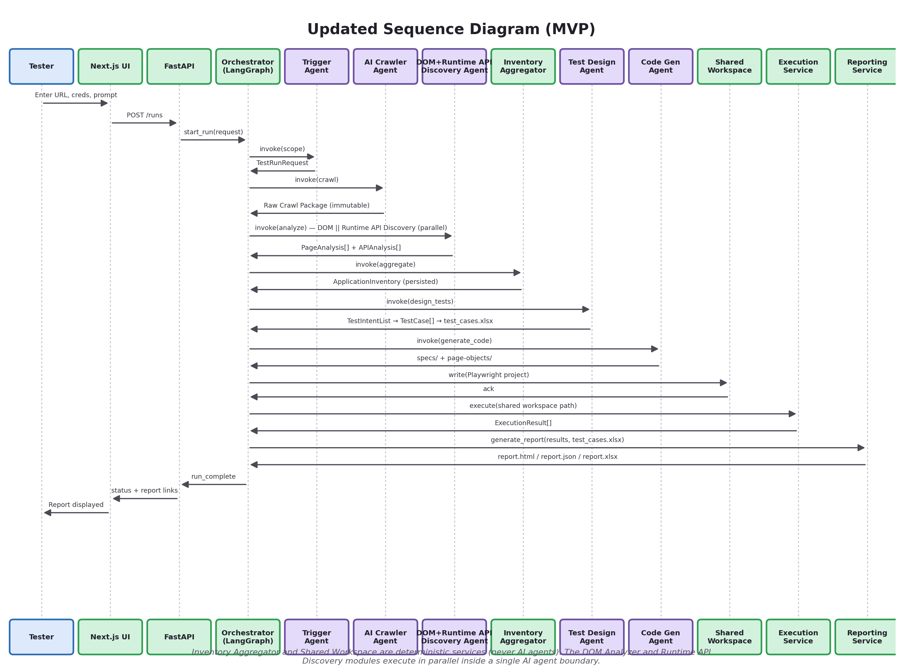
Figure 6.2 — Updated Sequence Diagram (MVP)

6.1.2 MVP Step-by-Step Execution
- Tester submits URL, credentials, prompt via the Next.js UI.
- FastAPI validates the request and creates a Run ID, delegating to the Trigger Agent.
- Trigger Agent decides reuse / recrawl / partial_refresh for the inventory.
- If crawling is needed: AI Crawler Agent logs in and explores the app within scope, collecting HTML, DOM, screenshots, network traffic, storage, and cookies — collection only, no analysis — and packages all of it into the immutable Raw Crawl Package.
- DOM + Runtime API Discovery Agent consumes the Raw Crawl Package and runs its two modules in parallel: the DOM Analyzer Module (components, forms, selectors, navigation/flow graph) and the Runtime API Discovery Module (endpoints, schemas, auth, dependency graph — observed from network traffic, never from source code).
- Inventory Aggregator (deterministic service) merges both modules' outputs, dedupes, normalizes, validates, and persists the versioned Application Inventory (Component, Page, API Inventory, Navigation Graph, Flow Graph).
- Test Design Agent retrieves the relevant Component Inventory (and API Inventory/Flow Graph, where relevant) slice, produces test intents, expands them into concrete steps + expected results validated against real inventory elements, and renders the canonical test_cases.xlsx.
- Code Generation Agent reads test_cases.xlsx and the Application Inventory, produces both executable Playwright spec files and the reusable Page Object Model classes (pages/, components/, common/), and writes the finished project to the Shared Workspace — it never touches Playwright execution itself.
- Execution Service reads the project from the Shared Workspace and runs the specs, capturing pass/fail, screenshots, and traces.
- Reporting Service aggregates results into HTML/JSON and appends execution outcomes onto the canonical Excel, producing report.xlsx.
- UI polls run status and displays the final report.
Steps 7 above collapses the original design's separate Reasoning Agent / Test Case Generator hand-off into one Test Design Agent invocation, and step 8 collapses the separate Script Generator / POM Generator hand-off into one Code Generation Agent invocation. Steps 5–6 make explicit that DOM analysis and Runtime API Discovery run in parallel inside one agent boundary, with the merge handled by a separate deterministic Inventory Aggregator — never by the AI agent itself. No step, artifact, or data contract is removed — see §6.2 for the full original flow these steps decompose into at Production tier.

6.2 Production-Tier Application Flow (Full Agent Breakdown)
The following is the original, full application flow this platform was designed around — preserved unchanged as the Production-tier target, where every merged MVP agent has been decomposed back into its original specialized form.

6.2.1 High-Level Sequence (Tester clicks “Run Test” → Report) — Original Diagram
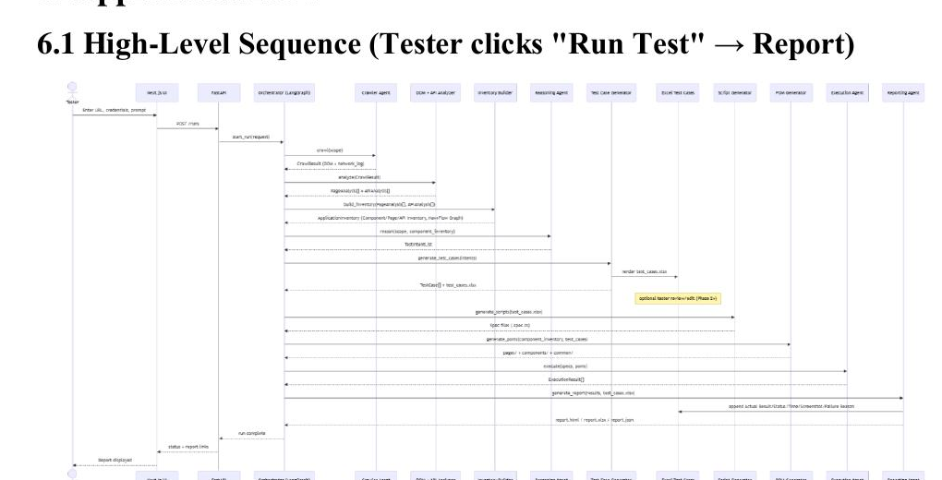
Figure 6.3 — Original Production-Tier Sequence Diagram (unchanged from the initial design)

6.2.2 Step-by-Step Execution
- Tester submits URL, credentials, prompt via the Next.js UI.
- FastAPI validates the request and creates a run_id, delegating to the Trigger Agent logic.
- Trigger Agent decides reuse / recrawl / partial_refresh for the inventory (prompt scope decision — unchanged in behavior, called out explicitly here since it now also gates whether the API Inventory needs refreshing).
- If crawling is needed: Crawler Agent logs in and explores the app within scope, producing the Raw Crawl Package (raw DOM + screenshots + the network_log).
- DOM + Runtime API Discovery Agent converts raw pages into structured element/form/table data and discovers/maps backend API endpoints, schemas, and page flows — entirely from observed runtime traffic (§4.3.1).
- Inventory Builder (Inventory Aggregator) merges this into a versioned Application Inventory, internally organized as Component Inventory, Page Inventory, API Inventory, Navigation Graph, and Flow Graph (persisted).
- Reasoning Agent retrieves the relevant Component Inventory (and API Inventory/Flow Graph, where relevant) slice and produces a list of test intents.
- Test Case Generator expands each intent into concrete steps + expected results, validated against real Component Inventory elements, and renders the canonical test_cases.xlsx.
- (New, optional) Tester reviews/edits test_cases.xlsx before proceeding (Phase 2+ approval workflow).
- Script Generator reads test_cases.xlsx, maps steps to real selectors, and produces executable Playwright spec files.
- (New) POM Generator produces reusable Page Object Model classes (pages/, components/, common/) from the Component Inventory, imported by the specs.
- Execution Agent runs the specs (using the POMs), capturing pass/fail, screenshots, and traces.
- Reporting Agent aggregates results into HTML/JSON (unchanged) and appends execution outcomes onto the canonical Excel, producing report.xlsx.
- UI polls (MVP) or streams (Phase 2, via SSE/websocket) run status and displays the final report.

6.2.3 Internal AI Reasoning Flow
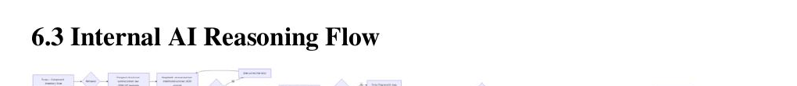
Figure 6.4 — Internal AI Reasoning Flow (unchanged — applies at every LLM touchpoint regardless of tier)
The recurring pattern — retrieve narrow context → structured-output prompt → validate → bounded single retry → deterministic fallback — is the core hallucination-mitigation strategy used at every LLM touchpoint in the system, at every tier.

7. Crawler Design
Owned by the AI Crawler Agent (MVP Agent 2, §4.0.2) at every tier — this design is unchanged by the agent-count consolidation.
How the crawler works: it is a bounded, scope-aware breadth-first explorer, not an unbounded spider. It starts from the authenticated home page and expands a frontier queue, using an LLM only to prune which discovered links are relevant to the requested scope.
How Playwright is used: a single (MVP) headless Chromium BrowserContext per crawl, one Page navigating sequentially; Phase 2 introduces multiple Page/context instances in parallel for throughput.
How login is handled: the crawler heuristically detects a login form (a <form>/container with one password-type input), fills username/password fields (matched by type, name, aria-label heuristics), submits, and confirms success by watching for a URL change away from the login route or the appearance of a post-login element (avatar, logout link). Phase 2 adds explicit, per-application login “recipes” for apps whose login doesn't fit the generic heuristic (e.g., multi-step SSO).
How pages are discovered: via <a href> elements, <button>s that trigger client-side navigation (detected by watching for URL/history changes after click), and nav/menu structures identified by common landmark roles (nav, role="navigation") or repeated sibling link groups.
How menus are discovered: elements with role="navigation"/<nav> tags, or heuristically, groups of ≥3 sibling <a>/<button> elements sharing a common parent with similar styling — expanded/hovered programmatically if they reveal sub-items (dropdown menus).
How DOM is collected: after each navigation, the crawler waits for network idle plus a short settle delay, then captures both the full HTML and Playwright's accessibility tree snapshot (the latter is what the DOM Analyzer Module prefers, since it's closer to how a screen reader — and Playwright's own recommended locators — see the page).
How network traffic is captured (feeds Runtime API Discovery, §4.3.1): the crawler attaches Playwright's native request/response interception — page.on('request') and page.on('response') listeners — for the lifetime of the crawl. Every request's method, URL, headers (secrets redacted), and body, and every response's status code, headers, and body, are recorded into the network_log and carried inside the Raw Crawl Package. This is pure, passive observation of runtime browser traffic; the crawler never inspects, and has no access to, backend source code, controllers, or databases (§4.3.1). This mechanism is what makes Runtime API Discovery possible without a Swagger/OpenAPI dependency.
How forms are detected: any <form> element, or (for non-semantic markup) a cluster of <input>/<select>/<textarea> elements sharing a common ancestor within a small DOM-distance threshold, followed by a submit-like button.
How tables are detected: <table> elements primarily; secondarily, ARIA role="grid"/role="table" structures and repeated-row <div> patterns (common in modern component libraries like AG Grid or MUI DataGrid) identified by repeated sibling structure with consistent column count.
How selectors are collected: for every interactive element, the DOM Analyzer Module computes a ranked candidate list (see §4.3) — data-testid first, then accessible role+name, then stable id, then a scoped CSS path, then visible text — and stores all candidates (not just the top one) so the Self-Healing Agent has fallback options later.
MVP sequential single-context crawl, generic login heuristic, hard budgets (30 pages, 3-minute time cap).
PHASE 2 parallel crawling, per-app login recipes, SPA route-change detection, incremental recrawl.
PRODUCTION MFA/CAPTCHA-aware flows, anti-detection rate limiting, distributed crawl workers.
Everything captured above — HTML, DOM, screenshots, network logs, cookies, storage state, console logs, visited URLs, and assets — is packaged into the immutable Raw Crawl Package (§2.1.1, §4.0.2) at the end of the crawl. Nothing here changes based on parsing/interpretation; that is the DOM + Runtime API Discovery Agent's job, run against the finished package rather than the live browser.

8. Inventory System
Built from the parallel outputs of the DOM + Runtime API Discovery Agent (§4.0.3) and persisted by the Inventory Aggregator (§4.0.6, §4.4) at every tier, including MVP. The Inventory's schema, structure, and purpose are completely unchanged by this revision — only the API Inventory's field set is extended to make its runtime-observed nature explicit (§8.4).

8.1 Why Crawling Every Execution Is a Bad Idea
Crawling is the slowest, most fragile, most expensive part of the pipeline — it involves real browser navigation, login, and LLM classification calls. If every test run re-crawled the entire application, (a) test execution time would be dominated by discovery rather than testing, (b) the same LLM classification cost would be paid repeatedly for a UI structure that rarely changes between runs, and (c) transient crawl flakiness (a slow page, a one-off network blip) would non-deterministically affect unrelated test runs. Separating “understand the app” from “test the app” mirrors how human QA teams work: they don't re-learn the application from scratch before every test cycle.

8.2 Inventory-Based Architecture
The Inventory is a persisted, versioned artifact representing the application's structure. Test runs consult it (fast DB read) instead of re-crawling. A crawl only happens when: no inventory exists yet, the tester explicitly forces a recrawl, the inventory has exceeded a staleness TTL, or a partial-refresh is triggered because execution repeatedly fails against a specific area (signaling drift). This remains unchanged from the original design; the Inventory Aggregator (§2.1.2, §4.4) has always owned writing to it, at every tier.

8.3 Component Inventory as the Central Knowledge Layer
The Application Inventory is a container for five explicit sub-layers:
- Component Inventory (the core, most-reused layer): selectors, reusable widgets, forms, tables, buttons, inputs, dropdowns, and their relationships. This is the single shared knowledge base consumed directly by the Test Design Agent, Code Generation Agent, and (from Phase 2) the Self-Healing Agent — each queries the Component Inventory rather than re-deriving component knowledge independently.
- Page Inventory: per-page metadata (URL pattern, title, which components/forms/tables it contains).
- API Inventory: discovered backend endpoints, their request/response schemas, and their mapping to the UI actions that trigger them — generated from observed runtime traffic, never from source code (§4.3.1), by the Runtime API Discovery Module (§4.3) and persisted by the Inventory Aggregator (§4.4).
- Navigation Graph: the page-to-page adjacency list.
- Flow Graph: ordered, multi-step journeys chaining Navigation Graph edges with API Inventory calls — used for cross-page/cross-call scenario reasoning and for the Code Generation Agent's navigation-helper methods.
The Application Inventory is not removed or replaced by this revision — it remains the top-level, versioned, persisted artifact; the Component Inventory is simply its core reusable subsystem, exactly as required.

8.4 Inventory JSON Schema
Unchanged from the prior revision except for the api_inventory.endpoints entries, which are extended below to make explicit that every field is derived from observed runtime traffic (§4.3.1), never from source code:
{
"application_id": "uuid",
"inventory_version": 4,
"base_url": "https://app.example.com",
"created_at": "2026-07-01T10:00:00Z",

"component_inventory": {
"components": [ { "component_id": "comp_emp_toolbar", "type": "toolbar",
"buttons": ["btn_add_employee", "btn_export"] } ],
"forms": [ { "form_id": "form_add_employee", "page_id": "page_add_employee",
"fields": [
{"field_id": "f_name", "label": "Full Name", "type": "text", "required": true},
{"field_id": "f_email", "label": "Email", "type": "email", "required": true},
{"field_id": "f_dept", "label": "Department", "type": "select", "required": true}
], "submit_button": "btn_save_employee" } ],
"buttons": [ {"button_id": "btn_add_employee", "label": "Add Employee",
"selectors": ["[data-testid=add-emp]", "role=button[name='Add Employee']"]} ],
"inputs": [ {"input_id": "f_email",
"selectors": ["#email", "role=textbox[name='Email']"]} ],
"dropdowns": [ {"dropdown_id": "f_dept", "options_source": "static",
"selectors": ["#department", "role=combobox[name='Department']"]} ],
"tables": [ {"table_id": "table_employee_list",
"columns": ["Name", "Email", "Department", "Actions"],
"row_selector": "table tbody tr"} ],
"selectors": { "f_email": ["[data-testid=email]", "#email",
"role=textbox[name='Email']"] },
"relationships": [
{"type": "form_belongs_to_page", "from": "form_add_employee", "to": "page_add_employee"},
{"type": "navigates_to", "from": "btn_add_employee", "to": "page_add_employee"}
]
},

"page_inventory": {
"pages": [ { "page_id": "page_employee_list", "url_pattern": "/employees",
"title": "Employee List", "components": ["comp_emp_table", "comp_emp_toolbar"],
"forms": ["form_add_employee"], "tables": ["table_employee_list"],
"navigation_out": ["page_employee_detail", "page_add_employee"] } ],
"urls": { "page_employee_list": "/employees", "page_add_employee": "/employees/new" }
},

"api_inventory": {
"endpoints": [ {
"endpoint_id": "ep_create_employee", "method": "POST",
"url_pattern": "/api/employees", "status_code": 201,
"request_schema": {"name": "string", "email": "string", "departmentId": "string"},
"response_schema": {"id": "string", "name": "string", "email": "string",
"departmentId": "string"},
"authentication_type": "Bearer",
"triggered_by_ui_action": "btn_save_employee",
"related_page_id": "page_add_employee", "confidence": "high",
"observed": true
} ],
"graphql_operations": []
},

"navigation": { "graph": {"page_employee_list": ["page_employee_detail",
"page_add_employee"]} },

"flow_graph": { "flows": [ {
"flow_id": "flow_add_employee",
"sequence": [
{"type": "page", "ref": "page_employee_list"},
{"type": "page", "ref": "page_add_employee"},
{"type": "api", "ref": "ep_create_employee"},
{"type": "page", "ref": "page_employee_list"}
]
} ] }
}
The top-level application_id, inventory_version, base_url, created_at, and navigation fields are unchanged from the original schema; component_inventory and page_inventory reorganize the original flat fields into their two respective sub-layers without dropping any field, and api_inventory/flow_graph are additive.
**observed: true** means the endpoint was actually executed and its request/response were captured during crawling — it is not inferred, guessed, or assumed from a spec. This is the field that makes the platform's black-box discovery honest: an entry with observed: true is something the platform watched happen; anything not observed simply does not appear in the inventory at all (§4.3.2).

8.5 Refreshing the Inventory After Application Updates
MVP manual “force recrawl” flag rebuilds the whole inventory; no automatic diffing.
PHASE 2 scheduled or event-triggered partial refresh — a nightly job re-crawls only pages tagged as “recently failing” or past their TTL, diffs against the prior version, and marks changed selectors as deprecated rather than deleting them.
PRODUCTION webhook-triggered refresh from CI/CD (app deploy → auto partial recrawl of affected routes based on deploy metadata), automatic change-impact report showing which existing test cases are affected by a detected structural change.

9. LLM Reasoning & Prompt Engineering
These prompts execute inside the Test Design Agent and Code Generation Agent at MVP tier (§4.0.4, §4.0.5), and inside their decomposed originals from Phase 2 onward. The strategy itself is identical at every tier.
How DeepSeek receives context: never the raw DOM. Every LLM call receives a purpose-built, compact JSON/text summary assembled deterministically from the Inventory — filtered to the requested scope, capped in size, and structured to match the exact schema the prompt asks the model to reason about. This keeps prompts small enough for an 8B-class local model to handle reliably and keeps token/latency costs predictable.
Prompt engineering strategy:
- System prompt per agent role (fixed, versioned in source control) defines the agent's single responsibility, the exact output schema (with a JSON Schema or TypeScript-like shape embedded), and 1–3 few-shot examples.
- User prompt per call carries only the task-specific data (scope, summarized inventory slice, prior errors on retry).
- Structured-output enforcement: prompts explicitly instruct “respond with ONLY valid JSON matching this schema, no prose, no markdown fences”; responses are parsed defensively (strip code fences if present) before validation.
- Temperature control: low temperature (≈0.1–0.3) for schema-bound reasoning/code-generation calls; the system does not rely on creative variation for correctness-critical output.
How AI understands application structure: through the curated Inventory summaries described above — pages, forms, and navigation edges expressed as compact natural-language-plus-JSON, not raw markup.
How AI generates scenarios: the reasoning stage (Reasoning Agent at Production tier; the reasoning half of the Test Design Agent at MVP tier) enumerates test intents against a fixed taxonomy (happy path, required-field validation, boundary/format validation, negative/error-path, and — Phase 2+ — cross-page workflow scenarios), rather than free-associating, which keeps output predictable and comparable across runs.
How AI generates Playwright scripts: the LLM is deliberately restricted to procedural glue — turning already-resolved selectors and already-decided steps into idiomatic code — never asked to invent selectors or decide test logic at this stage. This narrows the model's job to something an 8B model does reliably.
How hallucinations are minimized (summary of techniques used throughout):
- Narrow, scope-filtered context (never the whole app).
- Structured JSON output with schema validation and one bounded corrective retry.
- Reference validation — any element/selector the model claims to use is checked against the real Inventory; invalid references are stripped, not trusted.
- Deterministic fallback templates when generation repeatedly fails, so a bad LLM response degrades gracefully instead of producing broken test cases silently.
- Selectors are injected as literal data, never regenerated by the model from memory.

10. Playwright Integration
Playwright code is authored by the Code Generation Agent at MVP tier (§4.0.5) and run by the non-AI Execution Service at every tier. This section is updated in this revision to make the decoupling between agent and execution explicit (Principle 4, §2.6).

10.1 Complete Decoupling of Execution from AI Agents
AI agents never execute Playwright. AI agents only generate artifacts. This is a hard architectural boundary, not a convention: the Code Generation Agent's process has no ability to invoke npx playwright test, and the Execution Service's process has no LLM client. The two are connected only through the Shared Workspace, a deterministic hand-off point:
- Code Generation Agent generates the Playwright project (specs + Page Objects).
- The project is written to the Shared Workspace.
- Execution Service reads the project from the Shared Workspace.
- Playwright Runner executes it (npx playwright test).
- Execution Result is captured and handed to the Reporting Service.
This means a defect, hang, or runaway loop in the Code Generation Agent's LLM calls can never directly affect a live test execution in progress, and conversely a Playwright crash can never corrupt agent state — the Shared Workspace is the only thing they share, and it is a plain filesystem/object-storage boundary, not a shared process or memory space.

10.2 General Playwright Design
Why Playwright is required: LLMs cannot reliably interact with a live browser themselves at production quality — Playwright provides deterministic, auto-waiting, cross-browser automation with first-class debugging artifacts (trace viewer, video, screenshots) that a hand-rolled or LLM-driven browser loop cannot match in reliability.
Difference between AI and Playwright in this system: AI decides what to test and why (reasoning, scenario design); Playwright is the mechanism that executes the decided actions reliably and reports what actually happened. AI never directly controls the browser in real time step-by-step — it authors code ahead of time, which Playwright then runs deterministically.
How AI generates Playwright code: via the Code Generation Agent's constrained “steps + resolved selectors → idiomatic Playwright” prompt (§4.0.5 / §9), followed by automatic lint/format and a bounded regeneration retry on failure, before the result is written to the Shared Workspace.
How Playwright executes generated scripts: via the standard Playwright Test Runner (npx playwright test) invoked as a subprocess by the Execution Service, with trace: 'on-first-retry' and screenshot: 'only-on-failure' configured so debugging artifacts exist exactly when needed without bloating storage on passing runs.
How reports are collected: the Execution Service consumes Playwright's built-in JSON reporter output as the structured source of truth, and separately harvests the trace/screenshot/video files it references — the Reporting Service never re-parses HTML or console output.

11. Folder Structure

11.1 MVP Folder Structure (deliberately flat, single-service, 5 agents)
Updated in this revision: the agents/ folder now contains 5 agent modules instead of 9; services/ gains inventory_aggregator.py and shared_workspace.py; a new raw-crawl-packages/ storage path is introduced.
agentic-testing-platform/
├── frontend/ # Next.js app
│ ├── app/
│ │ ├── runs/[runId]/page.tsx
│ │ └── page.tsx # New run form
│ └── components/
├── backend/
│ ├── app/
│ │ ├── main.py # FastAPI entrypoint
│ │ ├── api/
│ │ │ └── runs.py # POST /runs, GET /runs/{id}
│ │ ├── agents/ # 5 MVP agents (was 9)
│ │ │ ├── trigger_agent.py
│ │ │ ├── crawler_agent.py # collects only — emits Raw Crawl Package
│ │ │ ├── dom_runtime_api_discovery_agent.py # DOM Analyzer + Runtime API
│ │ │ │ # Discovery modules run in parallel
│ │ │ ├── test_design_agent.py # merges reasoning + test_case_generator
│ │ │ └── code_generation_agent.py # merges script_generator + pom_generator
│ │ ├── services/ # non-AI services, unchanged in kind
│ │ │ ├── inventory_aggregator.py # merge/dedupe/normalize/validate/persist
│ │ │ ├── shared_workspace.py # decouples Code Gen from Execution
│ │ │ ├── execution_service.py
│ │ │ └── reporting_service.py
│ │ ├── graph/
│ │ │ └── orchestrator.py # LangGraph state machine, 8 MVP nodes
│ │ ├── llm/
│ │ │ └── ollama_client.py
│ │ ├── models/ # Pydantic + ORM models
│ │ ├── db/
│ │ │ └── sqlite.py
│ │ └── config.py
│ └── requirements.txt
├── raw-crawl-packages/{run_id}/ # immutable — html, dom, screenshots,
│ # network logs, cookies, storage, console
├── generated/
│ ├── test-cases/{run_id}/test_cases.xlsx # canonical editable artifact
│ └── reports/{run_id}/{report.html, report.xlsx, report.json}
├── shared-workspace/{run_id}/ # written by Code Generation Agent,
│ ├── scripts/*.spec.ts # read by Execution Service only
│ ├── pages/*.ts
│ ├── components/*.ts
│ └── common/*.ts
├── inventories/{application_id}/v{n}.json # persisted by inventory_aggregator.py
└── playwright.config.ts

11.2 Production Folder Structure (service-oriented, additive on top of MVP)
Unchanged from the original design — this is exactly what the MVP's agents/ folder decomposes into as agents split apart through Phase 2 and Production (§2.2).
agentic-testing-platform/
├── apps/
│ ├── web/ # Next.js
│ └── api-gateway/ # FastAPI edge/auth layer
├── services/
│ ├── orchestrator-service/ # LangGraph runtime, workers
│ ├── crawler-service/
│ ├── analyzer-service/ # DOM Analyzer + Runtime API Discovery (parallel)
│ ├── inventory-service/ # Inventory Aggregator — Component/Page/API
│ │ # Inventory, Nav+Flow Graph
│ ├── reasoning-service/
│ ├── testgen-service/ # emits TestCase[] + test_cases.xlsx
│ ├── scriptgen-service/ # emits specs only
│ ├── pomgen-service/ # emits pages/components/common
│ ├── execution-service/
│ ├── self-healing-service/
│ ├── reporting-service/ # emits html/json + annotates report.xlsx
│ └── credential-vault-service/
├── libs/
│ ├── shared-schemas/ # Pydantic/TS types shared across services
│ ├── llm-client/
│ └── observability/
├── infra/
│ ├── docker/
│ ├── terraform/ (azure|aws)
│ └── k8s/
└── docs/adr/ # Architecture Decision Records
The Production structure is a natural decomposition of the MVP's agents/ folder (5 modules) into independently deployable services (10–12, matching the original enterprise design) — no renaming/reshaping of core concepts is required, only extraction.

12. Database Design
Schema unchanged by the agent-count consolidation — tables are organized around runs and artifacts, not around which agent produced them.

12.1 Entity-Relationship Overview
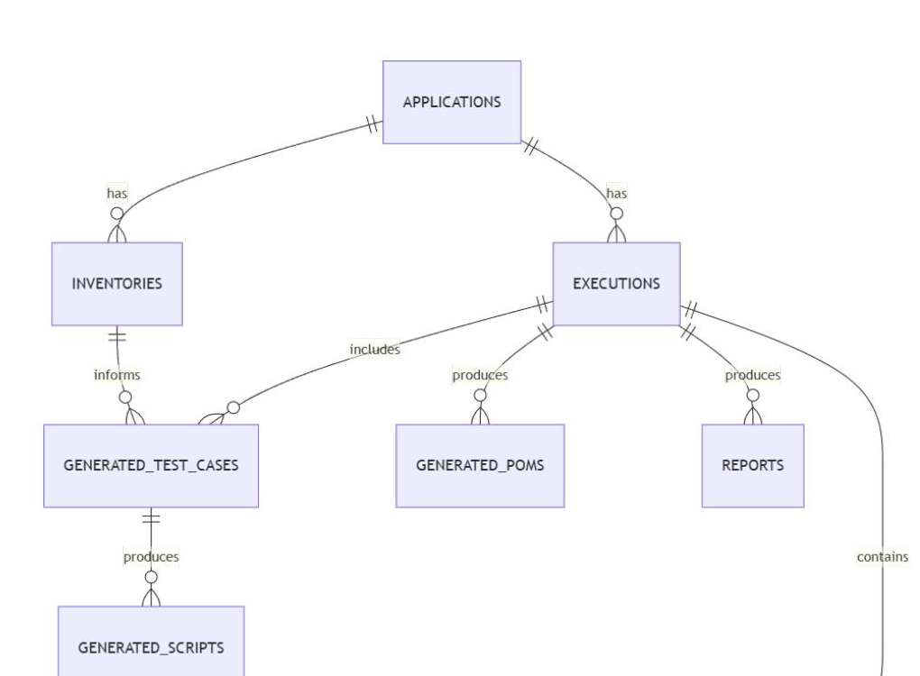
Figure 12.1 — Entity-Relationship Overview (unchanged from the original design)

12.2 Table Definitions

applications
Column | Type | Notes
id | UUID PK
base_url | TEXT | unique, normalized
name | TEXT
created_at | TIMESTAMP

inventories
Column | Type | Notes
id | UUID PK
application_id | UUID FK
version | INT | monotonic per application
json_blob | TEXT/JSONB | full inventory (SQLite: TEXT; Postgres: JSONB)
created_at | TIMESTAMP

executions (a "run")
Column | Type | Notes
id | UUID PK | run_id
application_id | UUID FK
inventory_version | INT | which inventory version was used
prompt | TEXT | original tester prompt
scope | TEXT/JSONB | resolved scope
status | TEXT | pending/running/passed/failed/partial
started_at / completed_at | TIMESTAMP

generated_test_cases
Column | Type | Notes
id | UUID PK
execution_id | UUID FK
module | TEXT
title | TEXT
priority | TEXT | P0/P1/P2
steps_json | JSONB
expected_result | TEXT
test_cases_xlsx_path | TEXT | (new) path to the canonical test_cases.xlsx this row was rendered into/read from

generated_scripts
Column | Type | Notes
id | UUID PK
test_case_id | UUID FK
file_path | TEXT
language | TEXT | ts/py
version | INT | regeneration attempts

generated_poms (new table)
Column | Type | Notes
id | UUID PK
execution_id | UUID FK
component_id | TEXT | references the Component Inventory element/page this class represents
pom_type | TEXT | page / component / common
file_path | TEXT
language | TEXT | ts/py
version | INT | regeneration attempts

execution_history
Column | Type | Notes
id | UUID PK
script_id | UUID FK
status | TEXT | passed/failed/skipped
duration_ms | INT
screenshot_paths | JSONB
trace_path | TEXT
error_message | TEXT
retry_count | INT

reports
Column | Type | Notes
id | UUID PK
execution_id | UUID FK
html_path / xlsx_path / json_path | TEXT
summary_json | JSONB | pass rate, counts
MVP SQLite, all eight tables (the original seven plus the new generated_poms), no multi-tenancy column.
PHASE 2 migrate to PostgreSQL, add organization_id/user_id for multi-user isolation, add indices on application_id/execution_id.
PRODUCTION partitioning/archival strategy for execution_history, read replicas for reporting queries, row-level security per tenant.

13. API Design
Base path: /api/v1
POST /applications — register/verify an application.
// Request
{ "base_url": "https://app.example.com", "name": "HR Portal" }
// Response 201
{ "application_id": "a1b2...", "base_url": "https://app.example.com" }
POST /runs — start a test run (the core action behind “Run Test”).
// Request
{
"application_id": "a1b2...",
"credentials": { "username": "tester", "password": "***" },
"prompt": "Test Employee Management",
"force_recrawl": false
}
// Response 202
{ "run_id": "r9f3...", "status": "pending" }
GET /runs/{run_id} — poll run status.
{
"run_id": "r9f3...",
"status": "executing",
"phase": "execution",
"progress": { "test_cases_total": 12, "executed": 7 }
}
GET /runs/{run_id}/test-cases — (new) fetch the canonical test_cases.xlsx for review before execution (Phase 2+ approval workflow).
{ "xlsx": "/test-cases/r9f3/test_cases.xlsx", "status": "awaiting_review" }
GET /runs/{run_id}/report — fetch report links. xlsx is now the same canonical Excel Test Cases file, annotated with execution outcome columns (Actual Result, Status, Execution Time, Screenshot, Failure Reason); html/json are unchanged from the original design.
{
"html": "/reports/r9f3/report.html",
"xlsx": "/reports/r9f3/report.xlsx",
"json": "/reports/r9f3/report.json"
}
GET /applications/{application_id}/inventory — inspect latest inventory (debugging/transparency).
{ "application_id": "a1b2...", "version": 4, "pages_count": 18, "forms_count": 6 }
POST /applications/{application_id}/inventory/refresh — force a recrawl.
MVP the six endpoints above, simple polling for status (no websockets); the new /test-cases endpoint exists but the MVP flow does not pause on it (no review gate yet).
PHASE 2 GET /runs/{run_id}/stream (SSE) for live progress, PATCH /runs/{run_id}/test-cases/{id} for tester edits before execution, auth headers (JWT).
PRODUCTION full OpenAPI-documented versioned API, rate limiting, org/tenant scoping on every route, webhook endpoints for CI/CD triggers.

14. Additional Sequence Diagrams (Production Tier)
The four diagrams in this section are unchanged from the original design and depict the fully decomposed Production-tier architecture (separate Reasoning Agent, Test Case Generator, Script Generator, POM Generator, and Self-Healing Agent lanes). For the MVP-tier equivalent, see the Updated Sequence Diagram in §6.1.1 and the Updated LangGraph State Diagram in §16.1.

14.1 Agent Flow (Orchestrator perspective)
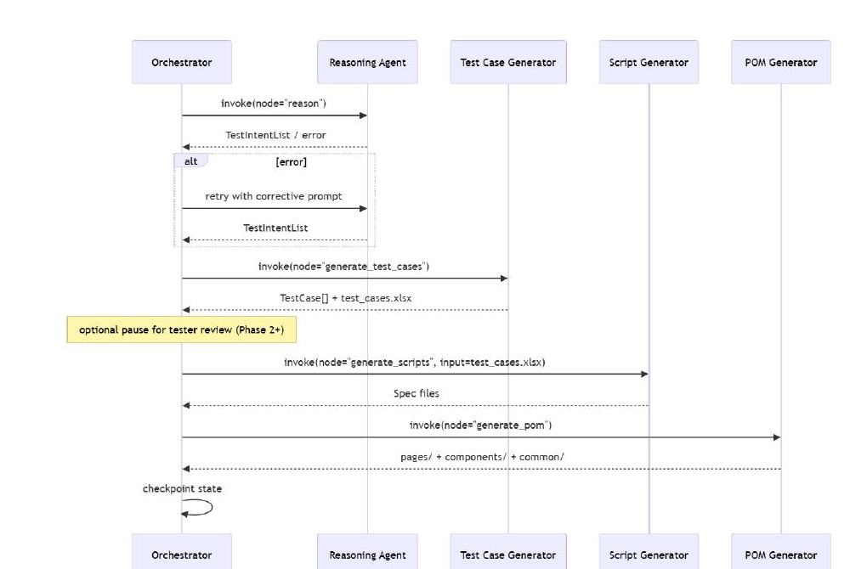
Figure 14.1 — Agent Flow, Orchestrator Perspective (Production tier, unchanged)

14.2 Crawler Flow
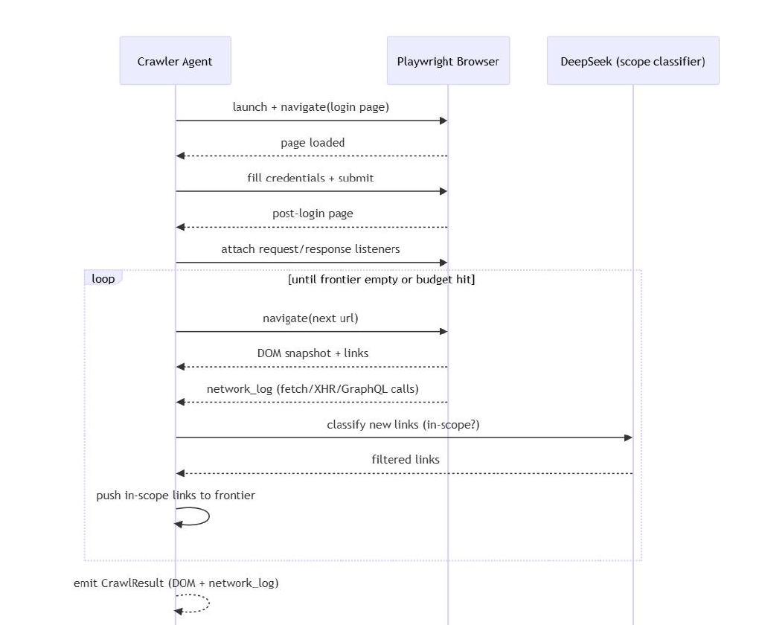
Figure 14.2 — Crawler Flow (unchanged — identical at MVP tier, since the AI Crawler Agent is not merged)

14.3 Execution Flow
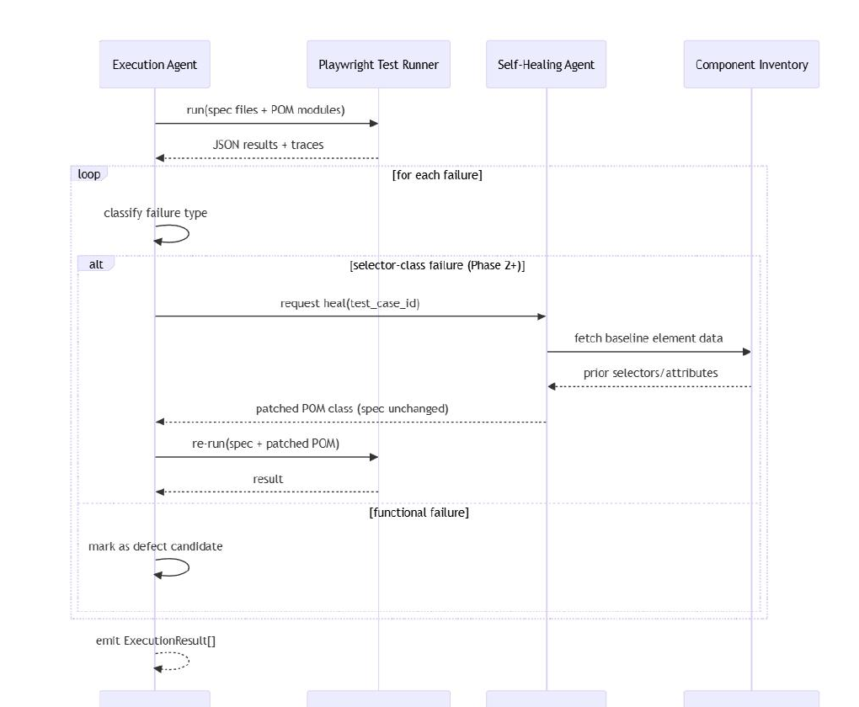
Figure 14.3 — Execution Flow (Production tier, with Self-Healing Agent shown)
At MVP tier, the Self-Healing branch shown here does not exist yet (Self-Healing is a Phase 2 introduction, §4.11); an MVP-tier execution failure is simply marked as a functional failure.

14.4 Report Flow
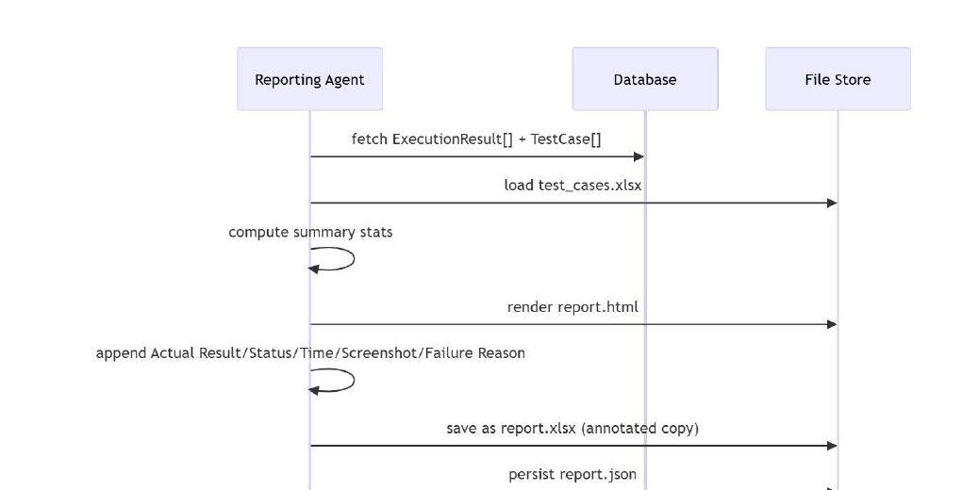
Figure 14.4 — Report Flow (unchanged from the original design)

15. High-Level Design (HLD)

15.1 MVP HLD
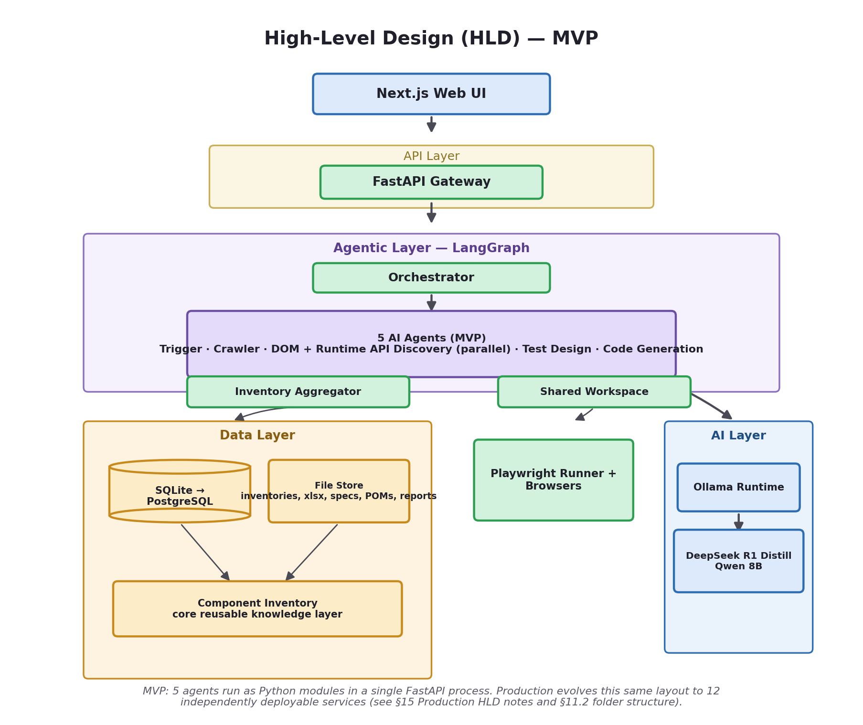
Figure 15.1 — High-Level Design, MVP tier (5 agents as Python modules in a single FastAPI process)

15.2 Production HLD (Original, Unchanged)
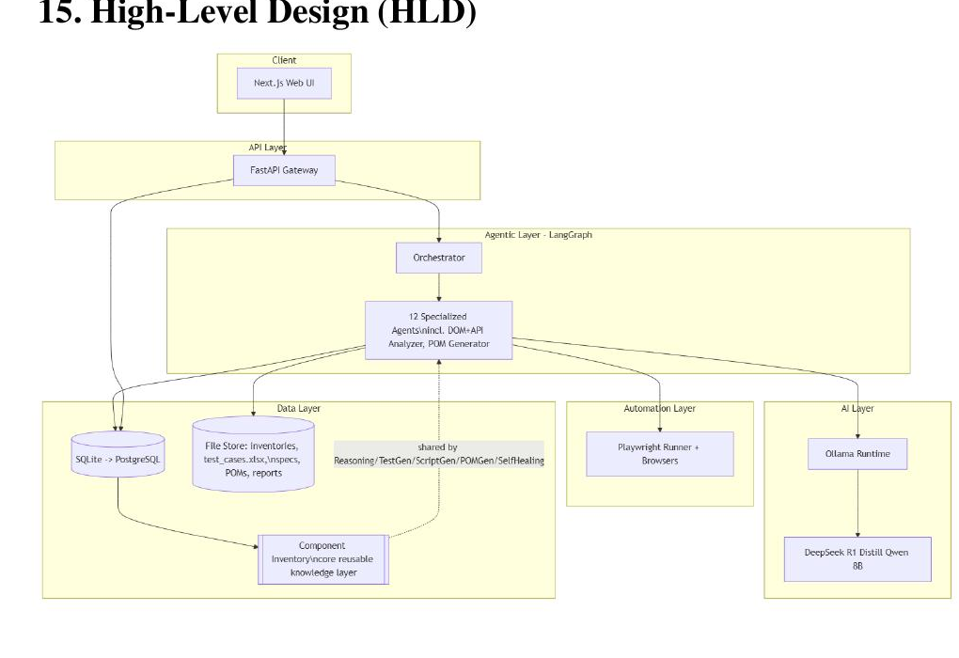
Figure 15.2 — High-Level Design, Production tier (12 specialized agents, unchanged from the original design)
HLD narrative (unchanged at every tier): the UI never talks to agents directly — everything passes through the API gateway, which is the single trust boundary for auth and validation. The Orchestrator is the only component allowed to sequence agent calls. Agents talk to exactly two external systems: the LLM runtime (for reasoning/generation) and Playwright (for browser truth) — plus the shared data layer for persistence, whose core reusable element is the Component Inventory, queried directly by the Test Design Agent, Code Generation Agent, and (from Phase 2) the Self-Healing Agent. This keeps the blast radius of any one agent's failure contained.
MVP everything above runs as a single deployable FastAPI process (5 agents as Python modules, not services), SQLite file on local disk, Ollama on the same host/network.
PHASE 2 agents remain in-process but run under a task queue for concurrency; PostgreSQL; Ollama on a shared internal host; Test Design and Code Generation begin splitting into their specialized originals.
PRODUCTION agents extracted into independently deployable services (per §11.2), containerized, behind an API gateway with auth/rate-limiting, Ollama (or hosted LLM) behind an internal load balancer — the full original 12-agent architecture.

16. Low-Level Design (LLD)

16.1 LangGraph State Machine

16.1.1 MVP — 8-Node Graph (Parallel Analysis + Aggregation)
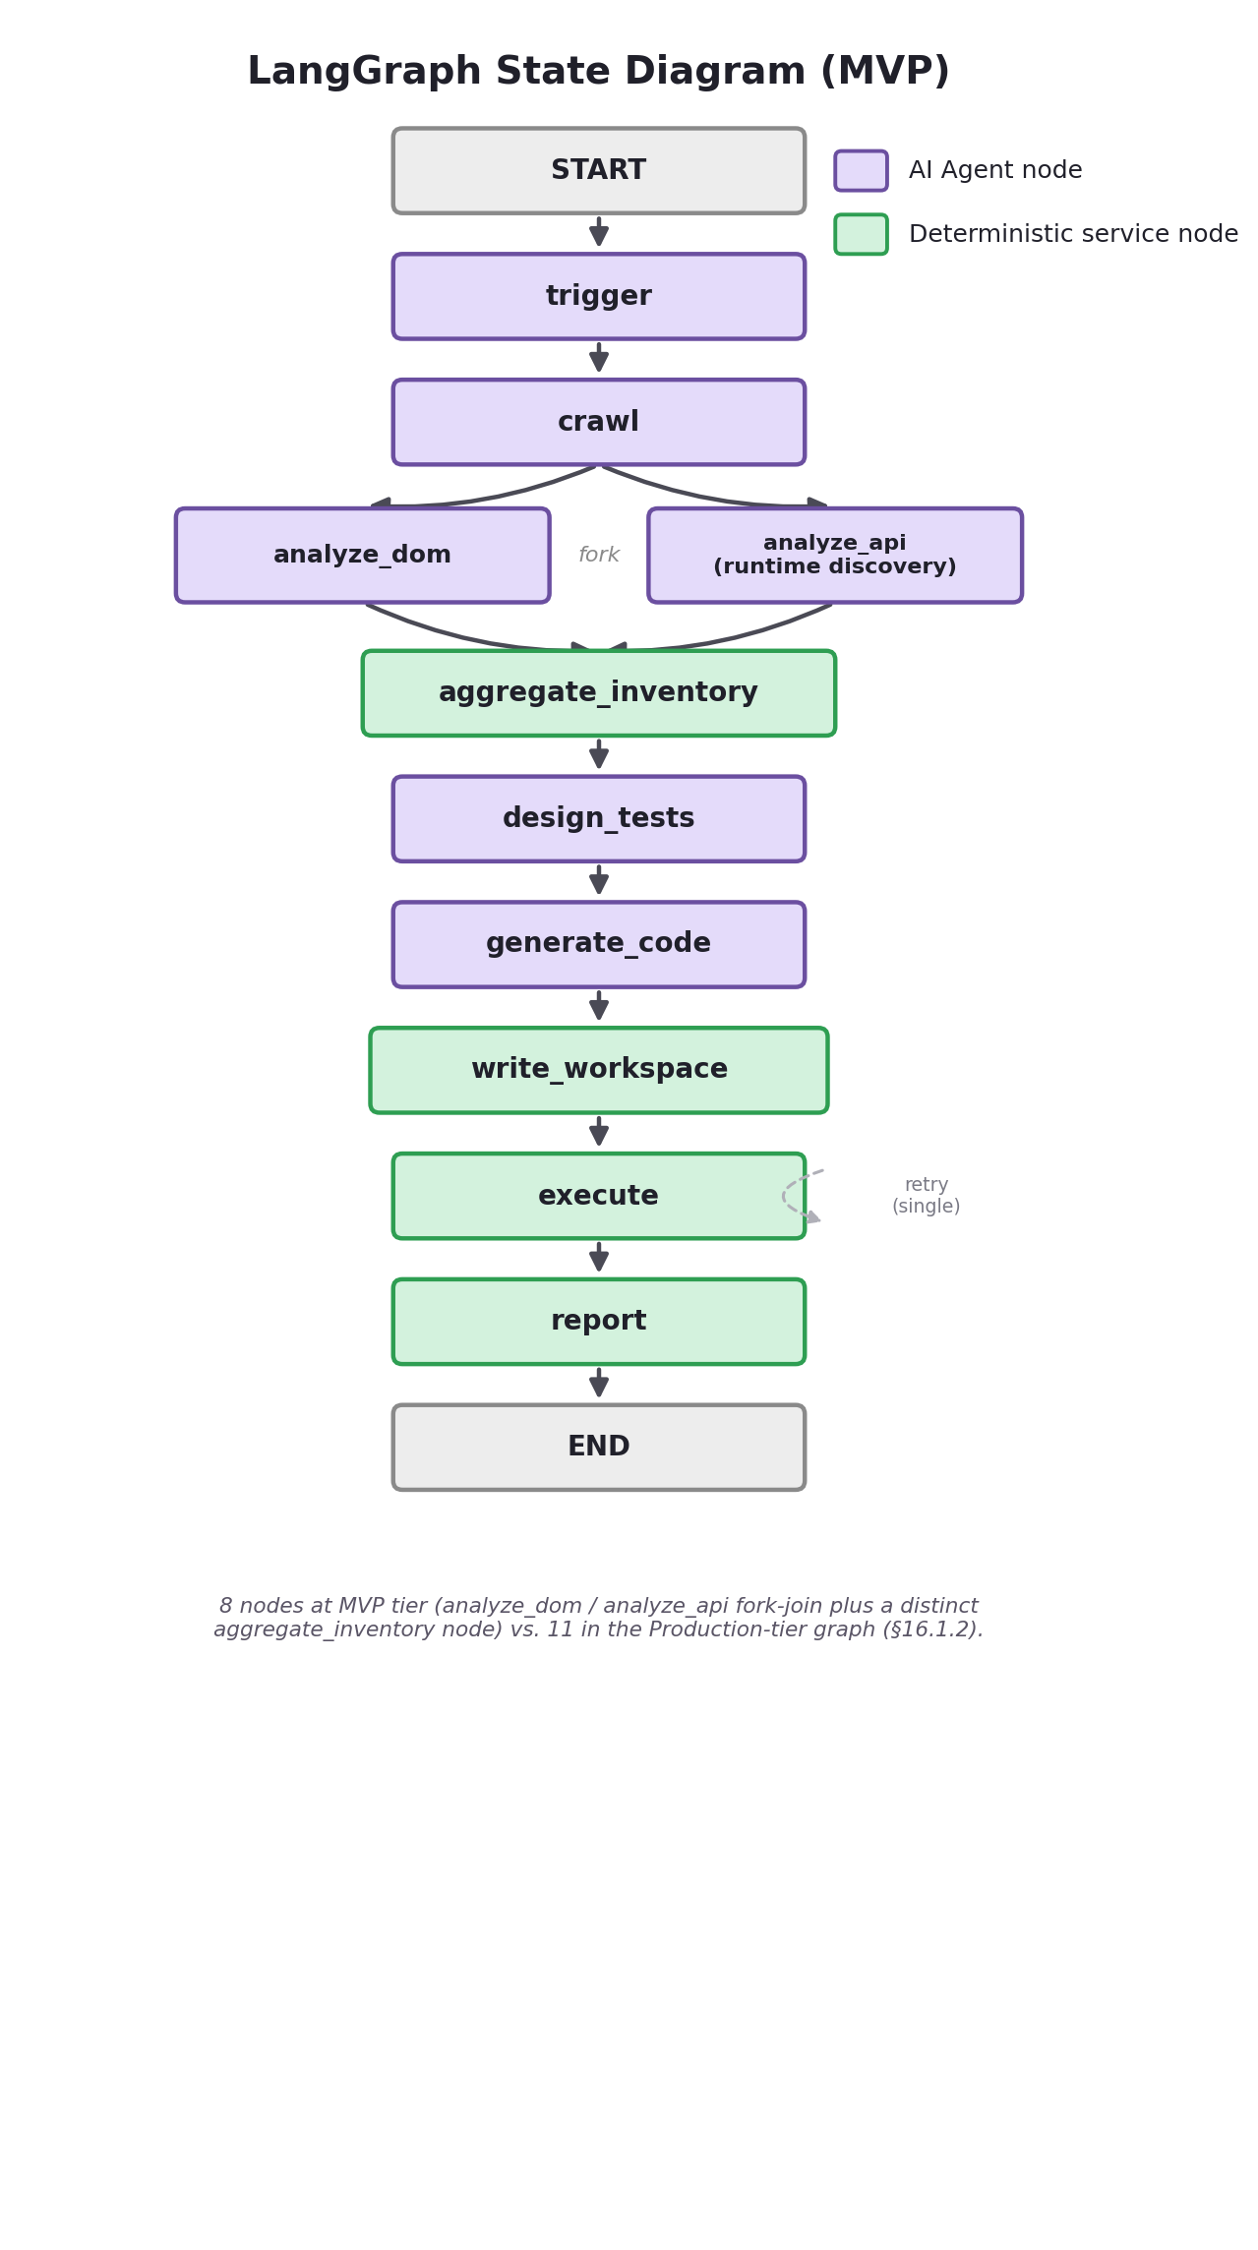
Figure 16.1 — Updated LangGraph State Diagram (MVP)
Conceptual node/edge definition for the MVP graph. analyze_dom and analyze_api run as parallel branches (a LangGraph fork), joined at aggregate_inventory:
# graph/orchestrator.py — MVP (illustrative, not exhaustive)
graph = StateGraph(RunState)

graph.add_node("trigger", trigger_agent.run)
graph.add_node("crawl", crawler_agent.run) # emits Raw Crawl Package
graph.add_node("analyze_dom", dom_analyzer_module.run) # parallel branch 1
graph.add_node("analyze_api", runtime_api_discovery_module.run) # parallel branch 2
graph.add_node("aggregate_inventory", inventory_aggregator.run) # deterministic, join
graph.add_node("design_tests", test_design_agent.run) # reasoning + test case gen
graph.add_node("generate_code", code_generation_agent.run) # script gen + POM gen
graph.add_node("write_workspace", shared_workspace.write) # deterministic hand-off
graph.add_node("execute", execution_service.run)
graph.add_node("report", reporting_service.run)

graph.set_entry_point("trigger")
graph.add_conditional_edges(
"trigger",
lambda s: s.inventory_action,
{"reuse": "design_tests", "recrawl": "crawl", "partial_refresh": "crawl"},
)
graph.add_edge("crawl", "analyze_dom") # fork: both branches read the same
graph.add_edge("crawl", "analyze_api") # immutable Raw Crawl Package
graph.add_edge("analyze_dom", "aggregate_inventory") # join
graph.add_edge("analyze_api", "aggregate_inventory") # join
graph.add_edge("aggregate_inventory", "design_tests")
graph.add_edge("design_tests", "generate_code")
graph.add_edge("generate_code", "write_workspace")
graph.add_edge("write_workspace", "execute")
graph.add_edge("execute", "report")
graph.add_edge("report", END)
8 nodes at MVP tier (the analyze_dom / analyze_api fork-join plus a distinct aggregate_inventory node) vs. 11 in the Production-tier graph below, which additionally reintroduces reason / generate_test_cases / generate_scripts / generate_pom / heal as separate nodes and keeps build_inventory and write_workspace as their own nodes — Production's build_inventory node is functionally identical to aggregate_inventory here, renamed only for continuity with the original catalog numbering (§4.4).

16.1.2 Production — 11-Node Graph (Original, Terminology-Corrected)
Conceptual node/edge definition for the Production graph — identical in structure to the original design; node names are updated only to reflect the Runtime API Discovery terminology correction (§4.3.1) and the explicit write_workspace hand-off (§10.1), neither of which changes any edge or behavior:
# graph/orchestrator.py (illustrative, not exhaustive)
graph = StateGraph(RunState)

graph.add_node("trigger", trigger_agent.run)
graph.add_node("crawl", crawler_agent.run)
graph.add_node("analyze", dom_runtime_api_discovery_agent.run) # DOM + runtime
# API discovery
graph.add_node("build_inventory", inventory_builder_agent.run) # = Inventory Aggregator
graph.add_node("reason", reasoning_agent.run)
graph.add_node("generate_test_cases", test_case_generator_agent.run)
graph.add_node("generate_scripts", script_generator_agent.run)
graph.add_node("generate_pom", pom_generator_agent.run)
graph.add_node("write_workspace", shared_workspace.write)
graph.add_node("execute", execution_agent.run)
graph.add_node("heal", self_healing_agent.run) # Phase 2
graph.add_node("report", reporting_agent.run)

graph.set_entry_point("trigger")
graph.add_conditional_edges(
"trigger",
lambda s: s.inventory_action,
{"reuse": "reason", "recrawl": "crawl", "partial_refresh": "crawl"},
)
graph.add_edge("crawl", "analyze")
graph.add_edge("analyze", "build_inventory")
graph.add_edge("build_inventory", "reason")
graph.add_edge("reason", "generate_test_cases")
graph.add_edge("generate_test_cases", "generate_scripts")
graph.add_edge("generate_scripts", "generate_pom")
graph.add_edge("generate_pom", "write_workspace")
graph.add_edge("write_workspace", "execute")
graph.add_conditional_edges(
"execute",
lambda s: "heal" if s.has_selector_failures else "report",
{"heal": "heal", "report": "report"},
)
graph.add_edge("heal", "execute") # re-run healed tests (patched POM, spec unchanged)
graph.add_edge("report", END)

16.2 Selector Resolution Algorithm
Deterministic, used by the Code Generation Agent at MVP tier and by the Script Generator / POM Generator from Phase 2 onward — unchanged:
resolve(target_ref, component_inventory):
candidates = component_inventory.selectors[target_ref]
for selector in candidates: # already ranked: testid > role+name > id > css > text
if selector.last_verified_valid:
return selector
return candidates[0] # best-effort fallback, flagged low_confidence

16.3 Structured-Output Validation Loop
Used by the Test Design Agent and Code Generation Agent at MVP tier (and by Reasoning / Test Case / Script agents from Phase 2 onward) — unchanged:
call_llm_structured(prompt, schema, max_retries=1):
response = llm.invoke(prompt)
parsed = try_parse_json(strip_code_fences(response))
if parsed and validates(parsed, schema):
return parsed
if max_retries > 0:
corrective_prompt = prompt + "\nYour previous response was invalid JSON. Return ONLY valid JSON matching the schema."
return call_llm_structured(corrective_prompt, schema, max_retries - 1)
return deterministic_fallback(schema)

17. Security
Credential storage: credentials are never stored in plaintext. MVP encrypts at rest using a symmetric key (e.g., Fernet/AES-GCM) managed via an environment variable; Production upgrades to a dedicated secrets manager (HashiCorp Vault, Azure Key Vault, or AWS Secrets Manager) with per-application scoped access.
Secrets management: application config (Ollama endpoint, DB connection strings, encryption keys) loaded from environment variables in MVP, from a secrets manager with rotation policies in Production. No secret is ever committed to source control or embedded in generated scripts/reports.
Encryption: at-rest encryption for the credentials table (MVP: field-level; Production: full-disk + field-level); TLS in transit for all API/UI traffic from day one, non-negotiable even in MVP.
Authentication: MVP ships with a single shared admin/tester login (basic auth on the API) suitable for an internal pilot; Phase 2 adds per-user accounts (JWT-based sessions); Production adds SSO/OIDC integration with the org's identity provider and role-based access.
Authorization: MVP has no fine-grained authorization (single trusted user base). Phase 2 introduces role separation (tester vs admin). Production adds org/tenant-scoped authorization so Tenant A can never see Tenant B's applications, inventories, or reports, enforced at the database query layer (row-level security), not just the API layer.
Prompt injection prevention: the platform's LLM prompts are built entirely from structured, code-controlled data (inventory summaries, fixed schemas) — the tester's free-text prompt is only ever used for scope classification against a closed set of known module names, never concatenated directly into a reasoning/code-generation prompt. Any text scraped from the target application (e.g., a form label) is treated as untrusted content: it is inserted only as a quoted data value inside an otherwise fixed instruction template, never as an instruction itself, and the LLM's output is always validated against a strict schema before being trusted — so even if the target app's DOM contained an injected instruction-like string, the worst case is a rejected/invalid response that triggers the existing retry/fallback path, not an unchecked action.
Sandbox execution: generated Playwright scripts run in an isolated browser context, never with elevated OS privileges. MVP runs execution on the same host as the backend (acceptable for an internal pilot with trusted applications); Phase 2 moves execution into ephemeral Docker containers (destroyed after each run); Production runs execution in fully isolated, network-egress-restricted containers/VMs with no access to platform secrets.
Shared Workspace isolation: because the Shared Workspace (§4.0.6, §10.1) is the only channel between the Code Generation Agent and the Execution Service, it is scoped per run_id and access-controlled so one run's generated project can never be read or overwritten by another run — this is what prevents a credential or selector belonging to one tester's application from leaking into a concurrent run's generated code (Phase 2+ concurrency, §18).
This section is unaffected by the agent-count consolidation: at MVP tier, the Code Generation Agent and Execution Service handle credentials exactly as the original Script Generator/POM Generator/Execution Agent did — via a credentials_ref, never a plaintext secret in an LLM prompt.

18. Scalability
Multiple simultaneous users: MVP is explicitly single-run-at-a-time (acceptable for a pilot). Phase 2 introduces a task queue (e.g., Celery/RQ, or LangGraph's async execution) so multiple runs can be in flight concurrently, each with its own isolated RunState and browser context. Production scales this horizontally with a worker pool that autoscales based on queue depth, plus per-tenant concurrency quotas so no single tenant can starve others.
Hosting Ollama centrally: rather than one Ollama instance per developer/agent process, Phase 2 centralizes Ollama on a shared internal host (or small GPU pool) that all backend workers call over the network, with a simple queue/concurrency limiter in front of it since a single 8B model instance can only serve a handful of concurrent requests efficiently; Production load-balances across multiple Ollama instances (or a mix of local + hosted fallback) based on queue depth and latency SLOs.
Migrating to Azure OpenAI / hosted GPT APIs without changing business logic: the LLM client is abstracted behind a single internal interface (llm.invoke(prompt, schema) -> structured_response) that every agent calls — never a direct Ollama SDK call scattered through agent code. Swapping the backing model means changing the implementation behind that interface (and its config), not the agents themselves.
At MVP tier, 5 agents share this same abstracted LLM client interface instead of 9–12 — the interface contract does not change, only the number of callers.

19. Performance Optimizations
- Inventory caching: the Application Inventory is the primary cache — reused across runs until stale, avoiding repeat crawls (§8).
- Incremental crawling: Phase 2's partial-refresh mode re-crawls only pages flagged as changed/stale rather than the whole app, cutting crawl time dramatically for large applications.
- Parallel execution: Phase 2 uses Playwright's native test sharding/workers to run independent test cases concurrently instead of sequentially.
- Concurrent Playwright sessions: Production runs multiple isolated browser contexts (or containers) in parallel across a worker fleet, bounded by per-tenant concurrency limits to avoid overwhelming the target application under test.
- Lazy loading: the UI (Next.js) streams run progress and only fetches full report detail (screenshots, traces) on demand when a tester drills into a specific failed test case, rather than loading every artifact up front.
- Retry strategies: bounded, purposeful retries at every layer — one corrective LLM retry for invalid structured output, one script regeneration retry on lint/compile failure, Playwright's built-in single retry for flaky execution — never unbounded retry loops that could mask real failures or burn compute indefinitely.

20. Future Enhancements (Beyond Production Tier)
- Visual Testing — screenshot-diff based regression detection layered on top of existing screenshot capture.
- Self-Healing — already introduced at Phase 2 (§4.11); future work extends confidence-tuning and learning.
- API Testing — extend the Test Design Agent's reasoning half to also generate API-level test cases from a discovered Swagger/OpenAPI spec, not just UI flows.
- Swagger Integration — auto-ingest an application's OpenAPI spec into the Inventory as a parallel “API inventory.”
- Accessibility Testing — run axe-core checks during crawl and surface violations in the report.
- Performance Testing — hook in Lighthouse/k6 runs alongside functional execution.
- Jira Integration — auto-file defects from failed executions with attached traces/screenshots.
- Slack Notifications — push run-complete/failure alerts to a configured channel.
- CI/CD Integration — trigger runs from pipeline webhooks, gate deploys on pass rate.
- BrowserStack Integration — extend the Execution Service to target BrowserStack's cloud grid for real-device/cross-browser coverage.
- Docker Deployment — package each service as a container image (foundation laid in Phase 2's execution sandboxing).
- Azure / AWS Deployment — managed hosting via each cloud's container/orchestration + managed Postgres offerings, using the Terraform modules sketched in §11.2.

21. Development Roadmap
Milestones 1–5 (MVP) are updated in this revision to reference the 5 consolidated MVP agents. Milestones 6–8 (Phase 2 onward) are unchanged, since that is exactly where the original agents reappear as the merged agents split apart.

Milestone 1 — MVP Skeleton (Weeks 1–3)
- FastAPI + Next.js scaffolding, SQLite schema, single-application registration.
- Trigger Agent (basic URL/credential validation, hardcoded module list).
- AI Crawler Agent (sequential, generic login heuristic, page-count cap) producing the immutable Raw Crawl Package, including Playwright network interception for later Runtime API Discovery.

Milestone 2 — Understanding Pipeline (Weeks 4–6)
- DOM + Runtime API Discovery Agent: DOM Analyzer Module (rule-based selector ranking, form/table grouping) and Runtime API Discovery Module (endpoint/method/status/auth discovery from observed traffic, optional Swagger ingestion), running in parallel against the Raw Crawl Package.
- Inventory Aggregator deterministic service (merge, dedupe, normalize, validate, persist the versioned Application Inventory — structured as Component Inventory, Page Inventory, API Inventory, Navigation Graph, Flow Graph).
- Manual inspection tooling (GET /inventory) to validate crawl quality before trusting it downstream.

Milestone 3 — Reasoning & Generation (Weeks 7–9)
- Ollama + DeepSeek integration behind the abstracted LLM client interface.
- Test Design Agent: reasoning half, with structured-output validation loop, reading from the Component Inventory.
- Test Design Agent: test-case-generation half, with reference validation, rendering the canonical test_cases.xlsx.

Milestone 4 — Code Generation & Execution (Weeks 10–12)
- Code Generation Agent, script half (reads test_cases.xlsx, flat .spec.ts per test case, lint/regeneration loop).
- Code Generation Agent, POM half (basic per-page classes from the Component Inventory, pages//components//common/ output).
- Shared Workspace deterministic hand-off (§4.0.6, §10.1) completely decoupling the Code Generation Agent from execution.
- Execution Service (sequential Playwright Test Runner integration reading from the Shared Workspace, JSON reporter parsing).
- End-to-end run against one real pilot application — this is the MVP ship gate.

Milestone 5 — Reporting & Pilot Feedback (Weeks 13–14)
- Reporting Service (HTML + JSON unchanged; Excel now delivered as the annotated report.xlsx copy of the canonical Excel Test Cases).
- Internal pilot with a real QA team; collect feedback on generated test case quality, selector reliability, and Excel-based review workflow.

Milestone 6 — Phase 2 Hardening (Weeks 15–20)
- PostgreSQL migration, task queue for concurrent runs, JWT auth.
- Agent decomposition begins: Test Design Agent splits into Reasoning Agent + Test Case Generator Agent; Code Generation Agent splits into Script Generator Agent + POM Generator Agent (§2.2.1).
- Self-Healing Agent introduced (healing shared POM classes via the Component Inventory), parallel execution/sharding.
- POM Generator: shared component classes and Flow-Graph-derived navigation helpers; Excel tester-review/approval pause before script generation.
- Partial-refresh incremental crawling, automatic Swagger/OpenAPI discovery, LLM-generated executive summaries.

Milestone 7 — Production Readiness (Weeks 21–28)
- Agent decomposition completes: Credential Vault Agent is introduced, restoring the full original 12-agent architecture (§2.2.2). The Inventory Aggregator, already a standalone deterministic service since MVP, is extracted into its own independently deployable service (inventory-service/) — a deployment change, not an architectural one.
- Service extraction per §11.2, Docker packaging, observability stack (logs/metrics/traces).
- Credential Vault Agent + real secrets manager integration.
- Org/tenant isolation, RBAC, rate limiting, cloud deployment (Azure/AWS) via Terraform.

Milestone 8 — Ecosystem Integrations (Weeks 29+)
- CI/CD triggers, Jira/Slack integration, BrowserStack, accessibility/performance testing modules.

22. Coding Standards
Folder naming: lowercase-kebab or snake_case per language convention (snake_case for Python modules, kebab-case for Next.js route folders); one agent per file under agents/, named {agent_name}_agent.py — 5 files at MVP tier, growing to 9–10 as agents split apart through Phase 2 and Production (§2.2, §11.1).
Coding conventions: Python — black + ruff enforced in CI, type hints mandatory on all agent public functions, Pydantic models for every cross-agent data contract (no raw dicts passed between nodes). TypeScript — eslint + prettier, strict mode enabled, no any in shared types.
Error handling: every agent function returns a typed result-or-error (never raises uncaught across the LangGraph boundary); the Orchestrator is the only place that decides whether an agent error is retryable, fallback-able, or run-terminating (per the patterns in §9/§16.3) — agents themselves never silently swallow errors.
Logging: structured (JSON) logs from day one, tagged with run_id and agent_name on every line, so a single run's full trace can be reconstructed by filtering on run_id alone; MVP logs to stdout/file, Production ships to a central log aggregator (§ observability). At MVP tier, agent_name values are one of the 5 consolidated agent names; downstream tooling that filters by agent_name should not assume a fixed enum, since Phase 2/Production introduce additional values as agents split.
Configuration: all environment-specific values (Ollama URL, DB path, crawl budgets, TTLs) come from a single typed config module (Pydantic BaseSettings) reading from environment variables — no hardcoded constants scattered across agent files.
Dependency injection: agents receive their dependencies (LLM client, DB session, Playwright browser instance) as constructor/function arguments, never import global singletons directly — this is what makes each agent independently testable and, later, independently deployable as its own service without a rewrite. This property is exactly what makes the MVP→Phase 2→Production agent-splitting path (§2.2) a mechanical extraction rather than a redesign.

23. Architecture Review

23.1 Design Decisions
- Separate crawling from testing via a persisted Inventory — the single highest-leverage decision in this design; it's what makes repeated test runs fast and affordable.
- Constrain the LLM to narrow, structured-output tasks rather than one large autonomous “figure it all out” agent — trades some flexibility for reliability, which is the right trade for a testing tool whose entire value proposition is trustworthiness.
- Deterministic code wherever possible (selector ranking, selector resolution, report rendering) — reserves the LLM's judgment for the parts that genuinely require it (intent, scenario design, code synthesis glue).
- LangGraph over a simple linear chain — because self-healing, conditional recrawl, and retry logic are naturally conditional-edge problems, not a straight pipeline.
- Agent ownership is decoupled from agent responsibility (new in this revision) — consolidating 12 responsibility areas under 5 deployable agents for MVP, and splitting them back apart on a schedule driven by operational need rather than architecture rework, is itself a design decision: it treats “how many services” as a delivery lever, not a fixed property of the system.

23.2 Trade-offs
- Choosing a small local model (DeepSeek R1 Distill Qwen 8B) trades raw reasoning power for cost, data privacy, and offline capability — mitigated architecturally by narrow context and structured-output enforcement, but it does mean more orchestration complexity than “just ask a frontier model to do everything.”
- SQLite-first trades production concurrency for zero-setup MVP velocity — an explicit, time-boxed trade-off with a clear migration path (§12.2).
- No human-approval gate in the MVP trades safety/oversight for speed of pilot validation — acceptable only because MVP targets internal/trusted pilot applications, not production systems with real customer data (Production tier reintroduces approval gates).
- Consolidating 12 agents into 5 (new in this revision) trades per-responsibility deployability and independent scaling for a dramatically smaller MVP build surface — acceptable because the internal module boundaries (§4.0) are preserved, so the trade is reversible on a predictable schedule (§2.2) rather than a one-way door.

23.3 Risks
- Selector fragility is the platform's single biggest risk to long-term trust — mitigated by ranked selector candidates + Self-Healing Agent (Phase 2), but Playwright script quality is only as good as how “testable” the target application's markup is.
- Small-model reliability — an 8B model can still produce plausible-but-wrong structured output; the retry/fallback pattern bounds the damage but doesn't eliminate the need for a human review step before this tool is trusted on business-critical suites.
- Crawl scope drift — an overly aggressive or overly narrow scope classifier can miss important pages or waste budget on irrelevant ones; needs real-world tuning against the pilot application in Milestone 4/5.
- Credential handling during MVP (encrypted-at-rest, backend-injected, but no dedicated vault) is acceptable only for internal pilots — this must not be used against real production credentials before Phase 2/Production security hardens it.
- Consolidated-agent blast radius — because the DOM + Runtime API Discovery Agent, Test Design Agent, and Code Generation Agent each own more responsibility at MVP tier than any single Production-tier agent, a defect or outage in one of these three has a wider effective blast radius during MVP/early Phase 2 than it will after decomposition. The internal module boundaries (§4.0) exist specifically so this risk shrinks on the same schedule as §2.2, rather than requiring a redesign. The Inventory Aggregator and Shared Workspace are unaffected by this risk, since they were never merged into an AI agent to begin with (§2.1.2).

23.4 Assumptions
- The pilot application(s) are reasonably standards-compliant HTML (real <form>/<table> semantics or at least consistent ARIA roles) — heavily custom/canvas-rendered UIs are out of scope until Phase 2/Production visual-parsing enhancements land.
- A single GPU-capable host can serve Ollama adequately for MVP/Phase 2 pilot-scale concurrency; this assumption should be load-tested before Production commitments are made on response-time SLOs.
- Testers provide credentials for a dedicated test account/environment, not shared production credentials, for the lifetime of MVP/Phase 2.

23.5 Recommended Improvements (Beyond This Document's Scope)
- Introduce a lightweight human-review UI step earlier than Production tier — even a simple “approve these 12 generated test cases before I execute them” checkpoint materially reduces risk at low engineering cost, and could reasonably be pulled into Phase 2.
- Invest early in a small suite of “golden” test applications with known-correct expected inventories/test cases, used as a regression benchmark for the agents themselves.
- Track selector-confidence and healing-frequency metrics from day one (even in MVP, as simple log fields) — this data is what will justify and guide Self-Healing Agent investment in Phase 2 rather than guessing at its priority.

23.6 Revision Note — Architecture Alignment Update
This revision realigns the document with the latest architecture diagram while preserving every existing section, phase, and technology decision:
- The DOM Analyzer Agent is now the DOM + Runtime API Discovery Agent (§4.3), adding endpoint discovery, schema detection, and UI-to-API mapping alongside its original UI analysis responsibilities.
- The Component Inventory (§8.3) is introduced as the central, reusable knowledge layer inside the existing Application Inventory, which now also explicitly names its Page Inventory, API Inventory, Navigation Graph, and Flow Graph sub-layers.
- A dedicated POM Generator Agent (§4.8) is introduced between the Script Generator and Execution Agent, promoting Page Object Model generation from a Phase 2 “future enhancement” to a core pipeline stage.
- The test case flow is now Excel-first: Reasoning → Test Cases → Excel Test Cases (canonical, editable) → Script Generator, with the Reporting Agent annotating the same workbook with execution outcomes rather than generating a disconnected summary.
- All previously existing agents, infrastructure, technology stack, delivery phases, security model, scalability approach, and roadmap remain fully intact and are only extended by the above.

23.7 Revision Note — MVP Agent Consolidation (5-Agent Architecture)
This revision re-scopes MVP agent ownership — not the architecture's responsibilities, data contracts, schemas, or Production-tier design — from 12 agents down to 5, plus a small set of deterministic services:
- Trigger Agent and AI Crawler Agent are unchanged, no merge.
- DOM + Runtime API Discovery Agent runs its DOM Analyzer Module and Runtime API Discovery Module in parallel; its outputs are merged by the Inventory Aggregator, a deterministic service — not an internal module of this agent (see §23.8 for the correction of this document's prior framing).
- Test Design Agent merges the Reasoning Agent and Test Case Generator Agent — still one LLM call for scenario reasoning followed by one LLM call per intent, exactly as before, now under one deployable boundary.
- Code Generation Agent merges the Script Generator Agent and POM Generator Agent — one hand-off now produces both the Playwright specs and the POM classes they import, written to the Shared Workspace.
- Execution Agent and Reporting Agent are relabeled Execution Service and Reporting Service to make explicit what was already true in the original design: these were never AI agents.
- Self-Healing Agent and Credential Vault Agent are untouched — they were Phase 2 and Production introductions in the original design and remain so.
Phase 2 begins splitting the two merged agents apart (Test Design → Reasoning + Test Case Generator; Code Generation → Script Generator + POM Generator) and introduces Self-Healing. Production introduces Credential Vault and extracts the Inventory Aggregator into its own independently deployable service — at which point the architecture is, by design, identical to the original 12-agent enterprise design (§2.4). Every diagram, data contract, schema, and Production-tier capability description in this document is unchanged by this revision; only the MVP-tier agent count and the ownership-mapping content in §2 and §4.0 are new.

23.8 Revision Note — Raw Crawl Package, Parallel Analysis, and Runtime API Discovery Terminology
This revision makes three further corrections and additions on top of §23.7, based on finalized engineering decisions. None of them change any Production-tier capability, schema, or data contract:
- Raw Crawl Package. The AI Crawler Agent's output is now a named, immutable architecture component (§2.1.1, §4.0.2) rather than an implicit per-page result set. This makes “collect once, process many” (§2.6, Principle 1) concrete: the DOM + Runtime API Discovery Agent and the Phase 2 Self-Healing Agent both consume the same retained package instead of triggering fresh crawls.
- Parallel analysis, corrected ownership of the merge step. The DOM Analyzer Module and Runtime API Discovery Module have always run in parallel conceptually (the original design already combined DOM and API discovery in one agent); this revision makes the parallelism explicit and, more importantly, corrects this document's prior framing of the Inventory Builder/Aggregator. The previous revision described it as being “internalized” into the Analyzer agent at MVP tier and “extracted back out” at Production tier. That framing is now corrected: the Inventory Aggregator was always deterministic (§4.4's Prompt Strategy has never included an LLM call, at any point in this document's history) and is therefore modeled as its own standalone service, present unchanged from MVP through Production. Only its deployment footprint — in-process module vs. independently scaled service — changes across tiers (§2.2, §11).
- Shared Workspace and full execution decoupling. §10.1 now states explicitly what was previously only implied: no AI agent ever invokes Playwright. The Shared Workspace is the sole, deterministic hand-off between the Code Generation Agent and the Execution Service.
- Runtime API Discovery terminology correction. Every reference to “API Analyzer” or “API analysis” in this document is replaced with “Runtime API Discovery,” because the platform is black-box: it has no access to backend source code, controllers, services, DTOs, Swagger/OpenAPI specs, or databases, and instead observes API behavior at runtime via Playwright network interception (§4.3.1). The corresponding Application Inventory field set is extended with status_code, authentication_type, and observed (§8.4) to make this runtime-observed nature explicit and auditable. §4.3.2 adds a companion Limitations section disclosing exactly what the platform cannot determine as a result (hidden APIs, business logic, database queries) — this is a disclosed trade-off of black-box testing, not a defect.
New architecture principles (§2.6) formalize all of the above: Collect Once/Process Many; never parallelize browser crawling but do parallelize independent analysis; AI reasons, deterministic services execute; AI generates artifacts, normal services execute them; the Application Inventory is the single source of truth; typed JSON contracts only; no raw HTML between agents; structured inventory to minimize hallucination; reuse inventory whenever possible; performance must never reduce accuracy; and observe runtime behavior, never assume backend implementation. Every diagram in §2, §6, and §16 is updated to reflect the Raw Crawl Package, the parallel DOM/Runtime API Discovery modules, the Inventory Aggregator, and the Shared Workspace; the original Production-tier diagrams in §2.4, §6.2, §12, §14, and §15 are preserved unchanged except for the same terminology correction.
End of Software Design Document.

